1. Perform an API request to produce a list of all dog breeds

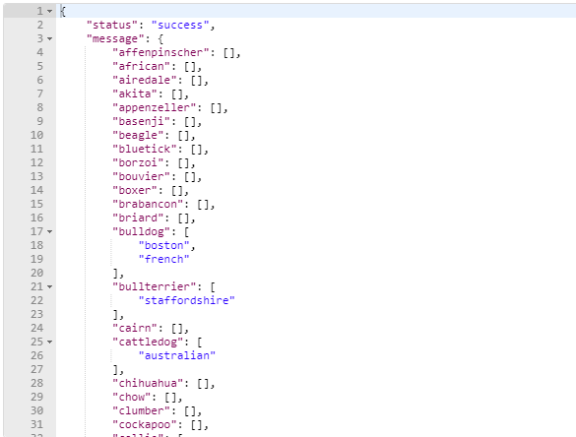

2. Using code, verify “retriever” breed is within the list

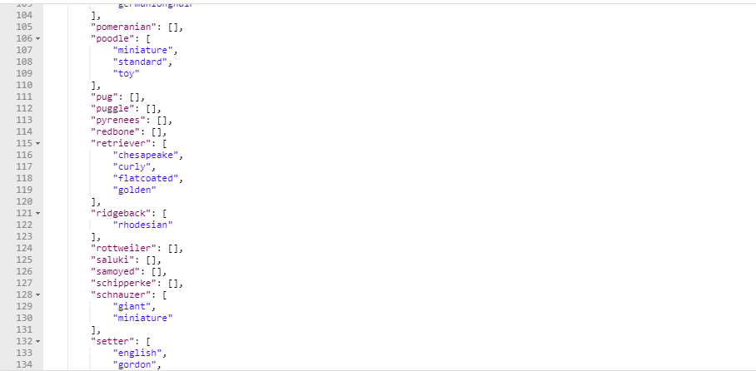

3. Perform an API request to produce a list of sub-breeds for “retriever”.

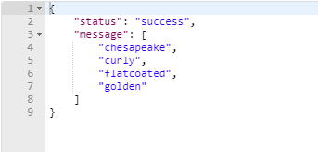

4. Perform an API request to produce a random image / link for the sub-breed “golden”

