Query 1 — Industry-Specific Salary Trends
from pyspark.sql import SparkSession
# Start a Spark session
spark = SparkSession.builder.config("spark.driver.host", "localhost").appName("JobPostingsAnalysis").getOrCreate()
spark.catalog.clearCache()
# Load the CSV file into a Spark DataFrame
df = spark.read.option("header", "true").option("inferSchema", "true").option(
"multiLine", "true").option("escape", "\"").csv("data/lightcast_job_postings.csv")
# Register the DataFrame as a temporary SQL view
df.createOrReplaceTempView("job_postings")
# Show Schema and Sample Data
print("---This is Diagnostic check, No need to print it in the final doc---")
# comment the lines below when rendering the submission
df.printSchema()
df.show(5)
WARNING: Using incubator modules: jdk.incubator.vector
Using Spark's default log4j profile: org/apache/spark/log4j2-defaults.properties
Setting default log level to "WARN".
To adjust logging level use sc.setLogLevel(newLevel). For SparkR, use setLogLevel(newLevel).
26/05/27 16:24:29 WARN NativeCodeLoader: Unable to load native-hadoop library for your platform... using builtin-java classes where applicable
26/05/27 16:24:53 WARN SparkStringUtils: Truncated the string representation of a plan since it was too large. This behavior can be adjusted by setting 'spark.sql.debug.maxToStringFields'.
---This is Diagnostic check, No need to print it in the final doc---
root
|-- ID: string (nullable = true)
|-- LAST_UPDATED_DATE: string (nullable = true)
|-- LAST_UPDATED_TIMESTAMP: timestamp (nullable = true)
|-- DUPLICATES: integer (nullable = true)
|-- POSTED: string (nullable = true)
|-- EXPIRED: string (nullable = true)
|-- DURATION: integer (nullable = true)
|-- SOURCE_TYPES: string (nullable = true)
|-- SOURCES: string (nullable = true)
|-- URL: string (nullable = true)
|-- ACTIVE_URLS: string (nullable = true)
|-- ACTIVE_SOURCES_INFO: string (nullable = true)
|-- TITLE_RAW: string (nullable = true)
|-- BODY: string (nullable = true)
|-- MODELED_EXPIRED: string (nullable = true)
|-- MODELED_DURATION: integer (nullable = true)
|-- COMPANY: integer (nullable = true)
|-- COMPANY_NAME: string (nullable = true)
|-- COMPANY_RAW: string (nullable = true)
|-- COMPANY_IS_STAFFING: boolean (nullable = true)
|-- EDUCATION_LEVELS: string (nullable = true)
|-- EDUCATION_LEVELS_NAME: string (nullable = true)
|-- MIN_EDULEVELS: integer (nullable = true)
|-- MIN_EDULEVELS_NAME: string (nullable = true)
|-- MAX_EDULEVELS: integer (nullable = true)
|-- MAX_EDULEVELS_NAME: string (nullable = true)
|-- EMPLOYMENT_TYPE: integer (nullable = true)
|-- EMPLOYMENT_TYPE_NAME: string (nullable = true)
|-- MIN_YEARS_EXPERIENCE: integer (nullable = true)
|-- MAX_YEARS_EXPERIENCE: integer (nullable = true)
|-- IS_INTERNSHIP: boolean (nullable = true)
|-- SALARY: integer (nullable = true)
|-- REMOTE_TYPE: integer (nullable = true)
|-- REMOTE_TYPE_NAME: string (nullable = true)
|-- ORIGINAL_PAY_PERIOD: string (nullable = true)
|-- SALARY_TO: integer (nullable = true)
|-- SALARY_FROM: integer (nullable = true)
|-- LOCATION: string (nullable = true)
|-- CITY: string (nullable = true)
|-- CITY_NAME: string (nullable = true)
|-- COUNTY: integer (nullable = true)
|-- COUNTY_NAME: string (nullable = true)
|-- MSA: integer (nullable = true)
|-- MSA_NAME: string (nullable = true)
|-- STATE: integer (nullable = true)
|-- STATE_NAME: string (nullable = true)
|-- COUNTY_OUTGOING: integer (nullable = true)
|-- COUNTY_NAME_OUTGOING: string (nullable = true)
|-- COUNTY_INCOMING: integer (nullable = true)
|-- COUNTY_NAME_INCOMING: string (nullable = true)
|-- MSA_OUTGOING: integer (nullable = true)
|-- MSA_NAME_OUTGOING: string (nullable = true)
|-- MSA_INCOMING: integer (nullable = true)
|-- MSA_NAME_INCOMING: string (nullable = true)
|-- NAICS2: integer (nullable = true)
|-- NAICS2_NAME: string (nullable = true)
|-- NAICS3: integer (nullable = true)
|-- NAICS3_NAME: string (nullable = true)
|-- NAICS4: integer (nullable = true)
|-- NAICS4_NAME: string (nullable = true)
|-- NAICS5: integer (nullable = true)
|-- NAICS5_NAME: string (nullable = true)
|-- NAICS6: integer (nullable = true)
|-- NAICS6_NAME: string (nullable = true)
|-- TITLE: string (nullable = true)
|-- TITLE_NAME: string (nullable = true)
|-- TITLE_CLEAN: string (nullable = true)
|-- SKILLS: string (nullable = true)
|-- SKILLS_NAME: string (nullable = true)
|-- SPECIALIZED_SKILLS: string (nullable = true)
|-- SPECIALIZED_SKILLS_NAME: string (nullable = true)
|-- CERTIFICATIONS: string (nullable = true)
|-- CERTIFICATIONS_NAME: string (nullable = true)
|-- COMMON_SKILLS: string (nullable = true)
|-- COMMON_SKILLS_NAME: string (nullable = true)
|-- SOFTWARE_SKILLS: string (nullable = true)
|-- SOFTWARE_SKILLS_NAME: string (nullable = true)
|-- ONET: string (nullable = true)
|-- ONET_NAME: string (nullable = true)
|-- ONET_2019: string (nullable = true)
|-- ONET_2019_NAME: string (nullable = true)
|-- CIP6: string (nullable = true)
|-- CIP6_NAME: string (nullable = true)
|-- CIP4: string (nullable = true)
|-- CIP4_NAME: string (nullable = true)
|-- CIP2: string (nullable = true)
|-- CIP2_NAME: string (nullable = true)
|-- SOC_2021_2: string (nullable = true)
|-- SOC_2021_2_NAME: string (nullable = true)
|-- SOC_2021_3: string (nullable = true)
|-- SOC_2021_3_NAME: string (nullable = true)
|-- SOC_2021_4: string (nullable = true)
|-- SOC_2021_4_NAME: string (nullable = true)
|-- SOC_2021_5: string (nullable = true)
|-- SOC_2021_5_NAME: string (nullable = true)
|-- LOT_CAREER_AREA: integer (nullable = true)
|-- LOT_CAREER_AREA_NAME: string (nullable = true)
|-- LOT_OCCUPATION: integer (nullable = true)
|-- LOT_OCCUPATION_NAME: string (nullable = true)
|-- LOT_SPECIALIZED_OCCUPATION: integer (nullable = true)
|-- LOT_SPECIALIZED_OCCUPATION_NAME: string (nullable = true)
|-- LOT_OCCUPATION_GROUP: integer (nullable = true)
|-- LOT_OCCUPATION_GROUP_NAME: string (nullable = true)
|-- LOT_V6_SPECIALIZED_OCCUPATION: integer (nullable = true)
|-- LOT_V6_SPECIALIZED_OCCUPATION_NAME: string (nullable = true)
|-- LOT_V6_OCCUPATION: integer (nullable = true)
|-- LOT_V6_OCCUPATION_NAME: string (nullable = true)
|-- LOT_V6_OCCUPATION_GROUP: integer (nullable = true)
|-- LOT_V6_OCCUPATION_GROUP_NAME: string (nullable = true)
|-- LOT_V6_CAREER_AREA: integer (nullable = true)
|-- LOT_V6_CAREER_AREA_NAME: string (nullable = true)
|-- SOC_2: string (nullable = true)
|-- SOC_2_NAME: string (nullable = true)
|-- SOC_3: string (nullable = true)
|-- SOC_3_NAME: string (nullable = true)
|-- SOC_4: string (nullable = true)
|-- SOC_4_NAME: string (nullable = true)
|-- SOC_5: string (nullable = true)
|-- SOC_5_NAME: string (nullable = true)
|-- LIGHTCAST_SECTORS: string (nullable = true)
|-- LIGHTCAST_SECTORS_NAME: string (nullable = true)
|-- NAICS_2022_2: integer (nullable = true)
|-- NAICS_2022_2_NAME: string (nullable = true)
|-- NAICS_2022_3: integer (nullable = true)
|-- NAICS_2022_3_NAME: string (nullable = true)
|-- NAICS_2022_4: integer (nullable = true)
|-- NAICS_2022_4_NAME: string (nullable = true)
|-- NAICS_2022_5: integer (nullable = true)
|-- NAICS_2022_5_NAME: string (nullable = true)
|-- NAICS_2022_6: integer (nullable = true)
|-- NAICS_2022_6_NAME: string (nullable = true)

+--------------------+-----------------+----------------------+----------+--------+---------+--------+--------------------+--------------------+--------------------+-----------+-------------------+--------------------+--------------------+---------------+----------------+--------+--------------------+-----------+-------------------+----------------+---------------------+-------------+-------------------+-------------+------------------+---------------+--------------------+--------------------+--------------------+-------------+------+-----------+----------------+-------------------+---------+-----------+--------------------+--------------------+-------------+------+--------------+-----+--------------------+-----+----------+---------------+--------------------+---------------+--------------------+------------+--------------------+------------+--------------------+------+--------------------+------+--------------------+------+--------------------+------+--------------------+------+--------------------+------------------+-------------------+--------------------+--------------------+--------------------+--------------------+-----------------------+--------------------+--------------------+--------------------+--------------------+--------------------+--------------------+----------+--------------------+----------+--------------------+--------------------+--------------------+--------------------+--------------------+--------------------+--------------------+----------+--------------------+----------+--------------------+----------+---------------+----------+---------------+---------------+--------------------+--------------+--------------------+--------------------------+-------------------------------+--------------------+-------------------------+-----------------------------+----------------------------------+-----------------+----------------------+-----------------------+----------------------------+------------------+-----------------------+-------+--------------------+-------+--------------------+-------+---------------+-------+---------------+-----------------+----------------------+------------+--------------------+------------+--------------------+------------+--------------------+------------+--------------------+------------+--------------------+
| ID|LAST_UPDATED_DATE|LAST_UPDATED_TIMESTAMP|DUPLICATES| POSTED| EXPIRED|DURATION| SOURCE_TYPES| SOURCES| URL|ACTIVE_URLS|ACTIVE_SOURCES_INFO| TITLE_RAW| BODY|MODELED_EXPIRED|MODELED_DURATION| COMPANY| COMPANY_NAME|COMPANY_RAW|COMPANY_IS_STAFFING|EDUCATION_LEVELS|EDUCATION_LEVELS_NAME|MIN_EDULEVELS| MIN_EDULEVELS_NAME|MAX_EDULEVELS|MAX_EDULEVELS_NAME|EMPLOYMENT_TYPE|EMPLOYMENT_TYPE_NAME|MIN_YEARS_EXPERIENCE|MAX_YEARS_EXPERIENCE|IS_INTERNSHIP|SALARY|REMOTE_TYPE|REMOTE_TYPE_NAME|ORIGINAL_PAY_PERIOD|SALARY_TO|SALARY_FROM| LOCATION| CITY| CITY_NAME|COUNTY| COUNTY_NAME| MSA| MSA_NAME|STATE|STATE_NAME|COUNTY_OUTGOING|COUNTY_NAME_OUTGOING|COUNTY_INCOMING|COUNTY_NAME_INCOMING|MSA_OUTGOING| MSA_NAME_OUTGOING|MSA_INCOMING| MSA_NAME_INCOMING|NAICS2| NAICS2_NAME|NAICS3| NAICS3_NAME|NAICS4| NAICS4_NAME|NAICS5| NAICS5_NAME|NAICS6| NAICS6_NAME| TITLE| TITLE_NAME| TITLE_CLEAN| SKILLS| SKILLS_NAME| SPECIALIZED_SKILLS|SPECIALIZED_SKILLS_NAME| CERTIFICATIONS| CERTIFICATIONS_NAME| COMMON_SKILLS| COMMON_SKILLS_NAME| SOFTWARE_SKILLS|SOFTWARE_SKILLS_NAME| ONET| ONET_NAME| ONET_2019| ONET_2019_NAME| CIP6| CIP6_NAME| CIP4| CIP4_NAME| CIP2| CIP2_NAME|SOC_2021_2| SOC_2021_2_NAME|SOC_2021_3| SOC_2021_3_NAME|SOC_2021_4|SOC_2021_4_NAME|SOC_2021_5|SOC_2021_5_NAME|LOT_CAREER_AREA|LOT_CAREER_AREA_NAME|LOT_OCCUPATION| LOT_OCCUPATION_NAME|LOT_SPECIALIZED_OCCUPATION|LOT_SPECIALIZED_OCCUPATION_NAME|LOT_OCCUPATION_GROUP|LOT_OCCUPATION_GROUP_NAME|LOT_V6_SPECIALIZED_OCCUPATION|LOT_V6_SPECIALIZED_OCCUPATION_NAME|LOT_V6_OCCUPATION|LOT_V6_OCCUPATION_NAME|LOT_V6_OCCUPATION_GROUP|LOT_V6_OCCUPATION_GROUP_NAME|LOT_V6_CAREER_AREA|LOT_V6_CAREER_AREA_NAME| SOC_2| SOC_2_NAME| SOC_3| SOC_3_NAME| SOC_4| SOC_4_NAME| SOC_5| SOC_5_NAME|LIGHTCAST_SECTORS|LIGHTCAST_SECTORS_NAME|NAICS_2022_2| NAICS_2022_2_NAME|NAICS_2022_3| NAICS_2022_3_NAME|NAICS_2022_4| NAICS_2022_4_NAME|NAICS_2022_5| NAICS_2022_5_NAME|NAICS_2022_6| NAICS_2022_6_NAME|
+--------------------+-----------------+----------------------+----------+--------+---------+--------+--------------------+--------------------+--------------------+-----------+-------------------+--------------------+--------------------+---------------+----------------+--------+--------------------+-----------+-------------------+----------------+---------------------+-------------+-------------------+-------------+------------------+---------------+--------------------+--------------------+--------------------+-------------+------+-----------+----------------+-------------------+---------+-----------+--------------------+--------------------+-------------+------+--------------+-----+--------------------+-----+----------+---------------+--------------------+---------------+--------------------+------------+--------------------+------------+--------------------+------+--------------------+------+--------------------+------+--------------------+------+--------------------+------+--------------------+------------------+-------------------+--------------------+--------------------+--------------------+--------------------+-----------------------+--------------------+--------------------+--------------------+--------------------+--------------------+--------------------+----------+--------------------+----------+--------------------+--------------------+--------------------+--------------------+--------------------+--------------------+--------------------+----------+--------------------+----------+--------------------+----------+---------------+----------+---------------+---------------+--------------------+--------------+--------------------+--------------------------+-------------------------------+--------------------+-------------------------+-----------------------------+----------------------------------+-----------------+----------------------+-----------------------+----------------------------+------------------+-----------------------+-------+--------------------+-------+--------------------+-------+---------------+-------+---------------+-----------------+----------------------+------------+--------------------+------------+--------------------+------------+--------------------+------------+--------------------+------------+--------------------+
|1f57d95acf4dc67ed...| 9/6/2024| 2024-09-06 20:32:...| 0|6/2/2024| 6/8/2024| 6| [\n "Company"\n]|[\n "brassring.c...|[\n "https://sjo...| []| NULL|Enterprise Analys...|31-May-2024\n\nEn...| 6/8/2024| 6| 894731| Murphy USA| Murphy USA| false| [\n 2\n]| [\n "Bachelor's ...| 2| Bachelor's degree| NULL| NULL| 1|Full-time (> 32 h...| 2| 2| false| NULL| 0| [None]| NULL| NULL| NULL|{\n "lat": 33.20...|RWwgRG9yYWRvLCBBUg==|El Dorado, AR| 5139| Union, AR|20980| El Dorado, AR| 5| Arkansas| 5139| Union, AR| 5139| Union, AR| 20980| El Dorado, AR| 20980| El Dorado, AR| 44| Retail Trade| 441|Motor Vehicle and...| 4413|Automotive Parts,...| 44133|Automotive Parts ...|441330|Automotive Parts ...|ET29C073C03D1F86B4|Enterprise Analysts|enterprise analys...|[\n "KS126DB6T06...|[\n "Merchandisi...|[\n "KS126DB6T06...| [\n "Merchandisi...| []| []|[\n "KS126706DPF...|[\n "Mathematics...|[\n "KS440W865GC...|[\n "SQL (Progra...|15-2051.01|Business Intellig...|15-2051.01|Business Intellig...|[\n "45.0601",\n...|[\n "Economics, ...|[\n "45.06",\n ...|[\n "Economics",...|[\n "45",\n "27...|[\n "Social Scie...| 15-0000|Computer and Math...| 15-2000|Mathematical Scie...| 15-2050|Data Scientists| 15-2051|Data Scientists| 23|Information Techn...| 231010|Business Intellig...| 23101011| General ERP Analy...| 2310| Business Intellig...| 23101011| General ERP Analy...| 231010| Business Intellig...| 2310| Business Intellig...| 23| Information Techn...|15-0000|Computer and Math...|15-2000|Mathematical Scie...|15-2050|Data Scientists|15-2051|Data Scientists| [\n 7\n]| [\n "Artificial ...| 44| Retail Trade| 441|Motor Vehicle and...| 4413|Automotive Parts,...| 44133|Automotive Parts ...| 441330|Automotive Parts ...|
|0cb072af26757b6c4...| 8/2/2024| 2024-08-02 17:08:...| 0|6/2/2024| 8/1/2024| NULL| [\n "Job Board"\n]| [\n "maine.gov"\n]|[\n "https://job...| []| NULL|Oracle Consultant...|Oracle Consultant...| 8/1/2024| NULL| 133098|Smx Corporation L...| SMX| true| [\n 99\n]| [\n "No Educatio...| 99|No Education Listed| NULL| NULL| 1|Full-time (> 32 h...| 3| 3| false| NULL| 1| Remote| NULL| NULL| NULL|{\n "lat": 44.31...| QXVndXN0YSwgTUU=| Augusta, ME| 23011| Kennebec, ME|12300|Augusta-Watervill...| 23| Maine| 23011| Kennebec, ME| 23011| Kennebec, ME| 12300|Augusta-Watervill...| 12300|Augusta-Watervill...| 56|Administrative an...| 561|Administrative an...| 5613| Employment Services| 56132|Temporary Help Se...|561320|Temporary Help Se...|ET21DDA63780A7DC09| Oracle Consultants|oracle consultant...|[\n "KS122626T55...|[\n "Procurement...|[\n "KS122626T55...| [\n "Procurement...| []| []| []| []|[\n "BGSBF3F508F...|[\n "Oracle Busi...|15-2051.01|Business Intellig...|15-2051.01|Business Intellig...| []| []| []| []| []| []| 15-0000|Computer and Math...| 15-2000|Mathematical Scie...| 15-2050|Data Scientists| 15-2051|Data Scientists| 23|Information Techn...| 231010|Business Intellig...| 23101012| Oracle Consultant...| 2310| Business Intellig...| 23101012| Oracle Consultant...| 231010| Business Intellig...| 2310| Business Intellig...| 23| Information Techn...|15-0000|Computer and Math...|15-2000|Mathematical Scie...|15-2050|Data Scientists|15-2051|Data Scientists| NULL| NULL| 56|Administrative an...| 561|Administrative an...| 5613| Employment Services| 56132|Temporary Help Se...| 561320|Temporary Help Se...|
|85318b12b3331fa49...| 9/6/2024| 2024-09-06 20:32:...| 1|6/2/2024| 7/7/2024| 35| [\n "Job Board"\n]|[\n "dejobs.org"\n]|[\n "https://dej...| []| NULL| Data Analyst|Taking care of pe...| 6/10/2024| 8|39063746| Sedgwick| Sedgwick| false| [\n 2\n]| [\n "Bachelor's ...| 2| Bachelor's degree| NULL| NULL| 1|Full-time (> 32 h...| 5| NULL| false| NULL| 0| [None]| NULL| NULL| NULL|{\n "lat": 32.77...| RGFsbGFzLCBUWA==| Dallas, TX| 48113| Dallas, TX|19100|Dallas-Fort Worth...| 48| Texas| 48113| Dallas, TX| 48113| Dallas, TX| 19100|Dallas-Fort Worth...| 19100|Dallas-Fort Worth...| 52|Finance and Insur...| 524|Insurance Carrier...| 5242|Agencies, Brokera...| 52429|Other Insurance R...|524291| Claims Adjusting|ET3037E0C947A02404| Data Analysts| data analyst|[\n "KS1218W78FG...|[\n "Management"...|[\n "ESF3939CE1F...| [\n "Exception R...|[\n "KS683TN76T7...|[\n "Security Cl...|[\n "KS1218W78FG...|[\n "Management"...|[\n "KS126HY6YLT...|[\n "Microsoft O...|15-2051.01|Business Intellig...|15-2051.01|Business Intellig...| []| []| []| []| []| []| 15-0000|Computer and Math...| 15-2000|Mathematical Scie...| 15-2050|Data Scientists| 15-2051|Data Scientists| 23|Information Techn...| 231113|Data / Data Minin...| 23111310| Data Analyst| 2311| Data Analysis and...| 23111310| Data Analyst| 231113| Data / Data Minin...| 2311| Data Analysis and...| 23| Information Techn...|15-0000|Computer and Math...|15-2000|Mathematical Scie...|15-2050|Data Scientists|15-2051|Data Scientists| NULL| NULL| 52|Finance and Insur...| 524|Insurance Carrier...| 5242|Agencies, Brokera...| 52429|Other Insurance R...| 524291| Claims Adjusting|
|1b5c3941e54a1889e...| 9/6/2024| 2024-09-06 20:32:...| 1|6/2/2024|7/20/2024| 48| [\n "Job Board"\n]|[\n "disabledper...|[\n "https://www...| []| NULL|Sr. Lead Data Mgm...|About this role:\...| 6/12/2024| 10|37615159| Wells Fargo|Wells Fargo| false| [\n 99\n]| [\n "No Educatio...| 99|No Education Listed| NULL| NULL| 1|Full-time (> 32 h...| 3| NULL| false| NULL| 0| [None]| NULL| NULL| NULL|{\n "lat": 33.44...| UGhvZW5peCwgQVo=| Phoenix, AZ| 4013| Maricopa, AZ|38060|Phoenix-Mesa-Chan...| 4| Arizona| 4013| Maricopa, AZ| 4013| Maricopa, AZ| 38060|Phoenix-Mesa-Chan...| 38060|Phoenix-Mesa-Chan...| 52|Finance and Insur...| 522|Credit Intermedia...| 5221|Depository Credit...| 52211| Commercial Banking|522110| Commercial Banking|ET2114E0404BA30075|Management Analysts|sr lead data mgmt...|[\n "KS123QX62QY...|[\n "Exit Strate...|[\n "KS123QX62QY...| [\n "Exit Strate...| []| []|[\n "KS7G6NP6R6L...|[\n "Reliability...|[\n "KS4409D76NW...|[\n "SAS (Softwa...|15-2051.01|Business Intellig...|15-2051.01|Business Intellig...| []| []| []| []| []| []| 15-0000|Computer and Math...| 15-2000|Mathematical Scie...| 15-2050|Data Scientists| 15-2051|Data Scientists| 23|Information Techn...| 231113|Data / Data Minin...| 23111310| Data Analyst| 2311| Data Analysis and...| 23111310| Data Analyst| 231113| Data / Data Minin...| 2311| Data Analysis and...| 23| Information Techn...|15-0000|Computer and Math...|15-2000|Mathematical Scie...|15-2050|Data Scientists|15-2051|Data Scientists| [\n 6\n]| [\n "Data Privac...| 52|Finance and Insur...| 522|Credit Intermedia...| 5221|Depository Credit...| 52211| Commercial Banking| 522110| Commercial Banking|
|cb5ca25f02bdf25c1...| 6/19/2024| 2024-06-19 07:00:00| 0|6/2/2024|6/17/2024| 15|[\n "FreeJobBoar...|[\n "craigslist....|[\n "https://mod...| []| NULL|Comisiones de $10...|Comisiones de $10...| 6/17/2024| 15| 0| Unclassified| LH/GM| false| [\n 99\n]| [\n "No Educatio...| 99|No Education Listed| NULL| NULL| 3|Part-time / full-...| NULL| NULL| false| 92500| 0| [None]| year| 150000| 35000|{\n "lat": 37.63...| TW9kZXN0bywgQ0E=| Modesto, CA| 6099|Stanislaus, CA|33700| Modesto, CA| 6|California| 6099| Stanislaus, CA| 6099| Stanislaus, CA| 33700| Modesto, CA| 33700| Modesto, CA| 99|Unclassified Indu...| 999|Unclassified Indu...| 9999|Unclassified Indu...| 99999|Unclassified Indu...|999999|Unclassified Indu...|ET0000000000000000| Unclassified|comisiones de por...| []| []| []| []| []| []| []| []| []| []|15-2051.01|Business Intellig...|15-2051.01|Business Intellig...| []| []| []| []| []| []| 15-0000|Computer and Math...| 15-2000|Mathematical Scie...| 15-2050|Data Scientists| 15-2051|Data Scientists| 23|Information Techn...| 231010|Business Intellig...| 23101012| Oracle Consultant...| 2310| Business Intellig...| 23101012| Oracle Consultant...| 231010| Business Intellig...| 2310| Business Intellig...| 23| Information Techn...|15-0000|Computer and Math...|15-2000|Mathematical Scie...|15-2050|Data Scientists|15-2051|Data Scientists| NULL| NULL| 99|Unclassified Indu...| 999|Unclassified Indu...| 9999|Unclassified Indu...| 99999|Unclassified Indu...| 999999|Unclassified Indu...|
+--------------------+-----------------+----------------------+----------+--------+---------+--------+--------------------+--------------------+--------------------+-----------+-------------------+--------------------+--------------------+---------------+----------------+--------+--------------------+-----------+-------------------+----------------+---------------------+-------------+-------------------+-------------+------------------+---------------+--------------------+--------------------+--------------------+-------------+------+-----------+----------------+-------------------+---------+-----------+--------------------+--------------------+-------------+------+--------------+-----+--------------------+-----+----------+---------------+--------------------+---------------+--------------------+------------+--------------------+------------+--------------------+------+--------------------+------+--------------------+------+--------------------+------+--------------------+------+--------------------+------------------+-------------------+--------------------+--------------------+--------------------+--------------------+-----------------------+--------------------+--------------------+--------------------+--------------------+--------------------+--------------------+----------+--------------------+----------+--------------------+--------------------+--------------------+--------------------+--------------------+--------------------+--------------------+----------+--------------------+----------+--------------------+----------+---------------+----------+---------------+---------------+--------------------+--------------+--------------------+--------------------------+-------------------------------+--------------------+-------------------------+-----------------------------+----------------------------------+-----------------+----------------------+-----------------------+----------------------------+------------------+-----------------------+-------+--------------------+-------+--------------------+-------+---------------+-------+---------------+-----------------+----------------------+------------+--------------------+------------+--------------------+------------+--------------------+------------+--------------------+------------+--------------------+
only showing top 5 rows
from pyspark.sql.functions import monotonically_increasing_id
companies_df = df.select(
"COMPANY",
"COMPANY_NAME",
"COMPANY_RAW",
"COMPANY_IS_STAFFING"
).distinct()
# Create primary key
companies_df = companies_df.withColumn(
"COMPANY_ID",
monotonically_increasing_id()
)
# Reorder columns
companies_df = companies_df.select(
"COMPANY_ID",
"COMPANY",
"COMPANY_NAME",
"COMPANY_RAW",
"COMPANY_IS_STAFFING"
)
# Register SQL table
companies_df.createOrReplaceTempView("companies")
companies_df.show(5)
[Stage 3:> (0 + 1) / 1]
+----------+--------+--------------------+--------------------+-------------------+
|COMPANY_ID| COMPANY| COMPANY_NAME| COMPANY_RAW|COMPANY_IS_STAFFING|
+----------+--------+--------------------+--------------------+-------------------+
| 0|35247729| Crowe| Crowe| false|
| 1|39461288|The Devereux Foun...|The Devereux Foun...| false|
| 2|40008275| Elder Research| Elder Research| false|
| 3|37060425| NTT DATA| NTT DATA Inc| false|
| 4|40882284|Frederick Nationa...|Frederick Nationa...| false|
+----------+--------+--------------------+--------------------+-------------------+
only showing top 5 rows

industries_df = df.select(
"NAICS_2022_6",
"NAICS_2022_6_NAME",
"SOC_5",
"SOC_5_NAME",
"LOT_SPECIALIZED_OCCUPATION_NAME",
"LOT_OCCUPATION_GROUP"
).distinct()
industries_df = industries_df.withColumn(
"INDUSTRY_ID",
monotonically_increasing_id()
)
industries_df = industries_df.select(
"INDUSTRY_ID",
"NAICS_2022_6",
"NAICS_2022_6_NAME",
"SOC_5",
"SOC_5_NAME",
"LOT_SPECIALIZED_OCCUPATION_NAME",
"LOT_OCCUPATION_GROUP"
)
industries_df.createOrReplaceTempView("industries")
industries_df.show(5)
[Stage 6:> (0 + 1) / 1]
+-----------+------------+--------------------+-------+---------------+-------------------------------+--------------------+
|INDUSTRY_ID|NAICS_2022_6| NAICS_2022_6_NAME| SOC_5| SOC_5_NAME|LOT_SPECIALIZED_OCCUPATION_NAME|LOT_OCCUPATION_GROUP|
+-----------+------------+--------------------+-------+---------------+-------------------------------+--------------------+
| 0| 424490|Other Grocery and...|15-2051|Data Scientists| SAP Analyst / Admin| 2310|
| 1| 562111|Solid Waste Colle...|15-2051|Data Scientists| Oracle Consultant...| 2310|
| 2| 457110|Gasoline Stations...|15-2051|Data Scientists| Oracle Consultant...| 2310|
| 3| 334111|Electronic Comput...|15-2051|Data Scientists| Oracle Consultant...| 2310|
| 4| 621320|Offices of Optome...|15-2051|Data Scientists| General ERP Analy...| 2310|
+-----------+------------+--------------------+-------+---------------+-------------------------------+--------------------+
only showing top 5 rows

locations_df = df.select(
"LOCATION",
"CITY_NAME",
"STATE_NAME",
"COUNTY_NAME",
"MSA",
"MSA_NAME"
).distinct()
locations_df = locations_df.withColumn(
"LOCATION_ID",
monotonically_increasing_id()
)
locations_df = locations_df.select(
"LOCATION_ID",
"LOCATION",
"CITY_NAME",
"STATE_NAME",
"COUNTY_NAME",
"MSA",
"MSA_NAME"
)
locations_df.createOrReplaceTempView("locations")
locations_df.show(5)
[Stage 9:> (0 + 1) / 1]
+-----------+--------------------+------------------+----------+-----------+-----+--------------------+
|LOCATION_ID| LOCATION| CITY_NAME|STATE_NAME|COUNTY_NAME| MSA| MSA_NAME|
+-----------+--------------------+------------------+----------+-----------+-----+--------------------+
| 0|{\n "lat": 24.55...| Key West, FL| Florida| Monroe, FL|28580| Key West, FL|
| 1|{\n "lat": 41.62...| Urbandale, IA| Iowa| Polk, IA|19780|Des Moines-West D...|
| 2|{\n "lat": 37.20...| Springfield, MO| Missouri| Greene, MO|44180| Springfield, MO|
| 3|{\n "lat": 40.74...|[Unknown City], NJ|New Jersey| Hudson, NJ|35620|New York-Newark-J...|
| 4|{\n "lat": 40.79...| West Orange, NJ|New Jersey| Essex, NJ|35620|New York-Newark-J...|
+-----------+--------------------+------------------+----------+-----------+-----+--------------------+
only showing top 5 rows

job_postings_df = df.select(
"ID",
"TITLE_CLEAN",
"EMPLOYMENT_TYPE_NAME",
"REMOTE_TYPE_NAME",
"BODY",
"MIN_YEARS_EXPERIENCE",
"MAX_YEARS_EXPERIENCE",
"SALARY",
"SALARY_FROM",
"SALARY_TO",
"POSTED",
"EXPIRED",
"DURATION",
"COMPANY",
"LOCATION",
"NAICS_2022_6"
)
job_postings_df = job_postings_df.join(
companies_df.select("COMPANY_ID", "COMPANY"),
on="COMPANY",
how="left"
)
job_postings_df = job_postings_df.join(
locations_df.select("LOCATION_ID", "LOCATION"),
on="LOCATION",
how="left"
)
job_postings_df = job_postings_df.join(
industries_df.select("INDUSTRY_ID", "NAICS_2022_6"),
on="NAICS_2022_6",
how="left"
)
job_postings_df = job_postings_df.select(
"ID",
"TITLE_CLEAN",
"COMPANY_ID",
"INDUSTRY_ID",
"EMPLOYMENT_TYPE_NAME",
"REMOTE_TYPE_NAME",
"BODY",
"MIN_YEARS_EXPERIENCE",
"MAX_YEARS_EXPERIENCE",
"SALARY",
"SALARY_FROM",
"SALARY_TO",
"LOCATION_ID",
"POSTED",
"EXPIRED",
"DURATION"
)
job_postings_df.createOrReplaceTempView("job_postings")
job_postings_df.show(5)

+--------------------+--------------------+----------+-----------+--------------------+----------------+--------------------+--------------------+--------------------+------+-----------+---------+-----------+--------+--------+--------+
| ID| TITLE_CLEAN|COMPANY_ID|INDUSTRY_ID|EMPLOYMENT_TYPE_NAME|REMOTE_TYPE_NAME| BODY|MIN_YEARS_EXPERIENCE|MAX_YEARS_EXPERIENCE|SALARY|SALARY_FROM|SALARY_TO|LOCATION_ID| POSTED| EXPIRED|DURATION|
+--------------------+--------------------+----------+-----------+--------------------+----------------+--------------------+--------------------+--------------------+------+-----------+---------+-----------+--------+--------+--------+
|1f57d95acf4dc67ed...|enterprise analys...| 14586| 1753|Full-time (> 32 h...| [None]|31-May-2024\n\nEn...| 2| 2| NULL| NULL| NULL| 3878|6/2/2024|6/8/2024| 6|
|1f57d95acf4dc67ed...|enterprise analys...| 14586| 1616|Full-time (> 32 h...| [None]|31-May-2024\n\nEn...| 2| 2| NULL| NULL| NULL| 3878|6/2/2024|6/8/2024| 6|
|1f57d95acf4dc67ed...|enterprise analys...| 14586| 1024|Full-time (> 32 h...| [None]|31-May-2024\n\nEn...| 2| 2| NULL| NULL| NULL| 3878|6/2/2024|6/8/2024| 6|
|1f57d95acf4dc67ed...|enterprise analys...| 14586| 942|Full-time (> 32 h...| [None]|31-May-2024\n\nEn...| 2| 2| NULL| NULL| NULL| 3878|6/2/2024|6/8/2024| 6|
|1f57d95acf4dc67ed...|enterprise analys...| 14586| 400|Full-time (> 32 h...| [None]|31-May-2024\n\nEn...| 2| 2| NULL| NULL| NULL| 3878|6/2/2024|6/8/2024| 6|
+--------------------+--------------------+----------+-----------+--------------------+----------------+--------------------+--------------------+--------------------+------+-----------+---------+-----------+--------+--------+--------+
only showing top 5 rows
query1 = """
SELECT
i.NAICS_2022_6_NAME AS industry_name,
i.LOT_SPECIALIZED_OCCUPATION_NAME AS specialized_occupation,
PERCENTILE_APPROX(j.SALARY, 0.5) AS median_salary
FROM job_postings j
JOIN industries i
ON j.INDUSTRY_ID = i.INDUSTRY_ID
WHERE
i.NAICS_2022_6 = '518210'
AND j.SALARY IS NOT NULL
AND j.SALARY > 0
GROUP BY
i.NAICS_2022_6_NAME,
i.LOT_SPECIALIZED_OCCUPATION_NAME
ORDER BY
median_salary DESC
"""
query1_result = spark.sql(query1)
query1_result.show(20, truncate=False)
[Stage 34:> (0 + 1) / 1]
+--------------------------------------------------------------------------------------+--------------------------------+-------------+
|industry_name |specialized_occupation |median_salary|
+--------------------------------------------------------------------------------------+--------------------------------+-------------+
|Computing Infrastructure Providers, Data Processing, Web Hosting, and Related Services|Financial Data Analyst |118140 |
|Computing Infrastructure Providers, Data Processing, Web Hosting, and Related Services|Data Quality Analyst |118140 |
|Computing Infrastructure Providers, Data Processing, Web Hosting, and Related Services|Marketing Analyst |118140 |
|Computing Infrastructure Providers, Data Processing, Web Hosting, and Related Services|Data Analyst |118140 |
|Computing Infrastructure Providers, Data Processing, Web Hosting, and Related Services|Enterprise Architect |118140 |
|Computing Infrastructure Providers, Data Processing, Web Hosting, and Related Services|General ERP Analyst / Consultant|118140 |
|Computing Infrastructure Providers, Data Processing, Web Hosting, and Related Services|Business Analyst (General) |118140 |
|Computing Infrastructure Providers, Data Processing, Web Hosting, and Related Services|Oracle Consultant / Analyst |118140 |
|Computing Infrastructure Providers, Data Processing, Web Hosting, and Related Services|SAP Analyst / Admin |118140 |
|Computing Infrastructure Providers, Data Processing, Web Hosting, and Related Services|Business Intelligence Analyst |118140 |
|Computing Infrastructure Providers, Data Processing, Web Hosting, and Related Services|Healthcare Analyst |118140 |
+--------------------------------------------------------------------------------------+--------------------------------+-------------+

query1_pdf = query1_result.toPandas()

import plotly.express as px
fig = px.bar(
query1_pdf,
x="median_salary",
y="specialized_occupation",
color="industry_name",
orientation="h",
title="Median Salary by Specialized Occupation in Technology Industry"
)
fig.show()
Unable to display output for mime type(s): application/vnd.plotly.v1+json
The median salaries of each specialized occupation in the technology industry are very close to one another, thus suggesting no matter the profession, this industry is a profitable one to work in for salaries of around 120k-130k

Query 2 — Top 5 Companies with the Most Remote Jobs in California
query2 = """
SELECT
c.COMPANY_NAME AS company_name,
COUNT(*) AS remote_jobs
FROM job_postings j
JOIN companies c
ON j.COMPANY_ID = c.COMPANY_ID
JOIN locations l
ON j.LOCATION_ID = l.LOCATION_ID
WHERE
j.REMOTE_TYPE_NAME = 'Remote'
AND l.STATE_NAME = 'California'
GROUP BY
c.COMPANY_NAME
ORDER BY
remote_jobs DESC
LIMIT 5
"""
query2_result = spark.sql(query2)
query2_result.show(truncate=False)
[Stage 66:> (0 + 1) / 1]
+------------------------+-----------+
|company_name |remote_jobs|
+------------------------+-----------+
|Unclassified |1509354 |
|University of California|9438 |
|Kaiser Permanente |2541 |
|Amentum |1650 |
|Randstad |1485 |
+------------------------+-----------+

query2_pdf = query2_result.toPandas()

import seaborn as sns
import matplotlib.pyplot as plt
plt.figure(figsize=(10,6))
sns.barplot(
data=query2_pdf,
x="company_name",
y="remote_jobs"
)
plt.title("Top 5 Companies Hiring Remote Workers in California")
plt.xlabel("Company Name")
plt.ylabel("Remote Job Postings")
plt.xticks(rotation=15)
plt.show()
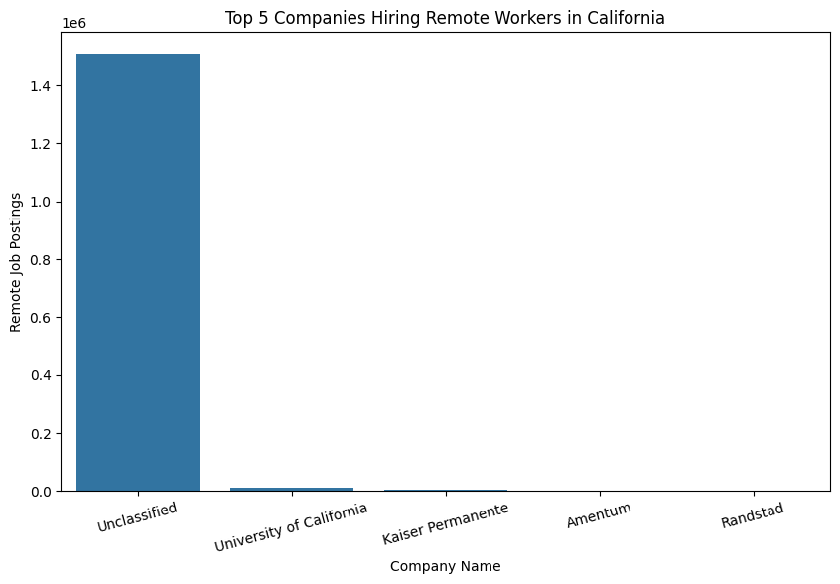
Though it may be skewed heavily towards unclassified, the number of remote opportunities at some of the largest hiring firms in the industry not having a very significant comparison to the smaller firms grouped together does give insight to how smaller firms likely utalize remote positions more than larger industry leaders

Query 3 — Monthly Job Posting Trends in California
query3 = """
SELECT
YEAR(try_to_timestamp(j.POSTED, 'M/d/yyyy')) AS year,
MONTH(try_to_timestamp(j.POSTED, 'M/d/yyyy')) AS month,
COUNT(*) AS job_count
FROM job_postings j
JOIN locations l
ON j.LOCATION_ID = l.LOCATION_ID
WHERE
l.STATE_NAME = 'California'
AND try_to_timestamp(j.POSTED, 'M/d/yyyy') IS NOT NULL
GROUP BY
YEAR(try_to_timestamp(j.POSTED, 'M/d/yyyy')),
MONTH(try_to_timestamp(j.POSTED, 'M/d/yyyy'))
ORDER BY
year DESC,
month DESC
"""
query3_result = spark.sql(query3)
query3_result.show(20, truncate=False)
[Stage 115:> (0 + 1) / 1]
+----+-----+---------+
|year|month|job_count|
+----+-----+---------+
|2024|9 |2787841 |
|2024|8 |1834724 |
|2024|7 |1787680 |
|2024|6 |1954292 |
|2024|5 |1658115 |
+----+-----+---------+

query3_pdf = query3_result.toPandas()

import seaborn as sns
import matplotlib.pyplot as plt
plt.figure(figsize=(12,6))
sns.lineplot(
data=query3_pdf,
x="month",
y="job_count",
hue="year",
marker="o"
)
plt.title("Monthly Job Posting Trends in California")
plt.xlabel("Month")
plt.ylabel("Job Count")
plt.show()
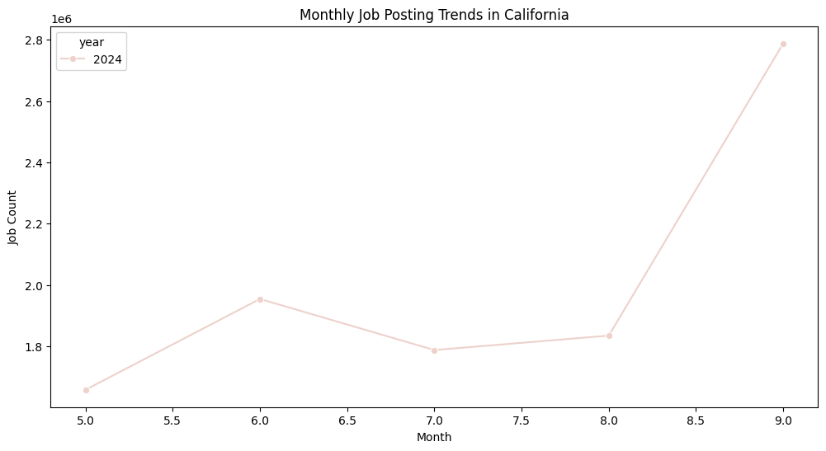
As the months go on, the number of job opporunites increases overall, with a significant rise in month 8 onward and slight dip between month 6 and 7. This showcases the economic patterns of the industry, as with more job counts in the later months, there likely is more economic activity and thus justification to hire more workers.

Query 4 — Salary Comparisons Across Major US Cities
query4 = """
SELECT
CASE
WHEN l.MSA = '14460' THEN 'Boston'
WHEN l.MSA = '47900' THEN 'Washington DC'
WHEN l.MSA = '35620' THEN 'New York'
WHEN l.MSA = '41860' THEN 'San Francisco'
WHEN l.MSA = '42660' THEN 'Seattle'
WHEN l.MSA = '31080' THEN 'Los Angeles'
WHEN l.MSA = '19100' THEN 'Dallas'
WHEN l.MSA = '26420' THEN 'Houston'
WHEN l.MSA = '12420' THEN 'Austin'
WHEN l.MSA = '34980' THEN 'Nashville'
WHEN l.MSA = '28140' THEN 'Kansas City'
WHEN l.MSA = '19740' THEN 'Denver'
END AS metro_area,
ROUND(AVG(j.SALARY), 2) AS avg_salary,
COUNT(*) AS job_count
FROM job_postings j
JOIN locations l
ON j.LOCATION_ID = l.LOCATION_ID
WHERE
j.SALARY IS NOT NULL
AND j.SALARY > 0
AND l.MSA IN (
'14460',
'47900',
'35620',
'41860',
'42660',
'31080',
'19100',
'26420',
'12420',
'34980',
'28140',
'19740'
)
GROUP BY
l.MSA
ORDER BY
avg_salary DESC
"""
query4_result = spark.sql(query4)
query4_result.show(truncate=False)
[Stage 149:============================> (1 + 1) / 2]
+-------------+----------+---------+
|metro_area |avg_salary|job_count|
+-------------+----------+---------+
|Washington DC|135606.59 |2287790 |
|San Francisco|133712.35 |1336910 |
|Seattle |127412.69 |655292 |
|Houston |116758.83 |1402474 |
|Los Angeles |115888.81 |1700450 |
|New York |111576.76 |2143319 |
|Boston |111506.67 |690133 |
|Nashville |110872.23 |101198 |
|Austin |110532.12 |2686063 |
|Dallas |106088.88 |2264019 |
|Denver |105159.8 |1686604 |
|Kansas City |77262.74 |169339 |
+-------------+----------+---------+

query4_pdf = query4_result.toPandas()

import seaborn as sns
import matplotlib.pyplot as plt
plt.figure(figsize=(12,6))
sns.barplot(
data=query4_pdf,
x="metro_area",
y="avg_salary"
)
plt.title("Average Salary Across Major US Metro Areas")
plt.xlabel("Metro Area")
plt.ylabel("Average Salary")
plt.xticks(rotation=20)
plt.show()
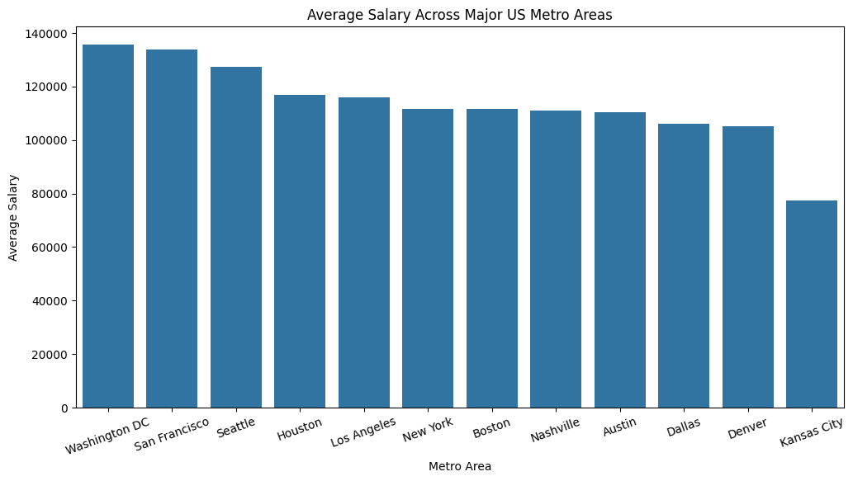
Again, most of the metro areas are relatively close to one another, however, it is clear that the predominently east and west coast areas have higher average salaries than otherwise. Houston is the one exception until Nashville of a non-east or non-west coast metro area being in the top 7, suggesting greater economic activity and opporunity in these regions.

