CSC143 Assignment Four

John Voorhess

Example of bad menu choice input:

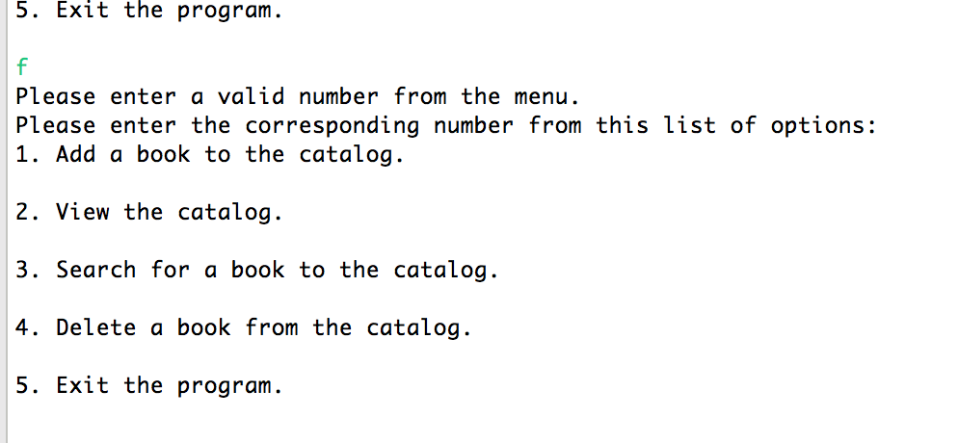

Adding a new book:

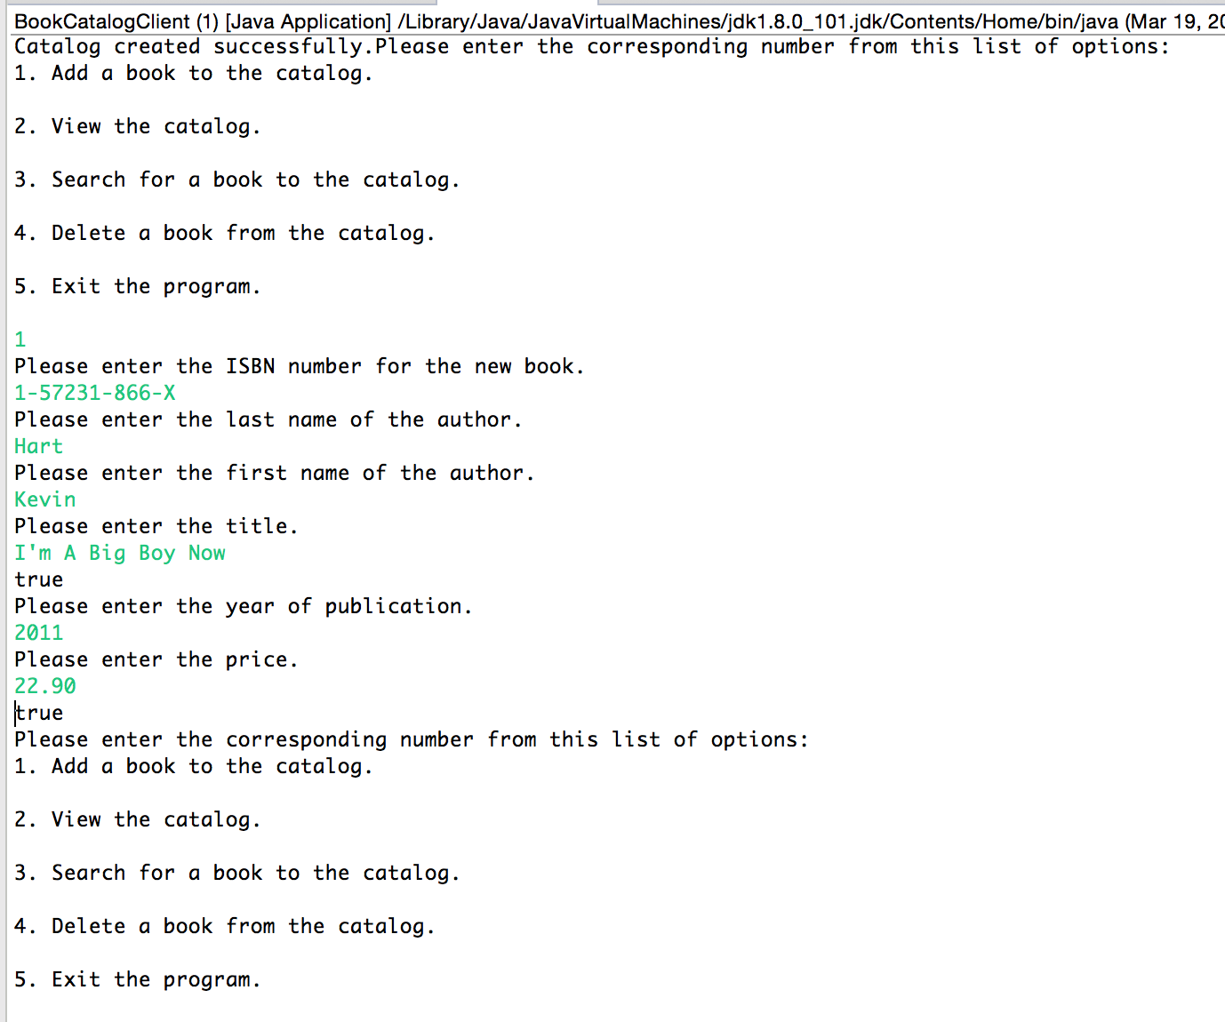

Viewing the catalog:

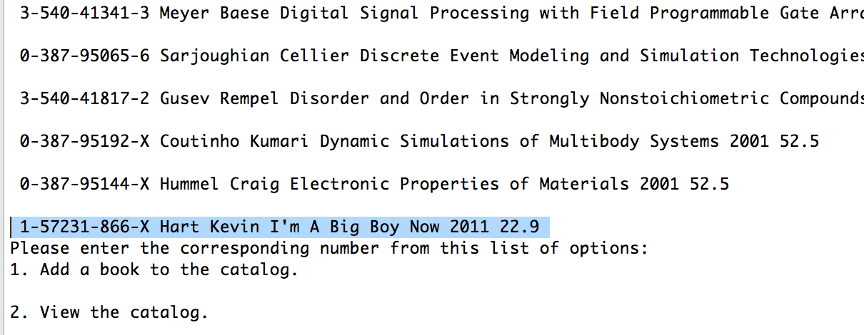

Searching for a book:

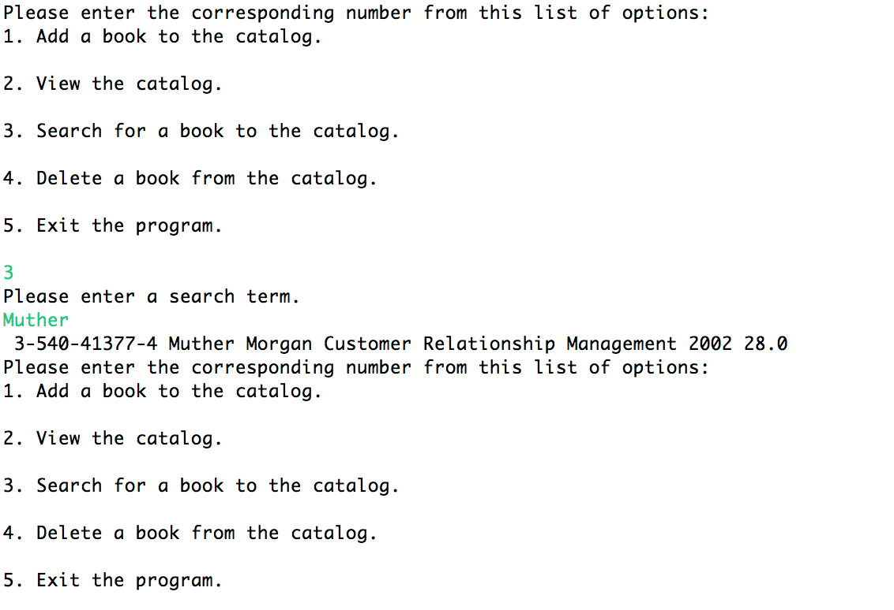

Delete a book:

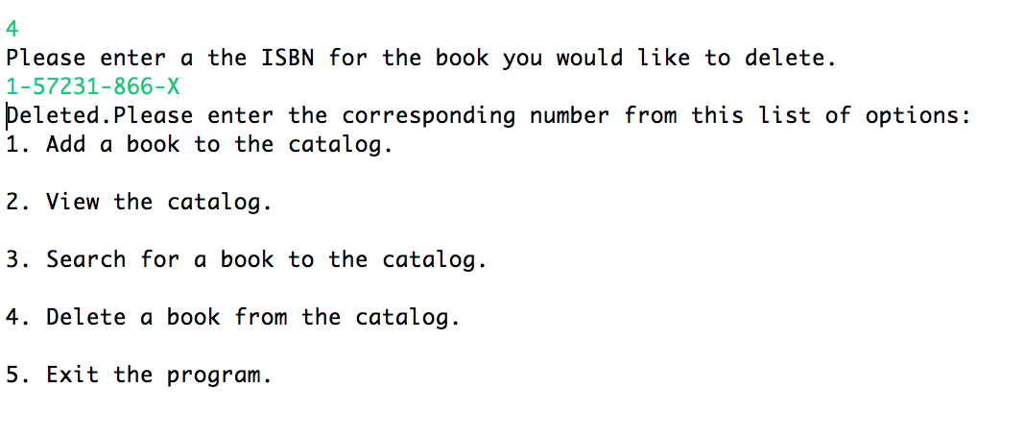

Exit the program and save:

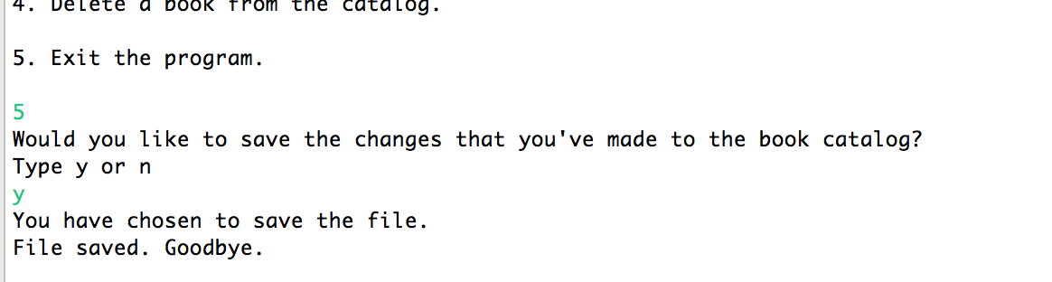

Exit the program without saving:

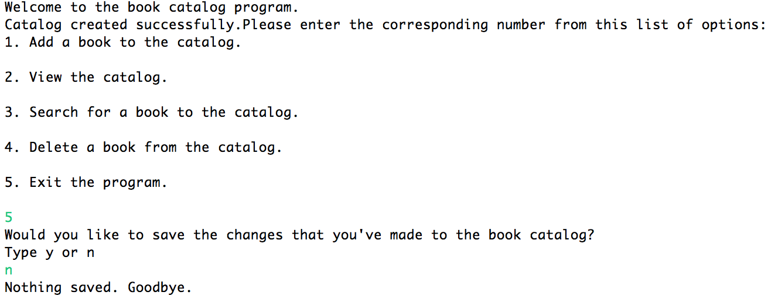

Summary:

Assignment four presented a significant number of elements to be combined, the most difficult of which being the methods to write output files. I spent much time creating and testing methods to add books to an array to use for file output. I destroyed many copies of the booklist file while trying to make file output work.

Using the linked list structure was very challenging. Learning how to move through the catalog by nodes was difficult, but I feel that it lent a deeper understanding of linked list mechanics. However deep, I’m sure that I will have to spend more time with trial and error to get this to work in another application, especially if I am not regularly using these structures in the future. The structure reminds me of tape or film-type media where you can skip to certain points and add sections in by physically attaching them and remove sections by cutting them out and taping the two ends back together, like a film reel.

This class has been extremely challenging but very rewarding. I believe that my understanding of programming concepts has been significantly widened in a way that will benefit me as I learn new technologies with analogous structures and concepts. Thank you.