**CSIS 4050 Project Proposal**

Group Members: **Yu-Hsiu Chang, Iana Vorobeva, Tung-Yu Chen**

Group Name: 200OK

**Introduction**

The main purpose of our project is to create a desktop application for a movie library. This app contains ability such as:

* Store data about movies(i.e., Title, Release Date, Genre, Director, Reviews) in a relational local database
* Basic CRUD of movie
* Search by keyword
* Filter search results by the director and gerne
* Account system makes users be able to save their favorite movies
* Display “Favorites” in a separated window only for the logged in users
* Show the details of movie by double click the list
* Logged in users can review the films and save it to the database

**Project ERD**

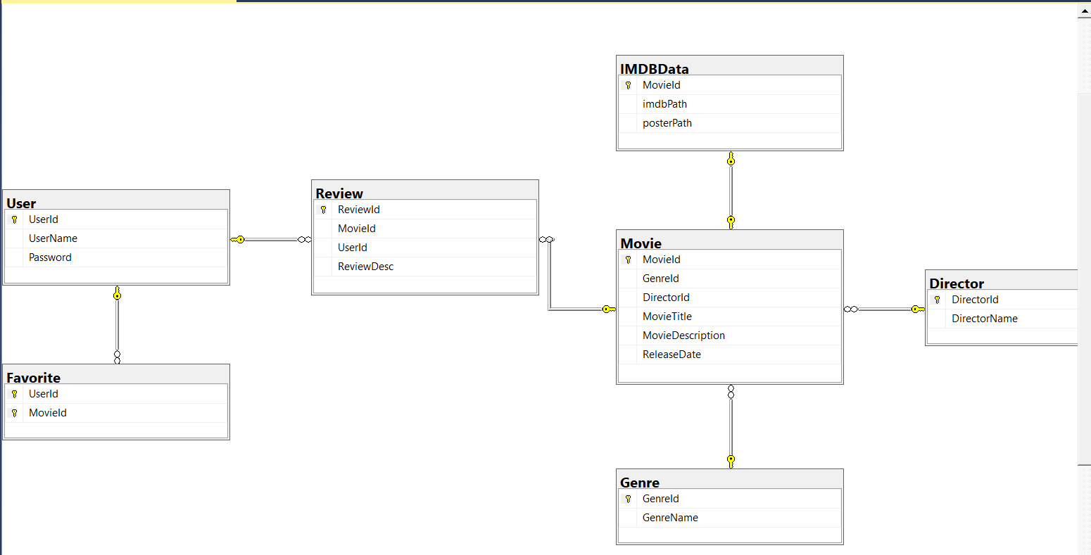

**Project Detail**

**Meeting Minutes**

**WBS**

|  |  |  |
| --- | --- | --- |
| Team Member | Business Object | Additional Features |
| Tung-Yu | Movie | Display the list of movies, support search, and update the list with accordance with search query |
| User | Sign Up/ Log In system with Encryption |
| Iana | Director | Filter the movies by Genre |
| Genre | Filter the movies by Director |
| Yu-Hsiu | Details | Display the details after double click |
| Reviews | Allow users to write reviews and save them to the database |
| Favorites | Allow user to save the favored movies and display them in a separate  tab/window |

**User Manual**

**Test Case**

|  |  |  |  |  |  |  |
| --- | --- | --- | --- | --- | --- | --- |
| **No** | **Test Case Description** | **Test Data** | **Expected Result** | **Actual Result** | **Pass/Fail** | **Verified by** |
| 1 | Create Account | Account: Anita  Password: 123123 | Account info should be added to User table | Account: Anita  had been created | Pass | Yu-Hsiu |
| 2 | Check response when valid account and password is entered | Account: Anita  Password: 123123 | Login should be successful | Login was successful | Pass | Yu-Hsiu |
| 3 | Add new movie info | Movie Title: Toys Story2  Release Date:2008-07-08  Director ID: 1  Genre Id: 1  IMDB Path: <https://www.imdb.com/title/tt0120363/>  Poster Path:  <https://www.myapifilms.com/imdb/image/poster/g9seio9edd9p7nm76ntimguch1.jpg> | Should add successfully to Database and show in DataGrid | movie was added successfully to Database and show in DataGrid | Pass | Yu-Hsiu |
| 4 | Edit existing movie | Select MovieId =2, and press “Edit ” button, then  Update Release Date from 2007-06-29 to 2021-07-08 | Should update it successfully and show new release date in DataGrid | Release date is updated successfully | Pass | Yu-Hsiu |
| 5 | Delete existing movie | Select MovieId =2, and press “Delete” button | Should delete it from movie table and favorite table where movie id = 2 successfully and disappear on DataGrid | MovieId =2 is deleted from both movie table and favorite table | Pass | Yu-Hsiu |
| 6 | Search by key word | Search by “Matt”, and DataGrid should only show the records that include “Matt”, meaning should only show MovieId =5 which director is “Matt Reeves” | Only show MovieId =5 | Only show MovieId =5 | Pass | Yu-Hsiu |
| 7. | Add movie to my favorite list | Click “Add to my favorite list” | This movie be in the user’s favorite list | This movie is in the user’s favorite list | Pass | Yu-Hsiu |
| 8. | Delete form my favorite list | Click “Delete form my favorite list” | This movie be delete from the user’s favorite list | This movie is deleted from the user’s favorite list | Pass | Yu-Hsiu |
| 9 | Add review | Type movie review in review text area and click “Add Review”, then the comment should be shown in review block | New review shows on review block | New review shows on review block | Pass | Yu-Hsiu |