Iga (Voronianu) Sanda Florina

Master PABD anul I 2018

Cu aplicatia OpenScad am proiectat:

- un copac cu mai multe ramuri si frunze

module simple_tree(size, dna, n) {

if (n > 0) {

// trunk

cylinder(r1=size/10, r2=size/12, h=size, $fn=18);

// branches

translate([0,0,size])

for(bd = dna) {

angx = bd[0];

angz = bd[1];

scal = bd[2];

rotate([angx,0,angz])

simple_tree(scal*size, dna, n-1);

}

}

else // leaves

color("green")

scale([1,1,3])

translate([0,0,size/6])

rotate([60,0,0])

cylinder(r=size/6,h=size/10);

}

// dna is a list of branching data bd of the tree:

// bd[0] - inclination of the branch

// bd[1] - Z rotation angle of the branch

// bd[2] - relative scale of the branch

dna = [ [12, 80, 0.85], [55, 0, 0.6],

[62, 125, 0.6], [57, -125, 0.6] ];

simple_tree(50, dna, 5);

- **o racheta**

// increase the visual detail

$fn = 100;

//

// the main body :

// a cylinder

rocket_d = 50; // 5 cm wide

rocket_r = rocket_d / 2;

rocket_h = 100; // 10 cm tall

cylinder(d = rocket_d, h = rocket_h);

//

// the head :

// a cone

head_d = 40; // 4 cm wide

head_r = head_d / 2;

head_h = 40; // 4 cm tall

// prepare a triangle

tri_base = head_r;

tri_height = head_h;

tri_points = [

[0,0],

[tri_base,0],

[0,tri_height]];

// rotation around X-axis and then 360° around Z-axis

// put it on top of rocket's body

translate([0,0,rocket_h])

rotate_extrude(angle = 360)

polygon(tri_points);

//

// the wings :

// 3x triangles

wing_w = 2; // 2 mm thick

many = 3; // 3x wings

wing_l = 40; // length

wing_h = 40; // height

wing_points = [[0,0],[wing_l,0],[0,wing_h]];

module wing() {

// let it a bit inside the main body

in_by = 1; // 1 mm

// set it up on the rocket's perimeter

translate([rocket_r - in_by,0,0])

// set it upright by rotating around X-axis

rotate([90,0,0])

// set some width and center it

linear_extrude(height = wing_w,center = true)

// make a triangle

polygon(wing_points);

}

for (i = [0:many-1])

rotate([0,0,360/many*i])

wing();

content = "Iga Sanda Florina";

font = "Liberation Sans";

translate ([-200,270,0]) {

linear_extrude(height = 5) {

text(content, font = font, size = 15);

}

}

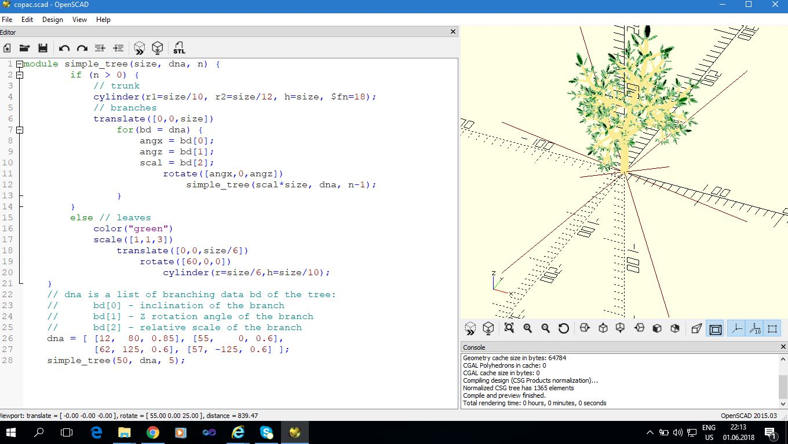

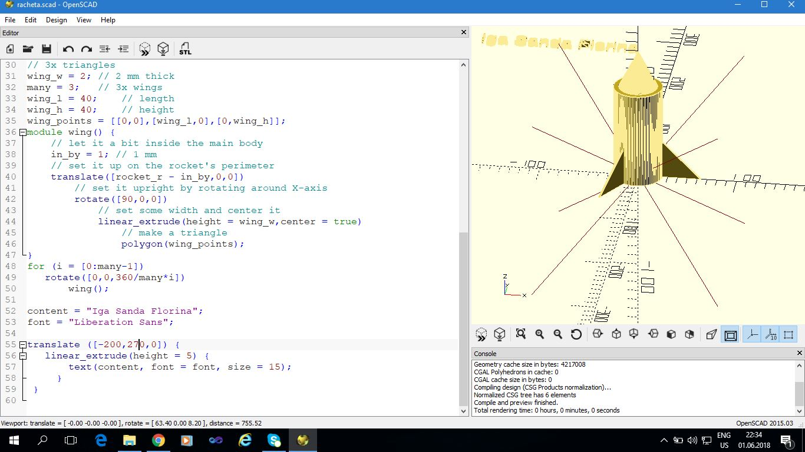

Urmatoarele obiecte le-am folosit pentru proiectare.

