# CS 255 System Design Document Template

## UML Diagrams

### UML Use Case Diagram

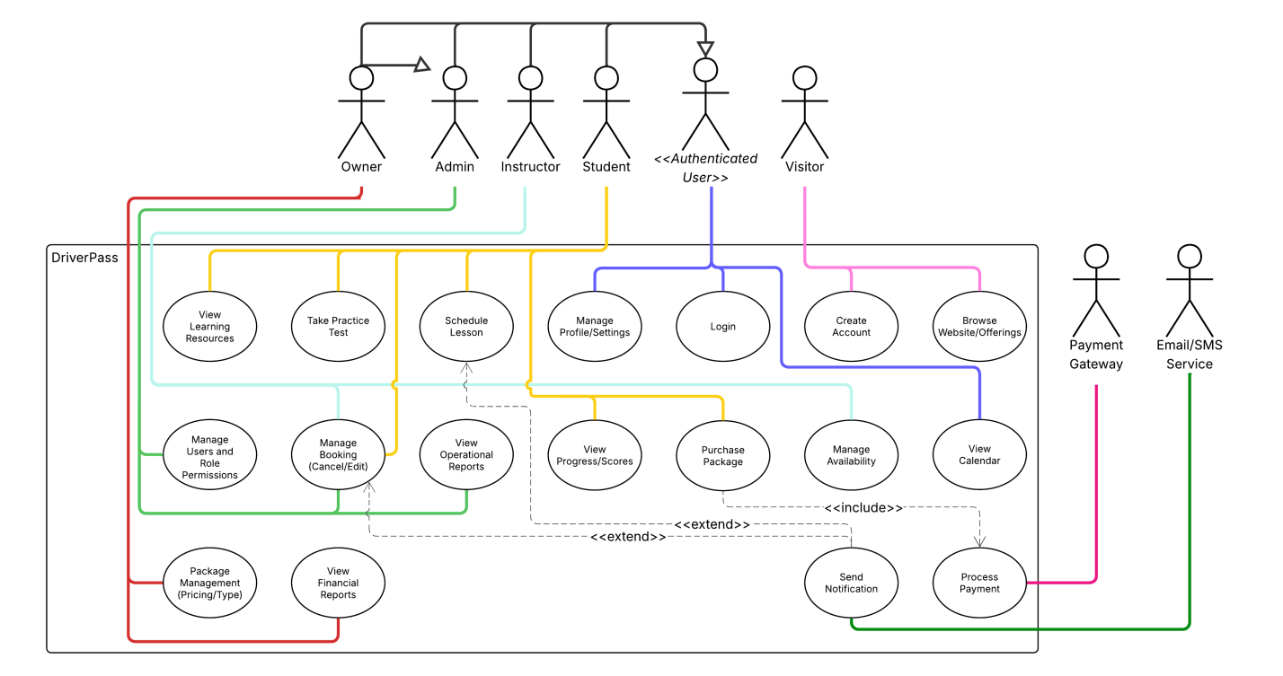

(I was unable to include the DMV system and integration use cases due to shape limits on LucidCharts.)

### UML Activity Diagrams

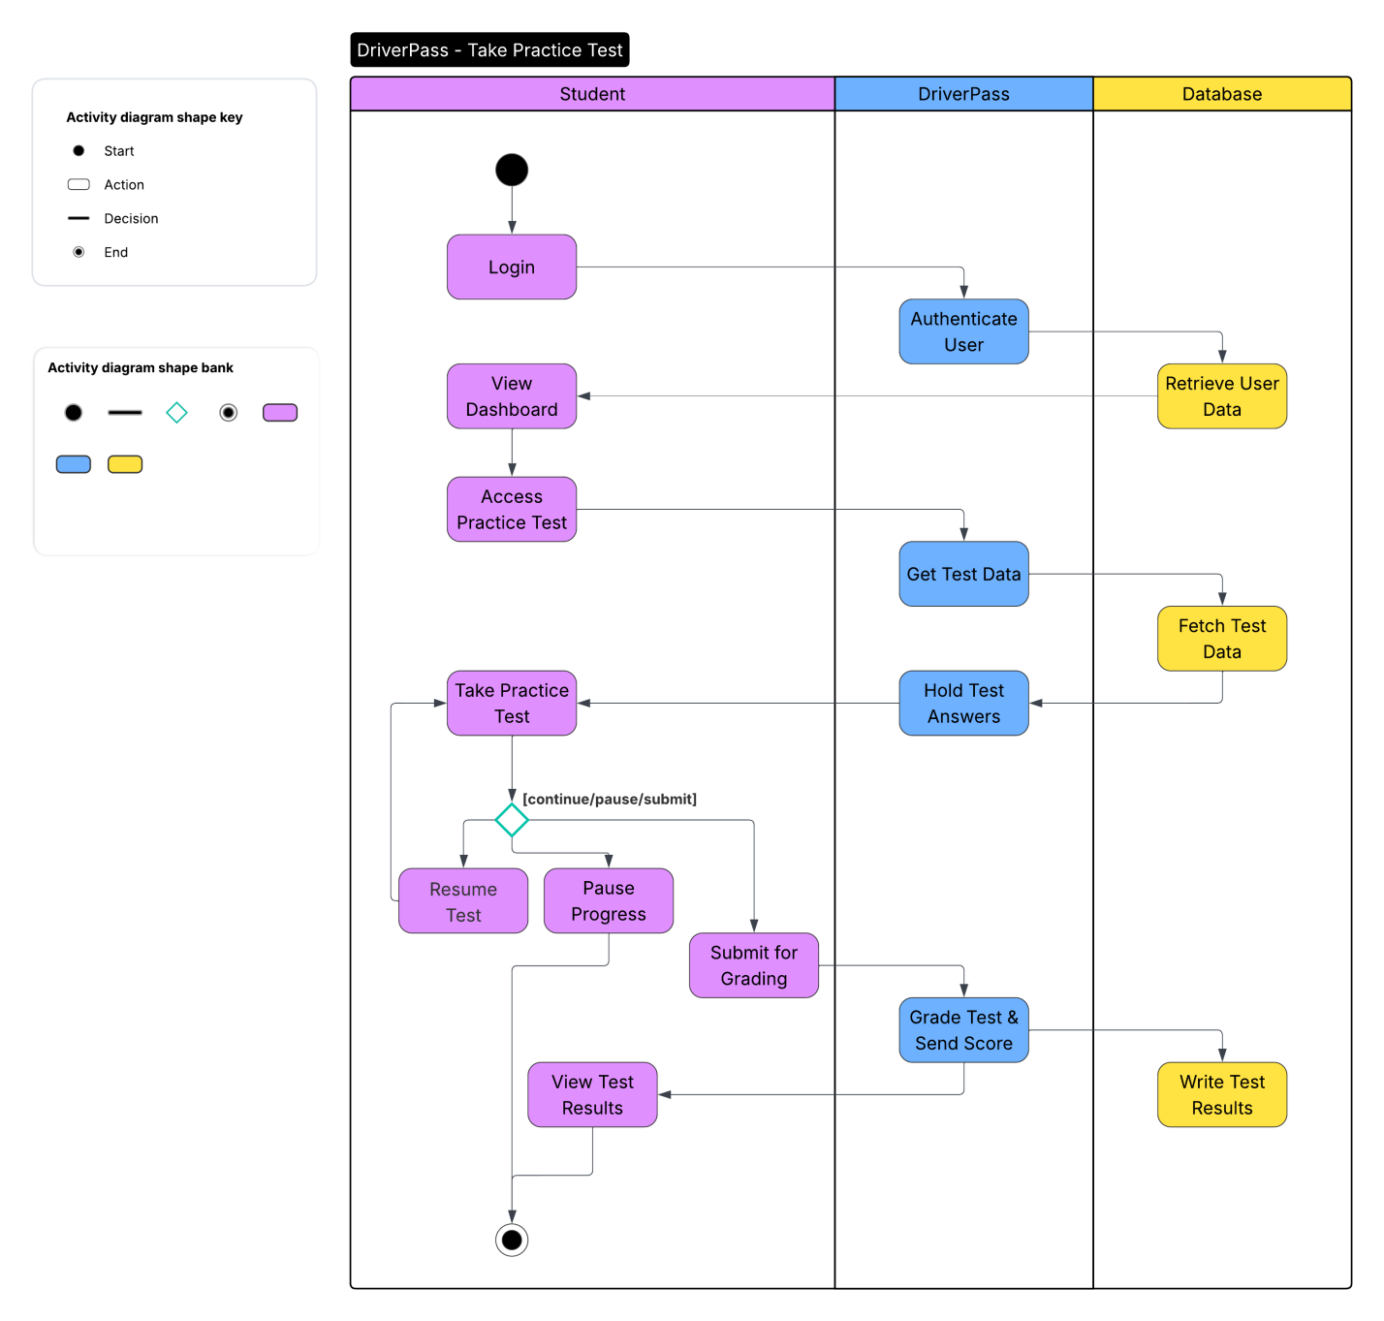

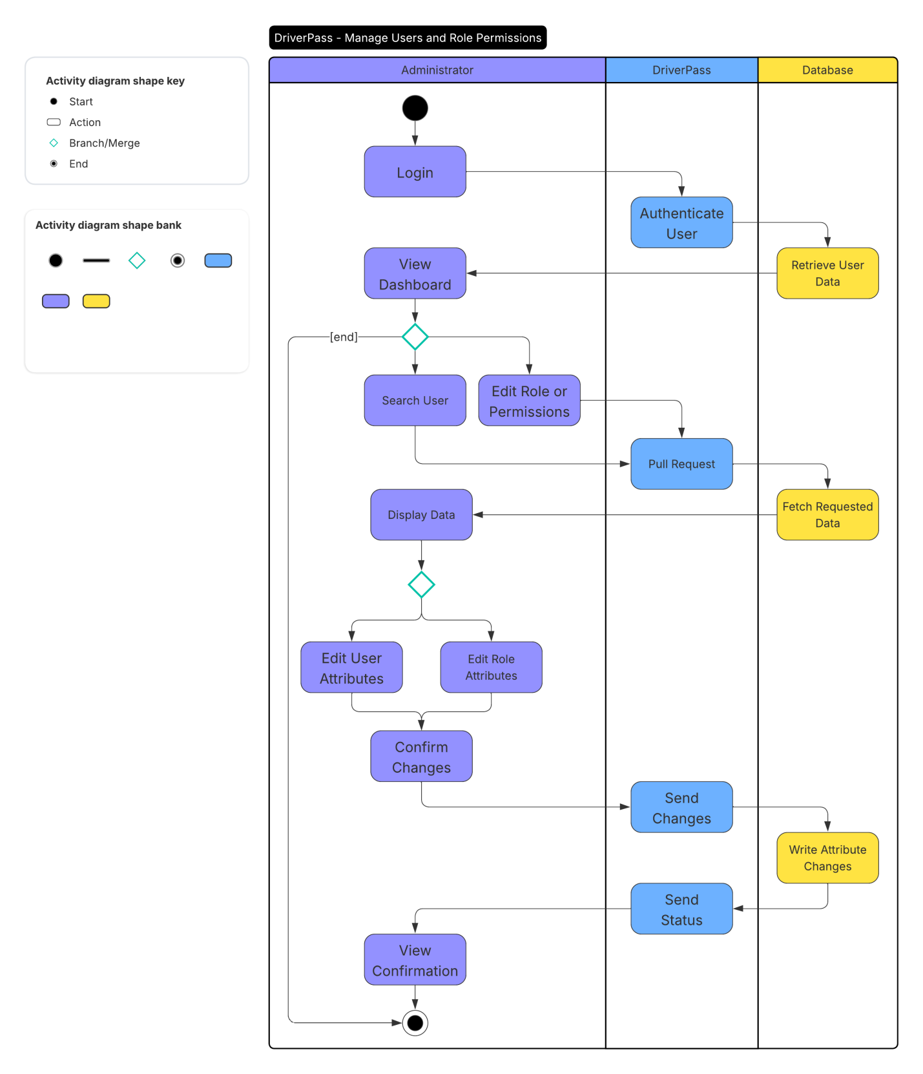

### UML Sequence Diagram

**Manage Users and Role Permissions**

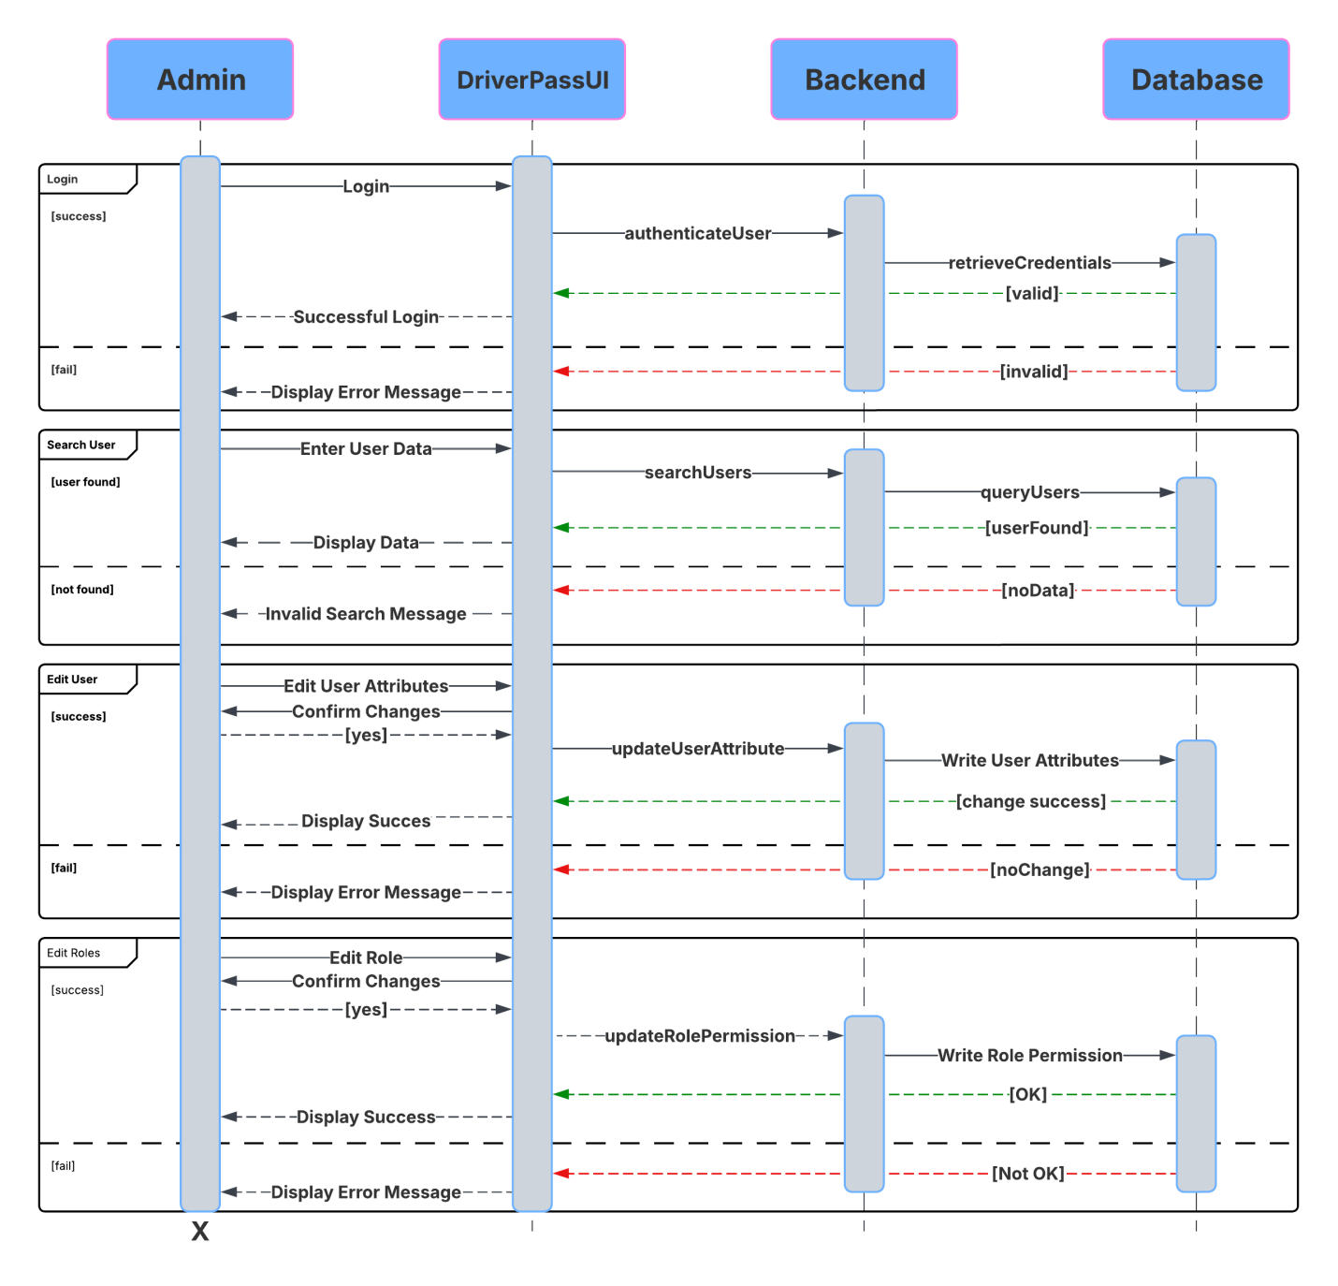

### UML Class Diagram

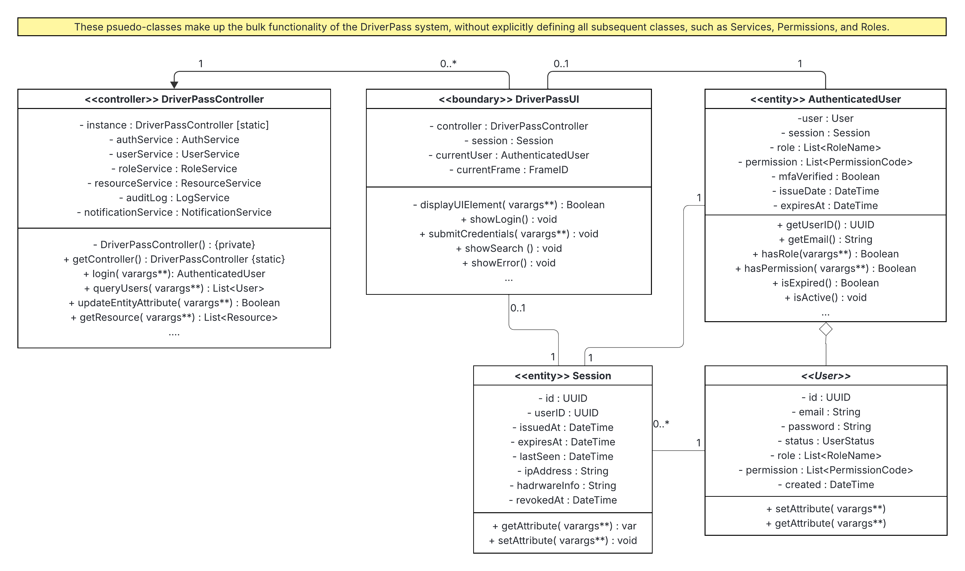

## Technical Requirements

**Hardware**

* The DriverPass platform will be hosted in a third-party cloud environment such as Amazon Web Services (AWS) or Microsoft Azure. This cloud-based deployment model will alleviate the need for on-premises hardware and significantly reduces operational overhead. Cloud providers offer virtual instance types defined by CPU, memory, storage, and networking capacity, which allows the DriverPass system to be dynamically scaled and right-sized based on current user demands. AWS provides a variety of instance families that combine these resources in different configurations to optimize applications performance (Amazon Web Services, 2025), while Microsoft Azure defines its virtual machine sizes according to workload requirements for the processing power, memory, storage, and bandwidth (Microsoft Learn, 2025). Utilizing these managed cloud services minimizes the need for in-house hardware maintenance and ensures high system availability through the provider’s distributed infrastructure.

**Software**

* The DriverPass application should utilize Java 25 for its backend layer. This layer will handle authentication, session management, business logic (e.g., DriverPassController and RBAC classes), and data persistence. This choice ensures enterprise-grade performance, language maturity, and compatibility with modern cloud infrastructures (Oracle, 2025).
* The frontend elements should utilize a JavaScript framework, such as React or Vue.js, to power the browser-based user interface. This design choice provides a responsive and dynamic experience through modern client-side rendering. Communication between frontend and backend will leverage RESTful APIs over HTTPS, maintaining independence between application layers and improving scalability.
* The data layer will use a relational database such as MySQL or PostgreSQL, which integrates seamlessly with Java-based backends. This approach ensures consistent data integrity, reliable transaction management, and efficient scalability across all system components.

**Tools and Infrastructure**

* The DriverPass platform will rely on a modern integrated development environment (IDE) supporting Java 25, such as Eclipse IDE, complete with source control integration and dependency management tools like Maven. Testing frameworks will be incorporated into the build process to automate verification of core system functionality before approval and deployment.   
    
  Deployment will follow a cloud-based model, with the application hosted on virtualized compute and database services within a managed environment. Containerization (e.g., Docker) will ensure consistent configurations across testing, staging, and production. Cloud infrastructure will provide automated scaling to handle heavy workloads, continuous monitoring, and regular data backups ensuring reliability and high availability without the need for dedicated on-premises hardware. Additionally, secure communication channels, encryption, and RBAC controls will protect all data and administrative functions. This infrastructure approach will allow the DriverPass platform to remain resilient as the user base expands.

**References:**

* Amazon Web Services, Inc. (2025). *Amazon EC2 instance type specifications.* AWS. <https://docs.aws.amazon.com/ec2/latest/instancetypes/ec2-instance-type-specifications.html>
* Microsoft Learn. (2025, March 27). *Virtual machines in Azure.* Microsoft. <https://learn.microsoft.com/en-us/azure/virtual-machines/overview>
* Oracle. (2025, September 16). *Press Release. Oracle Releases Java 25.* Oracle. <https://www.oracle.com/news/announcement/oracle-releases-java-25-2025-09-16/>
* eclipse marketplace. (2025, September 9). *Java 25 Support for Eclipse 2025-09 (4.37).* Eclipse Foundation AISBL. <https://marketplace.eclipse.org/content/java-25-support-eclipse-2025-09-437>