CS 305 Project One Template

Document Revision History

Version | Date | Author | Comments
1.0 | 01/20/2026 | Dylan Wienecke | - Part 1: Drafted  - Part 2: Drafted  - Dependency-Check(version 12.2.0): Successful
1.0 | 01/22/2026 | Dylan Wienecke | - Part 1: Finalized  - Part 2: Finalized  - Manual Code Review: Drafted
1.0 | 01/23/2026 | Dylan Wienecke | - Manual Code Review: Finalized  - Static Testing: Drafted and Finalized
1.0 | 01/24/2026 | Dylan Wienecke | - Mitigation Plan: Drafted and Finalized
1.1 | 01/25/2026 | Dylan Wienecke | - Reviewed and edited document

Client



Instructions
Submit this completed vulnerability assessment report. Replace the bracketed text with the relevant information. In this report, identify your security vulnerability findings and recommend the next steps to remedy the issues you have found.

- Respond to the five steps outlined below and include your findings.
- Respond using your own words. You may also include images or supporting materials. If you include them, make certain to insert them in the relevant locations in the document.
- Refer to the Project One Guidelines and Rubric for more detailed instructions about each section of the template.

Developer: Dylan Wienecke

- Interpreting Client Needs

Artemis Financial operates within the financial consulting industry, making the organization a high-risk target for malicious actors. Due to the sensitive nature of client financial records, including investment portfolios, retirement planning, savings, and insurance products, the organization requires a secure, regulatory compliant, web-based application to support its daily operations.

All client-server communications must be encrypted using proven, industry-standard security protocols to prevent interception, credential tampering, and impersonation attacks that could lead to the theft of client information or financial assets. Secure communication is essential not only to protect sensitive data but also to maintain client trust and meet financial regulatory obligations.

Because Artemis Financial consults on and manages investment portfolios, the organization likely supports international clients and transactions. Additional security and compliance considerations must be addressed, as financial data may cross borders and jurisdictions. International and regional regulations regarding data handling, encryption, and privacy may impose data residency requirements and compliance constraints that must be accounted for during system modernization.

To ensure accessibility and regulatory compliance, the web application must rely on widely accepted, standardized cryptographic methods that are legally approved and supported internationally. Deprecated methods or restricted encryption schemes could disrupt client access, violate regulations, or introduce unnecessary security risks.

The external threat landscape facing financial institutions is both broad and evolving. Common threats in this sector include SQL injection attacks, man-in-the-middle attacks, credential theft, authentication and authorization bypasses, remote code execution vulnerabilities, and weaknesses in outdated RSA or SHA cryptographic schemes. Additionally, during the modernization of Artemis Financial’s existing infrastructure, there is a significant risk that legacy vulnerabilities could migrate into the new platform if the original codebase and associated dependencies are not thoroughly reviewed.

To mitigate these risks, Artemis Financial must commit to continuous dependency monitoring, proactive version management, and regularly scheduled vulnerability assessments. These practices are critical to maintaining a secure, resilient, and compliant platform capable of protecting both the organization and its clients from current and emerging threats.

Client Needs:
- Secure, modernized web-based platform for financial consulting operations.
- Regulatory compliance for handling sensitive financial and personal data.
- Encrypted client-server communication using standard cryptographic means.
- Support for international clients and cross-border financial transactions.
- RESTful application architecture with a strong security posture.
- Continuous security practices aligned with the principle, “Security is everyone’s responsibility.”
- Ongoing dependency monitoring, version management, and vulnerability assessments.
Threat Sources:
- SQL injection attacks targeting backend data sources.
- Man-in-the-middle attacks against client-server communications.
- Credential theft leading the unauthorized account access.
- Authentication and authorization bypass vulnerabilities.
- Weak or deprecated RSA and SHA cryptographic schemes.
- Remove code execution vulnerabilities in application logic or dependencies.
- Migration of legacy vulnerabilities into the modernized platform due to insufficient codebase review.

- Areas of Security

All seven areas of vulnerability concern apply to Artemis Financial’s web-based application. Each area represents a potential point of entry that attackers could exploit to gain access to sensitive and regulated financial data. Excluding any area of concern would introduce unnecessary risk to both the organization and its clients.

Input Validation
- Highly critical source of vulnerability within Artemis Financial’s application. The system processes user-supplied data related to financial accounts and transactions, investment preferences, and personally identifiable information. All untrusted input must be tightly constrained through validation, sanitization, and data-type enforcement. Without proper restrictions in place, the risks of SQL injection, data exposure, and unauthorized access increase significantly and may compound across system components.
APIs
- The platform relies on RESTful APIs to facilitate communication between system components and potentially external services. All APIs used in the platform must be validated to ensure their interactions are secure, authenticated, and authorized to prevent misuse. Interfaces that facilitate financial transactions or account modifications present the highest risk for potential abuse and must enforce strict access controls that comply with applicable regulatory requirements.
Cryptography
- Cryptographic mechanisms are essential for maintaining secure server-client communication throughout the platform. Transport Layer Security (TLS/SSL) must be used to encrypt financial transactions and investment-related operations. Vulnerable algorithms could compromise financial data or expose client accounts to interception attacks while data is in transit.
Server/Client
- In the server-client model for Artemis Financial’s platform, the server must act as the sole source of truth. Data and requests originating from client devices should be treated as untrusted. Server-side validation enforcement are required to prevent maliciously crafted client requests from influencing internal logic. This reduces the risk of privilege escalation, authentication bypasses, and unauthorized access which could compromise financial records.
Code Errors
- Secure error handling is essential for protecting internal logic, sensitive client data, and system details from disclosure. Error-handling mechanisms must also ensure that system logs do not record unvalidated user input. When combined with minimal error messages presented to end users, these practices reduce the risk of information disclosure which could be leveraged in further attacks.
Code Quality
- Defensive coding strategies should be consistently applied to ensure input is validated and sanitized using established techniques. Secure coding patterns, such as boundary checking, safe object handling, and input normalization will help mitigate common vulnerabilities exploited through injection and logic flaws. Poor code quality increases the chance of exploitable vulnerabilities being discovered, and increases the attack surface of the application.
Encapsulation
- System objects should promote encapsulation through well-defined, bounded, and secure access control mechanisms. Proper enforcement of the encapsulation prevents unintended exposure of client data and internal system logic. Financial applications handle regulated information which must have strong boundaries to minimize the impact of potential breaches.

- Manual Review
Input Validation
- File: CRUDController.java
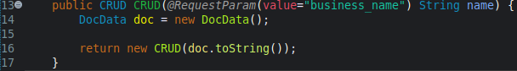
Description: This request parameter accepts user input but does not validate or use it within the method. If this method is later used to process sensitive data or construct queries, it may pose significant injection risks or runtime errors.
- File: GreetingController.java
Description: The endpoint accepts user input and reflects it in the response content without validation or constraints. This could potentially allow unsafe handling of untrusted input if reused in a different context.
- File: DocData.java
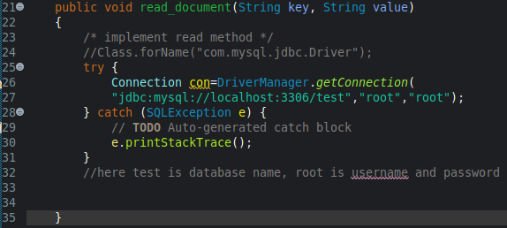
Description: This method suggests the input arguments will be used to construct dynamic queries. This could introduce SQL injection risks if implemented without proper input validation.

API
- File: CRUDController.java
Description: This endpoint is a publicly accessible and does not enforce authentication or authorization controls. Any user can invoke this endpoint without verification, which may allow unauthorized access to sensitive functionality or data in the future.
- File: GreetingController.java
Description: This endpoint is publicly accessible and does not enforce authentication or authorization controls.

Code Error
- File: myDateTime.java
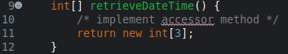
Description: The retrieveDateTime() method returns an array of integers without populating their values, which could cause runtime errors or unexpected behavior if used in application logic.
- File: DocData.java
Description: A connection to the database is established in this method, but never explicitly closed. This poses a serious risk of resource exhaustion and application instability during runtime.

Code Quality
- File: DocData.java
Description: The application connects to the database using a privileged “root” account, which violates the principle of least privilege. This poses a serious risk of system compromise and data disclosure.
- File: DocData.java
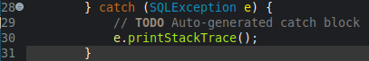
Description: The catch statement prints the stack trace, which may expose internal system details through logs or console output to end users.

Encapsulation
- File: customer.java
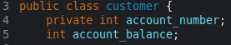
Description: The class attribute account_balance is not private. This would allow other classes in the package to modify sensitive financial data directly.

4. Static Testing

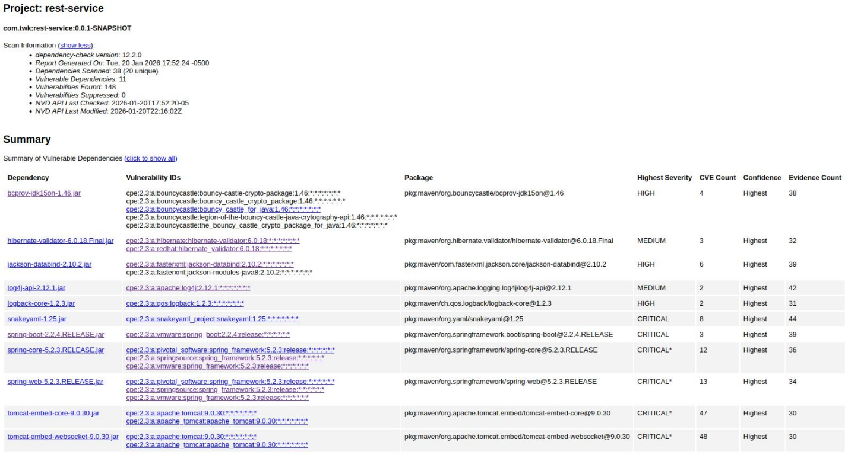

Overview
- OWASP Dependency-Check identified vulnerabilities across 11 third-party dependencies used in the Artemis Financial web application. For this portion of the assessment, two representative vulnerabilities from each affected dependency were selected to provide a structured scope of analysis. Where applicable, the more severe and/or known exploited vulnerabilities were selected to highlight the highest risk findings identified by the static testing tool.

Dependency | bcprov-jdk15on-1.46.jar
Package | pkg:maven/org.bouncycastle/bcprov-jdk15on
CVE Total | 4
Severity | High
Description | The Bouncy Castle Crypto package is a Java implementation of cryptographic algorithms. Lightweight API for JDK 1.5-1.7. (DSA, RSA, ECDSA signatures)
Vulnerability ID | Vulnerability Summary
- CVE-2016-1000338 | Improper validation of DSA (digital signature algorithm) signature encoding, where the cryptographic method doesn’t fully verify ASN.1 structures. This vulnerability could potentially undermine digital signatures within the Artemis Financial application, allowing tampered or maliciously crafted data to be accepted as valid.
- CVE-2020-15522 | This vulnerability stems from a timing discrepancy issue within the EC math library used for ECDSA generation. Differences in execution time may reveal private key information, which can be exploited. This could compromise integrity and authenticity of digitally signed data used in financial transactions and communications with the Artemis Financial web application.

Dependency | hibernate-validator-6.0.18.Final.jar
Package | pkg:maven/org.hibernate.validator/hibernate-validator@6.0.18.Final
CVE Total | 3
Severity | MEDIUM
Description | Hibernate’s Bean Validation (JSR-380) reference implementation.
Vulnerability ID | Vulnerability Summary
- CVE-2025-35036 | This vulnerability occurs due to unsafe use of Expression Language (EL) interpolation in constraint violation messages, where user-supplied input may be evaluated rather than treated as plain text. This would allow unauthorized access to sensitive application data or unintended execution of logic during validation processing within the Artemis Financial web application.
- CVE-2023-1932 | Improper validation of malformed HTML input inside the SafeHtmlValidator, allowing crafted input to bypass sanitization checks. In the financial web application, this could enable HTML injection attacks or cross-site scripting (XSS) attacks, potentially exposing sensitive client data or allowing authorized script execution in a user’s browser.

Dependency | jackson-databind-2.10.2.jar
Package | pkg:maven/com.fasterxml.jackson.core/jackson-databind@2.10.2
CVE Total | 6
Severity | HIGH
Description | General data-binding functionality for Jackson: works on core streaming API.
Vulnerability ID | Vulnerability Summary
- CVE-2020-25649 | Improper handling of entity expansion within the Jackson Databind library. XML External Entity (XXE) attacks are possible when processing XML input. An attacker could exploit this flaw to access or manipulate internal resources. This could compromise data integrity and expose sensitive data within the Artemis Financial web application.
- CVE-2020-36518 | This vulnerability is caused by insufficient handling of deeply nested object structures during deserialization, which can result in an overflow. Maliciously crafted requests containing excessive nesting could cause application crashes, leading to denial-of-service conditions.

Dependency | log4j-api-2.12.1.jar
Package | pkg:maven/org.apache.logging.log4j/log4j-api@2.12.1
CVE Total | 2
Severity | MEDIUM
Description | Apache Log4j API. Core logging framework used by Java applications.
Vulnerability ID | Vulnerability Summary
- CVE-2025-68161 | This vulnerability is caused by insufficient validation of user-controlled input within the logging mechanism. Maliciously crafted log messages may expose sensitive data or enables unintended internal behavior. This could allow attackers to influence log output, potentially leaking sensitive information, or interfering with system observability.
- CVE-2020-9488 | Improper handling of serialized data when Log4j is used in tandem with network-based logging configurations. Attackers can exploit this flaw by sending crafted input to trigger unsafe deserialization, resulting in unauthorized access. This may lead to exposure of sensitive information or unauthorized interaction with application resources and objects.

Dependency | logback-core-1.2.3.jar
Package | pkg:maven/ch.qos.logback/logback-core@1.2.3
CVE Total | 2
Severity | HIGH
Description | The logback-core module provides essential logging infrastructure such as appenders, encoders, layouts, and configuration support. Common in Java and Spring web applications to record application events.
Vulnerability ID | Vulnerability Summary
- CVE-2023-6378 | Improper handling of crafted input within logging configuration and message processing. Attacks may inject malicious data into log entries, leading to potential information disclosure or disruption of logging functionality. This could compromise log integrity, and obscure security events within Artemis Financial’s web application.
- CVE-2021-42550 | Unsafe deserialization behavior in Logback Core when processing externally influenced logging configurations. Successful exploits could allow attackers to execute unauthorized actions or access internal components. This may lead to remote code execution or compromise application integrity if untrusted data is logged and processed within the Artemis Financial web application.

Dependency | snakeyaml-1.25.jar
Package | pkg:maven/org.yaml/snakeyaml@1.25
CVE Total | 8
Severity | CRITICAL
Description | YAML 1.1 parser and emitter for Java. Commonly used in Java and Spring applications to load configurations. Frequently handles externally supplied configurations and serialized input.
Vulnerability ID | Vulnerability Summary
- CVE-2022-1471 | SnakeYaml’s constructor does not properly restrict data types during deserialization. This can lead to remote code execution when processing yaml content from an attacker. This vulnerability could fully compromise the web application’s integrity and underlying system resources.
- 2017-18640 | Improper handling of maliciously crafted YAML input could lead to excessive resource consumption during parsing. An attacker could exploit this flaw by submitting crafted YAML data to trigger denial-of-service conditions through memory exhaustion or application instability. This could lead to service disruptions and crashed within the Artemis Financial web application.

Dependency | spring-boot-2.2.4.RELEASE.jar
Package | pkg:maven/org.springframework.boot/spring-boot@2.2.4.RELEASE
CVE Total | 3
Severity | CRITICAL
Description | Spring Boot is a widely used Java framework designed to simplify stand-alone development of Spring applications.
Vulnerability ID | Vulnerability Summary
- CVE-2023-20873 | Improper handling of request mapping conditions within the Spring framework. Certain circumstances may lead to bypass security constraints or influence request routing behavior. This vulnerability could allow unauthorized access to protected administrative endpoints or manipulate application logic, potentially exposing Artemis Financial client data.
- CVE-2022-27772 | Insufficient input validation within Spring Boot’s web processing components. Specially crafted requests could trigger unintended behavior. This flaw could be exploited to produce denial-of-service conditions and disrupt normal request processing within the Artemis Financial web application.

Dependency | spring-core-5.2.3.RELEASE.jar
Package | pkg:maven/org.springframework/spring-core@5.2.3.RELEASE
CVE Total | 12
Severity | CRITICAL*
Description | Spring Core provides core utilities for Spring Framework, including dependency injection, resource loading, type conversion, and reflection-based infrastructure.
Vulnerability ID | Vulnerability Summary
- CVE-2022-22965 | CISA KEV exploit: Unsafe data binding behavior in the Spring Framework when running certain Java versions and deployment configurations. Attackers can exploit maliciously crafted HTTP requests to manipulate class loader properties. This can potentially lead to remote code execution and full compromise in underlying systems.
- CVE-2024-22259 | This vulnerability occurs due to improper handling of path resolutions within Spring web components. Attackers could exploit specific conditions to perform path traversal, potentially allowing unauthorized access to sensitive files and system components. This could lead to information disclosure or compromise application confidentiality.

Dependency | spring-web-5.2.3.RELEASE.jar
Package | pkg:maven/org.springframework/spring-web@5.2.3.RELEASE
CVE Total | 13
Severity | CRITICAL*
Description | Spring Web is responsible for HTTP request handling, RESTful web services, and client-server communications within a Spring Framework.
Vulnerability ID | Vulnerability Summary
- CVE-2016-1000027 | This vulnerability is used to deserialize untrusted Java objects. If an application allows deserialization of attacker controlled data, this flaw could potentially lead to remote code execution. Web applications that rely on deserializing untrusted data may be exposed to serious security risks if proper safeguards are not in place.
- CVE-22965 | CISA KEV exploit: This vulnerability affects Spring MVC and Spring WebFlux applications running JDK 9 or later. Unsafe data binding behavior can be exploited through crafted HTTP requests, potentially leading to remote code execution. This vulnerability requires an application deployed on WAR files on Apache Tomcat. This vulnerability represents a critical security risk for Artemis Financial web application.

Dependency | tomcat-embed-core-9.0.30.jar
Package | pkg:maven/org.apache.tomcat.embed/tomcat-embed-core@9.0.30
CVE Total | 47
Severity | CRITICAL*
Description | Core Tomcat Implementation. Apache Tomcat Embed Core provides the core implementation of the Apache Tomcat servlet container user for embedded and standalone Java web applications.
Vulnerability ID | Vulnerability Summary
- CVE-2020-1938 | CISA KEV exploit: This vulnerability is caused by improper trust handling of Apache JServ Protocol connections in Apache Tomcat. If AJP connector is enabled and accessible to untrusted users, an attacker could reach arbitrary files from the application or force files to be processed as JSPs. This could enable remote code execution, making it a critical risk when AJP ports are exposed in a web application.
- CVE-2024-50379 | This vulnerability is a time-of-check to time-to-use (TOCTOU) race condition which occurs during JSP compilation. When running case-insensitive file systems and when the servlet is fogured to write access, a flaw may be exploited to achieve remote code execution. Manipulation of the file system state, between validation and execution, allows malicious code to be executed during JSP processing. This could result in full compromise of the Artemis Financial web application.

Dependency | tomcat-embed-websocket-9.0.30.jar
Package | pkg:maven/org.apache.tomcat.embed/tomcat-embed-websocket@9.0.30
CVE Total | 48
Severity | CRITICAL*
Description | Core Tomcat implementation. WebSocket support for embedded servers used in Java web applications.
Vulnerability ID | Vulnerability Summary
- CVE-2024-52316 | Unchecked error condition in Tomcat Jakarta authentication integration. If Tomcat is configured to use custom ServerAuthContext that throws an exception during authentication without explicitly setting HTTP failure status, authentication may incorrectly succeed. This could allow authentication bypass in the Artemis Financial web application granting unauthorized access to protected resources.
- CVE-2025-24813 | CISA KEV exploit: This is a path equivalence flaw in Apache Tomcat that allows attackers to manipulate file paths using dot annotation. Using write-enabled default servlet, an attacker may upload malicious content, overwriting sensitive files, disclose information, or achieve remote code execution.

5. Mitigation Plan

Input Validation
- File: GreetingController.java
  - Lines: 15-18
  - The request parameter handling for the “/greeting” endpoint should validate the parameter “name” against a whitelist of allowable characters and maximum length constraints.
- File: CRUDController.java
  - Lines: 12-17
  - The request parameter handling for the “/read” endpoint should validate the parameter “business_name” against a whitelist of allowable characters and maximum length constraints. Additionally, this parameter should be checked against a list of valid business names and declare a default value.
- File: DocData.java
  - Lines: 21-32
  - The method read_document should validate both input arguments (key and value) before they are used in database query construction. User-input should not be permitted to influence query structure without strict validation and sanitization to mitigate SQL injection risks.
- File: customer.java
  - Lines: 12-14
  - The deposit method should validate numeric input to ensure only positive, reasonable values are accepted (i.e., daily limit, and amounts under 9999$, etc). Preventing integer overflow and compliance with financial regulations should constrain this value appropriately.
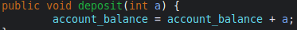
- File: myDateTime.java
  - Lines: 14-16
  - The setMyDateTime method should validate time-related inputs to ensure values fall within acceptable ranges (i.e., <= 59, etc).

APIs
- File: CRUDController.java
  - Lines: 12-17
  - The “/read” endpoint should enforce authentication and authorization controls to restrict access to authorized users only. Public access to this endpoint increases the risk of authorized data access if functionality is expanded.
- File: GreetingController.java
  - Lines: 15-18
  - The “/greeting” endpoint should implement access controls or request limitation to prevent misuse. Non-sensitive endpoints can be exposed to automated abuse or reconnaissance activity.
Cryptography
- File: application.properties
  - Lines: N/A
  - The application should enforce HTTPS by configuring TLS/SSL setting with the application configuration file. Sensitive client-server communication should be protected using encrypted transport to ensure confidentiality and integrity of financial data for regulatory compliance.
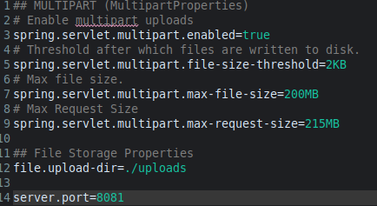
Server/Client
- File: DocData.java
  - Lines: 26-27
  - Database connection credentials should not be embedded directly in source code. Sensitive configuration values should be stored in server-side configuration (environment variables or application configuration file) to reduce the risk of credential disclosure.
- File: DocData.java
  - Lines: 26-27
  - Database connections should not use a privileged administrative (i.e., “root”) account. The connection should utilize a least-privilege database account with only the minimum required permissions to reduce impact if application compromise occurs.
Code Errors
- File: DocData.java
  - Lines: 21-33
  - Database connections established within the read_document method should be explicitly closed after use to prevent connection leaks and resource exhaustion.
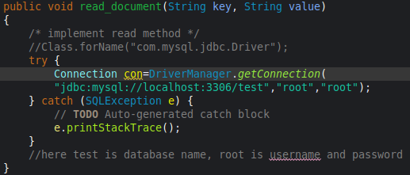
- File: myDateTime.java
  - Lines: 9-12
  - The retrieveDateTime method should return properly populated values to prevent runtime errors or undefined behavior in other application components.
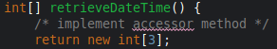
Code Quality
- File: DocData.java
  - Lines: 30
  - Stack trace printing should be replaced with centralized error handling and logging method to prevent error messages from disclosing internal system details.
- File: CRUDController.java
  - Lines: 16
  - The “/read” endpoint should not construct responses using built-in toString() output for internal objects. Server responses should return controlled fields only to reduce the risk of unintended data disclosure.
Encapsulation
- File: customer.java
  - Lines: 5
  - The account_balance attribute should be declared private to adhere to encapsulation principles.
- File: Application Error Handling (e.g., global exception handler)
  - Lines: N/A
  - Error handling should be centralized in order to prevent exceptions from exposing internal implementations details to end users. Centralized error handling supports consistent, sanitized error responses and promotes encapsulation of system components, not just class fields.
Dependency Check
- File: pom.xml
  - Lines: Dependency Declarations / Plugin Config
  - Third-party dependencies identified as vulnerable by OWASP Dependency-Check should be upgraded to recommended secure versions from the report. Priority should be given to critical and known exploits to reduce the attack surface of the application.
- File: pom.xml
  - Lines: Dependency Declarations / Plugin Config
  - The dependency-check plugin should remain integrated into the Maven build to facilitate recurring security evaluations of third-party libraries. This will shorten response time for newly disclosed vulnerabilities in third-party components.

Collectively, these mitigations reduce the applications attack surface by strengthening input handling, enforcing boundaries, improving error management, and maintaining secure third-party dependencies.

