

Practices for Secure Software Report

Table of Contents
Document Revision History 3
Client 3
Instructions 3
Developer 4
1. Algorithm Cipher 4
2. Certificate Generation 4
3. Deploy Cipher 4
4. Secure Communications 4
5. Secondary Testing 4
6. Functional Testing 4
7. Summary 4
8. Industry Standard Best Practices 4

Document Revision History

Version | Date | Author | Comments
1.0 | 02/17/2026 | Dylan Wienecke | - Ran initial dependency-check to establish baseline vulnerability count  - Refactored code successfully  - Generated and imported self-signed keystore into project folder  - Successfully established HTTPS connection  - JSON formatted response object displays correctly  - Ran secondary dependency-check post refactor (successful)
1.0 | 02/18/2026 | Dylan Wienecke | - Added checksum verification within the “/hash” endpoint  - Algorithm Cipher: Drafted  - Functional Testing: Drafted
1.0 | 02/19/2026 | Dylan Wienecke | - Algorithm Cipher: Finalized  - Functional Testing: Finalized  - Standards and Practices: Drafted
1.0 | 02/21/2026 | Dylan Wienecke | - Standards and Practices: Finalized  - Reviewed

Client



Developer:
Dylan Wienecke

Algorithm Cipher

In order to secure Artemis Financial’s web application, I have chosen the SHA-256 (Secure Hash Algorithm 256-bit) to implement checksum verification. This is a cryptographic algorithm that produces a fixed-length 256-bit (32 byte) message digest regardless of input size. When represented in hexadecimal format, this results in a 64-character output string, which is well suited for validating data integrity during secure communications.

SHA-256 is designed as a one-way, collision resistant hash function. It minimizes the likelihood that two different inputs will produce the same digest. The output space of SHA-256 contains approximately $2^{256}$ possible values (about $1.16 × {10}^{77}$), making the probability of a collision extremely unlikely. Generating two distinct inputs that produce identical hashes would be computationally complex and effectively infeasible. When verifying a checksum, any modification to the unique data will produce a different digest that would easily be detected during comparison. This collision resistance property is critical for maintaining data integrity within Artemis Financial’s platform.

Unlike symmetric and asymmetric encryption algorithms, which use keys to encrypt and decrypt data confidentially, hash functions are used for one-way data transformation. SHA-256 generates a deterministic digest based solely on the input and does not allow the original data to be recovered. In this implementation, randomness is incorporated into the unique data string through the use of OffSetDateTime.now() and UUID.randomUUID(), ensuring that each request generates a unique checksum. This further strengthens checksum integrity by eliminating predictable or repeated checksum outputs from identical endpoint calls.

Earlier hash functions, such as MD5 and SHA-1, have been phased out due to demonstrated vulnerabilities in their collision resistance. SHA-256 remains widely accepted as a secure industry standard for integrity validation when digital signatures are not required. For this reason, SHA-256 is the most appropriate algorithm for implementing secure checksum verification in Artemis Financial’s web application.

Certificate Generation

Certificate Creation
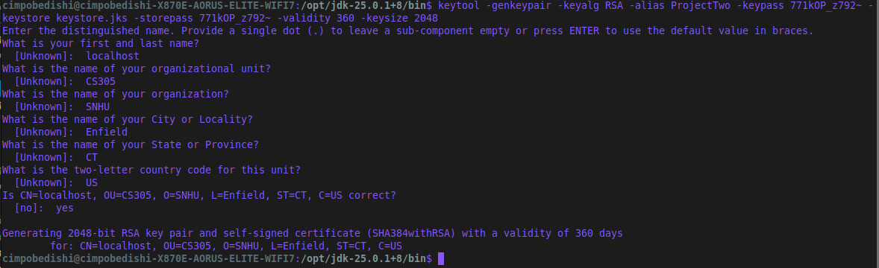

Export and Print Certificate
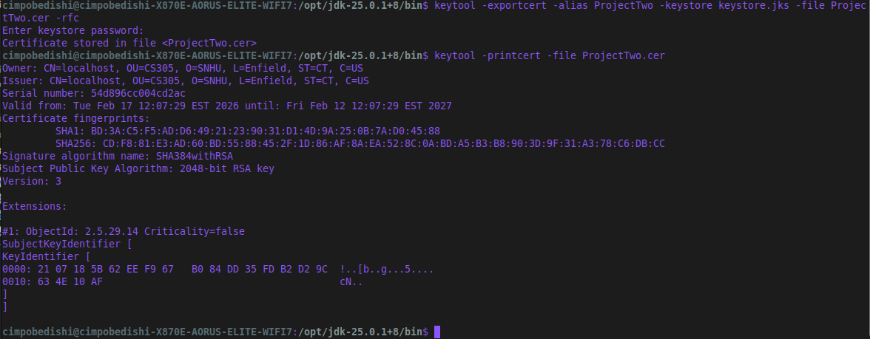

Deploy Cipher

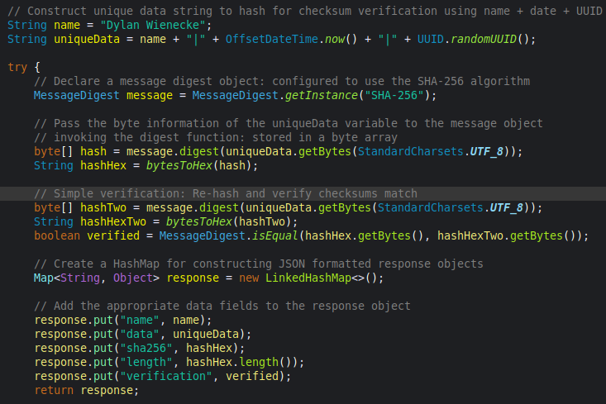

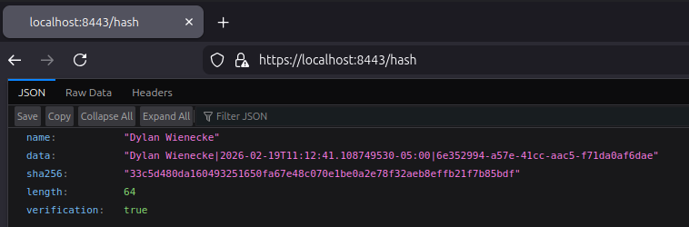

Secure Communications

Applications.properties
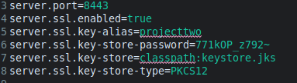

Secure HTTPS connection
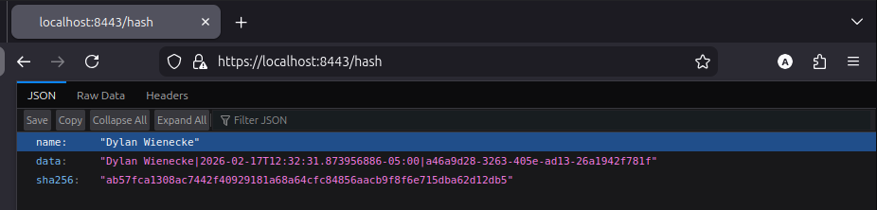

Added length and server-verified checksum output to JSON body.

Secondary Testing

Pre Code Refactor - Vulnerability Assessment
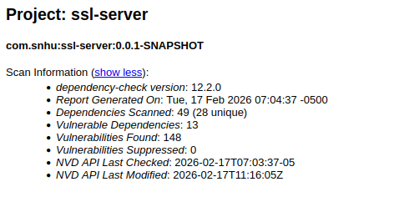

Post Code Refactor - Spring Boot Application: Successful
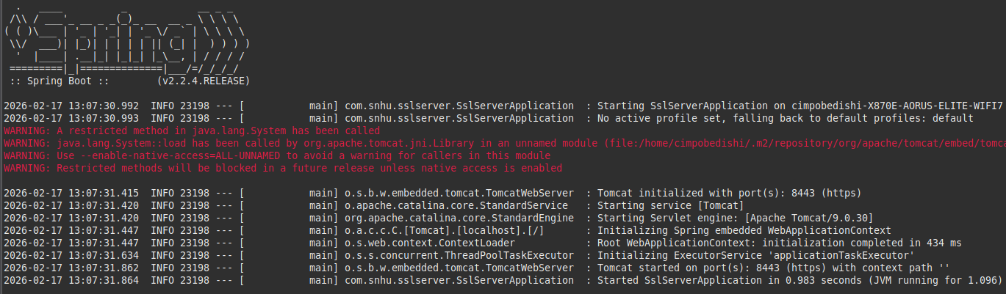

Post Code Refactor - Vulnerability Assessment
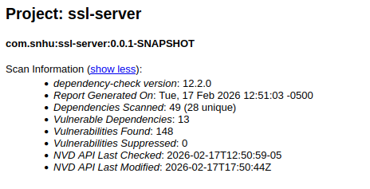

Functional Testing
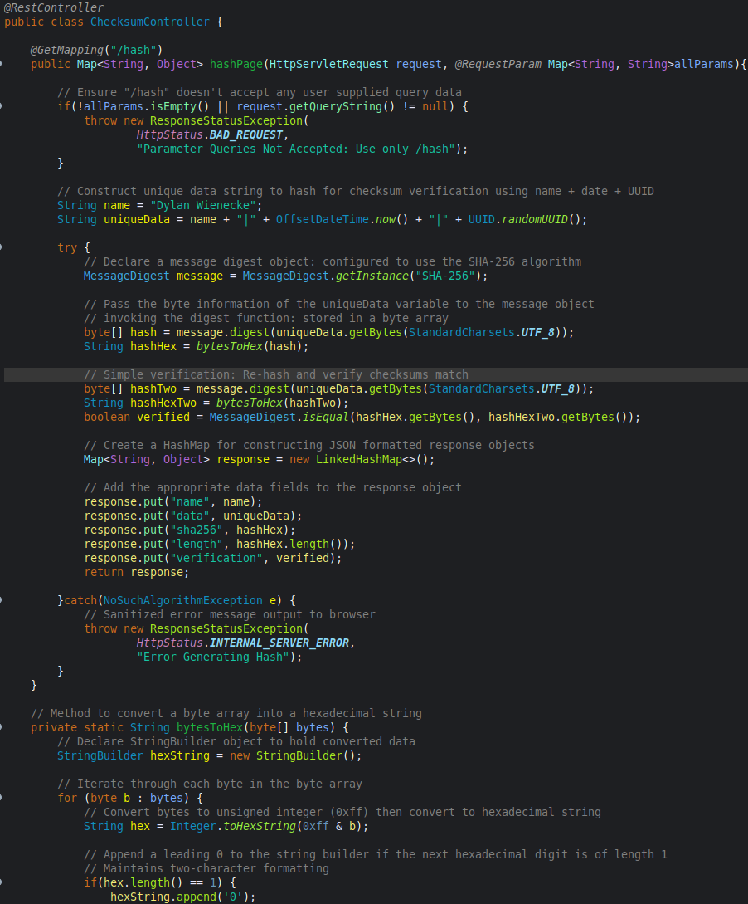
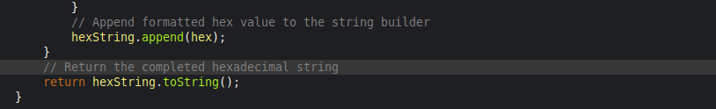
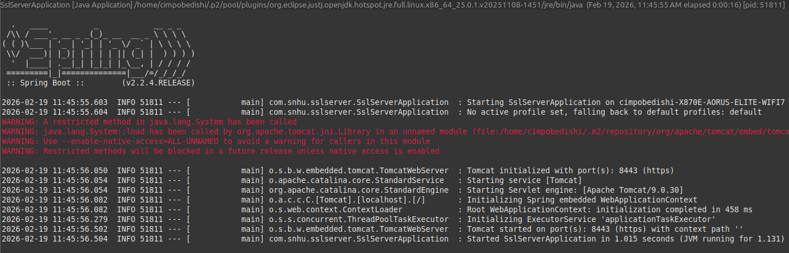

Syntax
- The refactored code compiles and executes without errors, as demonstrated by the successful launch of the Spring Boot application. The ChecksumController.java file defines the “/hash” endpoint using valid Spring Boot annotations (@RestController and @GetMapping) and a properly structured method that returns a Map<String, Object>. This return type is automatically serialized by Spring into a JSON format, ensuring structured and predictable output.
The application successfully binds to a secure port (8443) without throwing runtime exceptions. This confirms the refactored code did not introduce syntax-level vulnerabilities, misconfigurations, or dependency conflicts.
Code Logic
- The “/hash” endpoint logic behaves as expected and produces the correct result. A unique data string is constructed using the developer name (my name) combined with two dynamic identifiers: OffSetDateTime.now() & UUID.randomUUID(). This ensures each request produces a unique input value, resulting in a distinct checksum.
The MessageDigest instance is configured to use the SHA-256 algorithm and applies the .digest() method to the UTF-8 encoded bytes of the unique data string. This produces a valid 256-bit digest, which when converted to hexadecimal, results in a 64-character checksum. The output length was verified during testing to confirm consistency with SHA-256 specifications.
The checksum verification logic performs an integrity validation by re-hashing the unique data string and comparing the resulting digest to the original value. The comparison confirms that identical input produces identical output, demonstrating deterministic behavior and validating the integrity-check mechanism.
Security Considerations
- The “/hash” endpoint intentionally rejects user-supplied query parameters to reduce the application’s attack surface. The controller checks for the presence of query parameters and returns an HTTP 400 response if any are detected. By preventing user-controlled input from influencing server-side hashing operations, the risk of injection-based attacks or unexpected logic manipulation is significantly reduced.
I have included the use of StandardCharsets.UTF_8 when converting strings to byte data before hashing. This ensures platform independent encoding behavior if clients verify checksum values. This prevents discrepancies that could arise from environment-specific default encodings and guarantees reproducible checksum generation across systems.
In addition, the verification process uses the MessageDigest.isEqual() for digest comparison. This method provides a secure and consistent equality check, reducing the risk of partial comparisons or formatting inconsistencies.
This endpoint returns structured JSON and does not render user-controlled data into HTML content, which reduces the risk of cross-site scripting (XSS) in the current implementation. If future enhancements introduce dynamic HTML rendering or user-supplied content, input validation and output encoding consistent with OWASP secure coding guidelines would be required to mitigate XSS and related injection risks.

Summary

I refactored the original Spring Boot application to incorporate cryptographic integrity verification and secure communications (HTTPS) aligned with modern security testing protocols. I used an iterative process consistent with the vulnerability assessment process flow diagram, reviewing architecture, input handling, cryptographic implementation, and secure client-server communications before finalizing the design.

I first began by considering the architectural view of the “/hash” endpoint and designed it to return a structured JSON rather than dynamically rendered HTML content. This significantly reduced the risk of client-side script execution and potential injection attacks. By avoiding direct HTML rendering and limiting the application to a single controlled endpoint, the overall attack surface was intentionally minimized.

The ChecksumController explicitly checks for unexpected input and returns an HTTP 400 response when parameters are present. This input validation control ensures user-supplied query parameters do not influence server-side logic. By constraining the API behavior to a predictable response format and rejecting unanticipated input, the application’s interaction model remains secure and deterministic.

For the cryptographic considerations, I selected SHA-256 to provide collision-resistant checksum validation. I verified that the hashing mechanism functioned correctly before hardening the endpoint, ensuring the integrity logic was reliable. The implementation uses consistent UTF-8 encoding and internal verification to confirm that identical input produces identical output, validating the integrity-check process and aligning with secure cryptographic practices.

In addition to the integrity verification, I implemented secure client-server communication by enabling HTTPS over TLS on port 8443 using a self-signed certificate stored in a PKCS12 keystore. This added an additional layer of security by encrypting data in transit, protecting the checksum response and related data from interception or modification during transmission.

To ensure that the refactoring process did not introduce new vulnerabilities, I conducted a baseline dependency-check scan prior to modifications and a secondary scan after implementing the cryptographic and transport security enhancements. The post-refactor results confirmed that no additional vulnerabilities were introduced. This iterative testing reflects a secure development approach through modification, testing, reassessment, and validation of changes.

The resulting implementation reflects a layered security approach that addresses key architectural design, input validation, cryptographic integrity, secure transport, and constrained API behavior. Each aspect contributes to reducing the attack surface of the application while preserving stability and functionality.

Industry Standard Best Practices

I applied industry standard secure coding practices throughout the refactoring process to ensure that new functionality didn’t compromise the application’s, limited, but existing security configuration. I approached this project from a defensive design perspective, without focusing solely on checksum features. This included minimizing the attack surface, validating input, using proven National Institute of Standards and Technology (NIST) cryptographic standards, implementing encrypted transport via TLS, and performing static analysis both before and after code refactoring.

To maintain the application’s security integrity, I avoided introducing unnecessary endpoints, external libraries, or dynamic content rendering. This restrictive posture was deliberately implemented to prevent user-supplied input from influencing internal application logic, upholding the principle of least privilege and secure API design. By refactoring the response to structured JSON instead of dynamically generated HTML, exposure to cross-site scripting (XSS) risks was further minimized. The use of SHA-256 aligns the application with current NIST-recommended integrity verification standards, while enabling HTTPS ensures encrypted data transmission consistent with modern security practices.

Industry best practices also emphasize consistent encoding, proper error handling, and secure comparison techniques. By explicitly using UTF-8 encoding to ensure predictable byte representation across platforms and MessageDigest.isEqual() for checksum comparison, the implementation avoids subtle vulnerabilities that can arise from inconsistent encoding or improper equality checks. These decisions reinforce predictable, secure application behavior.

Applying industry standard secure coding principles contributes directly to the long-term stability and resilience of Artemis Financial’s platform. Secure development reduces the likelihood of data breaches, protects sensitive client information, and supports regulatory expectations for financial environments. By incorporating layered security controls and validating enhancements through incremental static analysis testing, the organization benefits from reduced operational risk, improved client trust, and greater resilience against evolving security threats.

