|  |  |  |  |
| --- | --- | --- | --- |
| **CS102** | **Fall 2020/21** | Project Group | 1D |
| Instructor: | **Uğur Güdükbay** |  |  |
| Assistant: | Sinan Sonlu |  |  |

|  |  |  |
| --- | --- | --- |
| **Criteria** | **TA/Grader** | **Instructor** |
| Presentation |  |  |
|  |  |  |
|  |  |  |
|  |  |  |
| Overall |  |  |

~ Sustainibility Coach ~

SavioursOfTheGreenWorld

Batuhan Balaban 21703122 | Berkay Yiğit 21702109 | Murat Ertan 22003067 | Selman Eldeniz 22003385 | Özgür Göker 22102317

|  |
| --- |
| UI Design Report  ( volume 1 )  11 November 2022 |

# Introduction

The UI design consist of pages designed by different group members. There are login –sign up pages, achievements page, profile page, forum page and news page. These pages shared here are not some graphical pictures that are drawn in a drawing environment. They show actual java swing library layouts designed using NetBeans. Therefore, these pages are actually part of the project in progress. These are not at their final forms and they will be developed further. Also, we preferred to implement the project for PC because we wanted to utilize CS 102 course material instead of some external development studio.

There is a menu bar above every page except for login and sign in pages. That way, the user navigates through the pages. Other details are explained in each of the following sections.

# Details

## Login – Sign Up pages

The first page that the users will encounter when they enter the site is in Figure 1. There will text to welcome them. There will be blanks for username and password that are already chosen by user. If they remember those correctly, after clicking login button they will face with achievements page. If they remember their e-mail but cannot remember their password, there will be button for that as well. If they click that “I forgot my password” button, they will be directed the page shown in Figure 2. After typing their e-mail, link will be sent to their e-mail addresses. There they can reset their password. These were the situations if they have an account. For first users, there will be button on login page to sign up. On that page, as shown in Figure 3, they will enter their names, age, e-mails, password etc. After clicking “Register” button, link will be sent to their e-mail addresses for confirmation. Once they confirm their e-mail, they will have an access to site.

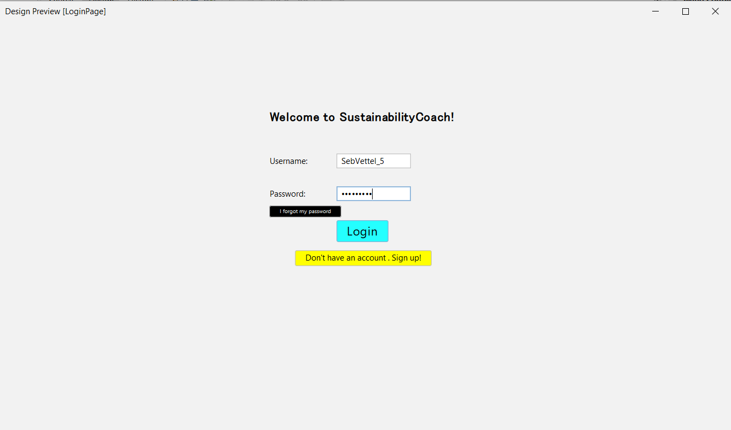

Figure 1

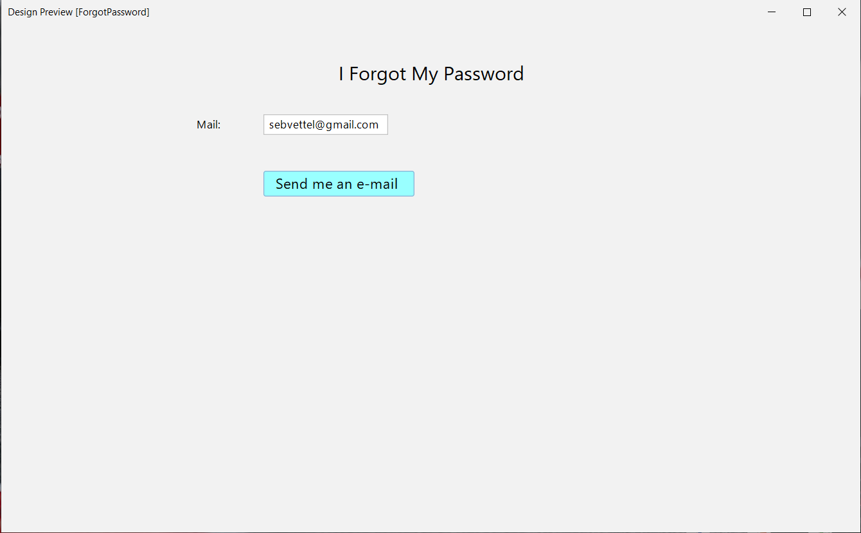

Figure 2

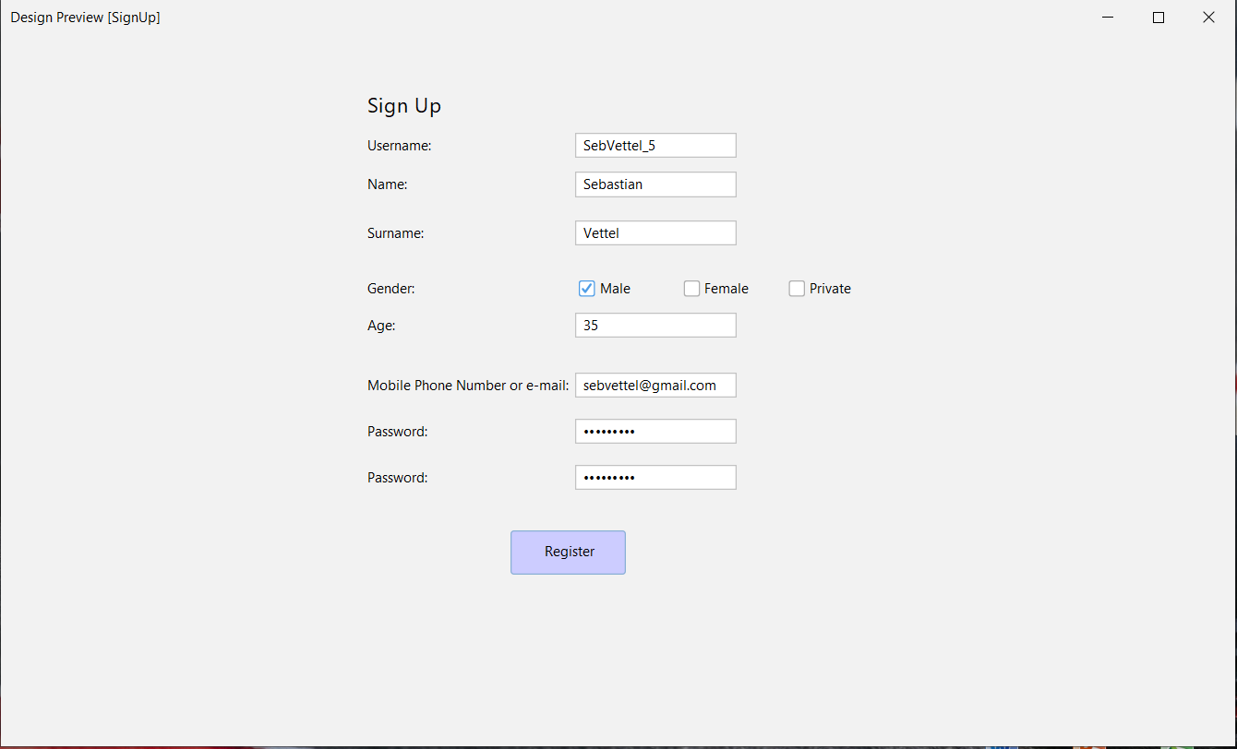

Figure 3

## Achievements

## Profile

In the profile section, intuitively, the player will be able to output their essential variables contained in the system, Sustainability Coach. Before describing the details, let’s have an example of the previous US president Donald Trump in Figure 6. On the leftmost part of our Java application in the profile section, to the corresponding section users will be able upload any part of their chosen avatar to be displayed on their specific parts in forum or the special badges created for the players. On the rightmost corner date will be shown. Notice that Datum corresponds to Date. In the coach tips section, players will be able to view daily tips for becoming more sustainable. This may be changed when the player runs re-run command by clicking to the dialogue box. In the information section, the players will be able view their in-game parameters such as scores and other labels designating specific aspects for them. The user will be able to update those by clicking & editing triggering the designated event listeners. Finally on the badges part, recent three of the achievements can be seen. Depending on the amount, the players will be able to extend this window to view all their trophies, if the amount exceeds the screen limit. Profile page is the page where the players will learn and edit their data (input) for the application to generate content (output).

Figure 6

## Forum

Forum page is the place where users discuss news or topics. On the left there are hot topics listed. The hot topics has what is called radio buttons. Users select one of them then discussion related to it is displayed. The shortened version of the news can be seen below the topic title. Below that text box, there is “see more” button which takes user to the news section to display the entire news. There is +1 and -1 buttons which user can click on to vote. Topic is listed in the hot topic according to these votes. Below the voting buttons and “see more” button there is the box where users can write their comments. At the bottom there are the comments written. Answers to a comment are located below the main comment and answers to the particular answer are again below the original answer. That is, they are nested. Each level of answer has different color to make it easier to differentiate. The user selects one of the comments clicking on the select button next to it. Then writes their answer to the box bellow the voting buttons. When they press the share button, it is displayed below the selected comment as an answer.

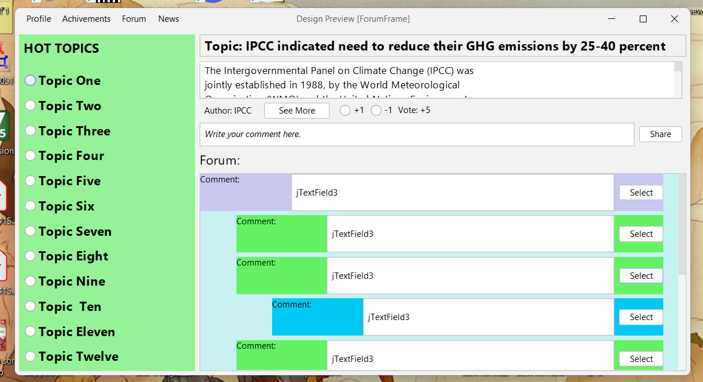

Figure 4

## News

In the news tab of the application, user will be able to see news about the topic. On the top of the page, there will be “Breaking News” panel and user will see the most important news. Under “Breaking News”, important and featured news will be listed, and the user will be able to switch to other news from the tabs above. Although it is currently set to switch between 7 news, we will increase the number of news that can be switched in this panel. On the left of the page, there will be news categories that can be selected by the user. Although these have been determined as "Top News, Country, World, Business, Health" for now, they will be added in different categories in the final version of the application. There will be 2 sections at the bottom of the page. The first of these will be the section with daily news.

The news in this section will consist of more casual content than the news at the top of the page. In the second part, there will be a panel showing the air quality of the user's location. Below that, there will be another panel showing the weather conditions of the user's location. The locations of these panels can be changed by the user. At the bottom, there will be a separate panel where the content can be personalized by the user. In addition, the user will be able to set how many news and indicators will be found in this section.

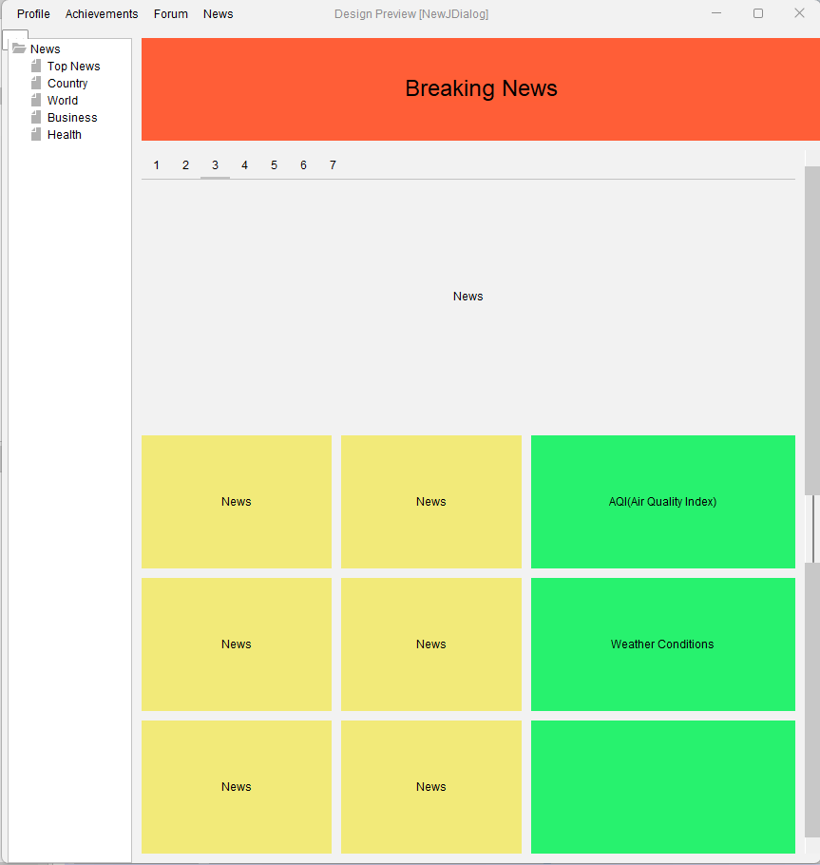

Figure 5

# Summary & Conclusions

And finally… don’t forget that Word can help to check your spelling (and grammar!)

Maintaining lists of research references that can be reused when writing journal articles can be a real pain, especially when citation styles vary so much from journal to journal. When you have time I suggest you look at reference managers (e.g. JabRef for BibTeX, or websites such as CiteSeer), as well as other document creation options (e.g. LyX, LateX and OpenOffice.)

Good Luck.