|  |  |  |  |
| --- | --- | --- | --- |
| **CS102** | **Fall 2020/21** | Project Group | 1D |
| Instructor: | **Uğur Güdükbay** |  |  |
| Assistant: | Sinan Sonlu |  |  |

|  |  |  |
| --- | --- | --- |
| **Criteria** | **TA/Grader** | **Instructor** |
| Presentation |  |  |
|  |  |  |
|  |  |  |
|  |  |  |
| Overall |  |  |

~ Sustainibility Coach ~

SavioursOfTheGreenWorld

Batuhan Balaban 21703122 | Berkay Yiğit 21702109 | Murat Ertan 22003067 | Selman Eldeniz 22003385 | Özgür Göker 22102317

|  |
| --- |
| UI Design Report  ( Volume 2 )  26 November 2022 |

# Introduction

The UI design consists of pages designed by different group members. There is login –sign-up pages, achievements page, profile page, forum page and news page. These pages shared here are not some graphical pictures that are drawn in a drawing environment. They show actual java swing library layouts designed using NetBeans. Therefore, these pages are actually part of the project in progress. These are not at their final forms and they will be developed further. Also, we preferred to implement the project for PC because we wanted to utilize CS 102 course material instead of some external development studio.

There is a menu bar above every page except for login and sign in pages. That way, the user navigates through the pages. Other details are explained in each of the following sections.

# Details

## Login – Sign Up pages

The first page that the users will encounter when they enter the site is in Figure 1. There will text to welcome them. There will be blanks for username and password that are already chosen by user. If they remember those correctly, after clicking login button they will face with achievements page. If they remember their e-mail but cannot remember their password, there will be button for that as well. If they click that “I forgot my password” button, they will be directed the page shown in Figure 2. After typing their e-mail, link will be sent to their e-mail addresses. There they can reset their password. These were the situations if they have an account. For first users, there will be button on login page to sign up. On that page, as shown in Figure 3, they will enter their names, age, e-mails, password etc. After clicking “Register” button, link will be sent to their e-mail addresses for confirmation. Once they confirm their e-mail, they will have access to site. The validation whether the same email exists, or the name will be made and notified of the user once they click on register. If the user remembers they have an account existing, they will be able to return sign in page from the “Remembered, Sign In!” button.

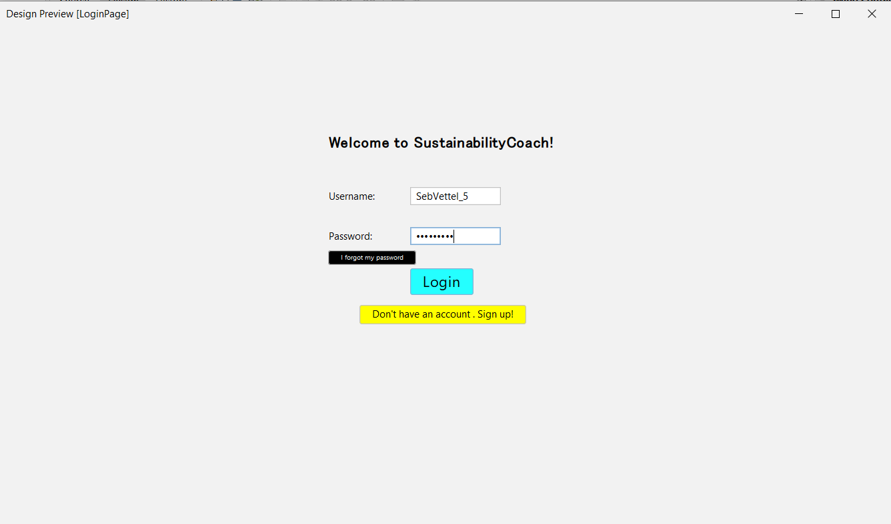

Figure 1

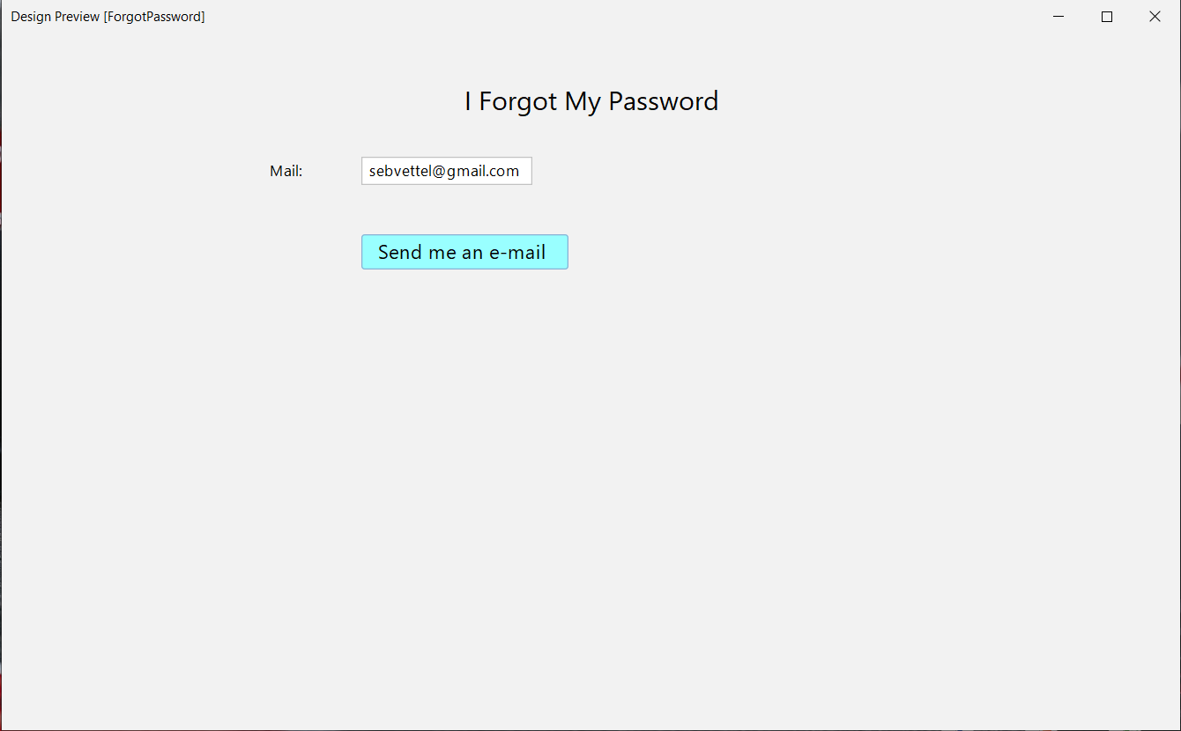

Figure 2

Figure 3

## Achievements

## Profile

In the profile section, intuitively, the player will be able to output their essential variables contained in the system, Sustainability Coach. Before describing the details, let’s have an example of the previous US president Donald Trump in Figure 6. On the leftmost part of our Java application in the profile section, to the corresponding section users will be able upload any part of their chosen avatar to be displayed on their specific parts in forum or the special badges created for the players. On the rightmost corner date will be shown. Notice that Datum corresponds to Date. In the coach tips section, players will be able to view daily tips for becoming more sustainable. This may be changed when the player runs re-run command by clicking to the dialogue box. In the information section, the players will be able view their in-game parameters such as scores and other labels designating specific aspects for them. The user will be able to update those by clicking & editing triggering the designated event listeners. Finally on the badges part, recent three of the achievements can be seen. Depending on the amount, the players will be able to extend this window to view all their trophies, if the amount exceeds the screen limit. Profile page is the page where the players will learn and edit their data (input) for the application to generate content (output). Once the player clicks on the awards, they will be able to see a summary of why they have been granted this reward. In the news page, the top players will be listed. Once clicked, the user will be able to see the top players profile page. Note that, only the top five players will be visible and accessible from the news page. The players can change their profile photo when they click on it and upload an image. Initially, there will be a default profile picture for all players.

Figure 4

## App News

In the news tab of the application, user will be able to see news about the application. On the top of the page, there will be “Breaking News” panel and user will see the most important news created by the application (Admins can manage this). Under “Breaking News”, important and featured news will be listed, such as the highest-ranking players and other special rankings. Additionally, We would like to use GPT-3 to be a companion in the application.

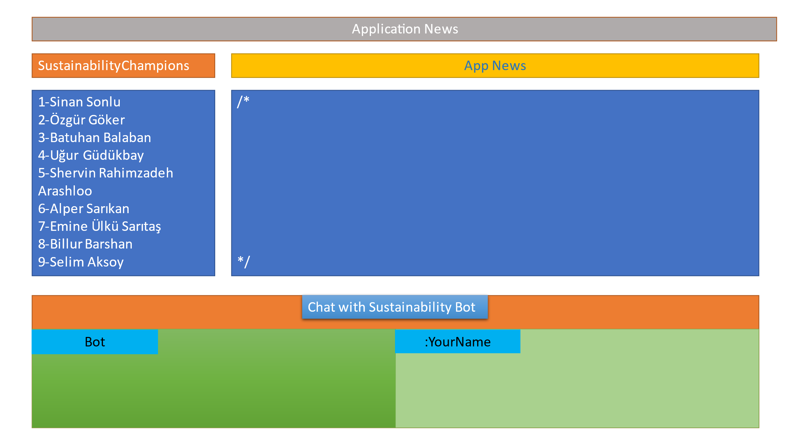

Figure 5

# Site Map

Figure 6

**Sign In:** Inputs Name and Password; Loads Data from Database and forwards to Achievements page. No menu is displayed.

**Forget Password:** To reset password. Can return to sign in. No menu is displayed.

**Register:** Creates a player object. Can return to sign in. No menu is displayed.

**Achievements:** The place where players will load data into the application. Main navigation menu is displayed at the top. Players will select missions which will launch pop-ups.

**Level Pop-Ups:** Special missions curated by the admins and the system.

**News:** The place where app news are displayed with the top (or five) ten ranked players. Chat-bot will be developed if necessary here. Main navigation menu is displayed at the top.

**Ranked Profile:** Same as the profile page, except unchangeable content and views the ranked profile.

**Profile:** Basic player info displayed here. The players when interreact with the text-fields will be able to change their information. Profile photo (A default profile photo initially) could be changed on click and upload.

**Menu:** Main navigation menu enables navigating between: Achievements, News, Profile and Exit.

//No settings page will be set for the players. Admins may be able to change it from the code.