**Bilingual Personality Disorder**

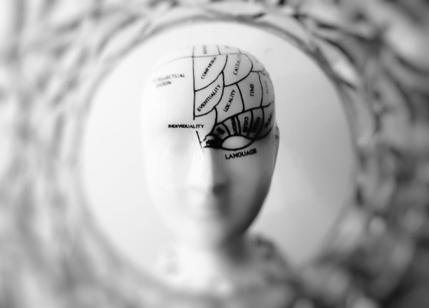One language, one person.

This may be the first time you hear about this made-up disorder but it actually isn’t so far from the truth. Even the studies that were conducted almost half a century show that **the language you speak has more effects on you than you realise**.

One of the very first experiments conducted on this topic dates back to 1964. [In the experiment](https://www.researchgate.net/publication/9440038_Language_and_TAT_content_in_bilinguals) designed by linguist Ervin-Tripp who is an authority expert in psycholinguistic and sociolinguistic studies, adults who are bilingual in English in French were showed series of pictures and were asked to create 3-minute stories. In the end participants emphasized drastically different dynamics for stories in English and French.

Another ground-breaking experiment which included bilingual Japanese women married to American men in San Francisco were asked to complete sentences. The goal of the experiment was to inve<FIO>stigate whether or not human feelings and thoughts are expressed differently in **different language mindsets**. Here is a sample from the the experiment:

|  |  |  |
| --- | --- | --- |
|  | **English** | **Japanese** |
| Real friends should | Be very frank | Help each other |
| I will probably become | A teacher | A housewife |
| When there is a conflict with family | I do what I want | It's a time of great unhappiness |

More recent [studies](https://books.google.pl/books?id=1LMhWGHGkRUC) show, the language a person speaks affects their cognition, behaviour, emotions and hence **their personality**. This shouldn’t come as a surprise [since we already know](https://en.wikipedia.org/wiki/Lateralization_of_brain_function) that different regions of the brain become more active depending on the person’s activity at hand. Since structure, information and especially **the culture** of languages varies substantially and the language a person speaks is an essential element of daily life.