“Dr. Caffeine’s All-Nighter Academy”

Does Sleep Affect Exam Scores?

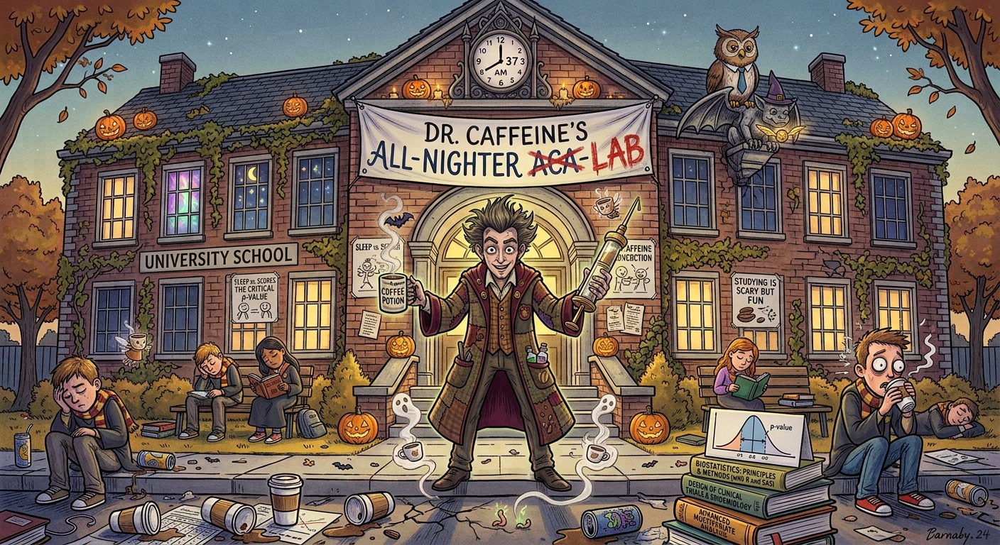

Linear regression is a statistical method that models the relationship between two quantitative variables by fitting a straight line to the data. It can help us describe the direction and strength of a linear relationship and evaluate whether the data provides evidence of an association between the variables.
“Dr. Caffeine’s All-Nighter Academy” 1
Does Sleep Affect Exam Scores? 1
Part 0: Warm up 2
Step 1: Set Up Your Google Sheet 2
Step 2: Calculate the Basics 2
Part 1: Scenario: 4
Step 1: Set Up Your Google Sheet 6
Step 2: Identify Variables 6
Step 3: Make a scatter plot 7
Step 4: Calculate linear regression 9
Step 5: Interpret the linear regression 10
Step 6: Evaluate regression 11
6.1 Interpret R² 11
Step 6.2 A: Calculate the regression statistics in Google Sheets 12
Step 6.2 B: Calculate the t-statistic 12
Step 6.2 C: Calculate the p-value 12
Step 7: Interpret results 13
PART 2: Why Straight Lines Fail, The Plot Twist! - QUADRATIC Regression! 14
STEP 8: Straight Linear Regression 14
Step 9: Create a SQUARED Sleep-Hours Column 16
Step 10: Calculate Quadratic Regression 17
Step 11: Run Quadratic Regression in Google Sheets 18
Step 12: Compare the Models 18
Our final TAKEAWAY! 20

____________________________________________________________________________

Part 0: Warm up
Welcome to All-Nighter Academy Orientation! Before we investigate whether sleep can predict exam performance, let’s warm up with some basic statistics using Google Sheets! In this section, you'll learn how to enter data and calculate the average amount of sleep students get using mean, median, and standard deviation using our dataset. These calculations will help us understand the data before moving on to the rest of the analysis.

Step 1: Set Up Your Google Sheet
Before we begin calculating statistics, we need to create a personal workspace where we can organize, analyze and interpret our data. Throughout this tutorial, you will be using Google Sheets to perform calculations and create visualizations.
- Open the template spreadsheet created by your favorite grad students
  - Dr. Caffeine’s All-Nighter Academy
- Make a personal copy of the Google Sheet by going under File and “Make a Copy”
  - 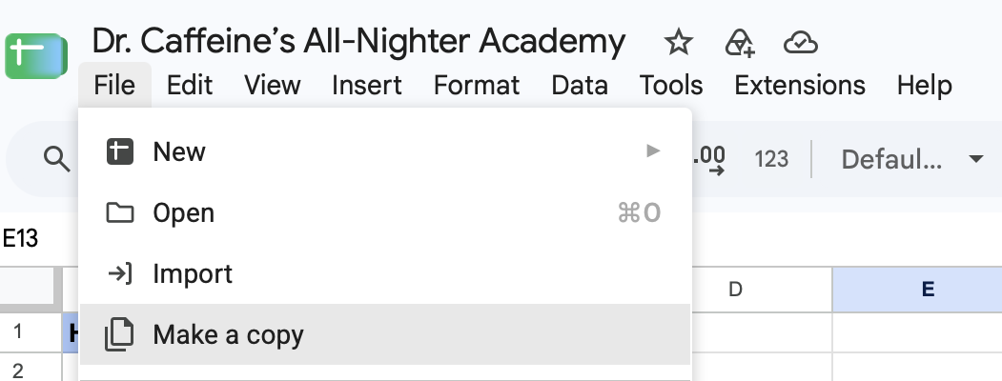
- Rename your spreadsheet with your name and the date
  - Example: Name_AllNighterAcademy_102126
- Take a moment to familiarize yourself with the Google Sheet layout. Notice all the different tabs located at the bottom of the workbook. Throughout this activity, different tabs will be used for descriptive stats, regression calculations, etc.
- Make sure you can view the column containing the Hours of Sleep and Exam Score data. These variables will be the focus of our analysis through this tutorial.
Once your Google Sheet is set up, you’re ready to begin exploring the data.

Step 2: Calculate the Basics
Before we examine whether sleep is related to exam performance, let’s summarize the data using descriptive statistics. Descriptive statistics help us understand the typical values in a dataset and how much those values vary from one student to another

For this activity, we will calculate the average amount of sleep students get, as well as summarize exam performance using the mean, median, and standard deviation.

Tasks: Perform the following calculations using spreadsheet functions:

Let's start by examining the amount of sleep students are getting in our dataset.
- Mean (Average Sleep) tells us the typical amount of sleep students get: Use the formula =AVERAGE(A2:A26) to find the mean of the scores. This will give you the average score, providing an overall measure of central tendency.
  - Average Hours of Sleep = _____ hours
Based on your result, do students appear to be getting enough sleep? Is the average higher or lower than you expected?

Unlike the mean, the median is less affected by unusually high or low scores. This makes it useful when a dataset contains potential outliers.
- Median (middle value) helps identify the center of the distribution and is less affected by unusually high or low scores: Use the formula =MEDIAN(B2:B26) to find the median score.
  - Median Exam Score = _____
Is the median similar to your mean?

While measures of center tells us what a typical score looks like, they do not tell us how much students differ from one another.
- Standard Deviation (spread of data): This measures how spread out the scores are from the mean, indicating the variability of student performance. Use the formula =STDEV(B2:B26) to calculate the standard deviation.
  - Standard Deviation = _____
A small standard deviation indicates that the scores are clustered closely around the average. A large standard deviation shows that the scores vary substantially from student to student.

Congratulations! You are now ready for your first day at All-Nighter Academy. You have successfully used Google Sheets to calculate descriptive statistics. Next, we’ll use a set of data to investigate whether hours of sleep can predict final exam scores.

Part 1: Scenario:
Welcome to the All-Nighter Academy, where the coffee is strong, the students are exhausted, and the final exams are approaching!
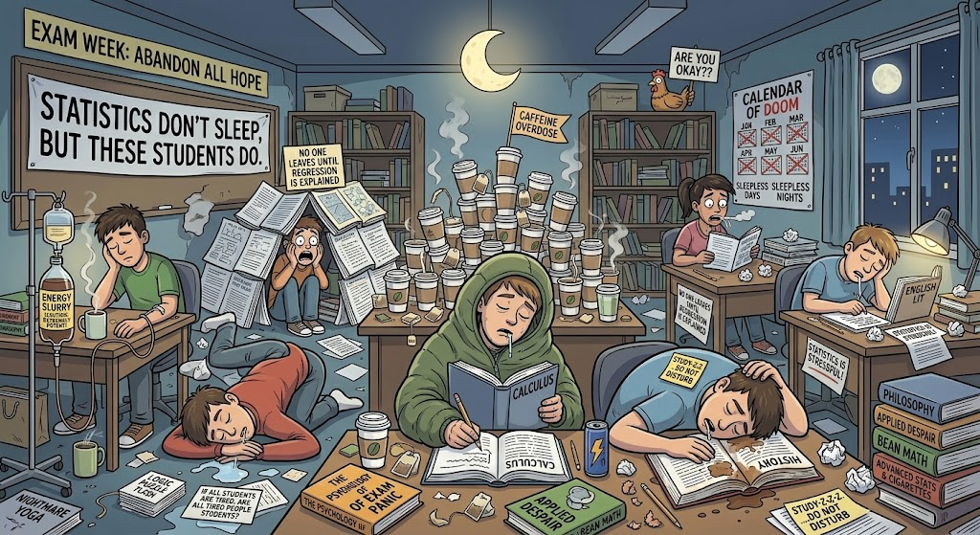
Dr. Caffeine has noticed that some students stay up late studying while others prioritize getting a full night’s sleep. He suspects that the amount of sleep students get may be related to their final exam scores.
But is there actually a relationship between sleep and exam performance, or is Dr. Caffeine just running on too much caffeine? In this tutorial, you will use Google Sheets to explore the relationship between students’ hours of sleep and their final exam scores. We’ll start by using linear regression to fit a straight line to the data. But what happens when students who get too much sleep start scoring lower on their exams? A straight line might not tell the whole story! We’ll then explore quadratic regression to see if a curved model might better describe the relationship. Grab your coffee, let’s get into it.

____________________________________________________________________________
Research Question
Does the number of hours of sleep a student gets predict their final exam score?
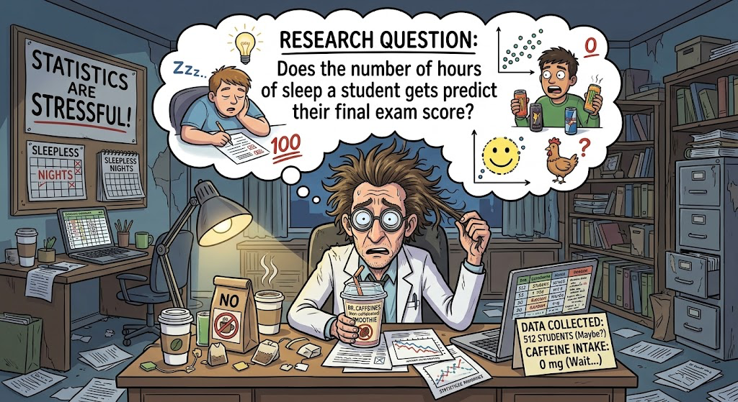
Hypotheses: What are we actually testing?
Null Hypothesis H0: There is no linear relationship between hours of sleep and final exam scores in the population.
Alternative Hypothesis H1: There is a linear relationship between hours of sleep and final exam scores in the population.
Basically, we’re testing whether there is evidence of a straight-line relationship between sleep and exam scores. Dr. Caffeine wants answers, and we have statistics!
____________________________________________________________________________

Step 1: Set Up Your Google Sheet
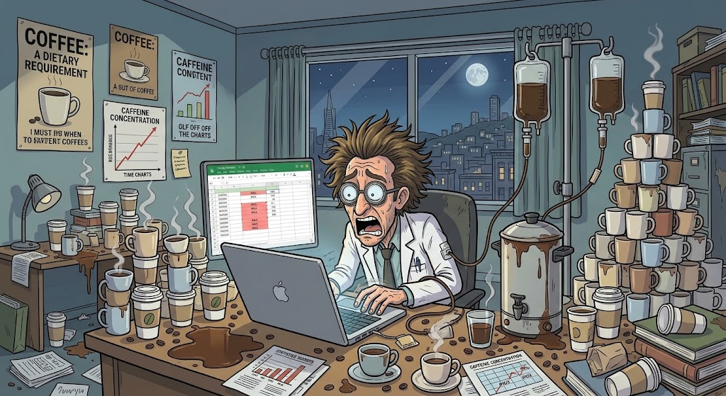
- Open the template spreadsheet created by your favorite grad students
  - Dr. Caffeine’s All-Nighter Academy
- Make a personal copy of the Google Sheet by going under File and “Make a Copy”
- Rename your spreadsheet with your name and the date
- Note that there are 6 number of tabs at the bottom
  - Data
  - Sample Mean
  - Linear Regression
  - Linear Regression Reflection
  - Quadratic Regression
  - Quadratic Regression Reflection
_____________________________________________________________________________________

Step 2: Identify Variables
Before performing any calculations, we need to identify the two variables in the study.
For both Pt. 1 and 2, we will be using the data in the Google Sheets ‘Data’ tab.
- X (predictor): hours of sleep a student gets
  - Column A of Linear Regression tab
- Y (response): the student’s final exam score
  - Column B of Linear Regression tab
In this scenario, sleep is the predictor variable, and exam score is the response variable. We are investigating whether students’ sleep duration can help predict their exam scores. This does not automatically mean that sleep causes a change in exam performance. Other factors, such as studying habits, stress, and maybe lack of or too much caffeine intake, may also affect scores.
____________________________________________________________________________

Step 3: Make a scatter plot
Before calculating a regression equation, it’s important to visualize the data. A scatterplot allows us to view the direction, form, and strength of the relationship between sleep hours and exam scores. Basically, each student becomes a dot; statistically useful.

3.1 Create the chart
- Begin by copying the data from the ‘Hours of Sleep’ and ‘Exam Score (%)’ columns in the ‘Data’ tab into the corresponding columns in the ‘Linear Regression’ tab
- Highlight the columns containing hours of sleep (A) and final exam scores (B), including the column headings
- Select Insert → Chart
- In the Chart editor, choose Scatter chart as the chart type.
- Make sure hours of sleep are on the x-axis and exam scores are on the y-axis
- Add an informative chart title, such as Hours of Sleep vs. Final Exam Scores
- Label the axes:
  - Horizontal axis: Hours of Sleep
  - Vertical axis: Final Exam Score (%)

3.2 Examine the relationship: What is our Scatterplot even Telling us?
Before running any calculations, look at the dots you have created. Are they showing us anything significant, or is this an academic disaster?

  - Positive relationship: students who sleep more tend to have higher exam scores. The points generally rise from left to right.
  - Negative relationship: students who sleep more tend to have lower exam scores. The points generally fall from left to right
  - Weak relationship: the points show a general upward or downward trend, but they are widely scattered instead of closely following a straight line
  - No apparent linear relationship: the points do not show a clear upward or downward trend. However, they may still show a pattern, like a curve
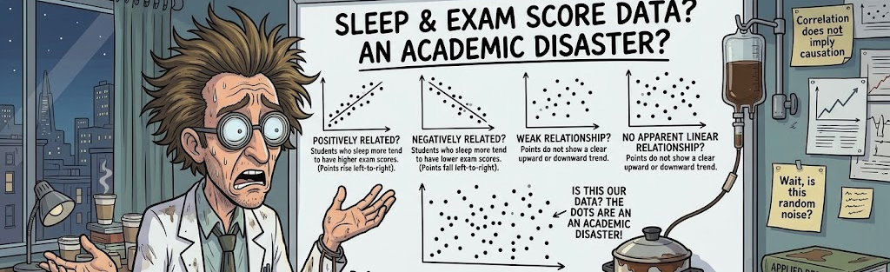
Pause and predict: Based on your scatterplot, do you expect the relationship between sleep and exam scores to be positive, negative, weak, or strong? Record your prediction before moving on. Don’t worry about getting it right just yet, we’re about to put this data to work.

Step 4: Calculate linear regression
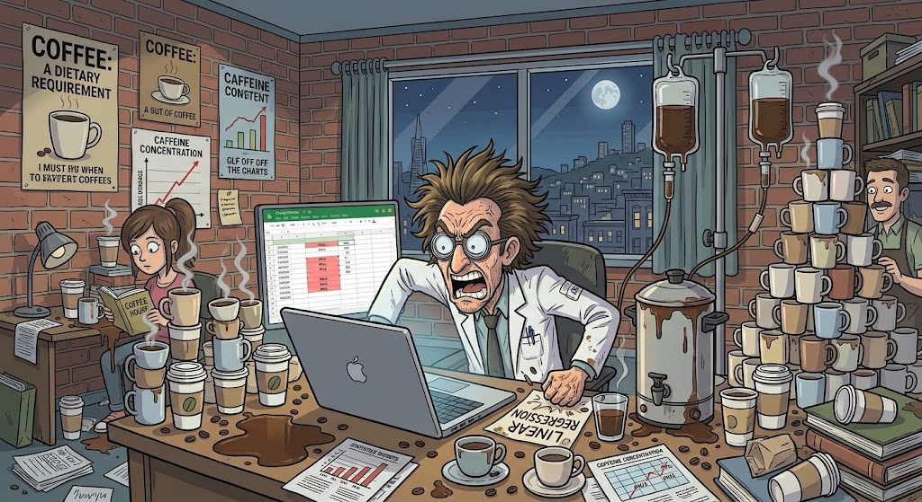

Now that you have visualized the data, you can use linear regression to describe the relationship mathematically.

Simple Linear Regression: Finds the straight line that best represents the overall pattern of the dots (each student is a dot on a scatterplot).

A simple linear regression equation is:
Predicted exam score = intercept + slope x hours of sleep

$\hat{y}=b_{0}+b_{1}x$

Don’t let the symbols scare you. Here’s what they actually mean:

$\hat{y}$ = Predicted exam score
$b_{0}$ = Intercept: predicted score at 0 hours of sleep
$b_{1}$ = Slope: predicted change in score for each additional hour of sleep
x = Hours of sleep

To calculate in Google Sheets:
- In cell D2, it should say "Slope"
- In cell E2, use the SLOPE function to calculate the sample slope:
  - Enter: =SLOPE(B2:B26,A2:A26)
  - This formula calculates the slope of the best-fitting straight line through the data. In other words, it tells us how much the predicted exam score changes for every additional hour of sleep.
- In cell D6, it should say "Intercept"
- In cell E6, use the INTERCEPT function to calculate the intercept of the regression line:
  - Enter: =INTERCEPT(B2:B26,A2:A26)
- In cell D10, it should say “R-squared”
- In cell E10, use the RSQ function to calculate the sample’s R²:
  - Enter: =RSQ(B2:B26,A2:A26)
  - This formula calculates the coefficient of determination, R², which describes the proportion of variation in exam scores explained by hours of sleep.
- Display the regression equation on the chart:
  - Select the scatterplot
  - Open the Chart Editor and select Customize → Series
  - Turn on the Trendline and select Linear
  - Under the trendline options, select Use Equation.
  - Optionally, display R² on the chart if this is available on your screen! Make sure the equation plus the R² displayed on your chart actually corresponds to the same data used in your calculations!
____________________________________________________________________________

Step 5: Interpret the linear regression
5.1 Okay, now we have our equation, but what does it actually mean?

Let’s use a hypothetical example:

Predicted exam score = 45 + (5 x hours of sleep)

Intercept (45): The model predicts an exam score of 45% for a student who gets 0 hours of sleep. This may not be practically meaningful.

Slope (5): For each additional hour of sleep, the predicted exam score increases by 5 percentage points, on average.

These values are hypothetical examples! Use actual values from your own spreadsheet when you are interpreting your results, and also remember that the slope describes an association and does not prove that the additional sleep causes higher exam scores.

5.2 Use the calculated slope and intercept from Dr. Caffeine’s data to write an interpretation on the Linear Regression Reflection page:
  - Slope (E2):
    - As hours of sleep increase by one hour, the predicted final score changes by approximately [insert your slope] points, on average.
    - A positive slope indicates an upward linear trend, while a negative slope indicates a downward linear trend. Think back to your prediction in section 3.2, based on your calculations in this section, which trend are you observing in this data?
  - Intercept (D6):
    - The intercept represents the predicted exam score when a student gets zero hours of sleep. What is the predicted exam score for a student who receives zero hours of sleep in Dr. Caffeine’s study?
    - Note: although the intercept is necessary to define the regression line, this prediction may not be practically meaningful if ‘0 hours’ falls outside the range of sleep durations in our dataset.
  - Use the simple linear regression equation to make a prediction:
    - Use the simple linear regression equation $\hat{y}=b_{0}+b_{1}x$ to predict the score for a student who gets 7 hours of sleep.
    - Substitute x = 7
      - $\hat{y}=b_{0}+$ $b_{1}$(7)
    - Use your own slope and intercept to calculate the predicted score. Remember that this is a model-based prediction, not a guarantee of what a student would actually score.
___________________________________________________________________________

Step 6: Evaluate regression
A regression equation can describe a pattern, but we also need to see how well it fits the data, and if there’s statistical evidence of a linear relationship.

6.1 Interpret R²
- R² describes the proportion of variation in the exam scores that is accounted for by the linear regression model using hours of sleep.
- For example, if R² = 0.60, then 60% of the variation in the exam scores is accounted for by the fitted linear regression model. However, R² alone does not tell us whether a straight line is the best way to describe the relationship.
- Reflection Question. Answer to following in your Google Sheets ‘Linear Regression Reflections’ tab:
  - What is the R² value for your linear regression model (cell E10), and what does this value tell you about how well the model fits the data?

6.2 To determine whether there is actual statistical evidence of a linear relationship, we need to test the regression slope!
We can test whether the population slope differs from zero with the following hypotheses:
- H₀: β₁ = 0 — There is no linear relationship between sleep hours and exam scores in the population.
- H₁: β₁ ≠ 0 — There is a linear relationship between sleep hours and exam scores in the population.

Step 6.2 A: Calculate the regression statistics in Google Sheets
  - One way to obtain the necessary regression statistics is to use LINEST.
  - In cell G1, it should say “Regression Statistics”
  - Select cell G2 and enter: =LINEST(B2:B26,A2:A26,TRUE,TRUE)
  - The output will contain the slope and intercept, their standard errors, and any additional regression statistics.
  - Locate the following:
- The slope in G2
- The intercept in H2
- The standard error of the slope in the G3
- The residual degrees of freedom in H5.

Step 6.2 B: Calculate the t-statistic
The t-stastistic measures how many standard errors the slope is from zero
t = slope / standard error of slope
  - In cell J2, it should say “t-statistic”
  - Select cell K2 and enter: =G2/G3

Step 6.2 C: Calculate the p-value
In this step we will calculate the two-tailed p-value to test whether the slope differs from zero in either direction.
Note: We would calculate a one-tailed p-value instead if we a had a specific directional hypothesis, for example if more sleep was associated with [higher|lower] exam scores, and we only wanted to test for evidence in that direction.

  - In cell J6, it should say “Residual degrees of freedom”
  - Select cell K6 and enter: =H5
  - In cell J10, it should say “Two-tailed p-value”
  - Select cell K10 and enter: =T.DIST.2T(ABS(K2),K6)

6.3 Finally, let’s make a decision! Is Dr. Caffeine onto something?

Okay, time to see if all that coffee-fueled studying is actually paying off! We’re going to use our p-value to decide whether there’s enough evidence to support a linear relationship between hours of sleep and exam scores.
Compare the p-value in K10 with the significance level of α = 0.05!
- If p < 0.05: Reject the null hypothesis! We have statistically significant evidence of a linear relationship between hours of sleep and exam scores. Dr. Caffeine might be onto something!
- If p ≥ 0.05: Fail to reject the null hypothesis. We don't have enough evidence to conclude that a linear relationship exists. Sorry, Dr. Caffeine, we can't blame the all-nighters just yet!
- Reflection Question: What is the p-value for your linear regression model? Using the significance level, do you reject or fail to reject the null hypothesis? What does your decision tell you about the evidence for a linear relationship between hours of sleep and exam scores?
* Just an Important note! A p-value doesn't tell us how strong the relationship is, and it doesn't tell us the probability that the null hypothesis is true. It just helps us decide whether our data provide enough evidence against the null hypothesis. Statistics: humbling us one coffee at a time.

Step 7: Interpret results
We’ve made our chart, calculated our regression equation AND tested our hypothesis. Now it’s time to take a step back and look at the bigger picture!

Reflection Question: Based on your scatterplot and the statistics calculated regarding it, does a straight line model appear to capture the overall pattern in the data? Why or why not?

PART 2: Why Straight Lines Fail, The Plot Twist! - QUADRATIC Regression!
Now that we’ve officially run our linear regression, Dr. Caffeine is staring at the results like he just failed his own exam. The line exists, sure, but the data is giving absolutely NOTHING linear. Looking back at our scatterplot from Part 1, the points form an upside-down U, almost like students’ brains function perfectly until they either get 2 hours of sleep or decide to hibernate for 14 hours. Apparently, there IS such a thing as too much sleep! Students who get a moderate amount of sleep tend to score the highest, while those getting too little or too much tend to score lower. Unfortunately, a straight line cannot capture this academic roller coaster. Dr. Caffeine needs a new plan, another cup of coffee, and possibly a nap himself?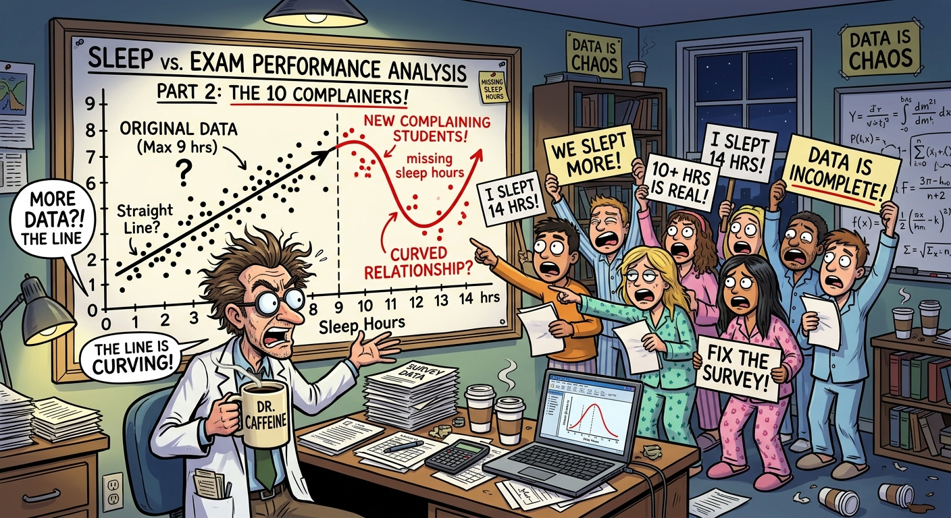
Let’s see why our linear regression is not giving what it needs to give.

STEP 8: Straight Linear Regression
- Add the Linear Trendline First: On your scatterplot, open the Chart Editor and select Customize → Series. Turn on the Trendline and select Linear. Make sure to display the equation and (R^2) value. We need receipts because Dr. Caffeine is NOT about to trust a line just because it looks official.
- Observe the Disconnect: Look at that straight line running through the middle of the scatterplot. Like… respectfully, what is going on here? Our data is forming a whole upside-down U, and this line is acting like everything is perfectly linear. Students who get a moderate amount of sleep tend to score higher, while those who barely sleep or sleep like they’re in a three-day coma tend to score lower. The pattern is an academic roller coaster.
- Check your linear receipts: Pull your R2 value over from your Part 1 linear sheet. Notice how low or unconvincing it is? Dr. Caffeine has his coffee, we have our calculations, and yet this line is still not connecting the dots. A lower R2 value indicates that the linear model just isn't capturing the real variation in exam scores. At this point, we need to regroup.
Time for QUADRATIC REGRESSION! Since exam scores appear to peak at a moderate amount of sleep and decrease when students get either too little or too much, a curved model may better represent the relationship. Because apparently, sleep has a sweet spot, and statistics refuse to let us have a simple answer. Let’s see if quadratic regression can save this project before Dr. Caffeine has a full academic crisis!
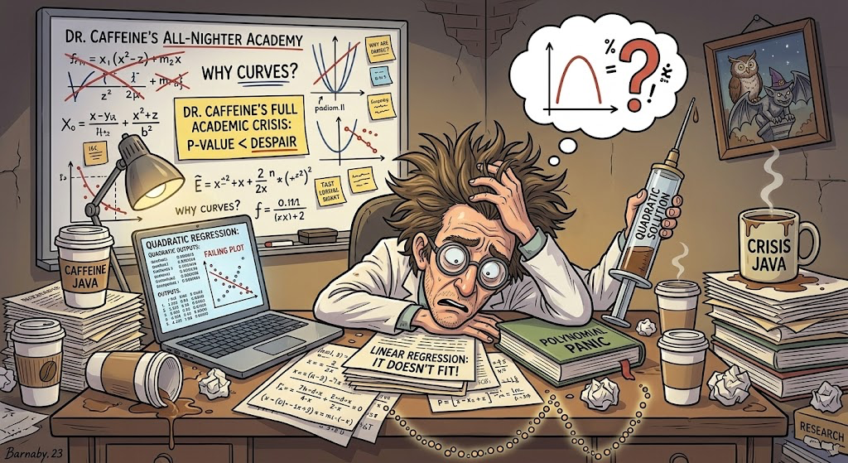

Our New Research Question: Does the quadratic regression model BETTER describe the relationship between hours of sleep and final exam scores than a linear model?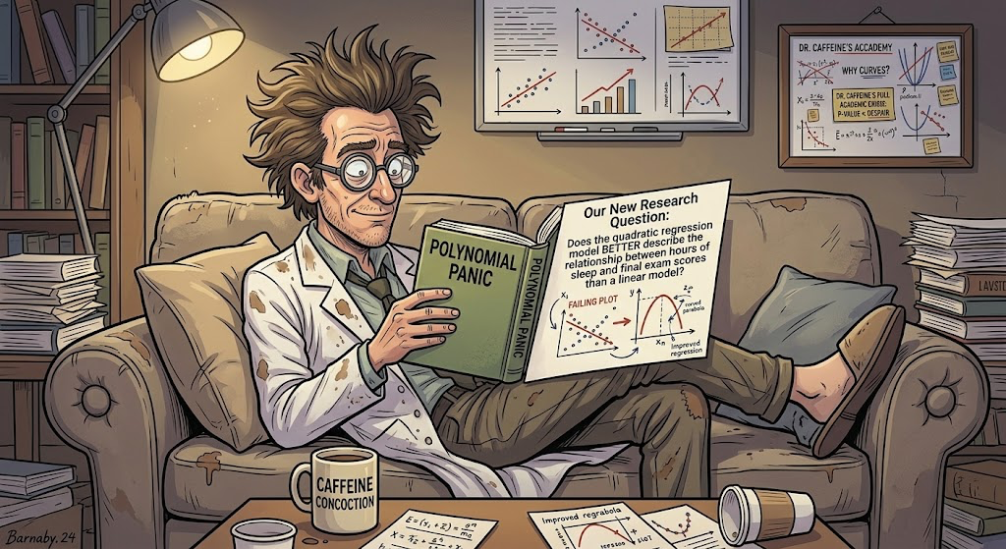

Hypotheses for Quadratic Term: This time, we’re looking at whether adding a squared sleep-hours term provides evidence of curvature

- H₀: β₂ = 0 — There is no quadratic term in the population model.
- H₁: β₂ ≠ 0 — There is evidence of a quadratic term in the population model
Basically, we’re asking whether the relationship needs a curve instead of a straight line.

Step 9: Create a SQUARED Sleep-Hours Column
To let our regression model curve, we need to square our predictor variable (x).
- Add a new column to your spreadsheet.
- Label it Sleep Hours Squared (x^2)
- If the sleep hours are in cell A2, enter: =A2^2
- Press Enter, then drag the little blue square all the way down to the bottom to make sure it applies to all students! Basically, we’re taking each student’s hours of sleep and multiplying that number by itself. If someone slept 6 hours, their squared sleep value is 36! Don’t worry, they didn’t sleep for 36 hours!

Step 10: Calculate Quadratic Regression
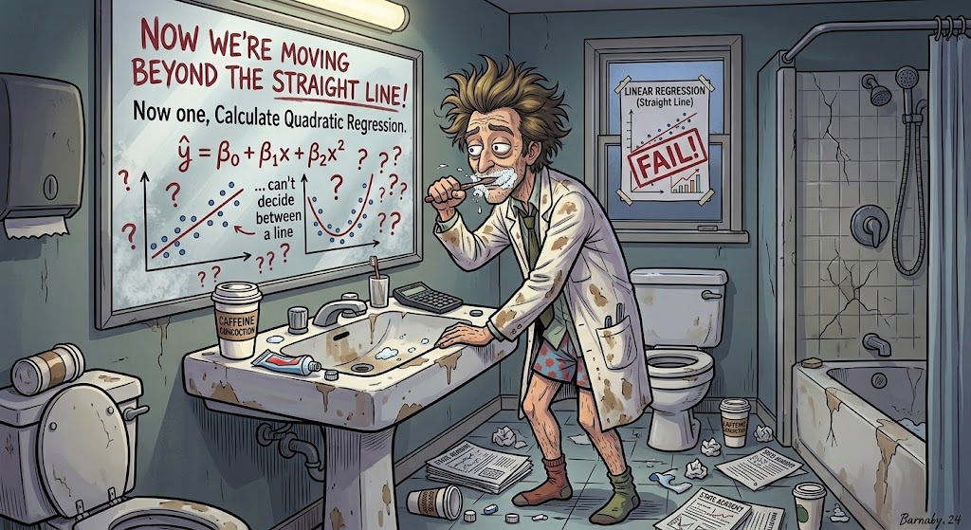

Now we are moving beyond the straight line!
Quadratic Regression: a type of polynomial regression that is curved with respect to x.

Our Equation is:
$\hat{y}=b_{0}+b_{1}x+b_{2}x^{2}$

Here’s the breakdown:
$\hat{y}$ = Predicted exam score
$b_{0}$ = intercept
$b_{1}x$ = linear term
$b_{2}x^{2}$ = quadratic term, which lets the relationship curve
x = hours of sleep

That extra x^2 term is what gives the model its curve. Now that we know what all these symbols mean, let’s get into Google Sheets and see whether or not your data actually is giving us a curve.

Step 11: Run Quadratic Regression in Google Sheets
We can use LINEST to fit the quadratic model by including both sleep hours and squared sleep hours as predictors. To avoid accidentally including exam scores as a predictor, create a separate two-column predictor table:
- Column E: Sleep Hours
- Column F: Sleep Hours Squared
If exam scores are in B2, sleep hours are in E2, and squared sleep hours are in F2, enter:
=LINEST(B2:26,E2:F26,TRUE,TRUE)
We only want to use the sleep-hours column and the squared sleep-hours column as predictors. If column A contains sleep hours and column E contains sleep hours squared, select those two columns together in a separate, adjacent range first, or use the formula that combines them:
=LINEST(B2:B26,{A2:A26,,E2:E26},TRUE,TRUE)
This tells Google Sheets to predict exam scores using both sleep hours and sleep hours squared! The first term captures the linear part of the relationship, while the squared term lets the model CURVE!
An important note, the output from LINEST can be a little confusing sometimes because it lists the coefficients in reverse order of the predictor columns. For our model:
- The first coefficient is for sleep hours squared
- The second coefficient is for sleep hours
- The last value in the first row is the intercept.
Once we have the coefficients, we can plug them into our quadratic equation and see what the model predicts for exam scores at different amounts of sleep.

Step 12: Compare the Models
Okay, here comes the question! Did quadratic regression actually improve our model, or did we just make the equation more complicated for fun? Compare the R2 values from the linear and quadratic models.
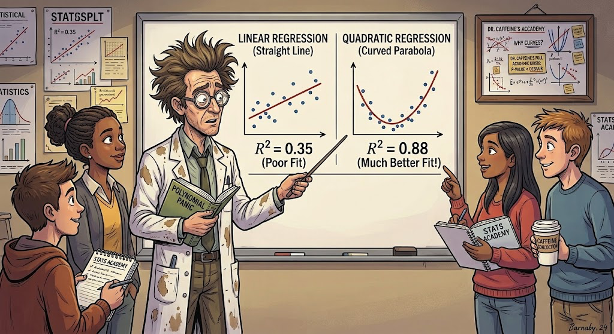Remember:
- Linear regression: Models the relationship using a straight line.
- Quadratic regression: Allows the relationship to curve.
A higher R2 means the model explains a larger proportion of the variation in the exam scores of this dataset. If your quadratic model has a higher R2, that will suggest that the curve fits these data better. HOWEVER! Adding another term will generally make R2 stay the same or even increase, so a higher value alone does not necessarily prove that quadratic regression is the better choice. Look at the actual pattern in the data, too. Does exam performance seem to increase with sleep and then level off? Do you see any curved pattern, or are we just trying to make the data tell us what we want to hear?

Our final TAKEAWAY!
Congratulations! You survived two regression models, your reward is hopefully a better understanding of statistics and maybe a snack (no coffee.) 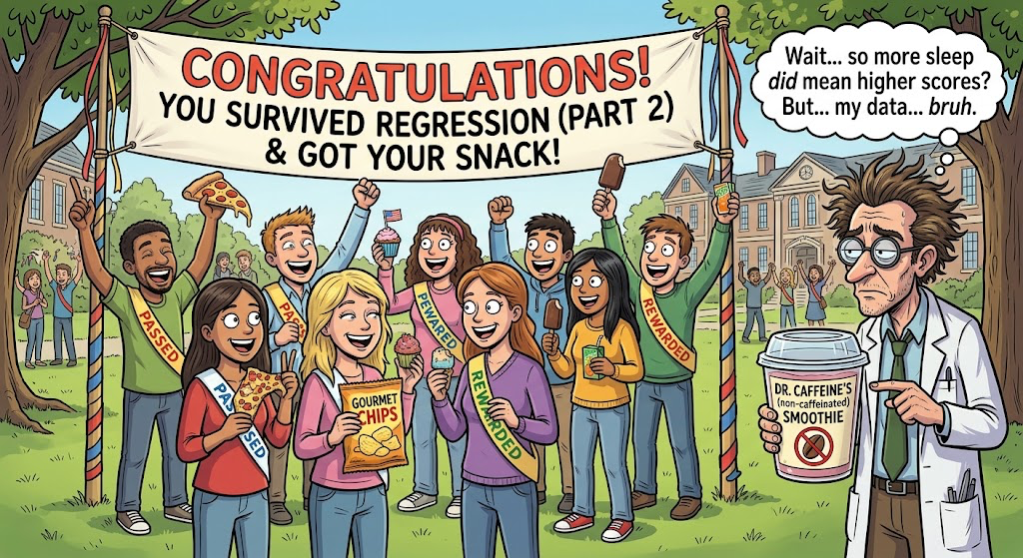
Linear regression helps us describe a straight-line relationship between sleep and exam scores. Quadratic regression gives us the option to model a curved relationship, and comparing the two models helps us figure out whether that extra curve is actually useful.
One thing to remember: A RELATIONSHIP DOES NOT AUTOMATICALLY MEAN CAUSATION! Even if students who sleep more tend to score higher, this alone cannot prove that sleep caused their scores to improve. Other factors could be involved, including studying, stress, and how much caffeine Dr. Caffeine has been distributing. With that, class is dismissed! Drink some water, close the 50 browser tabs you have open, and PLEASE get some sleep!

