"Joe's Hospital of Fried Foods" vs. National Average

Z-Test Tutorial for BIOL 318/418


A Z-test is a statistical test used when you want to know if the average of your sample is meaningfully different from a known population mean. It works by comparing the sample mean to the population mean, while taking into account the population’s standard deviation and the size of the sample. The result is a Z test statistic, which tells you how many standard deviations away your sample mean is from the population mean. If this distance is big enough (based on probability cutoffs called p-values), you can reject the idea that your sample is “just like” the population. Z-tests are only valid when the population standard deviation is known and the sample size is reasonably large (usually 30 or more).

Part 1 Scenario:
"Joe's Hospital of Fried Foods" claims that their babies are larger than the national average. The national average newborn weight is 7.5 lbs, with a known population standard deviation of 1.5 lbs. In this tutorial, you'll use Google Sheets to conduct a z-test using the sample data provided.
Null Hypothesis H0: babies are within the normal weight of the national average.
Alternative Hypothesis H1:fried foods make babies are larger than the national average

Step 1: Set Up Your Google Sheet
- Open the template spreadsheet created by the instructor
  - https://docs.google.com/spreadsheets/d/1A3hMTmSyL8Z-8v2K7Zit27SYXdgzQ7fHGqxqR7kCAPU/edit
- Make a personal copy of the Google Sheet by going under File and “Make a Copy”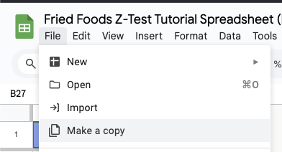
- Change the name of the Spreadsheet by adding your name and perhaps add the date

- Note that there are three tabs at the bottom…
  - Data for Parts 1 and 2
  - Part 1: National Z-Test
  - Part 2: National T-Test
- Copy the data from the first Google Sheet, tab named “Data for Part 1 and 2” and paste the data into the sheet named “Part 1: National Z-Test”
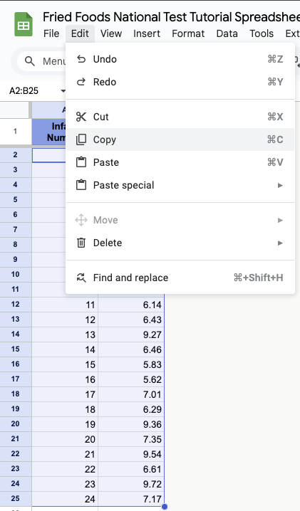 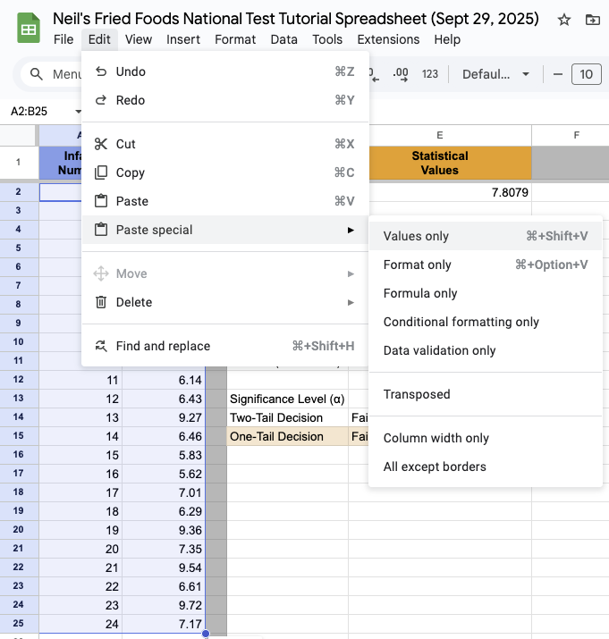

Step 2: Set Up the Known Population Values
Population statistic: A population statistic describes the entire group of interest, meaning every individual in the group you want to study, such as all babies born in the United States.
- Working in the tab “Part 1: National Z-Test”
- Columns D and E: Set aside this column for statistical calculations.
- In cell D1, it should say "Statistical Names"
- In cell E1, it should say "Statistical Values"
- In cell D2, it should say "Population Mean"
- In cell E2, enter "7.5"
  - ^ this is our representative mean baby weight of the population
- In cell D3, it should say "Population St.Dev."
- In cell E3, enter "1.5"
  - ^ this is our representative baby weight standard deviation of the population
- After completion your table should look similar to this:
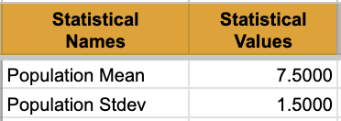

Step 3: Calculate the Sample Values
Sample statistic: A sample statistic describes a smaller subset drawn from that population, such as a group of babies born at one hospital which is a subset of all babies born in the United States.
- In cell D5, it should say "Sample Size"
- In cell E5, we will use the COUNT function to dynamically count the number of weights:
  - Enter: =COUNT(B2:B40)
  - This formula counts the weights from cells B2 to B40, allowing for flexibility if you add more data. It will automatically ignore empty cells.
- In cell D6, it should say "Sample Mean"
- In cell E6, use the AVERAGE function to calculate the sample mean:
  - Enter: =AVERAGE(B2:B40)
  - This formula calculates the mean of weights from cells B2 to B40, allowing for flexibility if you add more data. It will automatically ignore empty cells.
- In cell D7, it should say "Sample St.Dev."
- In cell E7, use the STDEV function to calculate the sample mean:
  - Enter: =STDEV(B2:B40)
  - This formula calculates the standard deviation of weights from cells B2 to B40, allowing for flexibility if you add more data. It will automatically ignore empty cells.
  - We will not be using the sample standard deviation for this statistical test

Step 4: Calculate the Z Test Statistic
- In cell D9, it should say "Z Test Statistic"
- In cell E9, calculate the Z test statistic using the formula:
  - Formula: (sample mean – population mean) / [ population standard deviation / sqrt(sample size) ]
  - Enter: =(E6 - E2) / (E3 / SQRT(E5))
  - This formula uses the sample mean (E6), population mean (E2), population standard deviation (E3), and sample size (E5). The use of SQRT(E5) adjusts for varying sample sizes.
Note: In a Z-test, the calculated value is called the Z test statistic, not a simple z-score. A z-score measures how far one data point is from the mean, while the Z test statistic measures how far the sample mean is from the population mean. Both use the same standardized scale, which is why they look alike but apply to different situations.

Step 5: Determine the Type of Test (One-Tailed or Two-Tailed) and Calculate the P-Value
When running a hypothesis test, you need to decide whether you care about differences in one direction or both. A one-tailed test looks only for an effect in a single direction (for example, asking if a group is larger than another), while a two-tailed test checks for any difference in either direction (larger or smaller). This choice depends entirely on how you frame your research question.

5.1: Understand the Research Question
- One-Tailed Test: Use this if testing whether babies at the hospital are larger than the national average.
- Two-Tailed Test: Use this if testing for any difference (either larger or smaller) in baby weights.

5.2: Calculate the P-Value Based on the Chosen Test
- Two-Tailed Test:
  - In cell D11, it should say "P-Value (Two-Tailed)"
  - In cell E11, enter: =2 * (1 - NORM.S.DIST(ABS(E9)))
- One-Tailed Test:
  - In cell D12, it should say "P-Value (One-Tailed)"
  - In cell E12, enter: =1 - NORM.S.DIST(E9)
NORM.S.DIST() is a spreadsheet function that gives the cumulative probability from the standard normal distribution. In other words, if you plug in a value for your Z test statistic, it tells you the probability of seeing a value less than or equal to that number under the bell-shaped curve of the standard normal distribution (mean = 0, standard deviation = 1). This is what allows us to turn a test statistic into a p-value.
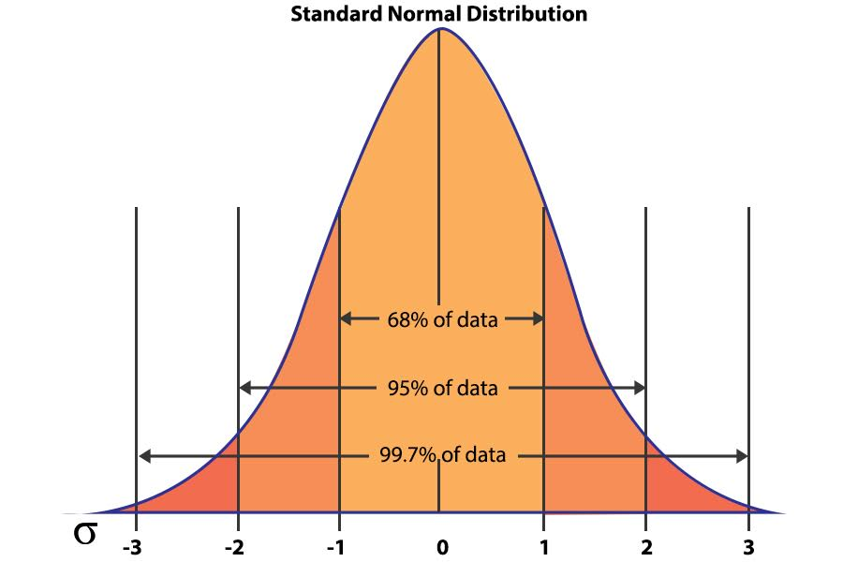

Step 6: Make a Decision Using an IF Statement
- In cell D14, it should say "Significance Level (α)."
- In cell E14, enter "0.05"
- In cell D16, it should say "Two-Tail Decision."
- In cell E16, use the IF statement to automatically determine whether to reject the null hypothesis:
  - Using the two-tailed test p-value (in E11), enter the formula:
=IF(E11 <= E14, "Reject the Null Hypothesis", "Fail to Reject the Null Hypothesis")
- In cell D17, it should say "One-Tail Decision."
- In cell E17, use the IF statement to automatically determine whether to reject the null hypothesis:
  - Using the one-tailed test p-value (in E12), enter the formula:
=IF(E12 <= E14, "Reject the Null Hypothesis", "Fail to Reject the Null Hypothesis")
- Explanation:
- The IF statement checks if the p-value (from either E11 or E12) is less than or equal to the significance level (in E14).
- If the condition is true (p-value ≤ 0.05), it returns "Reject the Null Hypothesis."
- If the condition is false (p-value > 0.05), it returns "Fail to Reject the Null Hypothesis."

Step 7: Interpret the Results
- In cell D19, it should say "Interpretation"
- In cell E19, write a brief interpretation of your findings based on your chosen test:
  - Two-Tailed Test Example: "With a p-value of [calculated value], we [reject/fail to reject] the null hypothesis, indicating that the average weight at 'Joe's Hospital of Fried Foods' [is/is not] significantly different from the national average"
  - One-Tailed Test Example: "With a p-value of [calculated value], we [reject/fail to reject] the null hypothesis, indicating that the average weight at 'Joe's Hospital of Fried Foods' [is/is not] significantly greater than the national average"

Practice Task:
- Add more baby weights to Column B (up to row B40) to see how the sample size impacts the Z test statistic and p-value.
- Modify some of the existing baby weight values to higher or lower numbers and observe how the sample mean, Z test statistic, and p-value in Column E adjust automatically.
- Discuss how changing the dataset size or individual baby weights affects the hypothesis test results and your interpretation.

Key Takeaways:
- Flexibility: By using a flexible range (B2:B40), this setup allows you to vary the number of babies and observe how it influences statistical outcomes.
- Z Test Statistics: Standardizing using Z test statistics helps compare the sample mean to a known population mean, even when sample sizes change.
- Dynamic Calculations: Google Sheets automatically recalculates the Z test statistic and p-value as you add or modify data, showing real-time effects on hypothesis testing.

Part 2 Setup:
Joe was ecstatic after conducting his Z-test, certain that his hospital’s babies were the heaviest in town. He was ready to claim the Baby Butter Ball Award and throw a butter-and-bacon-themed celebration.
But just as Joe began planning his victory speech, the award committee sent him a stern letter:
“Joe, we’ve reviewed your analysis. While you compared your babies’ weights to the national average using a Z-test, you assumed the population standard deviation was known. That’s risky, given the variation in hospital practices and diets. But there’s another problem: your sample size wasn’t large enough. You used fewer than 30 babies, which makes the Z-test invalid. You need a T-test that adjusts for this uncertainty. Until you redo the analysis properly, you’re disqualified from the Baby Butter Ball Award.”

Joe’s heart sank. As the news spread, protesters gathered outside the hospital. Some were angry with Joe, holding signs that read “You Should Know Better” and “Joe is a Fraud.” Others blamed the Butter Ball Committee, with signs like “We Were Cheated” and “The T-Test Was Created by Only a Student!”
Joe stood in disbelief, watching the chaos unfold. His hopes for the Baby Butter Ball Award were slipping away.

