How to Create an Account on Github

1. Go to <https://github.com/join> in a web browser. You can use any web browser on your computer, phone, or tablet to join.
2. Enter your personal details. In addition to creating an username and entering an email address, you’ll also have to create a password. Your password must be at least 15 characters in length or at least 8 character with at least one number and lowercase letter.

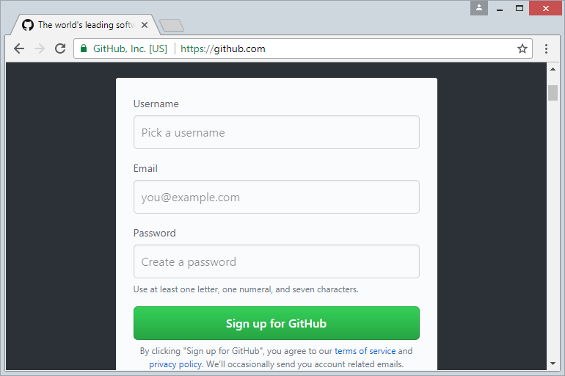

1. Click the green button. It’s below the form
2. Complete the CAPTCHA puzzle. The instructions vary by puzzle, so just follow the on-screen instructions to confirm that you are a human

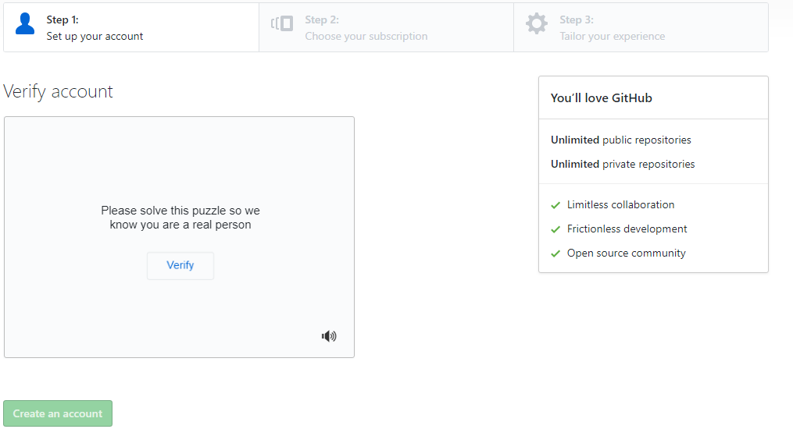

1. Click the  button for your desired plan. One you select a plan, GitHub will send an email confirmation message to the address you entered.

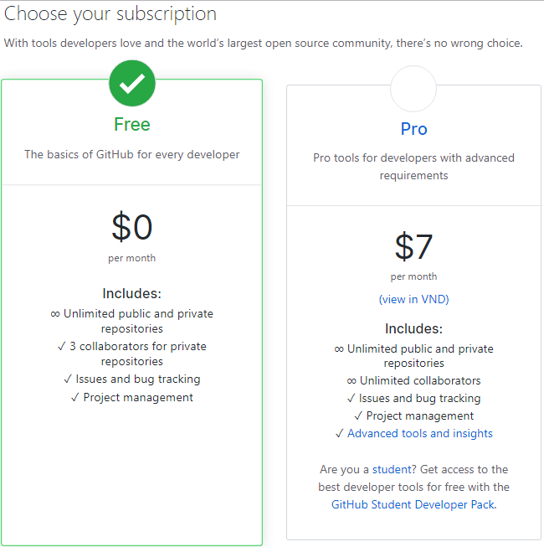

1. Click the  button in the message from GitHub. This confirms your email address and returns you to the sign-up process.
2. Review your plan selection and click . You can also choose whether you want to receive updates from GitHub via email by checking or un checking the “Send me update” a box.
3. Select your preferences and click . GitHub displays a quick survey that can help tailor your experience to match what you’re looking for. Once you make your selection, you’ll be taken to a screen that allows you to set up your first repository.