**SOFTWARE REQUIREMENT SPECIFICATION DOCUMENT**

# STUDENT MANAGEMENT

**Version:** Version 1.0

## ABSTRACT

This document is intended to be the SRS for developing **STUDENT MANAGEMENT SYSTEM**

|  |  |  |  |
| --- | --- | --- | --- |
| **Project Title** | **STUDENT MANAGEMENT** | | |
| **Lead Institution** | **International School** | | |
| **Project Mentor** | Mr.Nguyễn Đặng Quang Huy | | |
| **Team Name** | **Team 4** | | |
| **Team Members** | Lê Thị Thu Hương | | |
| Huỳnh Văn Tuấn | | |
| Phạm Hồng Thuận | | |
| Nguyễn Mạnh Vũ | | |
| Võ Thị Tú | | |
| **Start Date** | **2/10/2019** | End Date | **30/11/2019** |

**ROPRIETARY INFORMATION**: The information contained in this document is the property of **STUDENT MANAGEMENT**. Except as specifically authorized in writing by **STUDENT MANAGEMENT**, the holder of this document shall keep all information contained herein confidential and shall protect same in whole or in part from disclosure and dissemination to all third parties.

Software Requirement Specification Version 1.0

# Table of Contents

Revision History 4

1. Introduction 5
   1. Purpose 5
   2. Intended Audience and Reading Suggestions 5
   3. References 5
2. Project Overview 6
   1. Project Description 6
   2. Business Need 6
   3. Project Analyst 6
      1. Business Function Diagram 6
      2. System Context Diagram 6
      3. Data Flow Diagram 6
   4. Software Requirement Specification 6
      1. High level Fucntional Requirement (FR) 6
      2. Stakeholders 6
      3. Usecase 7
         1. STUDENT MANAGEMENT Use Case Diagram Overview 7
      4. List of use cases 7
      5. List of business rule 8
      6. Use Case Specification 9

UC 01: Create a New Place 9

UC 02: Edit a Place’s Information 11

UC 01: Create a New Place 9

UC 02: Edit a Place’s Information 11

UC 01: Create a New Place 9

UC 02: Edit a Place’s Information 11

UC 01: Create a New Place 9

UC 02: Edit a Place’s Information 11

UC 01: Create a New Place 9

UC 02: Edit a Place’s Information 11

UC 01: Create a New Place 9

UC 02: Edit a Place’s Information 11

* + 1. Software Quality Attributes 13
       1. Usability 13
       2. Reliability 14
       3. Security 14
       4. Maintainability 15
       5. Portability 15
       6. Performance 15
  1. Software Design Description 16
     1. Sequence Diagrams 16
        1. Cập nhật thông tin nhân viên 16
        2. Quan hệ Gia đình 17
     2. Activity Diagrams 18
        1. Cập nhật thông tin nhân viên 18
     3. State Diagram 18
     4. Class Diagram 19
     5. Allocation Diagram 19

Appendix A: Glossary 19

# Revision History

|  |  |  |  |  |
| --- | --- | --- | --- | --- |
| **Date** | **Change Iterm** | **Description** | **by** | **Version** |
|  |  |  |  |  |
|  |  |  |  |  |
|  |  |  |  |  |
|  |  |  |  |  |
|  |  |  |  |  |
|  |  |  |  |  |
|  |  |  |  |  |
|  |  |  |  |  |
|  |  |  |  |  |
|  |  |  |  |  |

# Introduction

## Purpose

This documentation describes a student management system including all needed information and feature materials in detail for implementation. The purposes of this document are as below:

* + - To supports the project manager having an overview of the system as well as doing project estimation
    - To describes the architectural drivers and use cases in details. Based on this document, architect analyst and designer will be able to implement the system easily.
    - To supports tester (QC) writing acceptance test and test plan.

## Intended Audience and Reading Suggestions

|  |  |
| --- | --- |
| **Intended Audience** | **Reading Suggestions** |
| Project manager | High level functional requirement, business constraints for estimation |
| Architect analyst and designer | Overall description and user cases to architect and design the system |
| Quality control | Overall description and user cases to make test plan and write acceptance test |
|  |  |

## References

# Project Overview

## Project Description

## Duy Tan University receives a number every year large student population. One of the difficulties that the school's training room The problem is student management, not just new students admission but also many students are currently studying at the school, the management This is most difficult in the final and final semester sessions year. Therefore, the requirement of the school is to have a student management department, of each class as well as of each department so that no errors can be made. in the process of managing students of the school.

* Track the entire learning process of students during the learning process.
* School from admission to graduation, make sure no errors occur in too course of updating information and statistical information of students. This system helps the training room follow track and evaluate student results in the fastest and most accurate way. It will greatly reduce the effort and paperwork. archive books.
* In addition to updating each student's information, the system can also look up a number Necessary information about students, related papers, ...
* The system of storing and processing information of each student according to the school's regulations.
* Statistical control of reward and discipline Students quickly and accurately. Through management work that is possible have specific records of students' academic results upon graduation.

Đại học Duy Tân nhận được số lượng sinh viên lớn mỗi năm. Một trong những khó khăn mà phòng đào tạo của trường là vấn đề quản lý học sinh, không chỉ nhập học sinh mới nhưng cũng có nhiều sinh viên đang học tại trường, quản lý điều này là khó khăn nhất trong năm học kỳ cuối cùng và cuối cùng . Vì vậy, yêu cầu của trường là phải có một bộ phận quản lý sinh viên, của mỗi lớp học cũng như của mỗi bộ phận để không có lỗi có thể được thực hiện. trong quá trình quản lý sinh viên của trường.

• Theo dõi toàn bộ quá trình học tập của học sinh trong quá trình học tập

• Trường từ nhập học để tốt nghiệp, đảm bảo không có lỗi xảy ra trong quá trình cập nhật thông tin và thông tin thống kê của sinh viên. Hệ thống này giúp phòng đào tạo theo dõi và đánh giá kết quả của sinh viên theo cách nhanh nhất và chính xác nhất. Nó sẽ làm giảm đáng kể nỗ lực và giấy tờ. sách lưu trữ.

• Ngoài việc cập nhật thông tin của mỗi học sinh, Hệ thống cũng có thể tìm kiếm một số thông tin cần thiết về sinh viên, giấy tờ liên quan,...

• Hệ thống lưu trữ và xử lý thông tin của mỗi học sinh theo quy định của trường.

• Kiểm soát thống kê các phần thưởng và kỷ luật học sinh nhanh chóng và chính xác. Thông qua công việc quản lý có thể có hồ sơ cụ thể về kết quả học tập của học sinh sau khi tốt nghiệp.

## Business Need

**Customers need a student management system.**

* + Student records management.
  + Update student records.
  + Update training program.
  + Management reward and discipline.
  + Manage related papers.

Khách hàng cần một hệ thống quản lý học sinh.

o quản lý hồ sơ học sinh.

o Cập nhật hồ sơ học sinh.

o Cập Nhật chương trình đào tạo.

o phần thưởng và kỷ luật quản lý.

o quản lý giấy tờ liên quan

## Project Analyst

* + 1. **Business Function Diagram**

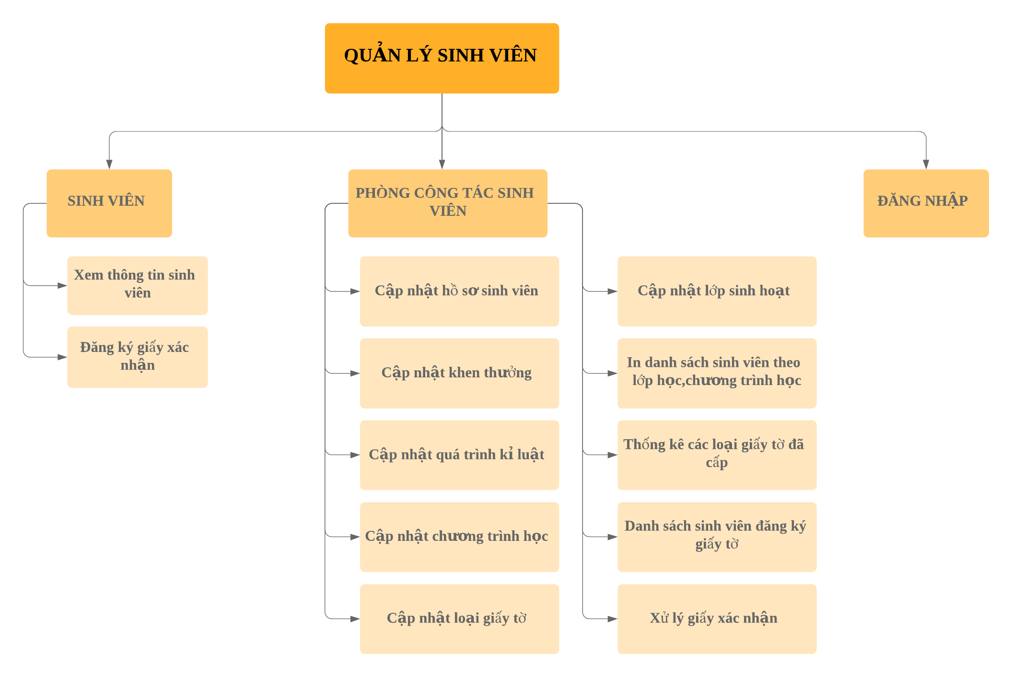**2.3.2.System Context Diagram**

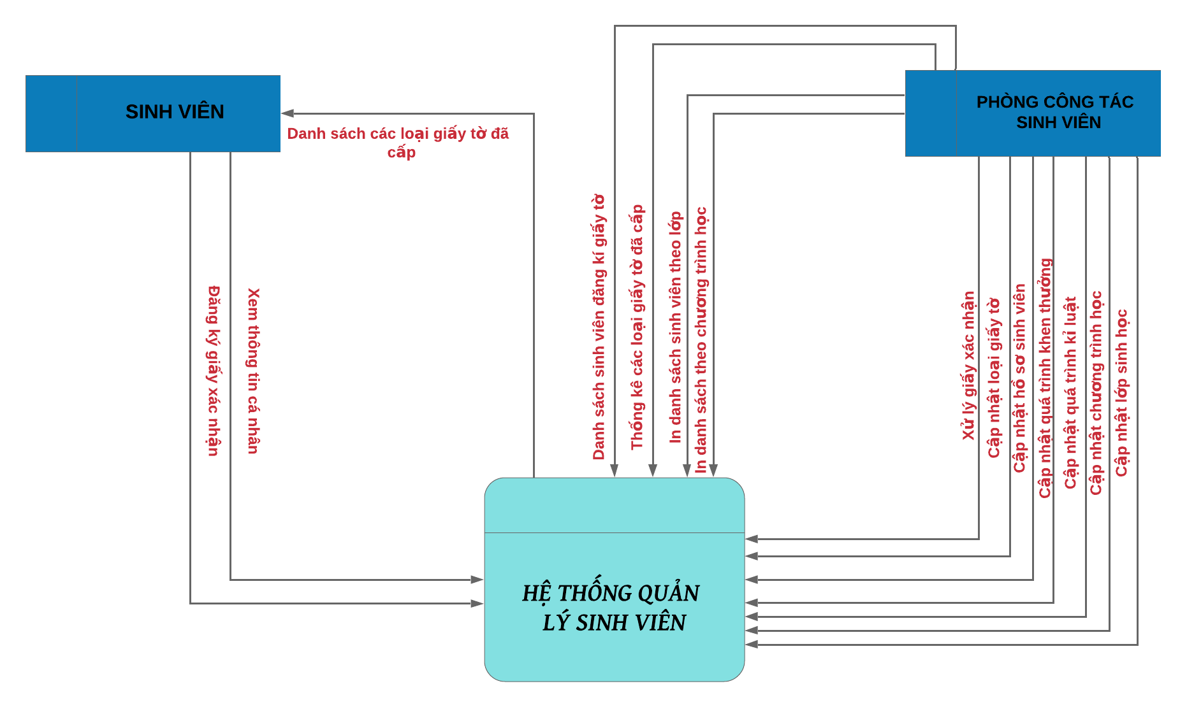

**2.3.3.Data Flow Diagram**

Data flow model at level 2.1

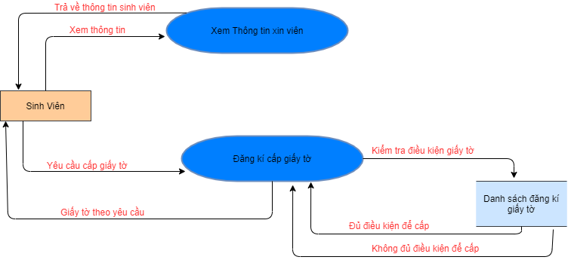

Data flow model at level 2

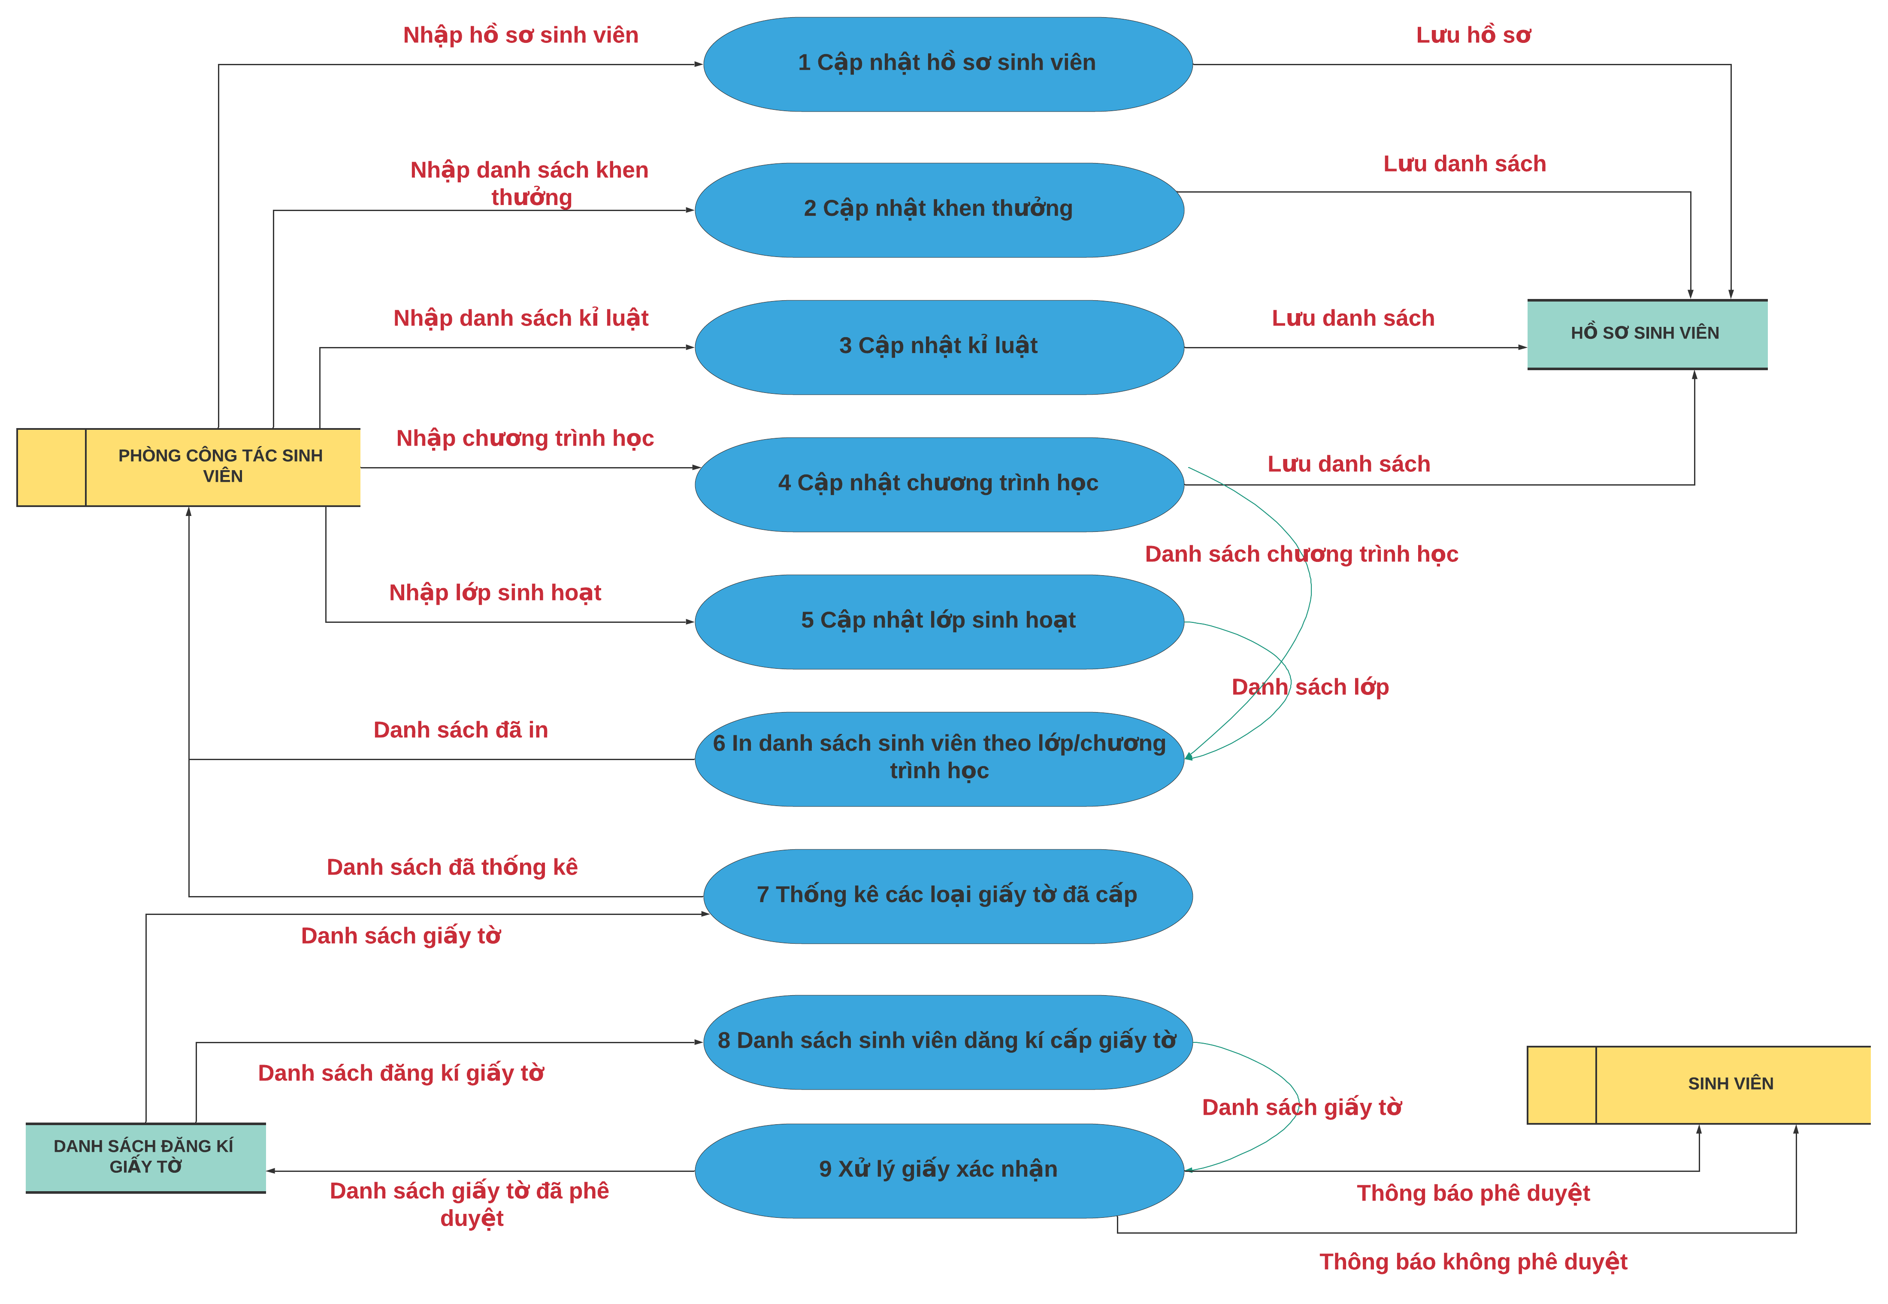

## Software Requirement Specification

## High level Fucntional Requirement (FR)

|  |  |  |
| --- | --- | --- |
| FR1.1 | **Title** | **Create and check account** |
| Stakeholder | Users who use jukebox for playing music |
| Description | If user is new one, the system will allow him/her establish an account and specify  amount the money that he/she allocate from their credit card into Jukebox account. Otherwise, user can check Jukebox balance. |
| FR1.2 | Title | **Select & play music** |
| Stakeholder | Users who use jukebox for playing music |
| Description | The system shall display list of songs grouped into music genres and will allow user select music genres and songs to play. Once the first song is selected the song will start playing while allowing user to make further choices. The system shall also record such selected and played song into database. User can deselect his/her songs from the current playlist and amount of deselecting shall refund. User can create account on one Jukebox and play music on another in distributed  system. |

## Stakeholders

|  |  |
| --- | --- |
| **Stakeholder** | **Description** |
| Users | People who use jukeboxes to play music |
| System administrators | People who administer and configure the jukebox system |
| Engineer | Person who deploy the Jukebox System |

## Usecase

## <<Student Management System >> Use Case Diagram Overview

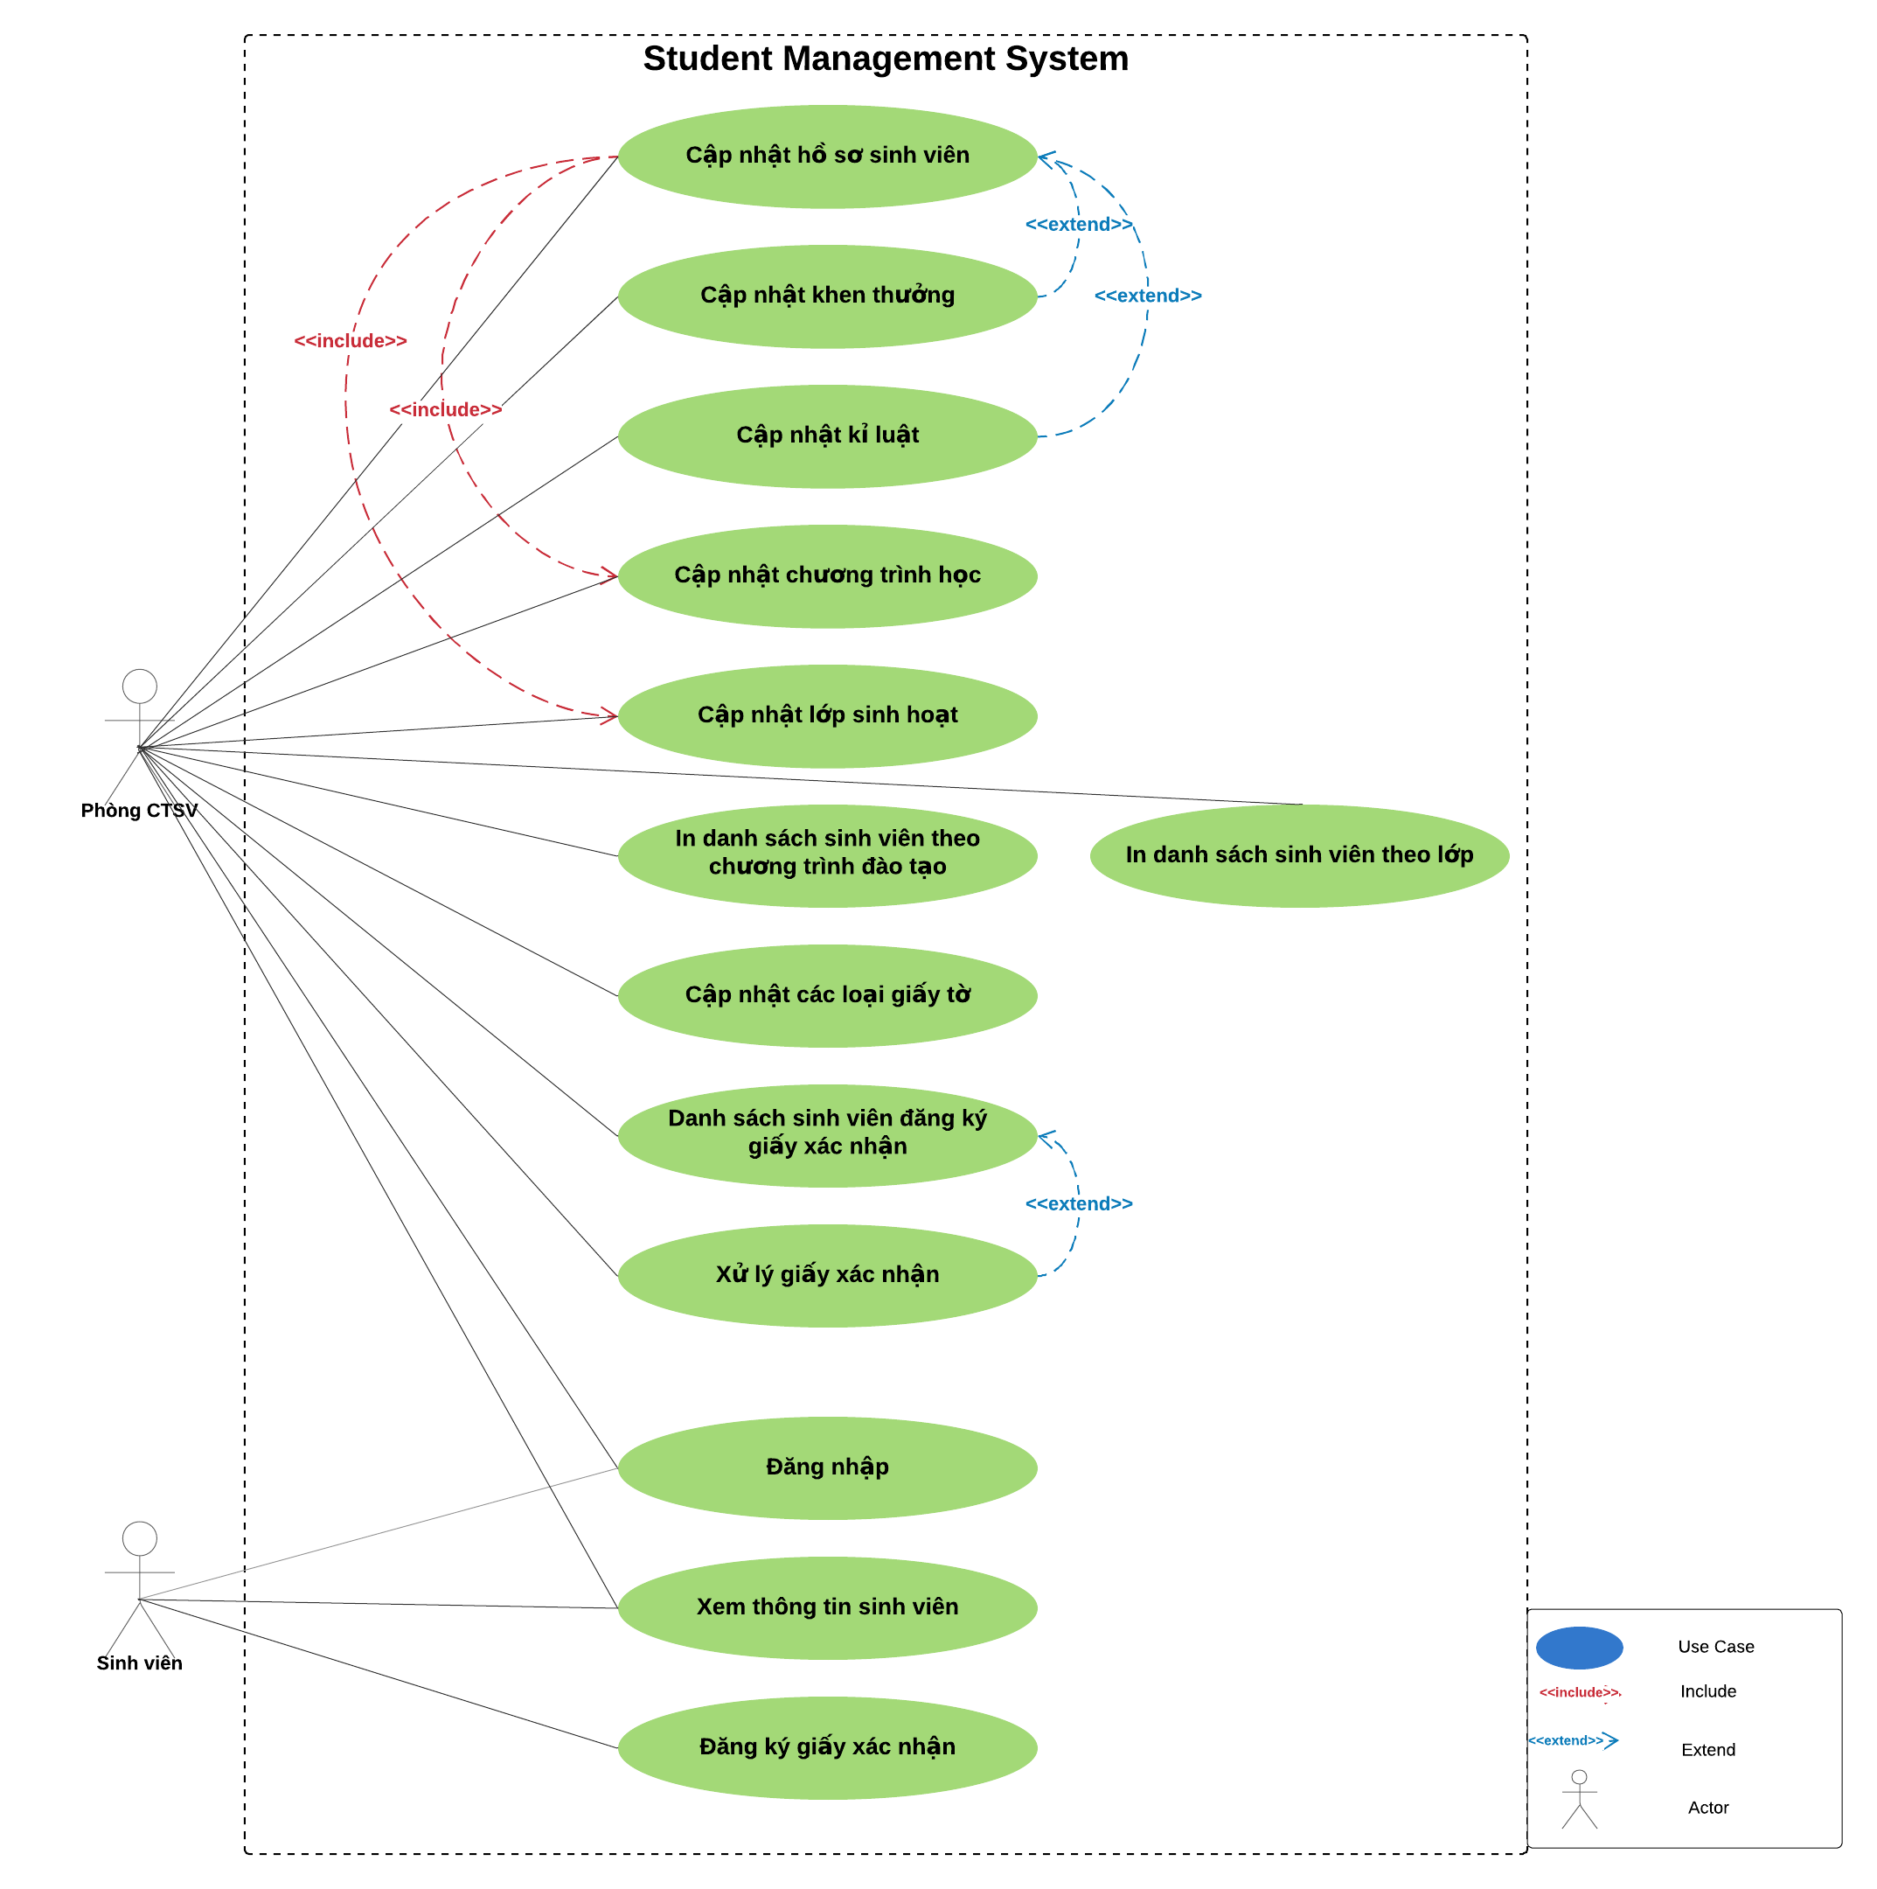

## List of use cases

|  |  |  |
| --- | --- | --- |
| **Use case ID** | **Use case name** | **Functional Req.** |
| UC.01 | Login | FR.1 |
| UC.02 | View student Information | FR.1 |
| UC.03 | Sign up for Certification | FR.1 |
| UC.04 | Update Student Profiles | FR.1 |
| UC.05 | Reward updates | FR.1 |
| UC.06 | Disciplinary updates | FR.1 |
| UC.07 | Program Update | FR.1 |
| UC.08 | Update the Living Class | FR.1 |
| UC.09 | Print a list of students | FR.1 |
| UC.10 | Update papers | FR.1 |
| UC.11 | List of students registered for certification | FR.1 |
| UC.12 | Handling of confirmation paper | FR.1 |

## List of business rule

|  |  |  |
| --- | --- | --- |
| **Code** | **Business rules** | **Use case** |
| BR1 | Rank of a user will be se based on the user’s contribution point (CP) | UC.02 |
| BR2 | Contribution Point (CP) is calculated as follow:   * Starter point for every user is 10 point * Create a place: + 20 point * Your place get deleted: ‐ 25 point | UC.02 |
| BR3 | For user has more than 1000 point (senior user):   * Can edit a place directly * Can upload place’s image directly * Can approve suggested edit * Can approve suggested images * Set a revision as current | UC. 02 |
| BR4 | For user has less than 1000 point (junior user):  ‐ an revision of a place created by these users  need approvals from senior users or admins to be displayed | UC.02 |

* + 1. **Use Case Specification**

### UC 01: Login

1. Use Case Diagram

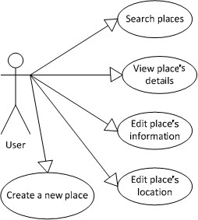

1. Use Case Specìication

|  |  |  |  |  |  |
| --- | --- | --- | --- | --- | --- |
| Use case ID | **UC1.01** | | | | |
| Use case name | **Login** | | | | |
| Create by | Thuan | | Thuan | | Thuan |
| Date created | Oct 26, 2019 | | Oct 26, 2019 | | Oct 26, 2019 |
| Actor | Engineer | | | | |
| Description | This function allows users to student management | | | | |
| Trigger | Click to “**Quản lí sinh viên**” in navigator at home page | | | | |
| Pre-condition | User logged into the system successfully. | | | | |
| Post-condition | The system will display student management, grades, statistics | | | | |
| Main Success  Scenario: | **Step** | **Actor Action** | | **System Response** | |
| 1 | Click to “**Quản lí sinh viên**” in navigator at home page | | Redirect to student management | |
| 2 | Fills all mandatory data fields | |  | |
| 3 | Click to “**Quản lí thông tin sinh viên**” button. | | Redirect to student information | |
| Alternative Scenario | **Step** | **Actor Action** | | **System Response** | |
| 1 | Click to “**Quản lí sinh viên**” in navigator at home page | | Redirect to student management | |
| 2 | Fills all mandatory data fields | |  | |
| 3 | Click to “**Quản lí lớp học**” button. | | Redirect to classroom list | |
| Exceptions | **Step** | **Actor Action** | | **System Response** | |
| 1 | Click to “**Quản lí sinh viên**” in navigator at home page | | Redirect to student management | |
| 2 | User fills some data fields. Some mandatory data fields are skipped. | |  | |
| 3 | Click to “**Quản lí thông kê**” button. | | Shows to tuhe list has statistics | |
| Priority | High | | | | |
| Business rule | N/A | | | | |
| Description: | When users choose to manage students. The system displays student information management, classroom information management, statistical management.  When the user selects 1 of 3, the system will display the information that the user needs | | | | |

c) Prototype

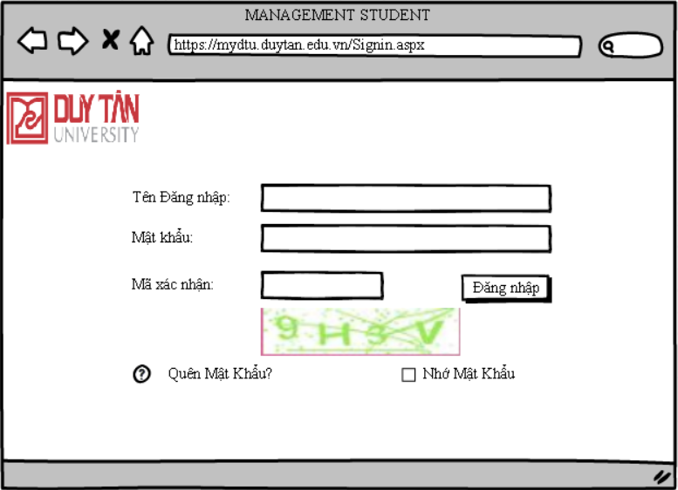

### UC 02: View Student Information

1. Use Case Diagram

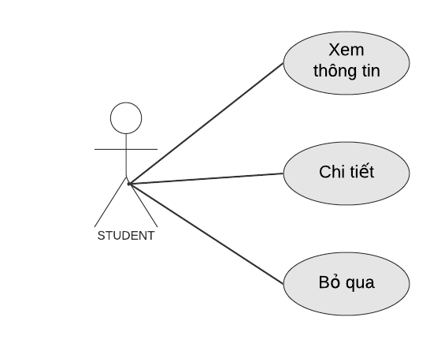

1. Use Case Specìication

|  |  |  |  |  |  |
| --- | --- | --- | --- | --- | --- |
| Use case ID | **UC1** | | | | |
| Use case name | **View Student Information** | | | | |
| Create by | Tuan | | Tuan | | Tuan |
| Date created | Nov 6, 2019 | | Nov 6, 2019 | | Nov 6, 2019 |
| Actor | Student | | | | |
| Description | This use case allows users to view detailed information | | | | |
| Trigger | Click to “**Xem thông tin chi tiết**” in menu at home page | | | | |
| Pre-condition | User logged into the system successfully. | | | | |
| Post-condition | The system displays a menu bar which has an item view detail information. | | | | |
| Main Success  Scenario: | **Step** | **Actor Action** | | **System Response** | |
| 1 | Click to “**Xem thông tin chi tiết**” in navigator at home page | | Redirect to the page that shows detailed information | |
| 2 | Click to “**Chi tiết**” button. | | Show full student record details | |
| Alternative Scenario | **Step** | **Actor Action** | | **System Response** | |
| 1 | Click to “**Xem thông tin chi tiết**” in navigator at home page | | Redirect to the page that shows detailed information | |
| 3 | Click to “**Bỏ Qua**” button. | | Redirect to the homepage | |
| Exceptions | **Step** | **Actor Action** | | **System Response** | |
| 1 | Click to “**Xem thông tin chi tiết**” in navigator at home page | | Redirect to the page that shows detailed information | |
| 3 | Click to “**Chi tiết**” button. | | Show all missing personal information in the profile | |
| Priority | High | | | | |
| Business rule | N/A | | | | |
| Description: | When a user wants to search or view student details they just need to click "View student Information".  When the user clicks the "Details" button, the system opens the page that shows all student details. By clicking the "Ignore" button, the user will return to the previous page. | | | | |

1. Prototype

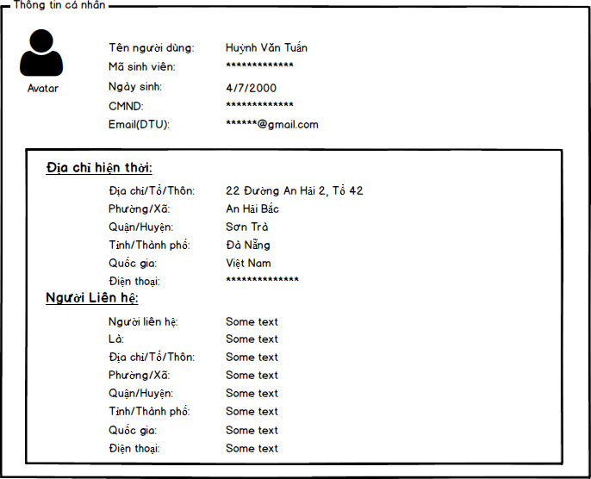

### UC 03: Sign up for Certification

1. Use Case Diagram

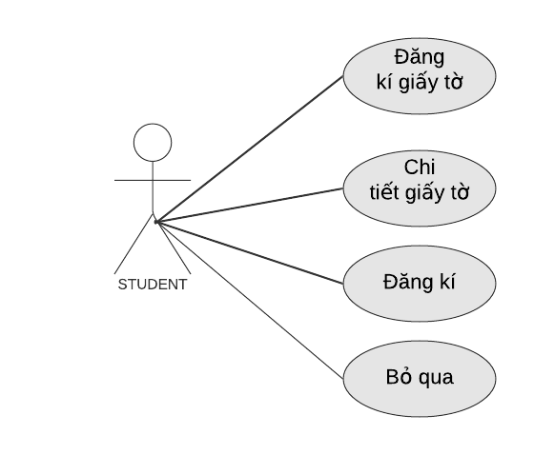

1. Use Case Specìication

|  |  |  |  |  |  |
| --- | --- | --- | --- | --- | --- |
| Use case ID | **UC2** | | | | |
| Use case name | **View Student Information** | | | | |
| Create by | Tuan | | Tuan | | Tuan |
| Date created | Nov 6, 2019 | | Nov 6, 2019 | | Nov 6, 2019 |
| Actor | Student | | | | |
| Description | This function allows users to sign up for a related document | | | | |
| Goal | Click to “**Đăng kí cấp giấy tờ**” in navigator at home page | | | | |
| Trigger | User logged into the system successfully. | | | | |
| Pre-condition | The system will display a paper registration page for the user | | | | |
| Post-condition | **UC1.01** | | | | |
| Main Success  Scenario: | **Step** | **Actor Action** | | **System Response** | |
| 1 | Click to “**Đăng kí cấp giấy tờ**” in navigator at home page | | Redirect to the Certification receipt page | |
| 2 | Click to “**Chi tiết**” button. | | Redirect to the details of the paper registration form | |
| Alternative Scenario | **Step** | **Actor Action** | | **System Response** | |
| 1 | Click to “**Đăng kí cấp giấy tờ**” in navigator at home page | | Redirect to the Certification receipt page | |
| 3 | Click to “**Thoát**” button. | | Redirect to the homepage. | |
| Exceptions | **Step** | **Actor Action** | | **System Response** | |
| 1 | Click to “**Đăng kí cấp giấy tờ**” in navigator at home page | | Redirect to the Certification receipt page | |

|  |  |  |  |
| --- | --- | --- | --- |
|  | 2 | User fills some data fields. Some mandatory data fields are skipped. |  |
| 3 | Click to “**Đăng kí**” button. | Shows all required messages for all missing mandatory data fields |
| Priority | High | | |
| Business rule | N/A | | |
| Description: | When a user wishes to register papers, they simply press "register". To register, enter full personal information, documents to grant.....  By clicking the "Register" button, the user can successfully register papers | | |

1. Prototype

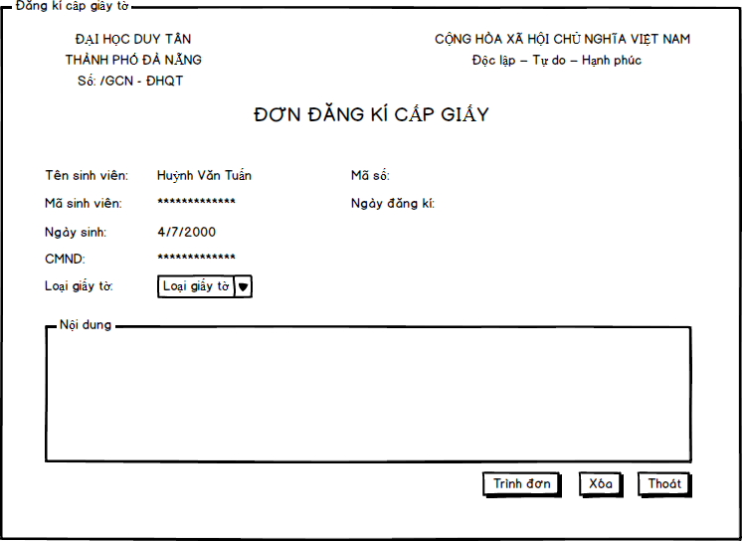

### UC 04: Update Student Profiles

1. Use Case Diagram

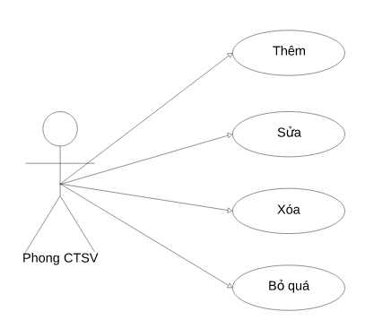

1. Use Case Specìication

|  |  |  |  |  |  |
| --- | --- | --- | --- | --- | --- |
| Use case ID |  | | | | |
| Use case name | **Update student profiles** | | | | |
| Create by | Vu | | Vu | | Vu |
| Date created | Oct 26, 2019 | | Oct 26, 2019 | | Oct 26, 2019 |
| Actor | Phong cong tac sinh vien | | | | |
| Description | This use case allows users to update, edit, add or delete information contained in the student's profile. | | | | |
| Trigger | Click to “**Cập nhật hồ sơ sinh viên**” in navigator at home page | | | | |
| Pre-condition | User logged into the system successfully. | | | | |
| Post-condition | The system redirects the user to the details page that requires confirmation. | | | | |
| Main Success  Scenario: | **Step** | **Actor Action** | | **System Response** | |
| 1 | Click to “**Cập nhật hồ sơ sinh viên**” in navigator at home page | | Redirect to the student profile list. | |
| 2 | Click to “**Thêm** ”, “**Chỉnh sửa** ” or “**Xóa** ” button | |  | |
| 3 | Fills all mandatory data fields | |  | |
| 4 | Click to “**Lưu** ” button. | | Redirect to login form | |
| Alternative Scenario | **Step** | **Actor Action** | | **System Response** | |
| 1 | Click to “**Cập nhật hồ sơ sinh viên**” in navigator at home page | | Redirect to the student profile list. | |
| 2 | Click to “**Thêm** ”, “**Chỉnh sửa** ” or “**Xóa** ” button | |  | |
| 3 | Fills all mandatory data fields | |  | |
| 4 | Click to “**Bỏ Qua**” button. | | Redirect to new place’s details page. | |
| Exceptions | **Step** | **Actor Action** | | **System Response** | |
| 1 | Click to “**Cập nhật hồ sơ sinh viên**” in navigator at home page | | Redirect to the student profile list. | |
| 2 | Click to “**Thêm** ”, “**Chỉnh sửa** ” or “**Xóa** ” button | |  | |
| 3 | User fills some data fields. Some mandatory data fields are skipped. | |  | |
| 4 | Click to “**Lưu** ” button. | | Shows all required messages for all missing mandatory data fields. | |
| Priority | High | | | | |
| Business rule | N/A | | | | |

|  |  |
| --- | --- |
| Description: | When users want to update or edit a student's information, they can go to "update student information". Here you can choose the features of "**Thêm**", "**Chỉnh** sửa", " **Xoá** ".  • “**Thêm**”: fill out student information according to available form.  • “**Chỉnh sửa**”: navigate to the information box you want to edit and enter again.  • “**Xóa**”: if a student quits, you can remove his / her information by pointing to the box and clicking the “Xóa” button.  Then click the “**Lưu**” button to save the data. |

1. Prototype

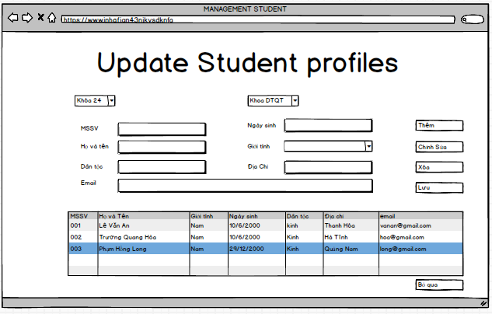

### UC 5: reward update

1. Use Case Diagram



1. Use Case Specìication

|  |  |  |  |  |  |
| --- | --- | --- | --- | --- | --- |
| Use case ID |  | | | | |
| Use case name | **reward update** | | | | |
| Create by | Vu | | Vu | | Vu |
| Date created | Oct 26, 2019 | | Oct 26, 2019 | | Oct 26, 2019 |
| Actor | Phong cong tac sinh vien | | | | |
| Description | This use case allow users to update and add new students to be rewarded. | | | | |
| Trigger | Click to “**Cập nhật khen thưởng**” in navigator at home page | | | | |
| Pre-condition | User logged into the system successfully. | | | | |
| Post-condition | The system redirects the user to the details page that requires confirmation. | | | | |
| Main Success  Scenario: | **Step** | **Actor Action** | | **System Response** | |
| 1 | Click to “**Cập nhật khen thưởng**” in navigator at home page | | Redirect to the student profile list. | |
| 2 | Click to “**Thêm** ”, “**Chỉnh sửa** ” or “**Xóa** ” button | |  | |
| 3 | Fills all mandatory data fields | |  | |
| 4 | Click to “**Lưu** ” button. | | Redirect to login form | |
| Alternative Scenario | **Step** | **Actor Action** | | **System Response** | |
| 1 | Click to “**Cập nhật khen thưởng**” in navigator at home page | | Redirect to the student profile list. | |
| 2 | Click to “**Thêm** ”, “**Chỉnh sửa** ” or “**Xóa** ” button | |  | |
| 3 | Fills all mandatory data fields | |  | |
| 4 | Click to “**Bỏ Qua**” button. | | Redirect to new place’s details page. | |

|  |  |  |  |
| --- | --- | --- | --- |
| Exceptions | **Step** | **Actor Action** | **System Response** |
| 1 | Click to “**Cập nhật khen thưởng**” in navigator at home page | Redirect to the student profile list. |
| 2 | Click to “**Thêm** ”, “**Chỉnh sửa** ” or “**Xóa** ” button |  |
| 3 | User fills some data fields. Some mandatory data fields are skipped. |  |
| 4 | Click to “**Lưu** ” button. | Shows all required messages for all missing mandatory data fields. |
| Priority | High | | |
| Business rule | N/A | | |
| Description: | When users want to update or edit a student's information, they can go to "update student information". Here you can choose the features of "**Thêm**", "**Chỉnh sửa**", " **Xoá** ".  • “**Thêm**”: fill out student information according to available form.  • “**Chỉnh** **sửa**”: navigate to the information box you want to edit and enter again.  • “**Xóa**”: if the you enters it incorrectly and wants to remove that student from the list, you can remove his / her information by pointing to the box and clicking the “**Xóa**” button.  Then click the “**Lưu**” button to save the data. | | |

1. Prototype

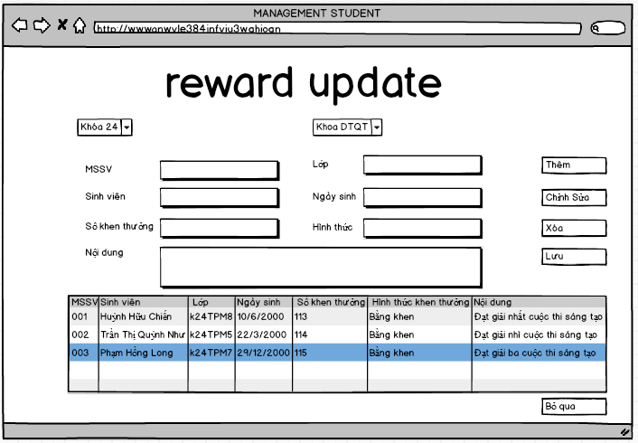

### 

### UC 6: disciplinary update

1. Use Case Diagram



1. Use Case Specìication

|  |  |  |  |  |  |
| --- | --- | --- | --- | --- | --- |
| Use case ID |  | | | | |
| Use case name | **disciplinary update** | | | | |
| Create by | Vu | | Vu | | Vu |
| Date created | Oct 26, 2019 | | Oct 26, 2019 | | Oct 26, 2019 |
| Actor | Phong cong tac sinh vien | | | | |
| Description | This use case allows users to update and add students who violate school rules or regulations and include discipline. | | | | |
| Trigger | Click to “**Cập nhật kỷ luật**” in navigator at home page | | | | |
| Pre-condition | User logged into the system successfully. | | | | |
| Post-condition | The system redirects the user to the details page that requires confirmation. | | | | |
| Main Success  Scenario: | **Step** | **Actor Action** | | **System Response** | |
| 1 | Click to “**Cập nhật kỷ luật**” in navigator at home page | | Redirect to the student profile list. | |
| 2 | Click to “**Thêm** ”, “**Chỉnh sửa** ” or “**Xóa** ” button | |  | |
| 3 | Fills all mandatory data fields | |  | |
| 4 | Click to “**Lưu** ” button. | | Redirect to login form | |
| Alternative Scenario | **Step** | **Actor Action** | | **System Response** | |
| 1 | Click to “**Cập nhật kỷ luật**” in navigator at home page | | Redirect to the student profile list. | |
| 2 | Click to “**Thêm** ”, “**Chỉnh sửa** ” or “**Xóa** ” button | |  | |
| 3 | Fills all mandatory data fields | |  | |
| 4 | Click to “**Bỏ Qua**” button. | | Redirect to new place’s details page. | |

|  |  |  |  |
| --- | --- | --- | --- |
| Exceptions | **Step** | **Actor Action** | **System Response** |
| 1 | Click to “**Cập nhật kỷ luật**” in navigator at home page | Redirect to the student profile list. |
| 2 | Click to “**Thêm** ”, “**Chỉnh sửa** ” or “**Xóa** ” button |  |
| 3 | User fills some data fields. Some mandatory data fields are skipped. |  |
| 4 | Click to “**Lưu** ” button. | Shows all required messages for all missing mandatory data fields. |
| Priority | High | | |
| Business rule | N/A | | |
| Description: | When users want to update or edit a student's information, they can go to "update student information". Here you can choose the features of "**Thêm**", "**Chỉnh sửa**", " **Xoá** ".  • “**Thêm**”: fill out student information according to available form.  • “**Chỉnh** **sửa**”: navigate to the information box you want to edit and enter again.  • “**Xóa**”: if the you enters it incorrectly and wants to remove that student from the list, you can remove his / her information by pointing to the box and clicking the “**Xóa**” button.  Then click the “**Lưu**” button to save the data. | | |

1. Prototype

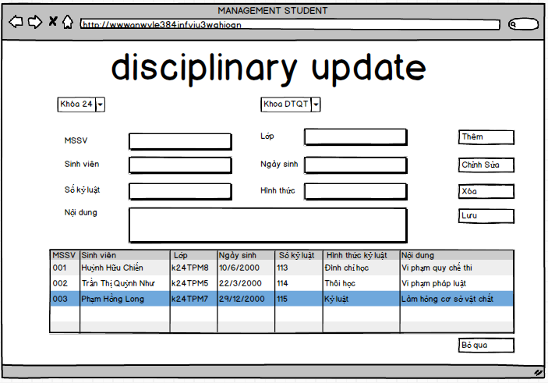

### UC 7: Program Update

1. Use Case Diagram

### Untitled Diagram

1. Use Case Specification

|  |  |  |  |  |  |
| --- | --- | --- | --- | --- | --- |
| Use case ID | **UC1.04** | | | | |
| Use case name | **Cập nhật chương trình học** | | | | |
| Create by | Huong | | Huong | | Huong |
| Date created | Oct 26, 2019 | | Oct 26, 2019 | | Oct 26, 2019 |
| Actor | Phòng công tác sinh viên | | | | |
| Description | This function allows users to update study propram. | | | | |
| Trigger | Click to “**Cập nhật chương trình học**” in navigator at home page | | | | |
| Pre-condition | The system will display a frame for users to update study propram. | | | | |
| Post-condition | The system will display a frame for users to update study propram | | | | |
| Main Success  Scenario: | **Step** | **Actor Action** | | **System Response** | |
| 1 | Click to “**Cập nhật chương trình học**” in navigator at home page | | Redirect to Update study propram | |
| 2 | Fills all mandatory data fields | |  | |
| 3 | Click to “**Cập nhật chương trình học**” button. | | Redirect to login form | |
| Alternative Scenario | **Step** | **Actor Action** | | **System Response** | |
| 1 | Click to “**Cập nhật chương trình học**” in navigator at home page | | Redirect to Login | |
| 2 | Fills all mandatory data fields | |  | |
| 3 | Click to “**Bỏ Qua**” button. | | Redirect to new place’s details page. | |
| Exceptions | **Step** | **Actor Action** | | **System Response** | |
| 1 | Click to “**Cập nhật chương trình học**” in navigator at home page | | Redirect to Login | |
| 2 | User fills some data fields. Some mandatory data fields are skipped. | |  | |
| 3 | Click to “**Cập nhật chương trình học**” button. | | Shows all required messages for all missing mandatory data fields. | |
| Priority | High | | | | |
| Business rule | N/A | | | | |
| Description: | When user want to update study program users need login into the account. Users clicks to the “cập nhật chương trình học” button,the system will open the Cập nhật chương trình học page.   * If users want to add a learning program, then click on the “thêm” button to add. * If users want to delete the course, then click on the “xóa” button to delete. * If users want to edit the study propram, then click on the “sửa” button to edit   *Users must enter full information to perform the job.  By clicking to "Huy" button, the user will go back to previous page. | | | | |

1. Prototype

### UC 8: Update living the class

1. Use Case Diagram

### Untitled Diagram (3)

1. Use Case Specification

|  |  |  |  |  |  |
| --- | --- | --- | --- | --- | --- |
| Use case ID | **UC1.05** | | | | |
| Use case name | **Cập nhật lớp sinh hoạt** | | | | |
| Create by | Huong | | Huong | | Huong |
| Date created | Oct 26, 2019 | | Oct 26, 2019 | | Oct 26, 2019 |
| Actor | Phòng công tác sinh viên | | | | |
| Description | This function allows users to see the class of activities. | | | | |
| Trigger | Click to “**Cập nhật lớp sinh hoạt** ” in navigator at home page | | | | |
| Pre-condition | The system will display a frame for users to see the class of activities. | | | | |
| Post-condition | The system will display a frame for users to see the class of activities | | | | |
| Main Success  Scenario: | **Step** | **Step** | | **Step** | |
| 1 | Click to “**Cập nhật lớp sinh hoạt**” in navigator at home page | | Redirect to see the class of activities. | |
| 2 | Fills all mandatory data fields | |  | |
| 3 | Click to “**Cập nhật lớp sinh hoạt**” button. | | Redirect to login form | |
| Alternative Scenario | **Step** | **Actor Action** | | **System Response** | |
| 1 | Click to “**Cập nhật lớp sinh hoạt**” in navigator at home page | | Redirect to see the class of activities. | |
| 2 | Fills all mandatory data fields | |  | |
| 3 | Click to “**Bỏ Qua**” button. | | Redirect to new place’s details page. | |
| Exceptions | **Step** | **Actor Action** | | **System Response** | |
| 1 | Click to “**Cập nhật lớp sinh hoạt**” in navigator at home page | | Redirect to see the class of activities. | |
| 2 | User fills some data fields. Some mandatory data fields are skipped. | |  | |
| 3 | Click to “**Cập nhật lớp sinh hoạt**” button. | | Shows all required messages for all missing mandatory data fields. | |
| Priority | High | | | | |
| Business rule | N/A | | | | |
| Description: | When user want to update study propram users need login into the account. Users clicks to the “**cập nhật lớp sinh hoạt**” button,the system will open the Cập nhật chương trình học page.  • If users want to add a learning program, then click on the “**thêm**” button to add.  • If users want to delete the course, then click on the “**xóa**” button to delete.  • If users want to edit the study propram, then click on the “**sửa**” button to edit  *Users must enter full information to perform the job.  By clicking to "**Hủy**" button, the user will go back to previous page. | | | | |

1. Prototype

### UC 9: Print a list of students

1. Use Case Diagram

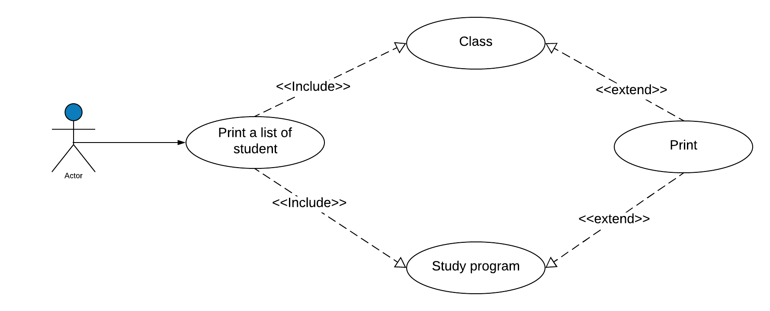

1. Use Case Specification

|  |  |  |  |  |  |
| --- | --- | --- | --- | --- | --- |
| Use case ID | **UC1.09** | | | | |
| Use case name | **Print a list of students** | | | | |
| Create by | Tu | | Tu | | Tu |
| Date created | Dec 10, 2019 | | Dec 10, 2019 | | Dec 10, 2019 |
| Actor | Engineer | | | | |
| Description | This function allows users to print the student list | | | | |
| Trigger | Click to “**In danh sách sinh viên**” in navigator at home page | | | | |
| Pre-condition | User logged into the system successfully. | | | | |
| Post-condition | The system will display a list of students by class and by training program | | | | |
| Main Success  Scenario: | **Step** | **Actor Action** | | **System Response** | |
| 1 | Click to “**In danh sách sinh viên**” in navigator at home page | | Redirect to print a list of students | |
| 2 | Select the layer you want to print | |  | |
| 3 | Click to “**In danh sách”.** | | Print display finished | |
| Alternative Scenario | **Step** | **Actor Action** | | **System Response** | |
| 1 | Click to “**In danh sách sinh viên**” in navigator at home page | | Redirect to print a list of students | |
| 2 | Select the curriculum you want to print | |  | |
| 3 | Click to “**In danh sách”.** | | Print display finished | |
| Exceptions | **Step** | **Actor Action** | | **System Response** | |
| 1 | Click to “**In danh sách sinh viên**” in navigator at home page | | Redirect to print a list of students | |
| 2 | User fills some data fields. Some mandatory data fields are skipped. | |  | |
| 3 | Click to “**Huy**” button. | | Return to home page | |
| Priority | High | | | | |
| Business rule | N/A | | | | |
| Description: | When the user chooses to print the student list. The system displays the form, the user selects the class or program he wants to print. After selecting the system displays the list of students. Click “IN DANH SÁCH” to print, or click “HỦY” if you do not want to print anymore. | | | | |

1. Prototype

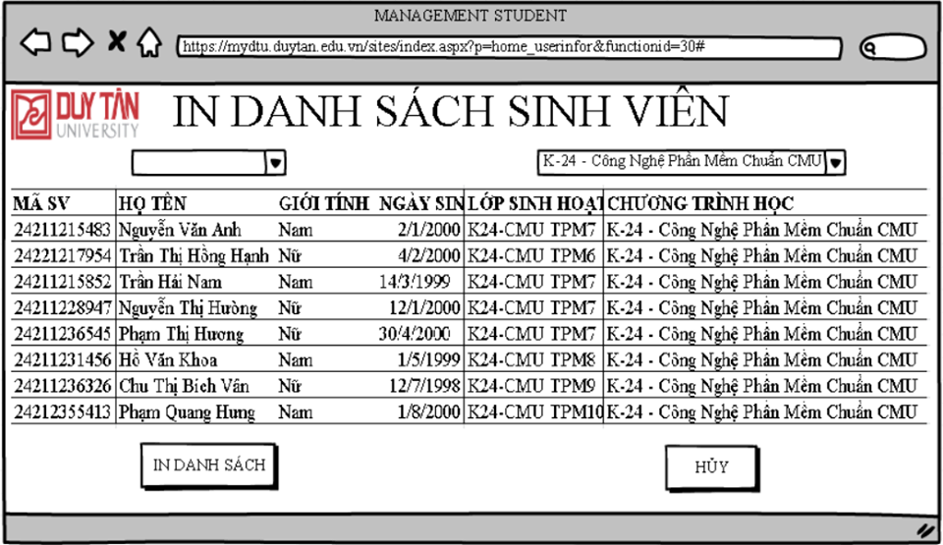

### UC 11: List of students registered for certification

1. Use Case Diagram

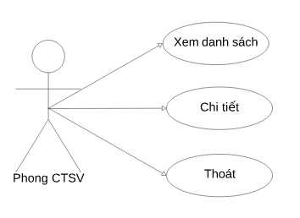

1. Use Case Specification

|  |  |  |  |  |  |
| --- | --- | --- | --- | --- | --- |
| Use case ID | **UC11** | | | | |
| Use case name | **Danh sách Sinh viên Đăng kí cấp giấy xác nhận** | | | | |
| Create by | Hồng Thuận | | Last updated by | | Hồng Thuận |
| Date created | Nov 1, 2019 | | Date last updated | | Nov 12, 2019 |
| Actor | Engineer | | | | |
| Description | This use case allows users to view the list of students who have requested confirmation in this system. | | | | |
| Trigger | Click to “**Danh sách Sinh viên Đăng kí cấp giấy xác nhận**” in navigator at home page | | | | |
| Pre-condition | User logged into the system successfully. | | | | |
| Post-condition | The system redirects the user to the details page that requires confirmation. | | | | |
| Main Success  Scenario: | **Step** | **Actor Action** | | **System Response** | |
| 1 | Click to “**Danh sách Sinh viên Đăng kí cấp giấy xác nhận**” in navigator at home page | | Redirect to the List of students applying for certification Page. | |
| 2 | Click to “**Chi tiết**” button. | | Redirecting to Student Details requires confirmation Page. | |
| Alternave Scenario: | **Step** | **Actor Action** | | **System Response** | |
| 1 | Click to “**Danh sách Sinh viên Đăng kí cấp giấy xác nhận**” in navigator at home page | | Redirect to the List of students applying for certification Page. | |
| 2 | Click to “**Thoát**” button. | | Redirect to the homepage. | |
| Priority | High | | | | |
| Business rule | N/A | | | | |
| Description: | When a user wants to see a list of students who have requested confirmation, they simply need click to “**Danh sách Sinh viên Đăng kí cấp giấy xác nhận**” menu on the navigation and get redirected to the List of students applying for certification Page. By clicking the “**Chi tiết**” button, the system will go to the Details to request confirmation Page so that users can view the details of each student's certification request.  When the user clicks on the “**Danh sách Sinh viên Đăng kí cấp giấy xác nhận**” button, the system will open the List of students applying for certification Page. By clicking the “**Thoát**”button, the user will return to the homepage. | | | | |

1. Prototype

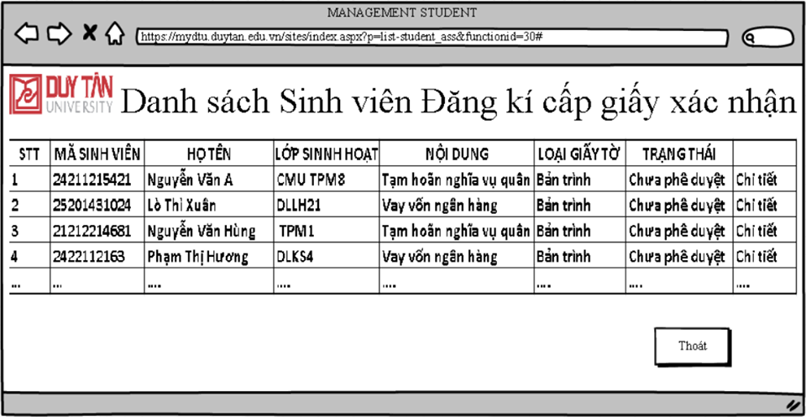

### UC 12: Handling of confirmation paper

1. Use Case Diagram

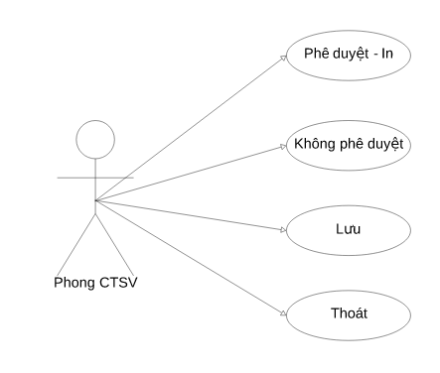

1. Use Case Specification

|  |  |  |  |  |  |
| --- | --- | --- | --- | --- | --- |
| Use case ID | **UC12** | | | | |
| Use case name | **Xử lý giấy xác nhận** | | | | |
| Create by | Hồng Thuận | | Last updated by | | Hồng Thuận |
| Date created | Nov 1, 2019 | | Date last updated | | Nov 12, 2019 |
| Actor | Engineer | | | | |
| Description | This use case allows users to view the list of students who have requested confirmation in this system. | | | | |
| Trigger | Click to “**Xử lý giấy xác nhận**” in navigator at Student Details requires confirmation Page. | | | | |
| Pre-condition | User logged into the system successfully. | | | | |
| Post-condition | The system redirects the user to the details page that requires confirmation. | | | | |
| Main Success 1  Scenario: | **Step** | **Actor Action** | | **System Response** | |
| 1 | Click to “**Phê duyệt-In**” button in navigator at Student Details requires confirmation Page. | |  | |
| 2 | Click to “**Lưu**” button. | | Display the Student Details requires confirmation subsequent. | |
| Main Success 2  Scenario: | **Step** | **Actor Action** | | **System Response** | |
| 1 | Click to “**Không** **Phê duyệt**” in navigator at Student Details requires confirmation Page. | | The system displays notes for administrators to fill out. | |
| 2 | Fill in the note | |  | |
| 3 | Click to “**Lưu**” button. | | Display to the Student Details requires confirmation subsequent. | |
| Alternave Scenario: | **Step** | **Actor Action** | | **System Response** | |
| 1 | Click to “**Thoát**” button in navigator at Student Details requires confirmation Page. | | Redirect to the List of students applying for certification Page. | |
| Priority | High | | | | |
| Business rule | N/A | | | | |
| Description: | When users are in the details view they can process the certificate there. By clicking the " **Phê duyệt-In**" button, user have agreed to approve the request, shortly after that the system will respond to the administrator to print the paper at the request of the student.  When the user presses the " **Không** **Phê duyệt**" button, user have not agreed to approve the request, shortly after that the system will display a notice board for administrators to fill in the notes for students to understand better.  When the user presses the " **Lưu** " button, the system will automatically classify and save the processed papers into the database and Display the Student Details requires confirmation subsequent.  When the user presses the " **Thoát** " button then Redirect to the List of students applying for certification Page. | | | | |

1. Prototype

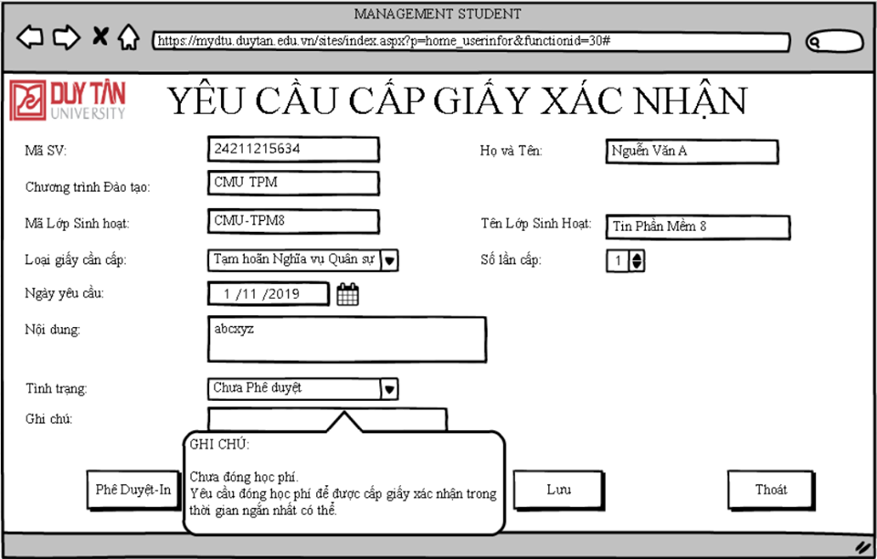

* + 1. **Software Quality Attributes**
       1. **Usability**
          - All the text, image text and help documents should be in Vietnamese.
          - should be elegant, simple and out‐standing.
          - All images must also provide alt attribute.

## Usability for end‐users

* + - * + Searching tool should be easy to use.
        + The website must provide a help page to support novice users.
        + Users can use main functionality of the system without logging in to the system.
        + The system should remember information (but not confidential) that users have to provide regularly. For example: name, address…

## Usability for admin and staff

* + - * + Website admin and shop’s staff should need no more than one day of training to be productive with the system.
        + Detailed help must be available for the admin and staff, both in web pages and separate documentations.

## The interface

- Must be modern, friendly and easy to use.  
- Main colors: red brown, ario.  
-Use the Responsive mechanism.

## Installation

* + - * + The system must be easy to deploy. Customer can deploy successfully and learn to configure, maintain the system within one day of training.
        + The documentation for installation must be included. It describes detailed steps for installing or deploying the system. The customer can follow the steps without direct help from the developing team.

## Reliability

* Initial data must be collected carefully and correctly
* The database must be backed up regularly and can be recovered if necessary
* Have a good spam filter
* Rating system must be reliable
* Not conflict with other software
* Rate of fault occurrence (ROFO): a number of 0.005 is acceptable. It means that it is acceptable to have 5 failures happen in each 1000 operational time units (e.g. 5 failures per 1000 hours of operation).
* Mean Time Between Failures (MTBF): 1 month
* Mean Time To Repair (MTTR): immediately when admin finds out problem or website is attacked by someone. Average 1 day.
* Accuracy: precision of floating number should be rounded to 0.01. All currency units must be displayed (e.g. $, VND…)
* Maximum Bugs or Defect Rate: 5 bugs / KLOC.
* Bugs or Defect Rate
  + Minor bugs: bugs related to GUI
  + Significant bugs: bugs related to minor business logic
  + Critical bugs: function can’t execute correctly, completely loss of data, disconnect to the server

## Security

* Privacy: the system should provide protection method for protecting user information from outside or from other users. All the information of users must not be available for anyone or software that is not part of the system. User password is also invisible for the system administrator.
* The system must provide methods to prevent common security attacks. E.g. SQL injection, Ddos,…
* Transformation of confidential information must be encrypted.
* The system must provide secure methods for users to recovery their password, including the interference of system’s admin.
* Secure information of customers should not be stored on customer’s machine.
* Utilize certain cryptographic techniques for database
* Provide options for users to choose whether to share private information
* Restrict communications between some areas of the program

## Software Design Description 2.5.1.Sequence Diagrams

## Biểu đồ tuần tự xem thông tin sinh viên

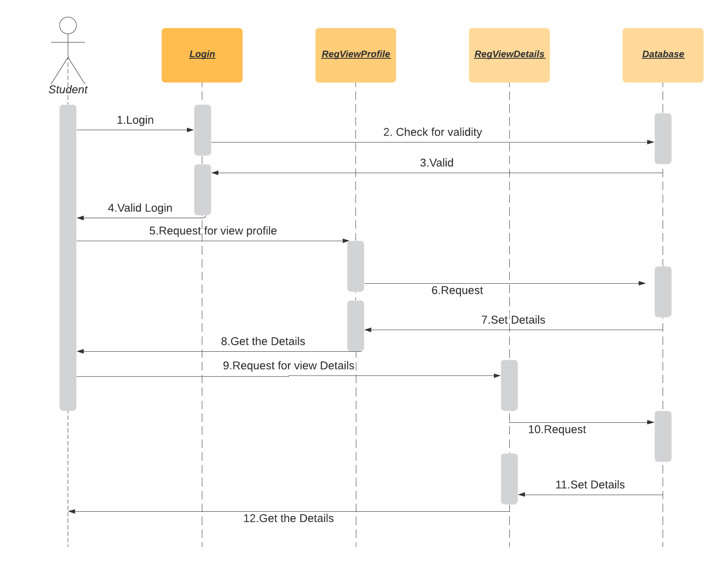

## Biểu đồ tuần tự tìm sinh viên

## Biểu đồ tuần tự nhập sửa thông tin

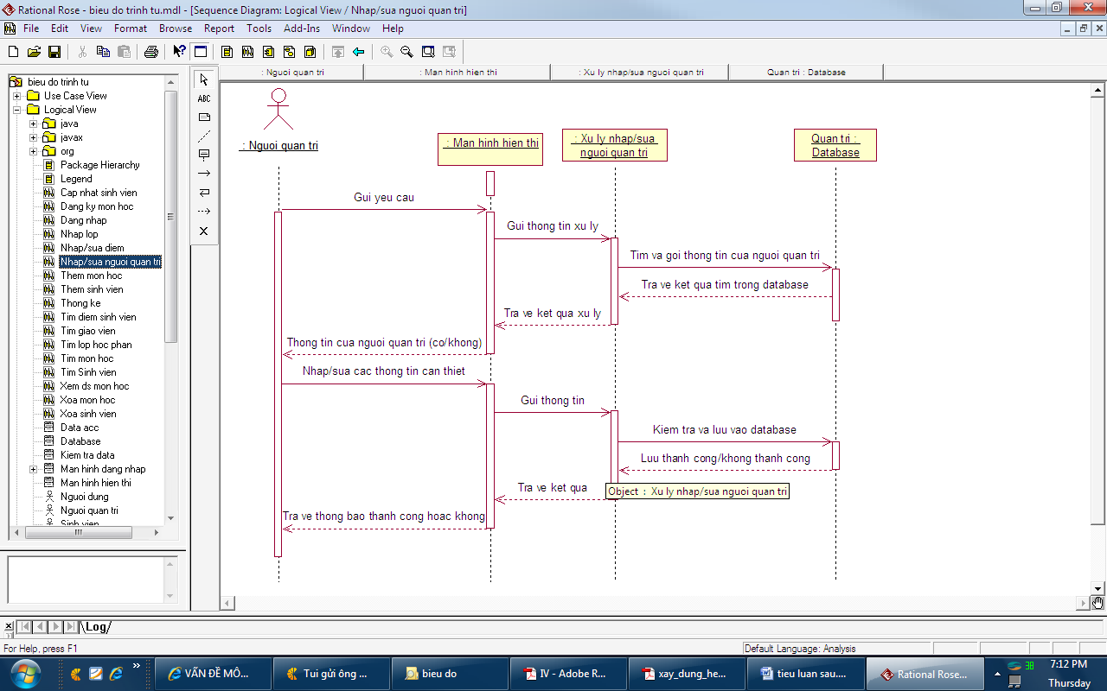

## Biểu đồ tuần tự thêm sinh viên

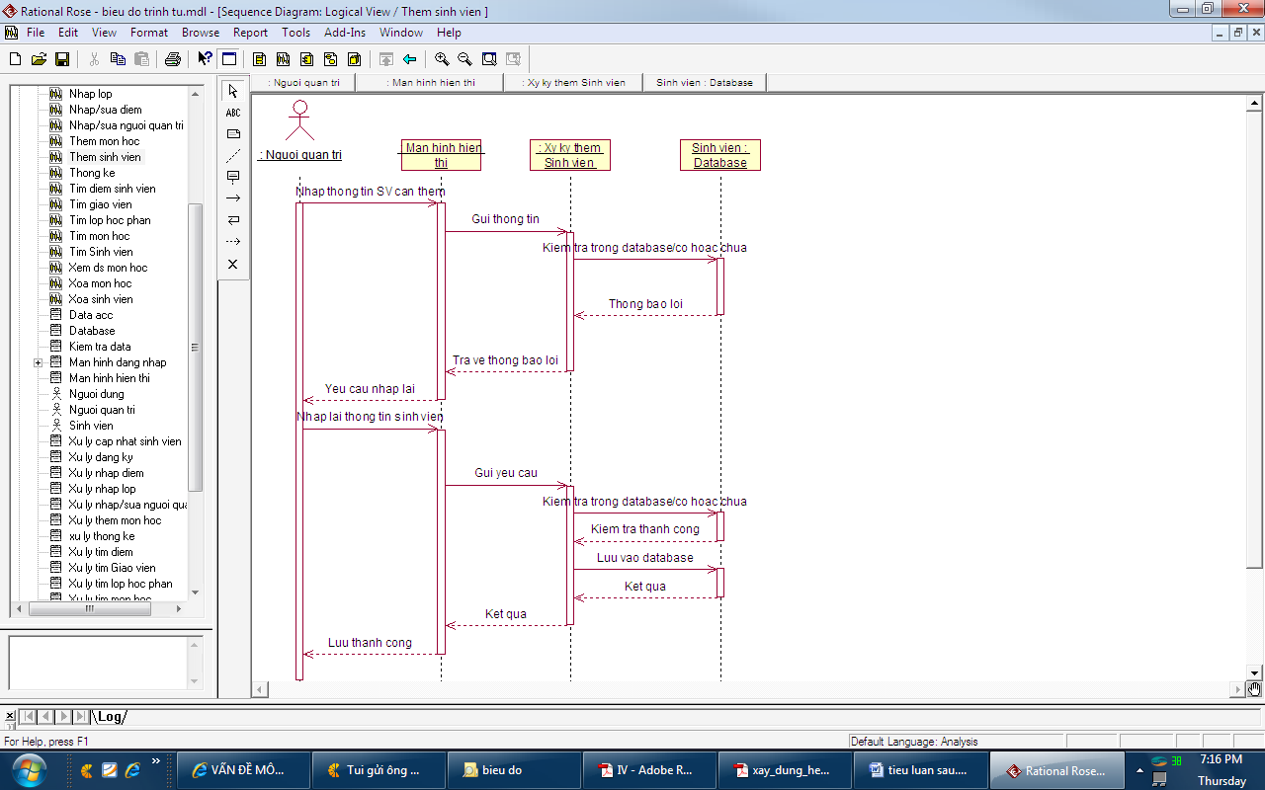

## Biểu đồ tuần tự xóa sinh viên

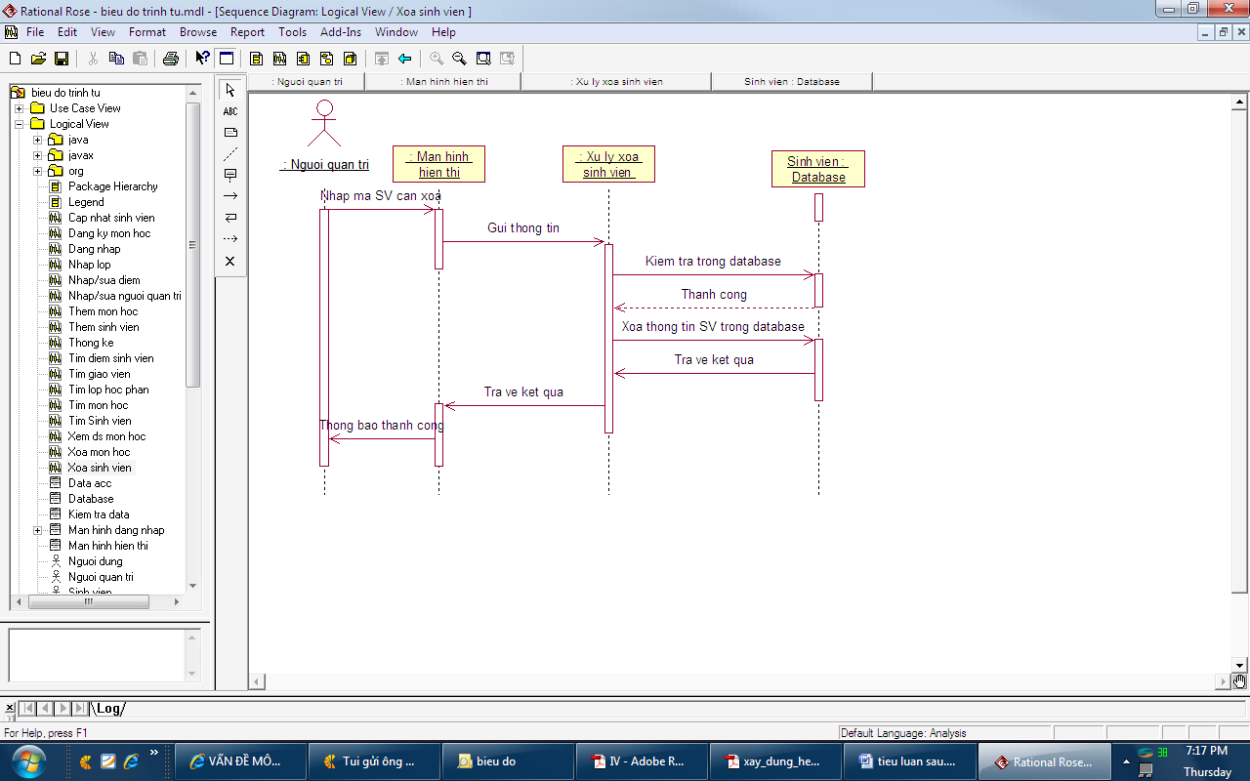

## Biểu đồ tuần tự thống kê

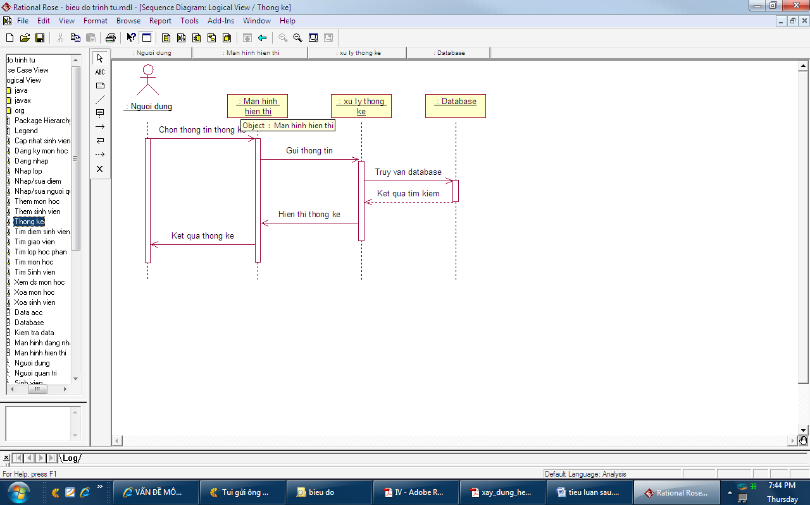

## Biểu đồ tuần tự thêm sinh viên khen thưởng

## 

## Biểu đồ tuần tự sửa sinh viên khen thưởng

## 

## Biểu đồ tuần tự xóa sinh viên khen thưởng

## 

## Biểu đồ tuần tự thêm sinh viên kỷ luật

## 

## Biểu đồ tuần tự sửa sinh viên kỷ luật

## 

## Biểu đồ tuần tự xóa sinh viên kỷ luật

## 

## Biểu đồ tuần tự chương trình học C:\Users\PC\Downloads\sq1.png

## Biểu đồ tuần tự lớp sinh hoạt C:\Users\PC\Downloads\Untitled Diagram (4).png

## Biểu đồ tuần tự xử lý cấp giấy xác nhận.

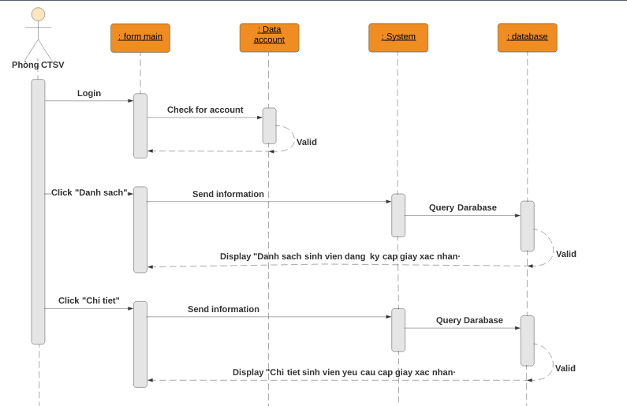

## Activity Diagrams

## Cập nhật thông tin nhân viên

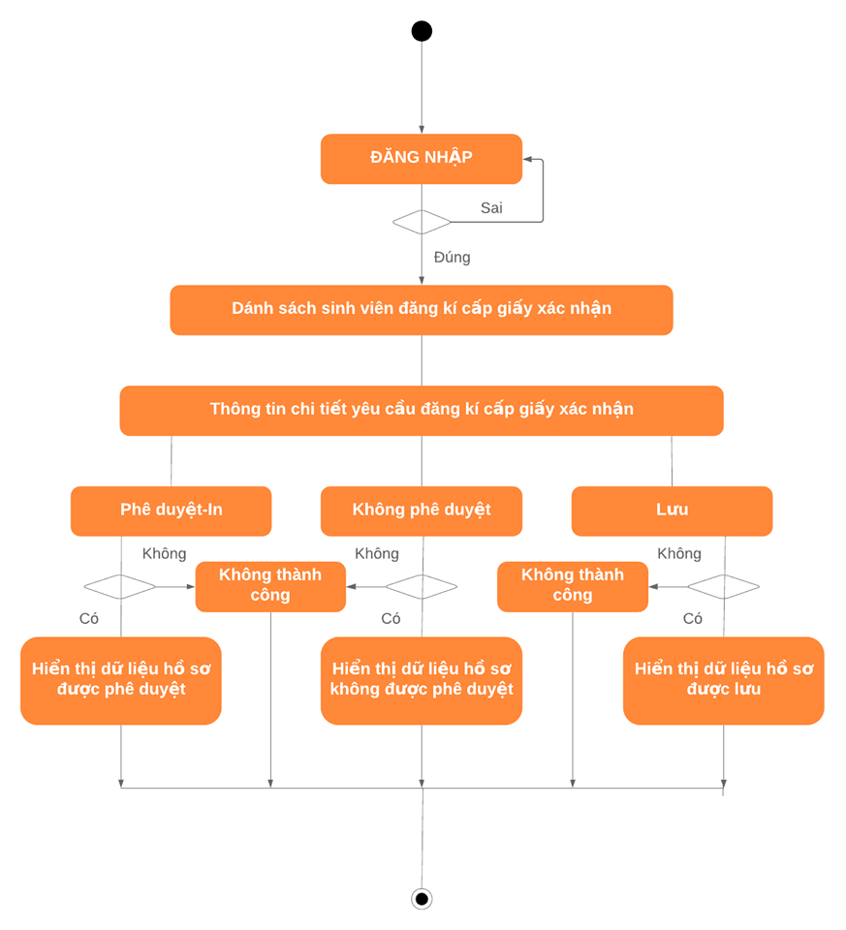

## State Diagram

## Class Diagram

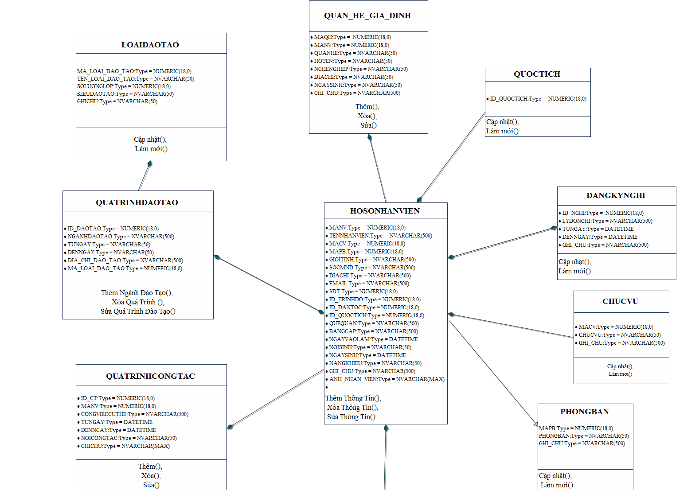

## Allocation Diagram

# Appendix A: Glossary

|  |  |
| --- | --- |
| BC | Business Constraint |
| TC | Technical Constraint |
| FR | Functional Requirement |
| QA | Quality Attribute |
| UC | Use case |
| BR | Business rule |