CURRICULUM VITAE
Dr. Lokesh Yadav
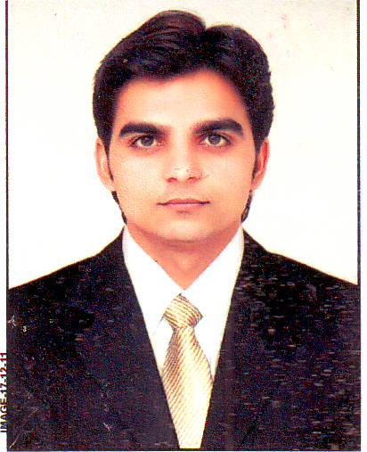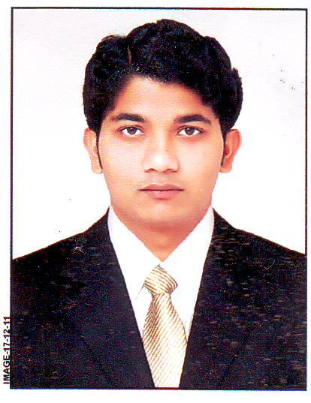
PERMANENT ADDRESS
S/O Radheshyam Yadav
Village-Kana, Post -Sandalpur
Taluka -Khategaon
Distt.-Dewas (M. P.)
PIN - 455339

POSTAL ADDRESS
Dr. Lokesh Yadav Email:-lokeshyadav192@gmail.com
College of Agriculture lokeshyadavjabugam@aau.in
Anand Agricultural University
Jabugam, GUJARAT (391155)
Career Objectives:
"Seeking a challenging opportunity where I will be able to utilize my skills and my experience as well as my superior Customer Service skills, which will allow me to grow personally and professionally"
Personal Particulars
Date of birth : 08 July 1987
Sex : Male
Father’s name : Sri Radheshyam Yadav
Marital Status : Married
State of domicile : Madhya Pradesh
Nationality : Indian
Caste : Gurjar (Hindu)
Languages known : English, Hindi, Gujarati.

Academic qualification:
Degree | Institution | Specialization | Year of completion | Percentage / OGPA
Ph.D.  Horticulture | Anand Agriculture University, Anand (Gujarat) | Fruit Science | September 2017 | 7.63
M.Sc. Horticulture | Junagadh Agricultural University, Junagadh (Gujarat) | Fruit Science | July 2013 | 7.52
B.Sc. Horticulture | Rajmata Vijayaraje Scindia Krishi Vishwa Vidyalaya Gwalior, (M.P) | Horticulture | June 2011 | 7.12
H S School | M.P. Board, Bhopal (M.P.) | Agriculture | March 2005 | 60.44%
Computer Proficiency | Computer courses: Course of Foundation and Office Automation (6 month + 6 months) | Pass | 2003-04 | A Grade
ASRB NET | ASRB, New Delhi | Fruit Science | 2015,2017 | 58%, 48%

Research work /Thesis Title:
M.Sc | : | "Effect of pre-harvest spray and post harvest treatment on shelf life and quality of papaya (Carica papaya L.) cv. Madhubindu."
Ph.D | : | “Effect of growth regulators and chemical on flowering, yield and quality of acid lime (Citrus aurantifolia S.) cv. Kagzi.”
Experience:

Post held/  Designation | Institute | Period |  |  | Duties performed
 |  | From | To date | Length of service  YY/MM/DD
Teaching Associate (contractual) | College of Agriculture Anand Agricultural University, Jabugam | 26.05.2014 | Till to date | 11/01/24 | Teaching of all courses in the discipline of horticulture both theory and practical in UG levels.  Academic work, Admission work, Extension activities, Campus beautification, Crop-cafeteria and Nursery management

Examination Duties Assigned and Performed

Sr. No. | Type of Examination Duties | Duties Assigned | Year
01 | Hort.1.1: Production Technology of Fruit Crops | Assessment of Answer sheets (O) | 2014-15
02 | UG Course COA AAU, Jabugam | Invigilator | 2013-14
 |  |  | 2014-15
 |  |  | 2015-16
 |  |  | 2016-17
 |  |  | 2017-18
 |  |  | 2018-19
 |  |  | 2021-22
 |  |  | 2022-23
03 | Hort5.5: Landscaping | Assessment of Answer books | 2021
04 | Hort5.5: Landscaping | Assessment of Answer books | 2022
05 | Hort.4.4 : Production technology for Ornamental Crops, MAPs and Landscaping | Assessment of Answer books | 2023

Special Trainings related to specialization/Distance Course :

S.  No | Name of Training | Organized at | Duration
 |  |  | From | To
1. | MOOC Teaching Competency for effective Teaching | ICAR-NAARM  Rajendranagar, Hyderabad | 18 Nov. 2016 | 18 Dec. 2016

Award:
- Best Oral presentation award for the paper entitled "Study of pre and post harvest treatment on post harvest quality of papaya during the national conference held at assembly hall St. Johns College, Agra on 22nd - 23rd February -2020.
Research contribution:
1. Research contribution in release of Variety (2022):- Mango (Anand Rasraj).
Extension Activities:
- Krishi Mahoutsav 2014 performed duty as Nodal Scientist.
- Farmer trainings : 11

Sr. No. | Extension and Related Activities |  | Year
01 | Krushi Mahotsav | Perform duty in Krushi Mahotsav-2014 as a Taluka Nodal Scientist at Santrampur , Dist. Mahisagar | 2014
02 | Khedut Shibir | Deliver a lecture on Importance of horticultural crops and PHM in Khedut Shibir at Training Center, College opf Agriculture, AAU, Jabugam. | 2015
03 | Khedut Shibir | Deliver a lecture on Kitchen gardening in mahila Khedut Shibir at Training Center, College of Agriculture, AAU, Jabugam 6-08-2015 | 2015
04 | Khedut Shibir | Deliver a lecture on Tomato Ketchup, aonla Candy and Lime squash in Khedut Shibir at Training Center, College of Agriculture, AAU, Jabugam organised by Deputy Director of Agriculture, Chhota Udaipur on 8/2/2016 | 2016
05 | Khedut Shibir | Deliver a lecture on Kitchen gardening in mahila Khedut Shibir at Training Center, College of Agriculture, AAU, Jabugam organised by ATMA, Chhota Udaipur on 07/06/2016 | 2016
06 | Khedut Shibir | Deliver a lecture on Tomato Ketchup and Lime squash in Khedut Shibir at Training Center, College o f Agriculture, AAU, Jabugam organised by Deputy Director of Agriculture, Chhota Udaipur on 8/2/2016 | 2016
07 | Khedut Shibir | Deliver a lecture on phal pakoma prakrutik/sajeev khetini upyogita at Training Center, College o f Agriculture, AAU, Jabugam 08/07/2021 | 2021
08 | Khedut Shibir | Deliver a lecture on Bagayati pako ni kheti padhdhtiyo at Training Center, College o f Agriculture, AAU, Jabugam 22/06/20232023 | 2023
09 | Khedut Shibir | Deliver a lecture on jivamrit ane ghanjivaamrit banavavani reet ane teno phal pako ma chhatkavani agtyata at Training Center, College of Agriculture, AAU, Jabugam 12/9/2023 | 2023
10 | Khedut Shibir | Deliver a lecture on vabayati pako ma prakrutik krushi ni agtyatao at Training Center, College of Agriculture, AAU, Jabugam 13/09/2023 | 2023
11 | Khedut Shibir | Deliver a lecture on shaakbhaji pako ma biyaranu mahatv at Training Center, College of Agriculture, AAU, Jabugam 20/09/2023 | 2023

Publication:
    - International research journal:-18
    - National Journal: - 0
    - Popular Article: - 10 ABSTRACT :- 03

Participation in Seminar, Conferenrence, Symposium, workshop etc.:
- National Seminars:- 06 Symposium:- 01
- International Seminars:- 02 Workshop:- 03
Hobbies:
- Farming

Strength:
- Adaptive
- Punctuality
- Perfection in work
- Creative
Reference:
- Dr. H. C. Patel (Principal, College of Horticulture, A. A. U., Aanand)
- Dr. S. R. Patel (Principal, College of Agriculture, AAU, Jabugam)
- Dr. N. J. Vihol (Rted. Professor, College of Horticulture, A. A. U., Aanand)

DECLARATION

I hereby declare that the above written particulars are true to the best of my knowledge and belief.

(Lokesh Yadav)

