CURRICULUM VITAE
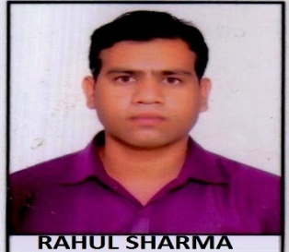
RAHUL SHARMA

H.No. 186 Malhawani Tehsil-Pichhore District- Shivpuri M.P.
Email Id- : Er.rahulsharma06@gmail.com
Contact No.- 9752536960, 9644499546

CAREER OBJECTIVE
My career objective is to learn new things that enhance my skill and knowledge and utilizing it towards the development of the organization.

PROFESSIONAL EXPERIENCE

- I have 1.6 year, working experience in the Teaching with IES College of technology Bhopal as Assistant Professor.

- I have currently working with Gyanarjan Institute Shivpuri as Principal from Aug. 2016 to till date.

Job Responsibility.

- Strong management ability with experience in formulating reporting policy and efficiency.
- Set learning goals for students and teachers based on national curricula.
- Research new resources and techniques to improve teaching.
- Manage school logistics and budgets.
- Strong Excel, Access and other MS capabilities & communication and interpersonal skills.
- Strong analytical and problem-solving skills.
- Computer system knowledge.
- Excellent verbal and written communication skills.
- Monitor and report on teacher performance Daily, Weekly and Monthly progress report.

Qualifications:-
  - Master of Engineering in VLSI Design & Embedded System from VIST Bhopal.
  - Bachelor of Engineering in Electronics & communication engineering from ASCE Bhopal.
  - HSC in 2008 from Govt. Boys Higher Secondary School Pichhore Shivpuri.
  - SSC in 2006 from Saraswati Shishu Vidhya mandir High School, Pichhore Shivpuri.

Vocational Training:-
- Attended training in Different switching, Transmission, Mobile and Data communication Certified by “BHARAT SANCHAR NIGAM LIMITED” Shivpuri (MP).

Computer Literacy:-

  - Microsoft PowerPoint, Excel and Word Knowledge
  - Command on Microsoft Windows XP, 7, 8.1 and 10.
  - Languages C, C+

Languages :-
  - Oral: Fluent in spoken Hindi, English
  - Written: English and Hindi.

Personal Qualities and skills:-
  - Personal motivation and ability to motivate others.
  - Able to establish and maintain good relationship.
  - Good Communication Skills.
  - Organized and Process Oriented.

PERSONAL PROFILE:-
- Language Known: HINDI , ENGLISH
- Date of Birth: 20th June 1990
- Marital Status : - Unmarried

CONTACT’S DETAILS:-

NAME- RAHUL SHARMA
S/O- RAJENDRA SHARMA
Nationality- Indian
Religion- Hindu

DECLARATION:-
I hereby declare that the above-mentioned information is correct to the best of my
Knowledge and I bear the responsibility for the correctness of the above-mentioned particulars.

Date Sign

