**Feeback 17: Remaining of feedback 14, 15 and 16 – 25/11/2024**

**Education and Certifications**

**In Other certifications:** Choose file and upload file doesn't work when you add other certifications

**Mandatory Training and Education :**

**Completed Mandatory Training:** Remove these 3 fields as they will be asked later each time.

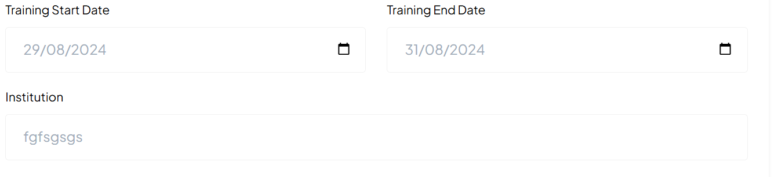

Just after **Completed Mandatory Training you will have this sentence:**

Please add required courses or certifications completed for compliance or safety

**Only green data have been added, Please complete the missing data:**

**IF Clinical Skills and Core Competencies Selected, then:**

Aggressive Behaviour Management

Aseptic Technique

Blood Transfusion Protocols

BloodSafe eLearning

Breastfeeding Promotion

Breastfeeding Support and Lactation Management

Certificate III Health Services Assistance (Nursing Acute Care assistance)

Certificate III in Aged Care

Chemotherapy Competency

Emergency and Trauma Care

Infection Prevention and Control

Medication Administration

Pain Management

Patient Assessment Skills

Perioperative Nursing Skills

Postpartum Hemorrhage Management

Venipuncture and IV Cannulation

Vital Signs Monitoring

Wound Care Management

**IF Midwifery-Specific Training Selected, then:**

Caesarean Section Assistance

Family Planning and Contraceptive Counseling

Fetal Monitoring

Gestational Diabetes Management

Labor and Delivery Management

Management of Obstetric Emergencies

Management of Preeclampsia and Eclampsia

Maternal and Child Health

Newborn Care and Resuscitation

Normal Birth and Vaginal Delivery

Perineal Suturing

Postnatal Care

Water Birth Facilitation

**IF Leadership and Professional Development Selected, then:**

Clinical Auditing

Clinical Supervision and Mentorship

Conflict Resolution and Mediation

Cultural Competency and Diversity in Care

Ethical Decision Making in Nursing

Health Informatics and EHR (Electronic Health Records)

Legal Issues in Healthcare

Nurse Leadership and Management

Nursing Policy and Advocacy

Professional Writing and Documentation Skills

Quality Improvement and Patient Safety

Research and Evidence-Based Practice

Teaching and Preceptorship Skills

Team Communication and Collaboration

Time Management and Delegation

**IF Technology and Innovation in Healthcare Selected, then:**

Advanced Wound Care Technologies

Data Analytics in Nursing Care

Electronic Fetal Monitoring

Mobile Health Apps for Nursing Care

Point-of-Care Ultrasound (POCUS)

Robotic-Assisted Surgery Nursing

Simulation-Based Clinical Training

Telehealth and Virtual Care Delivery

Use of Wearable Health Technology

**IF Wellness and Self-Care Selected, then:**

Compassion Fatigue and Burnout Prevention

Emotional Intelligence and Resilience Training

Ergonomics and Safe Patient Handling

Healthy Lifestyle Promotion for Nurses

Mindfulness and Mental Health

Workplace Stress Management

**+ Add another Completed Training:**

Upload Certificate: please fix the issue with the choose files design: the cross is on the wrong location, should be use below to remove the added files.



Please add a space between the button “+ Add another Completed Training” and “Mandatory Continuing Education”.

**Mandatory Continuing Education**

**Education**



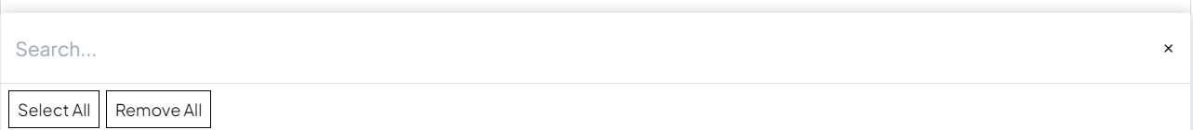

**Core Mandatory Continuing Education**

**Midwifery-Specific Mandatory Continuing Education:**

**Specialized Areas:**

**Safety and Compliance Training:**

**Emerging Topics and Continuing Education:**

**IF Core Mandatory Continuing Education**

Basic Life Support (BLS)

Advanced Cardiovascular Life Support (ACLS)

Neonatal Resuscitation Program (NRP)

Pediatric Advanced Life Support (PALS)

Infection Control and Prevention

Hand Hygiene and Aseptic Technique

Bloodborne Pathogens

Patient Safety and Risk Management

Workplace Safety (e.g., OSHA Compliance)

HIPAA (Health Insurance Portability and Accountability Act) Compliance – For U.S. healthcare workers

Ethics in Nursing and Midwifery

Cultural Competence and Sensitivity

Pain Management and Assessment

Medication Administration and Safety

Safe Patient Handling and Mobility

Sharps and Needlestick Injury Prevention

Basic and Advanced Wound Care

Communication and Interprofessional Collaboration

Legal Issues in Healthcare and Nursing

End-of-Life Care and Palliative Care

Health Informatics and Electronic Health Records (EHR)

Documentation and Legal Standards in Nursing

Confidentiality and Patient Privacy

Restraints and Seclusion

Substance Abuse and Impairment in Healthcare Professionals

**IF Midwifery-Specific Mandatory Continuing Education:**

Antenatal Care and Screening

Postpartum Hemorrhage Management

Fetal Monitoring and Interpretation and : **remove Perineal suturing (not in this list)**

Labor and Delivery Complications

Water Birth Safety and Guidelines

Maternal and Neonatal Resuscitation

Breastfeeding and Lactation Support

Management of High-Risk Pregnancies

Caesarean Section Assistance

Perinatal Mental Health

Preeclampsia and Eclampsia Management

Newborn Care (NICU Management, Special Care Nursery)

Intrapartum and Postpartum Care

Obstetric Emergencies

Contraception Counseling and Family Planning

Cultural Sensitivity in Maternity Care

Maternal Fetal Medicine (MFM) Updates

**There is an issue:**

**When you select :**

Antenatal Care and Screening

Postpartum Hemorrhage Management

Perineal suturing **(which should’nt be on this list)**

**Then:** When you unselect **Midwifery-Specific Mandatory Continuing Education, the sub fields** Antenatal Care and Screening and Postpartum Hemorrhage Management and Perineal suturing **still remain:**

**IF Specialized Areas : this sub section field is missing**

Emergency and Trauma Nursing

Critical Care Nursing (ICU/CCU)

Oncology Nursing

Pediatric Nursing

Mental Health Nursing

Geriatric Care and Nursing Home Care

Substance Abuse and Addiction Counseling

Chronic Disease Management (e.g., Diabetes, Hypertension)

Advanced Wound Care and Ostomy Management

Public Health and Community Nursing

Home Health and Hospice Care

Operating Room/Perioperative Nursing

Telehealth and Virtual Healthcare

Obstetric Anesthesia Management

LGBTQ+ Health and Care

**IF Safety and Compliance Training: this sub section field is missing**

Workplace Violence Prevention and Management

Aggressive Behavior Management (De-escalation Techniques)

Fire and Emergency Preparedness

Radiation Safety

Safe Use of Medical Devices and Equipment

Infectious Disease Control (including COVID-19 Protocols)

**IF Emerging Topics and Continuing Education: this sub section field is missing**

Telehealth and Digital Healthcare

Artificial Intelligence in Nursing Practice

Pandemic Response and Preparedness

Climate Change and Health Impacts

Trauma-Informed Care

Health Equity and Reducing Disparities

Mental Health First Aid

Gender-Affirming Care

Human Trafficking Awareness

Opioid Crisis and Pain Management Alternatives

**Other Educations:**

**Upload Certificate:** please fix the issue with the choose files design: the cross is on the wrong location, should be use below to remove the added files.



Please add et the end:



**Experience:**

**After this sentence: Please add your full nursing work experience to strengthen your profile and get hired faster. Please keep update as your experience grows:**

Please Add: **Work Experience 1**

Type of nurse and specialties should be the same falling tree system than in Profession and register nurse:

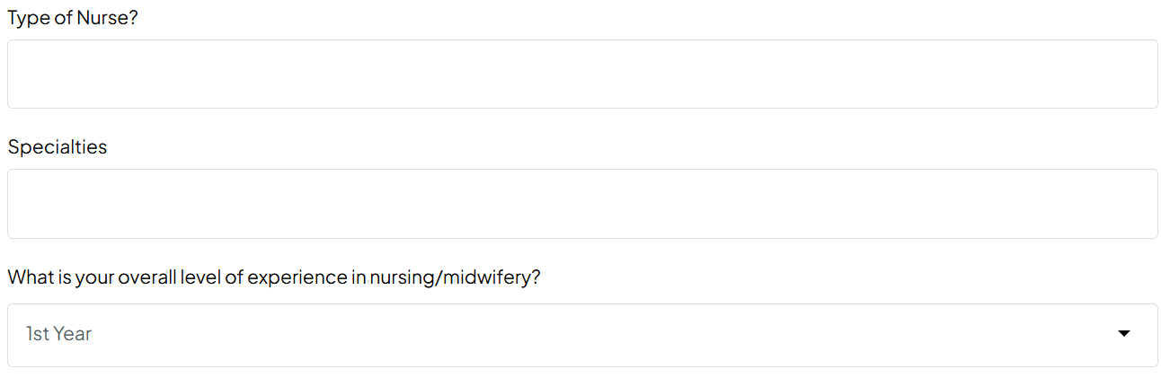

Please add:

What is your Level of experience in this specialty: (**Missing)**



Adults, Maternity OB/GYN/MFM, Paediatrics Neonatal Perinata,l Community: Should pop up only when selected, please use the same tree system than in Profession and register nurse:



**Remove Previous Employers** before Position Held

Employment Type:

**Permanent:**

**Temporary:**

If **Permanent:** selected:

Full-time

Part-time

Agency Nurse/Midwife

Freelance

Local

Volunteer

If **Temporary:** selected:

Temporary

Contract

Term Contract

Travel

Per Diem

Local

On-Call

PRN (Pro Re Nata)

Casual

Locum tenens (temporary substitute)

Agency Nurse/Midwife

Seasonal

Freelance

Internship

Apprenticeship

Residency

Volunteer

For each work experience **: After Detailed Job Descriptions, please add those fields:**

**Areas of Expertise**

Specific skills and competencies

Type of evidence

Upload evidence **Choose file:** For each work experience (Always possibility to delete the uploaded files)

**+Add another work experience:** button has to be placed at the end, after upload evidence and choose file.

**Please add** the possibility to delete added another work experience: For now you can just add but you can’t delete the added work experience.

When you **+Add another work experience, then** Update dynamically as the user adds work experience**: Work Experience 2, Work Experience 3,…..**

**References:**

When you +Add another Referee2, Referee 3, referee 4, after when you delete them back to referee1, after when you add another time, it is Referee 5 instead of Referee 2.

**Vaccinations: See feedback 16 sent on the 30/10/2024**

**Work Clearances: I’m working on the content, I will send you soon**

**Professional Memberships:**

**Interview:**

**Personal Preferences:**

**Job Search & Personal Preferences:**

**Testimonial and Reviews:**

**Additional Information:**