

**FOOTBALL FIELD BOOKING SYSTEM**

**Software Requirement Specification**

– HCM, August 2022 –

**Table of Contents**

I. Overview **4**

1. Introduction 4

2. System Functions 6

a. Screen Flow 6

b. Screen Details 7

c. User Authorization 8

d. Non-Screen Functions 10

3. Common Requirements 10

II. Functional Requirements **10**

1. View account’s profile 10

a. Query profile of user 10

b. Update profile of user 11

2. Authentication 11

a. Login 11

b. Authentication 12

3. Create account 12

Create account 12

4. Forgot password 13

Input new password 13

5. Manage manager information 13

Query all data manager of field 13

Search by id 13

Sort by created date 13

Search data by address 14

6. Manage customers information 14

Query all data of Customer 14

Search data by ID 14

Search data by Address 15

7. Manage actives of Field 15

Query all data of Field export 15

Query time active of Field(NF) 15

Query Field most recent 15

8. Manage all Field(NF) 15

Query all data 15

Search data 16

9. Detail actives of Field(NF) 16

Query all data of Field 16

Function trigger: when click Manage Field page. 16

Update data 16

10. List request create a field of Managers 16

Query all data 16

Search field request by name. 17

Search field request by address. 17

Accept request 17

Reject request 17

11. Customer view homepage 18

View customer page 18

12. List Fields 18

Query all fields 18

Search field request by name. 18

Search field request by address. 18

13. Field Detail 19

Query all fields data 19

14. Field Order(NF) 19

15. Rating(Review)(NF) 19

Rating by stars and comment 19

Calculate the average of stars 19

Feedback 20

16. Booking history 20

Search by name 20

17. User Profile 20

a. Update User Profile 20

# I. Overview

## 1. Introduction

After stressful working and studying hours, people today tend to go to entertainment areas to relieve stress such as: eating, meeting friends,.... Grasping these essential needs, many people have organised the business of rental field services. But to ensure the ability to attract customers to play, quality advertising and information provision is one of the leading essential things. This requires managers to set up a separate website for their football field to easily manage and provide information to guests. The website not only helps customers easily set the schedule to view the football field information, but also helps the football field manager to control the entire football field system, participants use the website on a computer easily.

The football field booking system that we want to mention here is to build a website to provide customers with detailed information about the field location, the situation of the football field. The specific price of each type of field and the services provided by the football field to customers exactly so that customers can choose the right and quick football field. It will also reduce difficulties in the management of the owner. This system can manage a large number of field owners at the same time. Field owners can use this system to have customers and create fields easier.

The admin can create, delete, update, see list of fields 5, 7, 11, list of free or busy fields. View a list of customer information. List of customers who book the most yards by month. The list of customers is not active (day, month, ...). Manage revenue of the field by day, month, year. Manage the process of online booking, online cancellation. Manage customer transaction information and between the yard owner. Manage the process of importing and exporting information of the fields, the price of the match. Manage information stored in the database, retrieve information. Manage the review, opinion of customers about the field.

The customer can view, edit their profile, view list field, search by name, search by location, book field, view field in details, booking order, feedback only when customer has booked the fields.

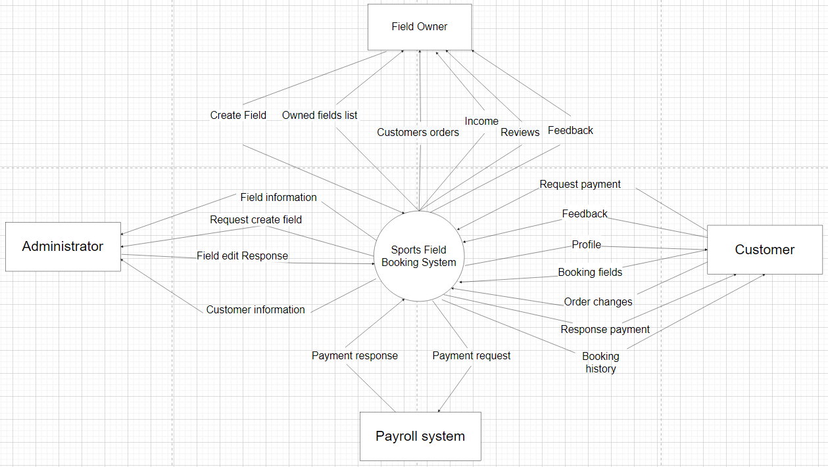

## 

## 2. System Functions

#### a. Screen Flow

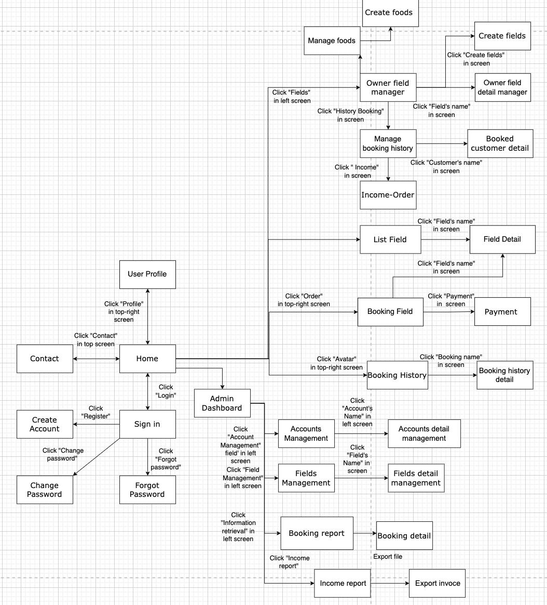

#### b. Screen Details

| **#** | **Feature** | **Screen** | **Description** |
| --- | --- | --- | --- |
| 1 | Authentication | Sign in | User logins account |
| 2 | Sign up account | Create account | User creates a new account |
| 3 | Reset password | Forgot password | User can find their forgotten password |
| 4 | Change new password | Change password | User can change their password |
| 5 | View account’s profile | User profile | User can view, edit their profile |
| 6 | View landing page | Home | User views home page |
| 7 | View list of field | List field | List of field will be shown to user |
| 8 | View field detail | Field detail | View the information of the field |
| 9 | Booking field | Order field | Customers book field |
| 10 | View contact information | Contact | Users view the contact of the specific field |
| 11 | Pay money | Payment | Customers paid booked field |
| 12 | View history of booking | Booking history | Customers view the history order |
| 13 | View detail history of booking | Booking history detail | Customers view the detail of history order |
| 14 | Manage list owner’s field | Owner field manager | Field owners view, search their own list of field |
| 15 | Manage owner’s field detail | Owner field detail manager | Field owners view, update, delete their own field detail |
| 16 | Create new field | Create fields | Field owners create new fields |
| 17 | View field category of owner’s field | Manage field category | Field owners view, search update, delete field category |
| 19 | View booking history of owner’s field | Manage booking history | Field owners can see customer who booked their fields |
| 20 | View booked customer detail | Manage booked customer | Field owners can see the profile of customer who booked their fields |
| 21 | Create new foods | Create foods | Field owners create new foods |
| 22 | View foods of owner’s field | Manage foods | Field owners view, search their own foods |
| 23 | View detail foods of owner’s field | Manage foods detail | Field owners view, update, delete their own food detail |
| 24 | View food category of owner’s field | Manage food category | Field owners view, search update, delete food category |
| 25 | View location of field | Manage location | Field owners view, search update, delete location |
| 26 | View city of field | Manage city | Field owners view, search update, delete city |
| 27 | View Income-Order | Income-Order | Field owners view the income of the specific field |
| 28 | View admin page | Admin Dashboard | When logged in as admin will be taken to the page |
| 29 | Manage list of fields | Fields Management | Admin can view, search list of fields  Allows admin to review or enable/disable fields |
| 30 | Manage detail of fields | Fields detail Management | Admin can view, update, delete field |
| 31 | Manage list of accounts | Accounts Management | Admin can view, search list of accounts  Allows admin to review or enable/disable accounts |
| 32 | Manage detail of accounts | Accounts detail Management | Admin can search, update, delete account |
| 33 | Manage booking history | Booking report | Admin can view, search update booking history |
| 34 | Manage foods | Food Management | Admin can view, search foods |
| 35 | Manage food detail | Food detail Management | Admin can search, update, delete food detail |
| 36 | Manage field category | Field category Management | Admin can view, search, update, delete field category |
| 37 | Manage food category | Food category Management | Admin can view, search, update, delete food category |
| 38 | Manage role | Role Management | Admin can view, search update, delete role |
| 39 | Manage city | City Management | Admin can view, search update, delete city |
| 40 | Manage location | Location Management | Admin can view, search update, delete city |

1 feature là có thể 1 hoặc nhiều screen : 1 screen nhiều function-> description

#### c. User Authorization

| **Screen** | **Admin** | **Field owner** | **Customer** | **Others** |
| --- | --- | --- | --- | --- |
| Contact | x | x | x | x |
| View contact information | x | x | x | x |
| Home | x | x | x | x |
| View home page | x | x | x | x |
| User Profile | x | x | x |  |
| Profile of user | x | x | x |  |
| Update profile of user |  | x | x |  |
| Sign in | x | x | x | x |
| Login | x | x | x | x |
| Create account | x | x | x | x |
| Create account | x |  | x |  |
| Forget Password | x | x | x | x |
| Input New Password | x | x | x |  |
| Change Password | x | x | x | x |
| Change new Password |  | x | x |  |
| Admin Dashboard | x |  |  |  |
| View admin page | x |  |  |  |
| Accounts Management | x |  |  |  |
| Create account | x |  |  |  |
| Search account | x |  |  |  |
| Accounts detail management | x |  |  |  |
| Delete account | x |  |  |  |
| Update account | x |  |  |  |
| Fields management | x |  |  |  |
| Search Fields | x |  |  |  |
| Fields detail management | x |  |  |  |
| Update Field | x |  |  |  |
| Delete Fields | x |  |  |  |
| Foods management | x |  |  |  |
| Search Fields | x |  |  |  |
| Update Field | x |  |  |  |
| Delete Fields | x |  |  |  |
| Booking report | x |  |  |  |
| Search info history Booking field | x |  |  |  |
| Sort info history booking | x |  |  |  |
| List Field | x | x | x | x |
| Search Active Field | x | x | x |  |
| Paging | x | x | x |  |
| Field detail | x | x | x | x |
| View detail of Field | x | x | x |  |
| Feedback | x | x | x |  |
| View Similar Field | x | x | x |  |
| Booking Field |  |  | x |  |
| Update Booking Field | x | x | x |  |
| Delete Booking Field |  |  | x |  |
| View Booking Field |  |  | x |  |
| Payment |  |  | x |  |
| View QR code |  |  | x |  |
| Check out |  |  | x |  |
| Booking History |  |  | x |  |
| View all Order of customer |  |  | x |  |
| Search order of customer |  |  | x |  |
| Booking history detail |  |  | x |  |
| View detail booked fields |  | x |  |  |
| Owner Field Manager |  | x |  |  |
| Search field of manager |  | x |  |  |
| Delete Field of manager |  | x |  |  |
| Search slot of field |  | x |  |  |
| Delete slot of field |  | x |  |  |
| Update slot of field |  | x |  |  |
| Create Field |  | x |  |  |
| Input information of new field |  | x |  |  |
| Create Food |  | x |  |  |
| Input information of new food |  | x |  |  |
| Create Slot |  | x |  |  |
| Input information of new slot |  | x |  |  |
| Manage Food |  | x |  |  |
| View list food of Manager |  | x |  |  |
| Search food of manager |  | x |  |  |
| Delete food of manager |  | x |  |  |
| Owner Field Detail manager |  | x |  |  |
| View information detail of Field |  | x |  |  |
| Update Field of manager |  | x |  |  |
| Manage booking history |  | x |  |  |
| View all booking field of customer |  | x |  |  |
| Search booked Field |  | x |  |  |
| Delete Customer Booking |  | x |  |  |
| Page table Customer booking |  | x |  |  |
| Manage booking detail |  | x |  |  |
| Ui detail booking |  | x |  |  |
| Income-Order |  | x |  |  |
| Search income |  | x |  |  |
| Update income |  | x |  |  |
| Delete income |  | x |  |  |
| Sum income of all order |  | x |  |  |

In which:

* Role1: Admin
* Role2: Manager
* Role3: Customer

#### d. Non-Screen Functions

| **#** | **Feature** | **System Function** | **Description** |
| --- | --- | --- | --- |
| 1 | Email | Send mail | When customers order, the system will automatically send an email to the manager of the system. |
| 2 | Payment by momo | Payment | When customers pay for booking, the system will automatically request payment by momo. |

## 3. Common Requirements

* Web Server Apache Tomcat 9/10-IIS
* Web Browser Chrome: Version 101.0.4951.67. ….
* SQL Server: 2019

# II. Functional Requirements

**1. View account profile**

### Profile of user

Function trigger: when logged in and choose profile

Function description: Admin/Manager/Customer can view their own profile information.

Screen Layout:

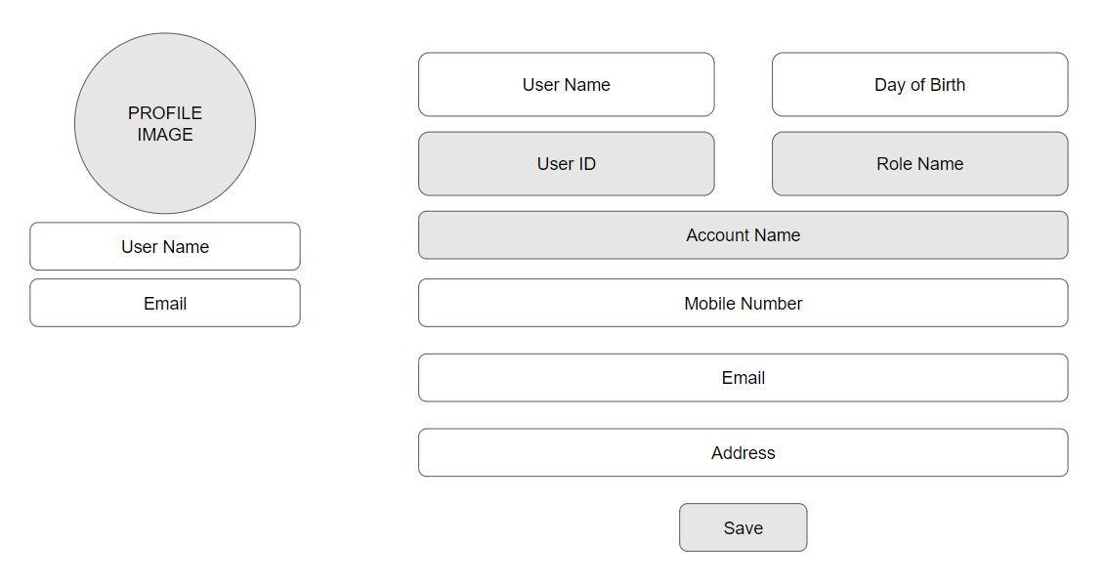

Function details: When clicking profile the system redirects the user to a profile page where they can see all of the information. If some information hasn’t been inputted when creating an account the system will show blank

### Update profile of user

Function trigger: when logged in, tap profile, input new Information and click save profile

Function description: Admin/Manager/Customer can edit/update their own profile information.

Function details: When clicking profile the system redirects the user to a profile page, users then edit information and click save profile

* System will not allow you to edit UserID, Roles, Email
* Input date with age < 10

Update fail:

* System will show “10 tuổi trở lên để có thể dùng Web, Cập nhật thất bại”
* Input all valid information:

Update success:

* System will show “Cập nhật thông tin thành công”

## 2. Authentication

### a. Login

Function trigger: when click Login button

Function description: User(admin/field owner/customer) can login to their account after filling UserName and Password and clicking the Login button.

Screen layout: 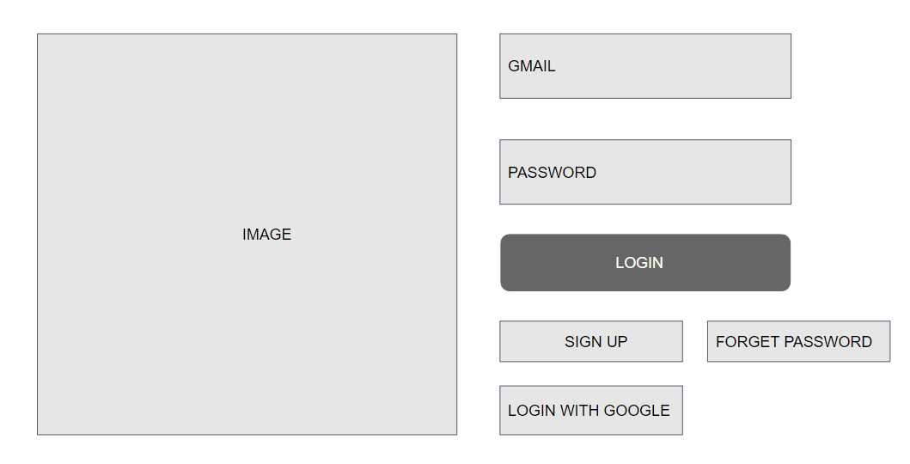

Function details: Users log in to their account with UserName and Password. Once the Login button is clicked both UserName and Password date will get searched in the database if matched User can log in to their account else if wrong Password or RoleID is not supported it will show the Error message to the User.

### b. Login with Gmail

Function trigger: User logs in with Gmail account

Function description: Admin/Manager/Customer login with Gmail account.

Screen layout:

Function details: Login page user chooses login with Gmail

if email and password are wrong or left blank

* Login failed and the user gets sent to login page

if correct system check roleID and send the user to correct page

Each page check roleID. The page will be shown if the page allows access

else the user gets sent to the login page

## 3. Create account

### Create account

Function trigger: Click create an account on login page fill in the form and click “Đăng kí”

Function description: Customer can create an account to log in to the website.

Screen layout:

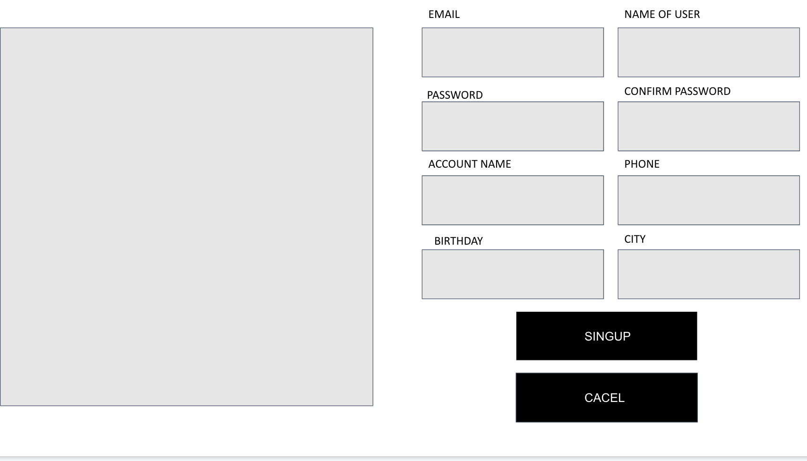

Function details: Fill in the form with valid input to create a new account

If left blank on some of the information

* Show “Fill out this field”

if age < 10

* Not allowed to create an account

if phone contains a string

* Not a number

If Success

* Send the user to Login Page

## 4. Forgot password

### Forgot password

Function trigger: click Forgot password on login page, input email, input new password and confirm new password, input OTP

Function description: User resets their password

Screen layout:

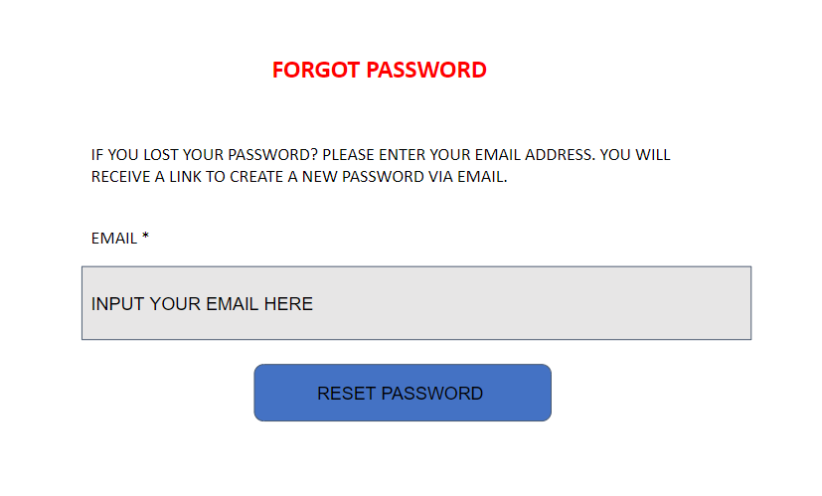

Function details: If the new password and confirm password are not correct. Show “Both passwords are not the same”

else send an OTP to the inputted email and start a 60sec countdown

If OTP is not correct show “OTP not correct”

If the 60sec countdown is done User needs to resend a new OTP

If OTP is correct User get sent to Login Page

**5. View Admin Page**

### View admin page

Function trigger: Logged in using an account with Admin role

Function description: Admin view their page when logged in to the website

Screen layout:

Function details: Admin gets sent to the admin page when logged in or click on the logo when logged in.

**6. Account Management**

### Search Account

Function trigger: Logged in using an account with Admin role and click Account Management

Function description: Admin searches an account using full name

Screen layout: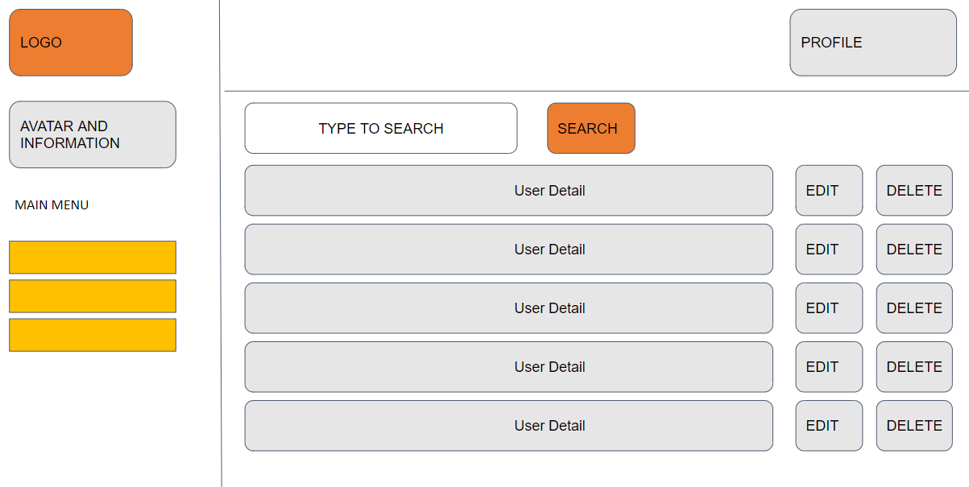

Function details: In the Accounts Management page

* If the search is null all of the accounts will be shown to admin
* If input a string in search the accounts that contain the same input will be shown and save the search value

### Update Account

Function trigger: Logged in using an account with Admin role and click Account Management and choose an account to update

Function description: Admin updates an account information

Function details: Admin input information of the account.

* System will not allow you to edit UserID, Roles, Email
* Blank input will save as null

Click update account to save

* If Success “Update account successfully”
* If Fail “Failed to update account”

### Delete Account

Function trigger: Logged in using an account with Admin role and click Account Management and choose an account to delete

Function description: Admin deletes an account

Function details: When click delete on a specific account

* System will check that account status if “false” “Account already deleted”
* If account status is “true” update that account status to false and shows “Delete account successfully”

Function details: In the Accounts Management page

* If the search is null all of the accounts will be shown to admin
* If input a string in search the accounts that contain the same input will be shown and save the search value

**7. Fields Management**

### Search Field

Function trigger: Logged in using an account with Admin role and click Fields Management

Function description: Admin searches a field using Field Name, Field Catagory, City, Field Owner and Field status

Screen layout:

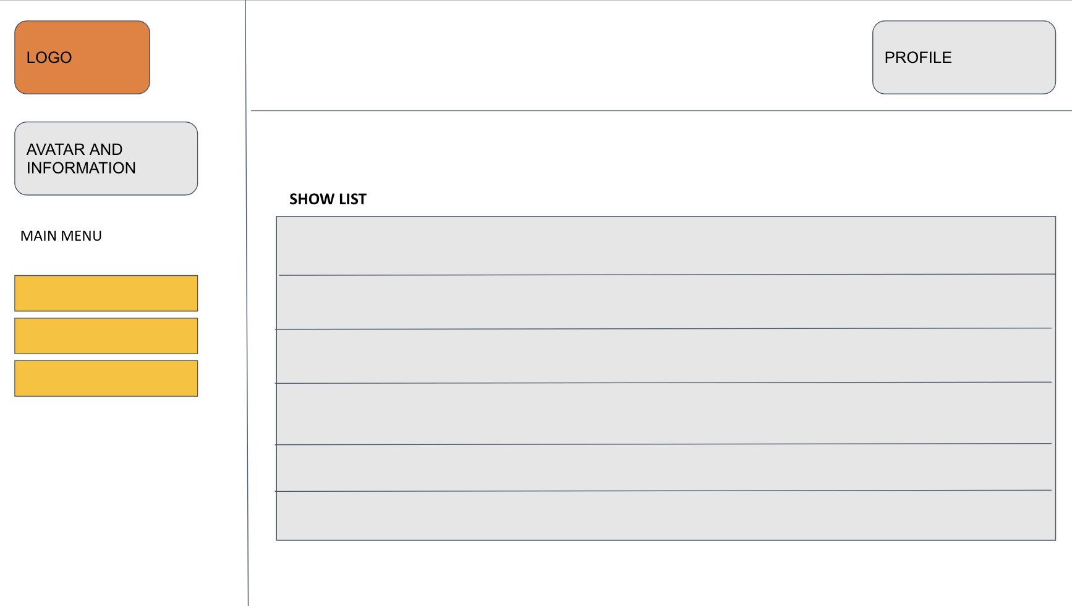

Function details: In the Fields Management page

* If the search is null all of the fields will be shown to admin
* If input a string in search the accounts that contain the same input will be shown and save the search value

### Update Field

Function trigger: Logged in using an account with Admin role and click Fields Management and choose a field to update

Function description: Admin updates a field information

Screen layout:

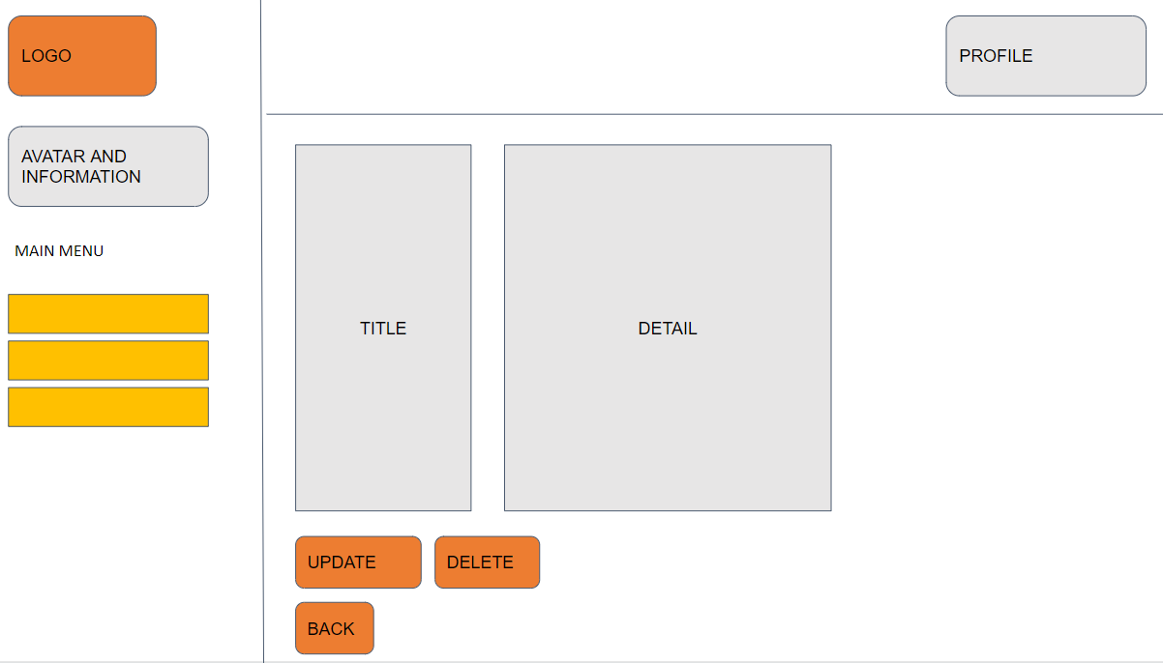

Function details: Admin input information of the field.

* System will not allow you to edit FieldID
* If the input is invalid show “invalid input”

Click update field to save

* If Success “Update field successfully”
* If Fail “Failed to update field”

### Delete Field

Function trigger: Logged in using an account with Admin role and click Fields Management and choose a field to delete

Function description: Admin deletes a field.

Function details: When clicking delete on a specific field

* System will check that field status if “false” Field already deleted”
* If field status is “true” update that field status to false and shows “Delete field successfully”
* If failed show “Failed to delete field”

**8. Create new field**

### Create Field

Function trigger: Logged in using an account with Admin role and click Fields Management and choose a field to delete

Function description: Admin deletes a field.

Screen layout:

Function details: When clicking delete on a specific field

* System will check that field status if “false” Field already deleted”
* If field status is “true” update that field status to false and shows “Delete field successfully”
* If failed show “Failed to delete field”

## 9. Detail actives of Field(NF)

### Query all data of Field

### Function trigger: when click Manage Field page.

Function description: The administrator view all of the Field information.

Screen layout:

Function details: The administrator clicks on Manage Field the system will go into the database and query all of the fields that are in the database if there’s a field result will be shown else “No Field” will be shown.

### Update data

Function trigger: when clicking the Manage Field page.

Function description: The administrator view all of the Field information.

Screen layout:

Function details: Administrator click on Manage Manager the system will go into the database and query all of the Manager that is in the database if the Manager exists result will be shown else “Not Found” will be shown.

## 10. List a field of Managers

### Query all data

Function trigger: when click Field Request page.

Function description: The administrator view all of the requests.

Screen layout:



Function details: The administrator clicks on the Field Request page the system will go into the database and query all of the requests that have the status of pending that are in the database if there are any requests result will be shown else “No Request” will be shown.

### Search field request by name.

Function trigger: when clicking the Field Request page choose search type(name) then input the name and click the search button.

Function description: The administrator view all of the requests that have the same input.

Function details: Administrator click on the Field Request page, choose search type(name) then input name, and click search the system will go into the database and query all of the requests that have the status of pending and has the same name that is in the database if there are any requests result will be shown else “No Request” will be shown.

### Search field request by address.

Function trigger: when clicking the Field Request page choose search type(Address) then choose an address in the dropdown list and click the search button.

Function description: The administrator view all of the requests that have the same input.

Function details: Administrator click on the Field Request page, choose search type(address) then choose an address in the dropdown list and click the search button the system will go into the database and query all of the requests that have the status of pending and have the same address that is in the database if there are any requests result will be shown else “No Request” will be shown.

### Accept request

Function trigger: when clicking the Field Request page choose the confirm button.

Function description: Administrator accepts requests.

Function details: The administrator clicks on the Field Request page and clicks the accept button on the field Administrator who wants to accept the system will go into the database and query that field and change the status to active.

### Reject request

Function trigger: when clicking the Field Request page choose the reject button.

Function description: Administrator rejects requests.

Function details: The administrator clicks on the Field Request page and clicks the reject button on the field Administrator who wants to reject the system will go into the database and query that field and change the status to reject.

## 11. Customer view homepage

### View customer page

Function trigger: when clicking home or visiting a website.

Function description: Customers will get redirected to a custom homepage.

Screen layout:

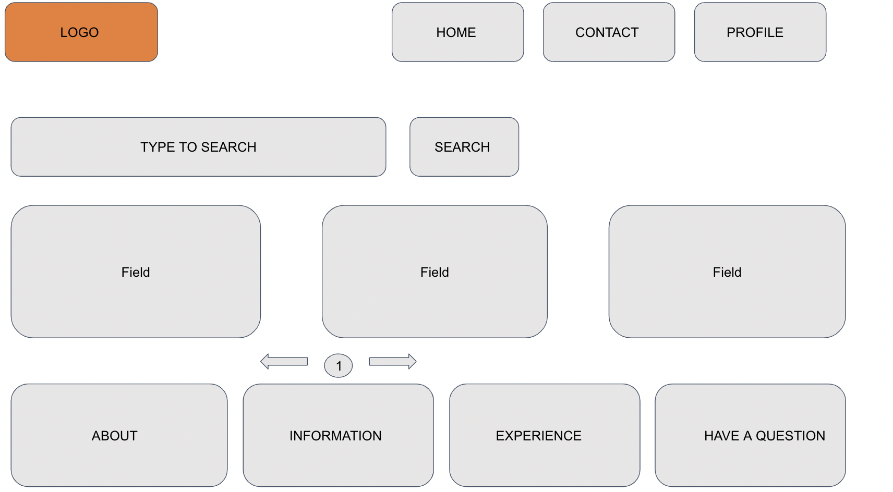

Function details: When customers click home or visit a website the system will redirect customers to the customer's homepage.

## 12. List Fields

### Query all fields

Function trigger: When clicking home or visiting a website.

Function description: Customers view all fields available.

Screen layout:



Function details: When customers click home or visit a website the system will query all of the fields that have the status of action if there are any fields available result will be shown else “No Field” will be shown.

### Search field request by name.

Function trigger: When on the homepage, choose the search type(name) then input the name, and click the search button.

Function description: Customers view all of the fields that have the same input.

Function details: When customers choose search type(name) then input name and click search the system will go into the database and query all of the fields that have the status of active and has the same name input if there are any fields result will be shown else “No Fields” will be shown.

### Search field request by address.

Function trigger: When on the homepage, choose search type(Address) then choose an address in the dropdown list and click the search button.

Function description: Customers view all of the fields that have the same input

Function details: When customers choose search type(address) then choose an address in the dropdown list and click the search button the system will go into the database and query all of the fields that have the status of active and has the same address if there are any fields result will be shown else “No Field” will be shown.

## 13. Field Detail

Function trigger: When clicking on field name or field picture.

Function description: Customers view all of the field's information like name, picture, location, and owner.

Screen layout:

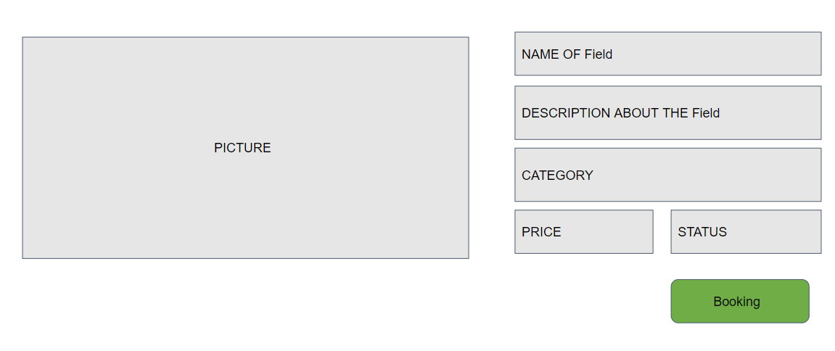

Function details: When customers click on field name or field picture the system will query all of the information of that field and then show it to the customer.

## 14. Field Order(NF)

Function trigger: When clicking on field name or field picture.

Function description: Customers view all of the field's information like name, picture, location, and owner.

Screen layout:

Function details: When customers click on field name or field picture the system will query all of the information of that field and then show it to the customer.

## 15. Rating(Review)(NF)

### Rating by stars and comment

Function trigger: In the field details page, choose the number of stars, comment, and click the leave review button.

Function description: Customers can rate a field by choosing the number of stars.

Screen layout:

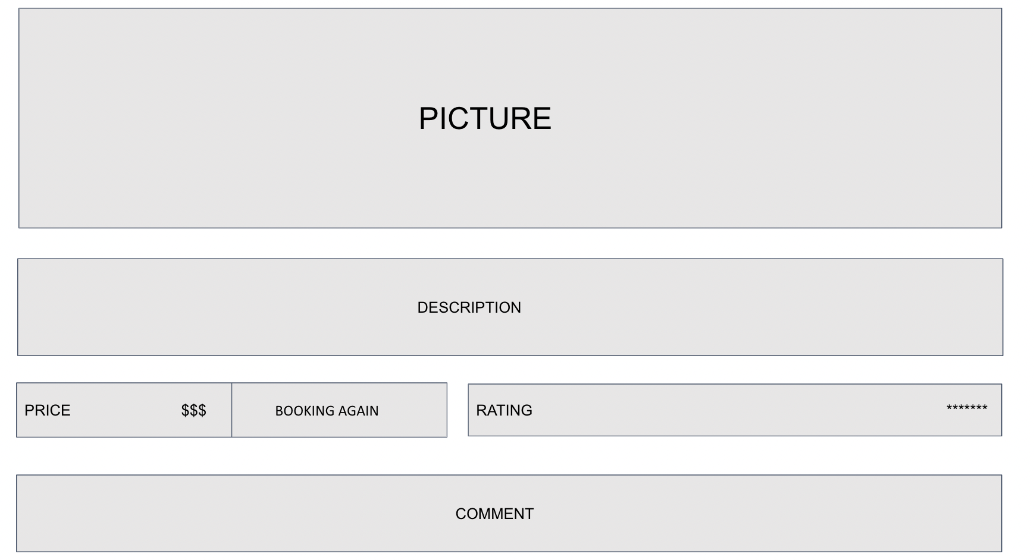

Function details: When Customers click on a field name or picture they will find a rating system that has 1 to 5 stars. Select a number of stars and input a comment or leave blank then click the leave review button. The system will save and show reviews of that customer in the field rating box.

### Calculate the average of stars

Function trigger: When clicking on field name or field picture.

Function description: Customers can view the average stars' point of that field.

Function details: When Customers click on a field name or picture the system will query the number of stars and the number of people who leaves a rating in the database then calculate the average and show it to customers.

### Feedback

Function trigger: When clicking feedback and typing in the feedback box then clicking a feedback button.

Function description: Customers or Managers can leave feedback on reviews.

Function details: When clicking feedback and typing in the feedback box then clicking a feedback button

**16. Booking Field Management**

### Search Booking

Function trigger: Logged in and choose Booking Management

Function description: User searches their booking history by BookingID, status

Screen layout:

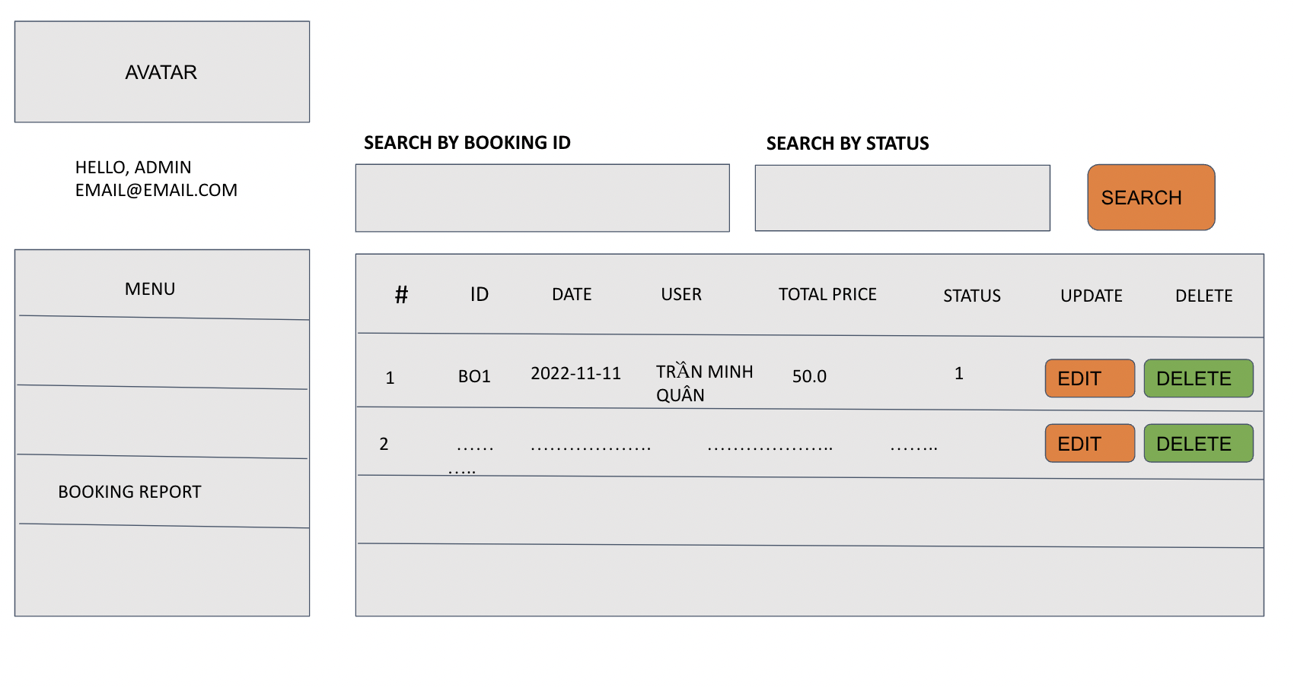

Function details: In the Booking Management page

System check role if User:

* If the search is null all of the bookings of that User will be shown
* If input a string in search the bookings that contain the same input will be shown and save the search value

System check role if Admin:

* If the search is null all of the bookings will be shown
* If input a string in search the bookings that contain the same input will be shown and save the search value

### View Booking Detail

Function trigger: Logged in and choose Booking Management and click on booking ID

Function description: User view the detail of a booking

Screen layout:

Function details: In the Booking Detail page

The system takes the booking ID that the user chooses to query in DataBase

* If specific information is null that information will be blank
* If no detail of that booking “No Result” will be shown
* If there a detail of that booking ID show all of the information

### Delete Booking

Function trigger: Logged in and choose Booking Management and click Delete

Function description: User delete a booking



Function details: In the Booking page modal will appear if click

* If that booking status is “On-Going” the booking status will change to “Cancel”
* If booking status is not “On-Going” the booking status will change to “Delete”

### Update Booking

Function trigger: Logged in and choose Booking Management and click Update

Function description: Admin update a booking information



Function details: In the Booking page modal will appear if click and a dropdown booking status will appear

* If admin wants to update status to “On-Going” or “Played”
* The system will check if the date valid or not:
  + If date valid show “Update Successfully”
  + If date invalid show “Invalid status”
* If the status admin wants to update the same as the booking status system will show “Same booking status”

**17.Pay ment**

Function trigger: Customer done booking field then click “Payment”.

Function description: Customers complete the order, will pay, have a QR code to pay via momo, and pay

Screen Layout:

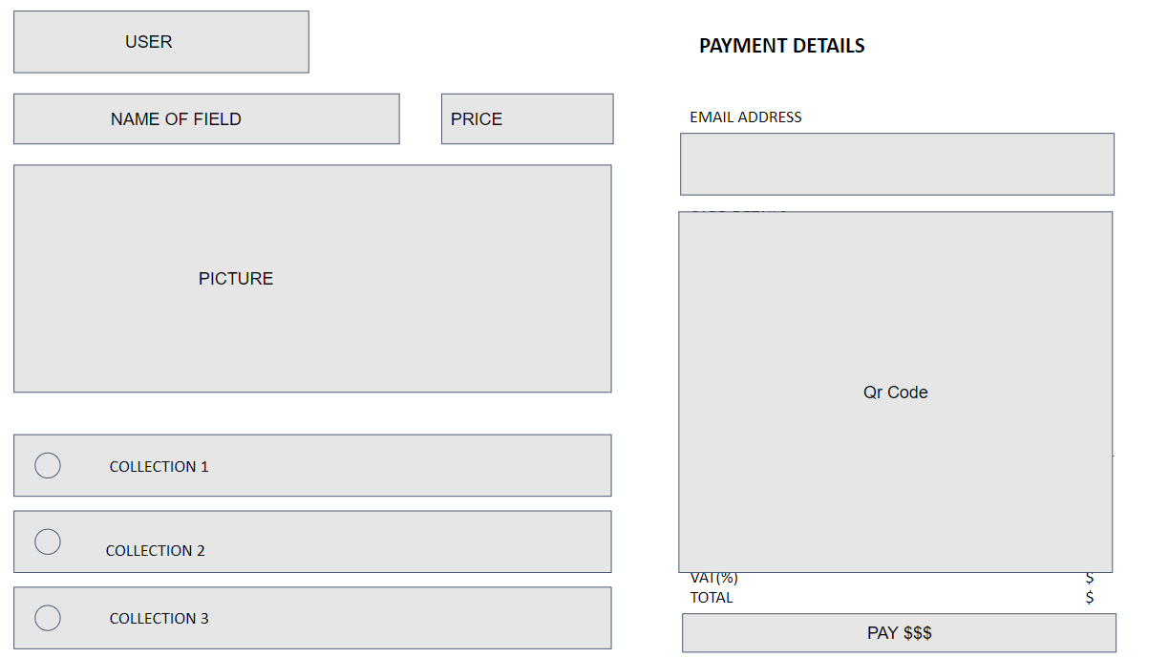

Function detail: When paying, if there is enough money in momo's account, and the money has been transferred. A success message will be displayed, if unsuccessful, a failure message will be displayed.

## 18. View contact page

### View contact information

Function trigger: when user click on contact button

Function description: When user need to contact with admin, they will click on the contack button for sending mail to admin, viewing admin’s phone number, e-mail, website link.

Screen layout:

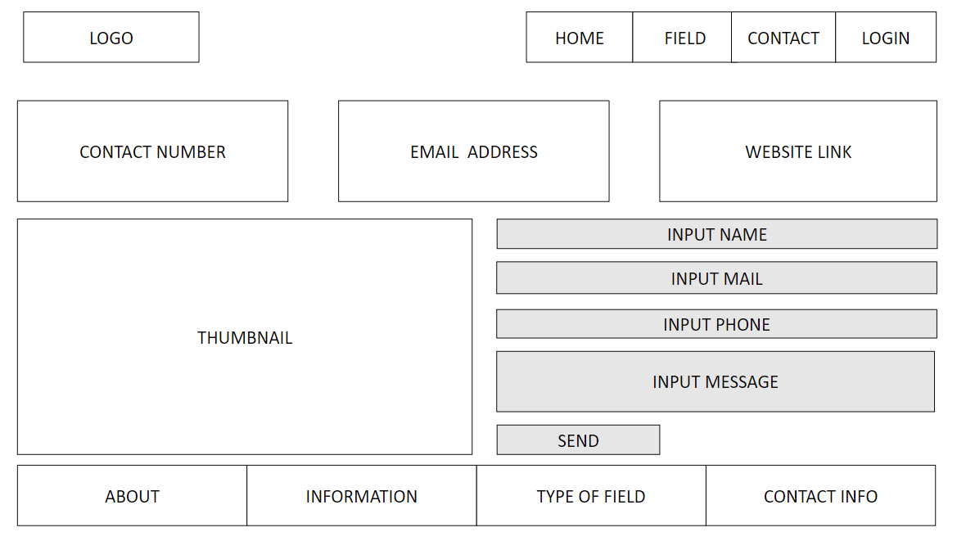

Function details: Clicking Contact button at the header of the home page, customers can redirect to the contact page which user need to input name, e-mail, phone number and message.