

**FOOTBALL FIELD BOOKING SYSTEM**

**Software Design Document**

– HCM, August 2022 –

**Table of Contents**

I. Overview 3

1. Code Packages 3

2. Database Schema 3

II. Code Designs 4

1. <Feature/Function Name1> 4

a. Class Diagram 4

b. Class Specifications 4

c. Sequence Diagram(s) 4

d. Database queries 5

2. <Feature/Function Name2> 5

III. Database Tables 5

1. <Table name 1> 5

2. <Table name 2…> 5

# I. Overview

## 1. Code Packages/Namespaces

*[Provide the package diagram for each sub-system. The content of this section including the overall package diagram, the explanation, package and class naming conventions in each package. Please see the sample and description table format below – following Java project naming convention]*

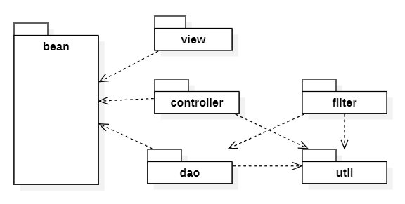

***Package descriptions & package class naming conventions***

| **No** | **Package** | **Description** |
| --- | --- | --- |
| *01* | *<Package name>* | *<Description of the package>*  *<Class naming convention>* |
| *02* |  |  |

## 2. Database Schema

ERD + Database Diagram

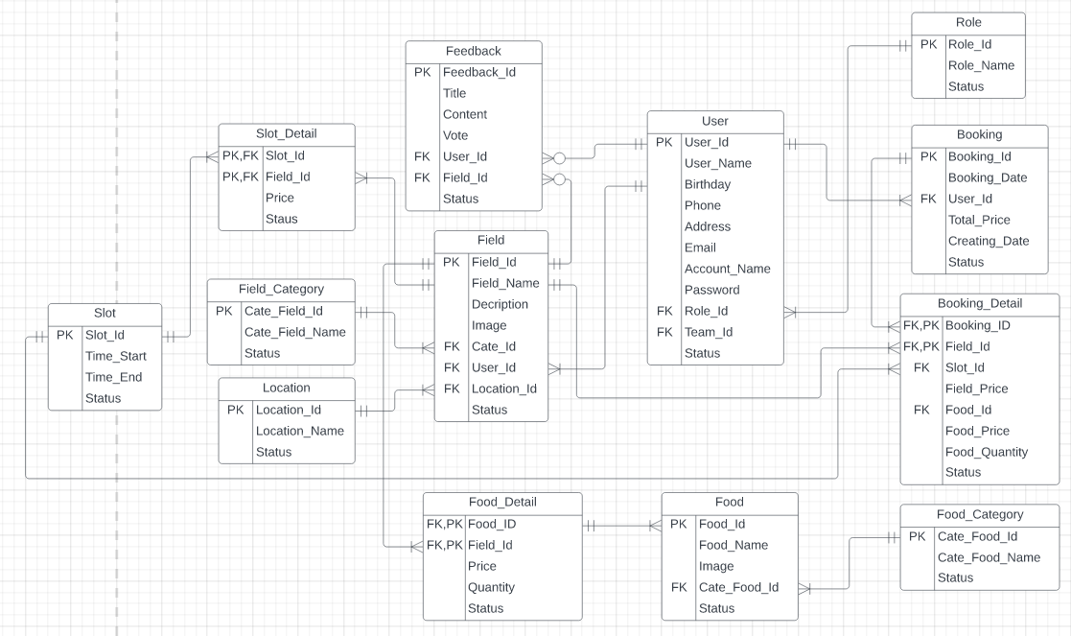

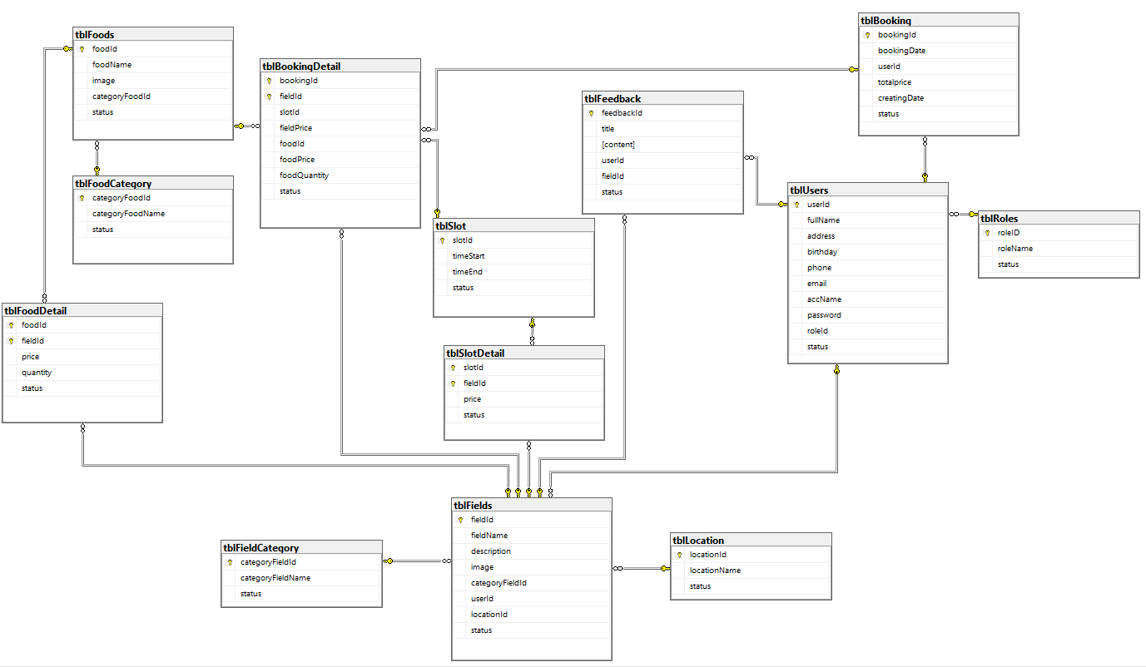

***Table descriptions & package class naming conventions are as below***

| **No** | **Table** | **Description** |
| --- | --- | --- |
| 01 | tblUsers | <Description of the table>  - Primary keys: userId  - Foreign keys: roleId |
| 02 | tblFields | <Description of the table>  - Primary keys: fieldId  - Foreign keys: categoryId, userId, locationId |
| 03 | tblRole | <Description of the table>  - Primary keys: roleId |
| 04 | tblBooking | <Description of the table>  - Primary keys: bookingId  - Foreign keys: userId |
| 05 | tblBookingDetail | <Description of the table>  - Primary keys: bookingId, fieldId  - Foreign keys: bookingId, fieldId |
| 06 | tblLocation | <Description of the table>  - Primary keys: locationId |
| 07 | tblCategory | <Description of the table>  - Primary keys: categoryId |
| 08 | tblFeedback | <Description of the table>  - Primary keys: feedbackId  - Foreign keys: userId, fieldId |
| 09 | tblSlot | <Description of the table>  - Primary keys: slotId |
| 10 | tblSlotDetail | <Description of the table>  - Primary keys: slotId, fieldId  - Foreign keys: slotId, fieldId |
| 11 | tblFood | <Description of the table>  - Primary keys: foodId  - Foreign keys: categoryFoodId |
| 12 | tblFoodDetail | <Description of the table>  - Primary keys: foodId, fieldId  - Foreign keys:foodId, fieldId |
| 13 | tblFoodCategory | <Description of the table>  - Primary keys: categoryFoodId |

# II. Code Designs

## 1. <Feature/Function Name1>

*[Provide the detailed design for the function <Feature/Function Name1>. It include Class Diagram, Class Specifications, and Sequence Diagram(s)]*

### a. Class Diagram

*[This part presents the class diagram for the relevant feature]*

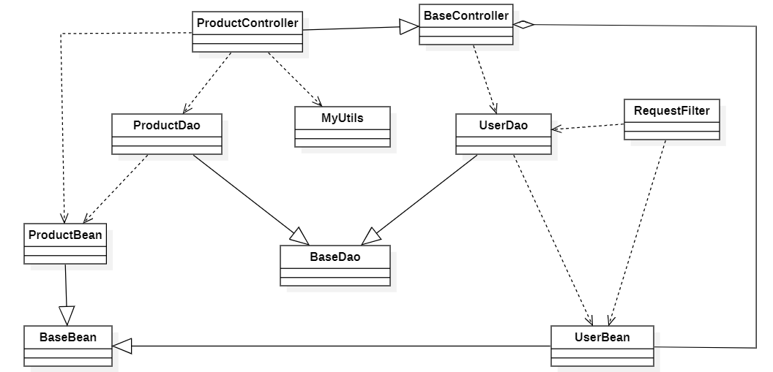

### b. Class Specifications

*[Provide the description for each class and the methods in each class, following the table format as below]*

#### XYZ Class

*[Provide the detailed description for the class methods]*

| **No** | **Method** | **Description** |
| --- | --- | --- |
| *01* | *<method name>* | *<Description of the method, including the inputs, outputs & internal method processing>* |
|  |  |  |

#### ABC Class

***Class Methods***

*[Provide the detailed description for the class methods]*

| **No** | **Method** | **Description** |
| --- | --- | --- |
| *01* | *<method name>* | *<Description of the method, including the inputs, outputs & internal method processing>* |
|  |  |  |

### c. Sequence Diagram(s)

*[Provide the sequence diagram(s) for the feature, see the sample below]*

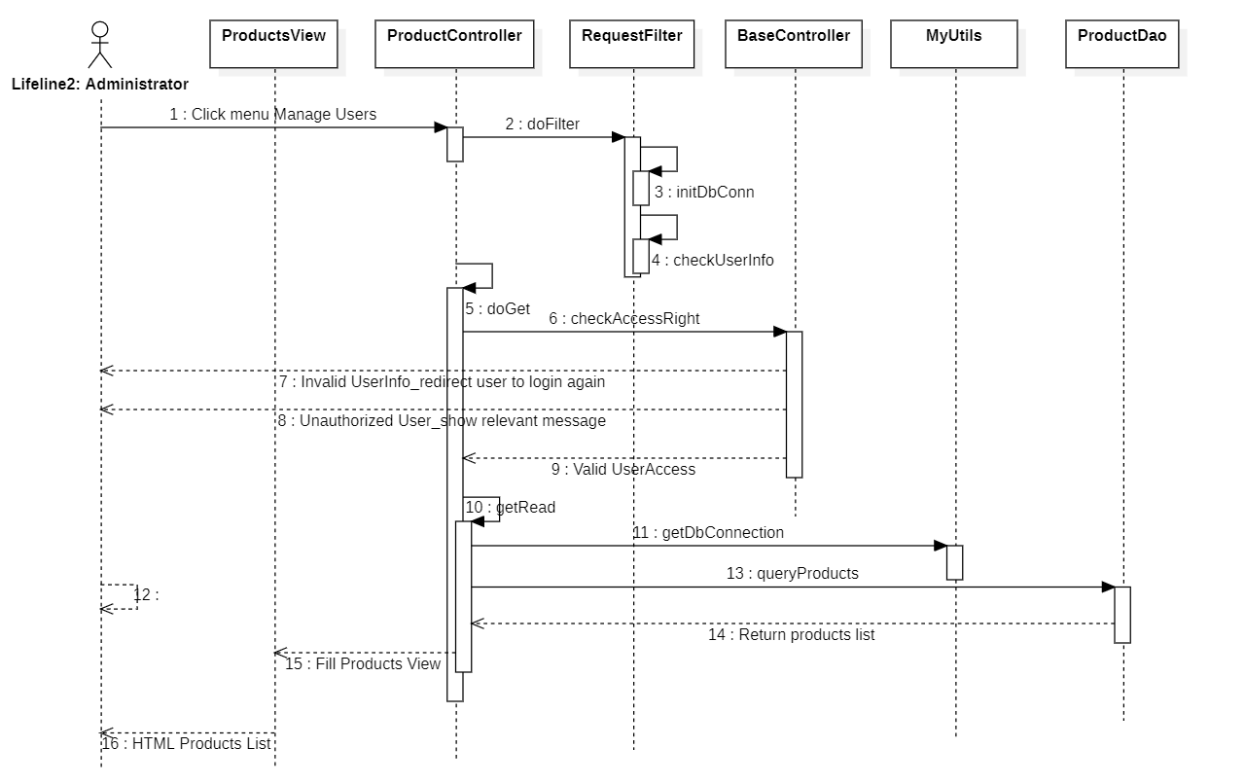

### d. Database queries

*[Provide the detailed SQL (select, insert, update...) which are used in implementing the function/screen]*

## 2. <Feature/Function Name2>

…

# III. Database Tables

## 1. <Table name 1>

*[Give some lines about the table here>>*

*[Table fields, in the form of table format as below]*

| **#** | **Field name** | **Type** | **Size** | **Unique** | **Not Null** | **PK/FK** | **Notes** |
| --- | --- | --- | --- | --- | --- | --- | --- |
| 1 | Field name1 |  |  |  |  |  |  |
| 2 | Field name2 |  |  |  |  |  |  |

## 2. <Table name 2…>