

**FOOTBALL FIELD BOOKING SYSTEM**

**Software Requirement Specification**

– HCM, August 2022 –

**Table of Contents**

I. Overview **4**

1. Introduction 4

2. System Functions 6

a. Screen Flow 6

b. Screen Details 7

c. User Authorization 8

d. Non-Screen Functions 10

3. Common Requirements 10

II. Functional Requirements **10**

1. View account’s profile 10

a. Query profile of user 10

b. Update profile of user 11

a. Login 11

b. Authentication 11

Create account 12

Input new password 12

Query all data manager of field 12

Search by id 12

Sort by created date 13

Search data by address 13

Query all data of Customer 13

Search data by ID 13

Search data by Address 14

Query all data of Field export 14

Query time active of Field(NF) 14

Query Field most recent 14

Query all data 15

Search data 15

Query all data of Field 15

Function trigger: when click Manage Field page. 15

Update data 15

Query all data 15

Search field request by name. 16

Search field request by address. 16

Accept request 16

Reject request 17

View customer page 17

Query all fields 17

Search field request by name. 17

Search field request by address. 17

Query all fields data 18

Rating by stars and comment 18

Calculate the average of stars 19

Feedback 19

Search by name 19

b. Update profile of user 20

… 20

2. Feature Name 2 20

# I. Overview

## 1. Introduction

After stressful working and studying hours, people today tend to go to entertainment areas to relieve stress such as: eating, meeting friends,.... Grasping these essential needs, many people have organised the business of rental field services. But to ensure the ability to attract customers to play, quality advertising and information provision is one of the leading essential things. This requires managers to set up a separate website for their football field to easily manage and provide information to guests. The website not only helps customers easily set the schedule to view the football field information, but also helps the football field manager to control the entire football field system, participants use the website on a computer easily.

The football field booking system that we want to mention here is to build a website to provide customers with detailed information about the field location, the situation of the football field. The specific price of each type of field and the services provided by the football field to customers exactly so that customers can choose the right and quick football field. It will also reduce difficulties in the management of the owner. This system can manage a large number of field owners at the same time. Field owners can use this system to have customers and create fields easier.

The admin can create, delete, update, see list of fields 5, 7, 11, list of free or busy fields. View a list of customer information. List of customers who book the most yards by month. The list of customers is not active (day, month, ...). Manage revenue of the field by day, month, year. Manage the process of online booking, online cancellation. Manage customer transaction information and between the yard owner. Manage the process of importing and exporting information of the fields, the price of the match. Manage information stored in the database, retrieve information. Manage the review, opinion of customers about the field.

The customer can view, edit their profile, view list field, search by name, search by location, book field, view field in details, booking order, feedback only when customer has booked the fields.

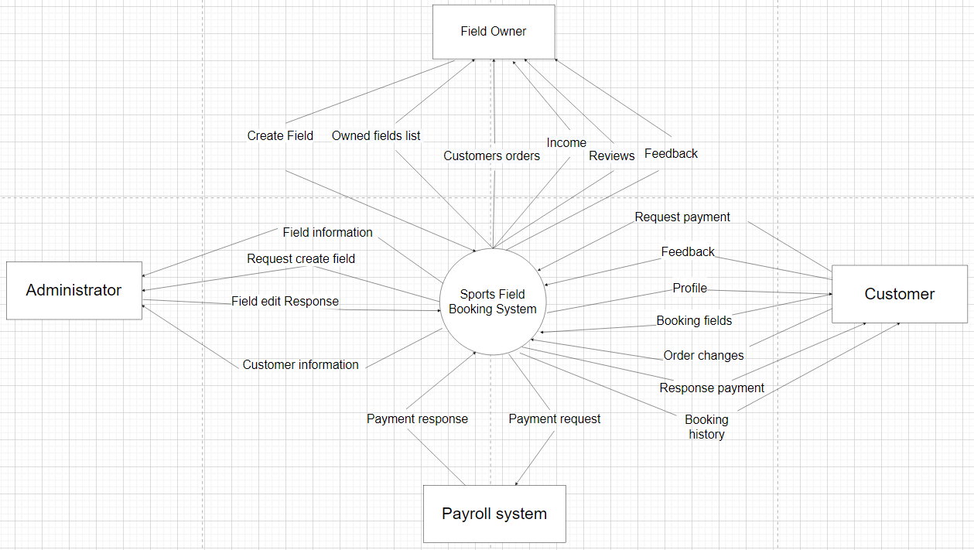

## 

## 2. System Functions

#### a. Screen Flow

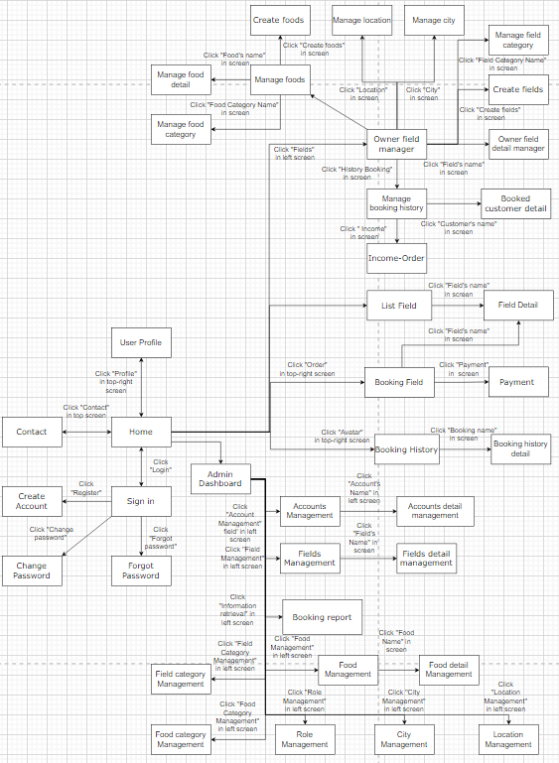

#### b. Screen Details

| **#** | **Feature** | **Screen** | **Description** |
| --- | --- | --- | --- |
| 1 | Authentication | Sign in | User logins account |
| 2 | Sign up account | Create account | User creates a new account |
| 3 | Reset password | Forgot password | User can find their forgotten password |
| 4 | Change new password | Change password | User can change their password |
| 5 | View account’s profile | User profile | User can view, edit their profile |
| 6 | View landing page | Home | User views home page |
| 7 | View list of field | List field | List of field will be shown to user |
| 8 | View field detail | Field detail | View the information of the field |
| 9 | Booking field | Order field | Customers book field |
| 10 | View contact information | Contact | Users view the contact of the specific field |
| 11 | Pay money | Payment | Customers paid booked field |
| 12 | View history of booking | Booking history | Customers view the history order |
| 13 | View detail history of booking | Booking history detail | Customers view the detail of history order |
| 14 | Manage list owner’s field | Owner field manager | Field owners view, search their own list of field |
| 15 | Manage owner’s field detail | Owner field detail manager | Field owners view, update, delete their own field detail |
| 16 | Create new field | Create fields | Field owners create new fields |
| 17 | View field category of owner’s field | Manage field category | Field owners view, search update, delete field category |
| 19 | View booking history of owner’s field | Manage booking history | Field owners can see customer who booked their fields |
| 20 | View booked customer detail | Manage booked customer | Field owners can see the profile of customer who booked their fields |
| 21 | Create new foods | Create foods | Field owners create new foods |
| 22 | View foods of owner’s field | Manage foods | Field owners view, search their own foods |
| 23 | View detail foods of owner’s field | Manage foods detail | Field owners view, update, delete their own food detail |
| 24 | View food category of owner’s field | Manage food category | Field owners view, search update, delete food category |
| 25 | View location of field | Manage location | Field owners view, search update, delete location |
| 26 | View city of field | Manage city | Field owners view, search update, delete city |
| 27 | View Income-Order | Income-Order | Field owners view the income of the specific field |
| 28 | View admin page | Admin Dashboard | When logged in as admin will be taken to the page |
| 29 | Manage list of fields | Fields Management | Admin can view, search list of fields  Allows admin to review or enable/disable fields |
| 30 | Manage detail of fields | Fields detail Management | Admin can view, update, delete field |
| 31 | Manage list of accounts | Accounts Management | Admin can view, search list of accounts  Allows admin to review or enable/disable accounts |
| 32 | Manage detail of accounts | Accounts detail Management | Admin can search, update, delete account |
| 33 | Manage booking history | Booking report | Admin can view, search update booking history |
| 34 | Manage foods | Food Management | Admin can view, search foods |
| 35 | Manage food detail | Food detail Management | Admin can search, update, delete food detail |
| 36 | Manage field category | Field category Management | Admin can view, search, update, delete field category |
| 37 | Manage food category | Food category Management | Admin can view, search, update, delete food category |
| 38 | Manage role | Role Management | Admin can view, search update, delete role |
| 39 | Manage city | City Management | Admin can view, search update, delete city |
| 40 | Manage location | Location Management | Admin can view, search update, delete city |

1 feature là có thể 1 hoặc nhiều screen : 1 screen nhiều function-> description

#### c. User Authorization

| **Screen** | **Admin** | **Field owner** | **Customer** | **Others** |
| --- | --- | --- | --- | --- |
| Contact | x | x | x | x |
| View contact information |  |  |  |  |
| Home | x | x | x | x |
| View home page |  |  |  |  |
| User Profile | x | x | x |  |
| Profile of user |  |  |  |  |
| Update profile of user |  |  |  |  |
| Sign in | X | x | x | x |
| Login |  |  |  |  |
| Create account | x | x | x | x |
| Create account |  |  |  |  |
| Forget Password | x | x | x | x |
| Input New Password |  |  |  |  |
| Change Password | x | x | x | x |
| Change new Password |  |  |  |  |
| Admin Dashboard | x |  |  |  |
| View admin page |  |  |  |  |
| Accounts Management | x |  |  |  |
| Create account |  |  |  |  |
| Search account |  |  |  |  |
| Accounts detail management | x |  |  |  |
| Delete account |  |  |  |  |
| Update account |  |  |  |  |
| Fields management | x |  |  |  |
| Search Fields |  |  |  |  |
| Fields detail management | x |  |  |  |
| Update Field |  |  |  |  |
| Delete Fields |  |  |  |  |
| Foods management | x |  |  |  |
| Search Fields |  |  |  |  |
| Update Field |  |  |  |  |
| Delete Fields |  |  |  |  |
| Booking report | x |  |  |  |
| Search info history Booking field |  |  |  |  |
| Sort info history booking |  |  |  |  |
| List Field | x | x | x | x |
| Search Active Field |  |  |  |  |
| Paging |  |  |  |  |
| Field detail | x | x | x | x |
| View detail of Field |  |  |  |  |
| Feedback |  |  |  |  |
| View Similar Field |  |  |  |  |
| Booking Field |  |  | x |  |
| Update Booking Field |  |  |  |  |
| Delete Booking Field |  |  |  |  |
| View Booking Field |  |  |  |  |
| Payment |  |  | x |  |
| View QR code |  |  |  |  |
| Check out |  |  |  |  |
| Booking History |  |  | x |  |
| View all Order of customer |  |  |  |  |
| Search order of customer |  |  |  |  |
| Booking history detail |  |  | x |  |
| View detail booked fields |  |  |  |  |
| Owner Field Manager |  | x |  |  |
| Search field of manager |  |  |  |  |
| Delete Field of manager |  |  |  |  |
| Search slot of field |  |  |  |  |
| Delete slot of field |  |  |  |  |
| Update slot of field |  |  |  |  |
| Create Field |  | x |  |  |
| Input information of new field |  |  |  |  |
| Create Food |  | x |  |  |
| Input information of new food |  |  |  |  |
| Create Slot |  | x |  |  |
| Input information of new slot |  |  |  |  |
| Manage Food |  | x |  |  |
| View list food of Manager |  |  |  |  |
| Search food of manager |  |  |  |  |
| Delete food of manager |  |  |  |  |
| Owner Field Detail manager |  | x |  |  |
| View information detail of Field |  |  |  |  |
| Update Field of manager |  |  |  |  |
| Manage booking history |  | x |  |  |
| View all booking field of customer |  |  |  |  |
| Search booked Field |  |  |  |  |
| Delete Customer Booking |  |  |  |  |
| Page table Customer booking |  |  |  |  |
| Manage booking detail |  | x |  |  |
| Ui detail booking |  |  |  |  |
| Income-Order |  | x |  |  |
| Search income |  |  |  |  |
| Update income |  |  |  |  |
| Delete income |  |  |  |  |
| Sum income of all order |  |  |  |  |

In which:

* Role1: Admin
* Role2: Manager
* Role3: Customer

#### d. Non-Screen Functions

| **#** | **Feature** | **System Function** | **Description** |
| --- | --- | --- | --- |
| 1 | Email | Send mail | When customers order, the system will automatically send an email to the manager of the system. |
| 2 | Payment by momo | Payment | When customers pay for booking, the system will automatically request payment by momo. |

## 3. Common Requirements

* Web Server Apache Tomcat 9/10-IIS
* Web Browser Chrome: Version 101.0.4951.67. ….
* SQL Server: 2019

# II. Functional Requirements

## 1. View account’s profile

### a. Query profile of user

Function trigger: When clicking on the User Profile.

Function description: Login User can access, click User Profile to show all of the information of that user by searching the database with UserID.

Screen layout:

Function details: Once click on the User Profile (if the User already logged in) the system will get the UserID of that User then search in the database and then send back all of the information of that User like name, phone, email, age, etc.. for the User

### b. Update profile of user

Function trigger: when click Save button in the User Profile.

Function description: Login User can access when clicking User Profile that User can update their information and click Save button to commit, the system will get all of the updated information with UserID and update it in the system.

Screen layout:

Function details: Users can edit their information when clicking on User Profile where they can input the new information and when done click the Save button, the system will take all the inputted information and update it in the database using UserID.

**2. …**

### a. Login

Function trigger: when click Login button

Function description: User(admin/field owner/customer) can login to their account after filling UserName and Password and clicking the Login button.

Screen layout:

Function details: Users log in to their account with UserName and Password. Once the Login button is clicked both UserName and Password date will get searched in the database if matched User can log in to their account else if wrong Password or RoleID is not supported it will show the Error message to the User.

### b. Authentication

Function trigger: when Users access any pages.

Function description: When Users join any page there will be a Role check to see if that User can further access that page or not.

Screen layout:

Function details: When Users access any pages of the website there will be a check if that User’s role can further access the page or not if the user tries to access pages that their role is not supported the User gets sent to the home page.

**3. …**

### Create account

Function trigger: when click Create account button in create account page.

Function description: Users create a new account after clicking the Create new account button on the login page.

Screen layout:

Function details: Users create new accounts by filling a form on the create account page with the Customer role. After clicking the create button all of the data will be sent and saved in the database and the User can log in with that account.

**4. …**

### Input new password

Function trigger: when click Forgot password button on the login page.

Function description: When Users forgot their password they can input a new password for their account after answering questions.

Screen layout:

Function details: Users that forgot the account password can input a new password for their account if they User correctly answers all of the questions to confirm if that User owns that account or not. When done the new password will be saved for that account in the database and the user can log in with the new account.

**5. Manage manager information**

### Query all data manager of field

Function trigger: when click Manage Manager page.

Function description: The administrator view all of the Manager information.

Screen layout:

Function details: Administrator click on Manage Manager the system will go into the database and query all of the Manager that is in the database if the Manager exists result will be shown else “Not Found” will be shown.

### Search by id

Function trigger: when choosing search type (AccountID) and click search on the Manage Manager page.

Function description: Administrator search Manager using AccountID to view all of the information.

Screen layout:

Function details: Administrator choose search type (AccountID) then input an AccountID of the Manager and click search, the system will get that input and then search in the database for that Manager if the Manager exists result will be shown else “Not Found” will be shown.

### Sort by created date

Function trigger: when click the Manage Manager page and choose Sort(Created Date).

Function description: The administrator views all of the Managers information in both Ascending and Descending order.

Screen layout:

Function details: The administrator clicks Sort by Created Date(Ascending or Descending) on the Manage Manager page, the system will sort all of the items into the order and then show all to the Administrator.

### Search data by address

Function trigger: when choosing search type (Address) and choose dropdown list Address then click search on the Manage Manager page.

Function description: The administrator views all of the information of the Manager that has the same Address.

Screen layout:

Function details: Administrator chooses search type (Address) then chooses an Address in the dropdown list and clicks search, the system will get that input and then search in the database for that Manager if the Manager exists result will be shown else “Not Found” will be shown.

**6. Manage Customer information**

### Query all data of Customer

Function trigger: when click Manage Customer page.

Function description: The administrator view all of the Customer information.

Screen layout:

Function details: The administrator clicks on the Manage Customer page the system will go into the database and query all of the customers that are in the database if the Customer exists result will be shown else “Not Found” will be shown.

### Search data by ID

Function trigger: when clicking the Manage Customer page, choose Search type(Account ID) input AccountID and click Search.

Function description: The administrator view all of the Customer information that has the same AccountID.

Screen layout:

Function details: On the Manage, Customer page Administrator can choose Search type(AccountID) and input AccountID then clicks Search the system will go into the database and query all of the customers that have the same input if the Customer exists result will be shown else “Not Found” will be shown.

### Search data by Address

Function trigger: when clicking the Manage Customer page, choose Search type(Address) choose Address in the dropdown list and click Search.

Function description: The administrator view all of the Customer information that has the same Address.

Screen layout:

Function details: On the Manage, Customer page Administrator can choose Search type(Address) and choose Address in a dropdown menu then click Search the system will go into the database and query all of the customers that have the same input if the Customer exists result will be shown else “Not Found” will be shown.

**6. Manage actives of Field**

### Query all data of Field export

Function trigger: when click Manage Field page.

Function description: The administrator view all of the Field information.

Screen layout:

Function details: The administrator clicks on Manage Field the system will go into the database and query all of the fields that are in the database if there’s a field result will be shown else “No Field” will be shown.

### Query time active of Field(NF)

Function trigger: when click Manage Field page.

Function description: The administrator view all of the Field information.

Screen layout:

Function details: Administrator click on Manage Manager the system will go into the database and query all of the Manager that is in the database if the Manager exists result will be shown else “Not Found” will be shown.

### Query Field most recent

Function trigger: when click Manage Field page and choose most recent sort.

Function description: The administrator view all of the most recent fields created by sorting.

Screen layout:

Function details: Administrator click on Manage Field and choose the most recent sort the system will go into the database and query all of the fields that are in the database then all fields get sorted and return to Administrator

**7. Manage all Field(NF)**

### Query all data

Function trigger: when click Manage Field page.

Function description: The administrator view all of the Field information.

Screen layout:

Function details: The administrator clicks on Manage Field the system will go into the database and query all of the fields that are in the database if there’s a field result will be shown else “No Field” will be shown.

### Search data

Function trigger: when click Manage Field page.

Function description: The administrator view all of the Field information.

Screen layout:

Function details: Administrator click on Manage Manager the system will go into the database and query all of the Manager that is in the database if the Manager exists result will be shown else “Not Found” will be shown.

**8. Detail actives of Field(NF)**

### Query all data of Field

### Function trigger: when click Manage Field page.

Function description: The administrator view all of the Field information.

Screen layout:

Function details: The administrator clicks on Manage Field the system will go into the database and query all of the fields that are in the database if there’s a field result will be shown else “No Field” will be shown.

### Update data

Function trigger: when clicking the Manage Field page.

Function description: The administrator view all of the Field information.

Screen layout:

Function details: Administrator click on Manage Manager the system will go into the database and query all of the Manager that is in the database if the Manager exists result will be shown else “Not Found” will be shown.

**9. List request create a field of Managers**

### Query all data

Function trigger: when click Field Request page.

Function description: The administrator view all of the requests.

Screen layout:

Function details: The administrator clicks on the Field Request page the system will go into the database and query all of the requests that have the status of pending that are in the database if there are any requests result will be shown else “No Request” will be shown.

### Search field request by name.

Function trigger: when clicking the Field Request page choose search type(name) then input the name and click the search button.

Function description: The administrator view all of the requests that have the same input.

Screen layout:

Function details: Administrator click on the Field Request page, choose search type(name) then input name, and click search the system will go into the database and query all of the requests that have the status of pending and has the same name that is in the database if there are any requests result will be shown else “No Request” will be shown.

### Search field request by address.

Function trigger: when clicking the Field Request page choose search type(Address) then choose an address in the dropdown list and click the search button.

Function description: The administrator view all of the requests that have the same input.

Screen layout:

Function details: Administrator click on the Field Request page, choose search type(address) then choose an address in the dropdown list and click the search button the system will go into the database and query all of the requests that have the status of pending and have the same address that is in the database if there are any requests result will be shown else “No Request” will be shown.

### Accept request

Function trigger: when clicking the Field Request page choose the confirm button.

Function description: Administrator accept requests.

Screen layout:

Function details: The administrator clicks on the Field Request page and clicks accept button on the field Administrator who wants to accept the system will go into the database and query that field and change the status to active.

### Reject request

Function trigger: when clicking the Field Request page choose the reject button.

Function description: Administrator rejects requests.

Screen layout:

Function details: The administrator clicks on the Field Request page and clicks the reject button on the field Administrator who wants to reject the system will go into the database and query that field and change the status to reject.

**10. Customer view homepage**

### View customer page

Function trigger: when clicking home or visiting a website.

Function description: Customers will get redirected to a custom homepage.

Screen layout:

Function details: When customers click home or visit a website the system will redirect customers to the customer's homepage.

**11. List Fields**

### Query all fields

Function trigger: When clicking home or visiting a website.

Function description: Customers view all fields available.

Screen layout:

Function details: When customers click home or visit a website the system will query all of the fields that have the status of action if there are any fields available result will be shown else “No Field” will be shown.

### Search field request by name.

Function trigger: When on the homepage, choose the search type(name) then input the name, and click the search button.

Function description: Customers view all of the fields that have the same input.

Screen layout:

Function details: When customers choose search type(name) then input name and click search the system will go into the database and query all of the fields that have the status of active and has the same name input if there are any fields result will be shown else “No Fields” will be shown.

### Search field request by address.

Function trigger: When on the homepage, choose search type(Address) then choose an address in the dropdown list and click the search button.

Function description: Customers view all of the fields that have the same input.

Screen layout:

Function details: When customers choose search type(address) then choose an address in the dropdown list and click the search button the system will go into the database and query all of the fields that have the status of active and has the same address if there are any fields result will be shown else “No Field” will be shown.

**12. Field Detail**

### Query all fields data

Function trigger: When clicking on field name or field picture.

Function description: Customers view all of the field's information like name, picture, location, and owner.

Screen layout:

Function details: When customers click on field name or field picture the system will query all of the information of that field and then show it to the customer.

**13. Field Order(NF)**

### 

Function trigger: When clicking on field name or field picture.

Function description: Customers view all of the field's information like name, picture, location, and owner.

Screen layout:

Function details: When customers click on field name or field picture the system will query all of the information of that field and then show it to the customer.

**14. Rating(Review)(NF)**

### Rating by stars and comment

Function trigger: In the field details page, choose the number of stars, comment, and click the leave review button.

Function description: Customers can rate a field by choosing the number of stars.

Screen layout:

Function details: When Customers click on a field name or picture they will find a rating system that has 1 to 5 stars. Select a number of stars and input a comment or leave blank then click the leave review button. The system will save and show reviews of that customer in the field rating box.

### Calculate the average of stars

Function trigger: When clicking on field name or field picture.

Function description: Customers can view the average stars' point of that field.

Screen layout:

Function details: When Customers click on a field name or picture the system will query the number of stars and the number of people who leaves a rating in the database then calculate the average and show it to customers.

### Feedback

Function trigger: When clicking feedback and typing in the feedback box then clicking a feedback button.

Function description: Customers or Managers can leave feedback on reviews.

Screen layout:

Function details: When clicking feedback and typing in the feedback box then clicking a feedback button

**15. Booking history**

### Search by name

Function trigger: On the history page, input the name in the search box, and click search.

Function description: Customers can rate a field by choosing the number of stars.

Screen layout:

Function details: When Customers click on a field name or picture they will find a rating system that has 1 to 5 stars. Select a number of stars and input a comment or leave blank then click the leave review button. The system will save and show reviews of that customer in the field rating box.

*[A function can be a screen or a non-screen function (listed in the part 5.1 above). In this part, you need to provide the details on the related function, focus on mentioning below information*

* *Function trigger: how this function is triggered (navigation path, a timing frequency, etc.*
* *Function description: actors/roles, purpose, interface, data processing, etc.*
* *Screen layout: mockup prototype of the screen, sample below is for Manage Products screen*

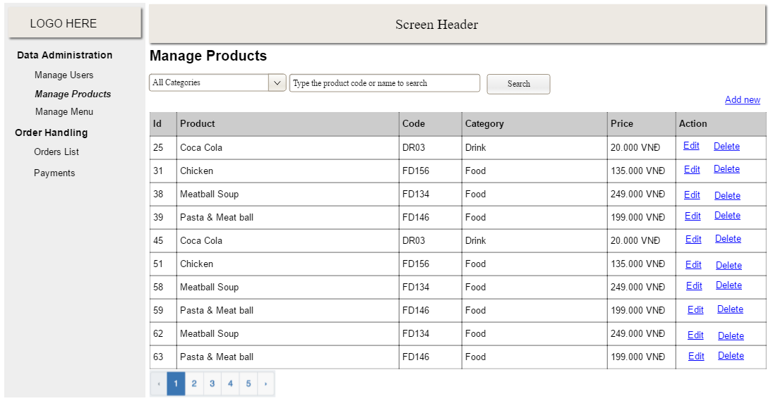

* *Function Details: provide explanation for the data, validation, business logics, functionalities (for both normal cases and abnormal cases), etc. of the function so that the reader can imagine how it works.*

*]*

### b. Update profile of user

### …

## 2. Feature Name 2

…