Voojibox Horn System User Guide

8 March 2014 Rev –

Written by :

Edward Wojtaszek dba Vooji Designs

votsek@yahoo.com

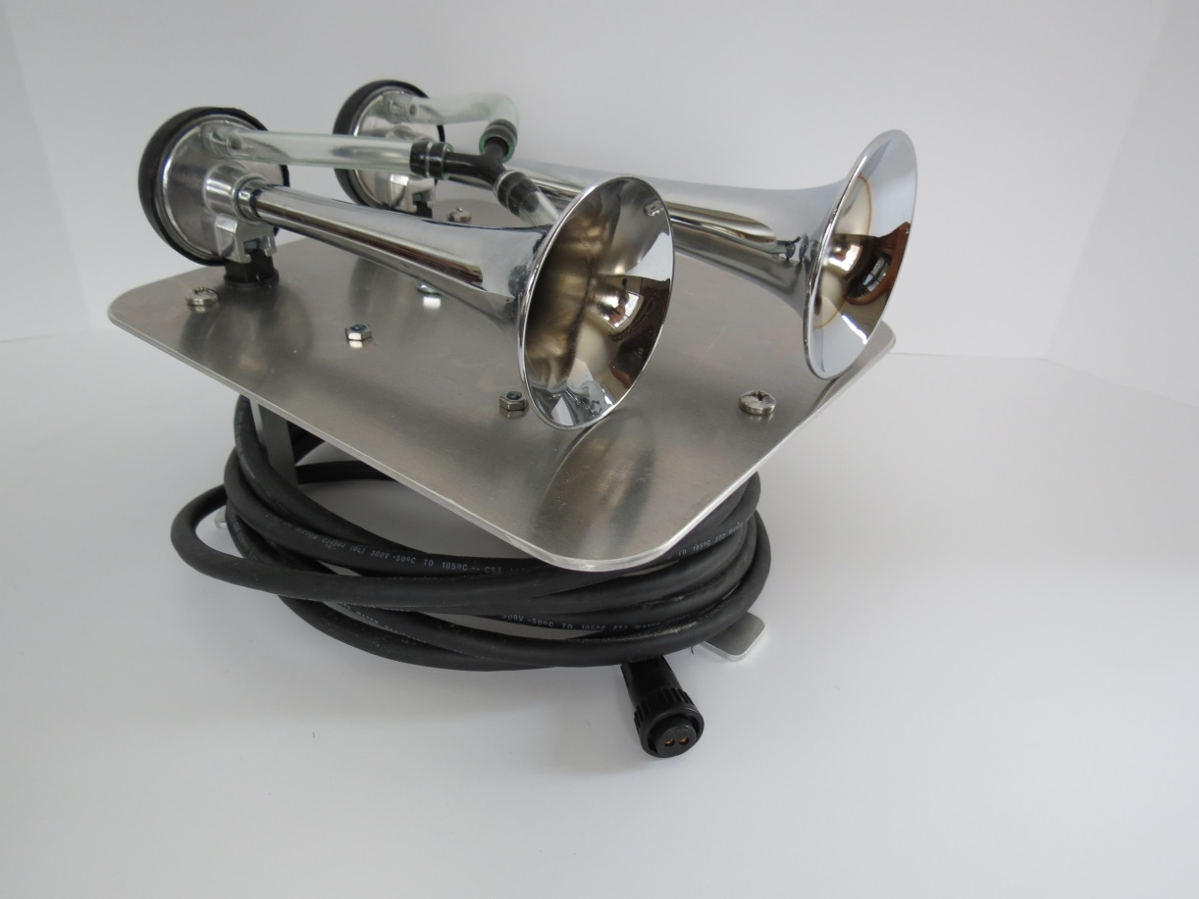

Voojibox Horn System User Guide

This document is provided for your personal use or for reuse under [Creative Commons BY-NC-SA 3.0](http://creativecommons.org/licenses/by-nc-sa/3.0/).

# Introduction

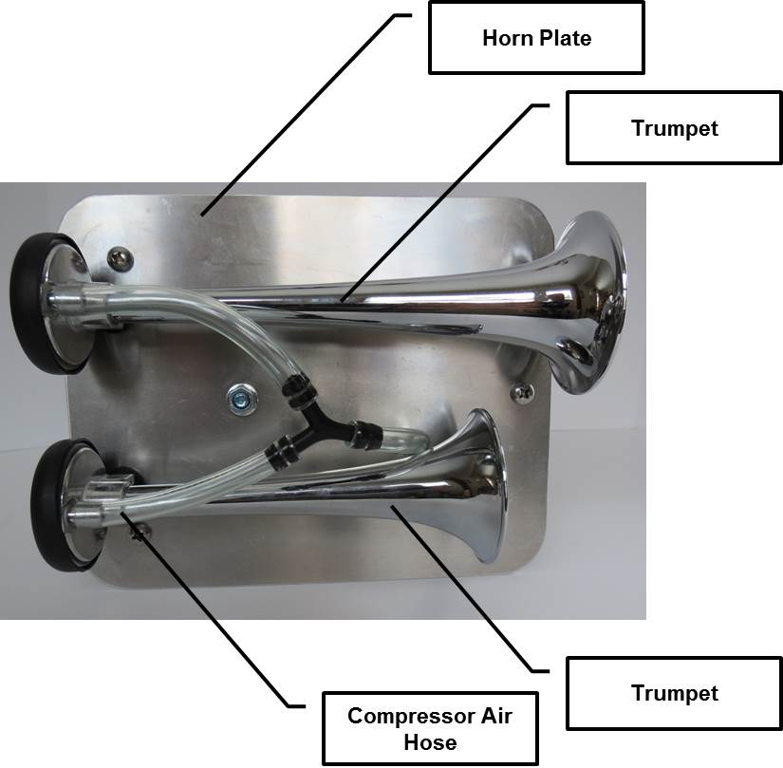The Voojibox Horn System does not have any switches or controls. It consists of the horn plate, the horn trumpets, compressor, and horn cable with polarized connector. The Horn Cable can only be connected one way to the Voojibox. The following photo shows the top of the horn system assembly.

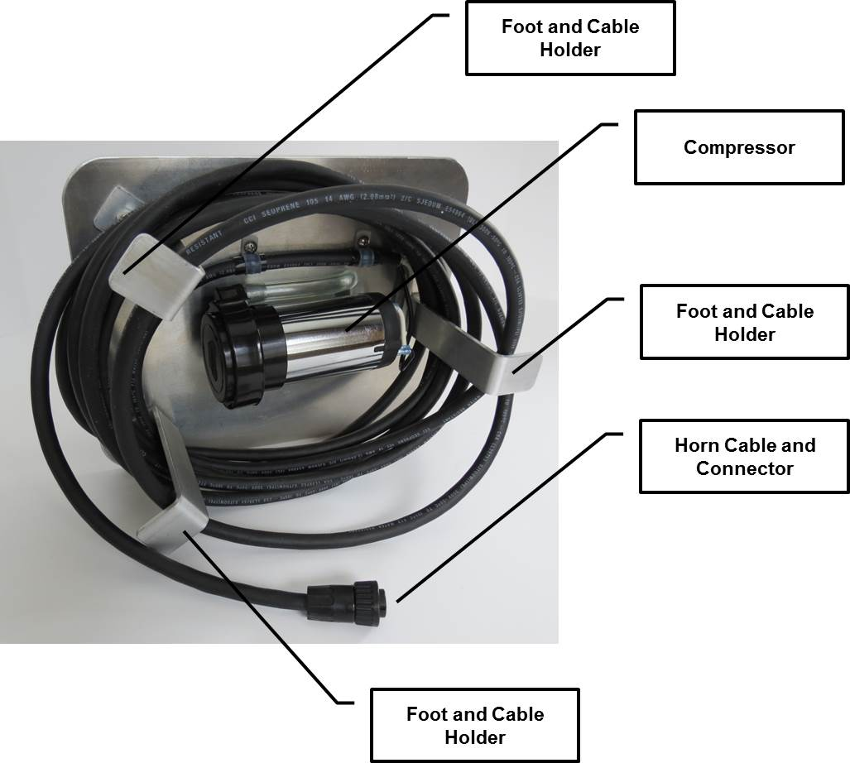The next photo shows the bottom of the horn system assembly. The feet are shaped so that the horn cable can be wrapped on them for storage.

# Setup and Use

The horn system must be connected to the Voojibox. The connector is polarized and will only fit one way. This protects the horn compressor from damage and assures the correct operation of the horns. Unwind the cord and fasten the connector to the Voojibox. The horn system should be connected to the Voojibox before the power is turned “ON”.

Place the horn assembly in a stable location with the trumpets facing away from the race personnel. Avoid locations where there is a risk of the assembly falling into the water. The horn assembly is not water proof.

The horn assembly must not be permanently attached to the committee vessel. The trumpets and compressor are not designed for outdoor storage or permanent outdoor mounting. Avoid excessive moisture. If the unit must be used in the rain, tilt the assembly so that the trumpets face slightly downward to avoid water entering them.

# Maintenance and Storage

Keep the horn cable clean and free of oil or solvents. Disconnect the horn cable from the Voojibox after use. Lightly wrap the horn cable around the feet of the horn system assembly for storage. Store the assembly in a dry location. It is recommended that the assembly be stored with the trumpet openings facing downward or tilted downward.