Voojibox User Guide

8 March 2014 Rev –

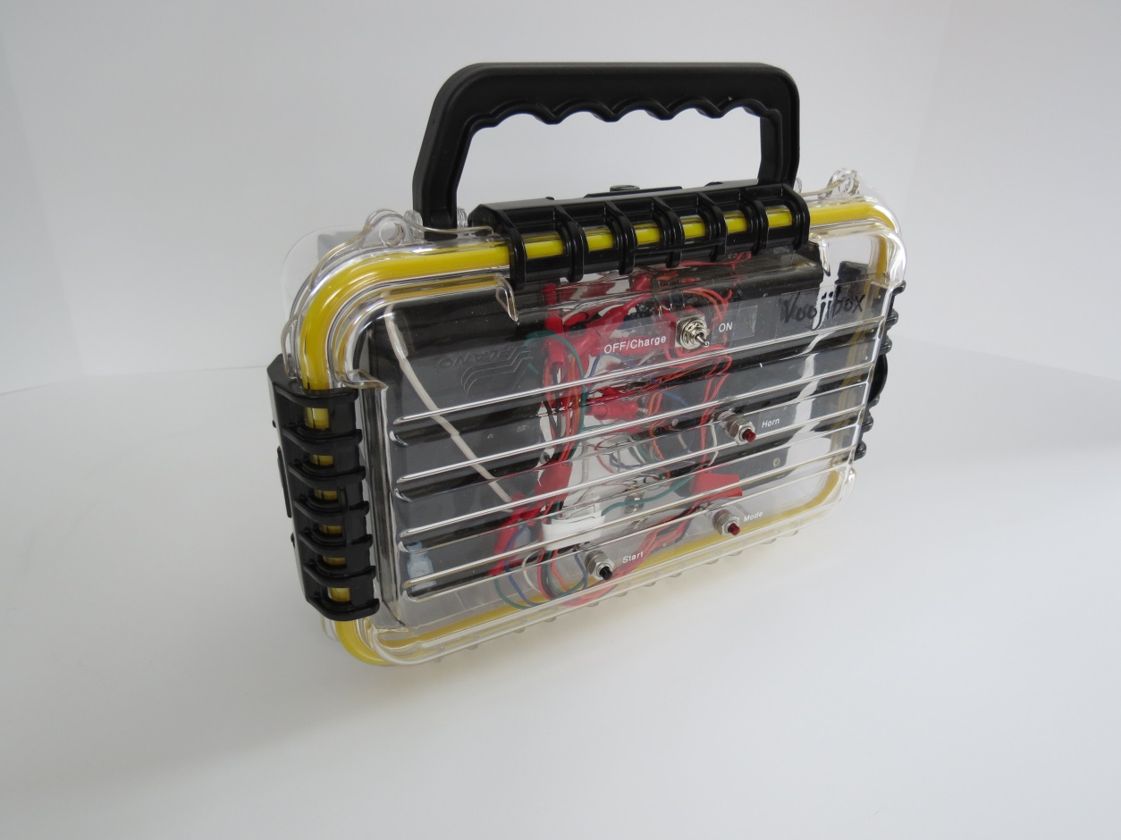

Written by :

Edward Wojtaszek dba Vooji Designs

votsek@yahoo.com

Voojibox User Guide

This document is provided for your personal use or for reuse under [Creative Commons BY-NC-SA 3.0](http://creativecommons.org/licenses/by-nc-sa/3.0/).

# Introduction

The Voojibox has simple controls and connections. Please familiarize yourself with these controls and connections before using the device. The following photo shows the controls. It also shows the position of the latches that must be released initially to connect the battery.

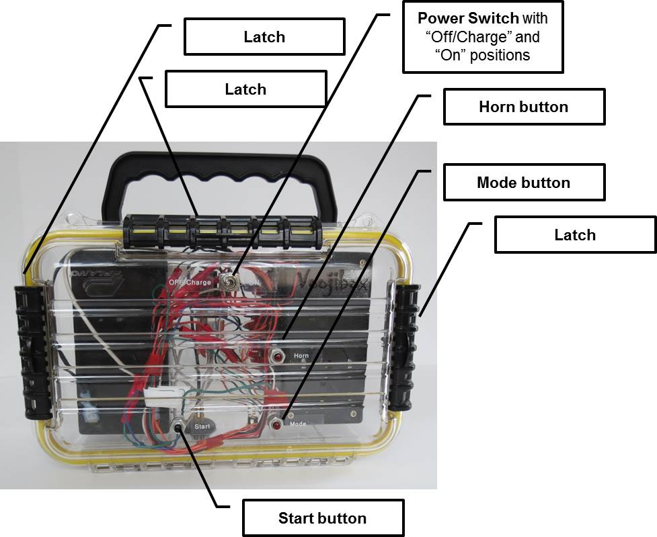

The next photo shows the location of the external connectors. The Horn Cable Connector is polarized and can only be connected one way. The Charger Connector is wired to be used with the charger provided. Use of any other charger may cause damage or may create a dangerous condition.

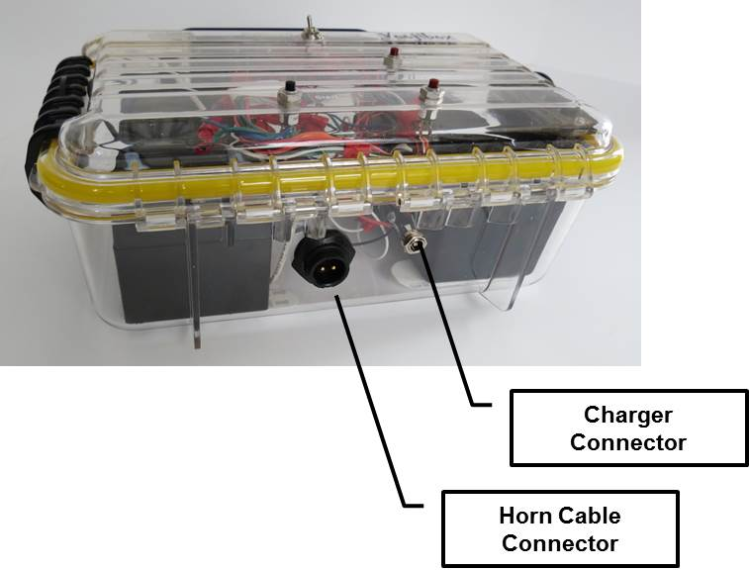

# Initial Setup

When you receive your Voojibox the battery must be connected and charged. Open the Voojibox case by lifting the latch tabs on three sides of the case. In addition to lifting the black latch tabs, you will also need to lift the black plastic latches away from the box.

Open the case and remove the packing material that is on top of the battery. Locate the white and black wires with the quick connect plugs. Connect the white wire to the positive (+) battery terminal and the black wire to the negative (-) battery terminal. Double check the connectors to be certain that they are attached to the correct battery terminals.

Close the case lid, being careful to avoid pinching the wires in the case seal since this can damage the wires. Turn the latches down over the latch seats on the bottom part of the case and flip the latch tabs up to the locked position.

The unit must be charges before first use. It is recommended that you charge in an open area away from flammable materials. The Voojibox power switch must be in the “Charge/Off” position. Connect the charger to the Voojibox using the coaxial charging plug on the side of the unit. Plug the charger block into a standard 115v wall outlet to charge. The initial charge may require eight hours or more.

After charging, disconnect the charger from the Voojibox and the wall outlet. The Voojibox is now ready for use.

# Race Setup

Place the Voojibox in a sturdy location on a console or the deck of the committee boat. Voojibox is not waterproof. Avoid placing it in a location where it will be hit by driving rain or salt water spray.

Connect the Voojibox to the horn system. Turn the device “On”. The green LED should be lit.

Select the start signal sequence. The Voojibox will “remember” the previously selected sequence since the last power off. Verify that the remembered sequence is the one desired. If it is, the Voojibox is ready to start the first race.

If the remembered sequence is not the one to be used, use the Mode button to select the sequence desired. The standard sequences are shown in the table below. The sequence is indicated by the yellow and red LEDs. The yellow LED, when lit, indicates that the signal sequence will be repeated as a rolling start. The red LED blinks to indicate the selected signal sequence as shown in the table. To set the mode, press and hold the Mode button for at least one second. You will see the yellow LED change state or blink once to indicate that the mode has been changed. Perform this button sequence to step through the available modes. After the last mode, the Voojibox will cycle back to the first mode.

|  |  |  |  |
| --- | --- | --- | --- |
| ***Table 1 – Voojibox Modes and LED Indicators*** | | | |
| **Mode** | **Selected Sequence** | **Red**  **Blinks** | **Yellow** |
| 0 | The starting sequence is three minutes long. The sequence is as specified in Appendix S, Sound-Signal Starting System, The Racing Rules of Sailing for 2013 - 2016, U.S. Sailing. A long signal is made at (t-0) to signal the start of the race. | 1 | OFF |
| 1 | Same as Mode 0, but the sequence repeats. The start of the three minute interval for fleets subsequent to the first is the long start signal at (t-0). | 1 | ON |
| 2 | Uses the Racing Rules of Sailing Rule 26 signaling. Sound signals are made at (t-5), (t-4), (t-1), and at the start (t-0). | 2 | OFF |
| 3 | The Mode 2 sequence repeats with the start of the five minute interval (t-5) being the start signal of the previous fleet at (t-0). | 2 | ON |
| 4 | Uses the Racing Rules of Sailing Rule 29.2. The first sound signal is made at (t-6), consisting of two long blasts. At (t-5), signaling reverts to Rule 26. | 3 | OFF |
| 5 | This rolling variant of Mode 4 uses the signaling of Mode 4 for the first start. After the first start signal at (t-0), the signaling reverts to Mode 3. That is, the start of the five minute interval (t-5) is the start signal of the previous fleet at (t-0). | 3 | ON |
| 6 | This is a special rolling mode called 3 x 1 Appendix S signaling. Appendix S signaling is used to start the first fleet as in Mode 0. Subsequent starts are signaled using the final one minute sequence of Appendix S. This is useful for pursuit races, which is an alternative to handicap races. | 4 | ON |

# Race Start

After the Start button is pressed and for all modes, there are five internal beeps, five short horn blasts, followed by five more internal beeps prior to the first start. These occur at one second intervals. The horn blasts are an aid to competitors, announcing the start signal will be made. The red LED is turned off; the yellow LED will remain on during rolling starts.

Rolling starts will continue until the device is turned off. After the start signal on non-rolling starts, the Start button can be used to start the next sequence of signals. The red LED will flash to indicate the mode. The mode may not be changed until the device is cycled off and back on.

During the signaling, the red LED is illuminated during the final minute of the sequence as an aid for the race committee. Also, for modes 2, 3, 4, and 5 there are three internal beeps fifteen seconds prior to each signal event. This is a race committee aid as well to alert them when flags supplement the audible signals.

The Horn button may be used during signaling to sound asynchronous blasts on the horn. It may also be used prior to the start of the race start signals. The purpose is to use the horn to call competitor attention to a general recall, a change in the race course, or other race committee action that affects the race. This is normally done in accordance with the racing instructions and The Racing Rules of Sailing.

# Race Sequence Abandon

To abandon a race sequence after a recall or other event that requires the start sequence to be terminated, the Voojibox must be reset by cycling the power Off and back On.

# Race End

After racing is completed, turn the Voojibox power switch to Charge/Off. Disconnect the horn. Store the Voojibox in a dry place so that it will be ready for the next race series.

# Maintenance

It is recommended to charge the Voojibox after each race series so that it is ready for next use. Remember that the Voojibox will only charge when the power is Off. Otherwise, no maintenance is required other than keeping the device clean and dry.