# *Petryna Volodymyr Vasyliovych*

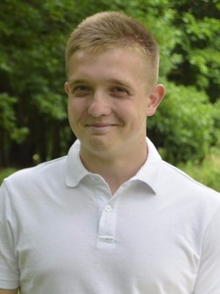

General information

***Occupation type***: Full time employment, part-time employment.

***Desired work city***: Lviv, Kyiv

***Categories***: IT, computers, Web.

Personal data

***Date of birth***: 18.07.1995.

***City of residence***: Lviv, Kyiv.

***Phone***: +38 (063) 724-32-98 +38 (095)361-02-31.

***Email***: [vovapetryna1995@gmail.com](mailto:vovapetryna1995@gmail.com)

***Skype: v***olodimir19951

Experience

***Position***: Customer support agent avia, calls, post, chats (en, ru, ua).

***Company***: “Tickets Travel Network”( “Tickets.ua” ).

***Period***: February 2017 – August 2017.

***Duties***: Providing full customer consultation on airfares, providing information about fare rules in case of changing date or returning tickets, paying and creating orders information, additional services, answering calls, online chats and mail.

***Position***: Customer support agent avia, calls (en).

***Company***: “Runway Ukraine”( “Norwegian air shuttle” ).

***Period***: November 2017 – Present time.

***Duties***: Full customer support, booking tickets, rebooking and providing the full and correct information about airline tickets.

Education

NU “Lviv Polytechnic”

Specialty: “International economics”, master.

***Period***: Higher education, from 09.2015 to 12.2016 (1 year 3 months)

In 2015, graduated from “Lviv Commercial Academy” (bachelor), specialty “Commodity and Business Entrepreneurship”.

In 2013 graduated from the “Lviv Cooperative College of Economics and Law” (Junior Specialist), specialty “Commodity Studies and Business”.

Additional education

English courses: March 2015 – Present time.

“Soft Serve”: “Python core” – basic course of programming language python, period: march 2017 – april 2017.

Computer skills

Basic knowledge of programming languages Python2/3, HTML, CSS, JavaScript, SQL(Postgresql), experienced in Django, Flask, Git, Linux(Bash), Understanding HTTP.

My Github: <https://github.com/vova1995>

Linkedin: https://www.linkedin.com/in/володимир-петрина-998135135

Language knowledge

English: upper-intermediate. Russian: advanced, ukrainian: native, polish: A2(courses February 2018-present time).

Professional skills

Communicative and stress-proof, I learned how to solve the issues of clients during the treatment and how to prevent reoccurrence. Knowledge about airline tickets fare rules and how to read it from GDS Amadeus, Sabre. I know how to behave correctly with conflicting clients to solve problem issues, I like studying especially languages and all that is connected with computers, have experience in work in the CRM, work with a large number of calls, in chats, and letters. I have experience working with foreign clients (Germany, Romania, Estonia, Lithuania, Latvia, Austria and others).

At present work I have a permanent experience of communication only in English with native speakers (Americans, British, Irish, clients from India and others).