
1. Sign In

Tên màn (technical): SignInScreen

- Sign Up
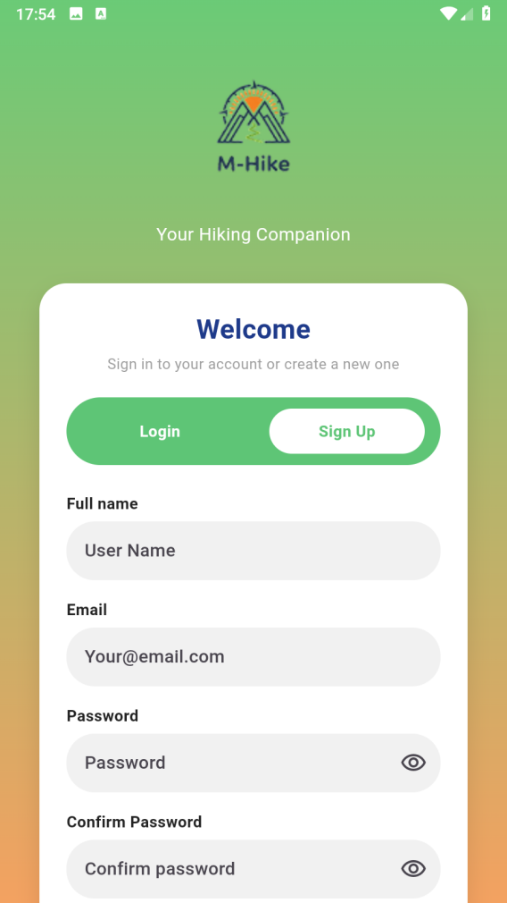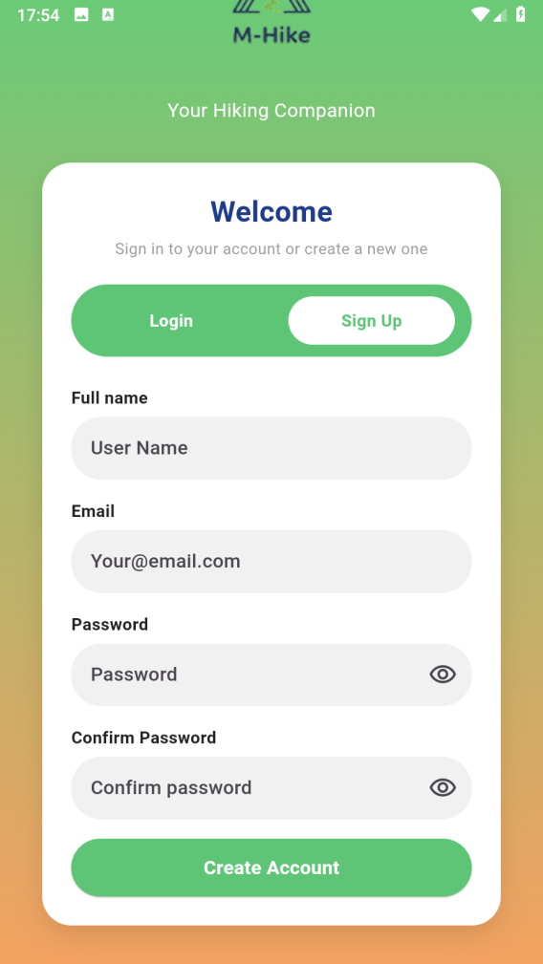

Tên màn (technical): SignUpScreen
3. Home / Danh sách Hike
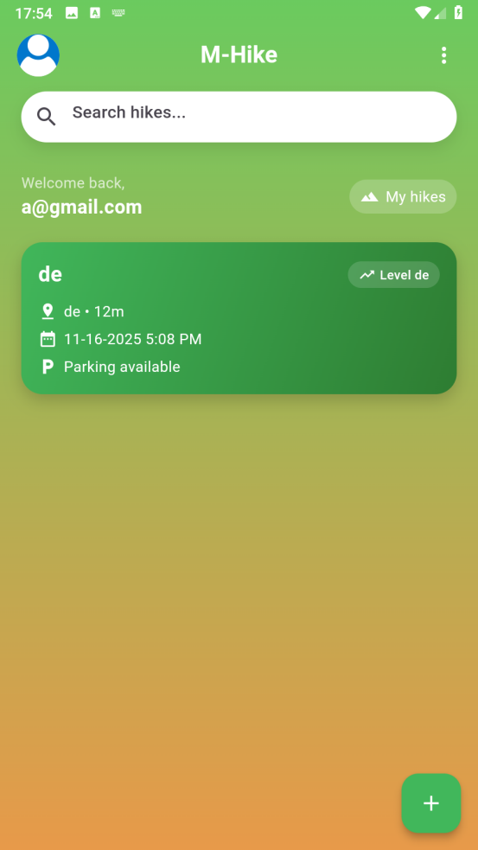
Tên màn (technical): HomeScreen

4. Bottom sheet Add Hike
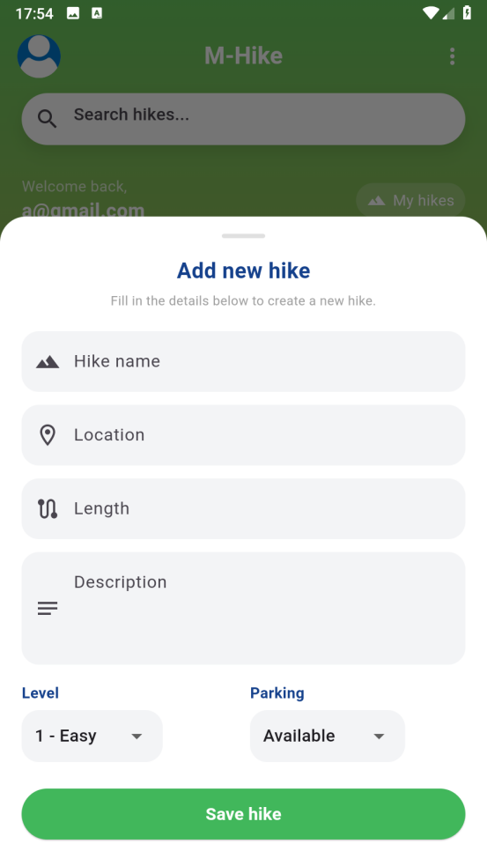
Tên (technical): _displayTextInputDialog (bottom sheet trong HomeScreen)
5. Settings / Account
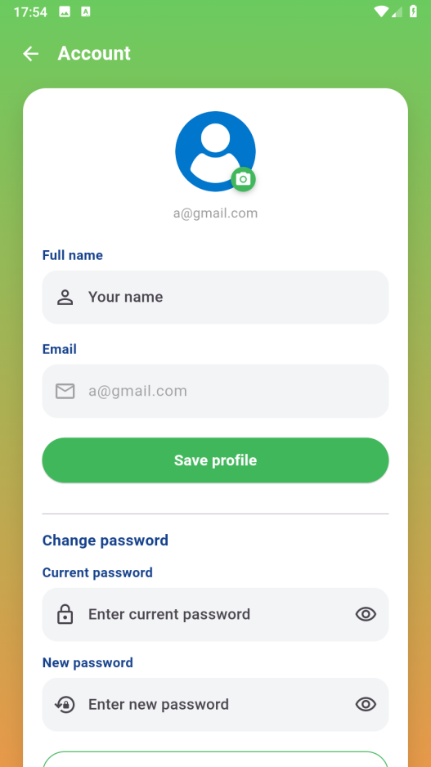
Tên màn (technical): AccountPage (trong setting.dart)

6. Hike detail

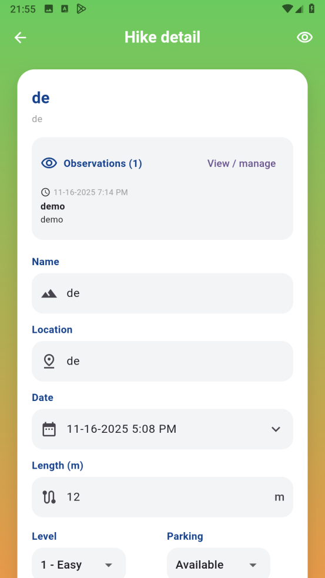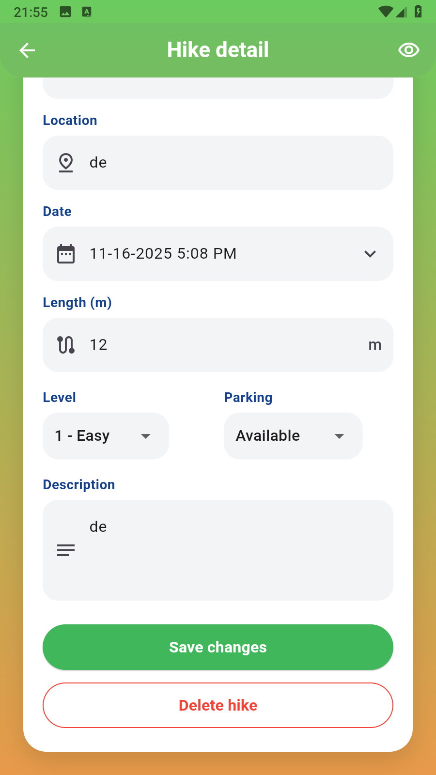

- Observations

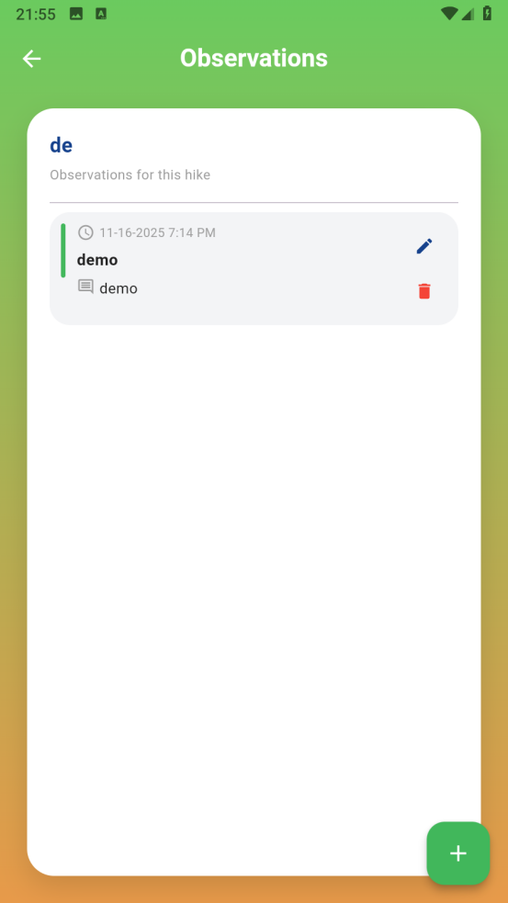

- Add Observations /edit

