COMP1786 (2025-526) | Mobile Application Design and Development | Contribution: 20% of course
Course Leader: Dr Tuan Nguyen | CW2 Logbook | Deadline Date: Arranged by Partnerships
This coursework should take an average student who is up-to-date with tutorial work approximately 10 hours
Feedback and grades are normally made available within 15 working days of the coursework deadline
Learning Outcomes:
C. Select and critically evaluate suitable software tools and APIs for the development of a particular mobile application and understand their strengths, scope and limitations.
D. Select and use appropriate application development tools to assist in the conception, design, writing and testing of various interactive programs for mobile devices.

Plagiarism is presenting somebody else's work as your own. It includes: copying information directly from the Web or books without referencing the material; submitting joint coursework as an individual effort; copying another student's coursework; stealing coursework from another student and submitting it as your own work. Suspected plagiarism will be investigated and if found to have occurred will be dealt with according to the procedures set down by the University. Please see your student handbook for further details of what is / isn't plagiarism.
All material copied or amended from any source (e.g. internet, books) must be referenced correctly according to the reference style you are using.
Your work will be submitted for plagiarism checking. Any attempt to bypass our plagiarism detection systems will be treated as a severe Assessment Offence.

Coursework Submission Requirements

For this coursework you must submit a single PDF document. In general, any text in the document must not be an image (i.e. must not be scanned) and would normally be generated from other documents (e.g. MS Office using "Save As .. PDF"). An exception to this is hand written mathematical notation, but when scanning do ensure the file size is not excessive.

For this coursework you must also upload a single ZIP file and the App containing supporting evidence.

There are limits on the file size.

Make sure that any files you upload are virus-free and not protected by a password or corrupted otherwise they will be treated as null submissions.

Your work will not be printed in colour. Please ensure that any pages with colour are acceptable when printed in Black and White.

You must NOT submit a paper copy of this coursework.

All courseworks must be submitted as above. Under no circumstances can they be accepted by academic staff

The University website has details of the current Coursework Regulations, including details of penalties for late submission, procedures for Extenuating Circumstances, and penalties for Assessment Offences. See http://www2.gre.ac.uk/current-students/regs

Detailed Specification

Complete the following exercises and upload the answer as a single PDF file and the developed App to the Logbook upload area by the logbook submission deadline.

You MUST also upload to the weekly uploads area by the specified dates in order to get feedback.

The THREE uploads should each be in the form of a completed logbook template document. An example template is given in appendix A at the end of this document. Please do not upload zip files if your uploads contain just PDF documents. Each upload has a specific score as mentioned in each exercise. The final grade is adjusted basing on the Grading Criteria section.
- Develop a simple calculator application (30%) (expected submission Week 5)

In this exercise, create an app with GUI like the below image. It contains 4 operators, Add, Subtract, Multiply and Divide for two operands, i.e. calculating between two numbers at a time. The app should check valid input.

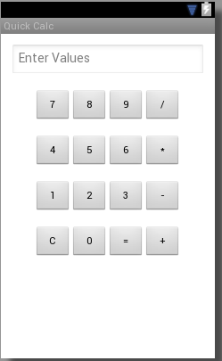
Figure 1 An example of Calculator GUI. You can freely design your GUI app

Note: Your app should use theme/style, resource (colour, images) when possible.

- Create an Android App allowing users to view images (30%) (expected submission deadline Week 7)

Create an App that has a user interface showing one image at a time and two buttons to display images forward and backward. Images are stored in Android Resource.

Note: Your app should use theme/style, resource when possible.

- Use Android Persistence to store data (40%) (expected submission deadline Week 9)

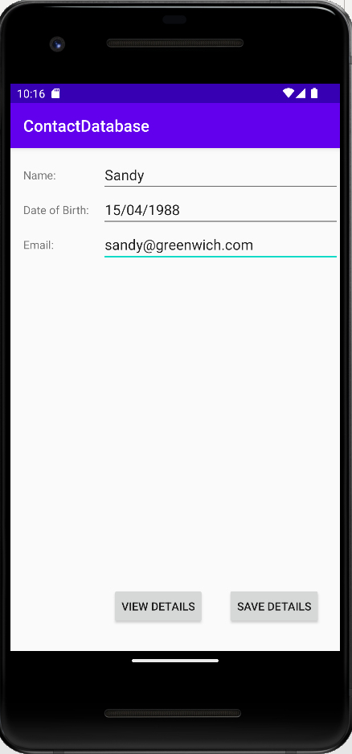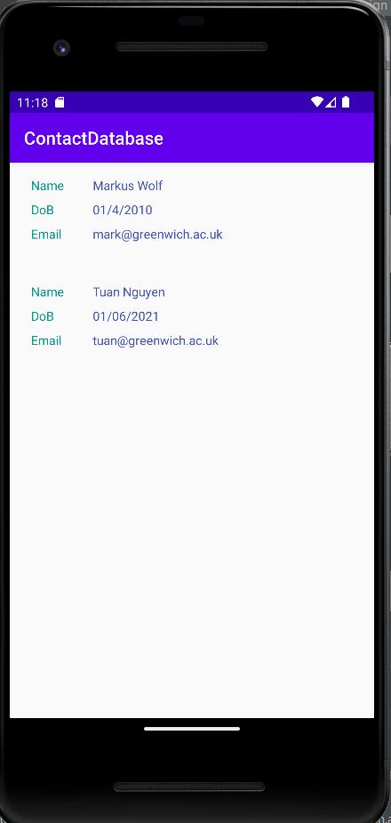
Figure 2 The GUIs of the ContactDatabase App (on the left)
with RecyclerView to display the list of contacts (on the right)

Extend the ContactDatabase App developed in Lecture 5 - Android Persistence like Figure 2 to allow users choose an avatar/profile images for each contact. Those avatars/ profile images can be maintained in the Android resources.

Note: Your app should use theme/style, resource when possible.

Deliverables

The deliverables are specified above. Each should be uploaded via the "Weekly Uploads" system. Please upload a completed logbook template document for each upload.

Grading Criteria

This coursework will not be marked anonymously.

85% and over

All three uploads completed by the specified dates and to a very good standard.
From 70% to 84%
Two uploads completed by the specified dates and to a very good and one to a good standard (only minor omissions or errors)

From 60 to 69%

Two uploads completed by the specified dates and to a very good standard.

From 50 to 59%

One upload completed by the specified dates and to a very good standard and one to a reasonable standard (some omissions and errors)

From 40 to 49%
Two uploads completed by the specified dates and to a reasonable standard (some omissions and errors)

Assessment Criteria

For the exercises marks will be awarded for:
- clear and accurate completion of section 1 of the template
- clear and accurate completion of section 2 of the template so that it can be seen what was achieved and how it was done
- how much of what was asked for in the exercise was completed
Appendix A
Complete and upload a copy of this template to the weekly uploads area for each of the exercises 1 to 3.

COMP1786 Logbook Upload Template
- Basic Information
1.1 Student name & ID
1.2 Who did you work with? Note that for logbook exercises you are allowed to work with one other person as long as you give their name and login id and both contribute to the work. | Name:  Login id:
1.3 Which Exercise is this? Tick as appropriate. | - Exercise 1  - Exercise 2  - Exercise 3
1.4 How well did you complete the exercise? Tick as appropriate. | - I tried but couldn't complete it  - I did it but I feel I should have done better  - I did everything that was asked  - I did more than was asked for
1.5 Briefly explain your answer to question 1.4.
Without any explanation/justification, your scores will be deducted.

- Exercise answer
2.1 Screen shots demonstrating what you achieved
Paste screen shots in here. Add explanation of what each screen shot demonstrates
2.2 Code that you wrote
Copy and paste relevant code here. Actual code please, not screen shots.
You need to add brief explanation.

