Võ Văn Vĩ - 22001515 Lab1

Node.js – Chapter 2 Lab Handbook

Lab 1: Node.js Fundamentals (3 hours)
Objectives:
- Understand Node.js runtime
- Create and use modules
Tasks:
1. Install Node.js
2. Create a simple Node.js program
3. Create a custom module and import it
Below is a step-by-step Lab Handbook students can follow directly.

Node.js – Chapter 2 Lab Handbook

Lab 1: Node.js Fundamentals (3 hours)

Lab Overview
In this lab, you will:
- Install Node.js and verify it works
- Run a simple Node.js program
- Create your own custom module and import it into another file

Learning Objectives
By the end of this lab, you can:
- Explain what Node.js is (runtime for running JavaScript outside the browser)
- Use the terminal to run Node programs
- Create and use modules with module.exports and require()

Part 0 — What You Need (Before Start)
✅ A computer with Internet
✅ A code editor (VS Code recommended)
✅ Terminal access:
- Windows: Command Prompt / PowerShell
- macOS: Terminal
- Linux: Terminal

Task 1 — Install Node.js (Approx. 30–40 minutes)

Step 1: Download Node.js
- Open the Node.js official website.
- Download LTS version (recommended for stability).
- Run the installer and follow default settings.
Tip: LTS is best for class + lab environments.

Step 2: Verify installation
Open Terminal (or PowerShell) and run:
node -v
You should see something like:
v20.x.x
Then check npm:
npm -v
You should see something like:
10.x.x
✅ If both commands show version numbers → installation is successful.

Common errors and fixes

Error: node is not recognized... (Windows)
- Restart Terminal
- Restart your PC
- Reinstall Node.js and ensure “Add to PATH” is enabled

macOS permission issue
Use the official installer. Avoid random third-party packages.

Task 2 — Create a Simple Node.js Program (Approx. 50–60 minutes)

Step 1: Create a lab folder
Choose a location (Desktop is fine). In terminal:
mkdir node-lab1
cd node-lab1

Step 2: Open folder in VS Code
If you have code command:
code .
(If not, open VS Code → File → Open Folder → select node-lab1)

Step 3: Create your first Node file
Create a file named:
📄 app.js
Add this code:
console.log("Hello Node.js!");

Step 4: Run the program
In terminal (inside node-lab1 folder):
node app.js
Expected output:
Hello Node.js!
✅ You have successfully executed JavaScript using Node.js.
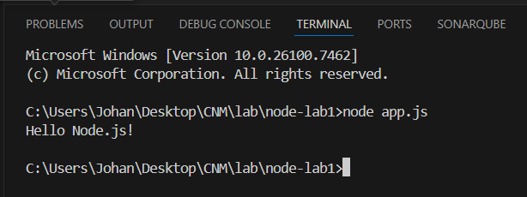

Task 3 — Create a Custom Module and Import It (Approx. 70–80 minutes)

Step 1: Create a module file
Create a new file:
📄 mathUtils.js
Add this code:
function add(a, b) {
return a + b;
}

function subtract(a, b) {
return a - b;
}

module.exports = {
add,
subtract
};

What this means
- You created 2 functions: add, subtract
- You exported them so other files can use them via module.exports

Step 2: Import module into app.js
Update your app.js:
const mathUtils = require("./mathUtils");

console.log("Add:", mathUtils.add(5, 3));
console.log("Subtract:", mathUtils.subtract(10, 4));

Step 3: Run again
node app.js
Expected output:
Add: 8
Subtract: 6
✅ You created and used a custom Node.js module.
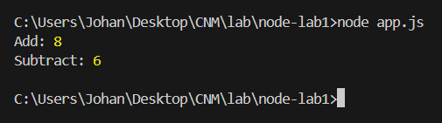

Extra Practice (If you finish early)

Practice A: Add one more function in module
Add this function to mathUtils.js:
function multiply(a, b) {
return a * b;
}
Export it and use it in app.js.
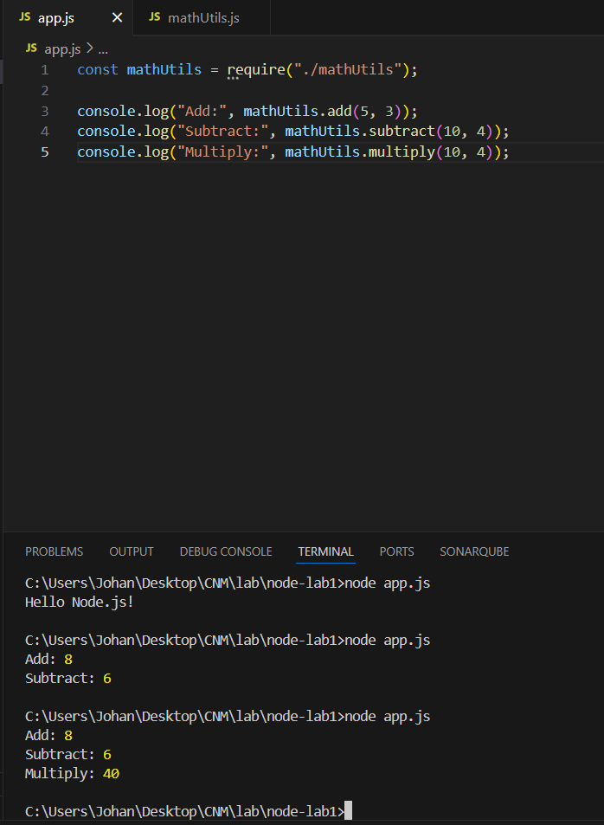

Practice B: Create a “greeting” module
Create:
- greeting.js exporting a function sayHello(name)
- import into app.js and print hello message
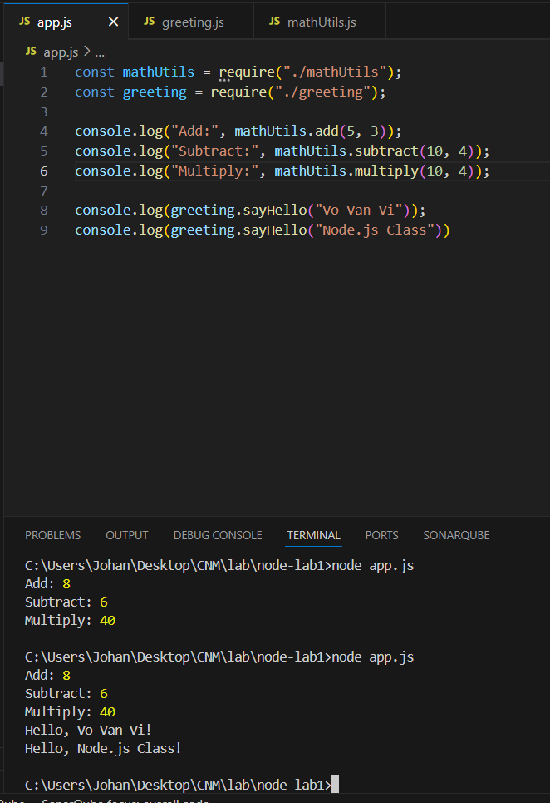

Submission Checklist (Student Evidence)
Students should submit:
- Screenshot of terminal showing:
  - node -v
  - npm -v
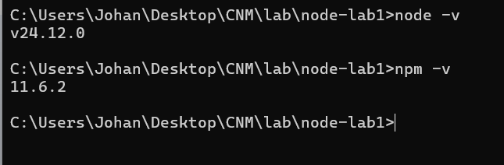
- Project folder includes:
  - app.js
  - mathUtils.js
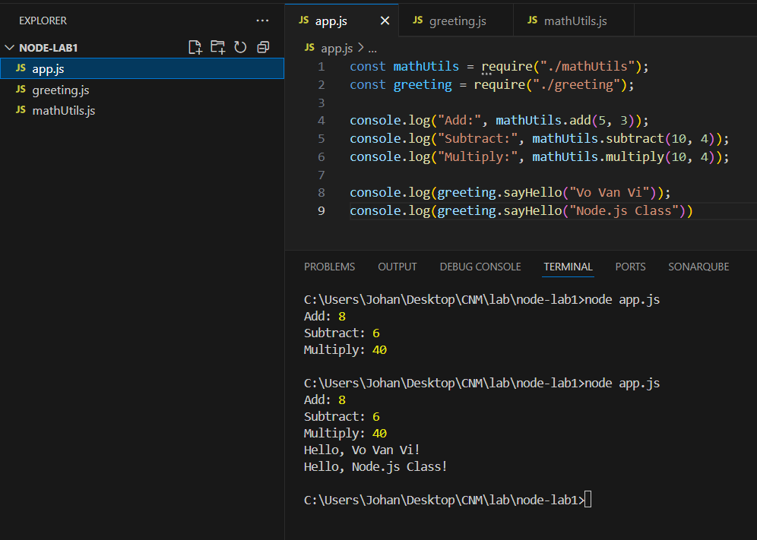
- Terminal output of running the final program

Quick Rubric (10 points)
- (2) Node.js installed + version verified
- (3) Simple Node program runs correctly
- (5) Custom module created, exported, imported, and used successfully
Nhập 2 số từ bàn phím:
