Võ Văn Vĩ
22001515
Lab 6
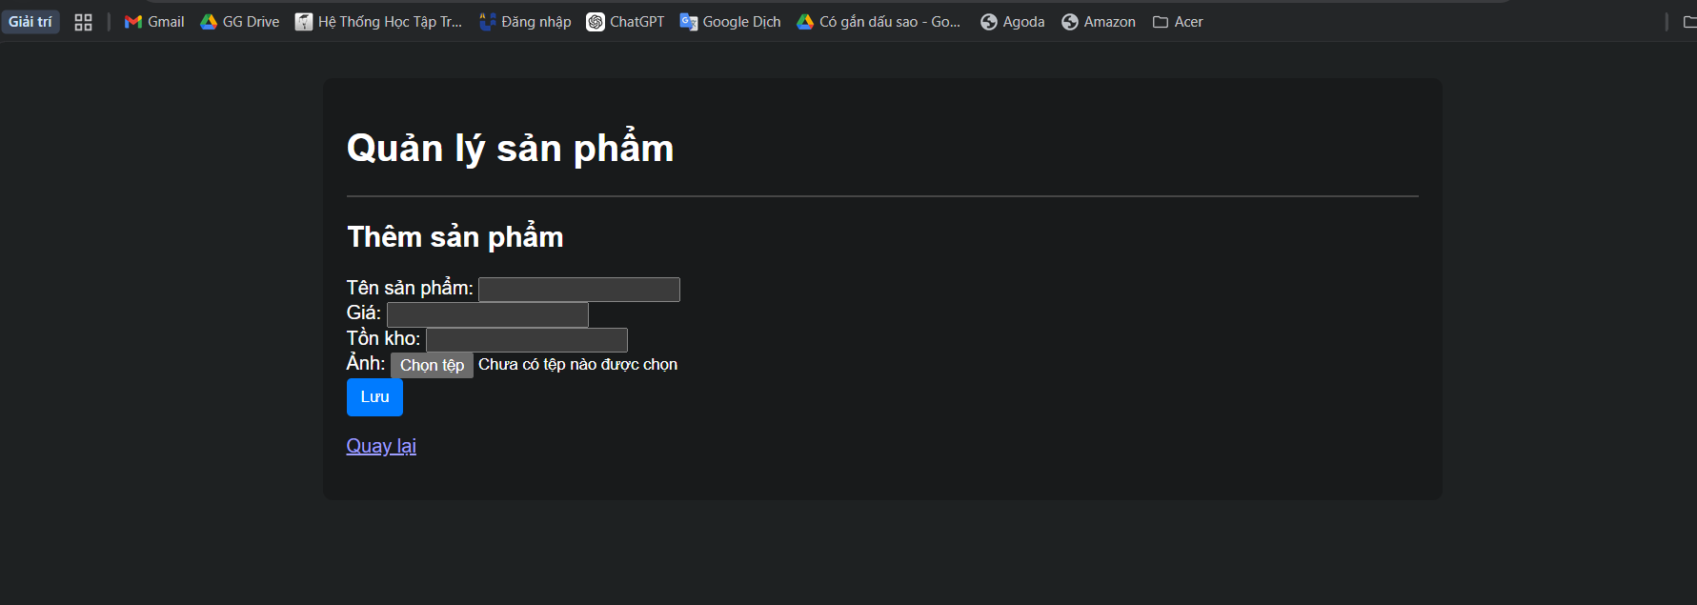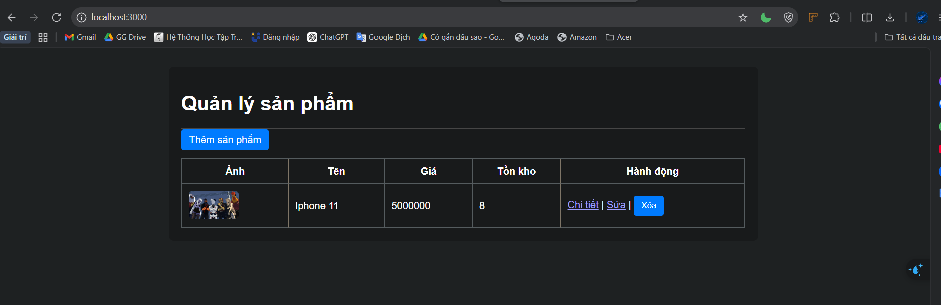
Link githud: https://github.com/vovanvi0906/VoVanVi_22001515_CNM.git

