E-commerce page

A javascript button that switches the content on the page by service or product  
  
  
If its product it should show it such as this

With the ability to specify quantity and add it to order.   


Obviously a very rough mock up, the books should be scrollable and the checkout footer should be anchored on scroll below.

The add button should allow them to specify the quantity when added.

When clicked the description should pop down below the picture and an overlay on the picture should appear similar to below.

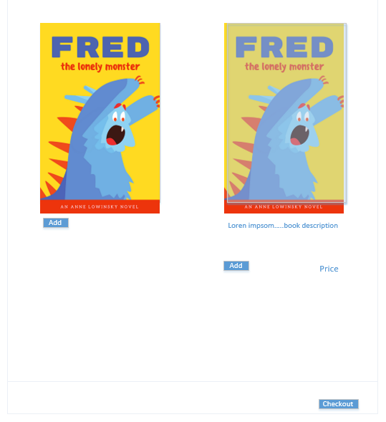

For the services offered, there should be a picture following the anchored theme of the products



For the services it should display similar to this, with scrolling pictures and a drop down menu to select the service they want and quantity.

Based on the amount of people they want to register it should then allow them to checkout, where they will be prompted with a user registration form. The form requires:  
First name, last name, email, phone number (area code) and an area for a discount code. It should also be able to comply and show them stuff for GPDR. A blurb they have to accept before they can checkout.   
  
Checkout should be paypal and stripe.