Luke Kljucaric

LEK70@pitt.edu

CS1520 | Project Plan | Part 2

Part 1 Results

Part one using php and html went fairly well. I was able to build a presentable site for my business. The site consists of five main pages that will direct customers to whatever information they need. The main page shows important and relevant information that customers would want to know immediately such as typical services we provide or any special deals. The form for a quote on this page actually sends an email to me with the information the user provided. This page can be seen in Figure 1.

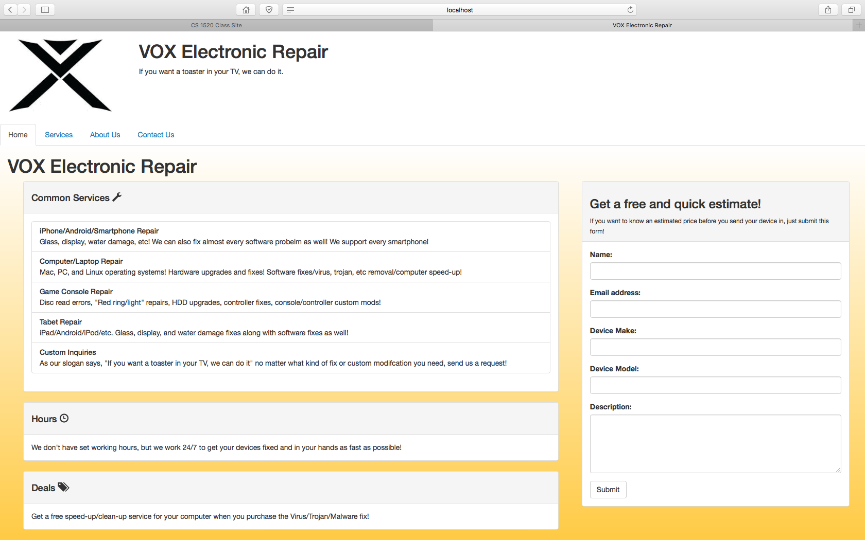

Figure

The next page contains a list of service categories that we currently offer. The list of these services is created from data in a table from a database. This page can be seen in Figure 2.

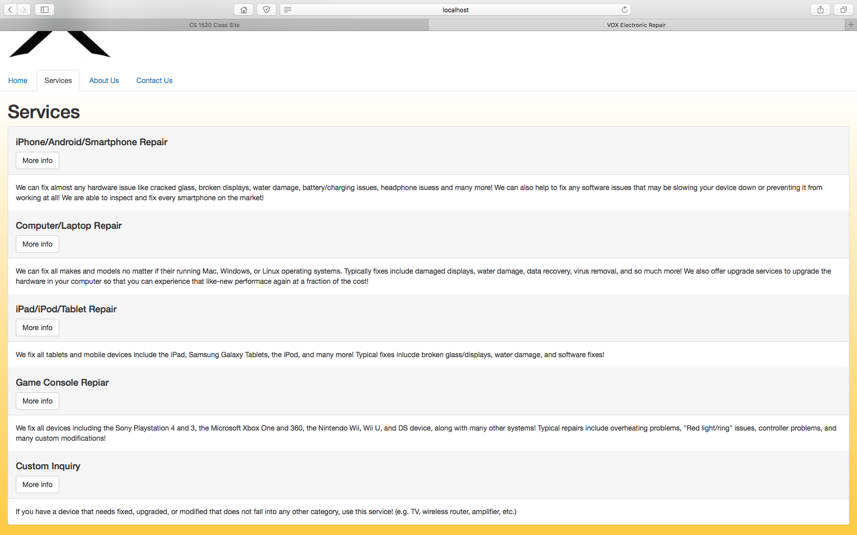

Figure

If a customer were to click on the “More Info” button, it brings them to a new page that lists more detail about that service and typical prices for specific requests. Again, this page’s information is all pulled from a database. This page can be seen in Figure 3. The reason for using a database for the pages in Figures 2 and 3 was so that the site wouldn’t have to be modified for simply adding/removing/editing services.

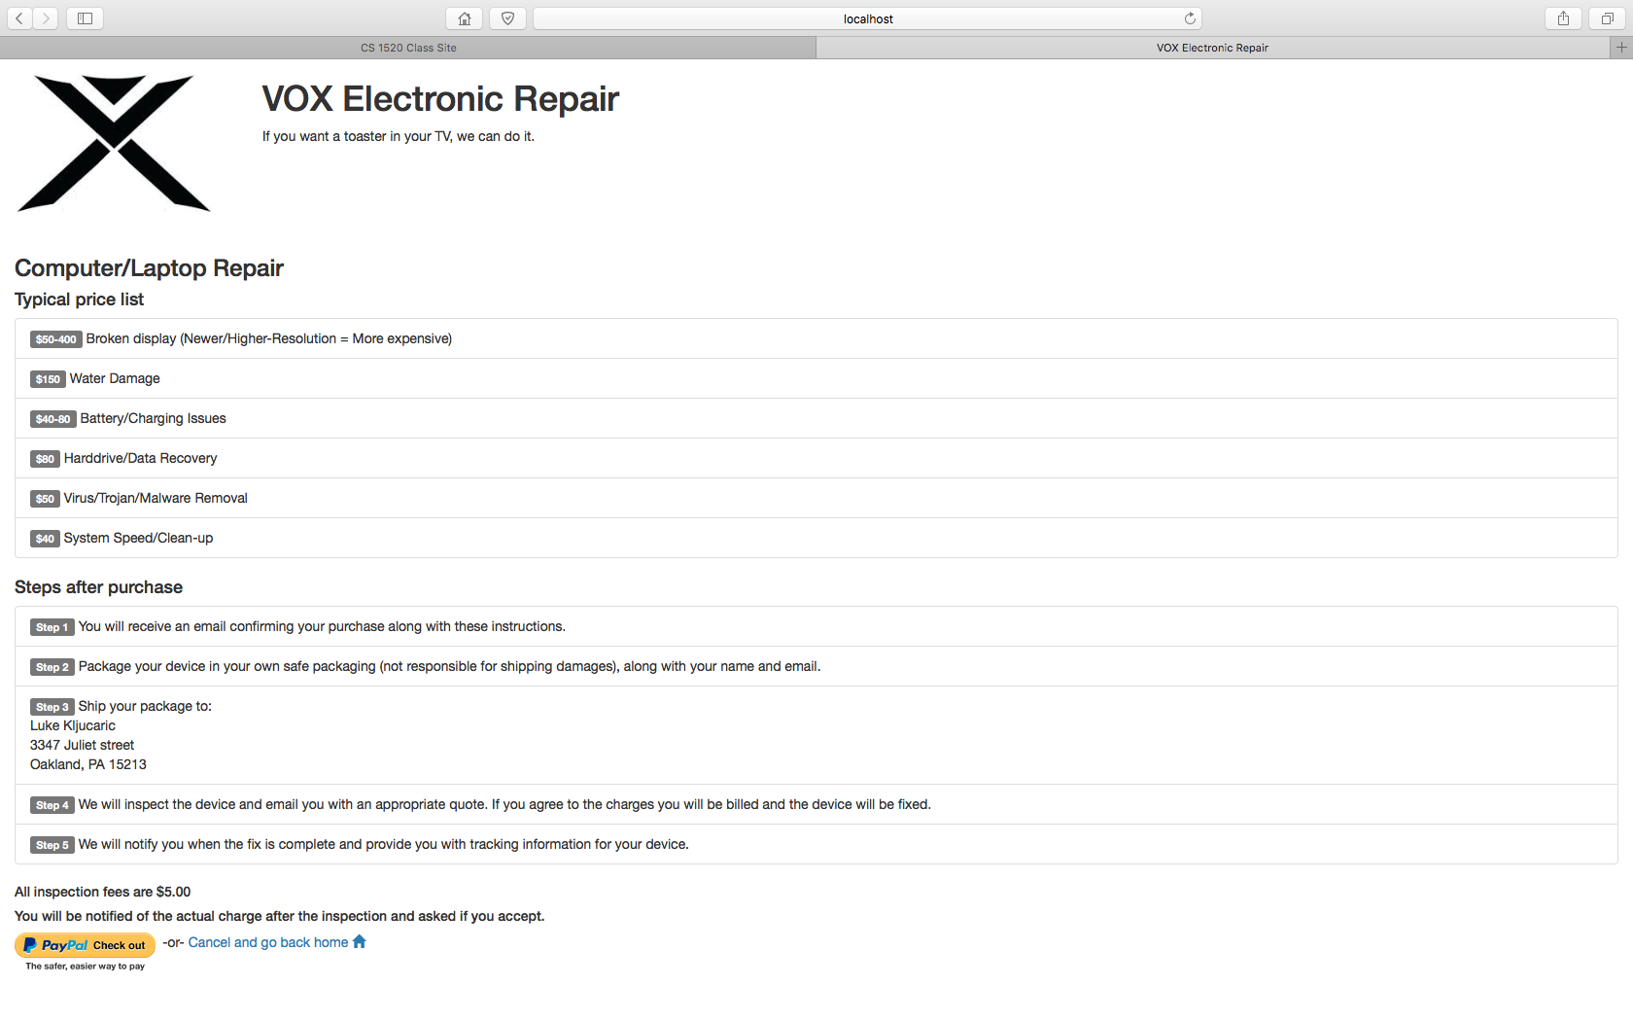

Figure

The next page is a simple “About Us” page. It simply talks about who we are, what we do, our motivation, etc. to allow the user to get a feel for who I am/we are. This can be seen in Figure 4.

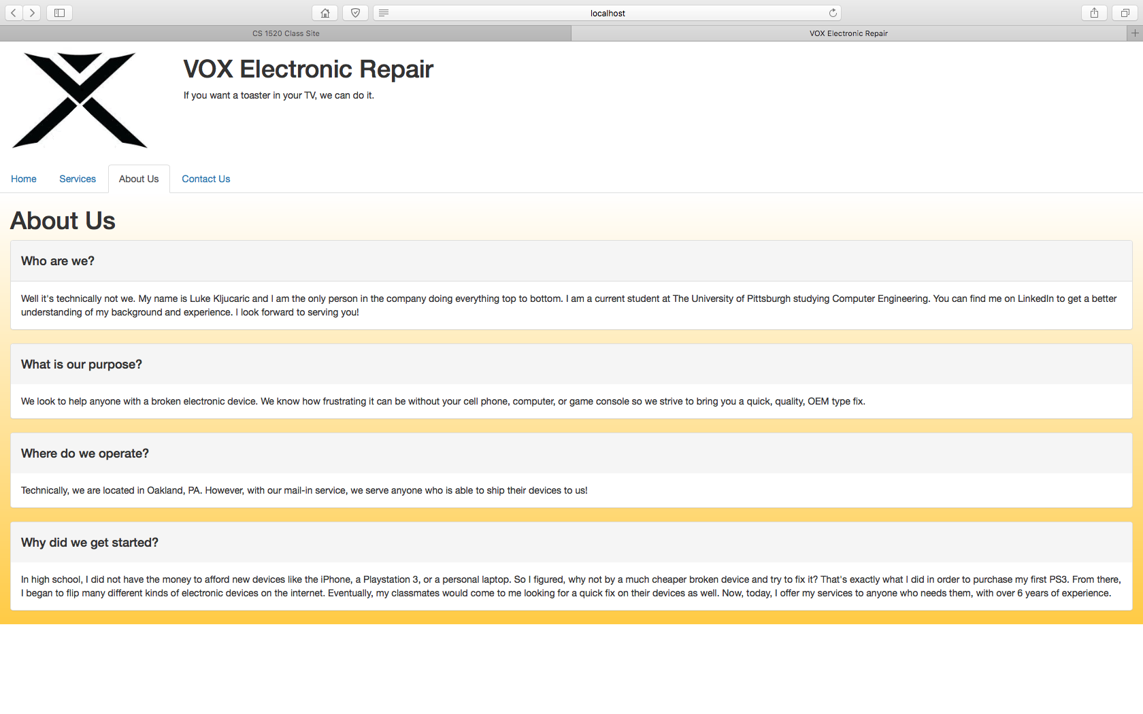

Figure

The final page is a simple contact page. It lists an email and phone number for someone to get into contact with me. The email link is a mailto: to it directs the user to their mail client. I wasn’t really sure what else to put here but it can be seen in Figure 5.

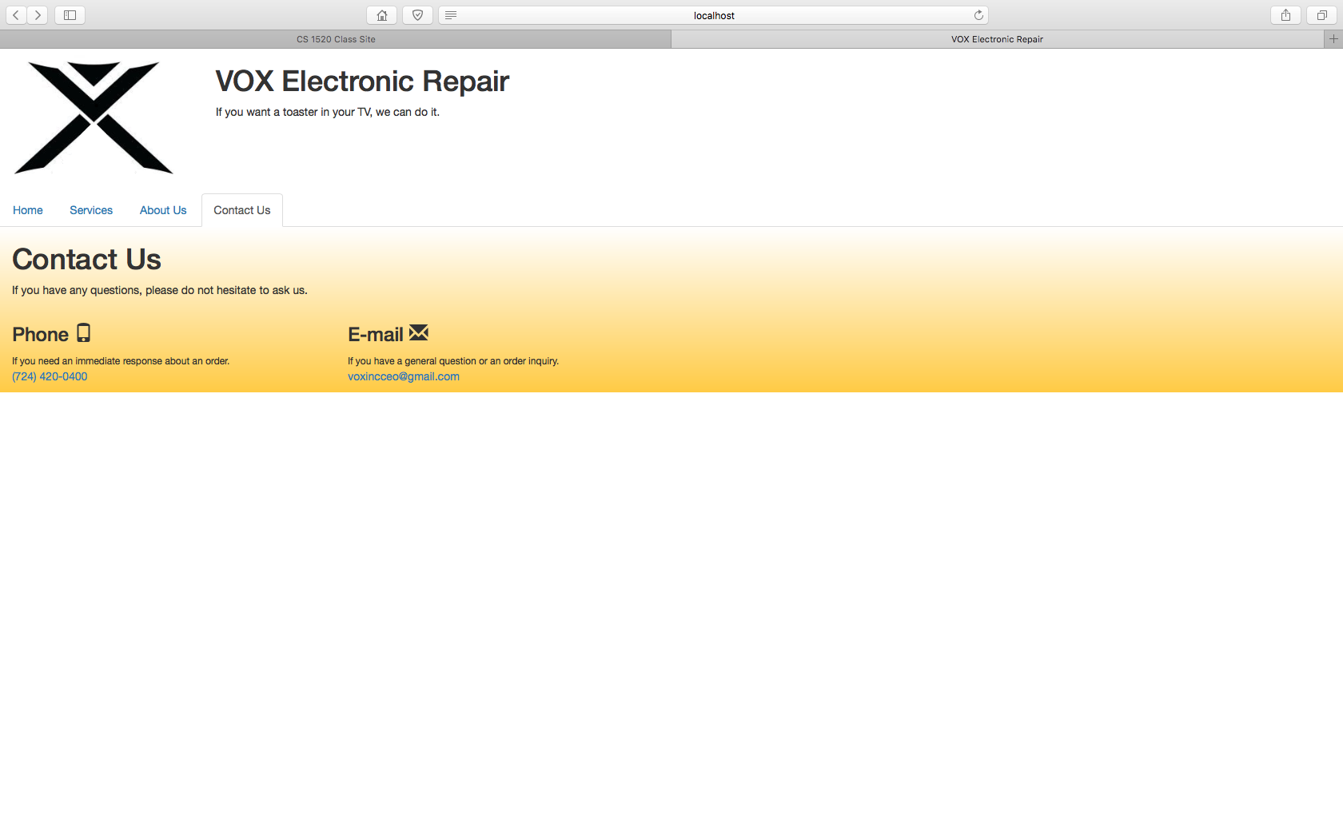

Figure

Part 2 Plan

For part two I don’t plan on changing much of the framework/layout of the site. Some minor improvement are to add one unified header as opposed to the two or three different ones I currently use (which are all the same).

The main place I plan to use javascript functionality is to do more information display in-place rather than loading new pages. For example, on a form submission you are brought to a new page saying that the form was filled out correctly or incorrectly. It would be a lot nicer to display that information within the same page rather than leaving that page. Additionally, I want to do the same for displaying the service information and just have a back button to show the listings again as opposed to showing an entire new page.

The other place I plan to use some javascript is for animations/making the site more aesthetic. It’s a pretty barebones site right now with no real animation/transition effects but I plan on using javascript with bootstrap as well for that part (I already have the bootstrap framework used).

Other than those two main points, I don’t know where else I could use javascript in my site, but as always I look forward to your feedback and what I can improve upon.