The New Maruti Suzuki Brezza 2026: Price, Specs & Full Review
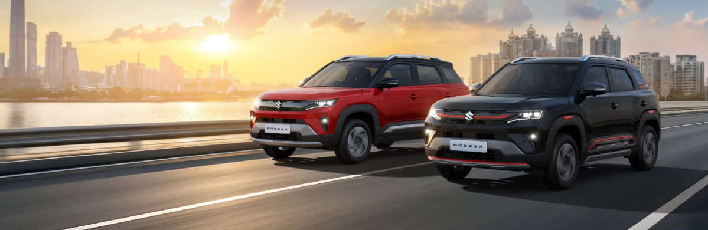
Maruti Suzuki has rolled out a refreshed version of one of India's most popular compact SUVs, and this time around the brand isn't holding back on the attitude. Branded with the tagline "Lead Every Play," the new Brezza arrives with sharper styling, a genuinely feature-rich cabin, and — for the first time — a Turbo Boosterjet petrol engine option alongside its familiar Smart Hybrid and S-CNG powertrains. Prices for the new Brezza start at ₹7,39,900 (ex-showroom), which keeps it firmly within reach of first-time SUV buyers while still packing in segment-leading technology.
In this detailed BikeCarHub review, we walk through everything covered in Maruti Suzuki's official brochure for the new Brezza — its design, engine options, interior features, safety kit, variants, mileage figures, colours, and how the trims stack up against one another. Whether you're comparing SUVs for your first car or looking to upgrade from an older Brezza, this guide should help you make sense of what's new.
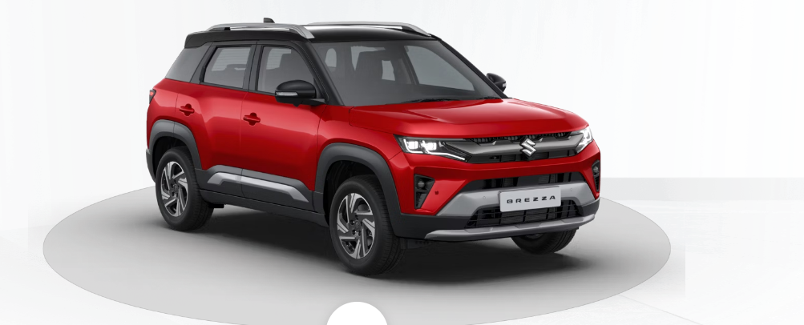

Design: A Bolder, More Aggressive Brezza
Maruti Suzuki's brochure doesn't shy away from big claims about the new Brezza's road presence, and for once, the styling backs it up. Upfront, the SUV gets a bold front grille finished with dark chrome accents, flanked by sharp LED headlamps and a chunky front bumper design that gives it a much more assertive stance than before. Toyota-badged rivals aside, Maruti seems intent on making sure the Brezza doesn't blend into a crowded parking lot.
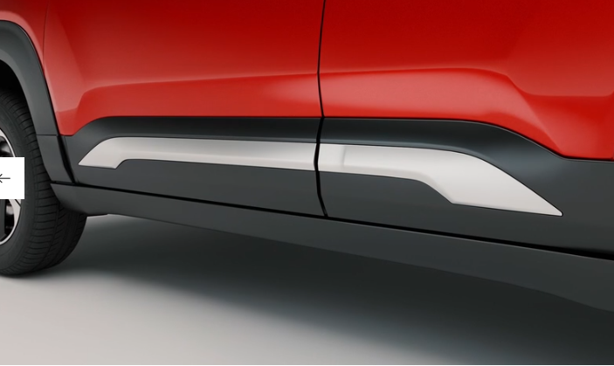
New precision-cut alloy wheels catch the light nicely, while dual-tone cladding along the body adds visual muscle without looking over the top. Higher variants also get the option of a dual-tone roof — offered in colours like Sizzling Red with Bluish Black Roof, Lustrous Beige with Bluish Black Roof, and Pearl Arctic White with Bluish Black Roof — a look that has become something of a signature for premium compact SUVs in India.
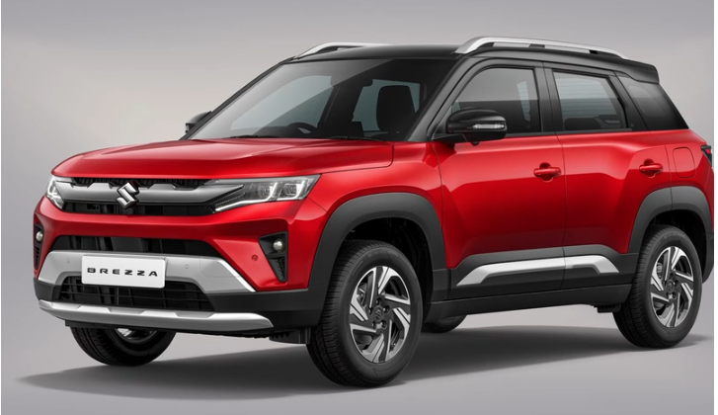

Interior: Where the Real Upgrade Lives
Step inside the cabin, and it's clear Maruti has put real thought into making the new Brezza feel special rather than just functional. The dashboard gets a premium semi-matte, soft-touch paint finish, paired with a dark brown and black interior theme and a sleek auto AC control panel. One particularly fun touch is the 64-colour ambient lighting system on the top ZXi+ trim, letting owners personalise the cabin mood to their liking.
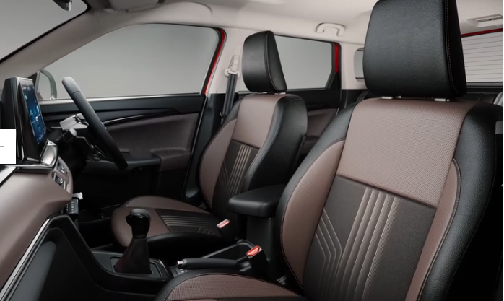
Seats are wrapped in plush leatherette upholstery, and comfort-focused buyers will appreciate the ventilated front seats — genuinely useful during Indian summers — along with a wireless charging pad with active cooling so your phone doesn't overheat while charging. An electric sunroof, auto-dimming rearview mirror, and a well laid out centre console round out a cabin that finally feels like it belongs in the premium end of the segment.
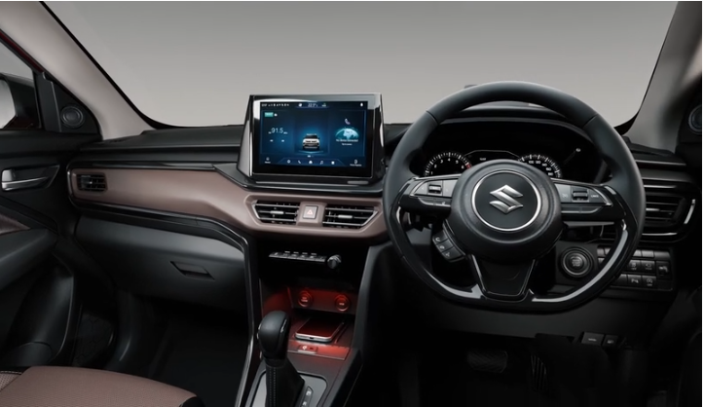

Engine Options: Turbo, Smart Hybrid & S-CNG
One of the biggest talking points in the new Brezza brochure is the addition of a genuine turbo-petrol engine, something the Brezza has never offered before. Buyers can now choose from three distinct powertrains, each aimed at a different kind of driver.
The 1.0-litre Turbo Boosterjet engine (K10C DiTC Smart Hybrid) is the headline addition, producing 81 kW (110.12 PS) at 5,500 rpm and 170 Nm of torque between 2,000 and 3,500 rpm. Maruti's brochure highlights its immediate throttle response and strong low-end torque, paired with a slick new 6-speed manual transmission that makes overtaking and city driving noticeably easier. This is the engine to pick if spirited driving matters more to you than outright efficiency.
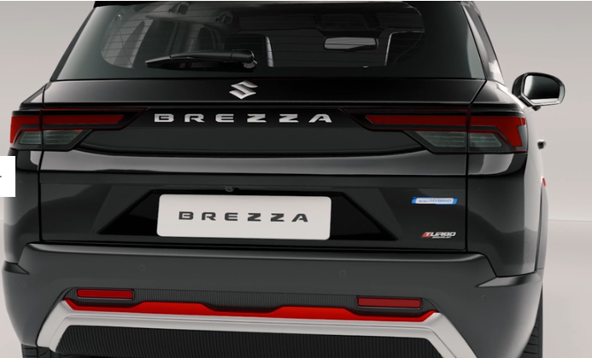
For buyers who prefer a more familiar, naturally aspirated experience, the 1.5-litre K15C Smart Hybrid petrol engine continues, now available with either a 6-speed manual or a 6-speed automatic transmission with paddle shifters. This unit makes 75.8 kW (103.05 PS) at 6,000 rpm and 139 Nm of torque at 4,400 rpm, and Maruti describes its character as "smooth where it matters, and strong when it counts."
Finally, for buyers focused on running costs, the 1.5-litre K15C Petrol CNG (ISS) variant offers a factory-fitted underbody S-CNG setup. In gasoline mode it produces 75.8 kW (103.05 PS) and 139 Nm of torque, while CNG mode delivers 64.6 kW (87.8 PS) and 121.5 Nm. An Idle Start-Stop system cuts the engine when the car is stationary, helping squeeze out better real-world fuel efficiency without eating into cargo space, since the CNG tank is neatly built into the underbody rather than the boot.

Mileage & Fuel Efficiency
Maruti Suzuki has published ARAI-certified efficiency figures for each engine and transmission combination, and the numbers are genuinely competitive for the segment. The 1.0L Turbo Boosterjet with manual transmission returns 20.47 km/l on the LXi/VXi trims and 19.96 km/l on the ZXi/ZXi+ trims. The 1.5L Smart Hybrid manual delivers 21.09 km/l on LXi/VXi and 20.81 km/l on the ZXi, while the automatic transmission variants (VXi/ZXi/ZXi+ AT) return 20.17 km/l. The S-CNG variant is the clear efficiency champion, rated at an impressive 26.90 km/kg.

Technology: Smarter, More Connected
The top-spec Brezza ZXi+ comes with a 25.65 cm (10.1-inch) touchscreen infotainment system running Maruti's SmartPlay Pro X interface, complete with a built-in Alexa voice assistant, Suzuki Navigation with traffic, speed, and camera alerts, and an ARKAMYS Surround Sense premium sound system. Wireless Android Auto and Apple CarPlay come standard from the VXi trim upward, and Over-The-Air (OTA) software updates ensure the system keeps improving even after purchase.
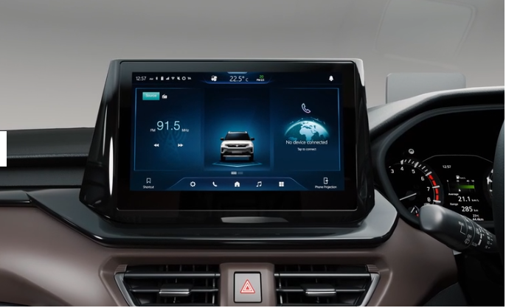
Perhaps the standout addition is the Next Gen Suzuki Connect suite with e-Call support, giving owners access to emergency alerts, stolen vehicle tracking, geo-fencing, driving behaviour scoring, remote AC control and scheduling (on automatic variants), and smartwatch or Alexa skill connectivity. For a segment where connected car tech was once reserved for much pricier vehicles, this is a genuinely useful step up. If you're researching feature-rich SUVs in this price bracket, BikeCarHub would rate this connected suite as one of the new Brezza's stronger selling points.

Comfort & Convenience Features
Beyond the headline tech, the new Brezza is loaded with everyday convenience features that make a real difference on longer drives. This includes an Auto Purify system with a PM2.5 air quality display, a 360-degree view camera for tighter parking manoeuvres, cruise control on the turbo variant, a 60:40 split rear seat for flexible cargo space, and a keyless entry system with engine push-button start on higher trims.
- Ventilated front seats to beat the summer heat
- Wireless charger with active cooling
- Electric sunroof
- Auto climate control with rear AC vents
- Cooled glove box
- Rear centre armrest with cup holder
These small but thoughtful details add up to a cabin experience that feels considerably more premium than the outgoing Brezza, and arguably ahead of several rivals in the same price range.
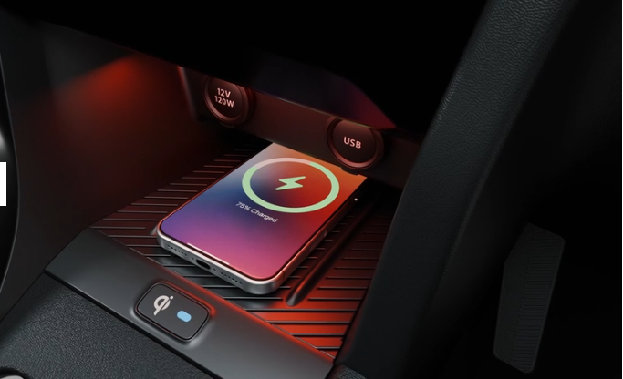

Safety: All-Round Protection
Safety has clearly been a focus area for Maruti Suzuki with this update. The new Brezza offers a suite of advanced driver assistance features including Blind Spot Warning with Lane Change Alert, Rear Cross Traffic Alert, a 360-degree HD camera, and front parking sensors — all offered on the turbo variants and standard on the ZXi+.
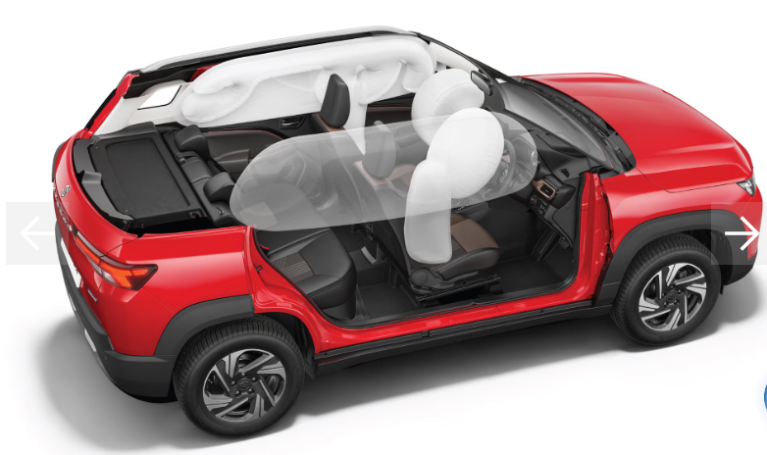
Beyond the newer ADAS-style features, the Brezza continues to offer 6 airbags (front, side, and curtain) across most trims, Electronic Stability Program (ESP), Hill Hold Assist, a Tyre Pressure Monitoring System, ISOFIX child seat anchors, front seat belt pre-tensioners with force limiters, and a High Speed Warning Alert that beeps if the car crosses 80 km/h and again past 120 km/h. Reverse parking sensors with an infographic display and a reverse parking camera are standard across the range, adding an extra layer of confidence while parking.
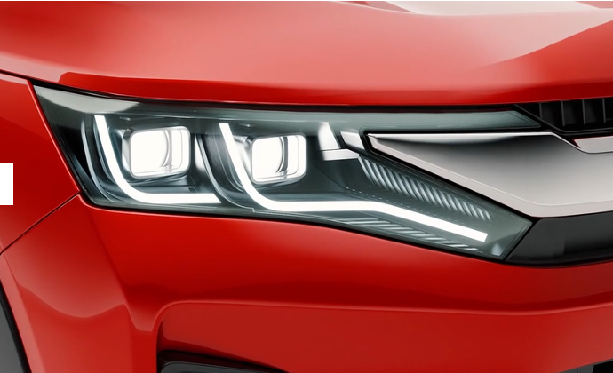

Variants Explained: LXi, VXi, ZXi & ZXi+
The new Brezza is offered across four trims — LXi, VXi, ZXi, and ZXi+ — each building meaningfully on the one before it.
- LXi — the base variant, offered with the 1.0L Turbo manual, 1.5L Smart Hybrid manual, or the CNG option. It comes with essential safety kit (6 airbags, ESP, Hill Hold Assist), manual AC, and basic convenience features, but skips the touchscreen infotainment system.
- VXi — adds the 17.78 cm (7-inch) touchscreen with wireless Android Auto and Apple CarPlay, steering-mounted audio controls, electrically adjustable ORVMs on the turbo variant, and the option of the 6-speed automatic transmission on the 1.5L Smart Hybrid engine.
- ZXi — steps up further with dual-LED projector headlamps, LED DRLs, an electric sunroof, 60:40 split rear seat, engine push start/stop with smart key, alloy wheels, and the turbo-exclusive Blind Spot Warning, Rear Cross Traffic Alert, and TPMS.
- ZXi+ — the flagship trim, exclusive to the 1.5L Smart Hybrid engine (manual or automatic), gets the full 10.1-inch touchscreen with Alexa, Next Gen Suzuki Connect with e-Call, 360-degree camera, ventilated front seats, 64-colour ambient lighting, wireless charger with active cooling, and machined alloy wheels.
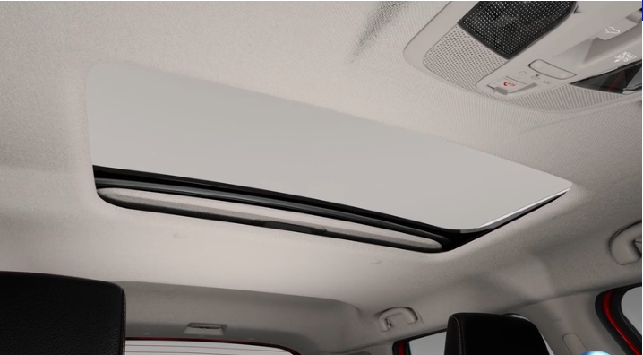
For buyers who want the complete package — connected tech, safety, and comfort — the ZXi+ is clearly the variant to aim for. Those on a tighter budget but who still want the fun of the turbo engine should seriously consider the ZXi turbo, which retains most of the meaningful safety and styling upgrades.
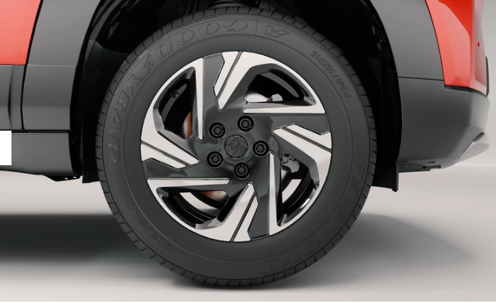

New Maruti Suzuki Brezza Price in India
The new Maruti Suzuki Brezza is priced starting from ₹7,39,900 (ex-showroom), making it one of the more accessible options in the premium compact SUV segment, especially considering the amount of technology and safety equipment now on offer. As always, final on-road prices will vary by city depending on registration charges, insurance, and local taxes, so it's worth checking with your nearest Maruti Suzuki Arena dealership for an exact quote in your area.

Colour Options
The new Brezza is available in an expanded palette of colours, including two dual-tone additions for 2026:
- Pearl Arctic White with Bluish Black Roof (dual tone)
- Sizzling Red with Bluish Black Roof (dual tone)
- Lustrous Beige with Bluish Black Roof (dual tone) — New
- Splendid Silver
- Sizzling Red
- Pearl Arctic White
- Magma Grey
- Bluish Black
- Vivacious Orange — New
- Lustrous Beige — New

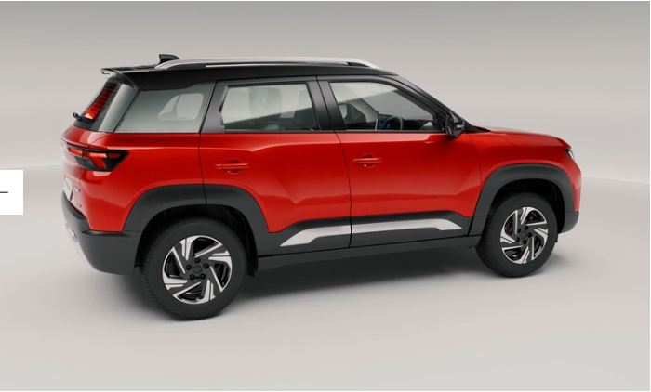

Warranty & Ownership
Maruti Suzuki backs the new Brezza with a standard warranty of 3 years or 100,000 km (whichever comes first), extendable up to 6 years for buyers who want extra peace of mind. Combined with Maruti's famously wide service network across India, this makes the Brezza a low-risk, easy-to-live-with choice for first-time SUV owners.

Full Specifications: New Maruti Suzuki Brezza
Here's a consolidated look at the core specifications of the new Brezza across its petrol and CNG powertrains, as per Maruti Suzuki's official brochure.
Specification | Petrol (1.0L Turbo / 1.5L) | CNG (1.5L K15C)
Length | 3,995 mm | 3,995 mm
Width | 1,790 mm | 1,790 mm
Height (unladen) | 1,685 mm | 1,685 mm
Wheelbase | 2,500 mm | 2,500 mm
Seating Capacity | 5 | 5
Engine Type | K10C Turbo / K15C Smart Hybrid | K15C ISS
Max Power | 110.12 PS (Turbo) / 103.05 PS (1.5L) | 103.05 PS (Petrol) / 87.8 PS (CNG)
Max Torque | 170 Nm (Turbo) / 139 Nm (1.5L) | 139 Nm (Petrol) / 121.5 Nm (CNG)
Fuel Tank Capacity | 48 L | Petrol: 48 L, CNG: 55 L (water equiv.)
Gearbox | 6MT / 6AT | 6MT
Front Suspension | MacPherson Strut | MacPherson Strut
Rear Suspension | Torsion Beam | Torsion Beam
Front Brakes | Ventilated Disc | Ventilated Disc
Rear Brakes | Drum | Drum
Tyre Size | 215/60 R16 | 215/60 R16

Variant Comparison: Which Brezza Should You Buy?
To make your decision simpler, here's a quick side-by-side comparison of key features across the Brezza line-up.
Feature | LXi | VXi | ZXi | ZXi+
Touchscreen Infotainment | No | 7-inch | 7-inch | 10.1-inch
Wireless Android Auto/CarPlay | No | Yes | Yes | Yes
Electric Sunroof | No | No | Yes | Yes
6 Airbags | Yes | Yes | Yes | Yes
Blind Spot Warning (Turbo) | No | No | Yes | Yes
360 View Camera | No | No | No | Yes
Ventilated Front Seats | No | No | No | Yes
Cruise Control (Turbo) | No | No | Yes | Yes
Next Gen Suzuki Connect | No | No | No | Yes
Automatic Transmission Option | No | Yes (1.5L) | No | Yes (1.5L)

What's New Compared to the Outgoing Brezza?
For existing Brezza owners or anyone who has driven the older version, the changes in this update go well beyond a cosmetic refresh. The most significant addition is the 1.0-litre Turbo Boosterjet engine, giving the Brezza a genuinely sporty character it never had before — something that should appeal to buyers who found the older naturally aspirated engine a touch underwhelming on highways or during quick overtakes.
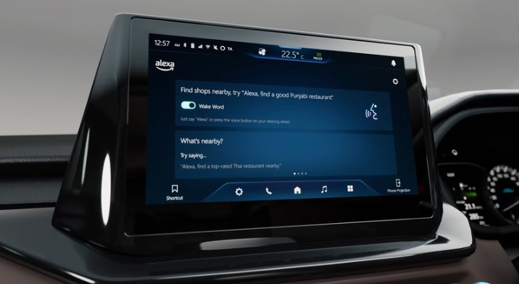
On the technology front, the jump from a smaller touchscreen to the new 25.65 cm (10.1-inch) SmartPlay Pro X system with built-in Alexa and Next Gen Suzuki Connect is a substantial upgrade, bringing the Brezza's cabin experience much closer to what buyers now expect even in cars priced well above this segment. Comfort features like ventilated seats, a wireless charger with active cooling, and 64-colour ambient lighting are also new additions that weren't previously offered on the Brezza, further strengthening its position as a genuinely premium compact SUV rather than a budget-friendly runabout.
Safety, too, sees a meaningful step up, with the addition of Blind Spot Warning, Rear Cross Traffic Alert, and a 360-degree view camera — features that were largely absent or limited to costlier SUVs until recently. Combined with the extended warranty option of up to 6 years, Maruti Suzuki appears to be making a clear pitch that this new Brezza is meant to be a long-term ownership proposition, not just an entry point into the SUV segment.

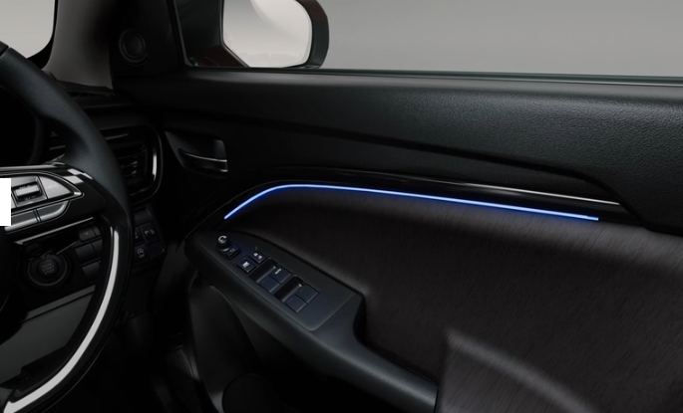

Fuel Efficiency vs Performance: Making the Right Trade-off
One of the more interesting decisions buyers will need to make with the new Brezza is choosing between outright performance and fuel efficiency, since the three engine options genuinely cater to different priorities rather than simply offering the same experience at different price points.
Buyers chasing the most engaging drive will naturally lean toward the 1.0L Turbo Boosterjet, accepting a very slightly lower efficiency figure (19.96–20.47 km/l) in exchange for noticeably stronger in-gear acceleration, useful for quick highway overtakes and merging into fast-moving traffic. Those who prioritise a smooth, predictable, low-maintenance ownership experience will likely be happiest with the 1.5L Smart Hybrid engine, especially in automatic guise, which balances a comfortable driving experience with respectable efficiency of 20.17 km/l.
Meanwhile, buyers who cover high monthly mileage — think daily commuters, delivery fleet operators, or ride-share drivers — stand to save considerably over the ownership period by opting for the S-CNG variant, given its 26.90 km/kg rating. The one trade-off here is the restriction to a manual gearbox and the 1.5L engine only, so buyers wanting an automatic will need to look at the petrol-only options instead.

Who Should Buy the New Maruti Suzuki Brezza?
The new Brezza makes a strong case across several buyer profiles. Young, first-time SUV buyers who want a fun daily driver will likely gravitate toward the 1.0L Turbo Boosterjet variants, thanks to their punchy low-end torque and eager throttle response. Families looking for a comfortable, tech-loaded SUV for daily use will find the 1.5L Smart Hybrid automatic — especially in the ZXi or ZXi+ trim — a well-rounded choice, with strong efficiency and a genuinely premium cabin experience.
For buyers who drive high monthly distances and want to keep running costs down, the S-CNG variant is hard to beat, especially with its 26.90 km/kg efficiency rating and factory-fitted underbody tank that doesn't compromise boot space. Whichever engine you choose, the new Brezza's safety kit and connected features make it a genuinely well-rounded package at its price point.

Final Verdict
The new Maruti Suzuki Brezza manages something that isn't easy in a mid-cycle update: it feels like a genuinely new car rather than a mild refresh. The addition of a proper turbo-petrol engine, a much more premium-feeling cabin, and a genuinely useful suite of connected car features push it well ahead of where the outgoing model stood. Starting at ₹7,39,900, it remains accessible while offering features that were, until recently, reserved for cars a segment or two above it. For anyone shopping in the compact SUV space in India, the new Brezza deserves a place on your test-drive list — and at BikeCarHub, we'll be following up with a full on-road driving review once units reach dealerships.

Frequently Asked Questions (FAQs)
1. What is the starting price of the new Maruti Suzuki Brezza?
The new Maruti Suzuki Brezza is priced starting from ₹7,39,900 (ex-showroom), varying by variant and engine choice.
2. What engine options are available on the new Brezza?
The new Brezza offers three engine options: a 1.0L Turbo Boosterjet petrol (110.12 PS/170 Nm), a 1.5L K15C Smart Hybrid petrol (103.05 PS/139 Nm), and a 1.5L K15C Smart Hybrid S-CNG variant.
3. Does the new Brezza get an automatic transmission option?
Yes, a 6-speed automatic transmission with paddle shifters is available on the 1.5L Smart Hybrid petrol engine, across the VXi, ZXi, and ZXi+ trims.
4. What is the mileage of the new Maruti Suzuki Brezza?
Mileage varies by engine and transmission: the 1.0L Turbo manual returns up to 20.47 km/l, the 1.5L manual up to 21.09 km/l, the automatic variant 20.17 km/l, and the CNG variant an impressive 26.90 km/kg.
5. How many variants of the new Brezza are on offer?
The Brezza is available in four variants — LXi, VXi, ZXi, and ZXi+ — each offering a progressively richer feature set.
6. Does the new Brezza come with a sunroof?
Yes, an electric sunroof is offered on the ZXi and ZXi+ variants of the new Brezza.
7. What safety features does the new Brezza offer?
The new Brezza offers 6 airbags, Electronic Stability Program, Hill Hold Assist, a Tyre Pressure Monitoring System, ISOFIX child seat anchors, and on turbo variants, Blind Spot Warning, Rear Cross Traffic Alert, and a 360-degree view camera on the ZXi+.
8. What is the warranty on the new Maruti Suzuki Brezza?
Maruti Suzuki offers a standard warranty of 3 years or 100,000 km, whichever is earlier, extendable up to 6 years.
9. Does the new Brezza support Alexa and connected car features?
Yes, the top-spec ZXi+ variant comes with a built-in Alexa voice assistant and the Next Gen Suzuki Connect suite, offering e-Call, remote AC control, geo-fencing, driving behaviour scoring, and more.
10. What colours are available on the new Brezza?
The new Brezza is available in ten colour options, including new additions like Vivacious Orange, Lustrous Beige, and Lustrous Beige with Bluish Black Roof (dual tone), alongside familiar shades like Sizzling Red and Pearl Arctic White.

SEO Details
Title Tag: New Maruti Suzuki Brezza 2026: Price & Full Specs
Meta Description: New Maruti Suzuki Brezza price starts at ₹7.39 lakh. Explore specs, features, mileage, variants, and colours in this detailed BikeCarHub review.
Suggested SEO Keywords: New Maruti Suzuki Brezza, Brezza 2026 price, Brezza turbo engine, Maruti Brezza specifications, Brezza variants, Brezza mileage, Brezza CNG, Brezza automatic, Brezza colours, Brezza review, Brezza on-road price, BikeCarHub Maruti Brezza

