BIKECARHUB · NEW BIKES · ROYAL ENFIELD

Royal Enfield Himalayan 750: Specs, Features, Colours and What's New
A 743cc twin-cylinder Himalayan, built for all roads and no roads. Everything Royal Enfield has revealed, in one place.
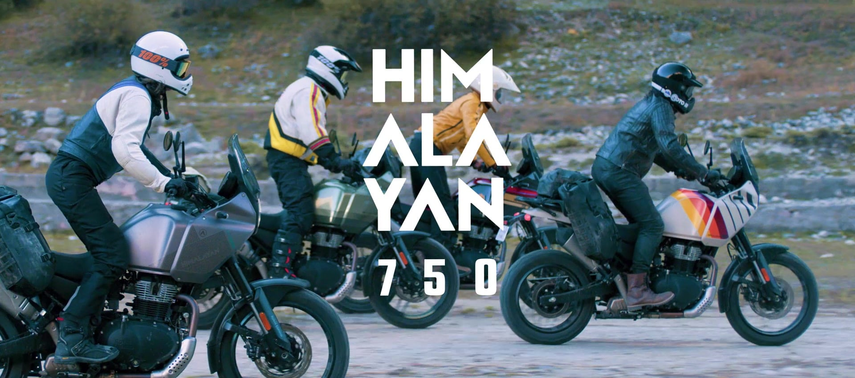
The Royal Enfield Himalayan 750. Image: Royal Enfield
For ten years the Himalayan has been Royal Enfield's answer to anyone who wanted one motorcycle for the commute, the highway and the mountain pass. The new Royal Enfield Himalayan 750 takes that idea to a much bigger engine. Royal Enfield's own tagline for it is simple: "All roads. No roads."
In this post we go through everything Royal Enfield has published about the Himalayan 750 on its official website: the 743cc twin-cylinder engine, the chassis and suspension, the electronics, the colours, and how it compares with the Himalayan 450 and Himalayan 440.

Himalayan 750 at a glance
743 cc  Twin-cylinder engine | 55 PS  @ 7,000 rpm | 63 Nm  @ 5,000 rpm | 17.8 L  Fuel tank

- Engine: 743cc air-oil-cooled inline twin, SOHC, 6-speed gearbox
- Weight and seat: 224 kg kerb weight (90% fuel and oil), 815 mm seat height
- Off-road: 205 mm ground clearance, 190 / 175 mm suspension travel
- Wheels: 19-inch front and 17-inch rear, cast alloy or tubeless spoked
- Electronics: Cornering ABS, lean-sensitive traction control, cruise control, TPMS
- Colours: Antarctic Silver, Siberia White, Viking Bronze, Aztec Green, Tectonic Black

A Himalayan built on ten years of riding
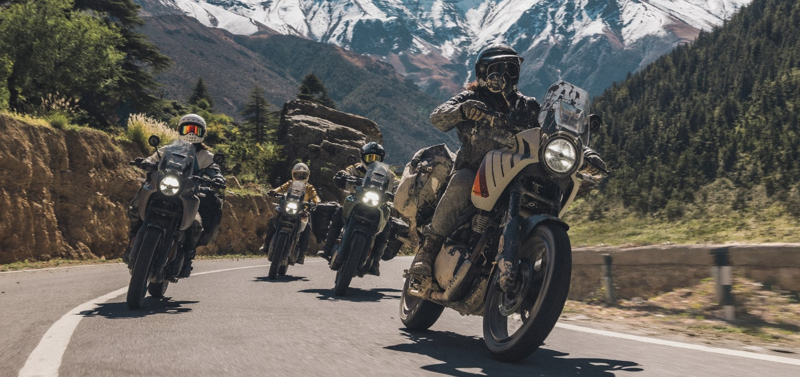
Built for long days in the mountains. Image: Royal Enfield
Royal Enfield calls the Himalayas its "spiritual home", and the Himalayan name has been tied to them from the start. The company's own timeline traces the story in three steps:
- 2016: The Himalayan 411 is born.
- 2023: A new spartan take on adventure motorcycling.
- 2026: The Himalayan 750, "a machine built to go further than you ever imagined."

“Every kilometre of experience and every terrain traversed in the last decade comes built into the Himalayan 750.”
Royal Enfield

The result is positioned as an adventure tourer for long-distance touring, "built to cross countries, continents and everything in between."

Himalayan 750 engine and performance
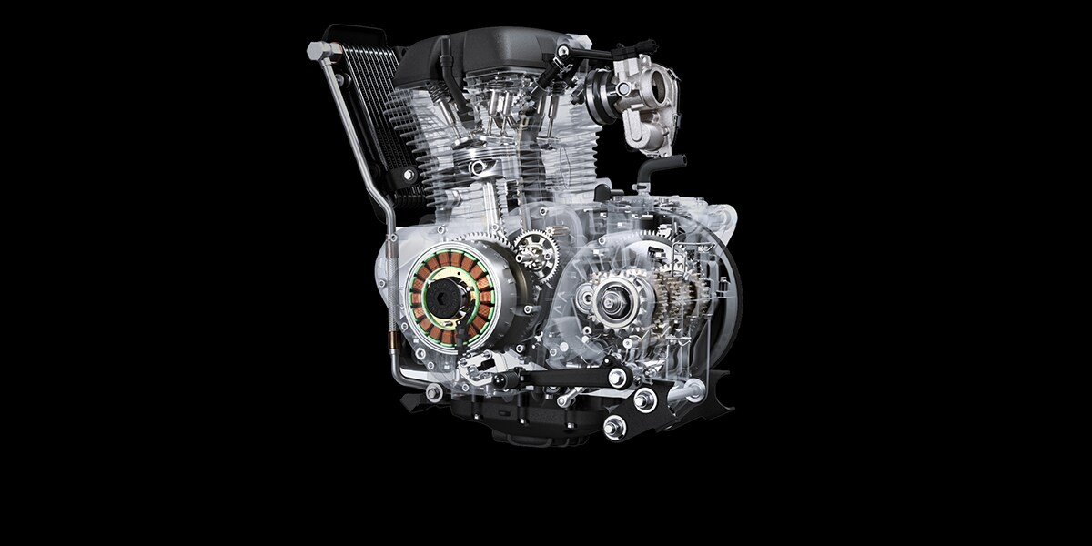 | The biggest change is the engine. The Himalayan 750 uses a 743cc air-oil-cooled inline twin-cylinder, 4-stroke motor with a single overhead camshaft.  Bore and stroke are 83.5 mm × 67.8 mm, and the compression ratio is 9.5:1.

Royal Enfield rates it at 55 PS (40.5 kW) at 7,000 rpm and 63 Nm of torque at 5,000 rpm. Power goes through a wet multi-plate clutch and a 6-speed gearbox. The engine uses a wet sump with fully synthetic 10W-50 oil (API SL / JASO MA2), and starting is electric.

Chassis, suspension and brakes

Suspension built for rough roads
The front suspension offers 190 mm of travel and is adjustable for preload, compression and rebound. At the rear is a Showa monoshock with a linkage, giving 175 mm of travel with preload and rebound adjustment. Ground clearance is 205 mm. | 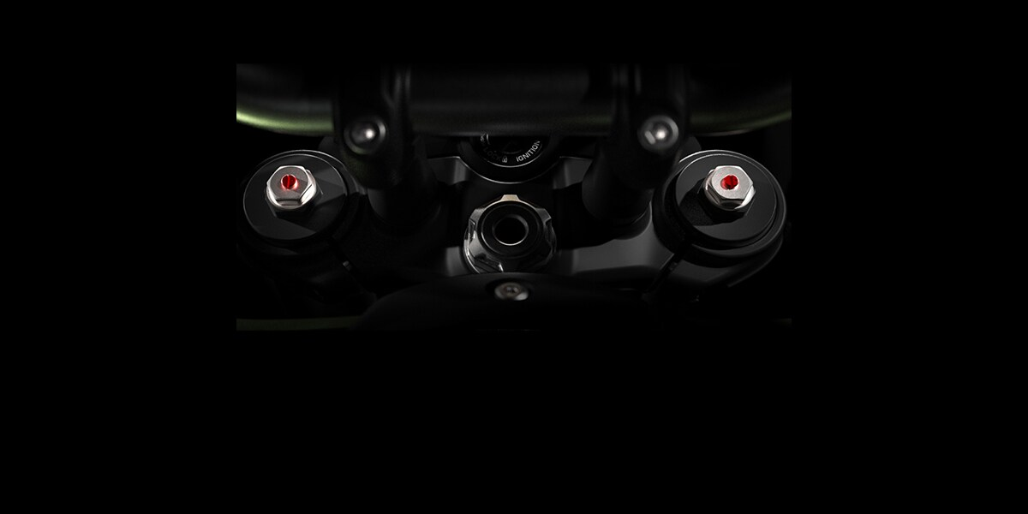

Wheels and tyres
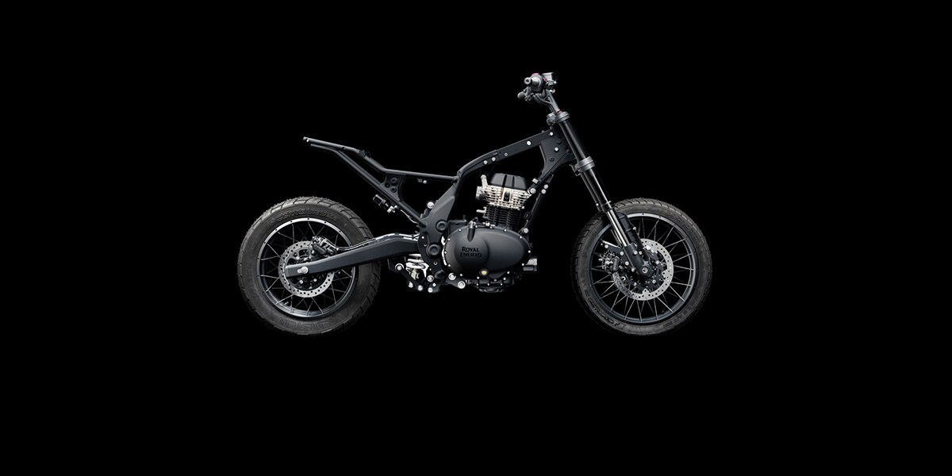 | The Himalayan 750 keeps the classic adventure combination of a 19-inch front and a 17-inch rear wheel, with 110/80 R19 and 150/70 R17 tyres. Buyers can choose cast-alloy or tubeless spoked wheels. Royal Enfield says the 19-inch front "delivers fluid handling across all roads and no roads".

Brakes and safety
Stopping is handled by twin 280 mm floating discs with 2-piston floating calipers at the front and a 255 mm disc with a 2-piston floating caliper at the rear. Dual-channel ABS is standard, and ABS can be switched off at the rear for off-road riding. Royal Enfield also lists cornering ABS, lean-sensitive traction control and a tyre pressure monitoring system (TPMS) as standard.

Dimensions and weight
The Himalayan 750 is 2,185 mm long, 840 mm wide and 1,450 mm tall, with a 1,522 mm wheelbase. Rake is 27.9° and trail is 121.5 mm.  Seat height is 815 mm, kerb weight is 224 kg, and the fuel tank holds 17.8 litres. | 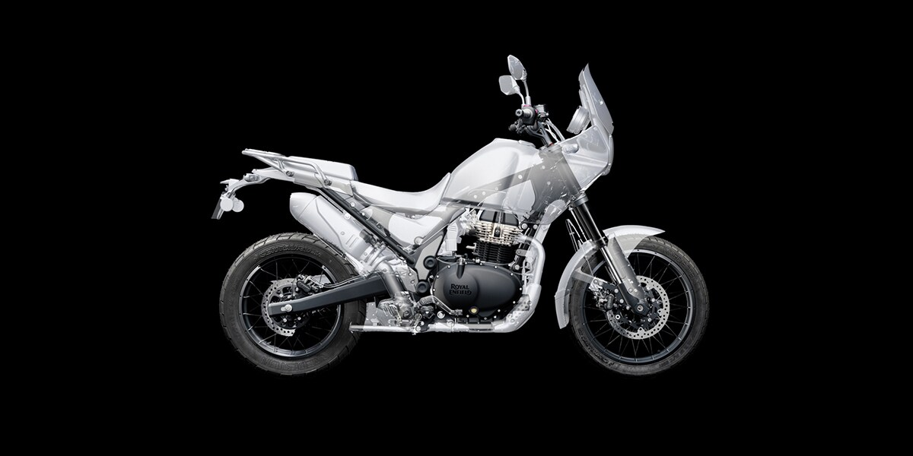

Payload capacity is 194 kg. Royal Enfield says you can "load up the Himalayan without losing stability", which matters for anyone planning to tour two-up with luggage.
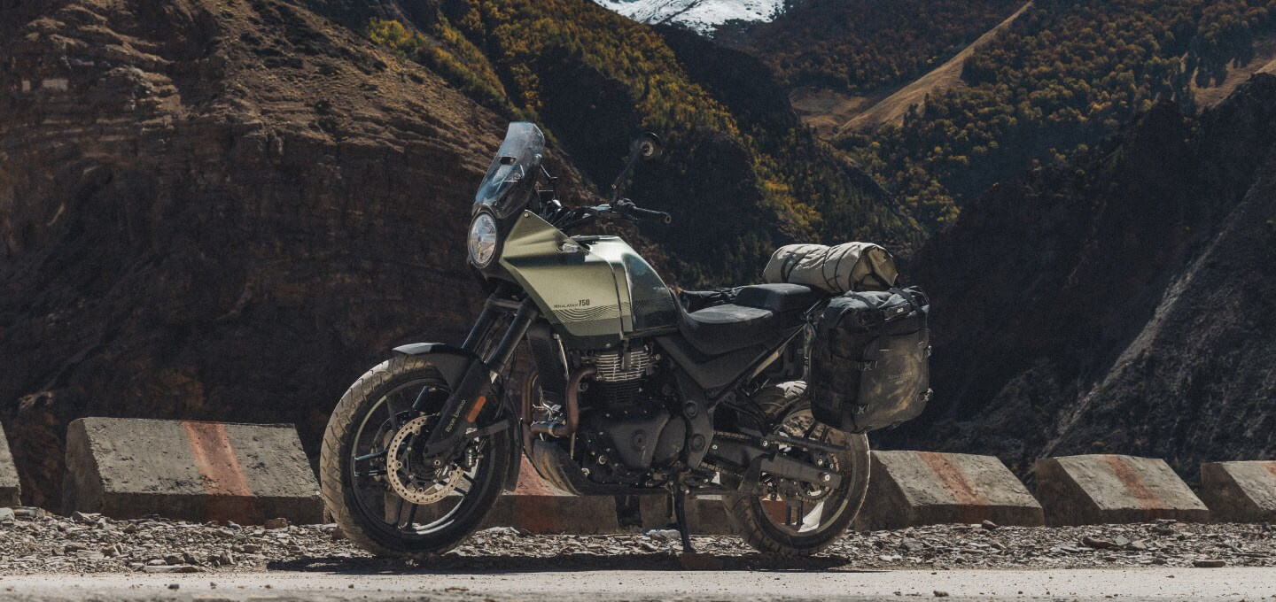
Ready for touring with panniers and a tail bag. Image: Royal Enfield

Features and technology
- TFT display: A circular 4-inch TFT screen "powered by Google engine", with contextual alerts, full-map Google navigation (Tripper Dash) and calls.
- Riding modes: Five riding modes that adjust ABS and traction control to the weather and terrain.
- Cruise control: Cruise control, including lean-sensitive cruise control.
- Connectivity: Bluetooth and Wi-Fi phone connectivity, plus Wingman 2.0 (4G/GPS).
- LED lighting: A 7-inch LED headlight and self-cancelling indicators.
- USB charging: Dual Type-C USB ports (27 W + 10 W) for phones and devices.

Himalayan 750 colours
Royal Enfield lists five colours for the Himalayan 750. Here is how each one looks on the fuel tank:
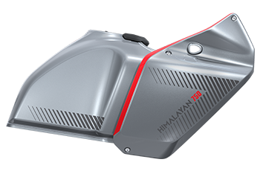  Antarctic Silver | 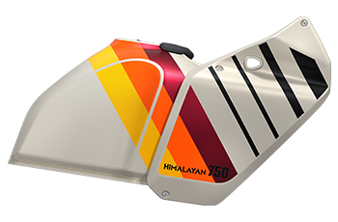  Siberia White | 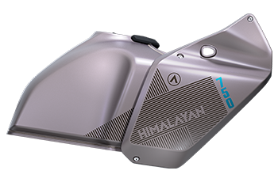  Viking Bronze | 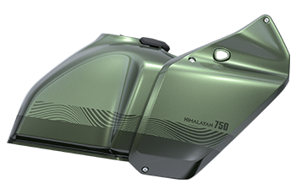  Aztec Green | 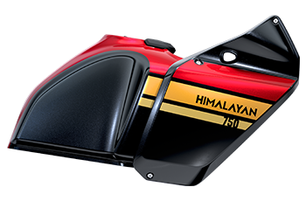  Tectonic Black

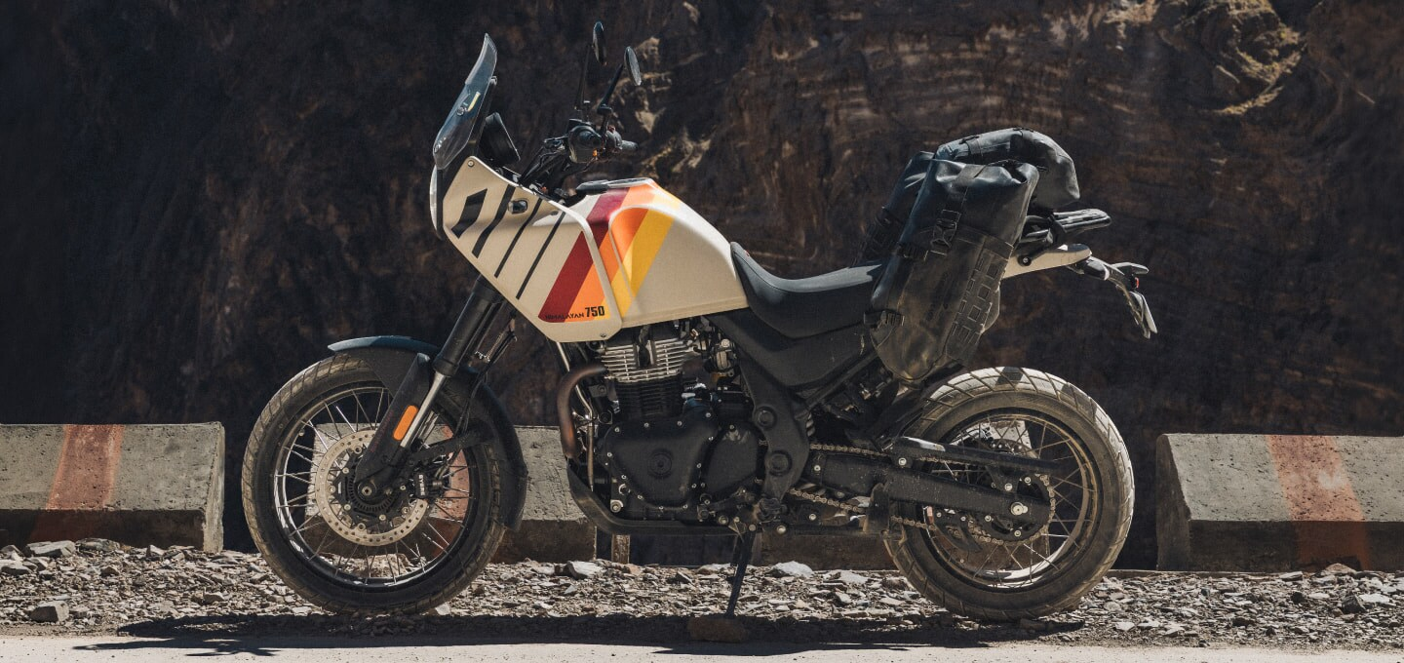  Image: Royal Enfield | 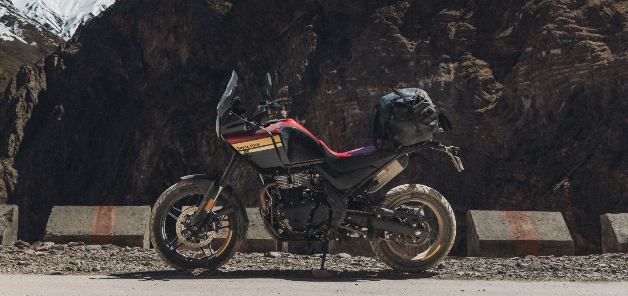  Image: Royal Enfield
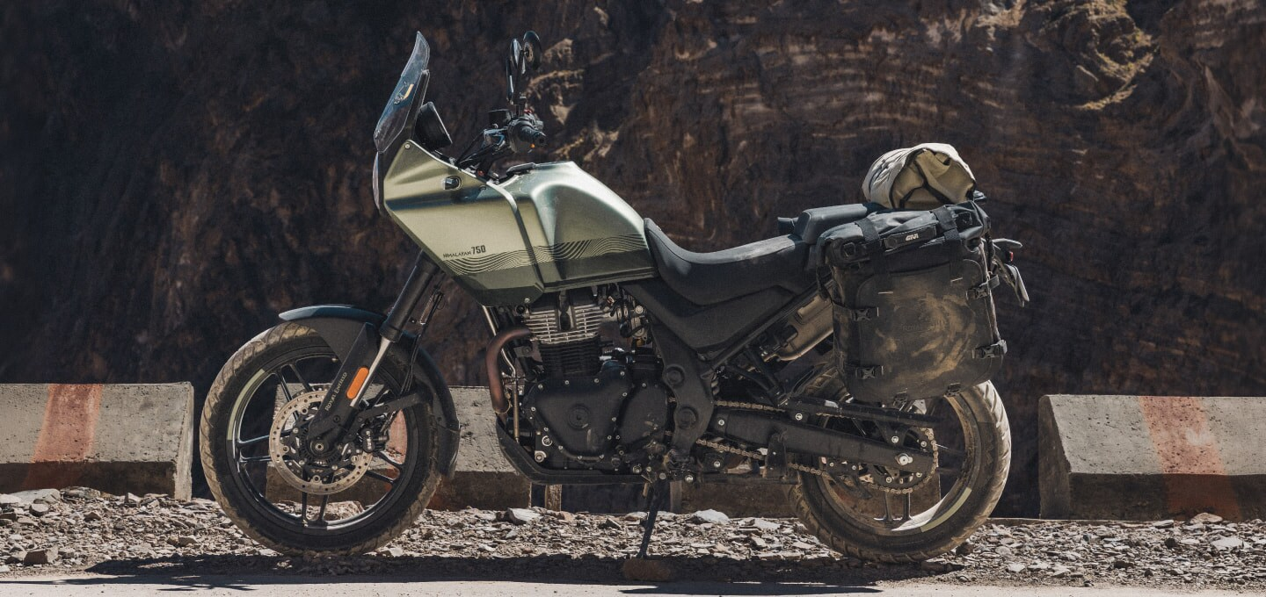  Image: Royal Enfield | 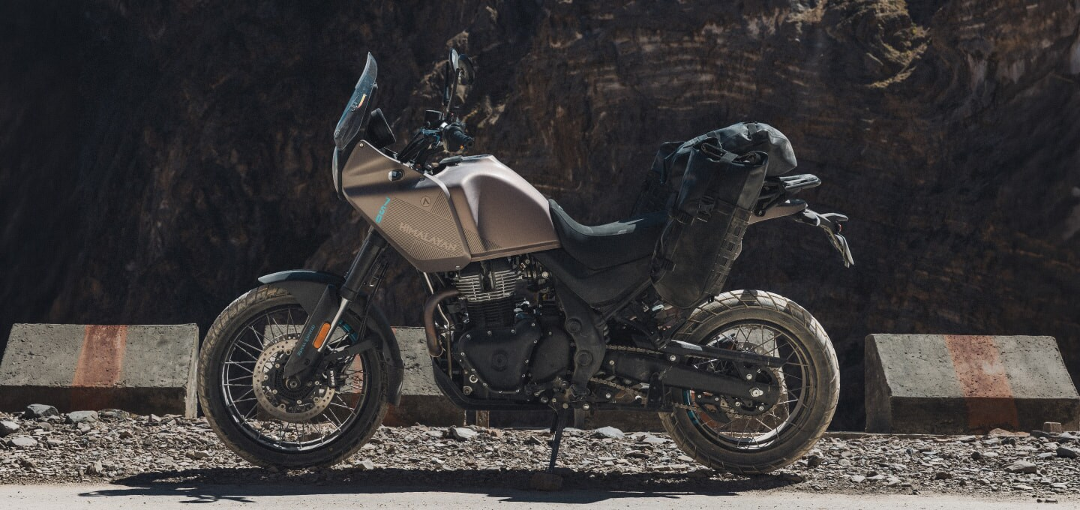  Image: Royal Enfield

Himalayan 750 full specifications
Specification | Himalayan 750
Engine type | Air-oil-cooled inline twin-cylinder, 4-stroke, SOHC
Displacement | 743 cc
Bore × stroke | 83.5 × 67.8 mm
Compression ratio | 9.5:1
Max power | 55 PS (40.5 kW) @ 7,000 rpm
Max torque | 63 Nm @ 5,000 rpm
Clutch | Wet multi-plate
Gearbox | 6-speed
Starting | Electric start
Engine oil | Fully synthetic 10W-50, API SL / JASO MA2
Front suspension travel | 190 mm (preload, compression and rebound adjustable)
Rear suspension | Showa monoshock with linkage, 175 mm travel (preload and rebound adjustable)
Wheelbase | 1,522 mm
Rake / trail | 27.9° / 121.5 mm
Ground clearance | 205 mm
Length × width × height | 2,185 × 840 × 1,450 mm
Seat height | 815 mm
Kerb weight | 224 kg (90% fuel + oil)
Payload capacity | 194 kg
Fuel capacity | 17.8 litres
Tyres (F/R) | 110/80 R19 / 150/70 R17
Wheels | Cast alloy / tubeless spoked option
Front brake | Twin 280 mm floating discs, 2-piston floating calipers
Rear brake | 255 mm disc, 2-piston floating caliper
ABS | Dual-channel, switchable at rear, cornering ABS
Traction control | Lean-sensitive
TPMS | Standard

Himalayan 750 vs Himalayan 450 vs Himalayan 440
On its Himalayan 750 page, Royal Enfield compares the new bike with the rest of the Himalayan family:
 | Himalayan 750 | Himalayan 450 | Himalayan 440
Engine | 743 cc twin | 452 cc single | 443 cc single
Cooling | Air-oil-cooled | Liquid-cooled | Air-cooled
Max power | 55 PS | 40.02 PS | 25.4 bhp
Max torque | 63 Nm | 40 Nm | 34 Nm
Fuel tank | 17.8 L | 17 L | 15 L

In short, the 750 adds a second cylinder, about 15 PS and 23 Nm over the Himalayan 450, along with more electronics such as cornering ABS, lean-sensitive traction control and cruise control. It is the Himalayan for riders who plan long-distance tours.
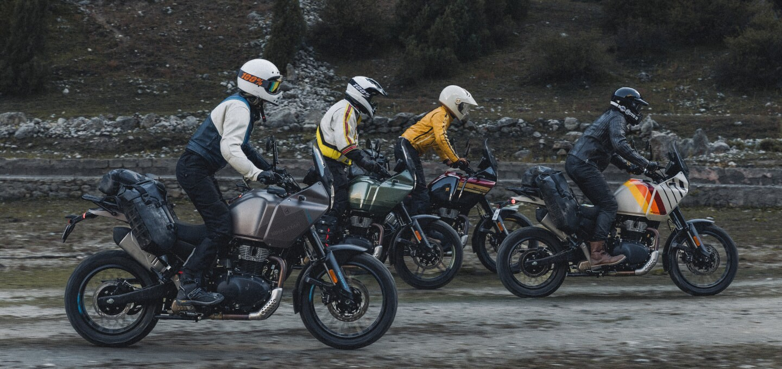
Image: Royal Enfield

Himalayan 750 price
Price not announced yet
Royal Enfield's official page does not list an ex-showroom price for the Himalayan 750 at the time of writing. The page offers a "Stay Updated" sign-up and test ride booking. We will update this post when the price is announced.

Frequently asked questions
Q. What is the engine capacity of the Royal Enfield Himalayan 750?
The Himalayan 750 has a 743cc air-oil-cooled inline twin-cylinder engine.
Q. How much power and torque does the Himalayan 750 make?
Royal Enfield rates it at 55 PS at 7,000 rpm and 63 Nm at 5,000 rpm.
Q. What is the seat height of the Himalayan 750?
The seat height is 815 mm, and ground clearance is 205 mm.
Q. How heavy is the Himalayan 750?
Kerb weight is 224 kg with 90% fuel and oil.
Q. What is the fuel tank capacity of the Himalayan 750?
The fuel tank holds 17.8 litres.
Q. Does the Himalayan 750 have cruise control and traction control?
Yes. Royal Enfield lists cruise control, lean-sensitive cruise control, five riding modes, cornering ABS and lean-sensitive traction control.
Q. What colours is the Himalayan 750 available in?
Antarctic Silver, Siberia White, Viking Bronze, Aztec Green and Tectonic Black.

Final word
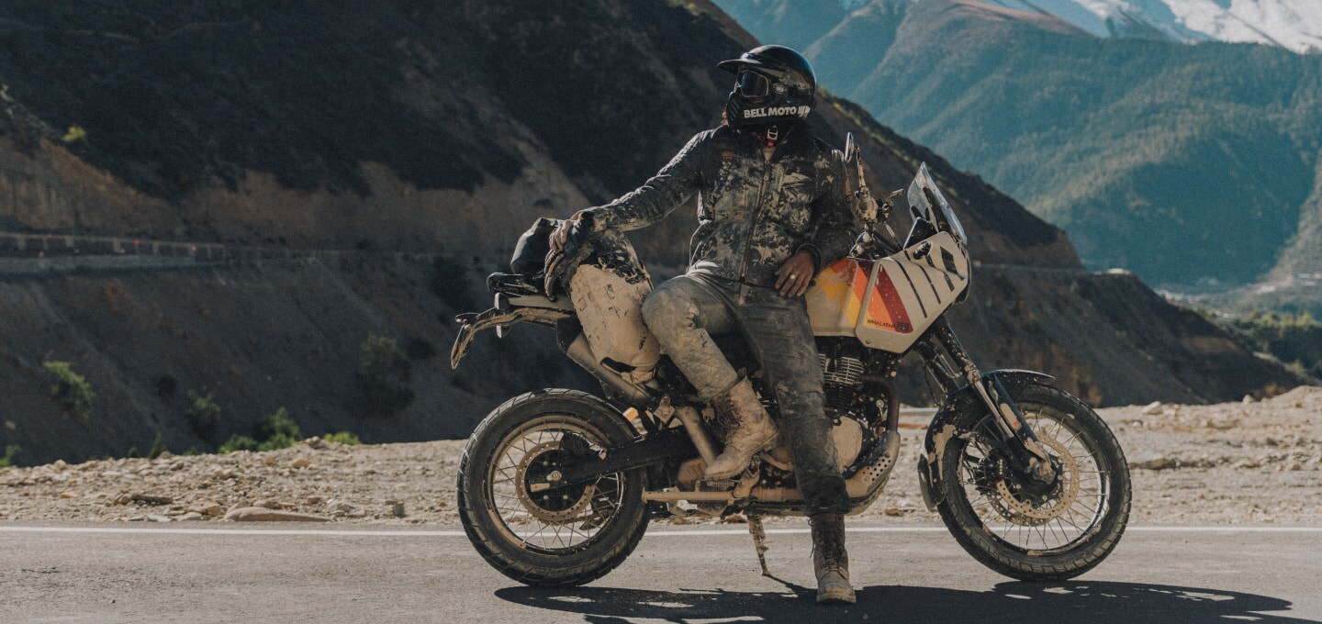
The Royal Enfield Himalayan 750 keeps what made the Himalayan name popular, a tall 19-inch front wheel, long-travel suspension and a focus on real-world touring, and adds a 743cc twin with 55 PS and 63 Nm. With cornering ABS, lean-sensitive traction control, cruise control and a Google-powered TFT, it is the most capable Himalayan Royal Enfield has made. Stay with BikeCarHub for the price announcement and our first impressions.

