SEO DETAILS · for the editor, do not publish this box
SEO title: Hyundai Bayon: Which Variant Is Best Value for Money? (53 chars)
Meta description: Hyundai Bayon variants compared on price and features. We pick the best value-for-money variant, the best budget option and which automatic to buy. (147 chars)
Slug: hyundai-bayon-best-value-for-money-variant
Focus keyword: Hyundai Bayon value for money variant
Secondary keywords: Hyundai Bayon best variant, Hyundai Bayon HX 5, Bayon variant-wise price, Bayon which variant to buy, Hyundai Bayon iVT price
Featured image: bayon-main-des-banner.jpg (watermarked)
Image credit: All images: Hyundai Motor India, with BikeCarHub watermark

BIKECARHUB · WHICH VARIANT TO BUY · HYUNDAI

Hyundai Bayon: Which Variant Is the Best Value for Money?
Seven variants, from ₹9.99 lakh to almost ₹18 lakh. We compare price jumps and features to find the one that gives you the most for your money.
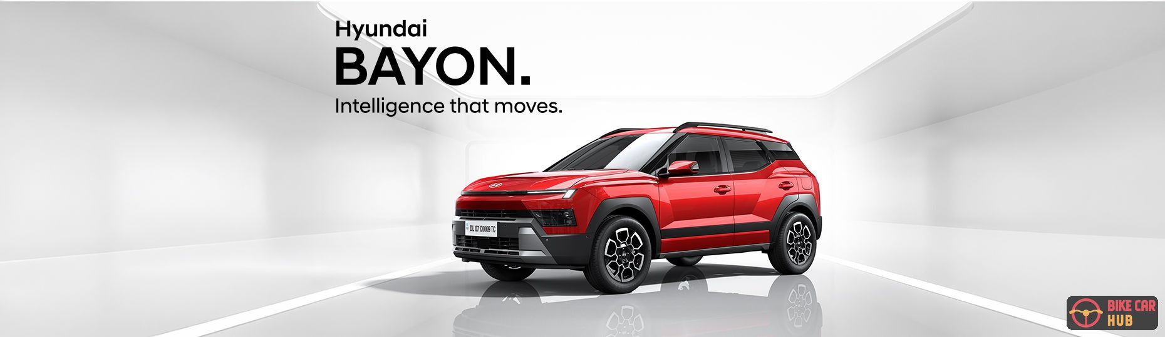
The Hyundai Bayon. Image: Hyundai Motor India
The Hyundai Bayon went on sale on 26 October 2026 with a starting price of ₹9,99,900 (ex-showroom). It comes in seven variants, HX 2, HX 3, HX 3+, HX 5, HX 6, HX 8 and HX 10. All of them use the same 1.5-litre petrol engine (115 PS, 144 Nm) with a 6-speed manual, and HX 5 and above also offer the iVT automatic.
With so many options, picking the right one is tricky. So we went through every variant's price and features to answer one question: which Bayon gives you the most car for your money?
Note: Features come from Hyundai India's official Bayon variants guide. Hyundai's website lists only the ₹9,99,900 starting price, so variant-wise prices are as reported at launch by TimesDrive and CarWale.

Our pick: Hyundai Bayon HX 5
HX 5  Our value pick | ₹12.45 L  Manual, ex-showroom | ₹13.85 L  Cheapest automatic | +₹65,000  Over HX 3+

The HX 5 is the Bayon to buy if you want the best balance of price and features. Here is why:
- Smallest price jump: It costs only ₹65,000 more than the HX 3+, the smallest step in the whole range, yet adds more useful features than any other step.
- Cheapest automatic: At ₹13,84,800, the HX 5 iVT is the cheapest way to get a Bayon automatic. HX 2, HX 3 and HX 3+ are manual only.
- Everyday comfort: Automatic climate control, automatic headlamps, cruise control and a wireless phone charger make daily driving easier.
- Connected and future-proof: Bluelink connected car tech and over-the-air (OTA) software updates keep the car current.
- Everything from below: It keeps the HX 3+'s electric sunroof, roof rails, R17 wheels, reversing camera, smart key and 10.25-inch touchscreen with wireless Android Auto and Apple CarPlay.
- No safety compromise: Six airbags, ESC, ABS with EBD, TPMS and rear parking sensors are standard on every Bayon, so you lose nothing on core safety by skipping the top variants.
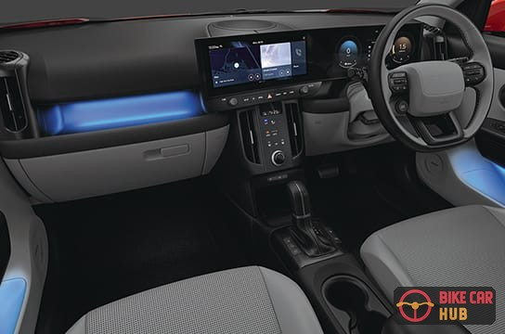 | Above the HX 5, every step costs ₹1.12 lakh to ₹1.55 lakh more.  Those steps add nice-to-haves like a panoramic sunroof, ventilated seats and ADAS rather than features you will use every day.

Hyundai Bayon variant-wise prices
Hyundai's own website lists only the starting price of ₹9,99,900. The variant prices below are the ex-showroom prices reported at launch by TimesDrive, and they match CarWale's launch figures. Dual-tone paint adds ₹15,000 on HX 5 and above.
Variant | Manual | iVT automatic | Jump over the variant below (MT)
HX 2 | ₹9,99,900 | — | Base price
HX 3 | ₹10,89,900 | — | +₹90,000
HX 3+ | ₹11,79,900 | — | +₹90,000
HX 5 ★ | ₹12,44,900 | ₹13,84,800 | +₹65,000 (smallest jump)
HX 6 | ₹13,56,900 | ₹14,96,800 | +₹1,12,000
HX 8 | ₹15,09,900 | ₹16,53,900 | +₹1,53,000
HX 10 | ₹16,64,900 | ₹17,99,900 | +₹1,55,000
Ex-showroom prices as reported by TimesDrive (updated 27 Oct 2026). Confirm the latest price with your Hyundai dealer.

Every variant: what you get and who it suits
Feature lists below come from Hyundai India's official Bayon variants guide. Each variant adds to the one below it.

HX 2 ₹9,99,900
Verdict: Good for the lowest price, but you miss the touchscreen and reversing camera.
Six airbags, ESC, ABS with EBD, rear parking sensors, TPMS, LED projector headlamps, R16 steel wheels, manual AC and rear AC vents.

HX 3 ₹10,89,900
Verdict: Best budget pick. Worth the ₹90,000 over HX 2.
Adds a reversing camera, smart key with push-button start and a 10.25-inch (26.03 cm) touchscreen with wireless Android Auto and Apple CarPlay.

HX 3+ ₹11,79,900
Verdict: Pay this only if you really want a sunroof.
Adds an electric sunroof, roof rails and R17 styled steel wheels. The ₹90,000 extra is mostly for looks.

HX 5 ₹12,44,900 MT · ₹13,84,800 iVT
Verdict: Best value for money in the range.
Adds the iVT automatic option, automatic headlamps, automatic climate control, Bluelink connected car tech, OTA updates, a wireless charger and cruise control.

HX 6 ₹13,56,900 MT · ₹14,96,800 iVT
Verdict: Buy it if style matters to you.
Adds dual LED projector headlamps, a panoramic sunroof, R17 diamond-cut alloy wheels, a leather-wrapped steering wheel and gear knob, and ambient lighting.
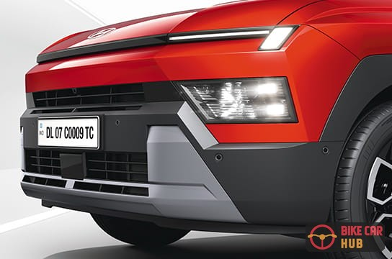  Dual LED projector headlamps (HX 6 and above) | 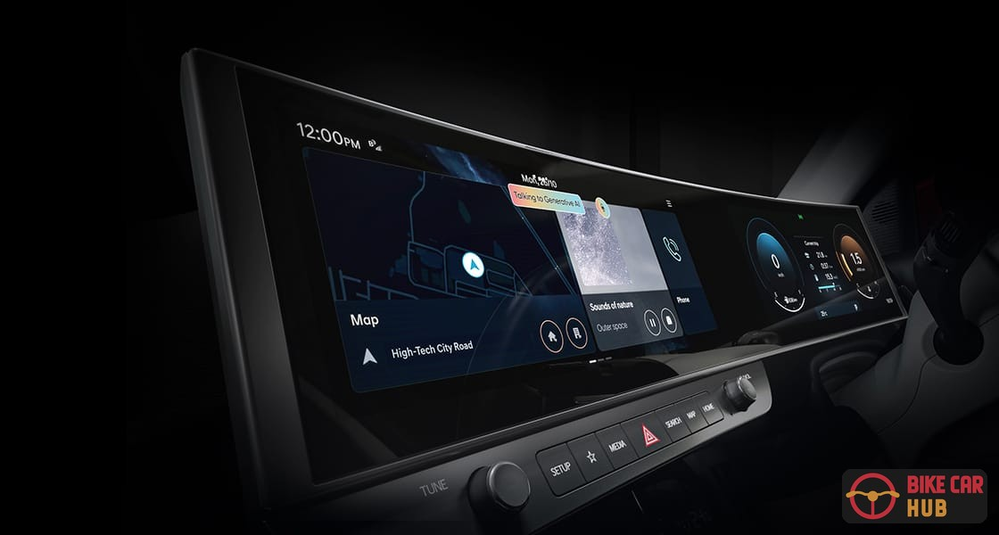  Dual curved displays (HX 10). Image: Hyundai Motor India

HX 8 ₹15,09,900 MT · ₹16,53,900 iVT
Verdict: Buy it for comfort, especially in hot cities.
Adds front and side parking sensors, a Surround View Monitor, a dashcam, rear disc brakes, leatherette seats, an 8-way electric driver seat and ventilated front seats.

HX 10 ₹16,64,900 MT · ₹17,99,900 iVT
Verdict: Buy it if you want every feature.
Adds SmartSense Level 2 Pro ADAS, a Blind-spot View Monitor, the 12.3-inch navigation screen and digital cluster, the generative AI voice assistant, Bose audio and the dual curved panoramic displays.

Our verdict at a glance
TIGHT BUDGET  HX 3  ₹10,89,900 (MT)  • Reversing camera  • Smart key, push-button start  • 10.25-inch touchscreen, wireless Android Auto and Apple CarPlay | BEST VALUE  HX 5  ₹12,44,900 MT · ₹13,84,800 iVT  • Cheapest automatic  • Auto climate control, cruise control  • Bluelink connected tech, OTA updates, wireless charger | WANT THE LOOKS  HX 6  ₹13,56,900 (MT)  • Dual LED projector headlamps  • Panoramic sunroof  • R17 diamond-cut alloys, ambient lighting

Whichever variant you choose, you get the same 505-litre boot, 205 mm of ground clearance and 1.5-litre petrol engine.  So the choice comes down to features and budget, not practicality or performance. | 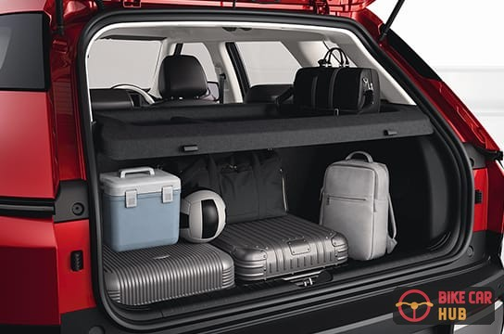

Should you buy the HX 5 manual or the iVT?
The iVT automatic costs ₹1,39,900 more than the HX 5 manual. If you drive mostly in city traffic, the iVT is worth it: it also gets Dash Boost Mode, Sporty Drive Tech and paddle shifters. If you drive mostly on highways or want to save money, the manual makes more sense.

Frequently asked questions
Q. Which Hyundai Bayon variant is the best value for money?
The HX 5. For ₹12,44,900 (manual) it adds automatic climate control, cruise control, Bluelink, OTA updates and a wireless charger, and it is the cheapest variant with an automatic option.
Q. Which is the cheapest Hyundai Bayon automatic?
The HX 5 iVT, at ₹13,84,800 ex-showroom.
Q. Is the Bayon base variant worth buying?
Only on a very tight budget. For ₹90,000 more, the HX 3 adds a touchscreen with wireless Android Auto and Apple CarPlay, a reversing camera and a smart key.
Q. Do all Bayon variants get six airbags?
Yes. Six airbags, ESC, ABS with EBD and TPMS are standard on every variant.
Q. Which Bayon variant has ADAS?
Hyundai SmartSense Level 2 Pro ADAS is on the top HX 10 variant.

Final word
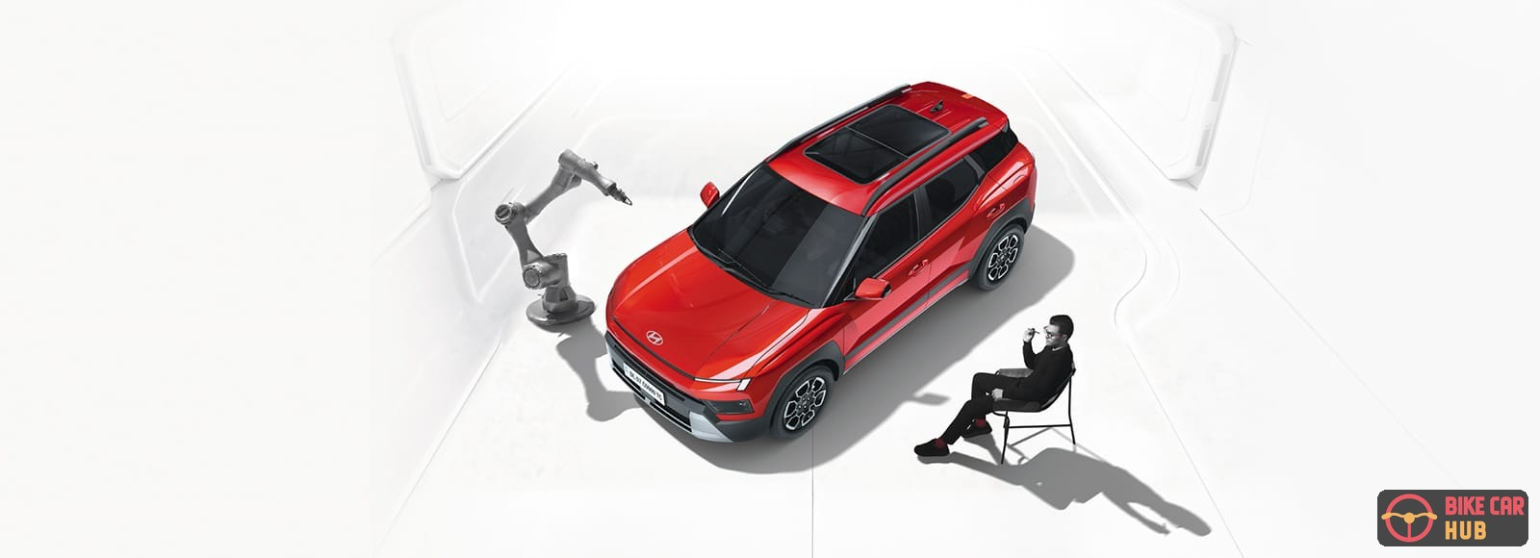
If you are buying a Hyundai Bayon, the HX 5 is the sweet spot. It costs ₹12,44,900 with the manual and ₹13,84,800 with the iVT, and it has the comfort and connected features most buyers use daily. On a tighter budget, go for the HX 3. If you want the full premium look, stretch to the HX 6.

