BIKECARHUB · UPCOMING BIKES · HERO

Hero Xpulse 450 Unveiled: Specs, Features, Launch Date and Expected Price
The biggest and most capable Xpulse yet, with a 421cc engine and DNA from Hero's Dakar rally bike.
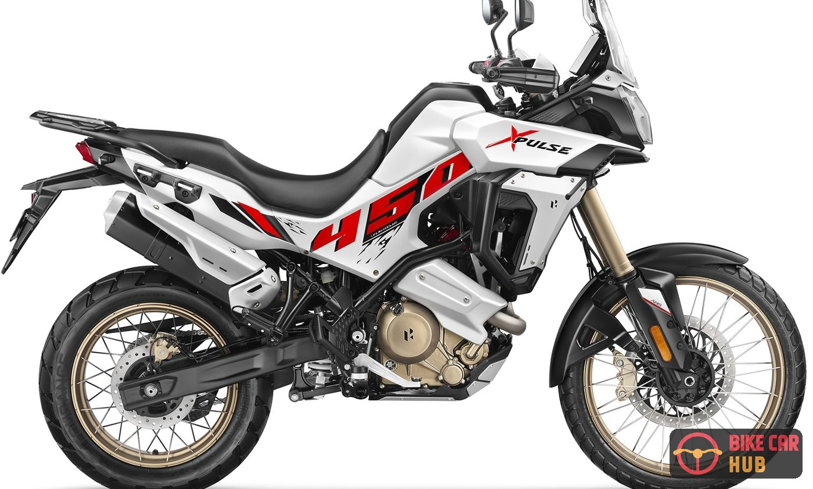
The Hero Xpulse 450. Image: Hero MotoCorp
Hero MotoCorp has unveiled the Xpulse 450 at EICMA 2026 in Milan. Hero calls it an "adventure motorcycle inspired from Hero Dakar 450" and says it brings "to the world the biggest and the most capable Xpulse".
It sits well above the Xpulse 210 and Xpulse 200 4V in Hero's line-up, with a new 421cc liquid-cooled engine, fully adjustable KYB suspension, a 21-inch front wheel and a 7-inch touchscreen with Android Auto and Apple CarPlay. Here is everything we know so far.
Note: The specifications below come from Hero MotoCorp's official EICMA 2026 page. Hero has not yet announced a price or an India launch date, so those sections use news reports and are marked as unconfirmed.

Hero Xpulse 450 at a glance
421 cc  Liquid-cooled, DOHC | 46.6 PS  34.3 kW | 225 mm  Front travel | 230 mm  Ground clearance

- Engine: 421cc liquid-cooled, 4-valve, DOHC single-cylinder
- Output: 34.3 kW (46.6 PS); torque reported as 38 Nm at 7,500 rpm
- Gearbox: 6-speed with assist and slipper clutch
- Suspension: KYB 43 mm USD fork with 225 mm travel; rear with 215 mm travel
- Wheels: 90/90-21 front and 140/80-17 rear, tubeless spoked
- Seat and clearance: 848 mm seat height, 230 mm ground clearance
- Display: 7-inch touchscreen TFT with Android Auto and Apple CarPlay

Born from Hero's Dakar rally bike
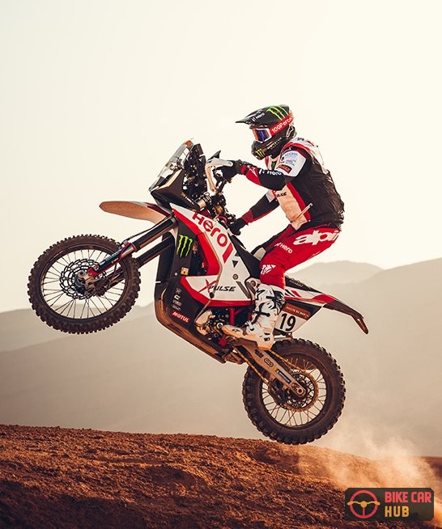 | Hero says the Xpulse 450 is "a direct descendant of the Hero Motosports Dakar Bike". News reports add that it was developed with direct input from the Hero MotoSports rally team.  That rally link shows in the long-travel suspension, 21-inch front wheel and 230 mm of ground clearance.

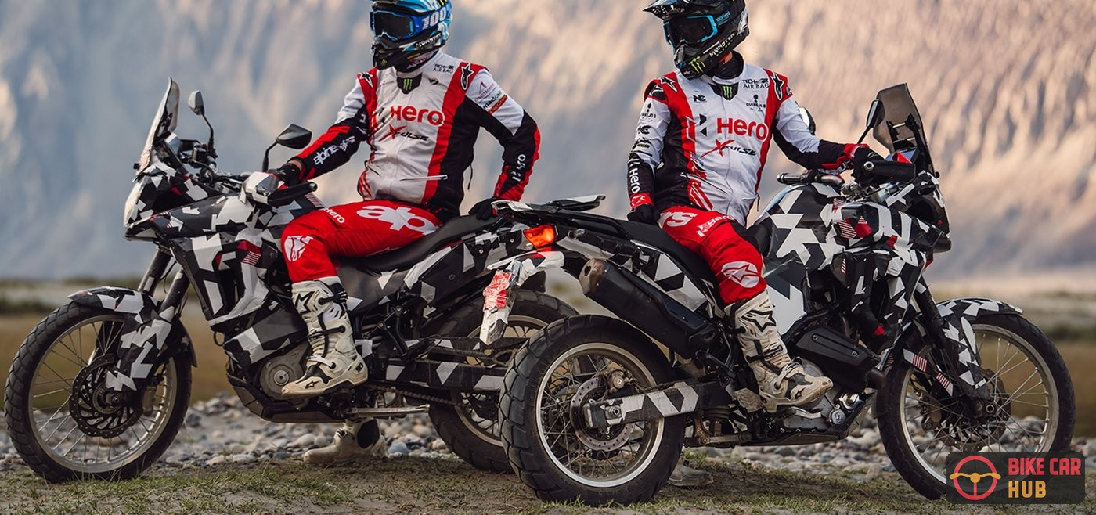
Camouflaged Xpulse 450 test bikes with Hero MotoSports riders. Image: Hero MotoCorp

Engine and performance
The Xpulse 450 uses a new 421cc liquid-cooled single-cylinder engine with four valves and double overhead camshafts (DOHC).  Hero lists output as 34.3 kW, which is about 46.6 PS. News reports put peak power at 9,100 rpm and torque at 38 Nm at 7,500 rpm.  It has a 6-speed gearbox with an assist and slipper clutch, which lightens the clutch lever and helps on hard downshifts. | 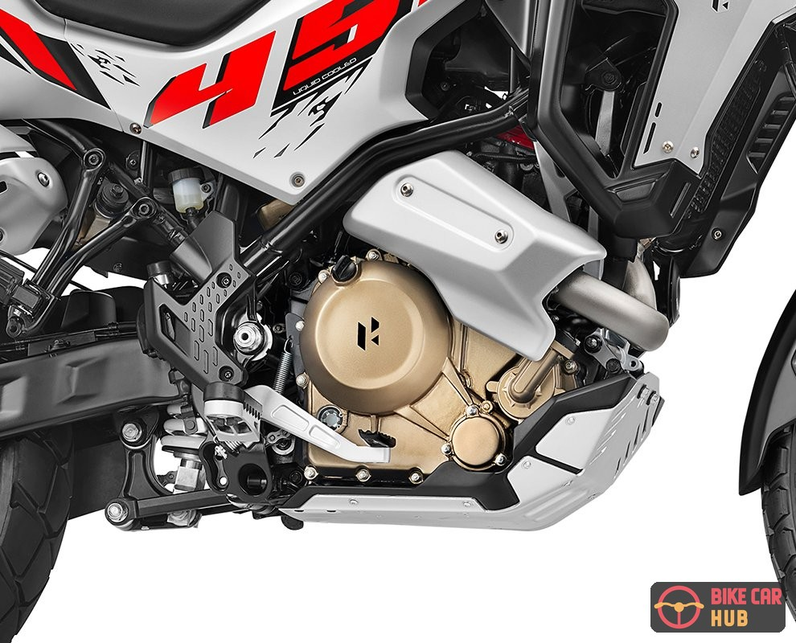

For comparison, that is more power than the Royal Enfield Himalayan 450 (40.02 PS) but slightly less torque (40 Nm), according to Royal Enfield's official figures.

Suspension, wheels and chassis
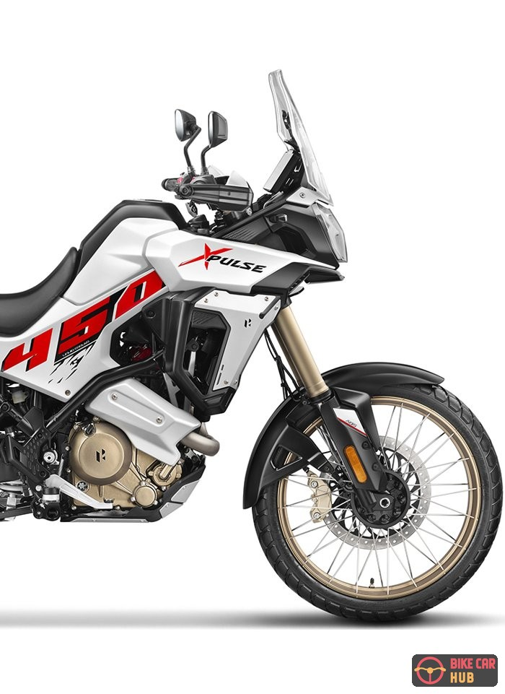 | Up front is a KYB 43 mm upside-down cartridge fork with 225 mm of travel and 22-step compression and rebound damping adjustment.  At the rear, Hero lists 215 mm of travel with 22-step rebound damping adjustment and a 10-step preload adjuster.  The bike runs a 90/90-21 front and a 140/80-17 rear on tubeless spoked wheels with gold rims. Seat height is 848 mm and ground clearance is 230 mm.

Disc brakes are fitted at both ends, with switchable ABS modes shown on the display. Hero has not yet published brake sizes, kerb weight or fuel tank capacity.

Display, electronics and features
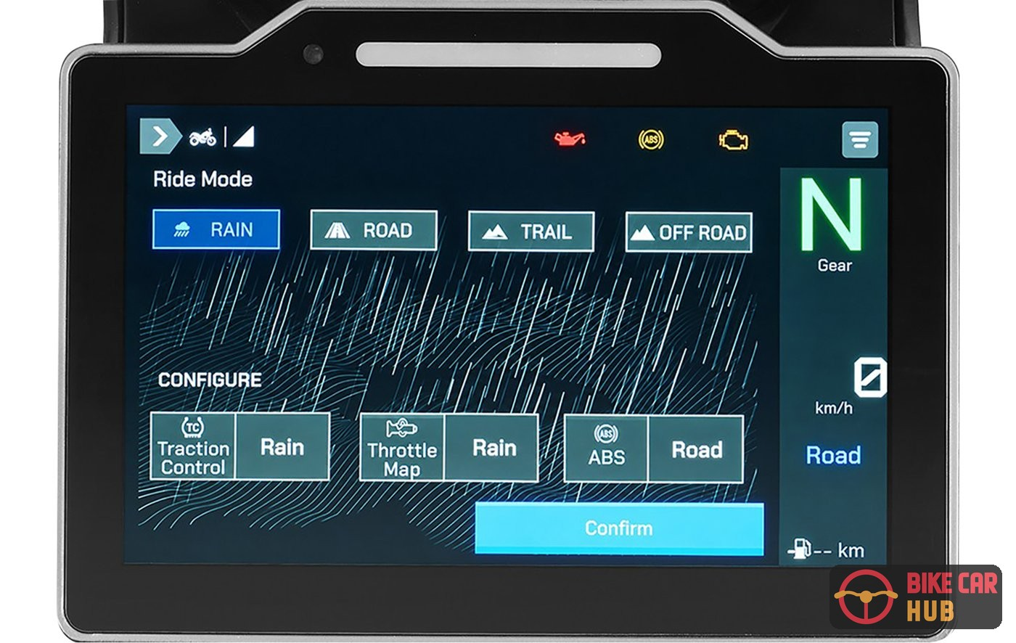
The touchscreen showing ride modes and traction control, throttle map and ABS settings. Image: Hero MotoCorp
- Touchscreen TFT: A 7-inch touchscreen TFT with Android Auto and Apple CarPlay, which Hero calls a segment first.
- Ride modes: Four ride modes: Rain, Road, Trail and Off Road. The screen shows traction control, throttle map and ABS settings for each.
- Bluetooth: Bluetooth for call and SMS alerts and music control.
- Charging: A USB Type-C port and a 12V socket built in.
- Cruise control: Hero's EICMA page and news reports mention cruise control with smart throttle override (you can speed up past the set speed without cancelling it). It switches off when you pull the clutch or use either brake.

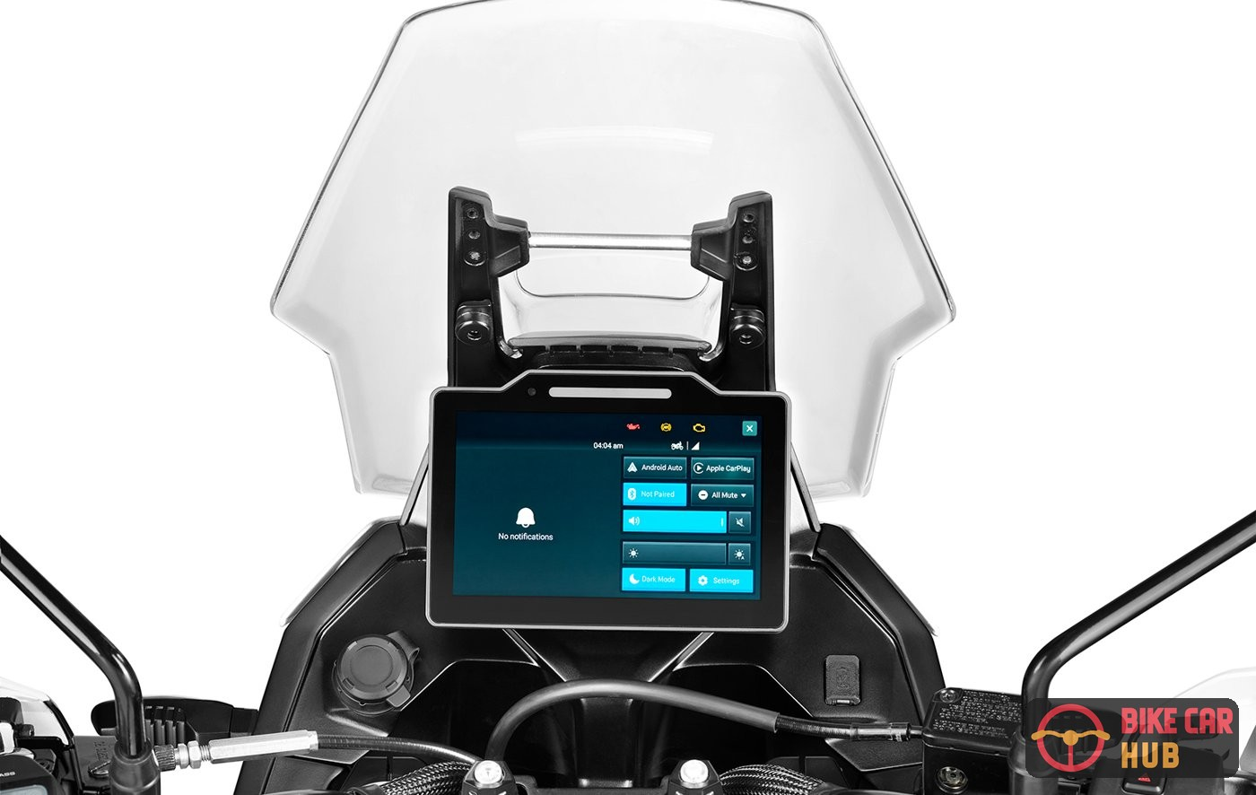  Tall windscreen and TFT cockpit | 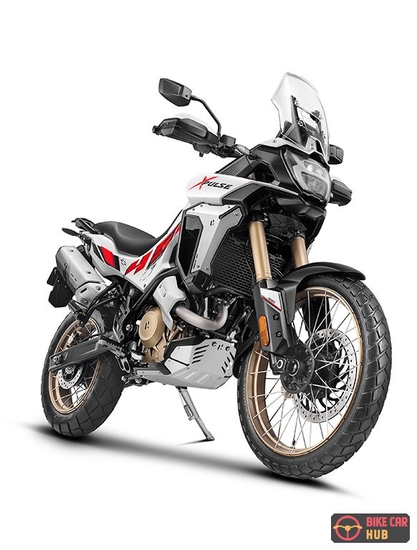  Front three-quarter view

Design and colour
The Xpulse 450 has a tall windscreen, a vertically stacked headlamp, a rally-style front fairing and a flat seat. The bike Hero showed is white with red and black "450" graphics, gold wheel rims and bronze engine covers. Hero has not announced other colours yet.
With its long-travel suspension, 21-inch front wheel and Dakar roots, the Xpulse 450 is pitched at riders who want a bike for both touring and serious off-road riding. | 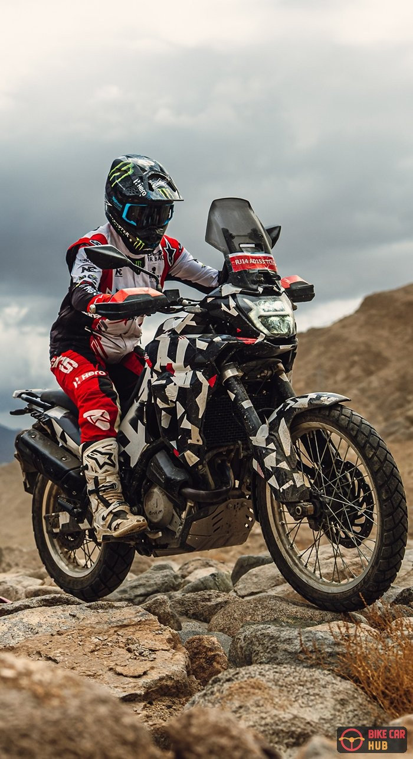

Hero Xpulse 450 specifications
Specification | Hero Xpulse 450
Engine | 421 cc, liquid-cooled, single-cylinder, 4-valve DOHC
Max power | 34.3 kW (46.6 PS); 9,100 rpm per news reports
Max torque | 38 Nm @ 7,500 rpm (per news reports)
Gearbox | 6-speed, assist and slipper clutch
Front suspension | KYB 43 mm USD cartridge fork, 225 mm travel, 22-step compression and rebound
Rear suspension | 215 mm travel, 22-step rebound, 10-step preload
Front tyre | 90/90-21
Rear tyre | 140/80-17
Wheels | Tubeless spoked
Brakes | Disc front and rear, with ABS modes
Seat height | 848 mm
Ground clearance | 230 mm
Display | 7-inch touchscreen TFT, Android Auto and Apple CarPlay
Ride modes | Rain, Road, Trail, Off Road
Connectivity | Bluetooth calls, SMS alerts, music control
Charging | USB Type-C and 12V socket
Kerb weight | Not announced
Fuel tank | Not announced

Xpulse 450 launch date and expected price
Hero MotoCorp has not announced a price or an India launch date. Several reports say the bike will go on sale in Europe first, with India to follow. Here is what different publications are reporting:
Report | What it says (not confirmed by Hero)
Autocar India / DriveSpark | Europe launch first, India to follow; no timeline or price given
ZigWheels | India launch expected early next year; expected price around ₹3 lakh (ex-showroom)
autoX | Earlier reports suggested an India arrival in 2027 at ₹2.70 to 2.90 lakh (ex-showroom)
BikeWale | Describes the EICMA bike as a prototype, with production in the second half of 2027

Once it launches, the Xpulse 450 will take on the Royal Enfield Himalayan 450 and the KTM 390 Adventure. We will update this post when Hero confirms the price and launch date.

Frequently asked questions
Q. What is the engine capacity of the Hero Xpulse 450?
It has a 421cc liquid-cooled, 4-valve, DOHC single-cylinder engine, even though it is badged 450.
Q. How powerful is the Xpulse 450?
Hero lists 34.3 kW (about 46.6 PS). News reports put torque at 38 Nm.
Q. What is the seat height of the Xpulse 450?
Hero lists 848 mm, with 230 mm of ground clearance.
Q. Does the Xpulse 450 get Android Auto and Apple CarPlay?
Yes. Hero says its 7-inch touchscreen TFT offers Android Auto and Apple CarPlay, a first in the segment.
Q. When will the Hero Xpulse 450 launch in India?
Hero has not announced a date. Reports say Europe will get it first, and estimates for India range from early 2027 to the second half of 2027.
Q. What will the Xpulse 450 cost?
Hero has not announced a price. Reports estimate roughly ₹2.7 lakh to ₹3 lakh (ex-showroom).

Final word
The Hero Xpulse 450 is the most serious adventure bike Hero has shown so far. It has a 421cc liquid-cooled engine, KYB suspension with 225 mm of travel, a 21-inch front wheel and a touchscreen with Android Auto and Apple CarPlay. If Hero prices it close to current estimates, it could be a strong rival to the Himalayan 450. Stay with BikeCarHub for the launch.

