BIKECARHUB · NEW CARS · HYUNDAI

Hyundai Bayon Launched at ₹9.99 Lakh: Price, Specs, Features, Variants and Colours
Hyundai's new "Intelligent Utility Vehicle" brings a 1.5L petrol, an iVT automatic, Level 2 ADAS and India's first Hyundai generative AI voice assistant.

The Hyundai Bayon. Image: Hyundai Motor India
Hyundai Motor India has launched the Hyundai Bayon, a car it calls an "Intelligent Utility Vehicle". It was unveiled on 12 October 2026 and launched on 26 October 2026, with a starting price of ₹9,99,900 (ex-showroom). Hyundai's tagline for it is "Intelligence That Moves".
In this post we cover everything Hyundai has published about the Bayon on its official India website: price, engine and gearbox options, dimensions, safety, technology, the seven variants and all ten colours.

Hyundai Bayon at a glance
115 PS  1.5L MPi petrol | 144 Nm  Peak torque | 505 L  Boot space | ₹9.99 L  Starting ex-showroom

- Price: ₹9,99,900 starting price (ex-showroom)
- Engine: 1.5L MPi petrol, 6-speed manual or iVT automatic
- Variants: HX 2, HX 3, HX 3+, HX 5, HX 6, HX 8, HX 10 (iVT from HX 5)
- Safety: Six airbags, ESC, HAC, roll-over sensor and TPMS standard on every variant
- Practicality: 205 mm ground clearance, 505-litre boot, 43-litre fuel tank
- Colours: 10 options, including two dual-tone and two matte shades

Hyundai Bayon price
Starts at ₹9,99,900 (ex-showroom)
Hyundai has announced only the starting price so far. Its official price page does not yet list a price for each variant, and notes that prices may change, so check with your nearest Hyundai dealer before booking. Bookings opened at ₹11,000 at dealerships and online.

Design: bold and upright
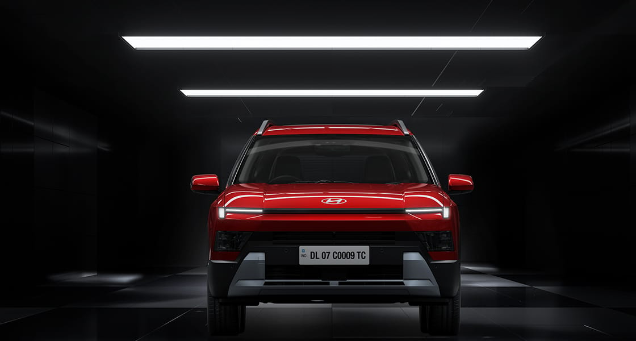
Image: Hyundai Motor India
Hyundai describes the Bayon's design as "Bold in expression. Precise in execution. Intelligent by design." Up front are Signature H-Edge LED DRLs and high-intensity dual LED projector headlamps, with matching H-Edge LED tail lamps at the back. Higher variants get R17 diamond-cut alloy wheels and bridge-type roof rails.
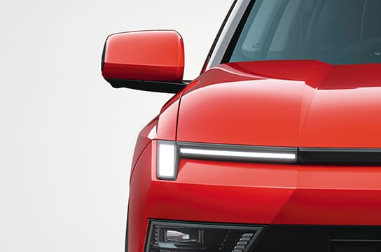  Signature H-Edge LED DRLs | 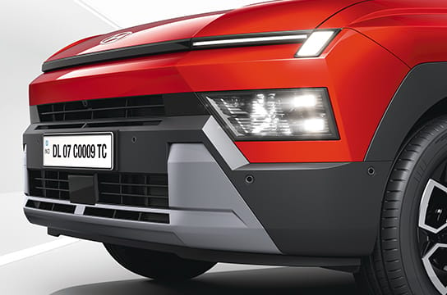  Dual LED projector headlamps

Engine, gearbox and performance
 | The Bayon uses a 1.5-litre MPi four-cylinder petrol engine (1,497 cc). It makes 115 PS (84.4 kW) at 6,300 rpm and 143.8 Nm (14.7 kgm) at 4,500 rpm.  You can pick a 6-speed manual or Hyundai's Intelligent Variable Transmission (iVT).

The iVT gets Dash Boost Mode and Sporty Drive Tech. Hyundai also lists Eco, Normal and Sport drive modes with a steering-mounted Drive Mode button, paddle shifters and Idle Stop & Go (ISG). Hyundai says more than 6 lakh of its cars with this engine have been sold in India since 2020.
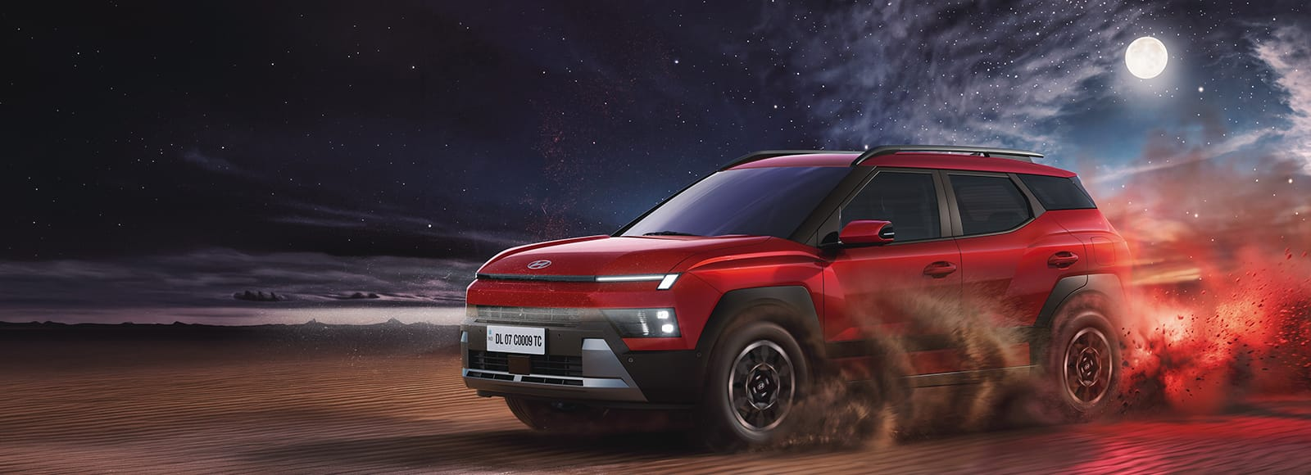
Image: Hyundai Motor India

Interior and technology
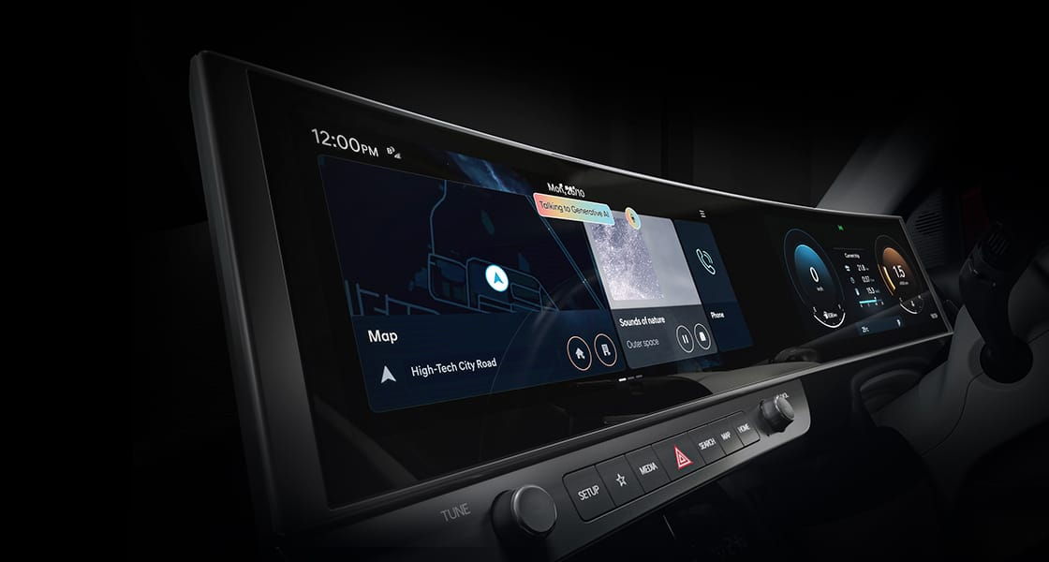
Dual curved panoramic displays. Image: Hyundai Motor India

Dual curved screens and AI voice assistant
The top variant gets dual 12.3-inch (62.5 cm) curved panoramic displays with a Connected Car Navigation Cockpit (ccNC) accelerated by NVIDIA. It also brings Hyundai India's first generative AI voice assistant, built with Intelligence by Perplexity and Voice AI by SoundHound AI. It can answer conversational requests such as travel plans, weather, hotels, restaurants and sports updates.
- Voice commands: 500+ embedded voice commands that work offline in English, Hindi, Hinglish, Tamil, Bengali and Telugu
- Connected car: 70+ Bluelink connected features, with three years of free Bluelink subscription
- Updates: Over-the-air (C-OTA) updates across up to 19 controllers
- Languages: 10 regional and 2 international languages on the screens
- Phone and audio: Wireless Android Auto and Apple CarPlay, and Bose premium sound

Comfort
The cabin has a dual-tone Black and Olive Grey theme, ambient lighting and a two-tone D-cut steering wheel. Comfort features include ventilated front seats, an 8-way electric driver seat, two-step rear reclining seats, rear AC vents, fully automatic climate control, a panoramic sunroof and a wireless phone charger. | 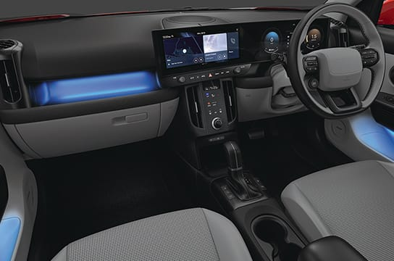

Space and practicality
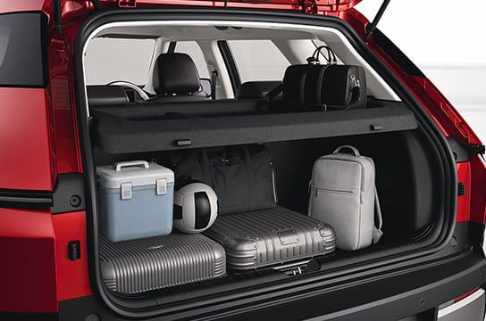 | Hyundai quotes a 505-litre boot, and the rear seats split 60:40.  The Bayon is 4,245 mm long, 1,810 mm wide and 1,605 mm tall (with roof rails), with a 2,600 mm wheelbase, 205 mm of ground clearance and a 5.16 m turning radius.

Safety
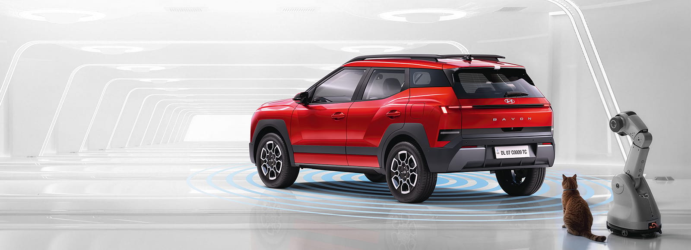
Image: Hyundai Motor India
The Bayon is built on Hyundai's Global K Enhanced Platform, which Hyundai says is engineered for 5-star Indian safety standards and uses 69% advanced high-strength steel. Hyundai lists more than 80 safety features in total and 35+ standard on every variant, including six airbags, ESC, Hill Assist Control, a roll-over sensor and TPMS (High).
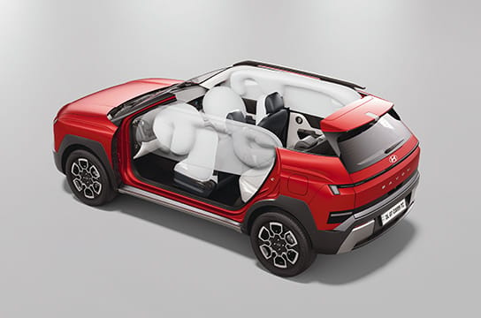  Six airbags as standard | 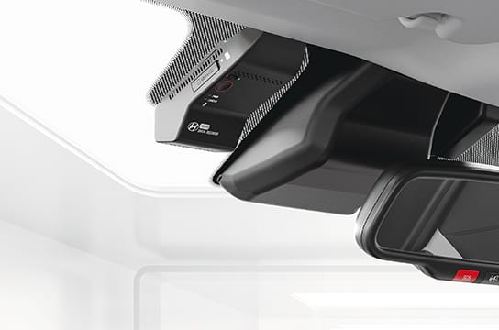  Built-in dashcam

The top variant adds Hyundai SmartSense Level 2 Pro ADAS with 23 driver assistance features, 3 radars and 12 parking sensors. This includes Highway Driving Assist, Navigation-based Smart Cruise Control, a Surround View Monitor, a Blind-spot View Monitor and disc brakes on all four wheels.
“The launch of Hyundai BAYON marks the beginning of Hyundai's next golden product cycle in India.”
Tarun Garg, MD & CEO, Hyundai Motor India Limited

Hyundai Bayon variants explained
The Bayon comes in seven variants. The 6-speed manual is offered on all of them, and the iVT automatic is offered on HX 5, HX 6, HX 8 and HX 10.
Variant | What you get (over the variant below)
HX 2 | Six airbags, ESC, ABS with EBD, rear parking sensors, TPMS, LED projector headlamps, R16 steel wheels, manual AC, rear AC vents
HX 3 | Adds reversing camera, smart key with push-button start, 26.03 cm (10.25-inch) touchscreen with wireless Android Auto and Apple CarPlay
HX 3+ | Adds electric sunroof, roof rails, R17 styled steel wheels
HX 5 | Adds the iVT option, automatic headlamps, automatic climate control, Bluelink connected car tech, OTA updates, wireless charger, cruise control
HX 6 | Adds dual LED projector headlamps, panoramic sunroof, R17 diamond-cut alloys, leather-wrapped steering wheel and gear knob, ambient lighting
HX 8 | Adds front and side parking sensors, Surround View Monitor, dashcam, rear disc brakes, leatherette seats, 8-way electric driver seat, ventilated front seats
HX 10 | Adds SmartSense Level 2 Pro ADAS, Blind-spot View Monitor, 12.3-inch navigation screen and digital cluster, Generative AI voice assistant, Bose audio, dual curved panoramic displays

Hyundai Bayon colours
Hyundai offers the Bayon in ten colours: six single tones, two dual tones with a black roof, and two matte finishes.
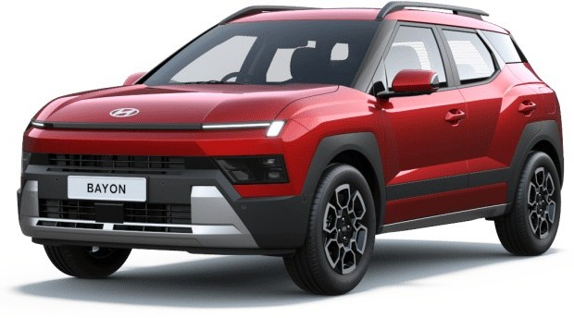  Fiery Red | 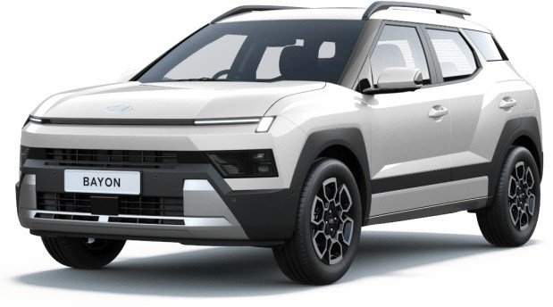  Atlas White | 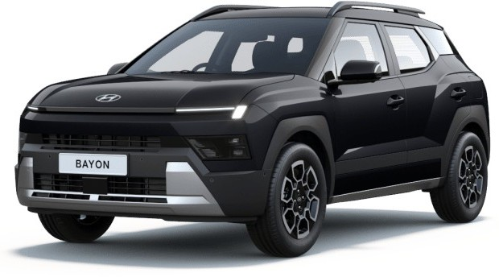  Titanium Black | 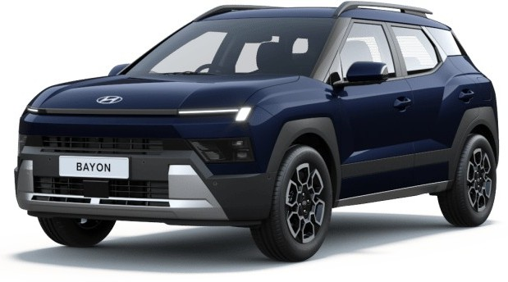  Classy Blue | 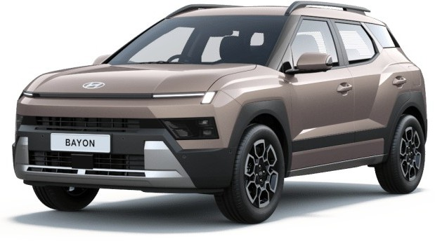  Golden Bronze
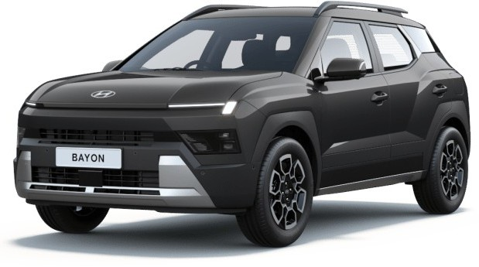  Ecotronic Grey | 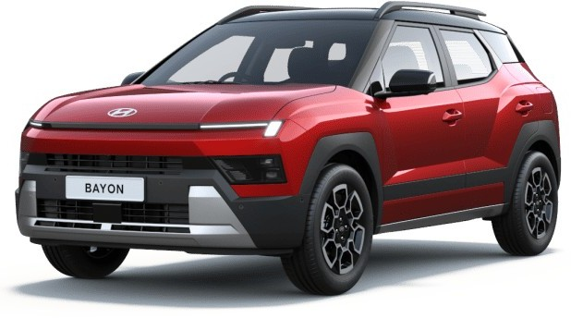  Fiery Red + Black Roof | 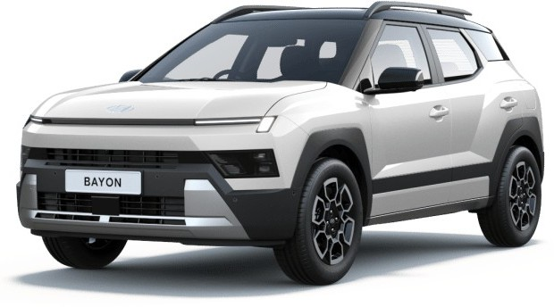  Atlas White + Black Roof | 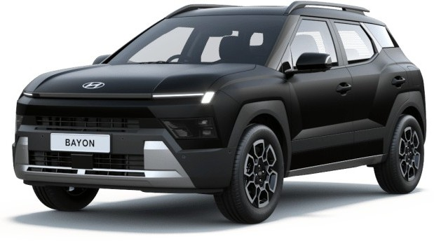  Titanium Black Matte | 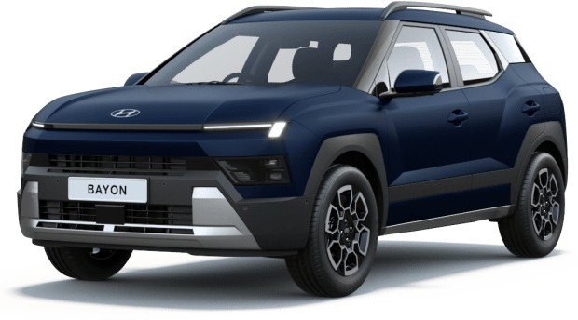  Classy Blue Matte

Hyundai Bayon specifications
Specification | Hyundai Bayon
Engine | 1.5L MPi petrol, 4 cylinders, 1,497 cc
Max power | 115 PS (84.4 kW) @ 6,300 rpm
Max torque | 143.8 Nm (14.7 kgm) @ 4,500 rpm
Transmission | 6-speed manual / iVT
Drive modes | Eco, Normal, Sport (iVT adds Dash Boost Mode)
Length | 4,245 mm
Width | 1,810 mm
Height | 1,605 mm (with roof rails)
Wheelbase | 2,600 mm
Ground clearance | 205 mm
Turning radius | 5.16 m
Boot space | 505 litres
Fuel tank | 43 litres
Front suspension | McPherson strut with coil spring
Rear suspension | Coupled torsion beam axle with coil spring
Brakes (F/R) | Disc / Drum or Disc (by variant)
Tyres | 205/65 R16 steel, 215/55 R17 styled steel, 215/55 R17 diamond-cut alloy
Spare wheel | 195/65 R15 (tyre mobility kit on HX 2)
Airbags | 6 (standard)
ADAS | SmartSense Level 2 Pro, 23 features (top variant)

Frequently asked questions
Q. What is the price of the Hyundai Bayon?
The Hyundai Bayon starts at ₹9,99,900 (ex-showroom). Hyundai has not yet published a price for each variant.
Q. Which engine does the Hyundai Bayon use?
A 1.5-litre MPi petrol engine making 115 PS and 143.8 Nm, with a 6-speed manual or iVT automatic.
Q. Which Bayon variants get the automatic?
The iVT automatic is available on HX 5, HX 6, HX 8 and HX 10.
Q. How big is the Bayon's boot?
Hyundai quotes 505 litres of boot space.
Q. Does the Hyundai Bayon have ADAS?
Yes. The top variant gets Hyundai SmartSense Level 2 Pro ADAS with 23 driver assistance features.
Q. How many airbags does the Bayon get?
Six airbags are standard on every variant.
Q. What colours is the Hyundai Bayon available in?
Titanium Black, Classy Blue, Atlas White, Fiery Red, Golden Bronze, Ecotronic Grey, Atlas White with Black Roof, Fiery Red with Black Roof, Titanium Black Matte and Classy Blue Matte.

Final word
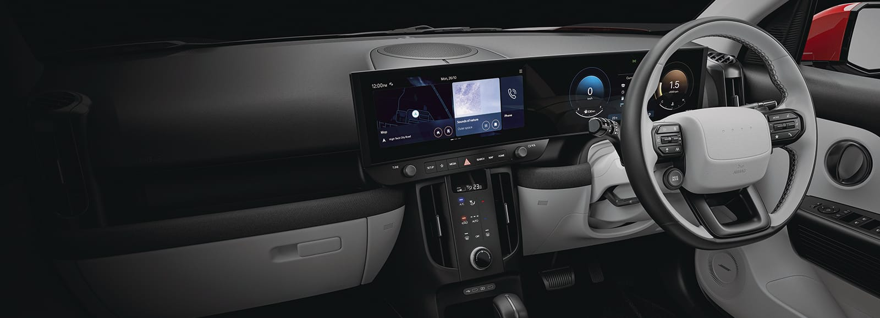
The Hyundai Bayon starts under ₹10 lakh and brings features that are new for Hyundai in India, such as a generative AI voice assistant, along with a 505-litre boot, six airbags as standard and Level 2 ADAS on the top variant. Stay with BikeCarHub for variant-wise prices and our drive review.

