10747883-AbhinavGupta-Surprisetest

Ans1.

First we will install docker

Now start docker and enable it.



Now pull httpd

Now pull ubuntu

Check for containers available and as it is empty now created a webapp container and then started it and then attached it and inside webapp we will first update it and then



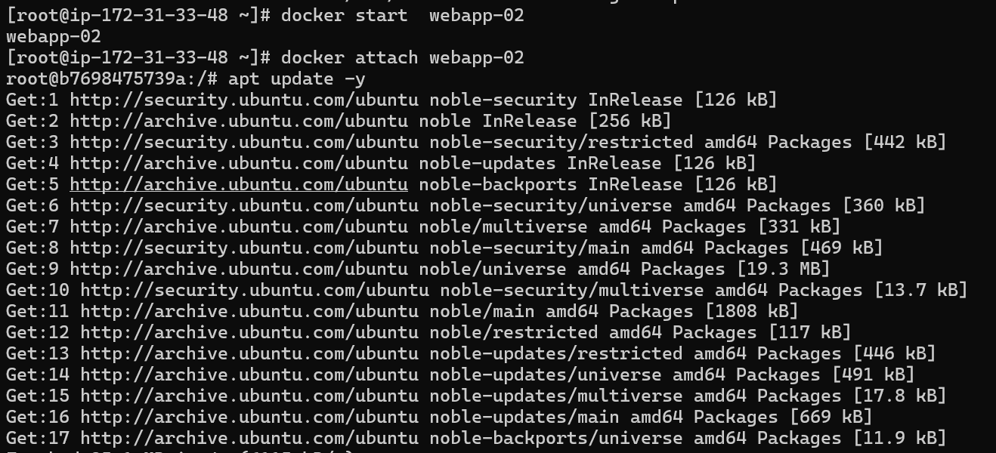

Then installed apache2

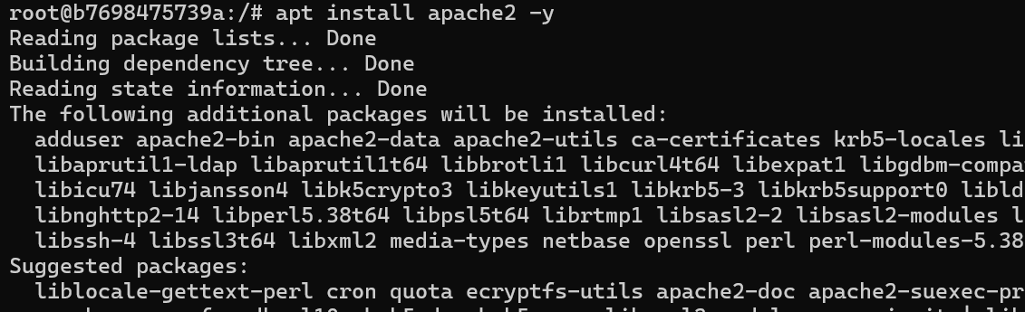

Start apache2 and check its status and created a file

Here we can see our server at port 80

Ans2.

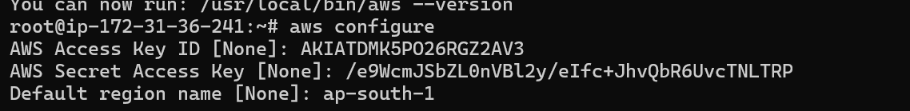

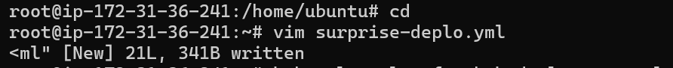

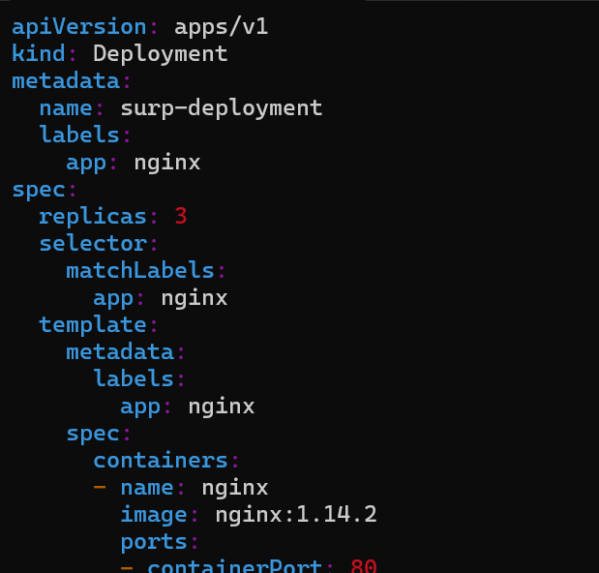

Ans3.

Create a new role with three permissions ElasticContainer full access , amazonkscluster policy and IAM full.

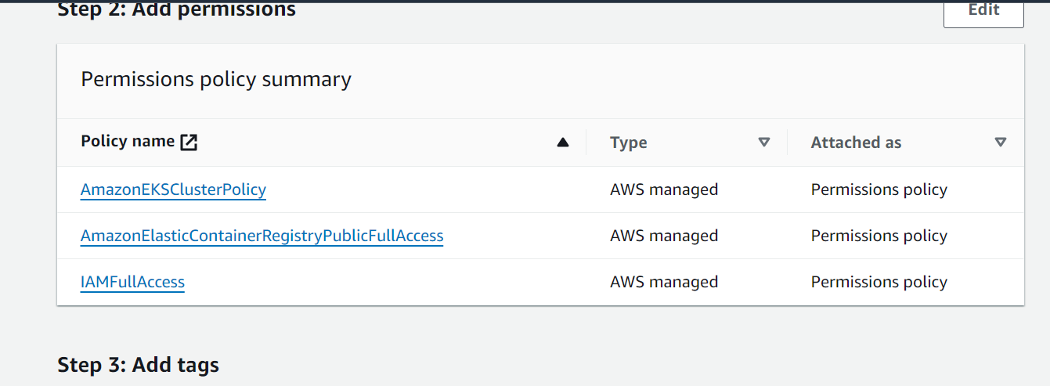

Attach it to the EKS server

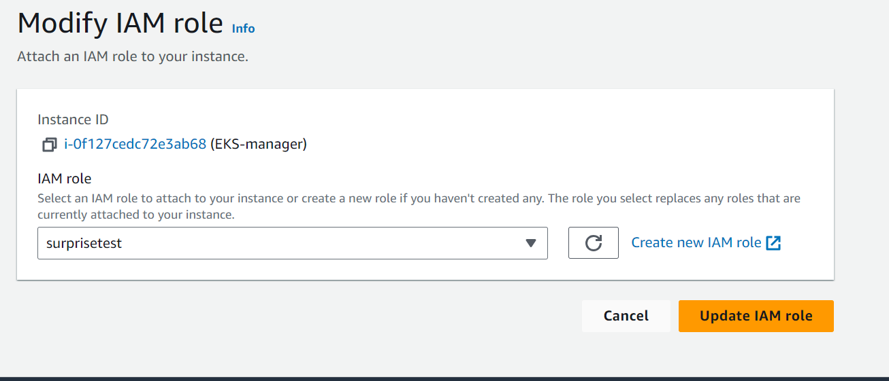

Then install unzip

Update aws configuration



Install EKS tools

Install kubectl

And created EKS cluster

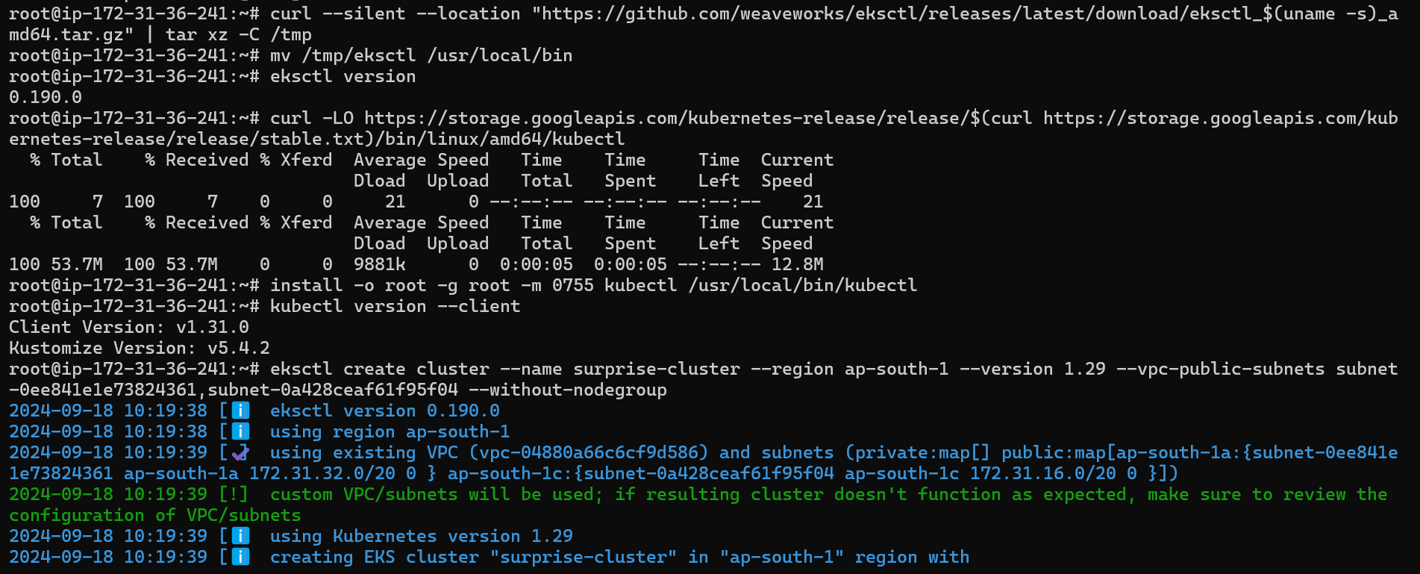

Create node3 group

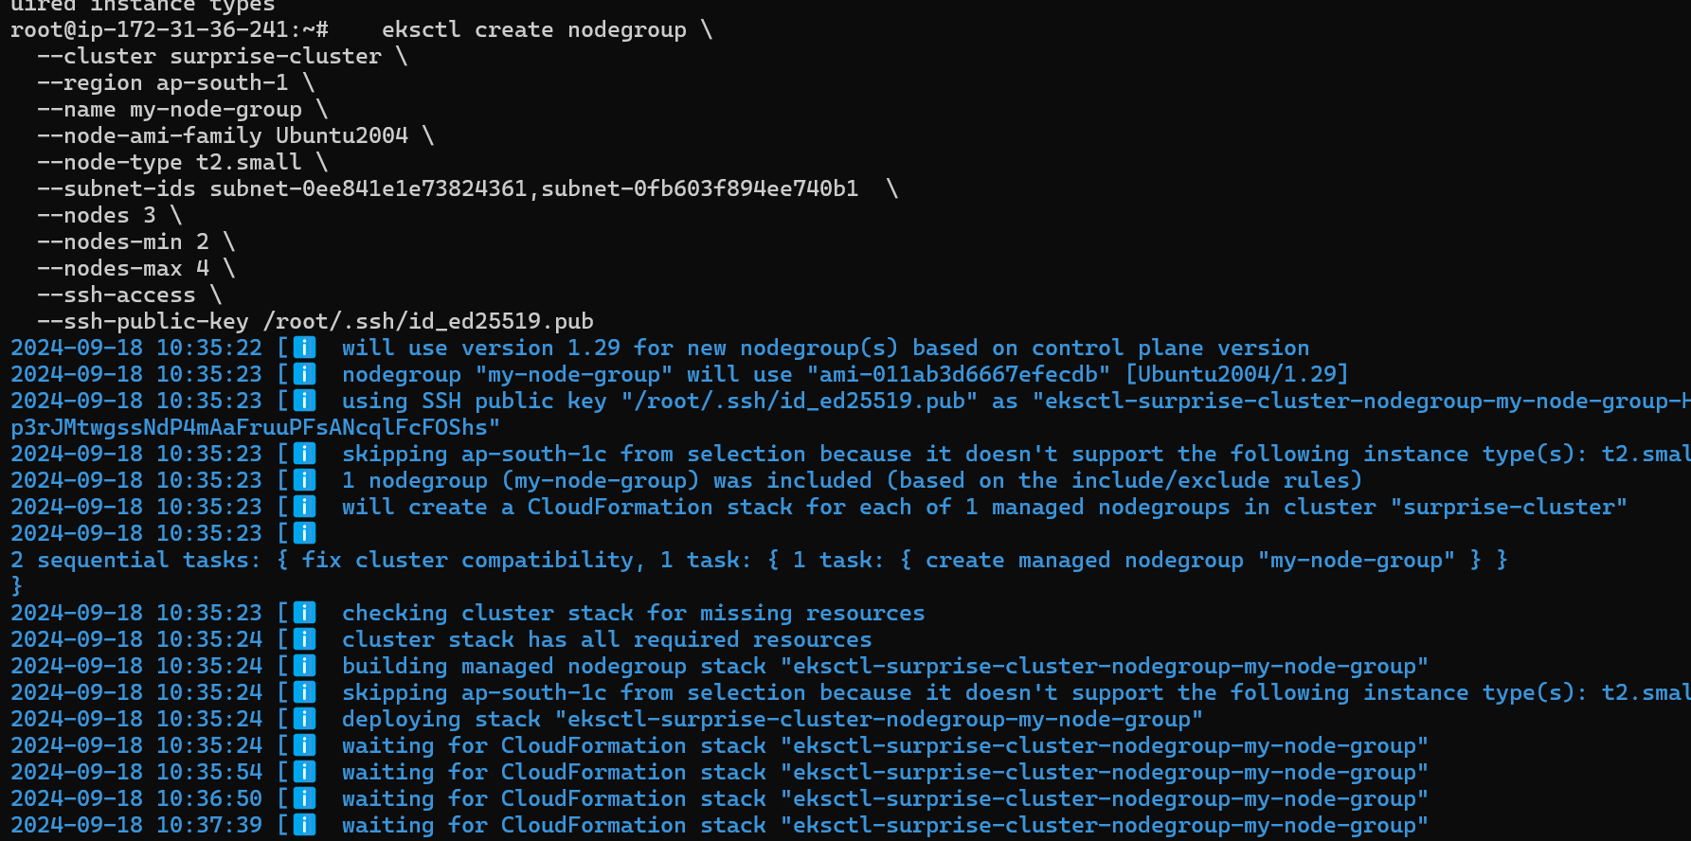

For replica set we have to create this file

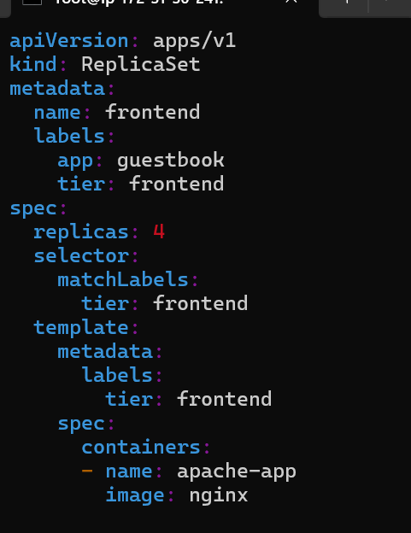

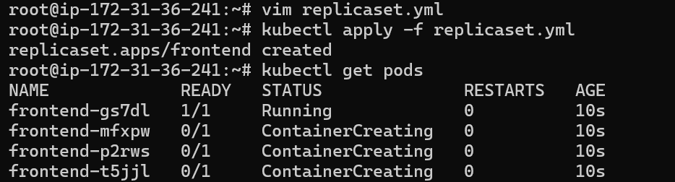

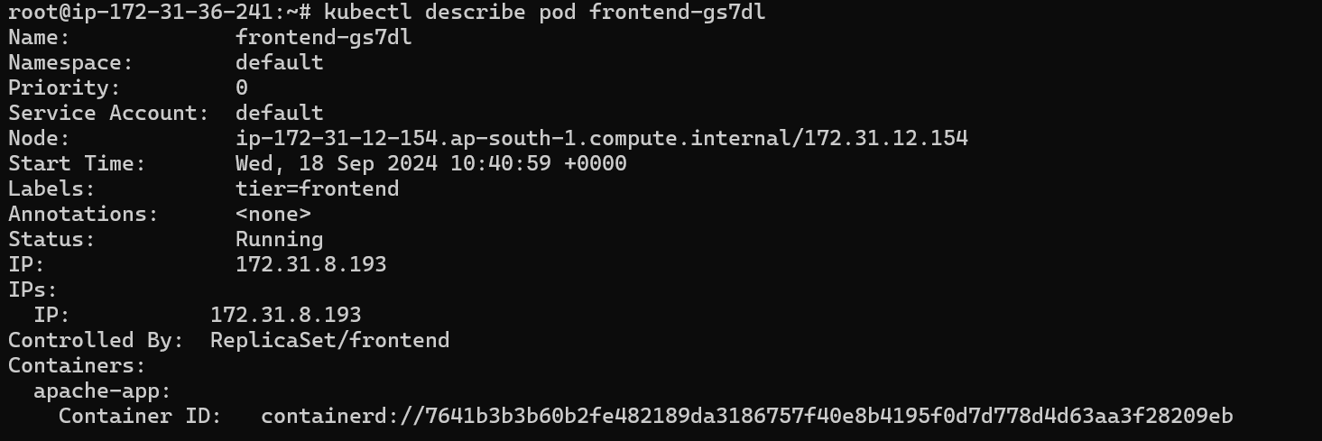

Ans4

Create one instance then create image then copy image

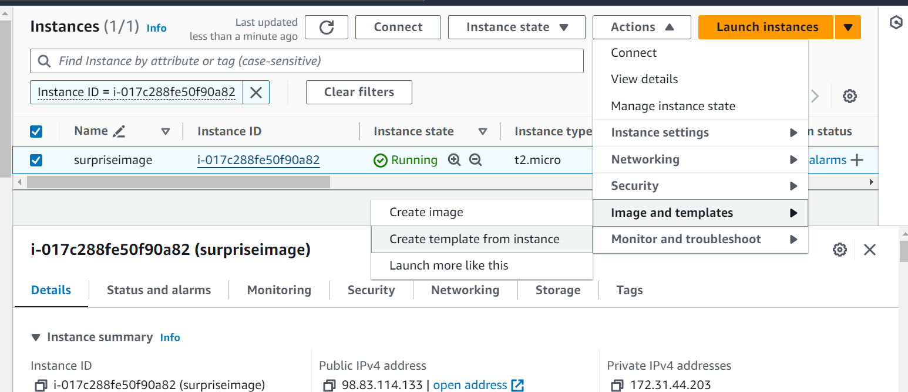

Copy image

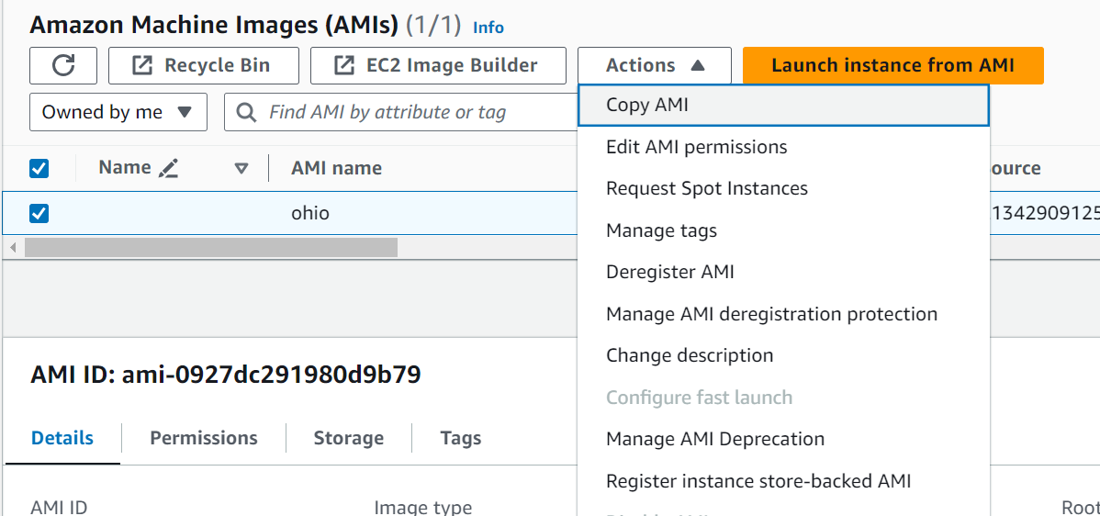

Choose ohio as destination

Now go to ohio regions and ami and launch the image

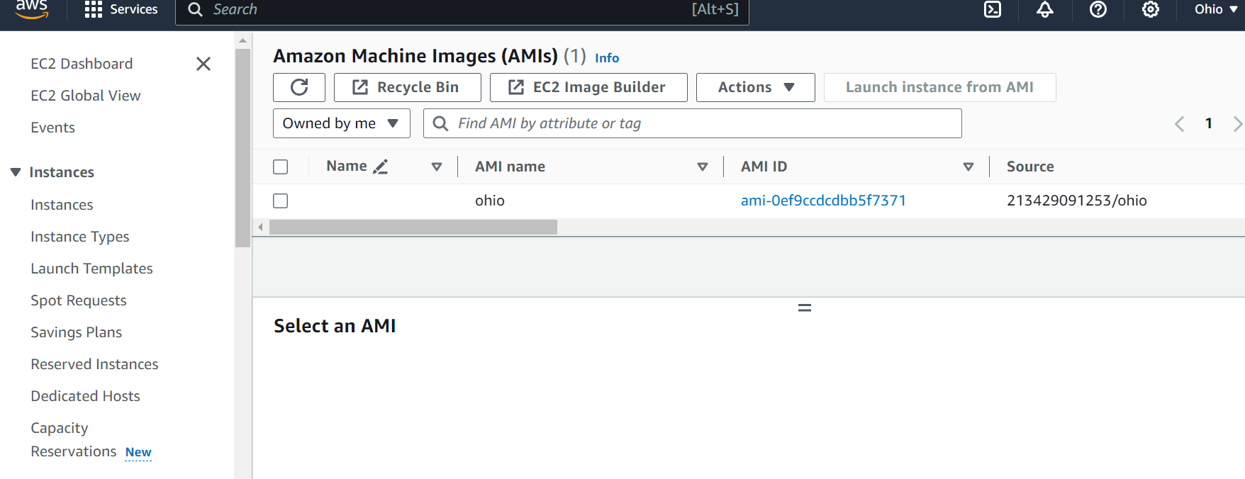

Ans 5

First install ansible

