Object methods, “this”

Javascript syntax:

let user = {

name: "John",

age: 30

};

user.sayHi = function() {

alert("Hello!");

};

user.sayHi(); // Hello!

Method shorthand:

user = {

sayHi() { // same as "sayHi: function(){...}"

alert("Hello");

}

In javascript, “this” is not bound. It can be used by any function. There will be no syntax error in doing so. “this” is evaluated during the run-time, depending on the context.

**Ch 5 Objects**

An object literal is wrapped entirely by curly brackets.

Object literal example:

const superman = {

name: 'Superman',

'real name': 'Clark Kent',

height: 75,

weight: 235,

hero: true,

villain: false,

allies: ['Batman','Supergirl','Superboy'],

fly() {

return 'Up, up and away!';

}

};

Creating an object literal:

const spiderman = {};

ES6 provided a shorthand method of creating objects if a property key is the same as a variable name that the property value is assigned to:

const name = 'Iron Man';

const realName = 'Tony Stark';

// long way

const ironMan = { name: name, realName: realName };

// short ES6 way

const ironMan = { name, realName };

team meeting questions:

question 1:

[Array.prototype.filter() - JavaScript | MDN (mozilla.org)](https://developer.mozilla.org/en-US/docs/Web/JavaScript/Reference/Global_Objects/Array/filter)

How did word get the properties of words?

Question 2:

[How to use Javascript .map() for Array of objects – Contact Mentor](https://contactmentor.com/javascript-map-array-of-objects/#:~:text=How%20to%20use%20Javascript%20.map%20%28%29%20for%20Array,each%20Key%2FValue%20Pair%20in%20Array%20of%20Objects.%20)

___________________________________________________________

Adding a property can be done be using the assignment operator removing can be done with delete operator

Objects can be used as parameters to functions, typically with {} or ${}

Parse() takes a string of data in JSON and returns a JavaScript object. Stringify does the opposite

Math can be done with the math object

RexExp object can be used to search strings for matches to the pattern.

**Chapter 6, the document object model**

The DOM represents things as a network of nodes that form a tree-like structure, like this:

<p *class*='warning'>Something has gone <em>very</em> wrong!</p>

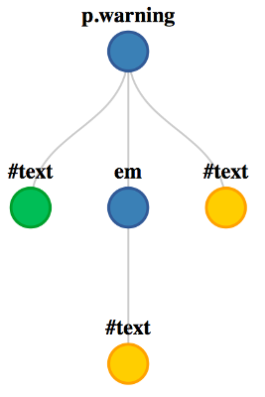

The nodeType method shows different codes, showing the type of node (element, attribute, etc.)

Document.queryselector allows you to find the first element in the document that matches a CSS selector provided as an argument.

**Events:**

Events are a part of the DOM

Events provide the link between the web page and user interactions.

They can listen for things that the user does, and then have the webpage make the appropriate response