**ReLu (Rectified Linear Unit) Activation Function**

<https://www.aitude.com/comparison-of-sigmoid-tanh-and-relu-activation-functions/>

ReLu is the best and most advanced activation function right now compared to the sigmoid and TanH because all the drawbacks like Vanishing Gradient Problem is completely removed in this activation function which makes this activation function more advanced compare to other activation function.

**Range**: 0 to infinity

Equation can be created by:

{ xi if  x >=0

0 if x <=0 }

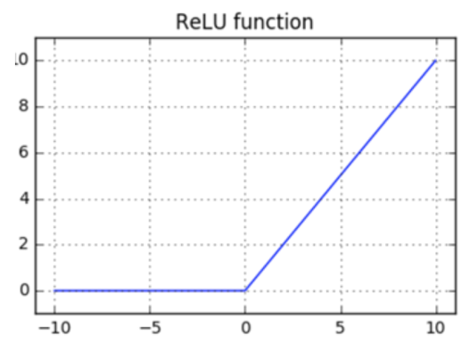

#### **Advantage** **of ReLu:**

* Here all the negative values are converted into the **0** so there are no negative values are available.
* Maximum Threshold values are Infinity, so there is no issue of Vanishing Gradient problem so the output prediction accuracy and there efficiency is maximum.
* Speed is fast compare to other activation function

## **Comparison**

