CS5590 APS -Python Programming

Lab Assignment-1

By:

Kranthi Kumar, Gangineni

Bhavesh, Polareddy

1. **Introduction**

Introduction to python programming language:

1. **Objectives**

Objectives for this lab assignment are:

1. **Web login application** that validates the password given by the user. The validation is in a way that the password must contain at least one Lower case alphabet, one upper case, at least one of the special character [$@! *] , at least one number and finally, the password must have 6-16 characters length.
2. **Sentence of words:** The program that accepts the sentence of words and display the following:
3. Middle word(s).
4. Longest word in the sentence
5. Reverse of words in the sentence
6. **Sum to Zero:** From the list of the Integers, we must find all the triplets whose sum equal to zero.
7. **Students in Python & Web programming class:**

Python program to retrieve the list of the students present common both of the web and python classes and also retrieve the list of the students who are not common in both of the classes.

1. **Management system:**
2. **Using NumPy:**

Python program that uses the NumPy libraries and generate the random vector of size 15 and the numbers should be in the range of 0 to 20. Then find the most frequent number from that vector.

1. **Methods Used**

Methods used in this lab assignment are:

1. re.search(pattern, strings, flags):
   1. **Pattern:** Regular expression.
   2. **String:** Might be any string that matches the pattern given in the first parameter.
   3. **Flags:** These are modifiers.
2. str.split(“ “):

Used to split the sentence in the str variable based on the spaces. Basically, it splits the sentence into words

1. set(list1).intersection(list2):

Returns the common elements in the list1 and list2.

1. np.random.randint(Range, size=length):

Here np is a NumPy variable, the function random.randint() will generate the vector of the random numbers. Parameter-1 represents range of the random numbers to be generated. Parameter-2 represents the size of the vector.

1. Work Flow
2. Parameters
3. **Evaluation**

1.**Password Validation:**

a. Validating whether it has 6 to 16 characters length.



b. Validating whether the password contains a number:



1. validating whether the password contains special character



1. validating whether the password contains one Lower case character and one upper case character

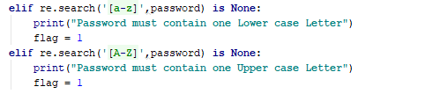

2. **Operations on sentence:**

**a.** Find the middle words:

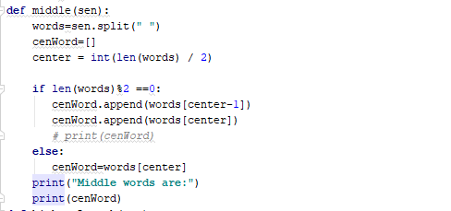

b. Highest length word:

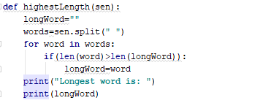

c. Reverse of the words in a sentence

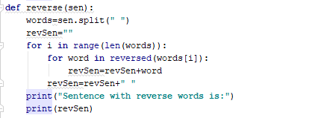

3. **Triplets sum to Zero:**

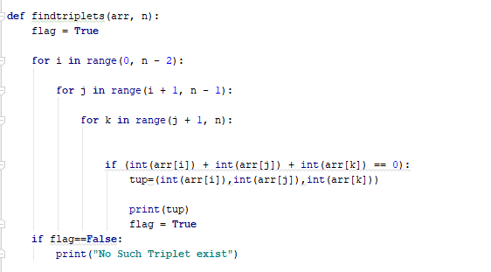

4. Students in Python and web Class:

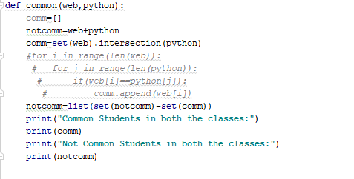

5. Management system

6. NumPy

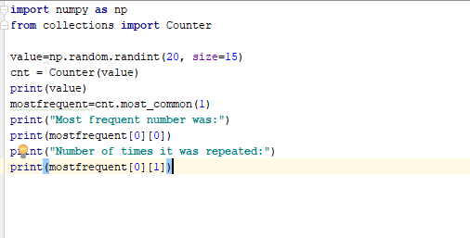

1. Conclusion