Normal run **learning rate 0.01**, num steps= 500 embedding_size = 150

valid_size = 16

output:

Total length of words is: 13303079

2018-07-13 15:37:29.051001: I T:\src\github\tensorflow\tensorflow\core\platform\cpu_feature_guard.cc:140] Your CPU supports instructions that this TensorFlow binary was not compiled to use: AVX2

of five and, possibly, other higher [[primate]]s such as adult [[gorilla]]s, [[Common chimpanzee|chimpanzee]]s and [[bonobos]]. Typical 5-year-olds can develop insights into other people's different knowledge, feelings, and intentions, interpretations based upon social cues (e.g., gestures, facial expressions). An individual with

Average loss at step 0 : 189.75755310058594

Average loss at step 100 : 130.45937286376954

Average loss at step 200 : 96.68123275756835

Average loss at step 300 : 125.09167158126832

Average loss at step 400 : 95.54309669494629

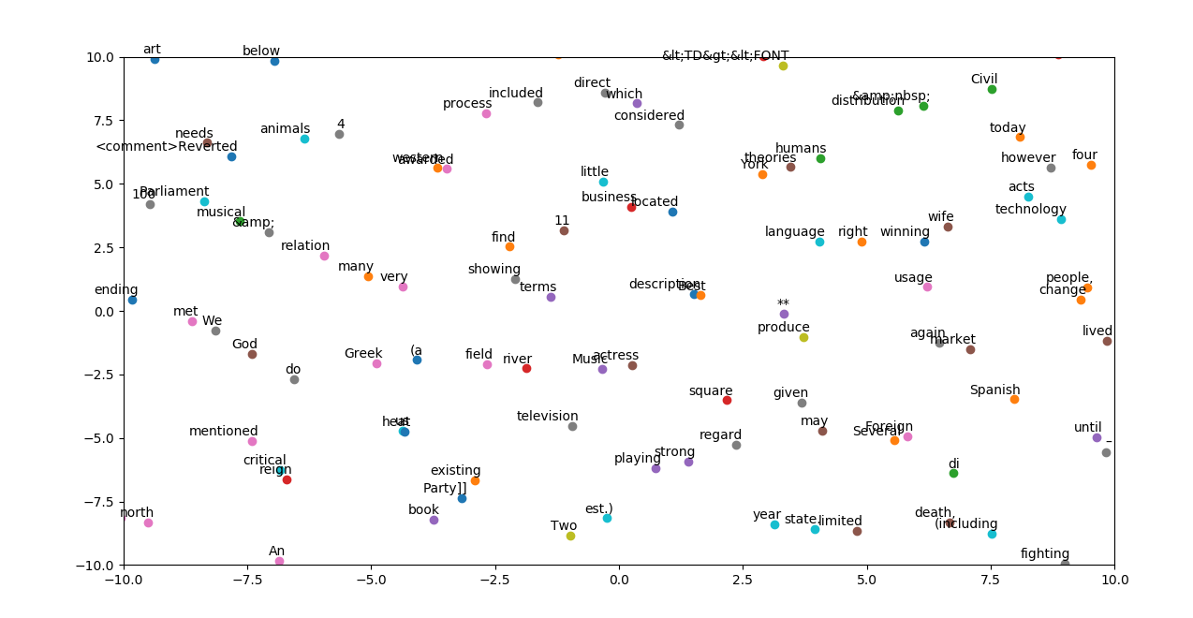

Normal run **learning rate 0.5,** num steps= 500 embedding_size = 150

valid_size = 16

output:

Total length of words is: 13303079

2018-07-13 15:44:02.275361: I T:\src\github\tensorflow\tensorflow\core\platform\cpu_feature_guard.cc:140] Your CPU supports instructions that this TensorFlow binary was not compiled to use: AVX2

of five and, possibly, other higher [[primate]]s such as adult [[gorilla]]s, [[Common chimpanzee|chimpanzee]]s and [[bonobos]]. Typical 5-year-olds can develop insights into other people's different knowledge, feelings, and intentions, interpretations based upon social cues (e.g., gestures, facial expressions). An individual with

Average loss at step 0 : 197.54220581054688

Average loss at step 100 : 229.70430702209472

Average loss at step 200 : 522.1963358306884

Average loss at step 300 : 776.2538475036621

Average loss at step 400 : 1296.7157330513

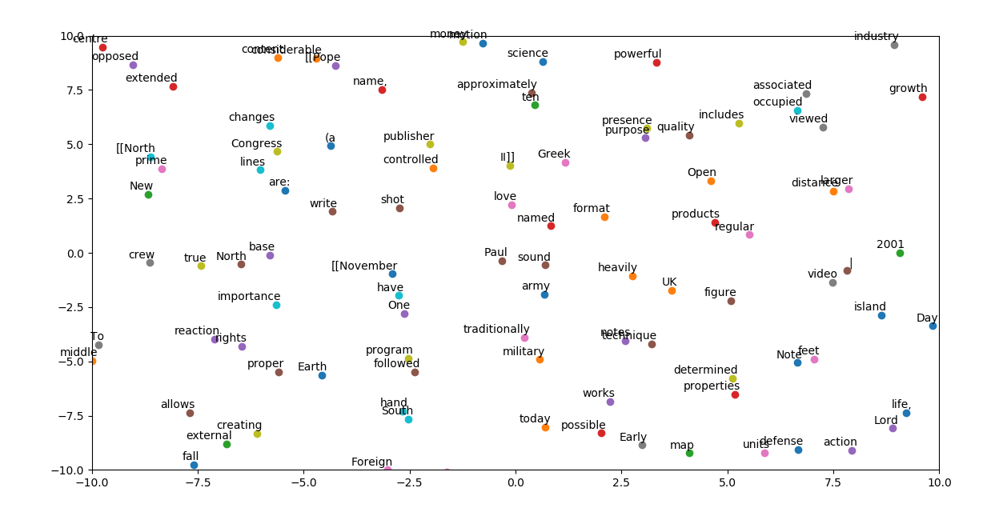

Normal run **learning rate 0.05,** num steps= 500 embedding_size = 150

valid_size = 16

output:

Total length of words is: 13303079

2018-07-13 15:49:11.571449: I T:\src\github\tensorflow\tensorflow\core\platform\cpu_feature_guard.cc:140] Your CPU supports instructions that this TensorFlow binary was not compiled to use: AVX2

of five and, possibly, other higher [[primate]]s such as adult [[gorilla]]s, [[Common chimpanzee|chimpanzee]]s and [[bonobos]]. Typical 5-year-olds can develop insights into other people's different knowledge, feelings, and intentions, interpretations based upon social cues (e.g., gestures, facial expressions). An individual with

Average loss at step 0 : 208.16387939453125

Average loss at step 100 : 112.9767667388916

Average loss at step 200 : 69.54157131195069

Average loss at step 300 : 120.56261176109314

Average loss at step 400 : 95.99842525482178

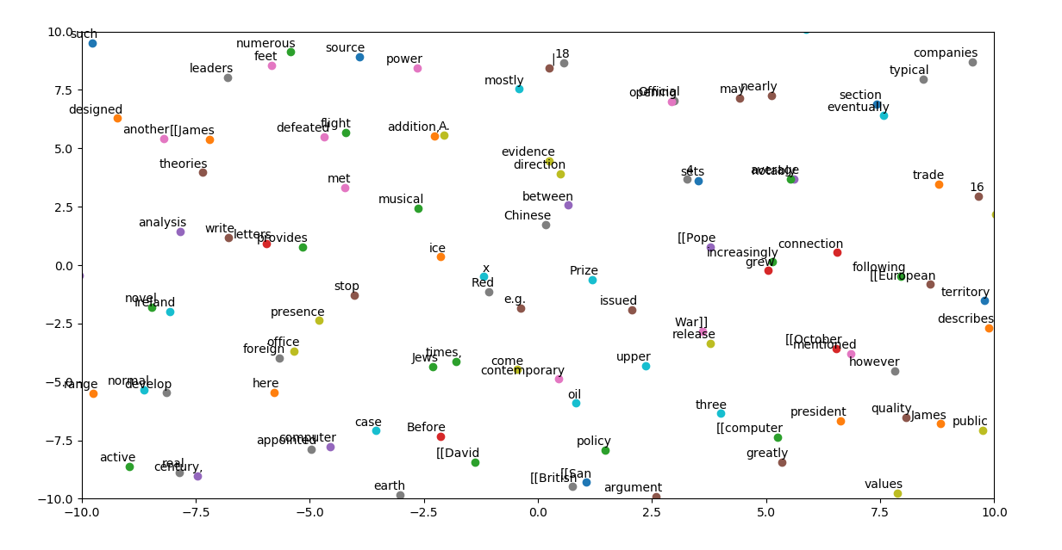

Normal run learning rate 0.01, **num steps= 900** embedding_size = 150

valid_size = 16

output:

Total length of words is: 13303079

2018-07-13 15:55:44.926101: I T:\src\github\tensorflow\tensorflow\core\platform\cpu_feature_guard.cc:140] Your CPU supports instructions that this TensorFlow binary was not compiled to use: AVX2

of five and, possibly, other higher [[primate]]s such as adult [[gorilla]]s, [[Common chimpanzee|chimpanzee]]s and [[bonobos]]. Typical 5-year-olds can develop insights into other people's different knowledge, feelings, and intentions, interpretations based upon social cues (e.g., gestures, facial expressions). An individual with

Average loss at step 0 : 205.767578125

Average loss at step 100 : 130.00954719543458

Average loss at step 200 : 101.53101232528687

Average loss at step 300 : 130.53954637527465

Average loss at step 400 : 97.72167248725891

Average loss at step 500 : 91.89974471092223

Average loss at step 600 : 55.243428101539614

Average loss at step 700 : 71.52635585784913

Average loss at step 800 : 58.94289908409119

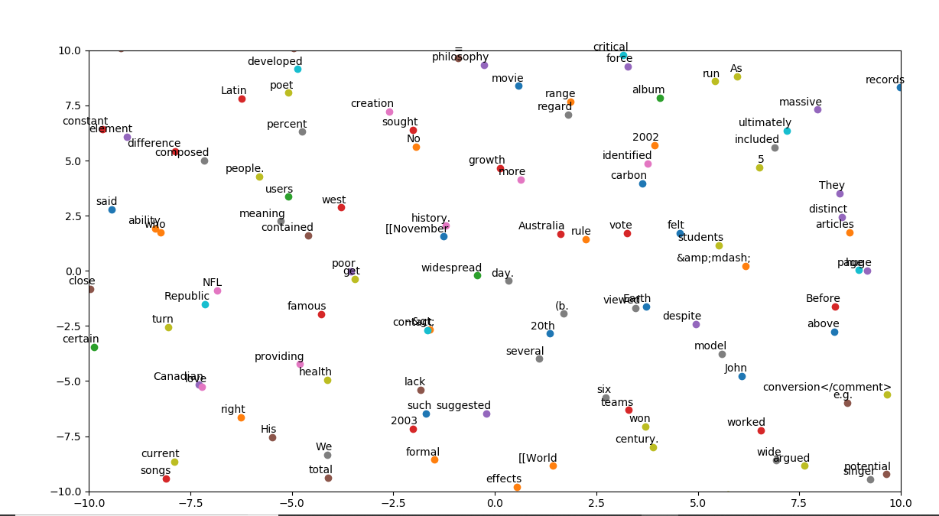

Normal run learning rate 0.01, **num steps= 500** embedding_size = 150

**valid_size = 64**

OUTPUT:

Total length of words is: 13303079

2018-07-13 16:01:50.834247: I T:\src\github\tensorflow\tensorflow\core\platform\cpu_feature_guard.cc:140] Your CPU supports instructions that this TensorFlow binary was not compiled to use: AVX2

of five and, possibly, other higher [[primate]]s such as adult [[gorilla]]s, [[Common chimpanzee|chimpanzee]]s and [[bonobos]]. Typical 5-year-olds can develop insights into other people's different knowledge, feelings, and intentions, interpretations based upon social cues (e.g., gestures, facial expressions). An individual with

Average loss at step 0 : 205.73818969726562

Average loss at step 100 : 130.17496829986572

Average loss at step 200 : 100.6285791015625

Average loss at step 300 : 122.9514017868042

Average loss at step 400 : 95.2148867893219

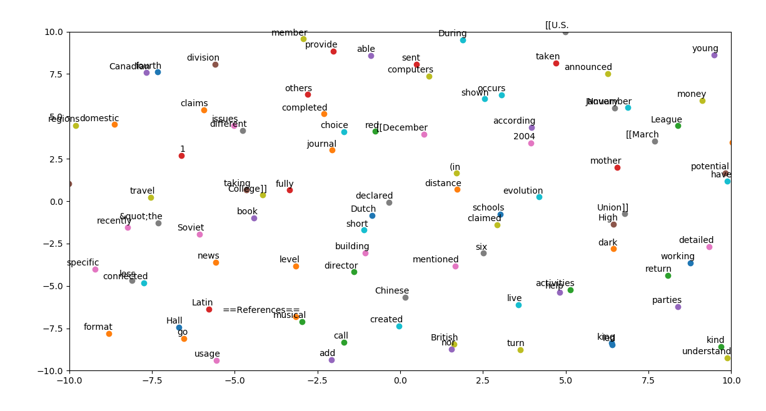

Normal run learning rate 0.01, **num steps= 500** **embedding_size = 300**

**valid_size = 16**

**output:**

Total length of words is: 13303079

2018-07-13 16:09:07.537169: I T:\src\github\tensorflow\tensorflow\core\platform\cpu_feature_guard.cc:140] Your CPU supports instructions that this TensorFlow binary was not compiled to use: AVX2

of five and, possibly, other higher [[primate]]s such as adult [[gorilla]]s, [[Common chimpanzee|chimpanzee]]s and [[bonobos]]. Typical 5-year-olds can develop insights into other people's different knowledge, feelings, and intentions, interpretations based upon social cues (e.g., gestures, facial expressions). An individual with

Average loss at step 0 : 187.07032775878906

Average loss at step 100 : 128.08714622497558

Average loss at step 200 : 89.64239013671875

Average loss at step 300 : 117.88436729431152

Average loss at step 400 : 96.23989868164062

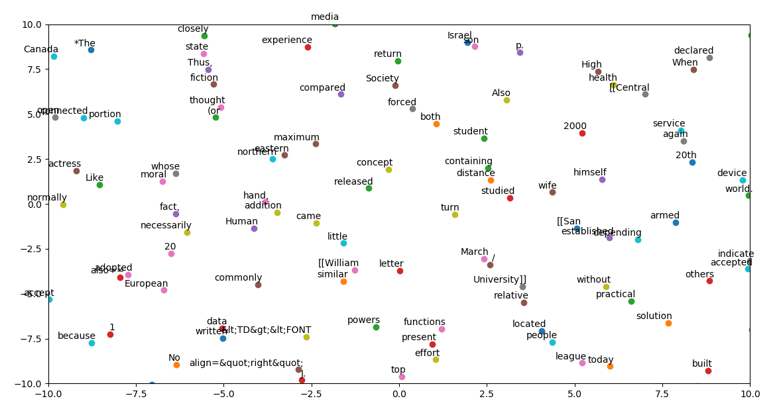

Normal run learning rate 0.01, **num steps= 500** **embedding_size = 150**

**valid_size = 16**

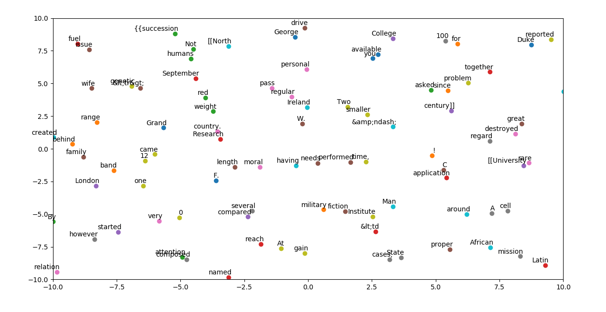

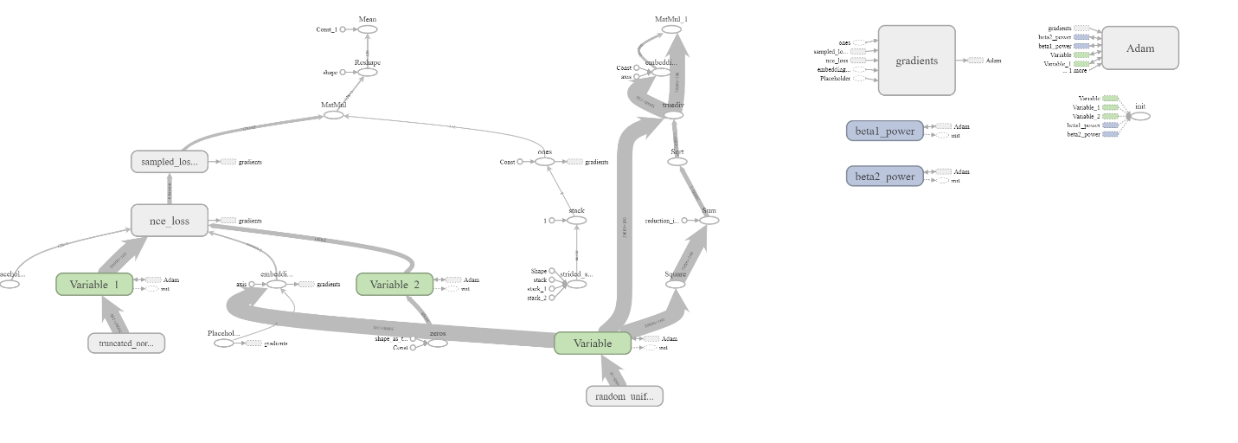

**PROBLEM-1:**

(Rows, Columns) (1797, 64)

2018-07-13 16:37:29.708956: I T:\src\github\tensorflow\tensorflow\core\platform\cpu_feature_guard.cc:140] Your CPU supports instructions that this TensorFlow binary was not compiled to use: AVX2

cost: -1.2713320308449396

cost: -3.1505570763916753

cost: -3.1641083028927626

cost: -3.1685790719513154

cost: -3.1708094043786414

cost: -3.1721473414995205

cost: -3.173039794033735

cost: -3.173677809542146

cost: -3.1741567927959538

cost: -3.1745297206249794

Accuracy Score is: -268.9511734443202 %

