Freejoy User Guide
A step-by-step guide for visitors and administrators
Version of 30 October 2026. Screenshots taken from the app at commit 5a8851d.
The About, Contact, Privacy, Cookie, Terms and Affiliate disclosure pages are still drafts with placeholder text pending legal review (see 5. About, contact, legal pages, 404 and cookies).
Contents
Click an entry to jump to it. In Word, View > Navigation Pane shows a clickable outline of the whole guide. If page numbers are missing, right-click the contents and choose Update Field.
Please read this first
The data in the screenshots is sample data
How the screenshots were taken
The legal and information pages are drafts
Things that are not built yet
Part 1. For visitors (the public site)
1. Home and finding your way around
Step 1. Open the home page
Step 2. Use the header menu
Step 3. Search from any page
Step 4. On a phone: the menu, search and tab bar
Step 5. Read a freebie card
What you will not find
2. Browse, search and filter
Step 1. Open the full list
Step 2. Search
Step 3. Choose a category
Step 4. Choose an offer type
Step 5. Show only offers with no postage
Step 6. Sort the list
Step 7. Move between pages
Step 8. When nothing matches
Step 9. When the catalogue cannot be loaded
Step 10. The phone filter drawer
Step 11. Category pages
3. Reading an offer
Step 1. Open an offer
Step 2. Read the top of the page
Step 3. Understand the claim button and the "Ad" label
Step 4. Read how to claim
Step 5. Read "The important bits"
Step 6. Look at "You might also love"
Step 7. Claim the offer
Step 8. What happens when an offer has ended
If you click a saved or old claim link
4. Email alerts
Step 0. If alerts are not open yet
Step 1. Open the sign-up page
Step 2. Fill in the form
Step 3. If something is missing
Step 4. Send the form
Step 5. Open the confirmation email
Step 6. Confirm
Step 7. Changing your categories or how often
Step 8. Unsubscribe
Things to know
5. About, contact, legal pages, 404 and cookies
Step 1. Find the pages
Step 2. About
Step 3. Contact
Step 4. Privacy notice
Step 5. Cookie notice, Terms and Affiliate disclosure
The "page not found" page
What Freejoy stores in your browser
Not covered here
6. Keyboard and accessibility tips
Step 1. Skip the menu
Step 2. Move around with the keyboard
Step 3. See where you are
Step 4. Fill in forms with confidence
Step 5. Screen readers
Step 6. Larger text and small screens
Step 7. If a page does not work for you
Part 2. For administrators (the admin area)
Admin 1. Signing in and the admin shell
Who can use the admin area
Step 1. Sign in
Step 2. Open the admin area
Step 3. Find your way around the admin shell
The account menu
On a phone
Step 4. The Dashboard
Tips for every admin page
Admin 2. Offers (freebies)
What the statuses mean
Step 1. Open the list
Step 2. Search and filter
Step 3. Use a row's menu
Step 4. Add a new offer
Step 5. Edit an offer
Step 6. Verify the offer ("Last checked")
Step 7. Publish
Step 8. Unpublish or expire
Step 9. Archive
Things to know
Not in the admin screens
Admin 3. Categories and merchants
Part A. Categories
Step 1. See the categories
Step 2. Add a category
Step 3. Edit a category
Step 4. Disable or enable a category
Part B. Merchants
Step 5. See the merchants
Step 6. Add a merchant
Step 7. Edit, deactivate or activate a merchant
Things to know
Admin 4. Users and two-factor sign-in
Step 1. Open the user list
Step 2. Search for someone
Step 3. Open a user's details
Step 4. Edit a user's profile
Step 5. Suspend or restore a user
Not on these screens yet
Two-factor authentication (2FA)
Admin 5. Subscriptions and analytics
Part A. Subscriptions
Step 1. Open the page
Step 2. Read the numbers
Step 3. Compare with Stripe
Step 4. Newest paid organisations
Part B. Analytics
Step 5. Open the page
Step 6. Read it
Admin 6. Audit logs, SEO and settings
Part A. Audit logs
Step 1. Open the log
Step 2. Filter and page through the log
Step 3. What is recorded, and what is not
Limits of the screen
Part B. SEO
Part C. Settings
When a page cannot load

Please read this first
A step-by-step guide to what Freejoy does and how to use it, written for people who are not developers. Every step has a real screenshot of the app. Pages are plain English; where the app shows a word or label, the guide uses the same word in bold.
Last updated: 2026-10-30. The screenshots were taken from the app at commit 5a8851d on 30 October 2026.

The data in the screenshots is sample data
The screenshots were taken from a private test copy of Freejoy running on a computer, not from a live website.
- Every brand in the screenshots is labelled (Sample), for example "Good Beans (Sample)". The 24 offers are made-up sample offers created by the project's seed_catalogue command. They are not real offers.
- The Last checked dates you see (such as "30 October 2026") are dates that the sample data was given. Nobody at Freejoy checked these offers. On the real site, "Last checked" is only ever the date an editor pressed Mark verified on that offer.
- The destination of every "claim" button in the sample data is a placeholder on example.com.
- Numbers in the admin screenshots (users, subscriptions, revenue, audit entries) come from an almost empty test database: two test accounts and no paying customers. They are not visitor or revenue figures.
- The admin offers list also contains two entries titled "Guide walkthrough sample (test entry)". They were made while writing this guide to show the publish steps, and were archived straight afterwards.
- Email addresses in the screenshots are test addresses on example.com or example.test. They are not real people.

How the screenshots were taken
- Public pages: a production build of the Next.js site served locally, reading the sample catalogue from a local FastAPI backend and a local test database. The alerts sign-up used the backend's fake email provider, which writes each email to a file instead of sending it. Nothing was sent to anyone and no other website was opened.
- Desktop images are 1440 pixels wide; phone images are 390 pixels wide. A phone image is only included where the layout differs from the desktop one.
- Admin pages: sign-in to the real site goes through Firebase, which needs a Firebase project. This guide was written without one. The admin screenshots were taken through the project's documented, test-only identity server (see admin-offers.md), which accepts only two throwaway session values that the developer sets when starting it, on a private test database and seeds one admin and one ordinary user. It is not part of the application, and the app has no sign-in shortcut. Screens that need a real Firebase sign-in, a Stripe account or two-factor authentication are marked Screen pending, with the reason (needs the Firebase test project, or a Stripe test account; both are owner actions); they have no picture. No image in this guide is a mock-up.

The legal and information pages are drafts
The About, Contact, Privacy, Cookie, Terms and Affiliate disclosure pages all carry the banner "Draft — placeholder text pending legal review" and say "Last reviewed: Not yet reviewed". Do not treat their wording as final or as legal advice. See page 5.

Things that are not built yet
Said plainly so nobody goes looking for them: the Contact form does not send messages; there are no "saved" or favourite offers; the alerts sign-up only sends a confirmation email today (no alert emails go out yet); the admin Dashboard and SEO pages are switched off ("Not available yet"); the admin Settings page shows statistics only; and creating affiliate links is not in the admin screens.

Part 1. For visitors (the public site)
Page | What it explains
1. Home and finding your way around | The home page, the menu, the search box, the phone tab bar, what a freebie card tells you
2. Browse, search and filter | The catalogue: search, categories, offer types, the no-postage filter, sorting, pages, "no results" and error messages, the phone filter drawer, category pages
3. Reading an offer | The offer page: "Last checked", postage and card notes, eligibility, the "Ad" label, the claim button, what happens when you click, ended offers
4. Email alerts | Signing up, the confirmation email, confirming, what you can and cannot change, unsubscribing
5. About, contact, legal pages, 404 and cookies | The information pages (all still drafts), the "page not found" page, what Freejoy stores in your browser
6. Keyboard and accessibility tips | Using Freejoy without a mouse, with a screen reader, on a phone or with larger text

1. Home and finding your way around
Back to the guide index
Freejoy lists UK free samples, trials, cashback, vouchers and competitions, with the postage, eligibility and card requirements shown before you click. You do not need an account to browse. (The brands in these screenshots are sample data: see the note in the index.)

Step 1. Open the home page
- Go to the Freejoy address in your browser. The home page opens.
- Read it from the top:
- The thin mint strip at the very top: "UK samples, trials and offers, with the terms in plain words."
- The header: the freejoy logo, then All freebies, Categories, Just added and How it works, a Search freebies box, Log in and the coral Get free alerts button.
- The hero: "Small treats. Big free energy." with two buttons, Explore freebies (opens the full list) and How it works (opens the About page at its "how it works" section).
- The trust strip with four short promises, ending "Read the terms: Offers can change at the provider, so check before you claim".
- Whatever makes you smile: one button for each category.
- Freshly found: featured offers as cards, and a See all freebies link.
- Make your inbox a happier place: a link to the email alerts sign-up.
- The footer: About, Contact, Privacy, Cookies, Terms and Affiliate disclosure.
Desktop (1440 wide):
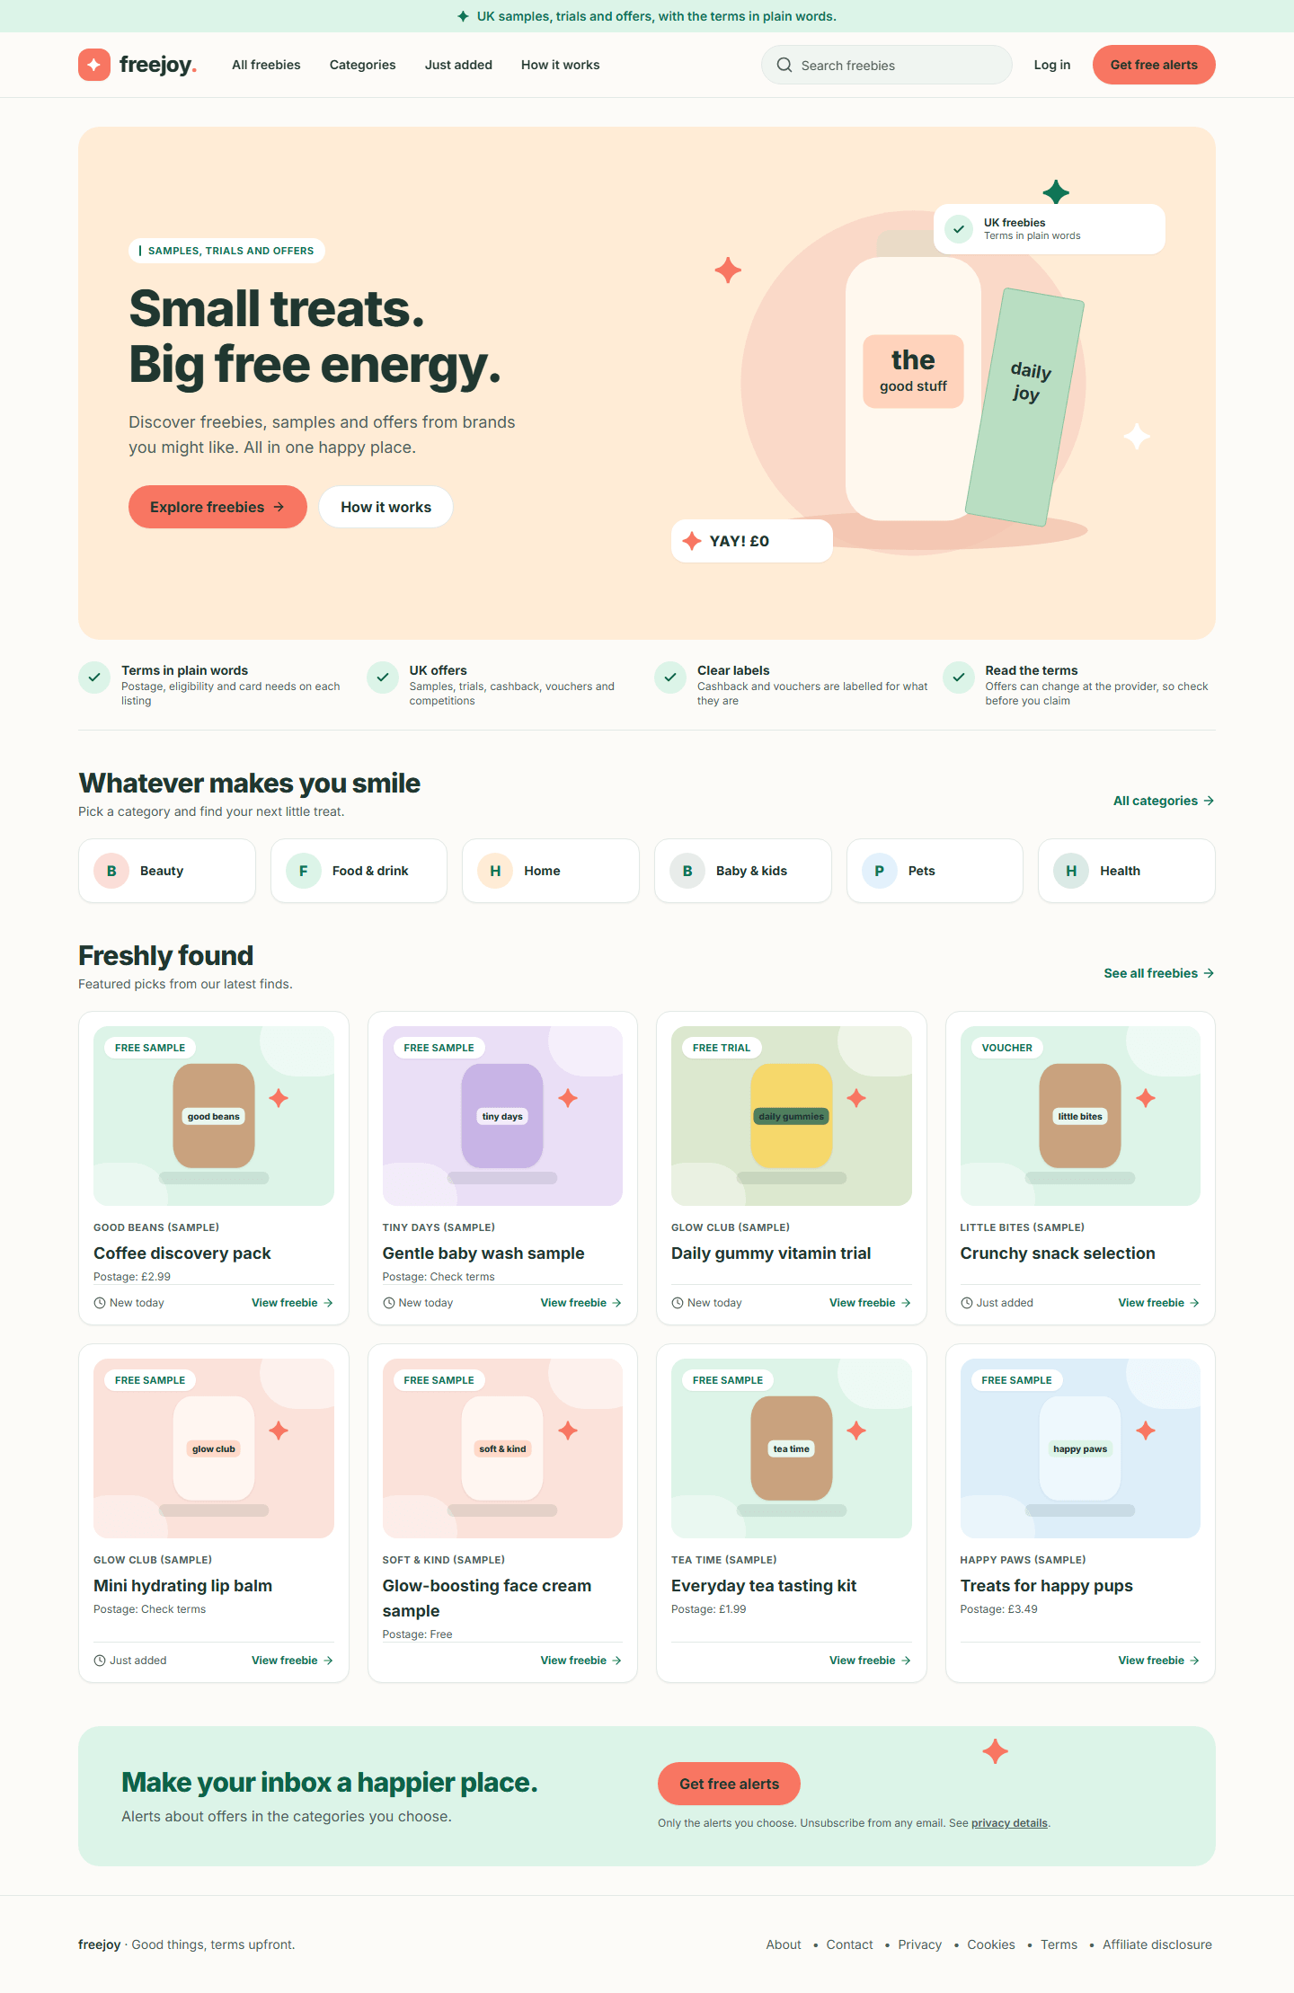
Figure 1. The Freejoy home page on a desktop screen
Phone (390 wide):
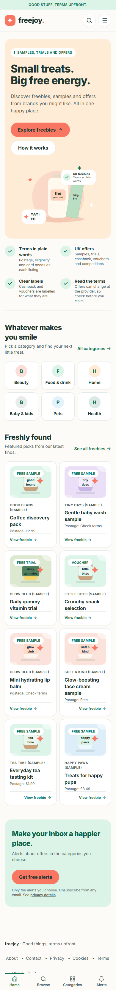
Figure 2. The Freejoy home page on a phone

Step 2. Use the header menu
Menu item | Where it takes you
All freebies | The full list of offers (page 2)
Categories | The full list, scrolled to the category choices
Just added | The full list sorted Newest first
How it works | The About page, "how it works" section
Log in | The sign-in page. You never need it to browse or to sign up for alerts
Get free alerts | The alerts sign-up form (page 4)

The menu item for the page you are on is highlighted in mint.

Step 3. Search from any page
- Click Search freebies in the header (or the magnifying glass on a phone).
- Type a word, for example tea, and press Enter.
- You land on the catalogue with your word applied. See page 2.

Step 4. On a phone: the menu, search and tab bar
On screens narrower than 1024 pixels the header shrinks to the logo plus two round buttons, and a tab bar sits at the bottom of the screen.
- Tap the magnifying glass to open the search box under the header. Tap the same button (now an X) to close it.
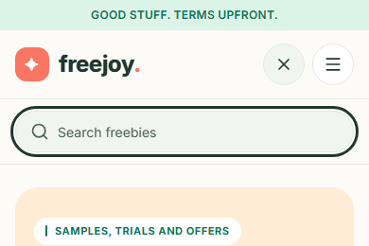
Figure 3. The search box open on a phone
- Tap the menu button (three lines) to open the Menu panel. It lists the four menu items, then Get free alerts and Log in. Tap the X, or tap outside the panel, to close it.
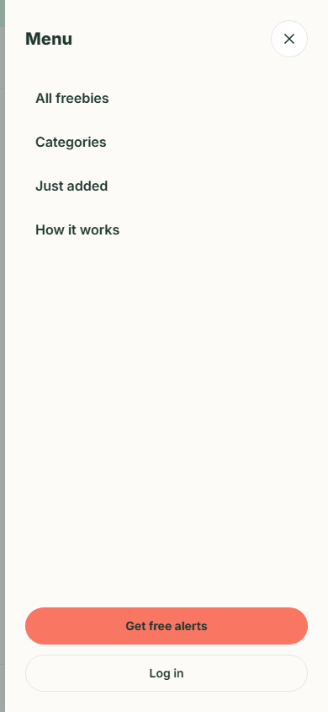
Figure 4. The phone menu panel
- Use the tab bar at the bottom: Home, Browse (all freebies), Categories and Alerts. The tab for the page you are on is underlined and green.

Step 5. Read a freebie card
Cards appear on the home page, in the catalogue, on category pages and under "You might also love" on offer pages. Each card shows, from top to bottom:
- A type badge on the picture: Free sample, Free trial, Cashback, Voucher or Competition. Cashback and vouchers are labelled for what they are, not as free items.
- The brand name in small capitals (in the sample data: "Good Beans (Sample)").
- The offer title.
- For free samples only, a Postage line: "Postage: £2.99", "Postage: Free" or "Postage: Check terms".
- A small clock label, New today or Just added, when the offer has one. These are labels an editor sets. Freejoy does not show urgency labels such as "Ending soon" or "Popular" on real offers.
- View freebie, which opens the offer page (page 3). The whole card is clickable.

What you will not find
There are no saved or favourite offers, no visitor counts and no countdown timers. Browsing does not set cookies or store anything in your browser (see page 5).

2. Browse, search and filter
Back to the guide index
The catalogue lists every offer that is currently live. Everything you choose (search word, category, type, postage, sort, page) is kept in the page address, so you can bookmark a view, share it, or press the browser's Back button to undo a choice.
The sample catalogue in these screenshots has 21 live offers. (It was seeded with 24; one is a draft, one has ended and one is archived, and those never appear here.)

Step 1. Open the full list
- Choose All freebies in the header (or Browse in the phone tab bar).
- The page is headed "Find your next little treat." and says how many freebies are in the collection, for example "21 freebies in this collection".
- Twelve cards show on each page. At the bottom a line reads "Showing 1–12 of 21".
Desktop: the filters sit in a panel on the left.
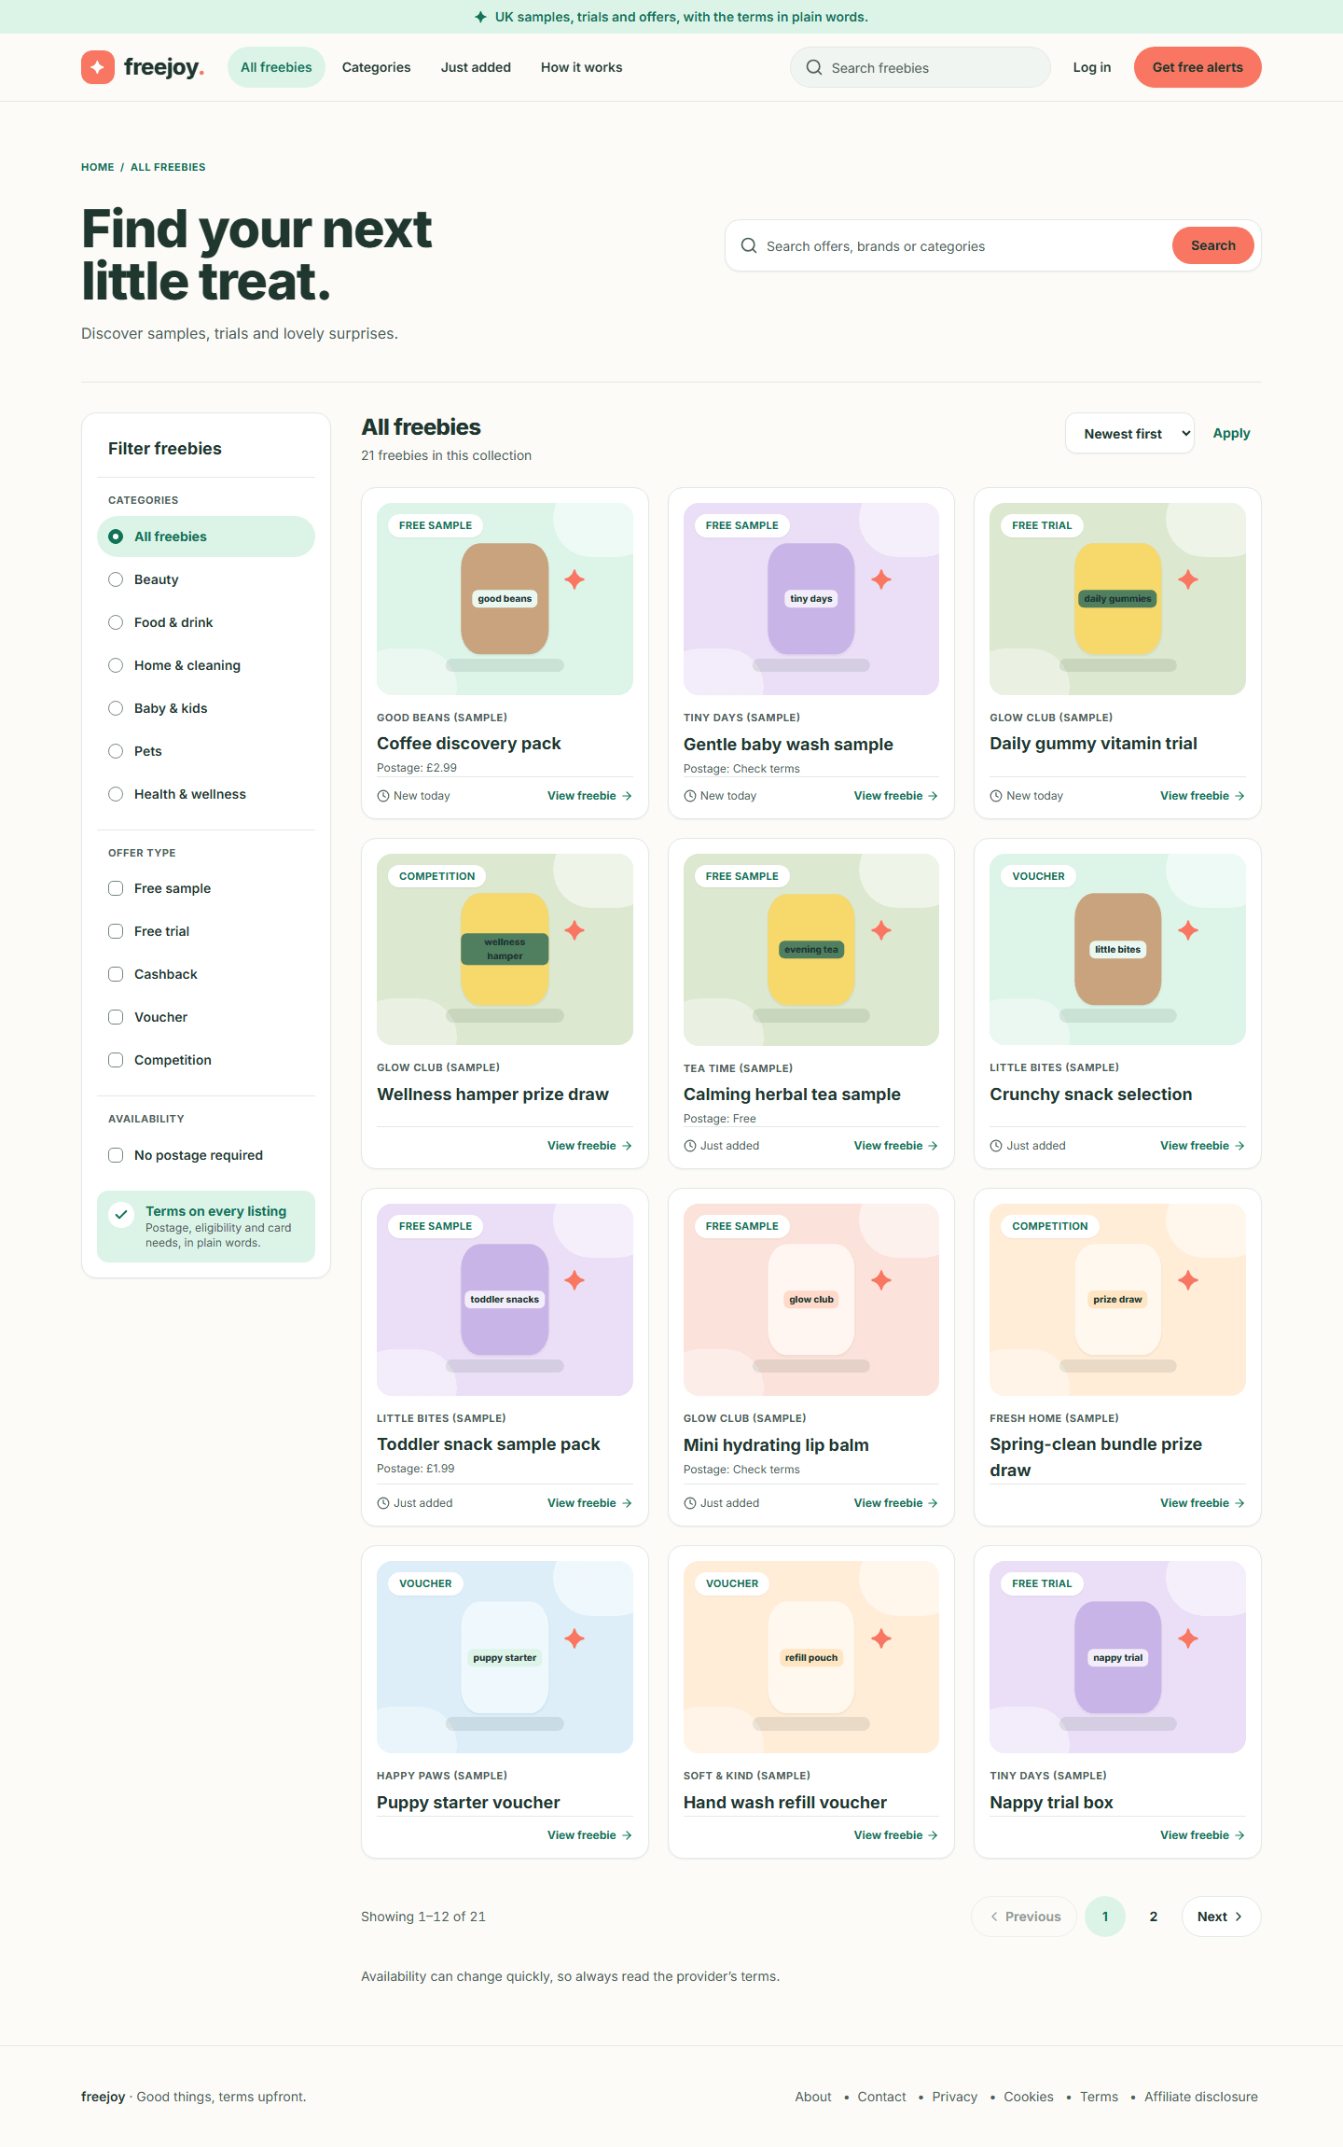
Figure 5. The catalogue on a desktop screen
Phone: the category choices run along the top as buttons you can swipe sideways, and a Filter button opens the other filters.
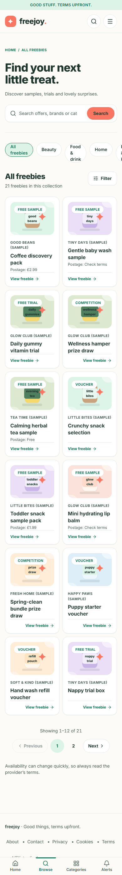
Figure 6. The catalogue on a phone

Step 2. Search
- Click the box that says "Search offers or brands" in the page heading (or use the search box in the header).
- Type a word, for example tea.
- Press Enter or click Search.
- The list shrinks to the offers whose title, summary or brand name contains your word. The heading count updates.
- Clear the box and search again to see everything.
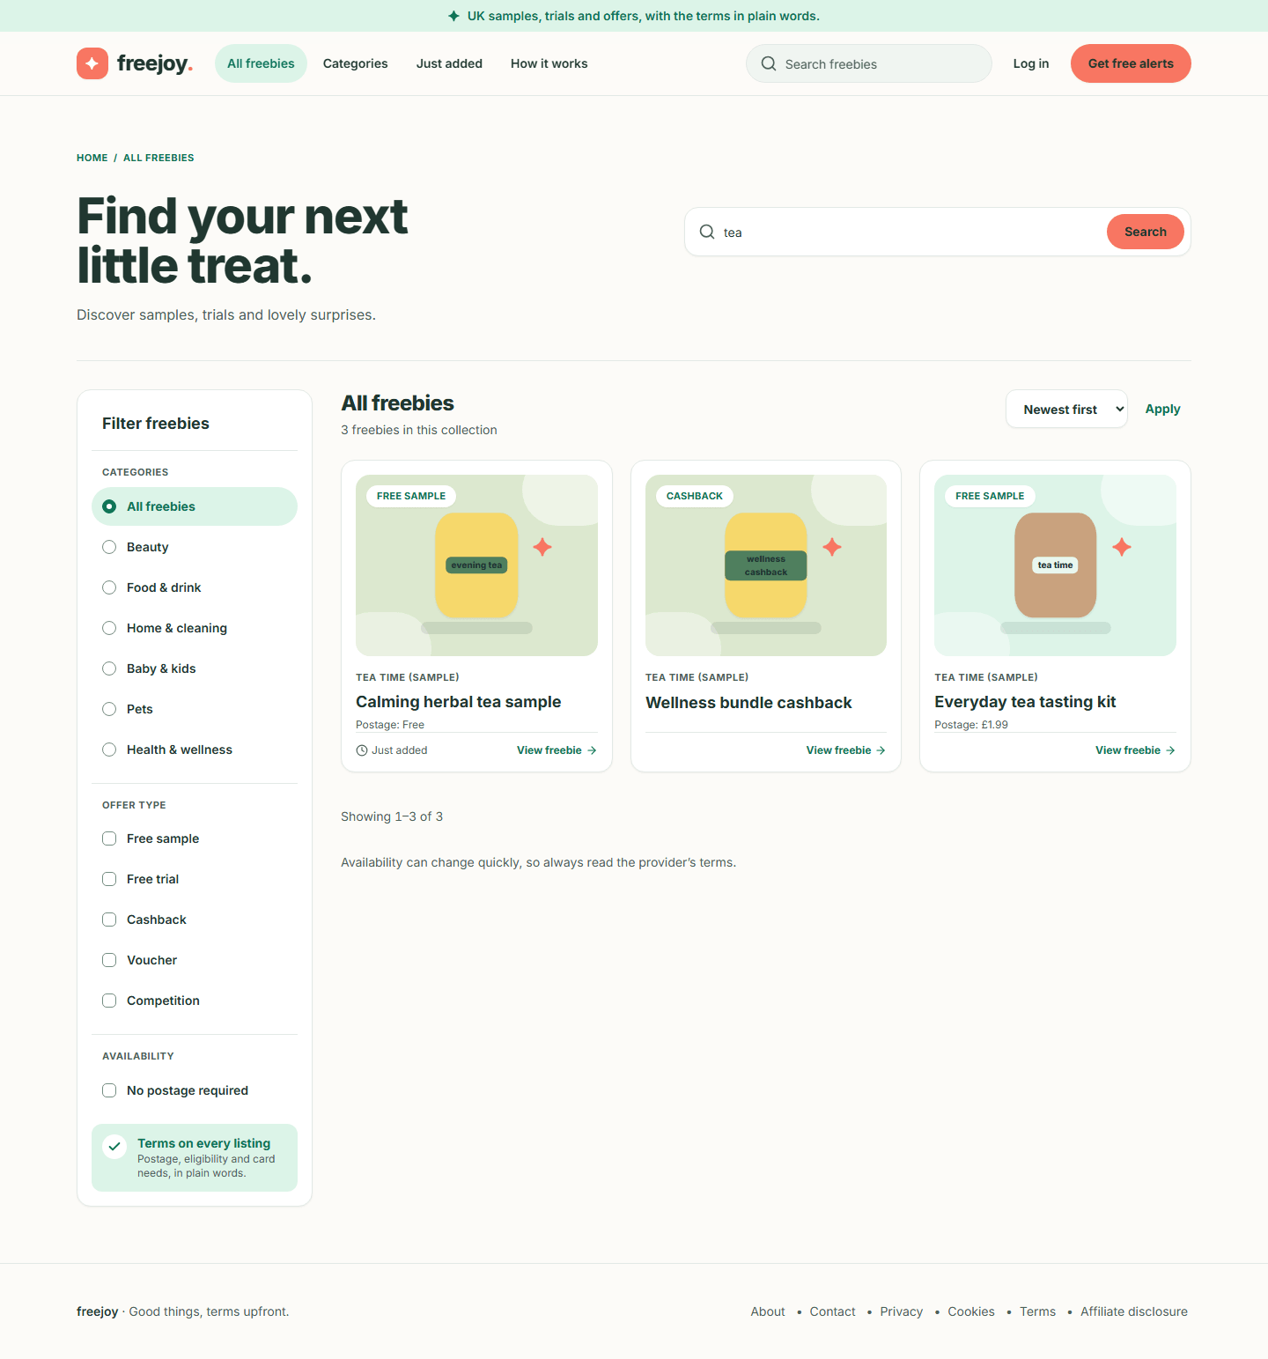
Figure 7. Search results for tea
On a phone:
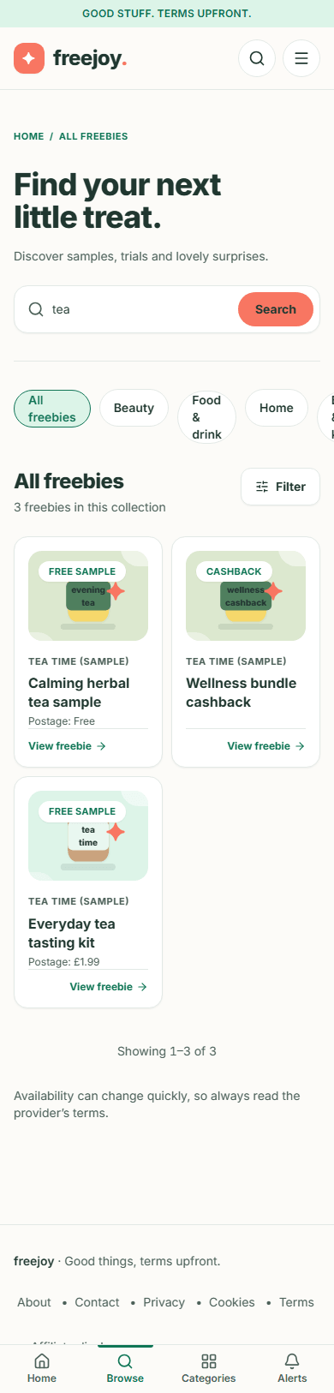
Figure 8. Search results for tea on a phone
Privacy tip. A search word travels in the page address, so it can stay in your browser history and in the web host's logs. Do not type an email address or any personal detail into the search box. The privacy notice says the same.

Step 3. Choose a category
- On a desktop, click a name under CATEGORIES in the left panel: Beauty, Food & drink, Home & cleaning, Baby & kids, Pets or Health & wellness. On a phone, tap the matching button along the top.
- The list shows only that category. The chosen name is highlighted and has a filled dot (a mark, not only a colour).
- Choose All freebies to go back.

Step 4. Choose an offer type
- Under OFFER TYPE (desktop) or in the Filter drawer (phone), tick one or more of Free sample, Free trial, Cashback, Voucher and Competition.
- Ticking several types widens the list: you see offers of any of the chosen types.
- The type filter combines with the category and search. For example, Food & drink plus Free sample:
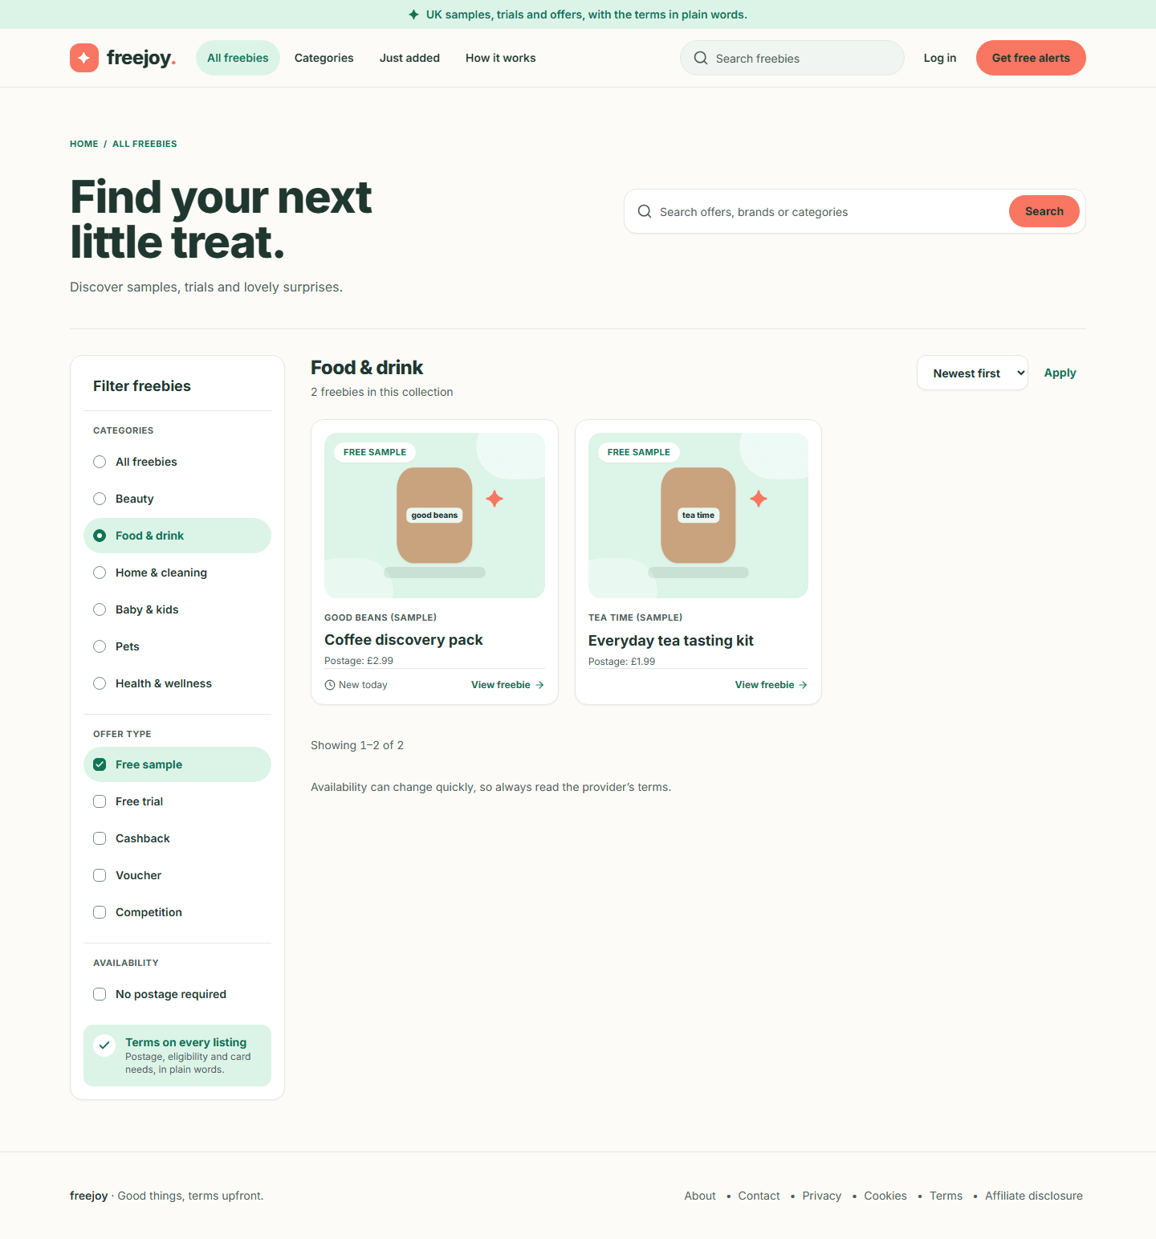  Figure 9. Food and drink free samples | Phone:  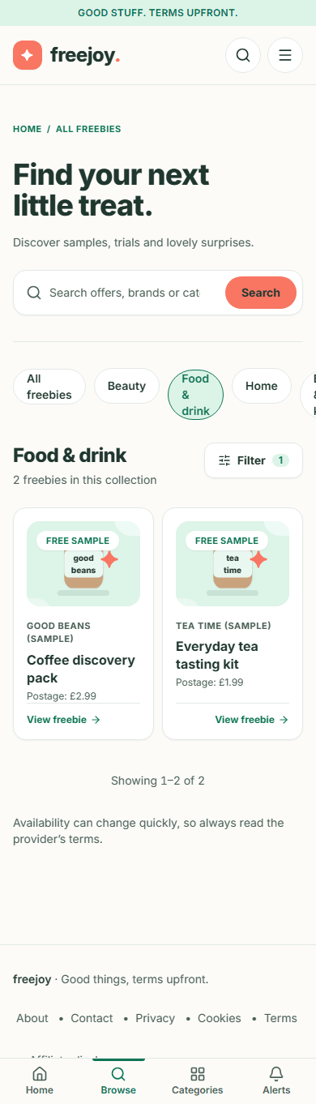  Figure 10. Food and drink free samples on a phone

Step 5. Show only offers with no postage
- Under AVAILABILITY (or in the phone drawer) tick No postage required.
- Only offers whose postage is listed as free remain. An offer whose postage says "Check terms" is not included, because Freejoy cannot say it is free.
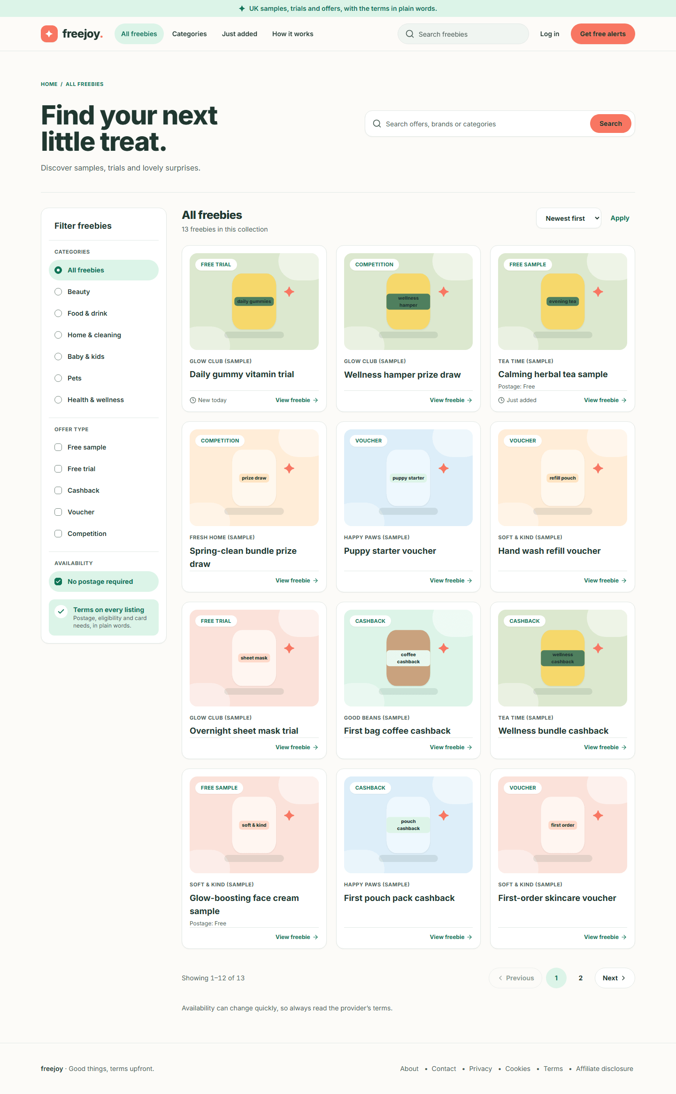
Figure 11. Offers with no postage required

Step 6. Sort the list
- Above the cards, open the Sort by drop-down (it shows "Newest first").
- Choose Newest first, Ending soon or A to Z.
- Click Apply. The list does not change until you click Apply; this is deliberate so keyboard users can move through the choices without the page jumping.
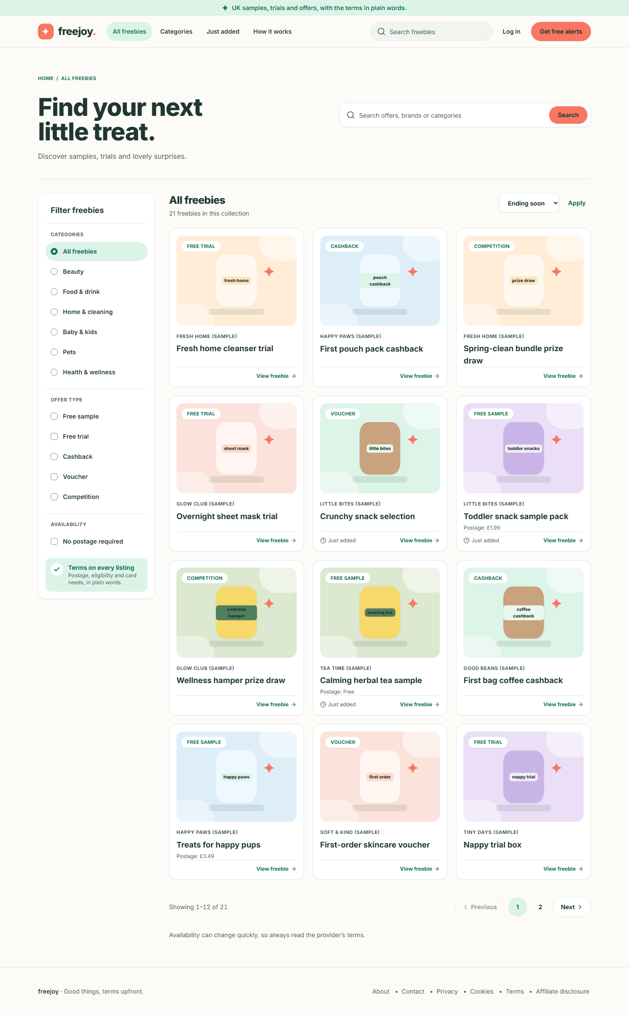
Figure 12. The list sorted by Ending soon

Step 7. Move between pages
- Scroll to the bottom of the list.
- Click Next, Previous or a page number. The current page is highlighted. "Showing 13–21 of 21" style text tells you where you are.
- Your filters stay applied on every page.
Figure 13. The pagination controls
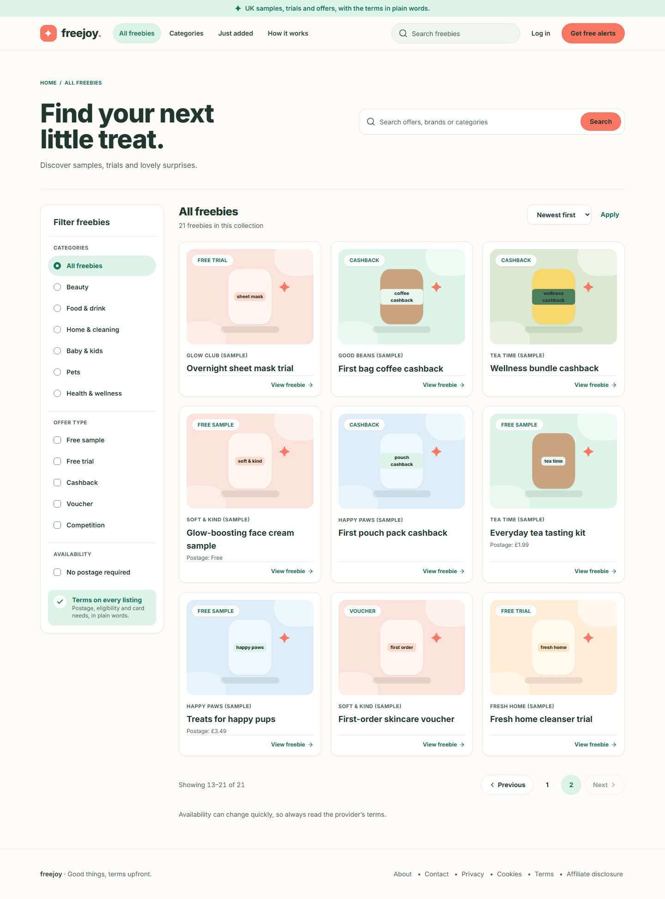
Figure 14. Page 2 of the catalogue

Step 8. When nothing matches
If your search and filters match nothing, the list is replaced by a panel headed No freebies match that yet. It repeats your search word, then offers:
- Clear filters (removes everything and shows the full list), and
- a row of category buttons under "Or browse a category".
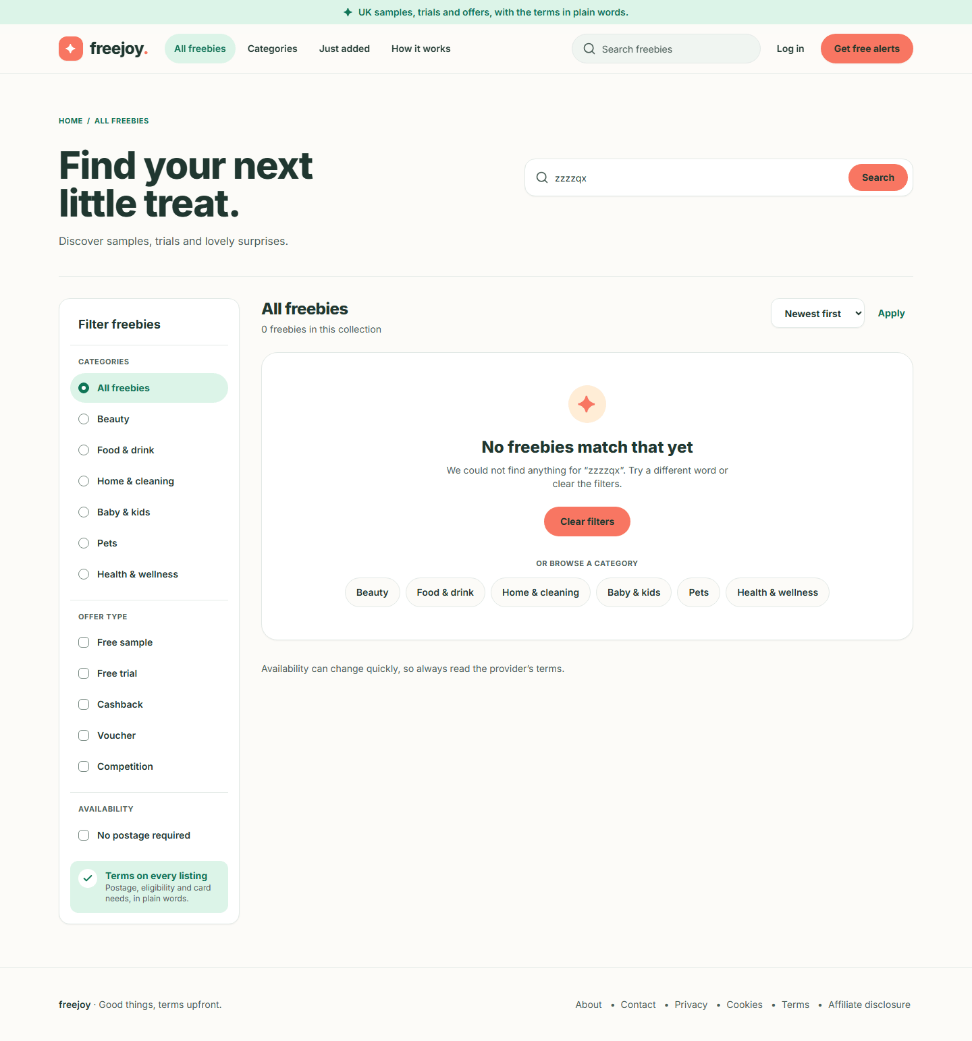  Figure 15. The no-results panel | Phone:  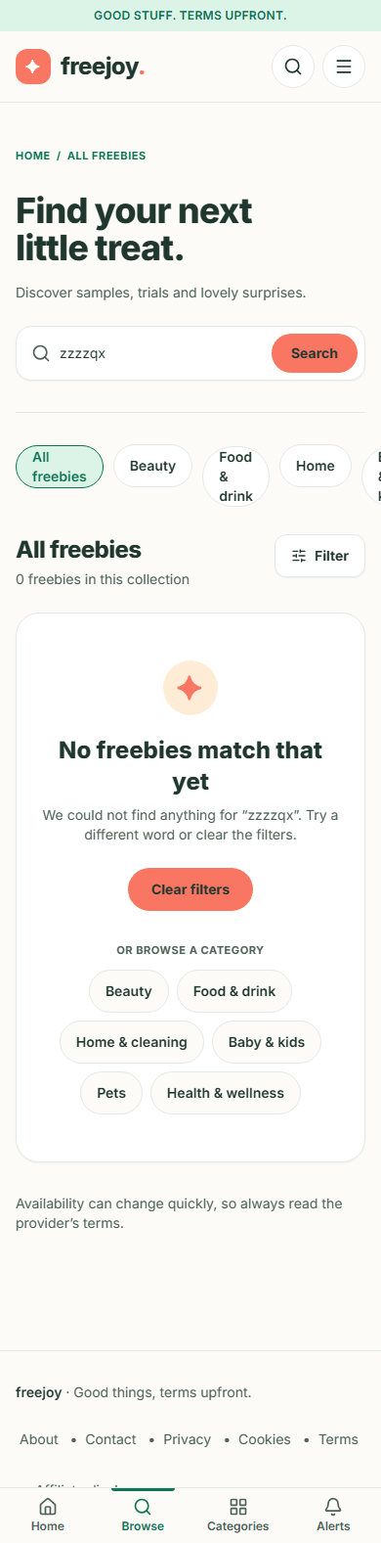  Figure 16. The no-results panel on a phone

Step 9. When the catalogue cannot be loaded
Rarely, the site cannot reach its catalogue. Instead of the list you see a panel headed The freebies are not loading with the message "We could not load the freebies just now. Please try again in a moment." and a Try again button. Click it, or wait a moment and reload. The page still works; only the list is missing.
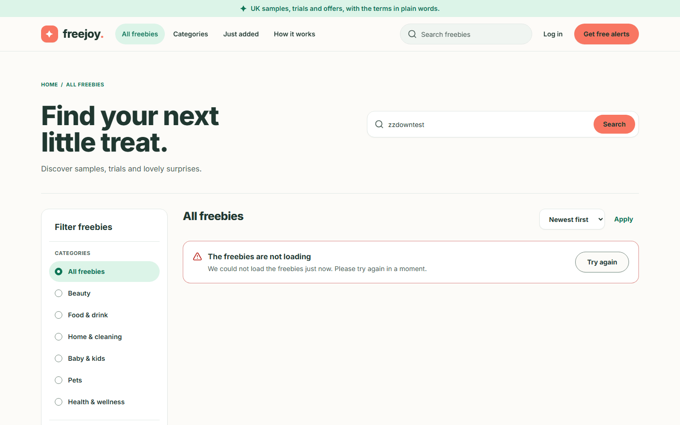  Figure 17. The catalogue error panel | Phone:  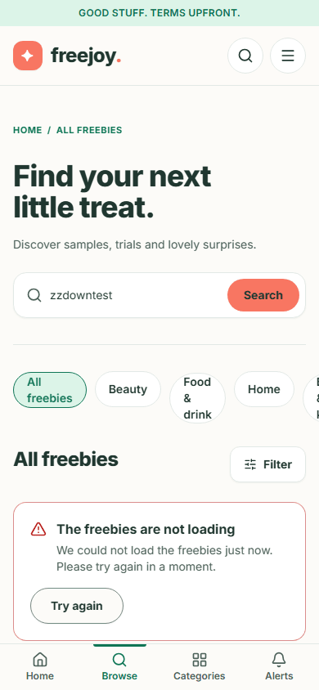  Figure 18. The catalogue error panel on a phone

Step 10. The phone filter drawer
- On a phone, tap Filter (next to the heading count).
- A panel slides up with Offer type, Availability (No postage required) and Sort by, plus a Clear filters button. Tap a choice to apply it.
- Close the drawer with the X (or the Escape key on a keyboard). The category buttons stay on the page behind it rather than inside the drawer.
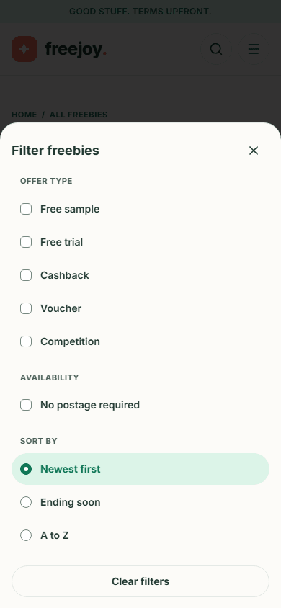
Figure 19. The filter drawer on a phone
The drawer needs JavaScript. Search, sort (with Apply), the category buttons and the page links work without it.

Step 11. Category pages
Each category also has its own page, for example /category/food-drink. Reach it from the home page's Whatever makes you smile buttons, or from a breadcrumb on an offer page.
- The page opens with a heading such as "Food & drink freebies", a short introduction and the count, such as "4 freebies in this category".
- The same type, postage and sort controls are there. Instead of the category list the panel says "You are browsing one category." with a Switch category link.
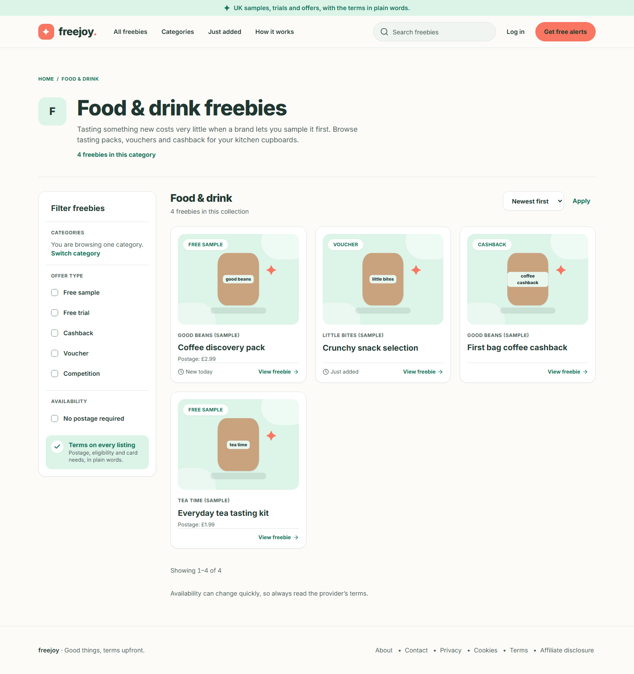
Figure 20. A category page on a desktop screen
Phone:
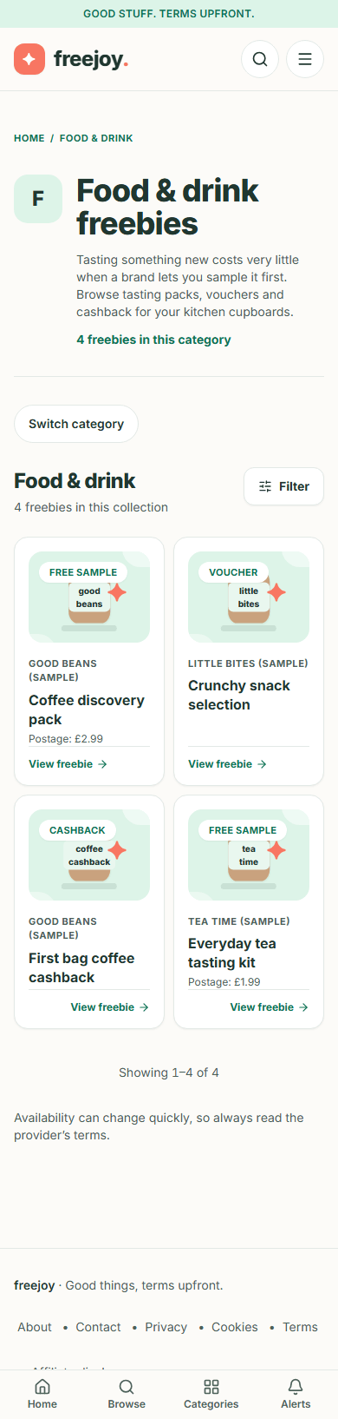
Figure 21. A category page on a phone
If a category does not exist, or an admin has disabled it, you get the 404 page.

3. Reading an offer
Back to the guide index
Every offer has its own page. This page is built so you can see the conditions before you leave Freejoy. (In the screenshots the brand is "Good Beans (Sample)" and the dates are sample dates: see the note in the index.)

Step 1. Open an offer
- Click any card, or its View freebie link, on the home page, the catalogue or a category page.
- The address looks like /freebies/coffee-discovery-pack.

Step 2. Read the top of the page
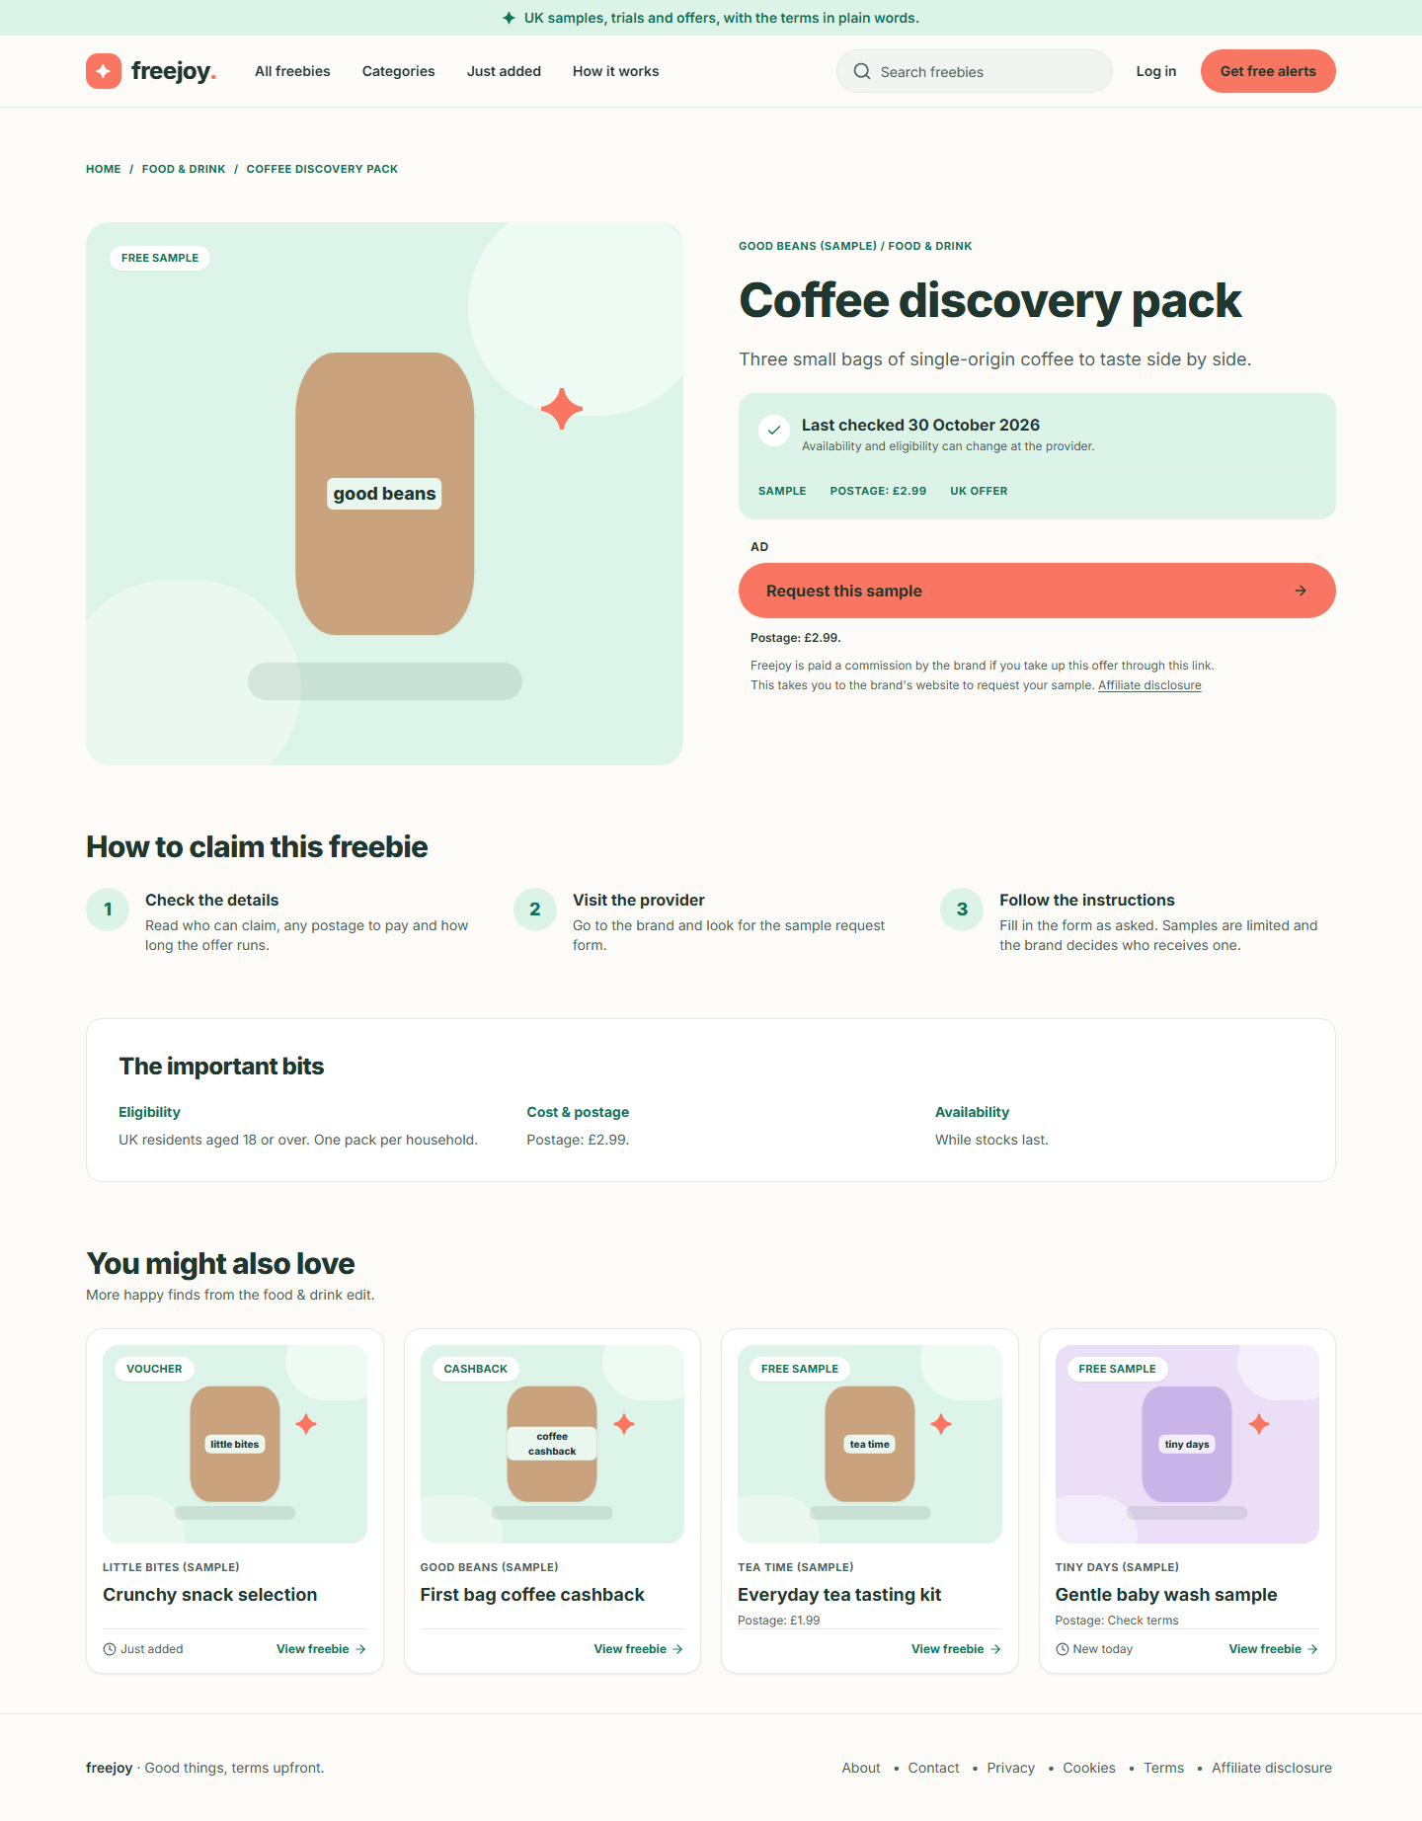
Figure 22. An offer page on a desktop screen
From the top:
- Breadcrumbs: "Home / Food & drink / Coffee discovery pack". Each part except the last is a link back.
- The picture and type badge. The picture is an illustration, not a photograph of the product.
- Brand and category, then the title and a one-line summary.
- The checks panel (the mint box). This is the most important part:
- Last checked and a date, for example "Last checked 30 October 2026", with the sentence "Availability and eligibility can change at the provider." The date is the day an editor last confirmed the offer. If it is not recent, check the brand's own page before you claim.
- A row of capital-letter facts: the kind of offer (SAMPLE, TRIAL, CASHBACK, VOUCHER or COMPETITION), POSTAGE: £2.99 (or FREE, or CHECK TERMS), CARD REQUIRED when you must enter a payment card, and UK OFFER.
- The claim area: see Step 3.
On a phone the same content is stacked in one column:
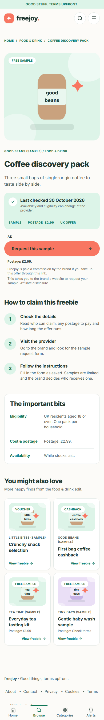
Figure 23. An offer page on a phone

Step 3. Understand the claim button and the "Ad" label
- Above the coral button you see the word AD. It tells you this link is an affiliate link: the brand pays Freejoy if you take up the offer through it.
- The button is named for the kind of offer: Request this sample, Start the trial, Get this cashback, Get this voucher or Enter this competition.
- Directly below the button is a line of conditions that travels with it:
- for a free sample, "Postage: £2.99." (or "Postage: Free." or "Postage: Check the brand's terms.");
- for a free trial that needs a card, "A payment card is required to start."
- Under that, in smaller type: "Freejoy is paid a commission by the brand if you take up this offer through this link." and "This takes you to the brand's website to request your sample." with a link to the Affiliate disclosure page (page 5).
A trial that needs a card looks like this:
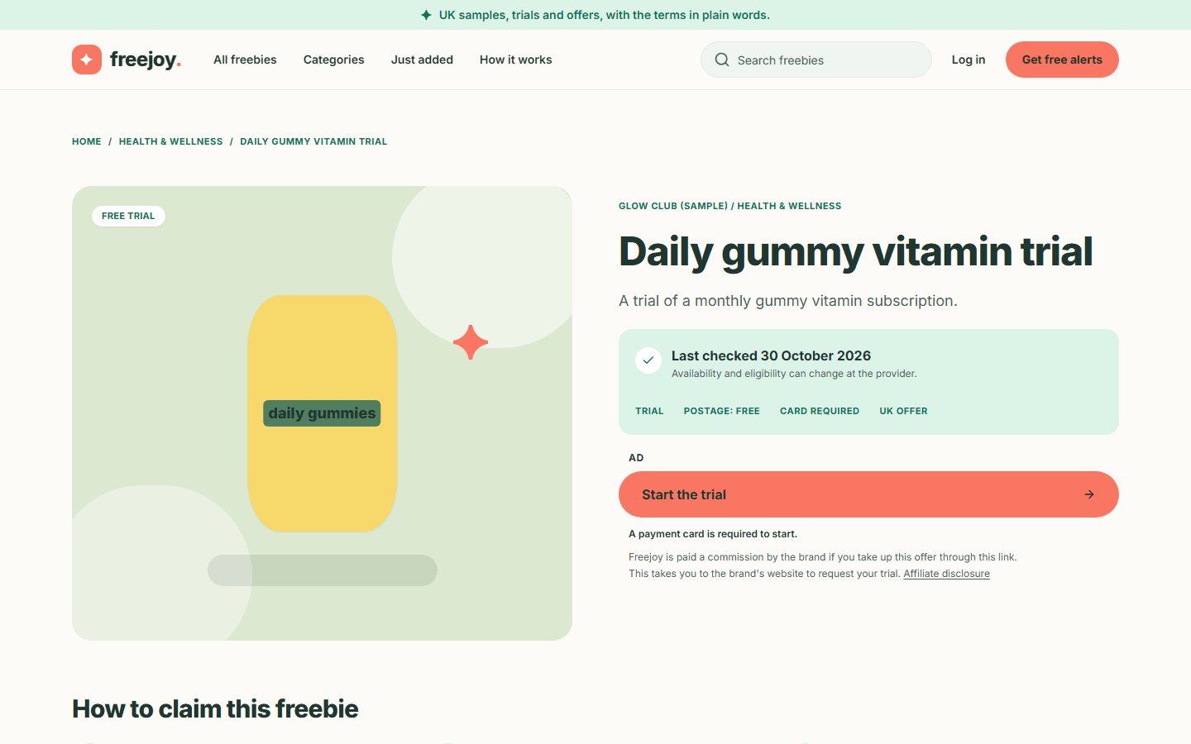
Figure 24. A free trial that needs a card
Phone:
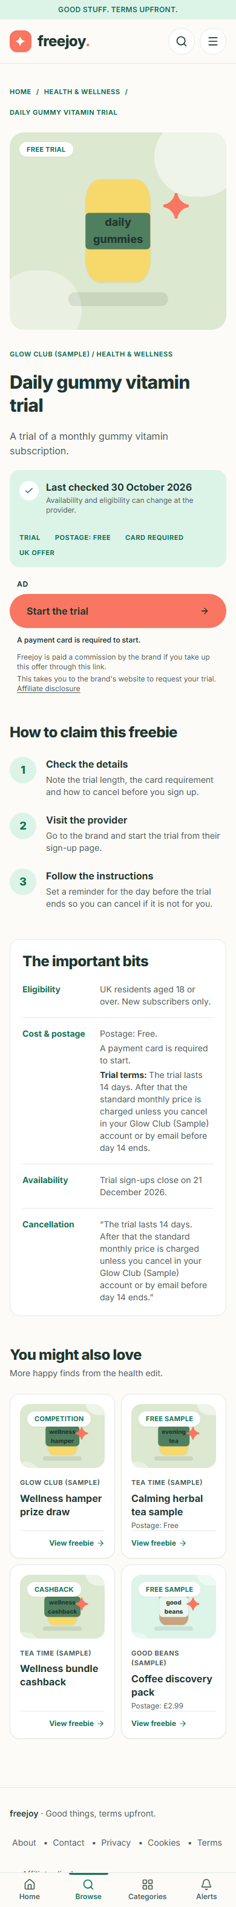
Figure 25. A free trial that needs a card, on a phone

Step 4. Read how to claim
Under the top section, How to claim this freebie lists numbered steps written by the editor, for example "Check the details", "Visit the provider", "Follow the instructions". Read step 1 first: it tells you what to look for before you start (postage to pay, trial length, how to cancel).

Step 5. Read "The important bits"
This box is your checklist. It always has:
- Eligibility: who can claim ("UK residents aged 18 or over. One pack per household.").
- Cost & postage: the postage again, and for trials that need a card, "A payment card is required to start."
- Availability: how long the offer runs or when sign-ups close ("While stocks last.", "Trial sign-ups close on 21 December 2026.").
For a free trial there are also Trial terms (how long it lasts and what is charged afterwards) and a Cancellation quote repeating them. Read these before you give card details to the brand.

Step 6. Look at "You might also love"
The last block shows up to four more offers from the same category. Use it to keep browsing.

Step 7. Claim the offer
- Click the coral button.
- Your browser goes to a Freejoy address that starts with /go/ and is immediately sent on to the brand's own website. You will not see the /go/ page; it only counts the click and passes you on.
- You are now on the brand's site. Complete the claim there. Freejoy does not collect your claim details, and Freejoy cannot change what the brand decides.
- Press Back in your browser to return to Freejoy.
What the click counts: which offer, the time to the nearest minute, the name of the website you came from (not the page) and a rough device type (desktop, mobile, tablet or automated). It does not store your IP address, set a cookie or store any identifier for you. The brand's website, or the affiliate network that tracks the click, handle your visit under their own policies and may set cookies of their own.
No screenshot for this step. After the click you are on another company's website, which is not part of Freejoy. In the test setup used for this guide, the browser was also prevented from reaching any outside site, and the sample destination is a placeholder on example.com.

Step 8. What happens when an offer has ended
An offer that was live and has since ended is not removed straight away. For up to 30 days after its end date, its page says so instead of showing the claim button:
- The headline is the offer title.
- A panel reads This offer has ended with "It ended on 25 October 2026. The provider is no longer accepting requests for this one. There are plenty of other happy finds to explore."
- Two links take you on: More in this category and Browse all freebies. There is no claim button, no steps and no terms.
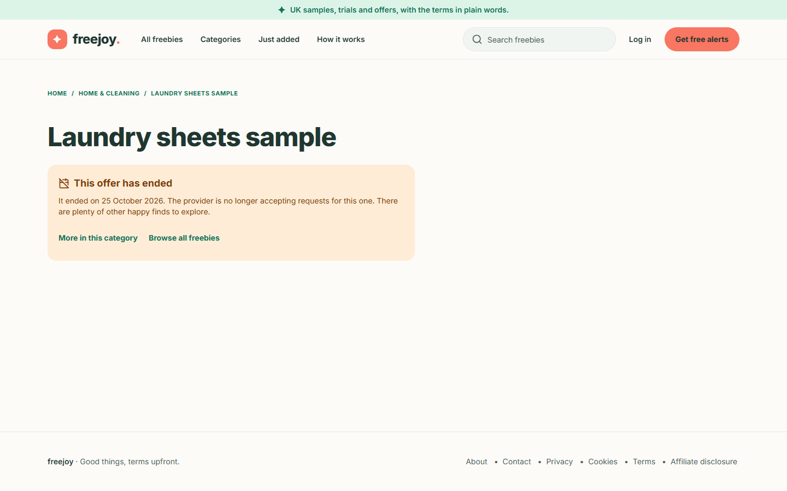  Figure 26. An ended offer on a desktop screen | Phone:  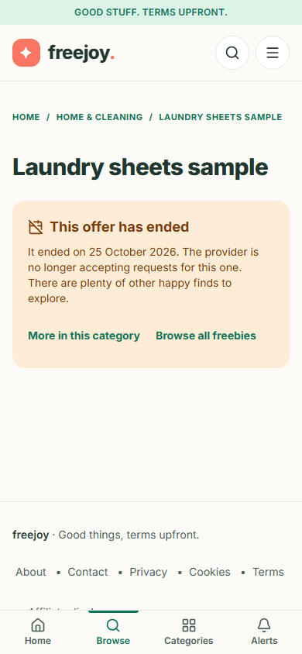  Figure 27. An ended offer on a phone

After those 30 days the page becomes a normal 404 "page not found". The same happens straight away for an offer that was never published or has been unpublished or archived.

If you click a saved or old claim link
If you had saved or bookmarked a claim link (/go/...) for an offer that has since ended, Freejoy does not send you to the brand. It sends you to the ended page above:
Figure 28. What you see after following an old claim link for an ended offer | Phone:  Figure 29. The same on a phone

For an offer that is not public at all (a draft, archived or unknown), the claim link shows a plain page with the words "This offer is not available." If you open claim links many times in a short while the site answers "Too many requests. Please try again shortly."; wait a minute and try again. If the site cannot reach its data you may see "This link is not available right now. Please try again later."

4. Email alerts
Back to the guide index
You can ask Freejoy to email you about new freebies in the categories you pick. Freejoy uses a double opt-in: nothing starts until you open a link in an email and press a button. You never need an account.
Status today. The sign-up form, the confirmation email, confirming and unsubscribing all work. The site only sends the confirmation email so far; regular alert emails are not built yet. Until the owner switches the form on, the site shows "Alerts aren't open yet" (Step 0).

Step 0. If alerts are not open yet
When the form is switched off, the page shows a notice instead of the form: Alerts aren't open yet. "Nothing you could enter here would be sent or saved, so the sign-up form is switched off until alerts launch." Use Browse freebies to carry on.
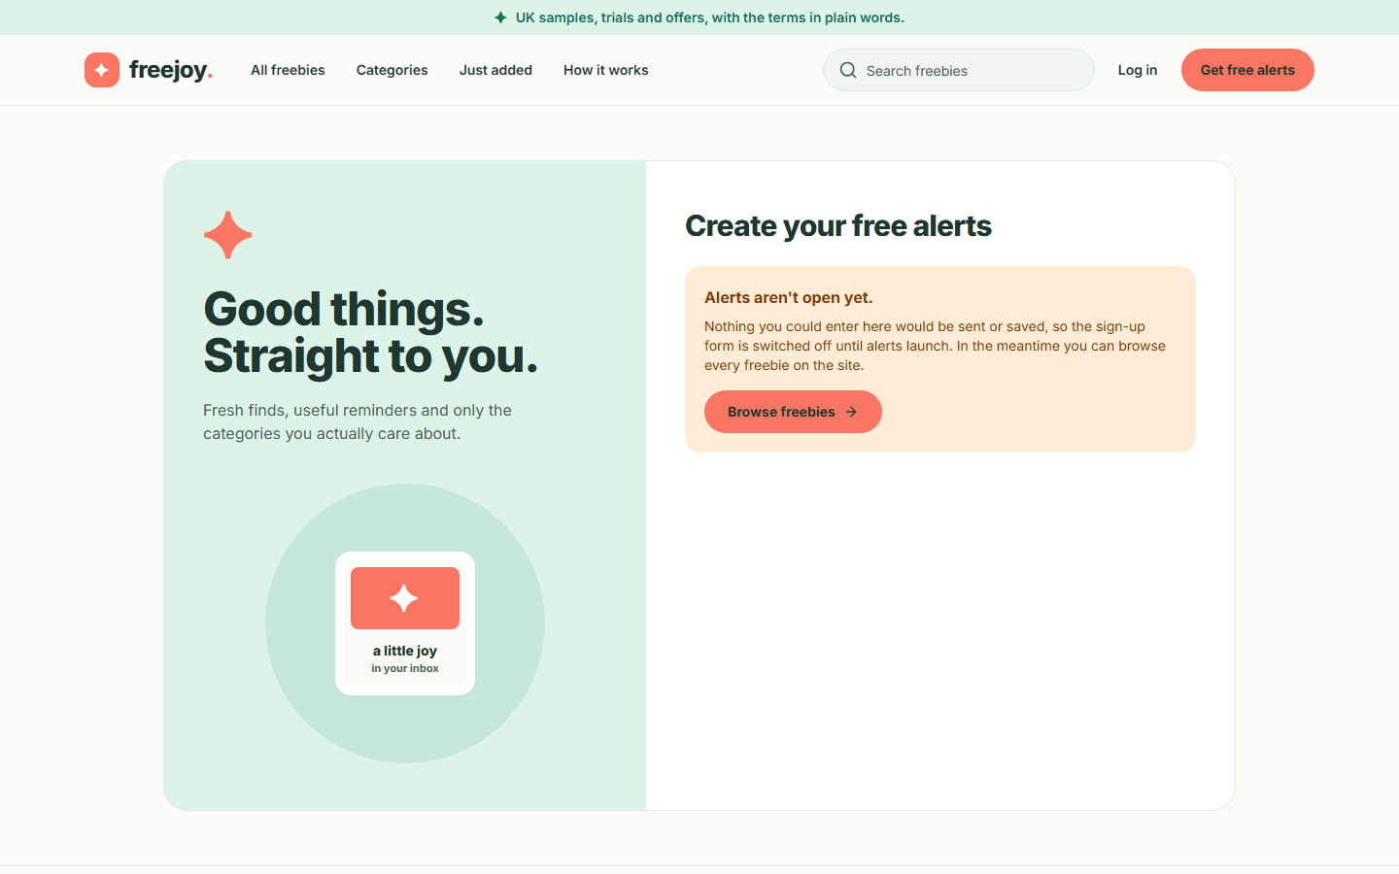  Figure 30. The alerts page when sign-up is switched off | Phone:  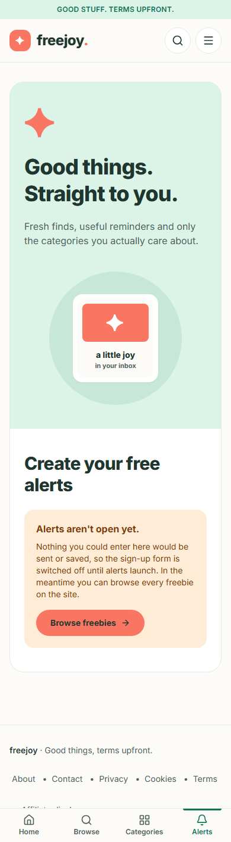  Figure 31. The alerts page when sign-up is switched off, on a phone

Step 1. Open the sign-up page
- Click Get free alerts in the header, the Alerts tab on a phone, or the button in the home page's "Make your inbox a happier place" band.
- The page "Create your free alerts" opens. (Nothing is typed into the address bar for you: Freejoy never puts an email address in a page address.)
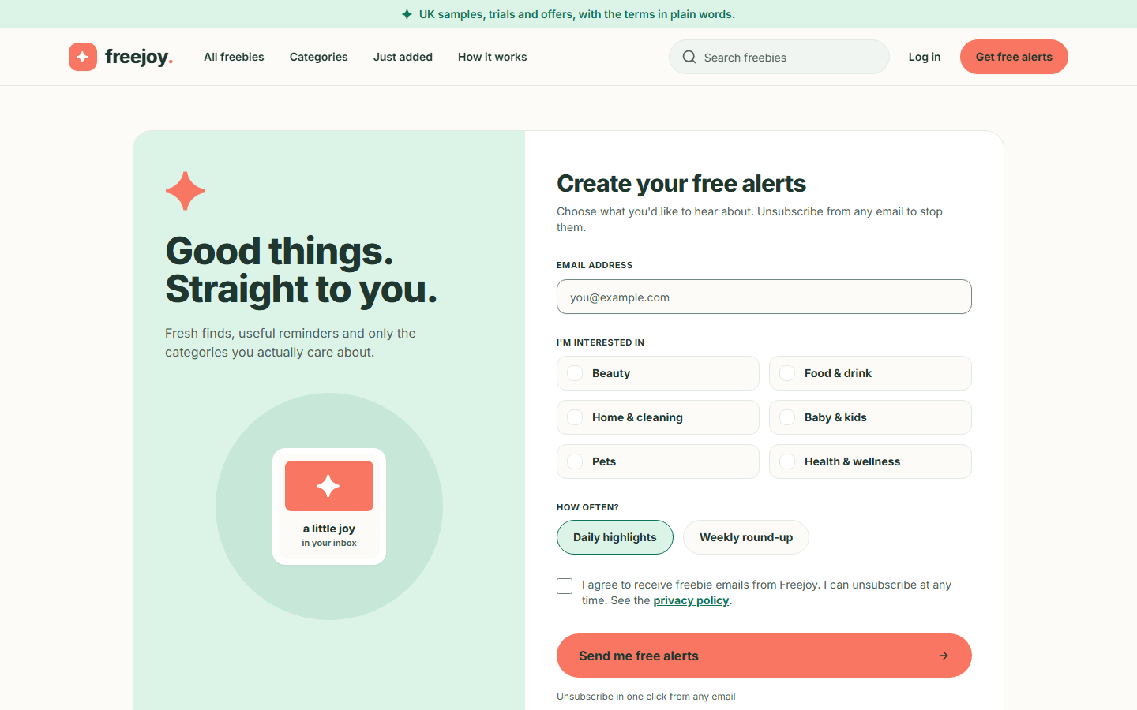
Figure 32. The alerts sign-up form on a desktop screen
Phone:
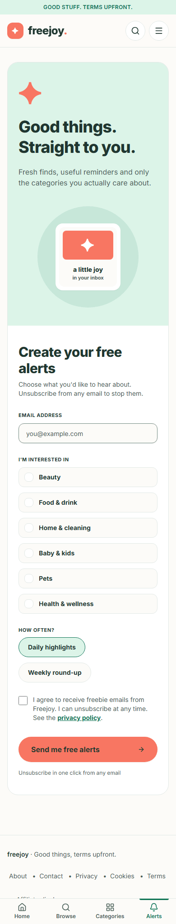
Figure 33. The alerts sign-up form on a phone

Step 2. Fill in the form
- Email address: type the address you want alerts sent to.
- I'm interested in: tick one or more categories (Beauty, Food & drink, Home & cleaning, Baby & kids, Pets, Health & wellness). You must pick at least one.
- How often?: choose Daily highlights or Weekly round-up. One is always selected; Daily highlights is selected to begin with.
- Tick I agree to receive freebie emails from Freejoy. I can unsubscribe at any time. The words "privacy policy" link to the (draft) privacy notice.
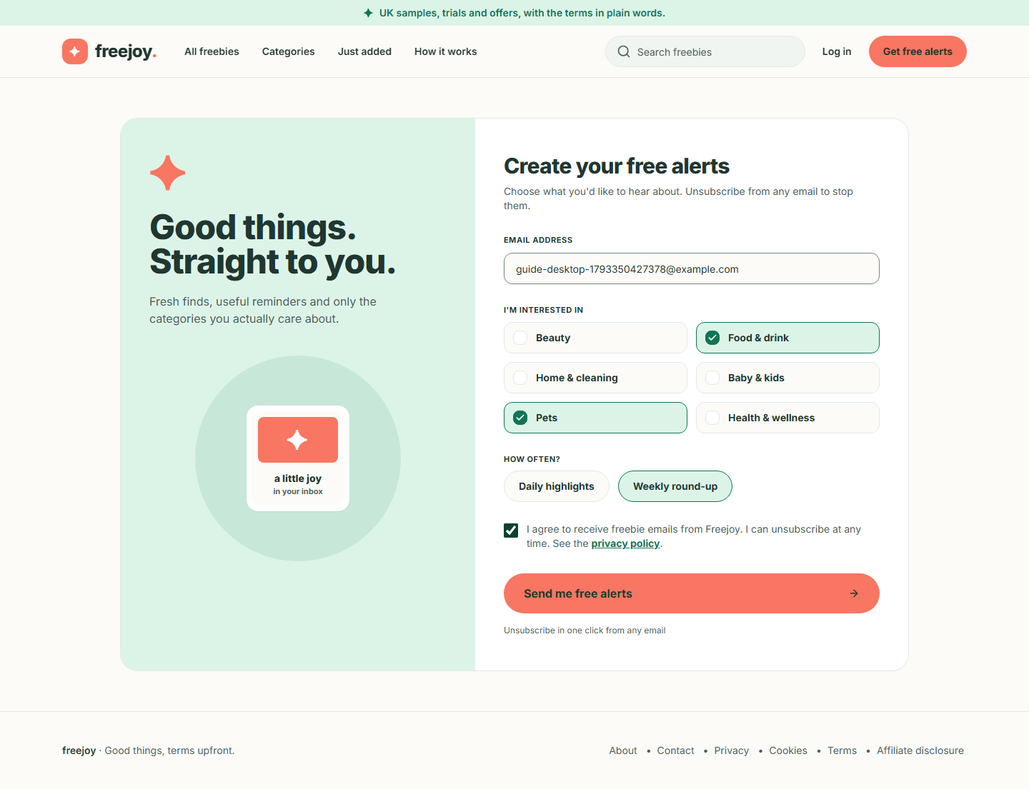
Figure 34. A completed form
Phone:
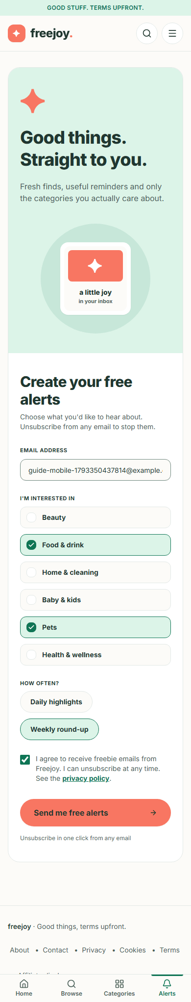
Figure 35. A completed form on a phone

Step 3. If something is missing
Press Send me free alerts with the form incomplete and each problem is written next to the field, and the first problem field is focused:
- "Enter your email address." (or "Enter a valid email address.")
- "Choose at least one category."
- "Please agree to receive emails to continue."
Fix them and press the button again.
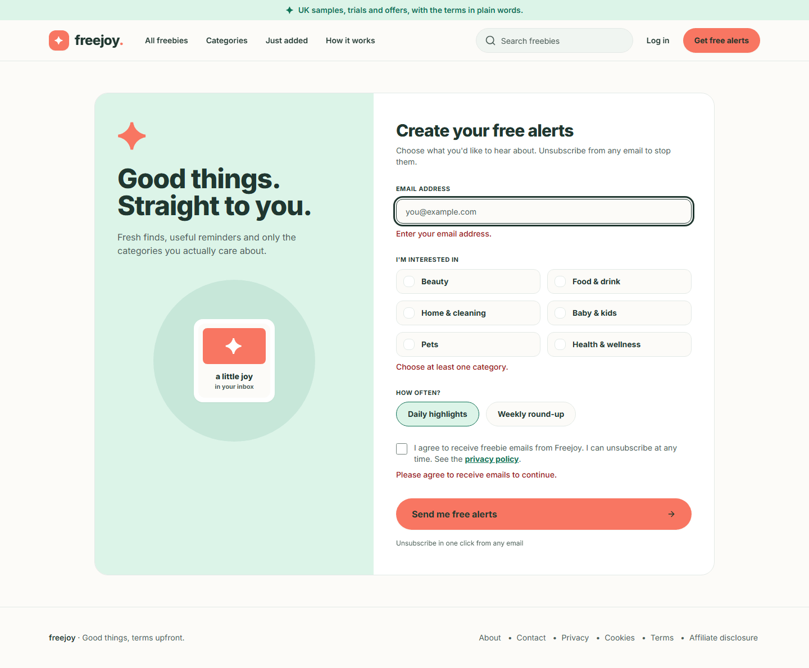
Figure 36. The form with its three messages
Phone:
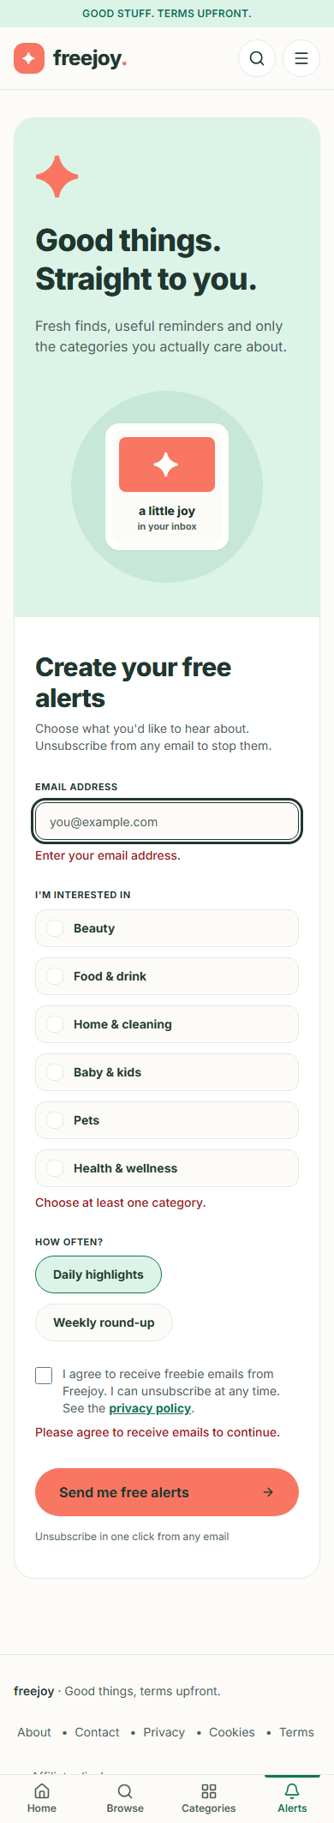
Figure 37. The form with its messages on a phone

Step 4. Send the form
- Press Send me free alerts. The button says "Sending..." for a moment.
- A green panel headed Check your inbox replaces the button: "If your address is new to our alerts, we have sent it a confirmation link. Open the link within 24 hours to start your alerts: nothing starts until you do. If you do not see it in a few minutes, check your spam folder. If it has not arrived after a few minutes, you can submit the form again. If you are already signed up, there is nothing more to do."
- Two links offer Browse freebies and Use a different address.
The same message appears for every address, whether it is new, waiting, already confirmed or previously unsubscribed. This is deliberate: nobody can use the form to find out whether someone else's address is on the list.
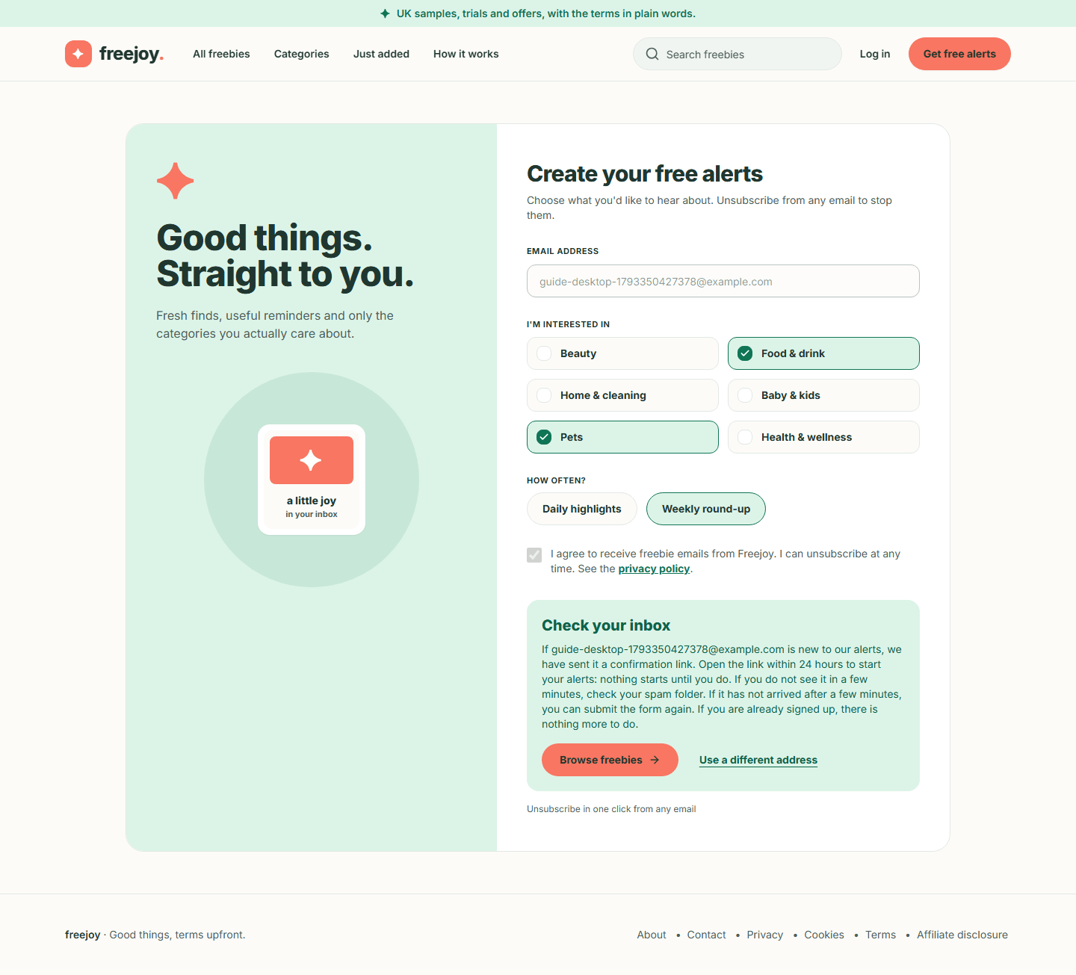
Figure 38. The Check your inbox panel
Phone:
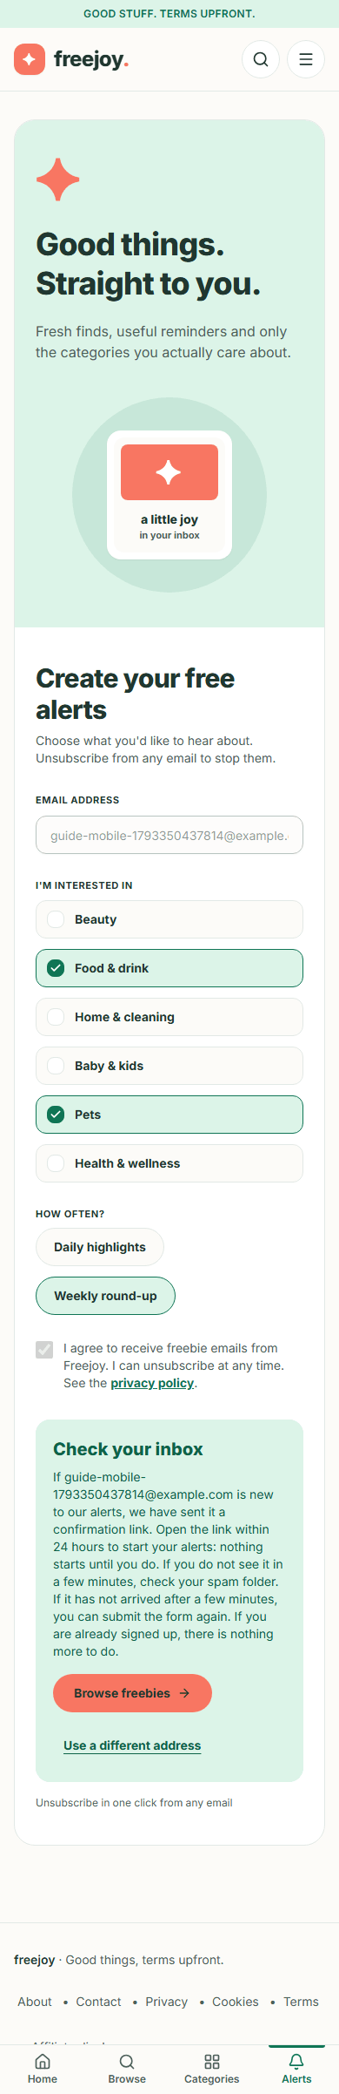
Figure 39. The Check your inbox panel on a phone

Step 5. Open the confirmation email
The email is sent a moment after you press the button. In the test used for this guide the email provider was a "fake" one that writes each email to a file, so there is no inbox screenshot. This is the text of the email that was captured (the two long codes are shortened to <code> and the local test address is replaced by <freejoy address>; real links carry one-use codes):
Subject: Confirm your Freejoy alerts
Hello,
Someone, hopefully you, asked for Freejoy alerts using this email address.
To confirm, open this link within 24 hours:
https://<freejoy address>/alerts/confirm?token=<code>
If this was not you, do nothing: you will not be added to the list. To make sure we never email this address, use
this link instead:
https://<freejoy address>/alerts/unsubscribe?token=<code>
Freejoy
The email also carries the standard "unsubscribe" header, so many mail apps show their own Unsubscribe button.
If it never arrives, look in your spam folder, then submit the form again. If the same address is waiting for confirmation, Freejoy re-sends the link (at most about once an hour).

Step 6. Confirm
- Open the confirm link from the email.
- The page "Confirm your free alerts" says "One last step. Press the button to start your alerts. The link in your email works for 24 hours." Opening the link alone changes nothing, so mail-scanning software cannot confirm for you.
- Press Confirm my alerts.
- The page changes to You are signed up: "Thank you. Your alerts are confirmed, and every email has an unsubscribe link." with a Browse freebies link.
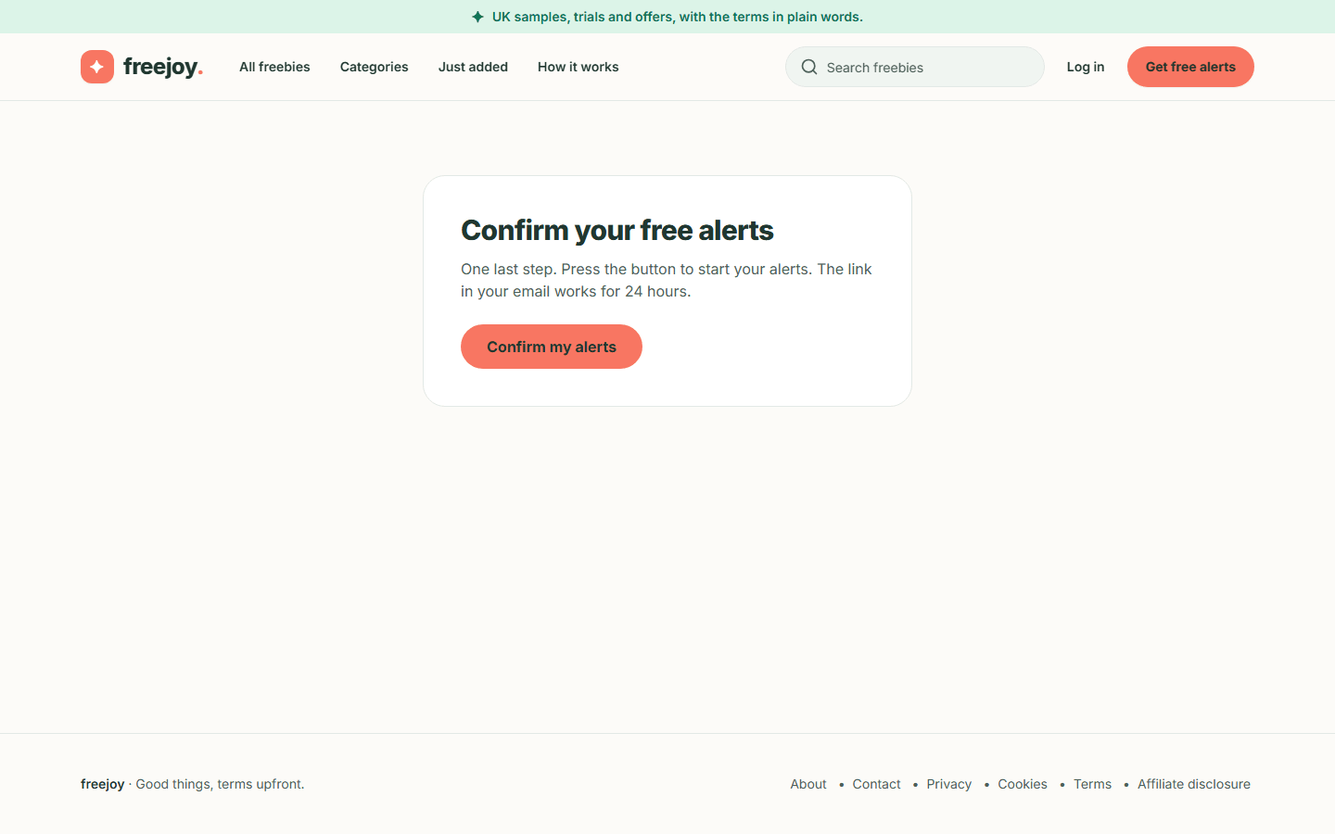
Figure 40. The confirm page
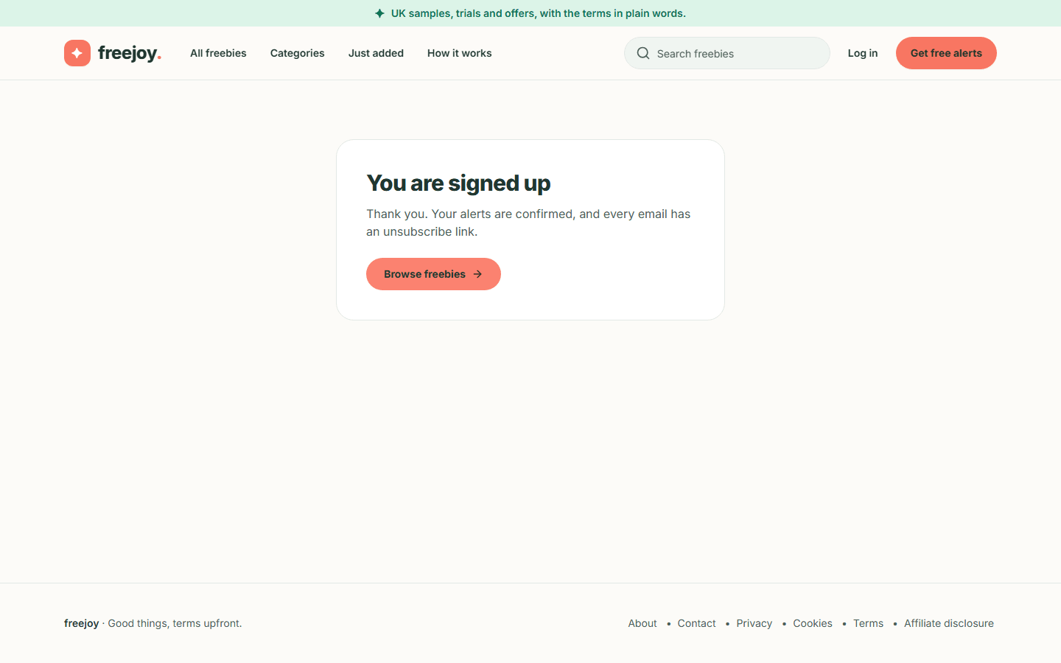
Figure 41. Confirmed
Phone:
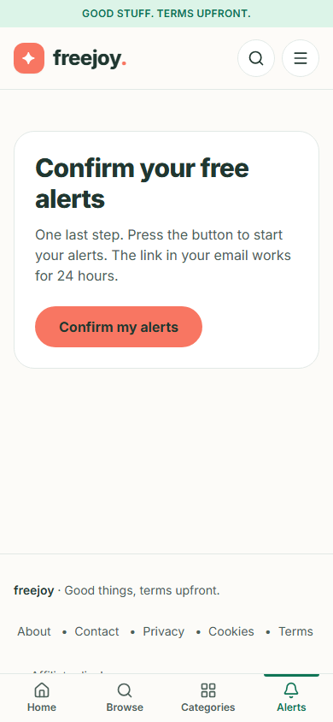
Figure 42. The confirm page on a phone
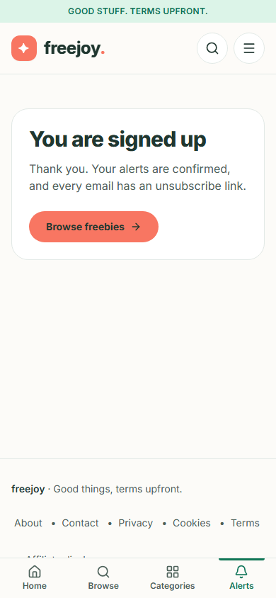
Figure 43. Confirmed on a phone
If the link is too old, already used, or was cut off when you copied it, the page says "This link is not valid any more. It may have expired or already been used. You can start again from the alerts page." (or "This link is incomplete. Please use the link in your email, or start again from the alerts page." when the code is missing). Use Back to alerts to start again.
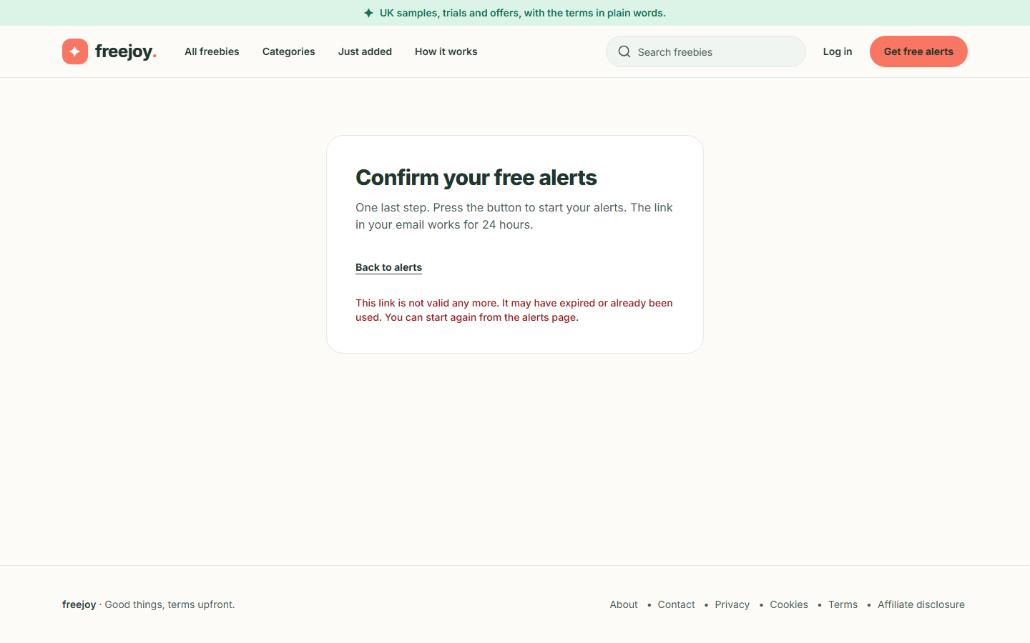  Figure 44. An expired or used link | Phone:  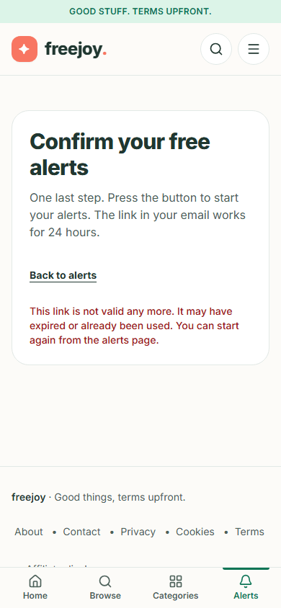  Figure 45. An expired or used link on a phone

Step 7. Changing your categories or how often
There is no preferences page yet. Your categories and frequency are the ones you chose on the form.
- Before you confirm, submitting the form again with the same address (once about an hour has passed, because Freejoy limits how often it re-sends the link) updates your categories and frequency and sends a new link.
- After you confirm, submitting the form again changes nothing (anyone could type your address, so the form is not allowed to alter a confirmed subscriber).
- If you want something different, you currently have to unsubscribe (Step 8). Note that an unsubscribed address cannot sign up again through the form; see "Things to know" below.

Step 8. Unsubscribe
You can unsubscribe from any email, in one step, with no login.
- Open the unsubscribe link in the email (or use your mail app's Unsubscribe button, which does the same thing without opening a page).
- The page "Unsubscribe from Freejoy alerts" says "Press the button and we will stop sending you alerts."
- Press the button.
- The page says You are unsubscribed: "We will not send you any more alerts. We keep your address on a do-not-email list for 12 months so it is not emailed again, then delete it." (Back to Freejoy returns to the home page.)
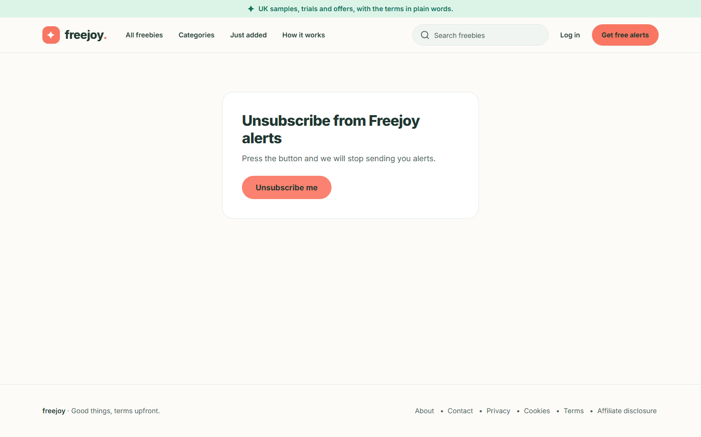
Figure 46. The unsubscribe page
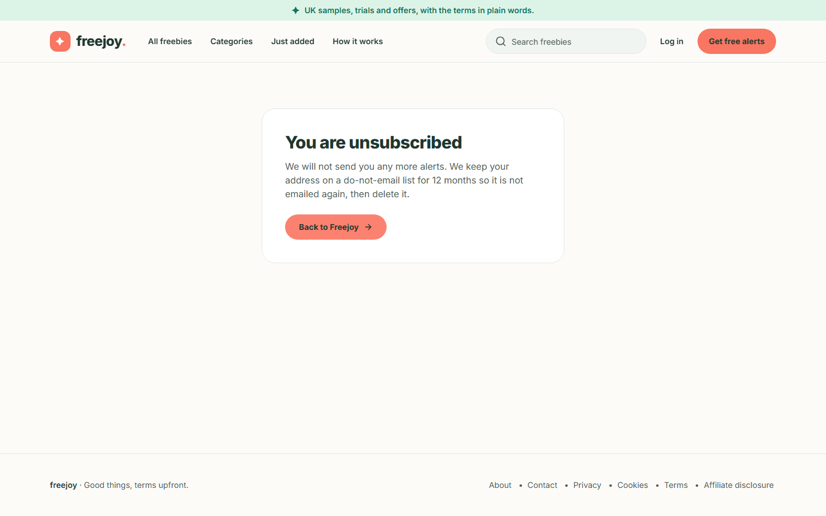
Figure 47. Unsubscribed
Phone:
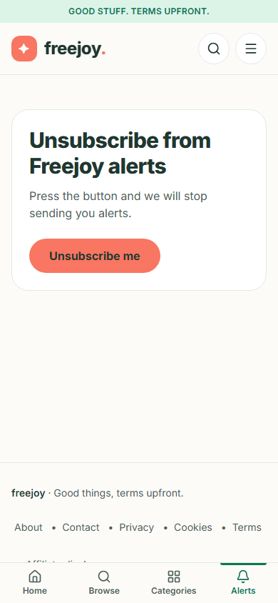
Figure 48. The unsubscribe page on a phone
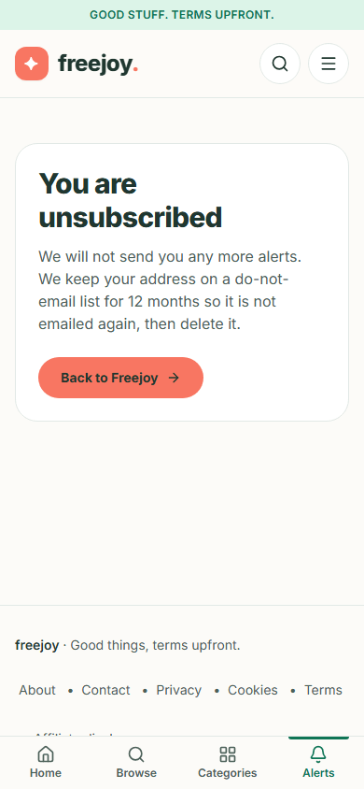
Figure 49. Unsubscribed on a phone

Things to know
- A sign-up that is never confirmed is deleted after 30 days (a maintenance command run by the operator).
- An address you unsubscribed stays on a do-not-email list for 12 months. During that time the sign-up form accepts the address but sends nothing, to protect you from someone else re-adding it. Bringing it back is currently something the site operator does by hand.
- Freejoy stores your address, your categories and frequency, and a record of your consent (the wording you saw, when you agreed and which form). It does not store your IP address in that record. See the draft privacy notice for the details, which are pending legal review.
- Freejoy limits how often one address, and one network, can use the form, so a very quick run of attempts may be slowed down.

5. About, contact, legal pages, 404 and cookies
Back to the guide index
Every page described in this section except the 404 page is a draft. Each shows a banner at the top reading "Draft — placeholder text pending legal review", and the About, Privacy, Cookie, Terms and Affiliate disclosure pages also say "Last reviewed: Not yet reviewed". Each, except Contact, ends with a "For the reviewer to confirm" checklist of open questions for the person who will review it. The wording is a placeholder and is not legal advice. The pages are also asked not to be indexed by search engines.

Step 1. Find the pages
- Scroll to the bottom of any page. The footer links to About, Contact, Privacy, Cookies, Terms and Affiliate disclosure.
- Click the one you want. On a phone the footer links wrap onto more than one line.

Step 2. About
The About page ("About Freejoy") explains in plain words:
- What Freejoy is: a UK guide to free samples, trials, cashback, vouchers and competitions. Freejoy does not run the offers; the brand does.
- Not everything is free: a free sample may have postage; a free trial may ask for a card and start charging; cashback and vouchers are not free; a competition is an entry, not a prize.
- How we intend to check offers and How it works (the page the header's How it works link jumps to): find something, read the terms first, claim it on the brand's site.
- How Freejoy plans to pay for itself: commission on some links, with a link to the affiliate disclosure.
- Keeping in touch.
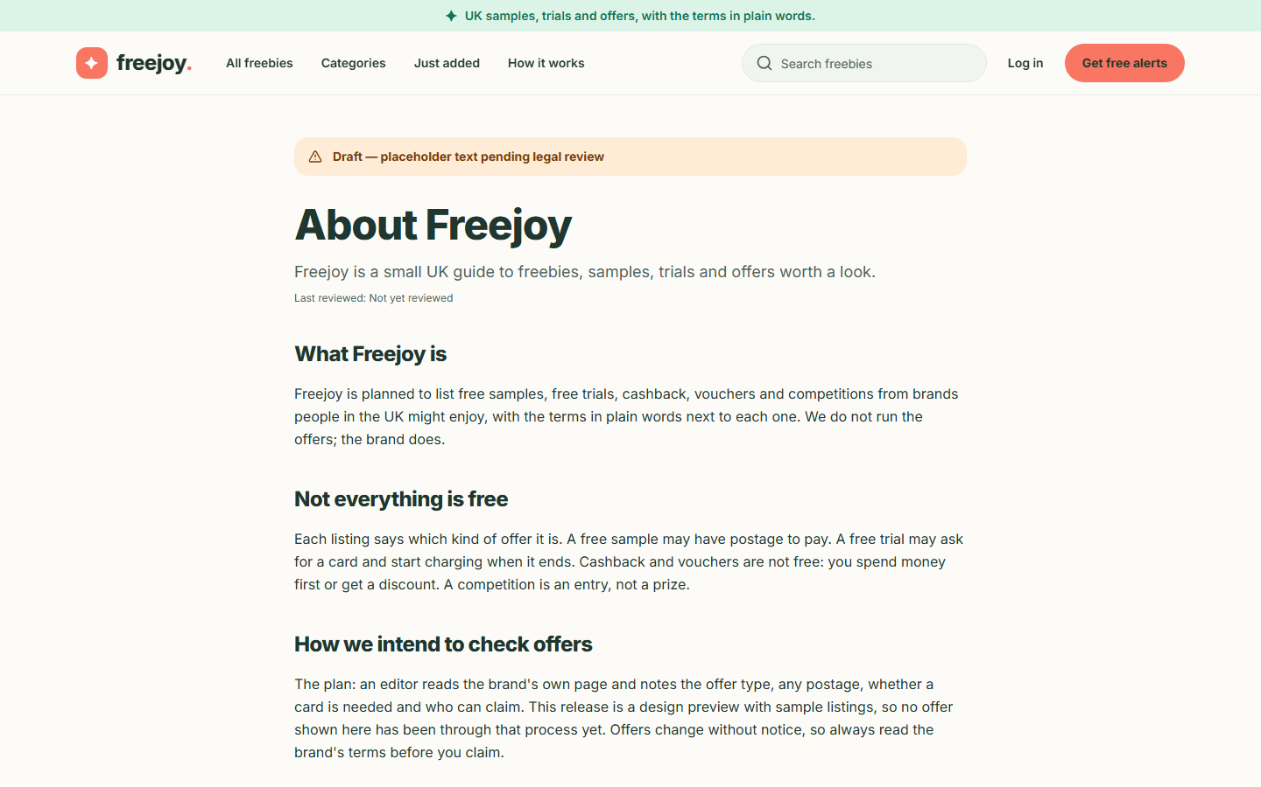  Figure 50. The About page | Phone:  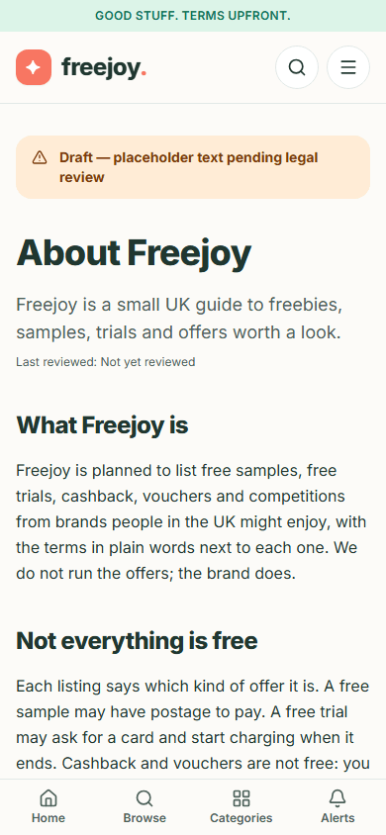  Figure 51. The About page on a phone

Two paragraphs change with the site's settings. "Keeping in touch" says you can sign up for email alerts when alerts are switched on, and says alerts are not open yet when they are off. "How we intend to check offers" adds a sentence calling the site a "design preview with sample listings" only while it shows sample listings, not real offers. The screenshots above were taken before this wording was corrected, so those two paragraphs read differently in them. The page is still a draft and its text still needs legal review.

Step 3. Contact
- Open Contact. It says "A support contact is coming soon. Messages cannot be sent from this page yet."
- You will see a form (First name, Last name, Email, Company, Subject, Message), but it is switched off: it is labelled "This form is unavailable and does not send messages", and the Send message button says "Message sending is coming soon."
- A Support Contact note says email, phone and sales channels are not available yet, and Who runs Freejoy says the operator's name, address and contact email will be added before any real offer goes live.
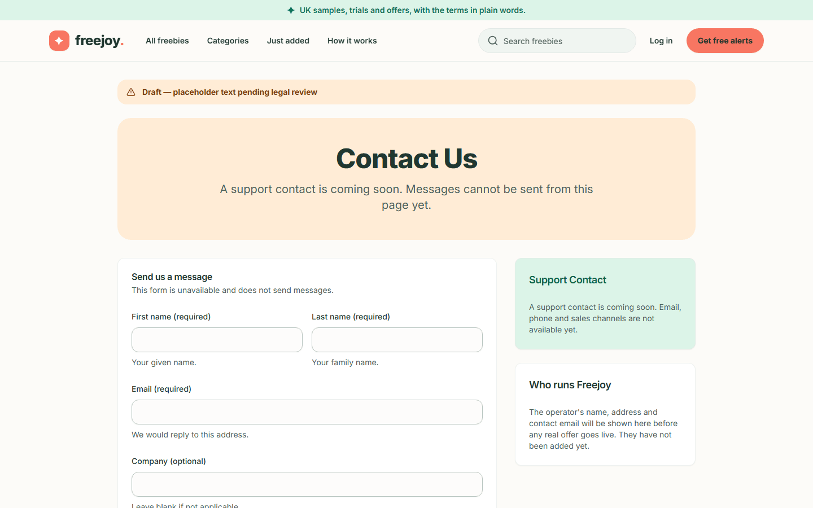
Figure 52. The Contact page

Step 4. Privacy notice
The Privacy notice says what Freejoy collects, in sections: What this release collects, If you create an account, Email alerts, If you use an offer button and Your rights. Key points it makes today:
- If you sign up for alerts: your email address, your categories and how often, and a record of your agreement. Your IP address is not stored in that record.
- A search word travels in the page address, so an email address typed into the search box can appear in server logs and your browser history. Do not type one there.
- The links in alert emails carry a single-use code that stops working once used.
- Using an offer button counts a click without identifying you (see page 3).
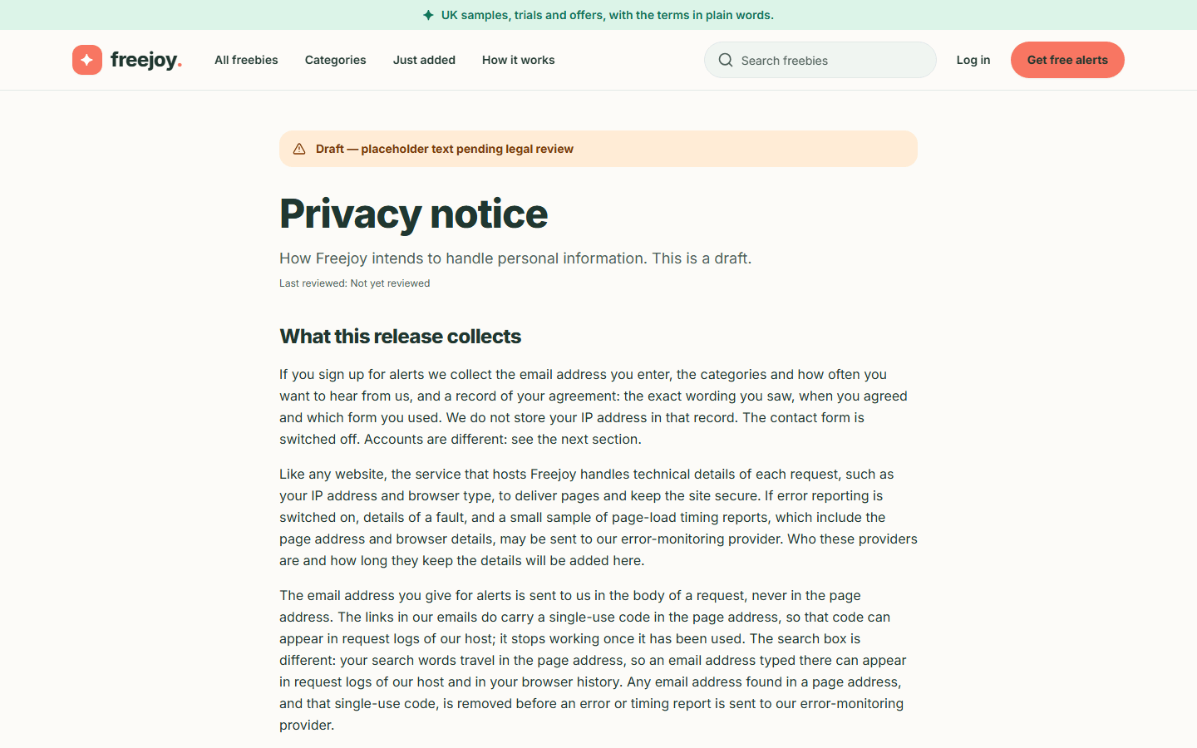  Figure 53. The Privacy notice | Phone:  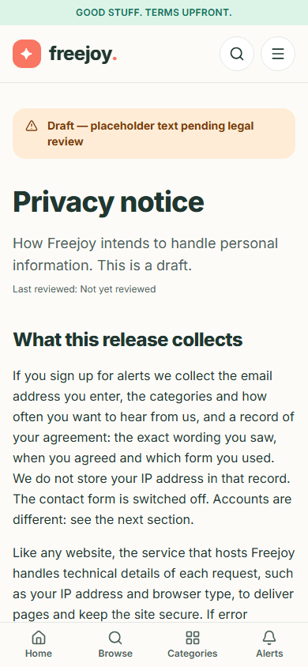  Figure 54. The Privacy notice on a phone

Step 5. Cookie notice, Terms and Affiliate disclosure
- Cookie notice: see What Freejoy stores in your browser below.
- Terms of use: Using the site, Accuracy of listings (offers change at the brand, so check before you claim) and Our responsibility.
- Affiliate disclosure: How Freejoy earns money (a commission, paid by the brand, never by you), How the links work (offer buttons go through a Freejoy address starting /go/, and are marked as paid links for search engines), What a click records, What we aim to keep separate (commission should not change the terms shown) and Paid placements (none planned; they would be labelled as ads).
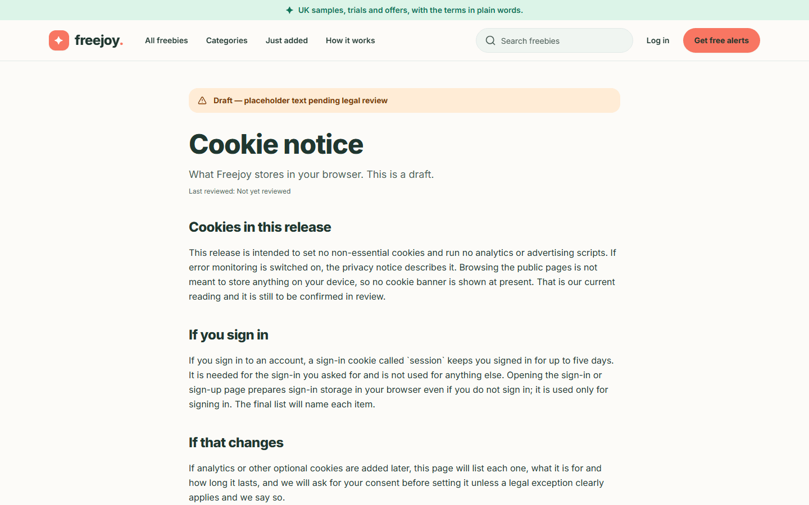
Figure 55. The Cookie notice
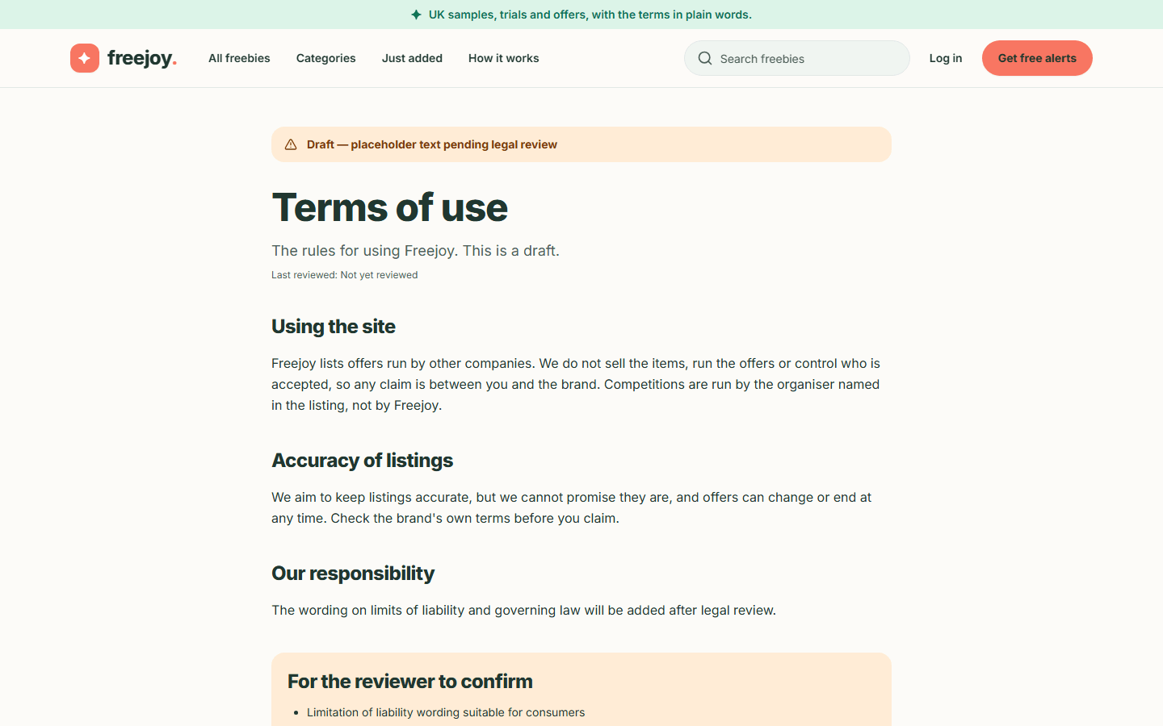
Figure 56. The Terms of use
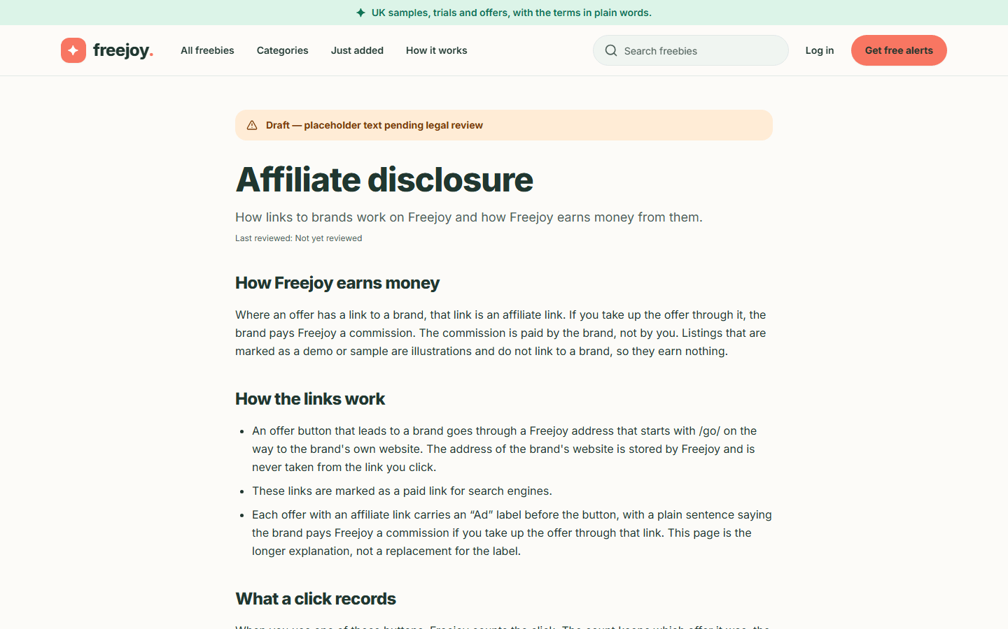
Figure 57. The Affiliate disclosure

The "page not found" page
If you follow a wrong or old address, for example a mistyped offer name, an offer that was never published, an offer that ended more than 30 days ago, or a category that does not exist, you see a calm panel with a large 404, the heading Page not found and the words "The page you are looking for does not exist or has moved." Two buttons help: Go home and Browse freebies. The page also tells search engines it is a genuine "not found".
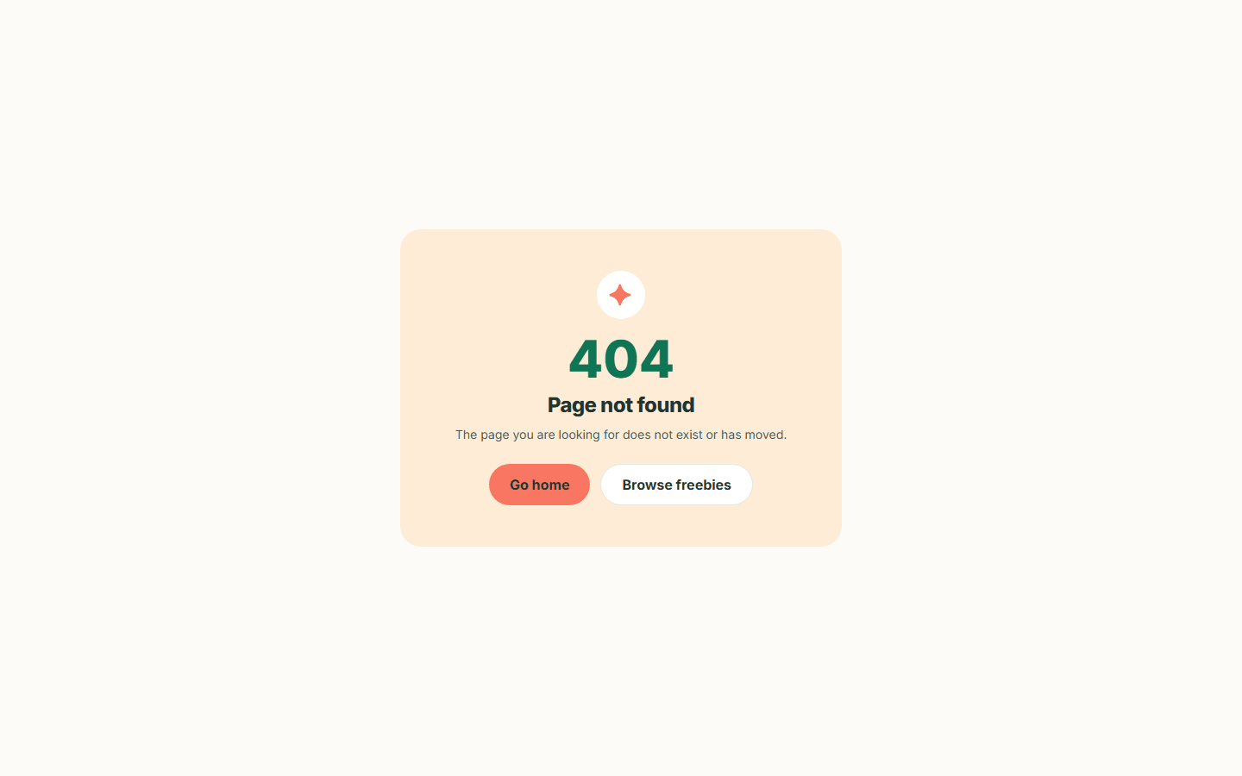  Figure 58. The 404 page | Phone:  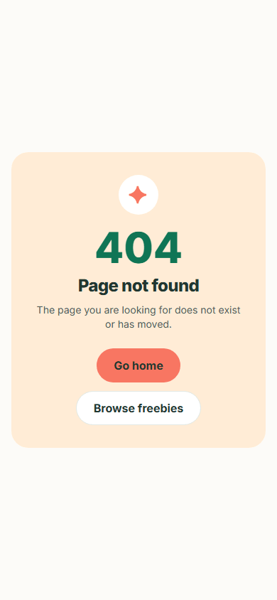  Figure 59. The 404 page on a phone

What Freejoy stores in your browser
No cookie banner is shown, and that is deliberate: while you only browse the public pages, Freejoy sets no cookies and stores nothing in your browser's local storage (the guide's author checked this by opening the home, catalogue, offer, alerts and About pages in a fresh browser and listing its cookies and storage: both were empty). There is no analytics or advertising script.
What can be stored, and when:
When | What | Why
Browsing the public pages, searching, filtering, using the alerts form | Nothing | The catalogue state lives in the page address
You click an offer's claim button | Nothing on your device. Freejoy counts the click on its own server (offer, minute, referring website name, rough device type). The brand's site may set its own cookies | Click counting
You open the Log in or Sign up page | The sign-in service prepares storage in your browser, even if you do not sign in | Signing in only
You sign in | A cookie called session that keeps you signed in for up to five days | Keeping you signed in

The draft Cookie notice also says that if optional cookies such as analytics are ever added, the notice will list each one and Freejoy will ask for consent first. The draft's reviewer checklist lists "whether the conclusion that no banner is needed on the public pages holds" as an open question for legal review. If error monitoring is switched on by the site owner, the privacy notice describes it; addresses and one-use codes are removed from error reports first.

Not covered here
The sign-in, sign-up, password reset, dashboard and pricing pages belong to the account part of the app, which is separate from the freebies site. The only account pages this guide shows are those an administrator uses (see the admin guide).

6. Keyboard and accessibility tips
Back to the guide index
Freejoy is designed to work with a keyboard, a screen reader, a phone and a zoomed-in screen. These are the tips that matter most. They describe what the app does today; they are not a certification (the project's own accessibility checks are described in the developer documentation).

Step 1. Skip the menu
- Load any Freejoy page.
- Press Tab once. A box labelled Skip to main content appears at the top left with a thick dark outline.
- Press Enter to jump straight to the page content, past the header and menu.
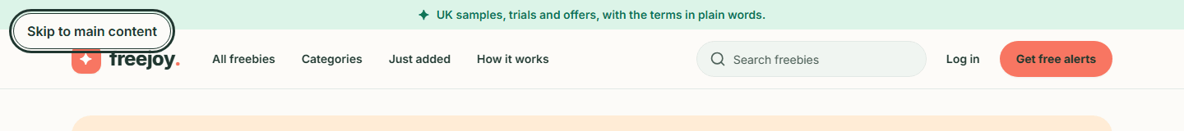
Figure 60. The skip link

Step 2. Move around with the keyboard
Key | What it does
Tab / Shift + Tab | Move forwards / backwards through links, buttons and form fields
Enter | Follow a link or press a button
Space | Tick a checkbox or press a button
Arrow keys | Change the choice in a drop-down such as Sort by (it does not apply until you press Apply)
Escape | Close the phone menu or the filter drawer

Everything in the catalogue, including every category, type and postage filter, page number and offer card, is a normal link or form control, so it can all be reached and used without a mouse.

Step 3. See where you are
The thing you are on always gets a clear outline. On a card, the whole card is outlined (not only the link inside it), so you can tell which offer you are about to open.
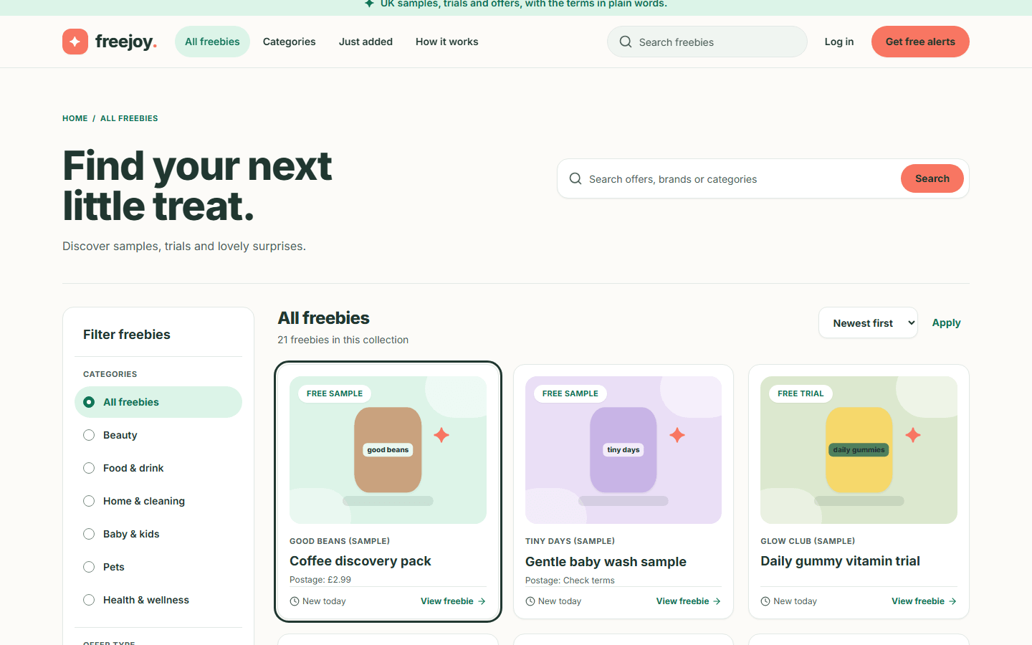
Figure 61. A freebie card with the keyboard focus outline
Other pointers that do not rely on colour alone:
- The page you are on in the header is highlighted and marked as the current page for screen readers.
- A chosen filter shows a filled dot or a tick, as well as a coloured background.
- Offer type, postage and "card required" are written as words, never only as icons or colours.

Step 4. Fill in forms with confidence
- Every field has a visible label.
- When the alerts form has a problem, the message is written next to the field and the first problem field is focused so you can fix it straight away.
- Buttons that start work (for example sending the alerts form) stay focused and say what they are doing, such as "Sending...", instead of disappearing.

Step 5. Screen readers
- The page has a main region, a header, a footer and labelled navigation areas ("Main", "Quick links" on a phone, "Legal and about" in the footer).
- Offer pictures are illustrations. Each has a short text description, and the offer's details are always written out in text beside it.
- The error panel ("The freebies are not loading") is announced as an alert; a loading message is announced as a status.
- Long tables are not used on the public pages; offers are lists of cards.

Step 6. Larger text and small screens
- Increase your browser's text size or zoom in. The layout re-flows into one column rather than scrolling sideways.
- On a phone, controls are at least about 44 pixels tall so they are easy to tap.
- The filter drawer and the menu panel trap the keyboard focus inside them while open, and return it to the button that opened them when closed.

Step 7. If a page does not work for you
The Contact page does not send messages yet (see page 5) and no support address is published yet, so there is no way to report an accessibility problem from the site today. Tell the site owner directly.

Part 2. For administrators (the admin area)
Page | What it explains
Admin 1. Signing in and the admin shell | Who counts as an admin, how to get to /admin, the sidebar, the phone tab bar, the Dashboard page
Admin 2. Offers (freebies) | The offers list, search and filters, adding an offer, editing, "Mark verified", publishing, unpublishing, expiring, archiving and what each status means
Admin 3. Categories and merchants | Adding, editing, enabling and disabling categories; adding, editing, activating and deactivating merchants
Admin 4. Users and two-factor sign-in | The user list, search, user details, editing a profile, suspending and restoring access, and two-factor sign-in
Admin 5. Subscriptions and analytics | The Subscriptions and Analytics pages (the optional Stripe billing module)
Admin 6. Audit logs, SEO and settings | The audit log, and the SEO and Settings pages, which are not fully built yet

Admin 1. Signing in and the admin shell
Back to the guide index
The admin area is where staff look after the catalogue (offers, categories, merchants) and see users and reports. It is at the address /admin on the Freejoy site. Visitors cannot use it.
Screenshots in the admin guide. The admin screens were captured through the project's test-only identity server on a private test database (details in the index), so the account in the pictures is a test account named "E2E Admin" with the role Super Admin. The brands, offers and numbers are sample data. The sign-in step itself needs a Firebase project, so it is marked as pending below.

Who can use the admin area
You are an admin if someone has given your account an admin role and a list of permissions. Being signed in is not enough: an ordinary account is sent to its own dashboard. Permissions decide which buttons work. For the catalogue they are: offers.read (see lists), offers.write (create and edit offers), offers.publish (verify, publish, unpublish, expire, archive), categories.write and merchants.write. A Super Admin has every permission.
There is no screen for making someone an admin. An existing admin with the right permission grants it through the backend, and the very first admin is set up directly in the database by a developer (see the developer notes in admin-settings.md and local-e2e.md).
If you open a page and your account lacks the permission, you still see the page; when you try the action the message "You do not have permission to do that" appears.

Step 1. Sign in
Admins sign in on the same page as everyone else.
- Go to /login (the Log in link in the public header).
- Type your Email and Password and press Sign In, or use Continue with Google or Continue with GitHub. Forgot password? starts a reset.
- If your email address is not verified yet you are sent to Verify your email: open the link in the email Firebase sent you, then sign in again.
- Once you are in you land on your own dashboard (the account area), unless the site sent you to the sign-in page from a page that needs sign-in, such as /admin or a dashboard page (see Step 2): then you return to that page. If you use two-factor authentication, the code step comes first and the return still happens after it. Your sign-in lasts up to five days (a cookie called session).
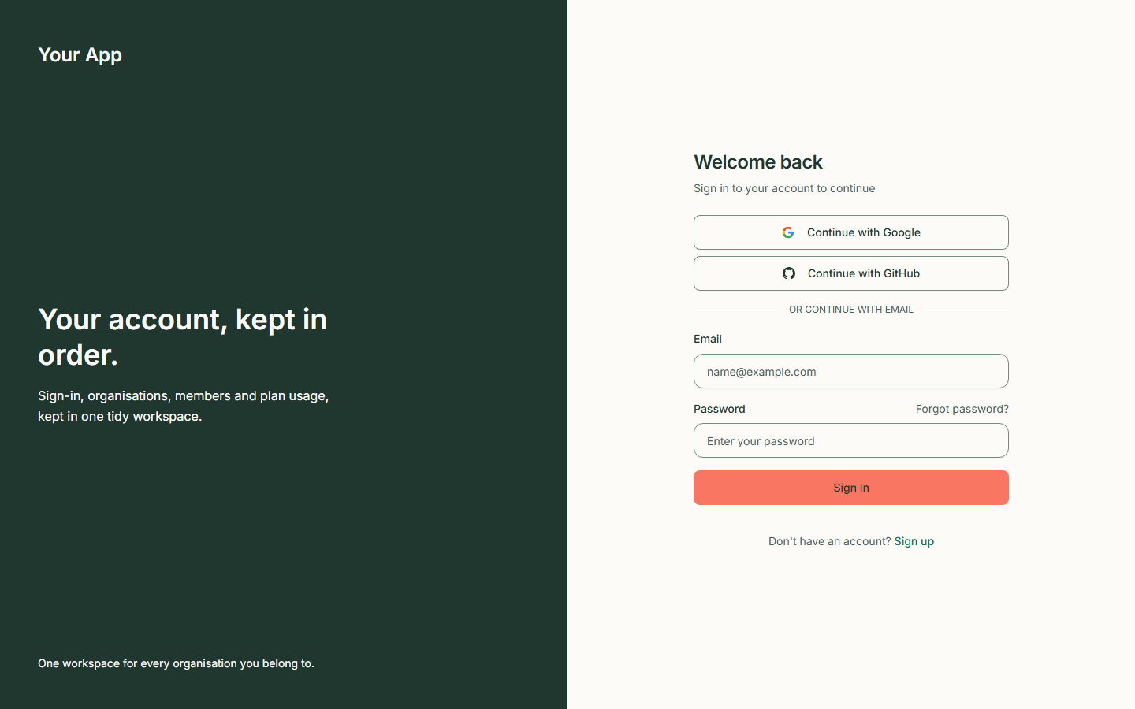  Figure 62. The sign-in page on a desktop screen | Phone:  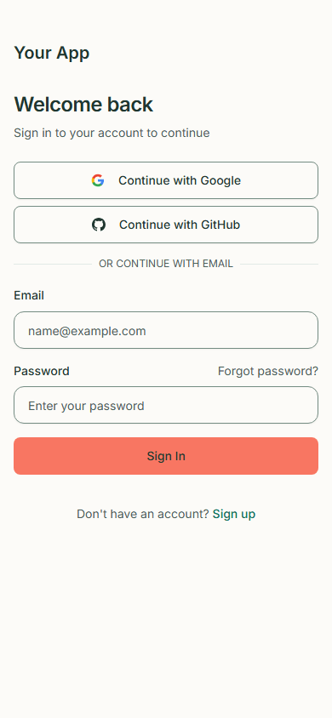  Figure 63. The sign-in page on a phone

Screen pending: needs the Firebase test project (owner action). The picture above is the sign-in form only (this build used placeholder Firebase settings). The result of a successful sign-in, the email-verification page and the Google and GitHub pop-ups have no screenshot, because no Firebase project was available and the guide does not use anyone's real credentials.

Step 2. Open the admin area
- Open the account menu on your dashboard (the round button with your picture or initial). If your account is an admin, the menu has an Admin link. You can also type /admin after the Freejoy address. There is no link to the admin area on the public site, and ordinary accounts do not see the Admin link.
- What happens depends on who you are:
You are... | What you see
Not signed in | The sign-in page, with ?redirect=/admin added to the address. Sign in (password, Google or GitHub, and the two-factor code if you use one) and you come back to /admin and go through the checks in the rest of this table. Pressing Back to sign in on the code step and signing in again keeps the return too
Signed in, email not verified | The Verify your email page
Signed in as an ordinary user (not an admin) | Your own dashboard (an account page with Overview, Billing, Settings, Profile and Security)
Signed in and the system no longer accepts your session | The session is cleared and you go back to sign in
An admin | The admin shell, below

The return address only works for pages of the Freejoy site. If the address in ?redirect= is anything else (another website, the sign-in pages themselves, or a technical address), it is ignored and you land on your dashboard. Only the page path is remembered, not anything after a ? such as a search or a page number. An ordinary account that returns to /admin is sent on to its own dashboard.
Screen pending: needs the Firebase test project (owner action). The return after sign-in has no screenshot, for the same reason as the sign-in result above.

Step 3. Find your way around the admin shell
On a desktop screen (900 pixels wide or more) the shell has:
- A dark sidebar on the left with the site name ("Freejoy") and the word ADMIN. The name is the one the site is configured with, so it follows the site name. (The screenshots below were taken before the sidebar showed the site name and still read "Your App".)
- The sidebar links, in this order: Dashboard, Freebies, Categories, Merchants, Users, Subscriptions, Analytics, SEO, Settings, Audit Logs. The page you are on is highlighted.
- A header with your role badge (for example "Super Admin") and a round account button.
- The page itself, to the right.
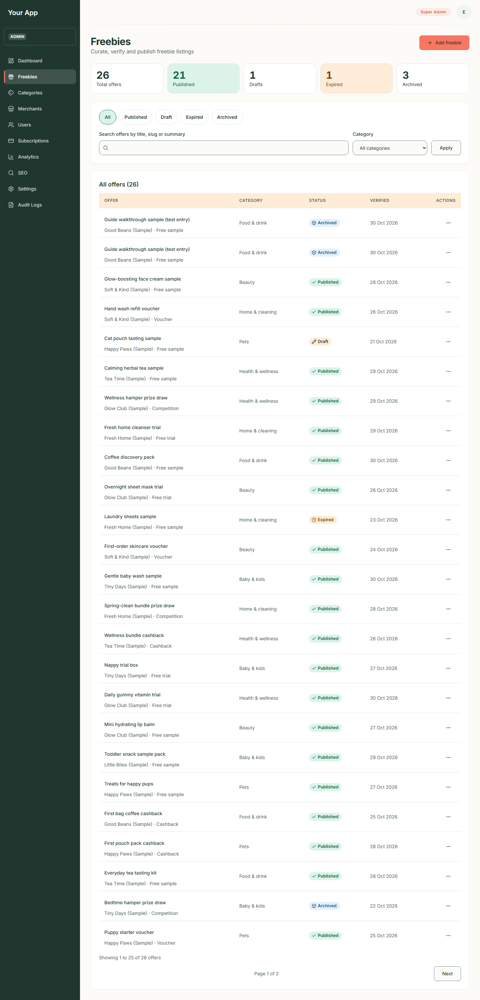
Figure 64. The admin shell on a desktop screen

The account menu
Click the round account button (it shows your initial). The menu shows your name and email, Back to Dashboard and Logout.
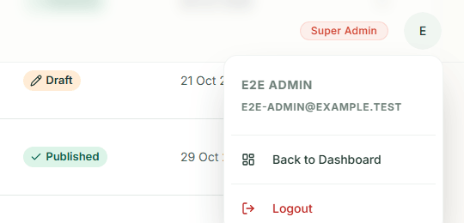
Figure 65. The account menu
Logout ends your session and returns you to the sign-in page.

On a phone
Below 900 pixels wide the sidebar is hidden.
- The header shows Admin (a link to the admin home), your role badge and the account button.
- A tab bar at the bottom has Dashboard, Freebies, Categories and More.
- Tap More to open a panel with the rest: Merchants, Users, Subscriptions, Analytics, SEO, Settings and Audit Logs.
Figure 66. The admin freebies list on a phone
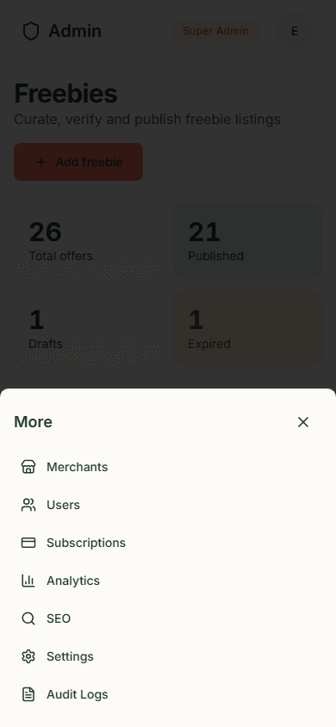
Figure 67. The More panel on a phone

Step 4. The Dashboard
Dashboard (/admin) is not built yet. It shows the heading "Admin Dashboard" with "Platform metrics are not available yet" and a panel Not available yet: "This page is switched off until its backend service is ready. Nothing is lost: it will return in a later release." The Go to Users button takes you to the user list.
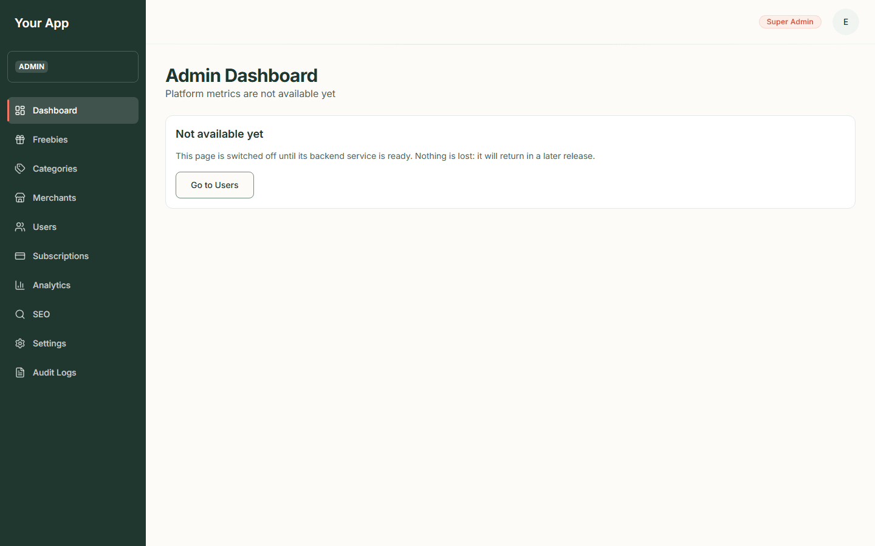  Figure 68. The Dashboard page | Phone:  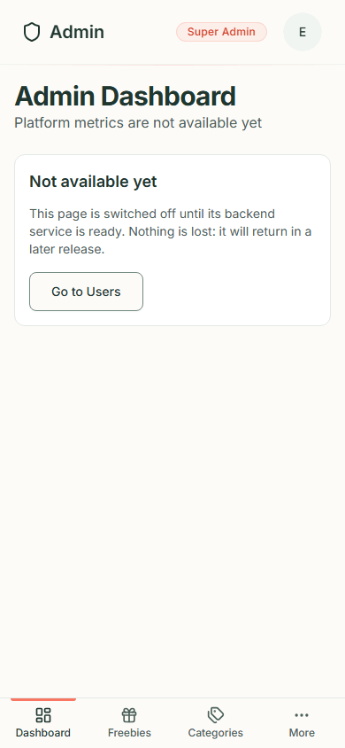  Figure 69. The Dashboard page on a phone

Tips for every admin page
- Use Skip to main content (press Tab once) to jump past the sidebar.
- Reports can be reloaded with the Refresh button where one is shown.
- If a page shows a red panel with Retry, the backend could not be reached. Nothing is lost; try again.
- Dates in the admin area are shown in UTC (for example "30 Oct 2026, 08:57 UTC").

Admin 2. Offers (freebies)
Back to the guide index
Freebies in the sidebar (/admin/offers) is where offers are created, checked, published and retired. Nothing reaches the public site until an admin has verified and published it. (The brands and offers in the screenshots are sample data, and the list includes two archived "Guide walkthrough sample (test entry)" items made while writing this guide: see the index.)

What the statuses mean
Status | Colour | On the public site? | What it means
Draft | Orange | No (the address gives "page not found") | Being written, or taken down. Every new offer starts here
Published | Green | Yes | Live in the catalogue, on its own page and in search
Expired | Orange | Shows the "This offer has ended" page for 30 days, then "page not found" | The offer is over, or you ended it. It can be published again
Archived | Blue | No | Retired for good. Cannot be edited, verified or published, and there is no un-archive button

Which actions each status allows:
Current status | Mark verified | Publish | Unpublish | Expire | Archive
Draft | yes (stays Draft) | yes | - | - | yes
Published | yes | - | yes (goes to Draft) | yes | yes
Expired | yes | yes (goes to Published) | - | - | yes
Archived | - | - | - | - | -

Step 1. Open the list
- Click Freebies in the sidebar (or the Freebies tab on a phone).
- At the top, a strip of numbers shows Total offers, Published, Drafts, Expired and Archived. Each number is counted live, and the total is their sum.
- Under it are the status chips, the search box and the category filter, then the table.
- The table columns are Offer (title, with the brand and offer type underneath), Category, Status, Verified (the date it was last checked, or "Not verified") and Actions.
Figure 70. The offers list on a desktop screen
On a phone each row becomes a card and every value names its column:
Figure 71. The offers list on a phone

Step 2. Search and filter
- Click a status chip (All, Published, Draft, Expired, Archived) to show only that status. The current chip is marked as the current page.
- To search, type in Search offers by title, slug or summary and press Apply.
- To narrow by category, pick one in Category and press Apply.
- The filters combine and the address updates, so you can bookmark a view. Searches are limited to 100 characters.
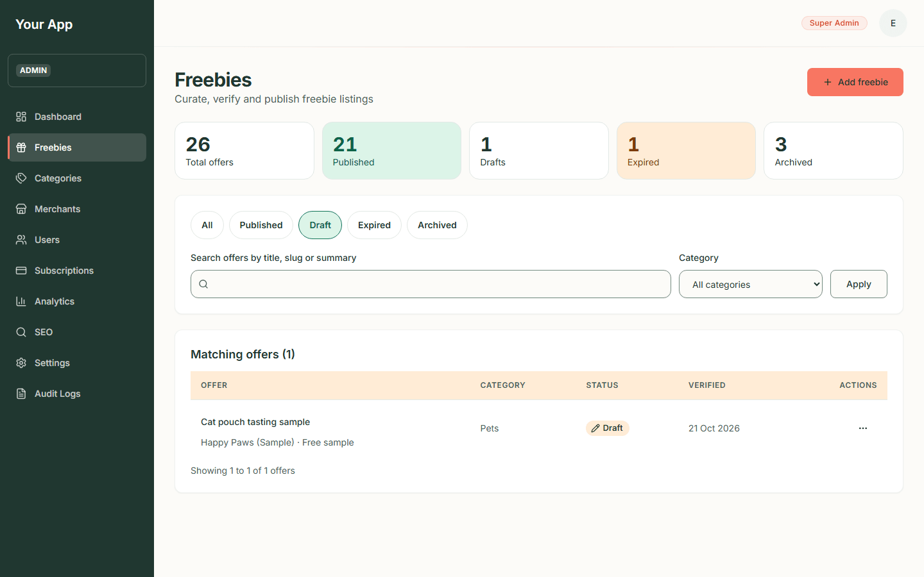
Figure 72. Draft offers only
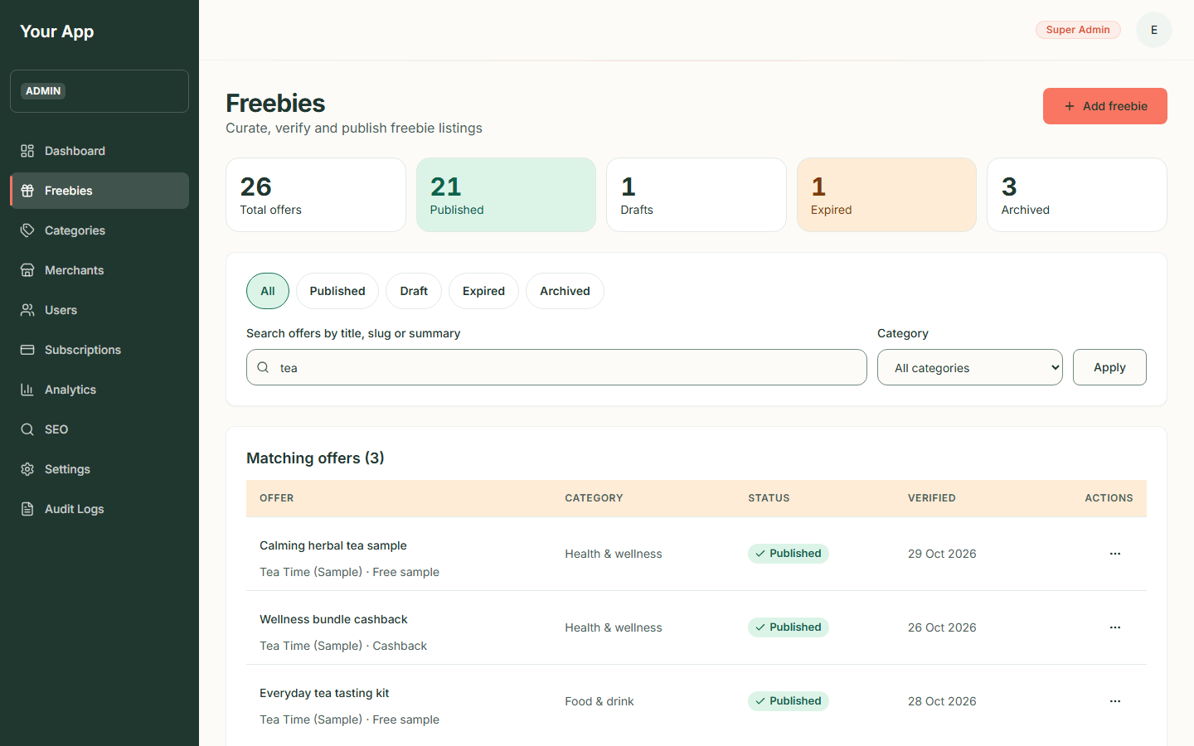
Figure 73. A search for tea
Phone:
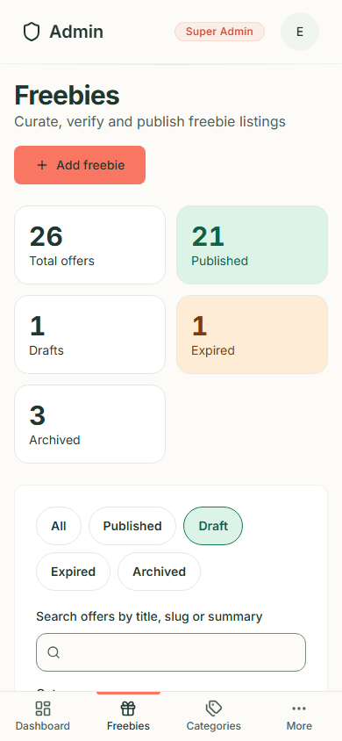
Figure 74. Draft offers on a phone
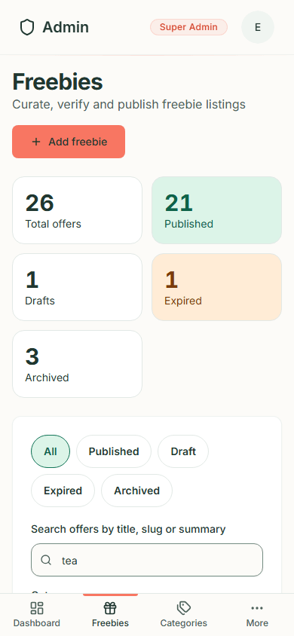
Figure 75. A search for tea on a phone
The list is paged, 25 offers at a time: a line such as "Showing 26 to 50 of 61 offers" and Previous / Next links appear under the table.

Step 3. Use a row's menu
- In the Actions column click the three dots (named "Open menu for offer title").
- The menu starts with Edit, then lists the steps the offer's status allows: Mark verified, Publish or Unpublish, Expire and Archive (in red).
- Archive asks you to confirm first (see Step 9). The other actions happen at once and a message appears.
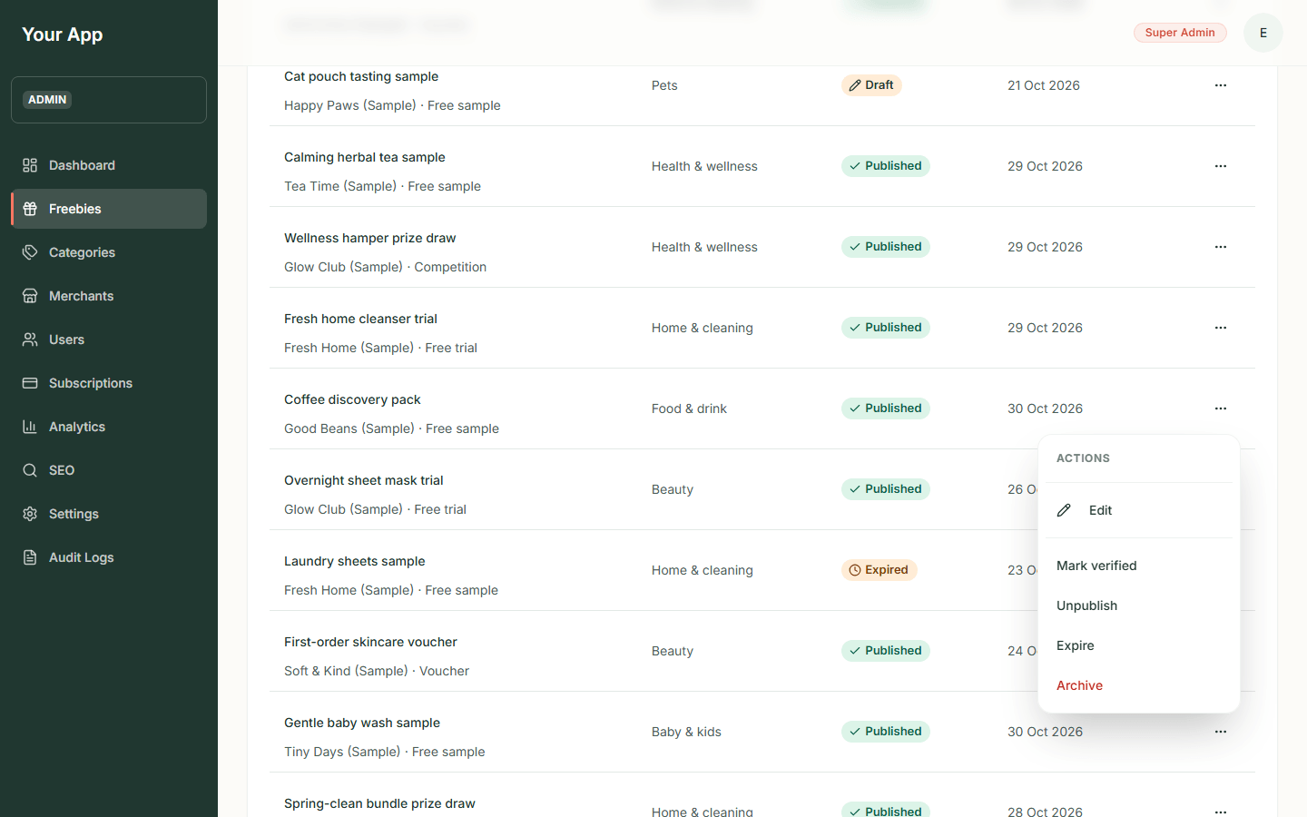  Figure 76. A row menu on a desktop screen | Phone:  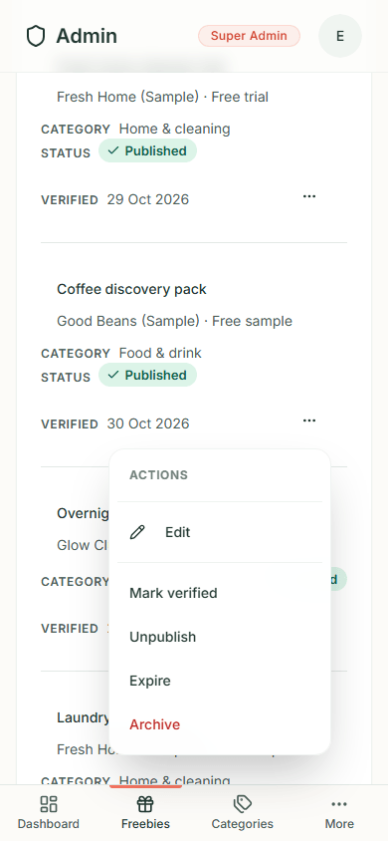  Figure 77. A row menu on a phone

If the menu is out of date (someone else changed the offer a moment ago), the action is refused with a message and nothing is changed.

Step 4. Add a new offer
- Click Add freebie (top right of the list). The page says "A new offer starts as a draft. Verify it, then publish it, to put it on the site."
- Fill in the form, which is in sections. Fields with a red star are required.
Section | Fields
Basics | Title*, Slug (the web address of the page; leave blank to use the title; it cannot be changed later), Summary*, Description (separate paragraphs with a blank line, up to 20)
Category and merchant | Category*, Merchant*, Offer type* (Free sample, Free trial, Cashback, Voucher, Competition), Freshness label (None, New today, Just added, Popular, Ends soon, Limited: an editor's label, never worked out from dates. Only New today and Just added are shown to visitors; Popular, Ends soon and Limited are saved but hidden on the public site), Featured on the home page
Picture | Picture tint* (Blush, Mint, Lavender, Sky, Butter, Cream, Sage, Sand), Picture label* (short text drawn on the illustration), Picture description* (text for people who cannot see the picture)
Terms and claiming | Postage* (Free postage, Postage costs money, Check the terms; with a Postage cost (GBP) box when it costs money), Needs a payment card to claim, Subscription terms, Who can claim*, Availability*, Source URL (the merchant's own page)
How to claim | Add a step: each step has a Step title and Step detail; steps can be removed
Schedule and notes | Starts (UTC), Ends (UTC) (optional), Publisher notes (for admins only, never shown to visitors)

- Press Create draft. If something is missing, each problem is written beside its field, the first problem field is focused, and the button stays on the page.
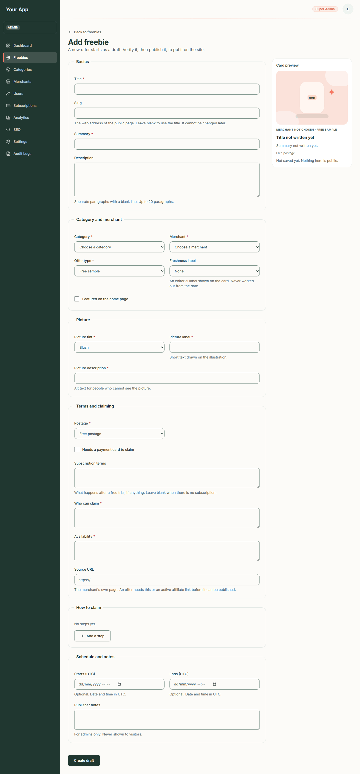
Figure 78. The empty Add freebie form
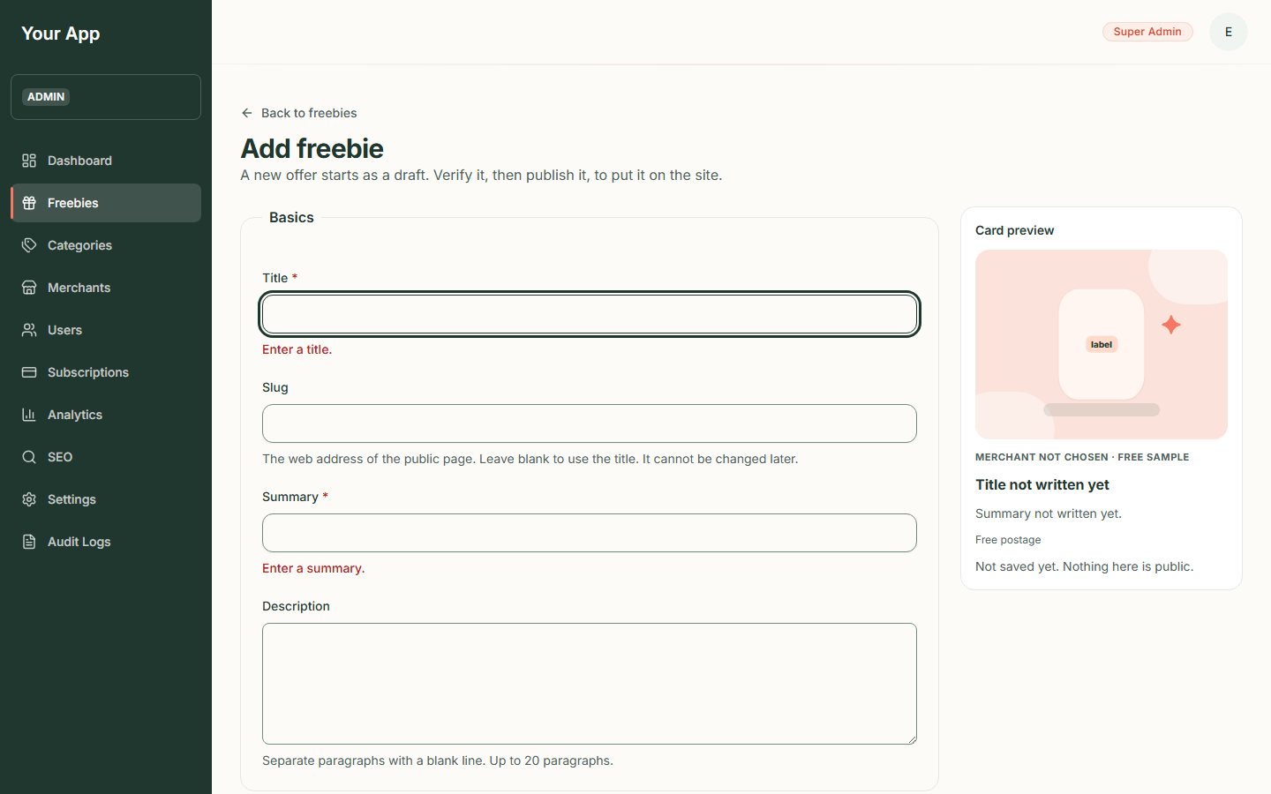
Figure 79. The form with its error messages
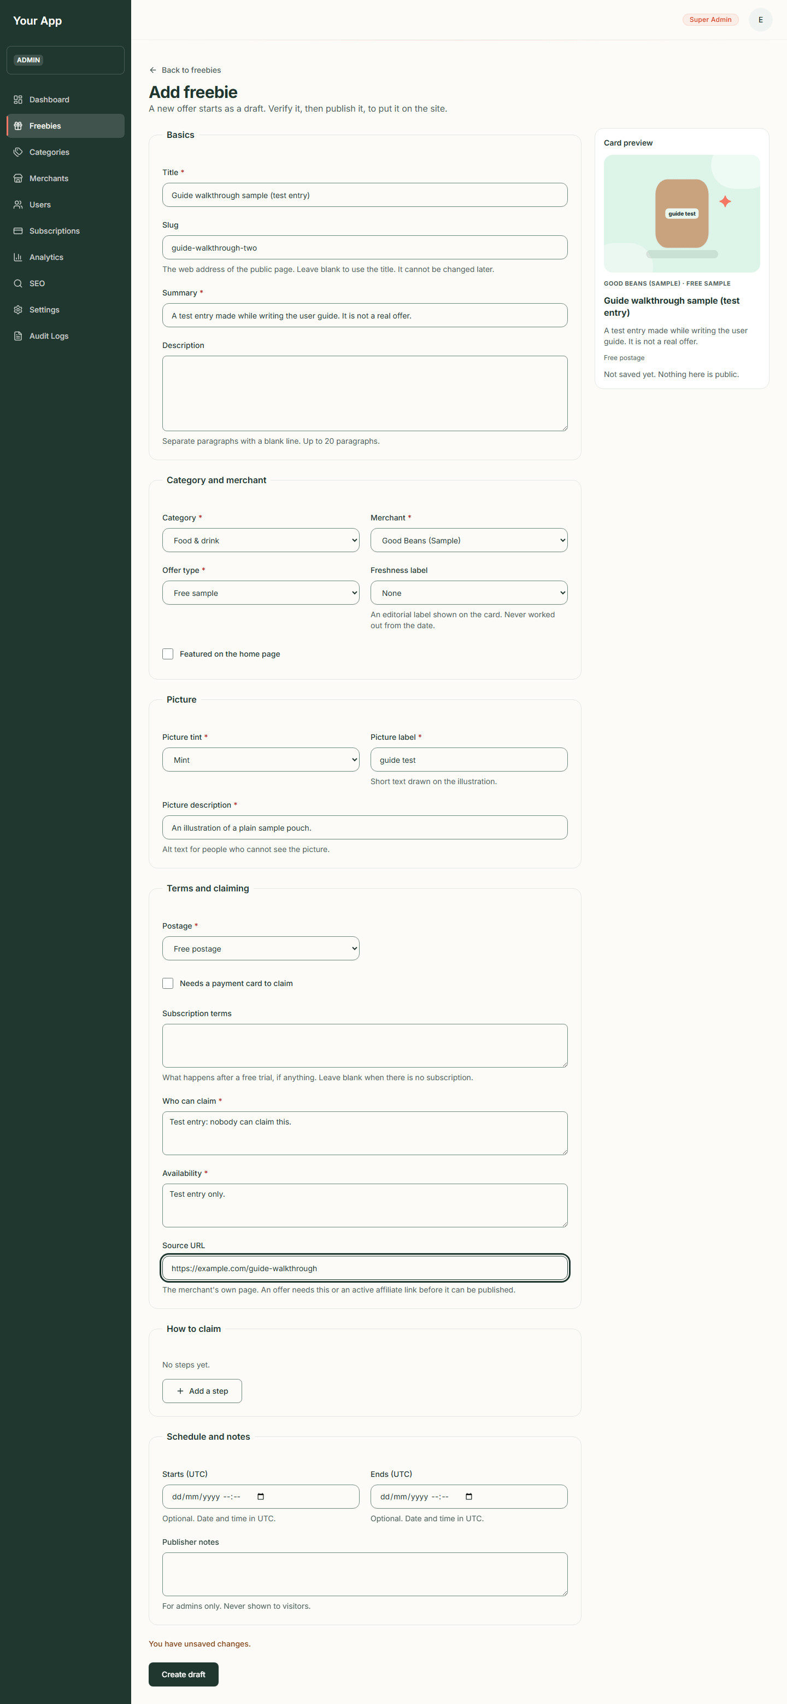
Figure 80. A completed form
- When it works you land on the new offer's editor page with status Draft.
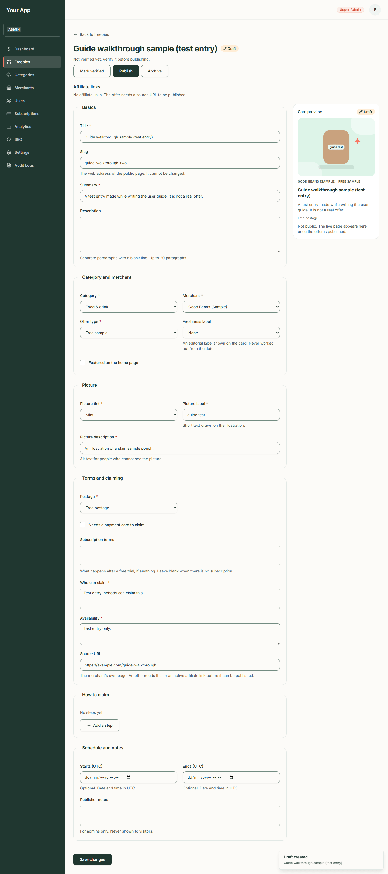
Figure 81. A new draft in the editor
Notes:
- Times are entered in UTC, and the form says so. Use the Ends (UTC) date for offers with a closing date.
- A card preview on the right is drawn from the form as you type and is labelled "Not public".
- The Postage and Needs a payment card boxes feed the "POSTAGE" and "CARD REQUIRED" facts visitors see.
- Affiliate links are shown on the editor page (read only). Creating them is not possible from these screens yet (see "Not in the admin screens" at the end).

Step 5. Edit an offer
- In the list click the offer's title (or Edit in the row menu).
- Change what you need. The slug and status cannot be changed here.
- Press Save changes. A "Changes saved." message appears. While you have unsaved edits the form says "You have unsaved changes." and your browser asks before you close the tab.
- Saving a published offer updates the public page straight away.
The status buttons at the top (Mark verified, Publish and so on) act on the last saved version of the offer, so while you have unsaved edits they wait and say why. Save first.
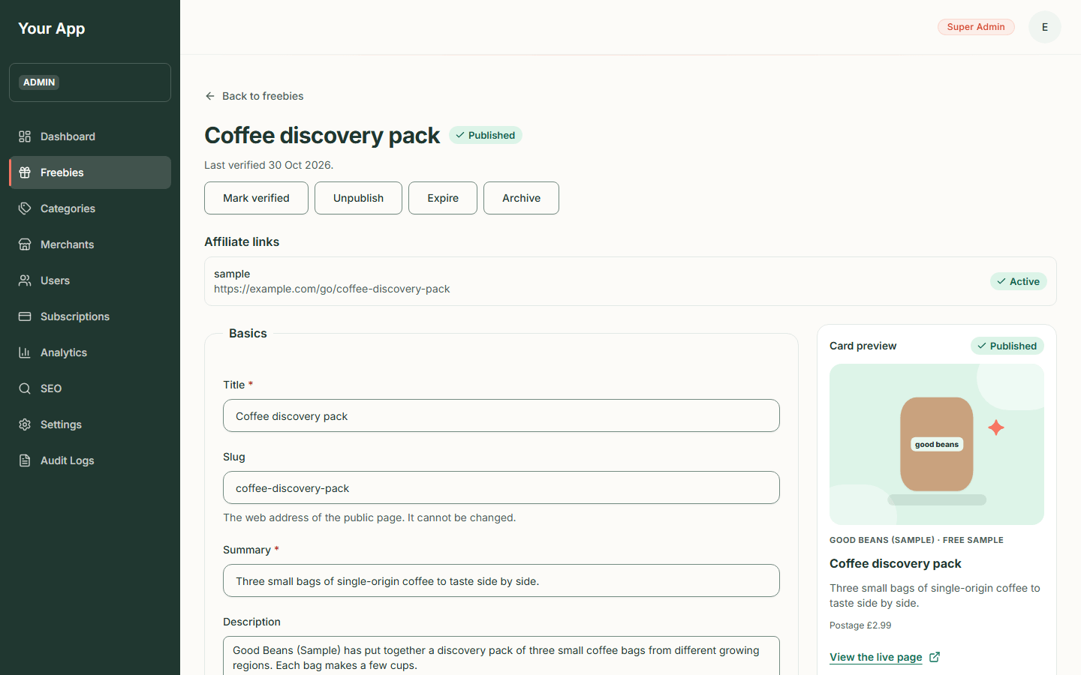
Figure 82. A published offer in the editor on a desktop screen
Phone:
Figure 83. A published offer in the editor on a phone

Step 6. Verify the offer ("Last checked")
Visitors see "Last checked date" on every offer, so this step is a promise that someone looked.
- Check the offer on the brand's own page: type of offer, postage, card needed, who can claim.
- On the editor page press Mark verified (or use the row menu).
- A message "Offer marked as verified" appears, and the line under the title reads "Last verified today's date."
Publishing does not do this for you. Verify first, every time you re-check an offer.
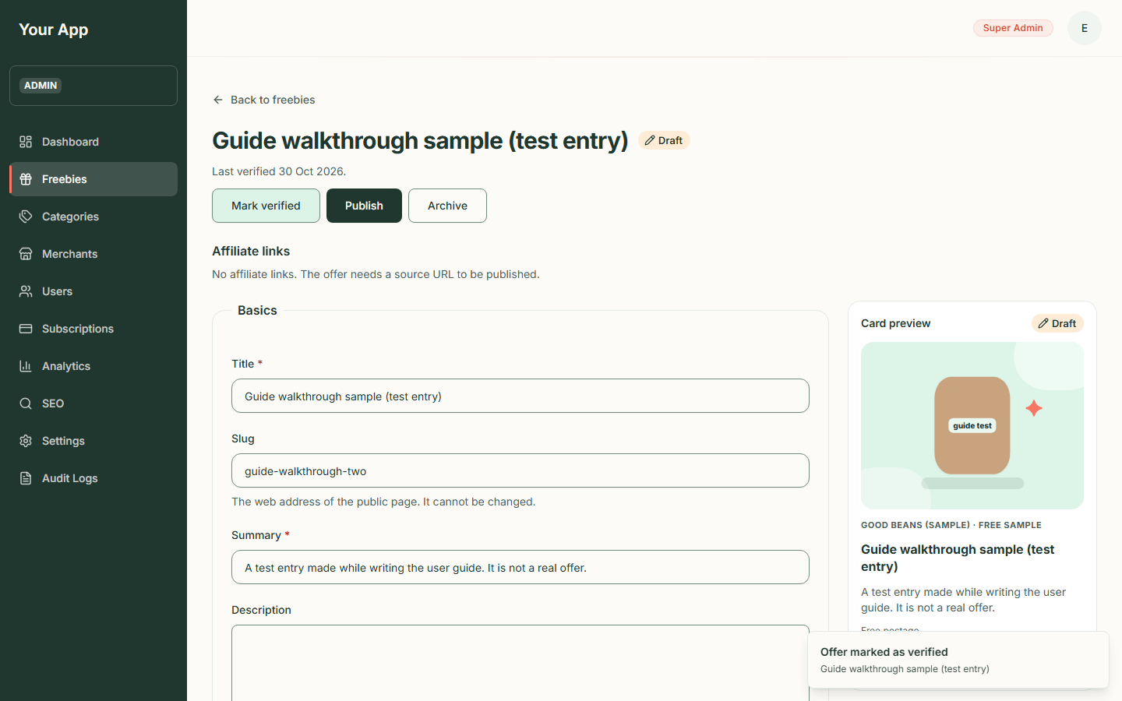
Figure 84. After Mark verified

Step 7. Publish
- Press Publish.
- Freejoy checks that: the category is enabled, the merchant is active, the offer has a Source URL or an active affiliate link, the end date is not in the past, and the offer has been verified.
- If any rule fails you get a red message such as "Could not publish - This offer cannot be published yet: it has not been verified." and the offer stays as it was. Fix the cause and try again.
- When it works the status turns Published, a message "Offer published" appears, and a link View the live page (opens in a new tab) appears in the card preview.
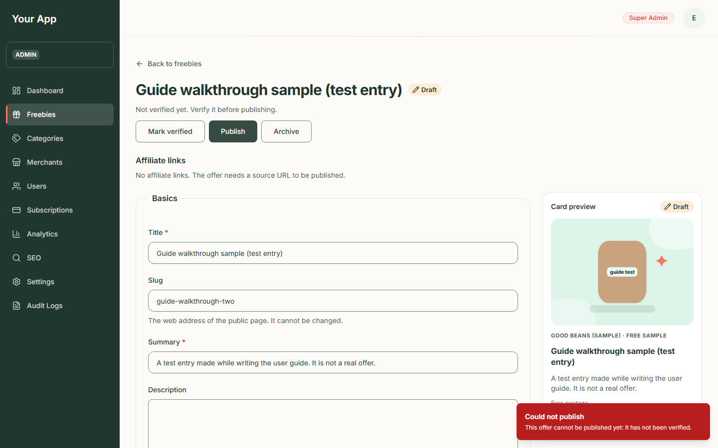
Figure 85. A refused publish
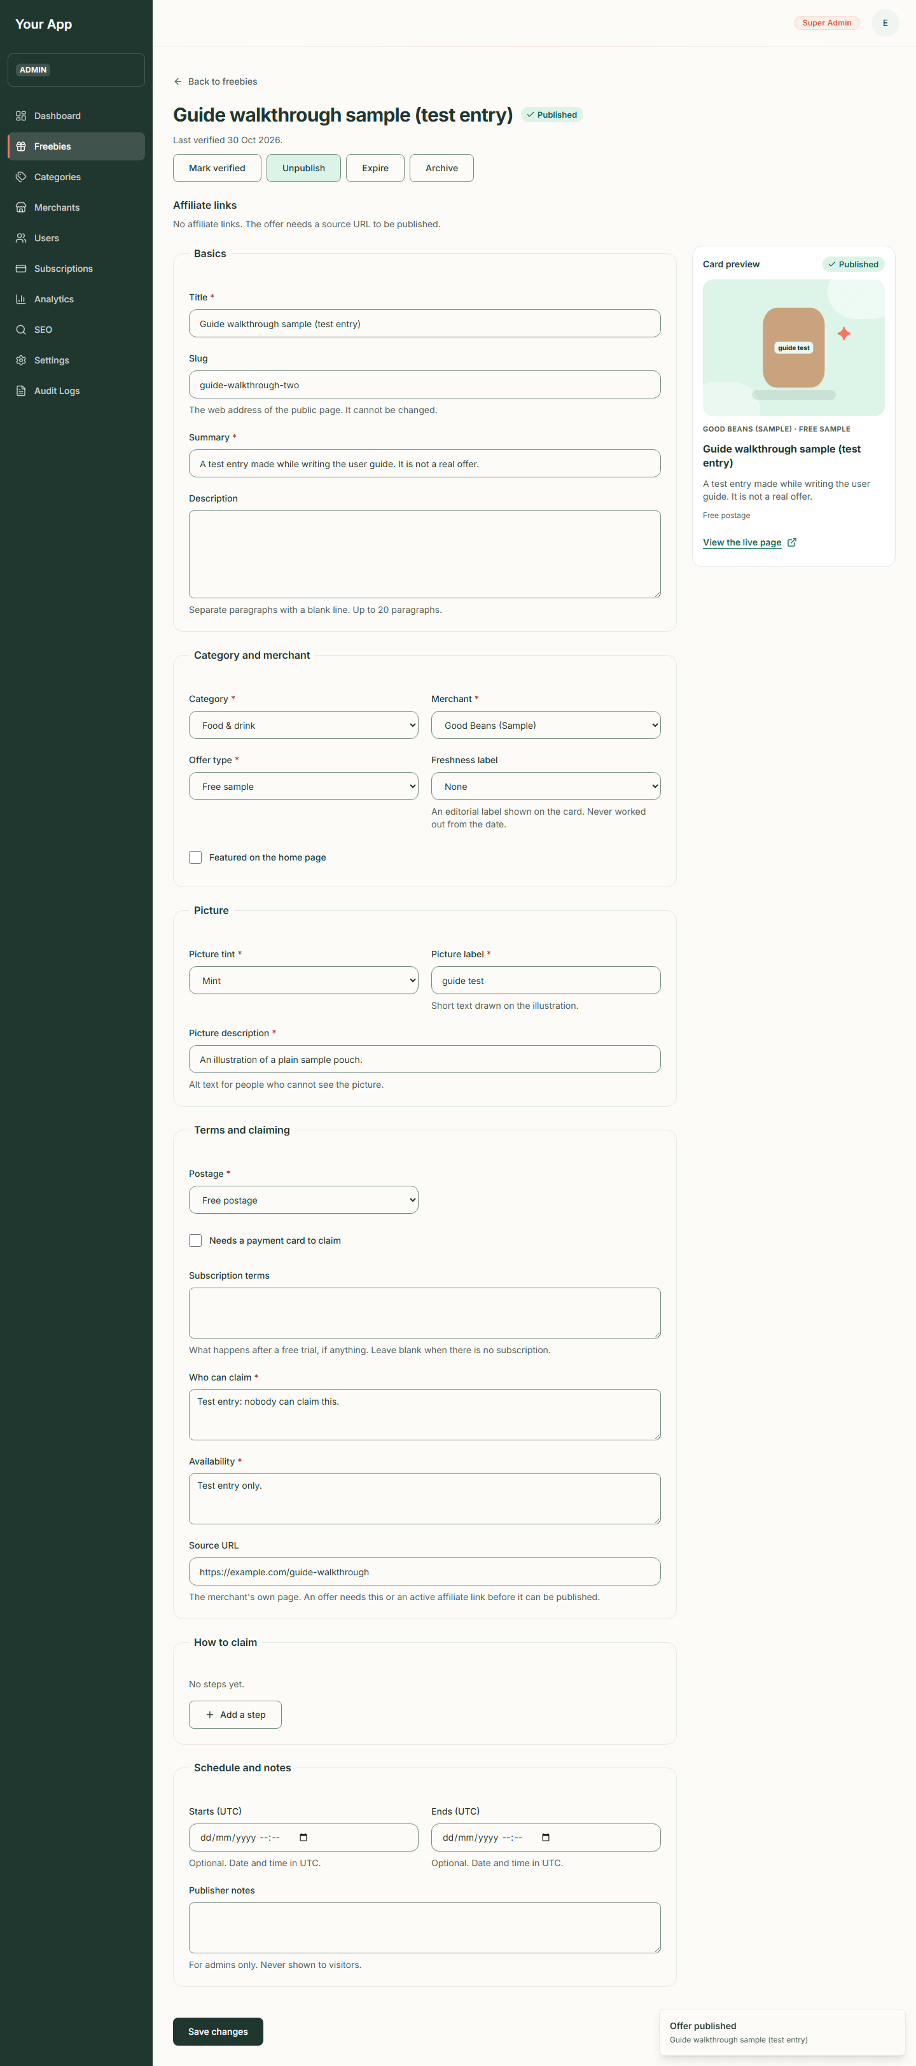
Figure 86. A published offer
- Open the live page to check it. This is how the offer now looks to visitors (it is the test entry made for this guide):
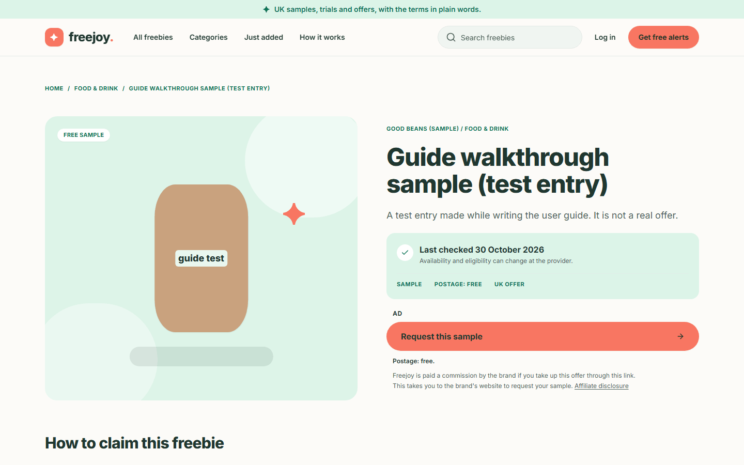
Figure 87. The offer on the public site

Step 8. Unpublish or expire
- Unpublish takes a published offer back to Draft. Its public address stops working at once.
- Expire marks a published offer as over. Visitors see the "This offer has ended" page for 30 days, and claim links for it send them there. An expired offer can be published again after you check it.
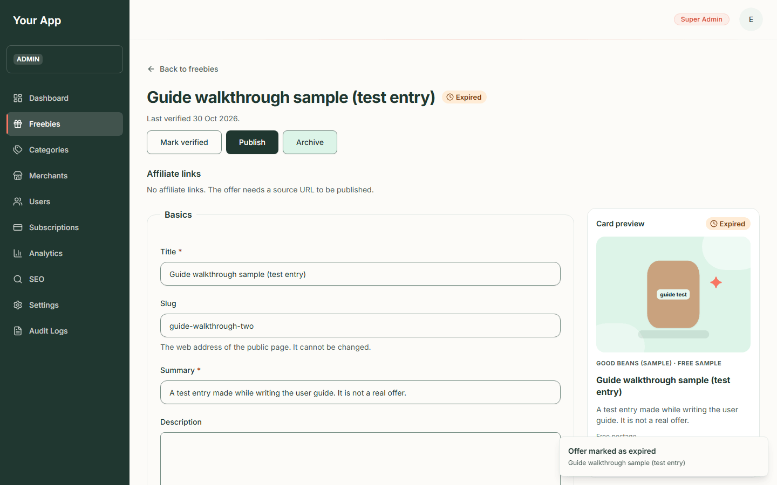
Figure 88. An expired offer

Step 9. Archive
- Press Archive.
- A box asks "Archive this offer?" and explains that the offer "will leave the public site and can no longer be edited, verified or published. Archiving cannot be undone from the admin."
- Press Archive offer to confirm (or Cancel).
- The page now says "This offer is archived and cannot be changed."
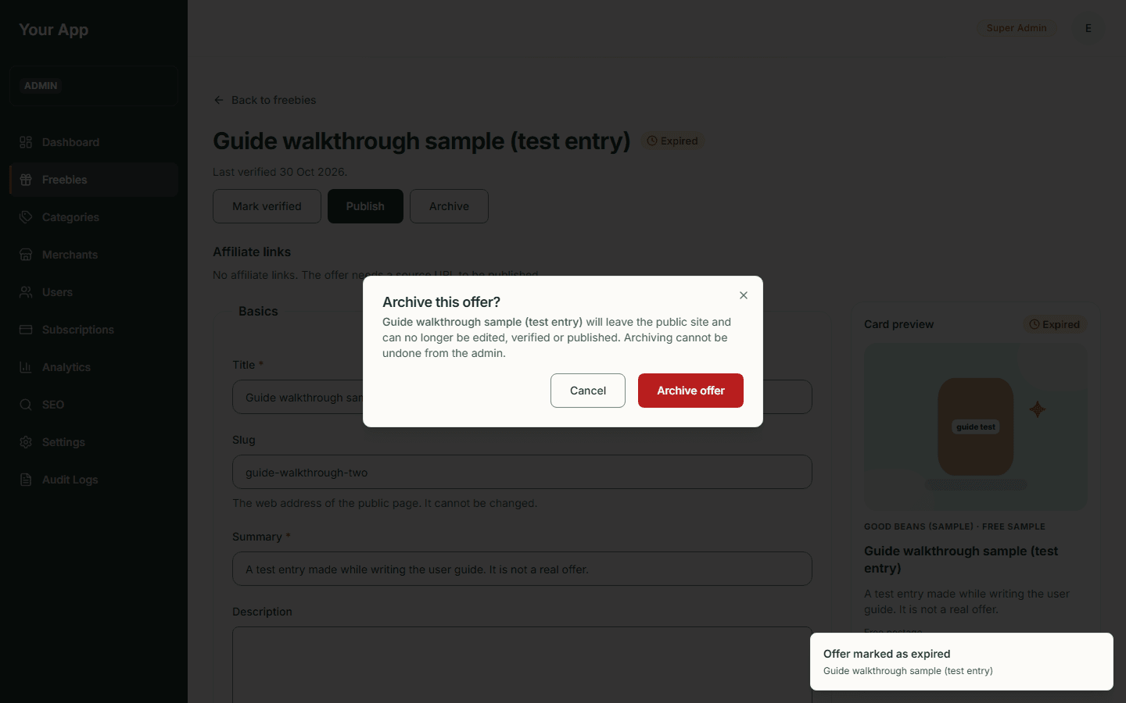
Figure 89. The archive confirmation
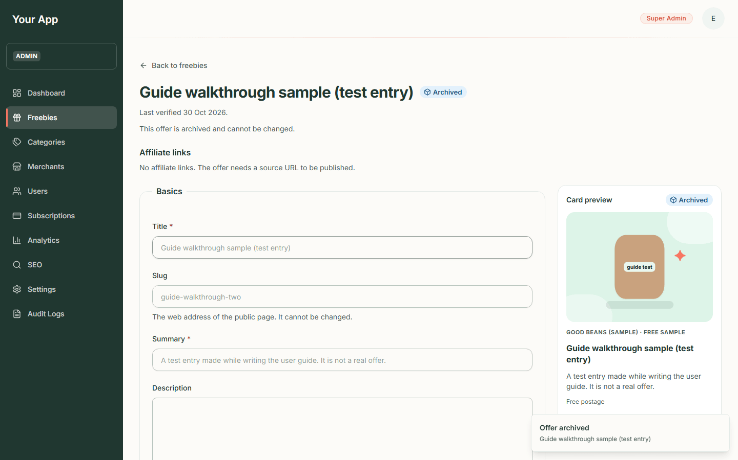
Figure 90. An archived offer

Things to know
- Disabling a category or deactivating a merchant does not unpublish its offers, but visitors stop seeing them. The admin list can therefore show Published offers that the public site hides.
- An offer that has passed its end date is not unpublished automatically. Expire it yourself.
- Two admins editing at once: the last save wins.
- Every change here is written to the audit log with who and when.

Not in the admin screens
These exist in the backend but have no screen yet: creating or switching off affiliate links, un-archiving an offer, and a "Needs review" count.

Admin 3. Categories and merchants
Back to the guide index
Every offer belongs to one category (such as Food & drink) and one merchant (the brand behind it). Both are managed here. (The categories and merchants in the screenshots are the project's sample data: every merchant name ends "(Sample)" and every website is a placeholder on example.com.)
You need the categories.write permission to change categories and merchants.write to change merchants. Anyone who can open the admin area can look at the lists.

Part A. Categories

Step 1. See the categories
- Click Categories in the sidebar (or the Categories tab on a phone).
- The page explains: "Group freebies on the public site. A disabled category and its offers are hidden."
- The table shows Name (with a one-line description), Slug (the web address part), Order (lower numbers come first), Status (Enabled or Disabled), Updated and Actions (Edit and a Disable or Enable button).
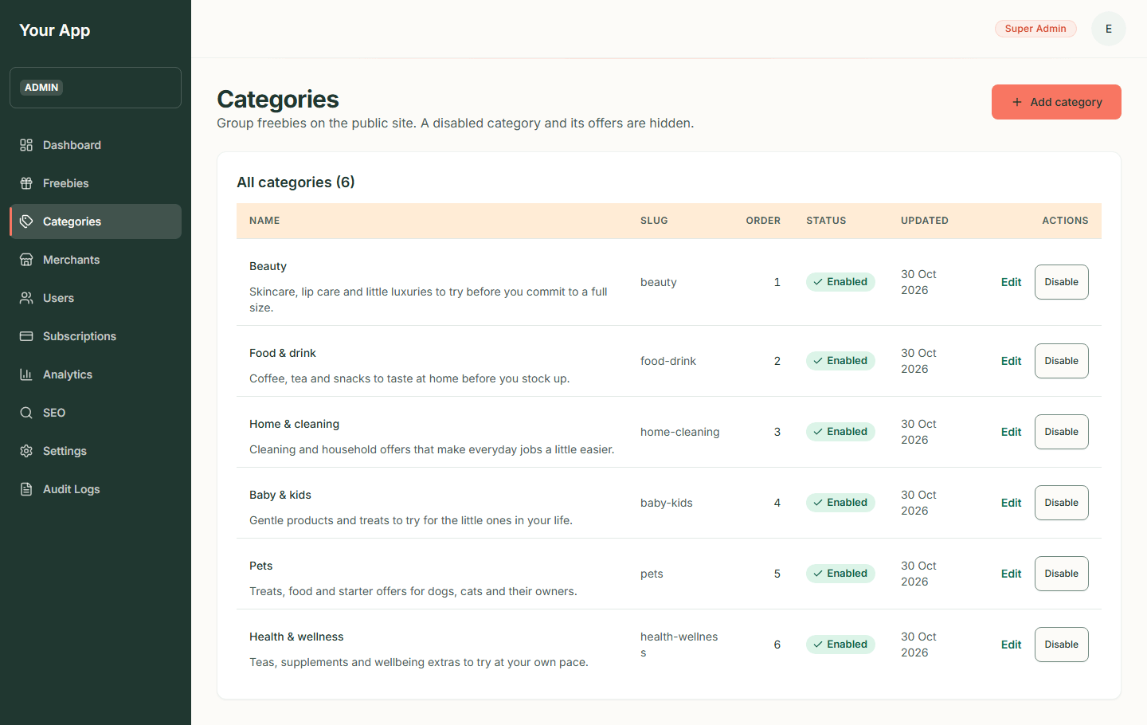
Figure 91. The categories list
Phone:
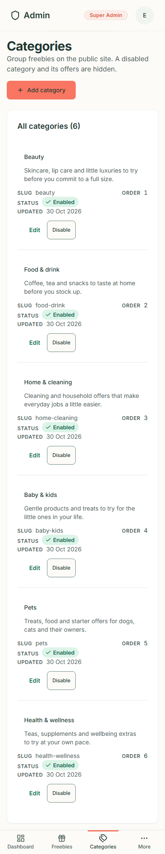
Figure 92. The categories list on a phone

Step 2. Add a category
- Click Add category.
- Fill in the form:
- Name*: the full name, for example "Food & drink".
- Slug: the web address of the category page. Leave it blank to make one from the name. It cannot be changed later.
- Short name*: used on chips and the phone grid.
- Description*: one sentence for cards and search results.
- Introduction*: the text at the top of the category's public page.
- Tint*: one of Blush, Mint, Lavender, Sky, Butter, Cream, Sage, Sand.
- Sort order*: a number; lower comes first.
- Enabled (visible on the public site): tick it to show the category straight away.
- Press Create category. Problems (a missing field, a slug that is already used) appear beside the field.
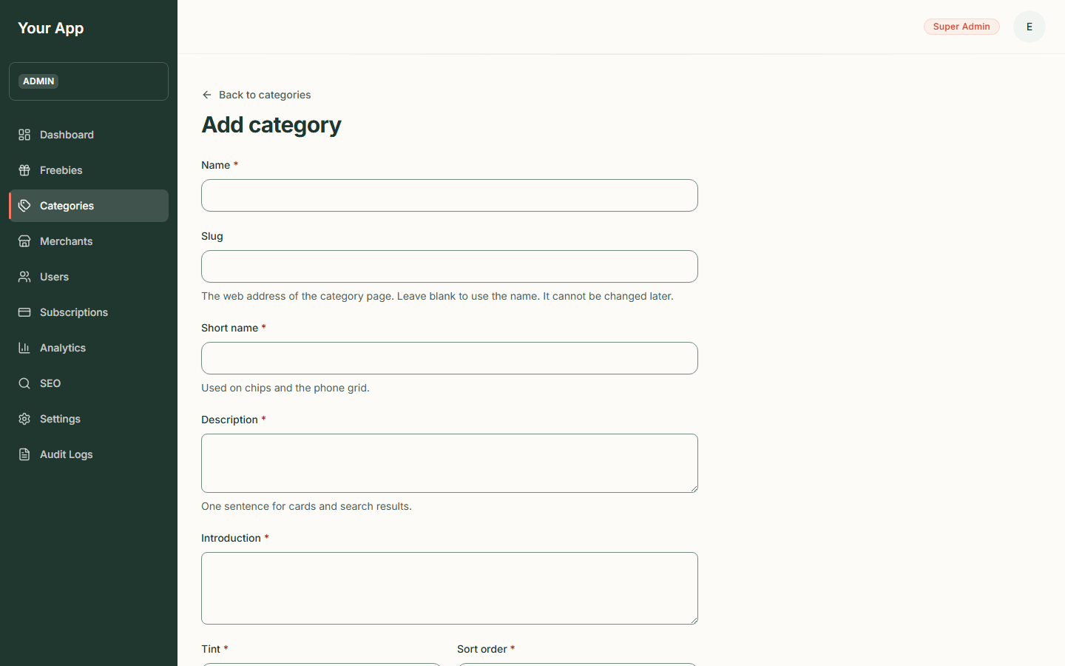  Figure 93. The Add category form | Phone:  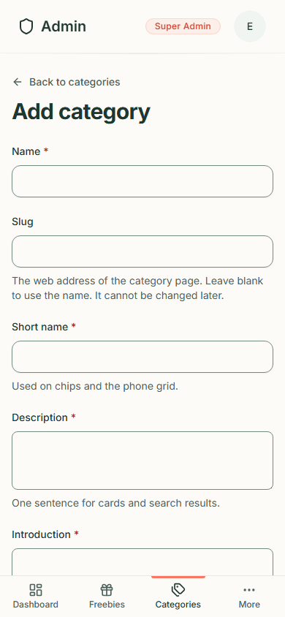  Figure 94. The Add category form on a phone

Step 3. Edit a category
- In the list, click Edit on the row.
- Change the fields (the slug is locked: "It cannot be changed.") and press Save changes.
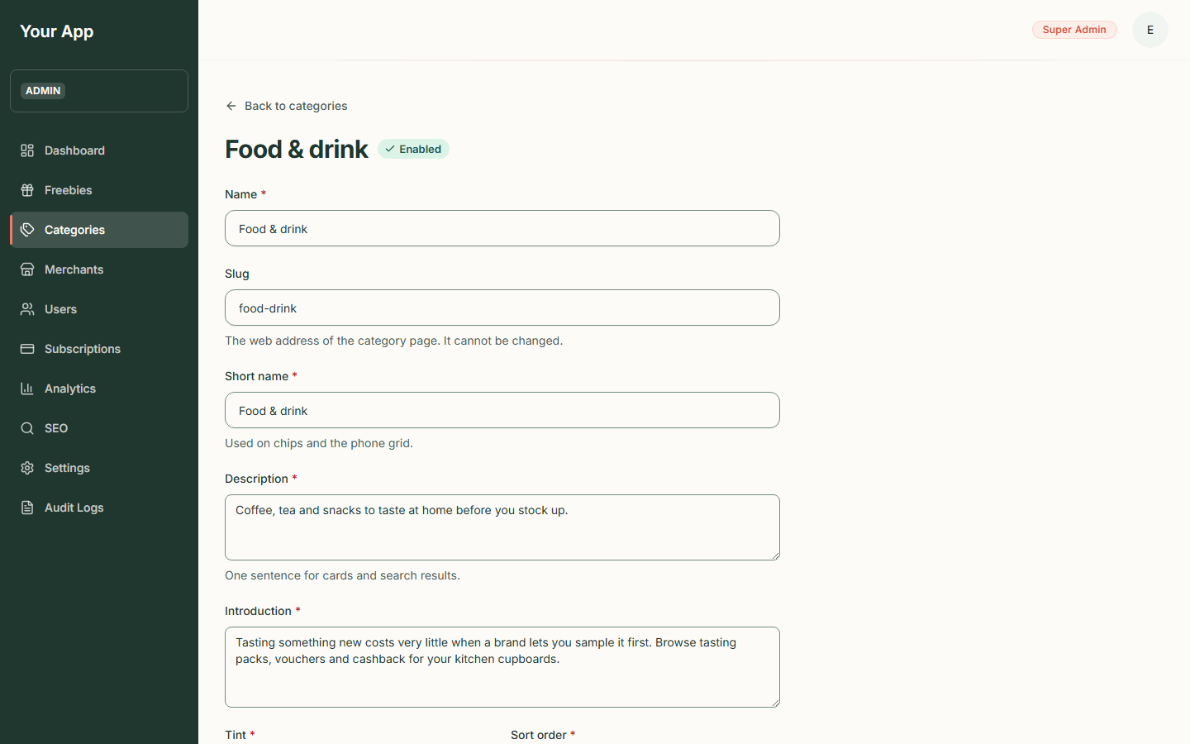  Figure 95. Editing a category | Phone:  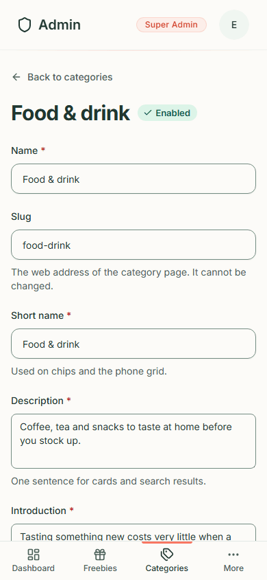  Figure 96. Editing a category on a phone

Step 4. Disable or enable a category
- Click Disable on the row. It happens at once (there is no confirmation) and a message such as "Pets disabled" appears. The row turns orange and the button becomes Enable.
- On the public site the category page now gives "page not found", and the category's offers no longer appear in the catalogue, search or home page.
- Click Enable to bring it back.
The offers inside a disabled category keep their status: they stay Published in the admin list but visitors cannot see them. A category must be enabled before an offer in it can be published.
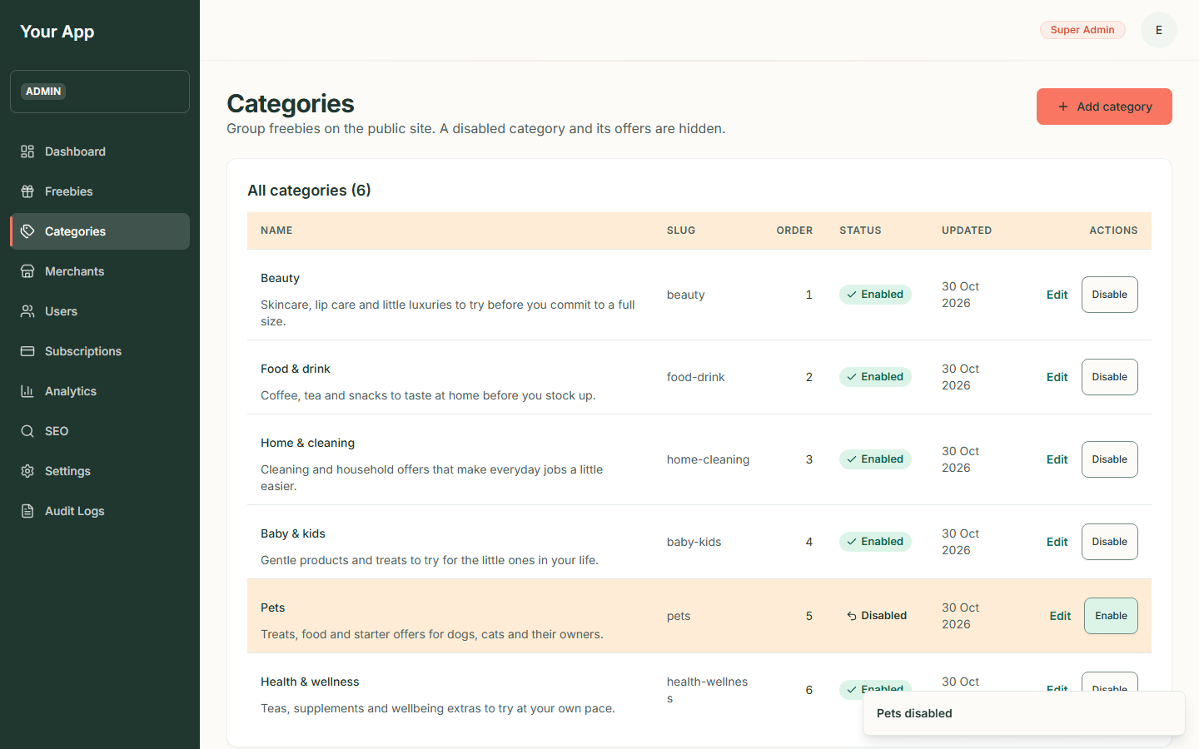
Figure 97. A disabled category

Part B. Merchants

Step 5. See the merchants
- Click Merchants (under More on a phone).
- The page explains: "The brands behind each freebie. An offer can only be published for an active merchant."
- The table shows Name, Slug, Website, Status (Active or inactive), Updated and Actions (Edit and Deactivate or Activate).
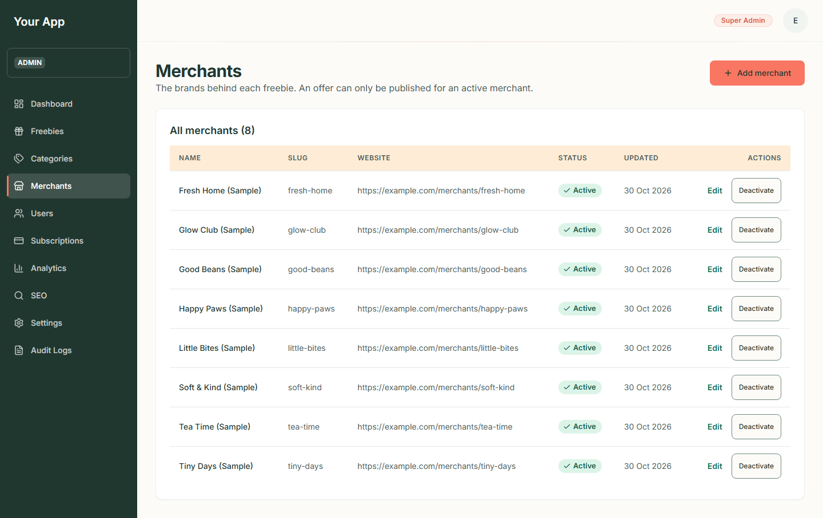
Figure 98. The merchants list
Phone:
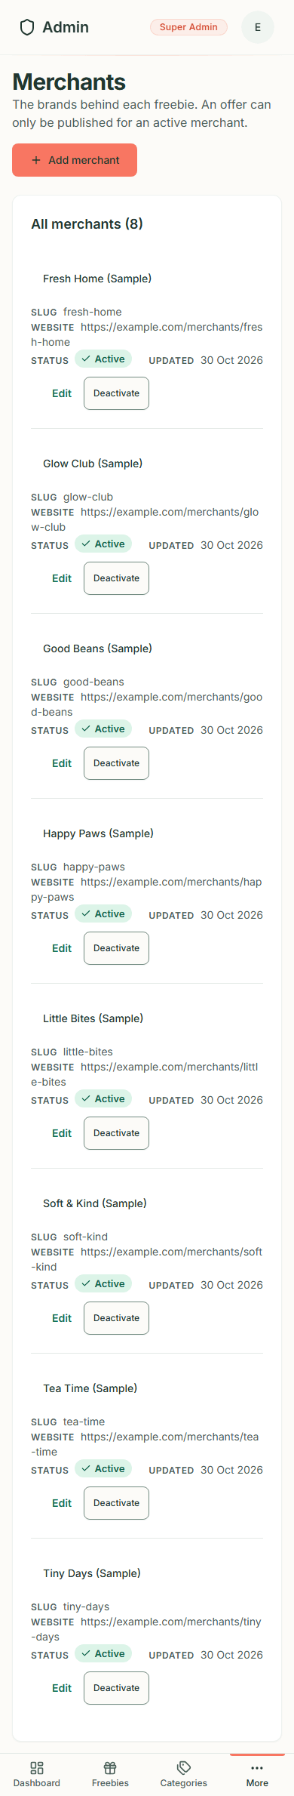
Figure 99. The merchants list on a phone

Step 6. Add a merchant
- Click Add merchant.
- Fill in the form: Name*; Slug (leave blank to use the name; it cannot be changed later); Website (optional, a full https:// address); Logo address (optional, a full https:// address of a logo you are licensed to use); and Active (its offers can be published).
- Press Create merchant. Web addresses must be https and look like normal website addresses.
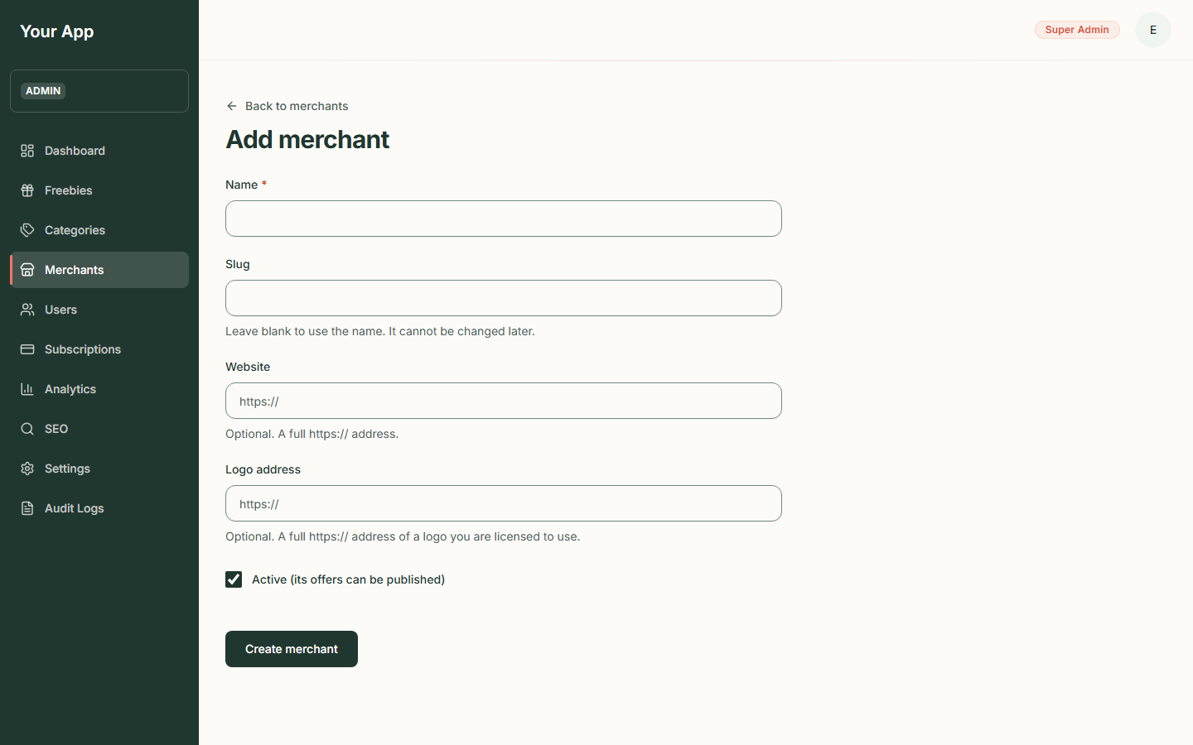  Figure 100. The Add merchant form | Phone:  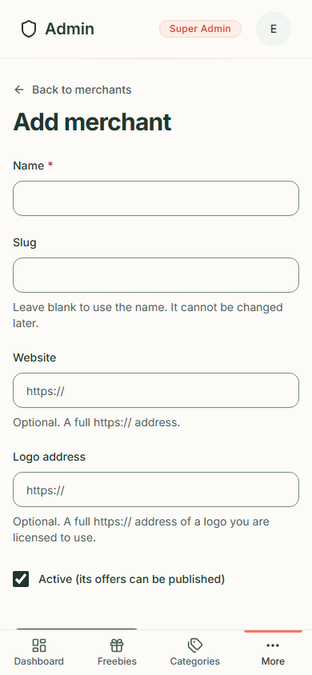  Figure 101. The Add merchant form on a phone

Step 7. Edit, deactivate or activate a merchant
- Click Edit, change the details and press Save changes (the slug is locked).
- Click Deactivate to switch a merchant off. Its offers stop appearing to visitors and cannot be published until you press Activate. As with categories, there is no confirmation and a message tells you what happened.
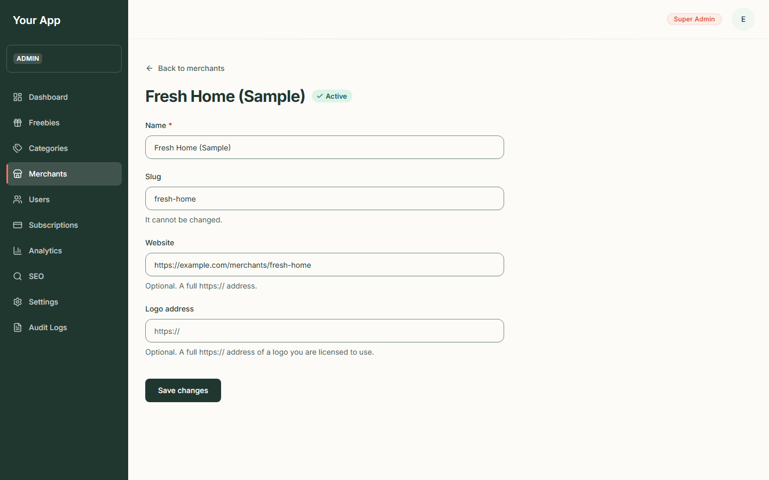  Figure 102. Editing a merchant | Phone:  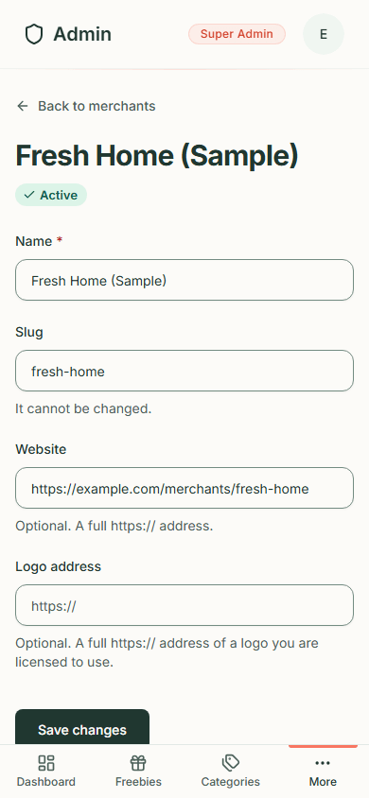  Figure 103. Editing a merchant on a phone

Things to know
- Only the first 100 categories and merchants are listed and offered in the offer form. If a catalogue ever grows past that, the page says "Showing the first N of M".
- Disabled categories and inactive merchants are marked as such in the offer form's drop-downs, so a refused publish is not a surprise.
- Every change is recorded in the audit log.
- The public alerts sign-up form lists the categories the public catalogue has, so an enabled category appears there too and a disabled one does not.

Admin 4. Users and two-factor sign-in
Back to the guide index
Users in the sidebar lets an admin look people up, edit their profile details, and suspend or restore their access. Deleting accounts and granting or removing admin roles are not on these screens yet. (The two accounts in the screenshots, "E2E Admin" and "E2E Plain User" on example.test addresses, are test accounts that came with the test setup. They are not real people.)
Looking people up needs the users.read permission. Editing, suspending and restoring need users.update; without it the screen answers "You do not have permission to do that". Every change is recorded in the audit log (see Admin 6).

Step 1. Open the user list
- Click Users (under More on a phone).
- The page is headed User Management: "View and manage all platform users".
- Under the search box, All Users (n) shows how many accounts there are, then a table:
Column | What it shows
User | Display name ("Not set" if none) and email address
Status | Verified (green) or Unverified (orange): whether the person has confirmed their email
Role | The admin role as a blue badge (for example Super Admin), or "User" for an ordinary account
Last sign-in | The date, or Never
Joined | The date the account was created
Actions | A three-dot menu: View Details, Edit User, Suspend User and Restore Access

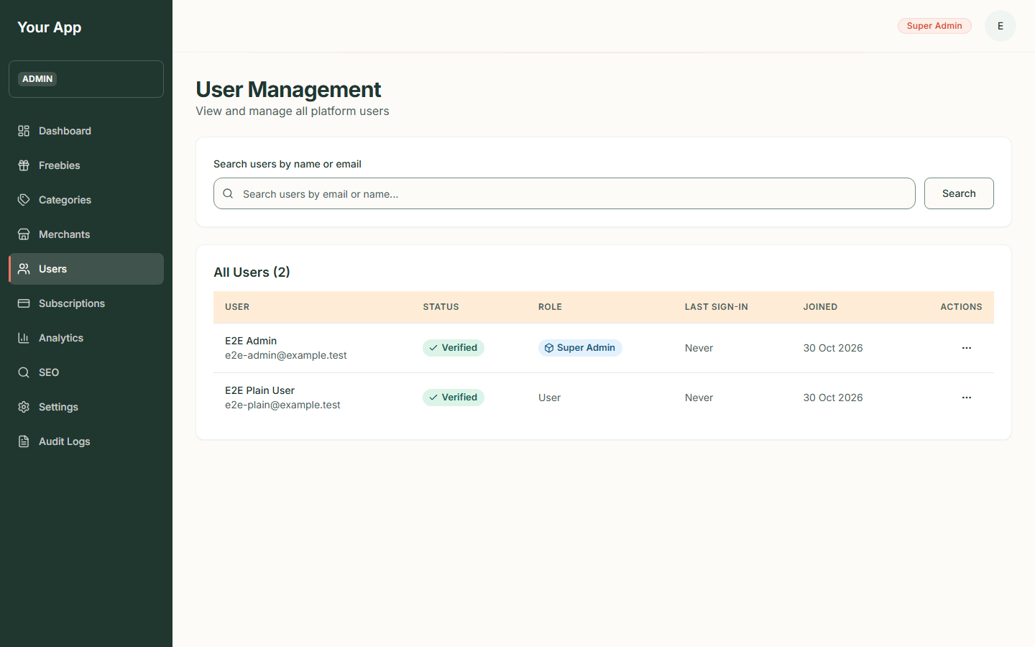  Figure 104. The user list on a desktop screen | Phone:  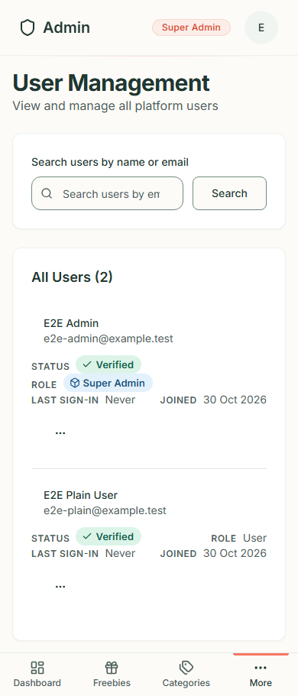  Figure 105. The user list on a phone

Step 2. Search for someone
- Type part of a name or an email address into Search users by name or email.
- Press Search. The heading counts the matches. If nothing matches the page says "No users match 'your words'" with a Clear button.
- If the list runs to more than one page, use Previous and Next at the bottom.
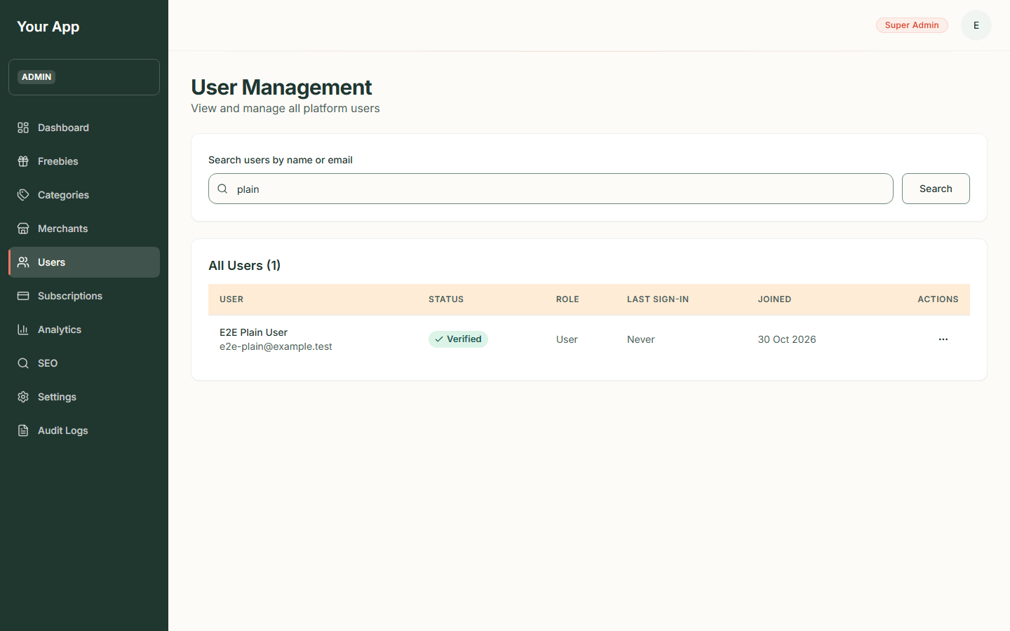  Figure 106. Searching for "plain" | Phone:  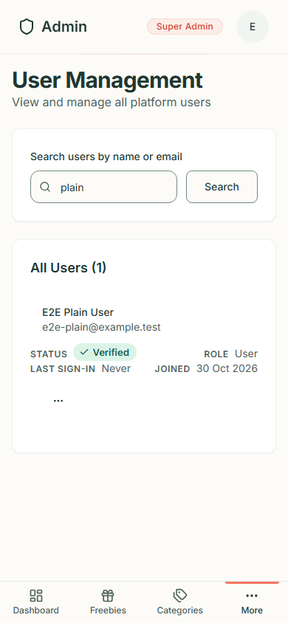  Figure 107. Searching on a phone

The search word travels in the page address, so an email address you type can stay in your browser history and in server logs. This is noted in the privacy information.

Step 3. Open a user's details
- Click the three dots in the Actions column, then View Details.
- The User Details page has an Edit user button and Back to Users, and shows three panels:
- Basic Information: Email, Display Name, User ID, Email Verified, Two-factor (Enabled or Disabled), Last Login and Member Since.
- Profile: Bio, Location, Website and Phone (a dash when not filled in).
- Admin Access: the Admin Role (or "None") and, for admins, the list of Permissions.
- Back to Users returns to the list.
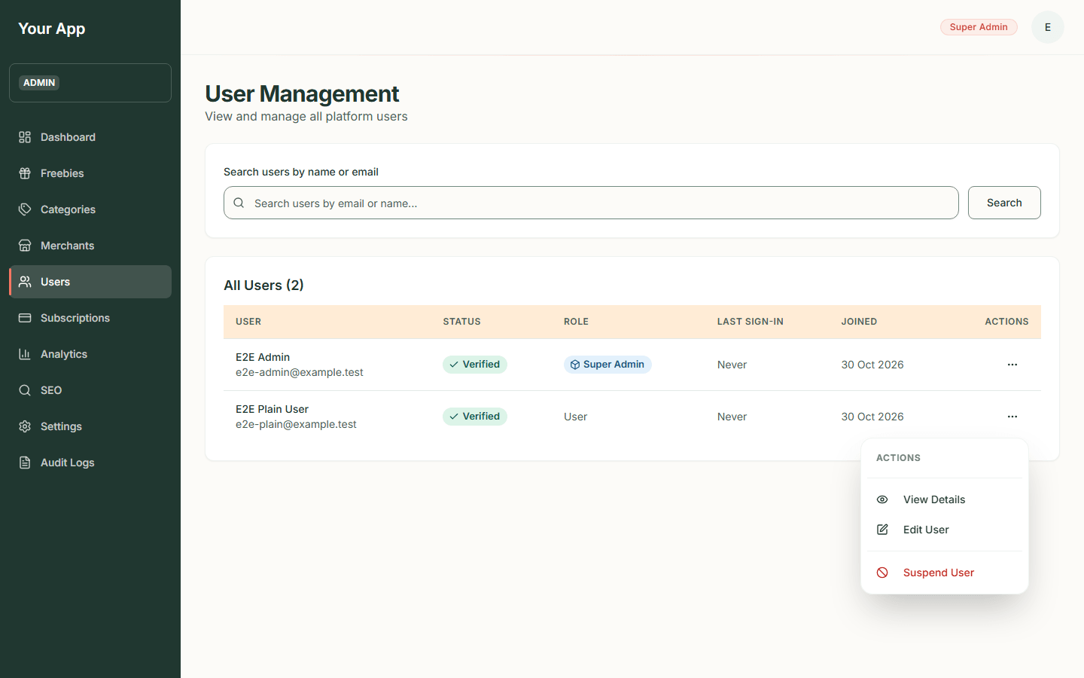
Figure 108. The user menu (this picture predates the Edit User and Restore Access items; screen pending, see the end of this
page)
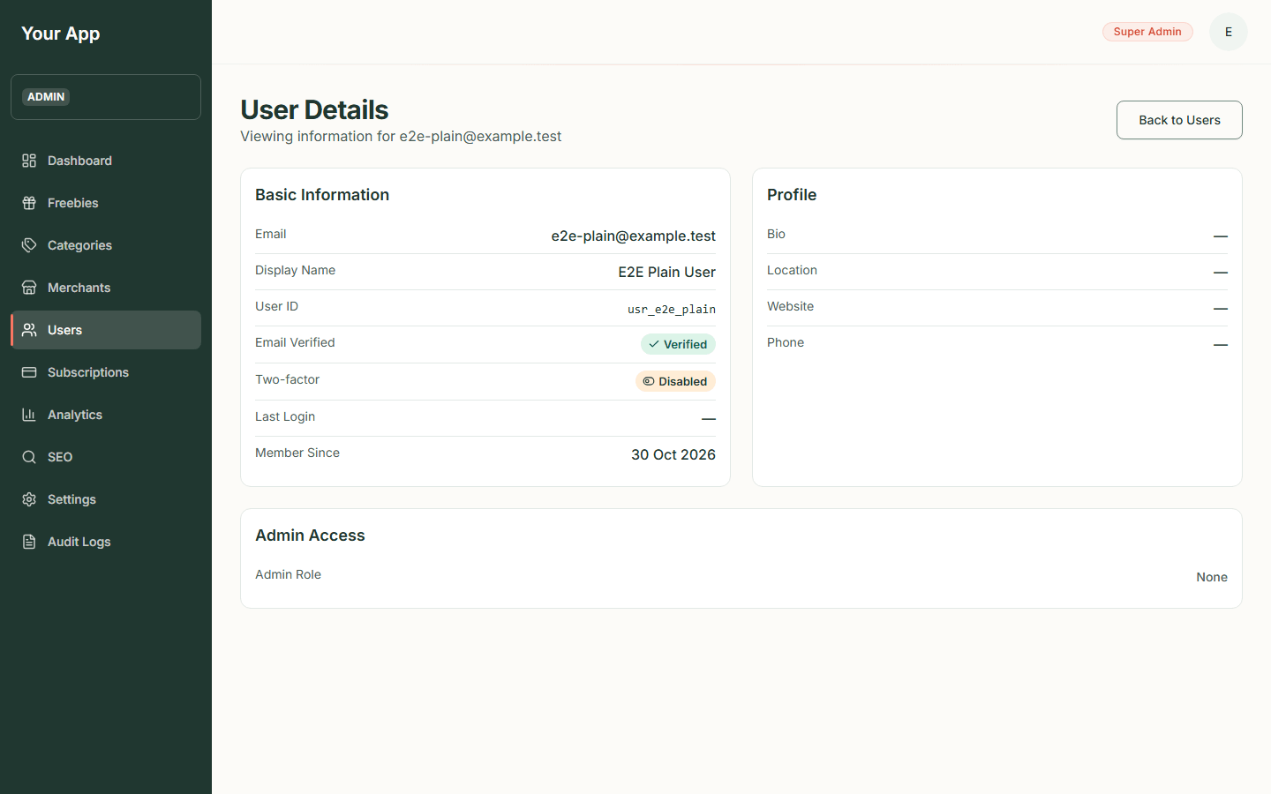  Figure 109. A user's details on a desktop screen | Phone:  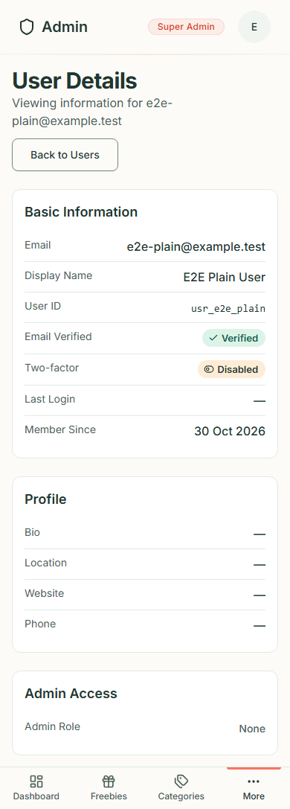  Figure 110. A user's details on a phone

Step 4. Edit a user's profile
- Click the three dots, then Edit User (or open View Details and click Edit user).
- The Edit user page shows the person's email and a form with Display name, Bio, Location, Website and Phone. The email address, admin role and two-factor setting cannot be changed here.
- Change what you need and press Save changes. Leave a box empty to clear that value.
- A green "Changes saved." message and a "User updated" notice confirm it. If something is wrong, an error says what: the website must start with http:// or https://, the phone number may hold only digits, spaces and + ( ) - ., and each box has a length limit. A refusal ("You do not have permission to do that") appears as Could not save.
- Back to user details returns to the details page.
The audit log records which fields were changed, never their values.

Step 5. Suspend or restore a user
- Click the three dots, then Suspend User.
- A box asks "Suspend this user?". It names the person and says they will be signed out and cannot sign in until you restore their access. You can type an optional Reason (up to 200 characters). It is kept in the audit log and is not shown to the user.
- Press Suspend user to confirm, or Cancel to leave things as they are. On success the box closes and a notice says the user was suspended.
- To undo it, choose Restore Access from the same menu and confirm. The person can sign in again.
Some refusals are expected. You cannot suspend or restore your own account (the box shows "You cannot suspend or restore your own account."). Suspending or restoring an admin also needs the admins.delete permission and every permission that admin holds; without them the box shows "You do not have permission to do that". The list and details pages do not show whether someone is suspended, so Restore Access is always offered; restoring someone who is not suspended leaves their access as it is (an audit entry is still written).

Not on these screens yet
The backend can also delete accounts and grant or remove admin roles, but there is no screen for either yet; a developer does those through the backend.
Screens pending: needs the Firebase test project (owner action). The pictures of the row menu and the User Details page above were taken before Edit User, Restore Access and the Edit user button existed, and there are no pictures yet of the Edit user form or of the Suspend this user? box. They need a signed-in admin.

Two-factor authentication (2FA)
Two-factor authentication adds a six-digit code from an authenticator app to signing in. Where it stands today:
- Account level. 2FA belongs to each person's own account, not to the admin area. Each person manages it on their own Security page, reached from their dashboard (/dashboard/security).
- Status only. The Security page has a Two-Factor Authentication panel that says either "Two-factor authentication is enabled" or "Two-factor authentication is not enabled" (or "Two-factor status unavailable" if it cannot be read).
- Signing in with 2FA. If an account has 2FA on, signing in has a second step. After the email and password (or Continue with Google or GitHub) are accepted, the page shows Two-factor authentication with one box, Authenticator code. Type the six-digit code from the authenticator app and press Verify and sign in. The code changes every 30 seconds, so type the current one. The messages you may see:
- That code did not work: the code was wrong or had expired. The box is cleared; try the new code.
- Enter the six-digit code: the box did not hold six digits.
- Too many attempts: after a few wrong codes (at most four in 15 minutes) sign-in is blocked; wait 15 minutes.
- Your sign-in timed out: the first step is only valid for about five minutes. The page returns to the sign-in form with this message; sign in again.
- Sign-in is unavailable right now: a problem on our side. Try again in a few minutes.
Back to sign in returns to the first step with the email still filled in (the password is cleared) and signs the browser out of the half-finished sign-in. There are no backup codes: if you cannot get a code, the page offers Contact support, but nothing in the screens can switch 2FA off for you (see below).
- Changing your password signs you out. For an account with 2FA on, changing the password on the Security page ends the session, because the new session needs a code too. You are sent to the sign-in page and sign in with the new password and a code.
- Setting it up is switched off. The Security page has no Enable button, on purpose: with no backup codes, a person who loses their phone would be locked out. To enable 2FA today a developer has to call the backend's two set-up routes (enrol, then confirm with a code) with that person's own signed-in session. Ordinary users cannot do it themselves yet, so in practice almost no account has 2FA on.
- Turning it off. An account that does have 2FA enabled sees a Disable 2FA button. It asks for your password (or a Google or GitHub sign-in) and a six-digit code from your authenticator app ("Disable Two-Factor Authentication"). Someone who has lost their authenticator cannot use it, because it needs a code; a developer would have to clear the setting in the database.
- For admins. An admin can see whether another user has 2FA enabled on that user's User Details page. Admins cannot switch another person's 2FA on or off from the screens.
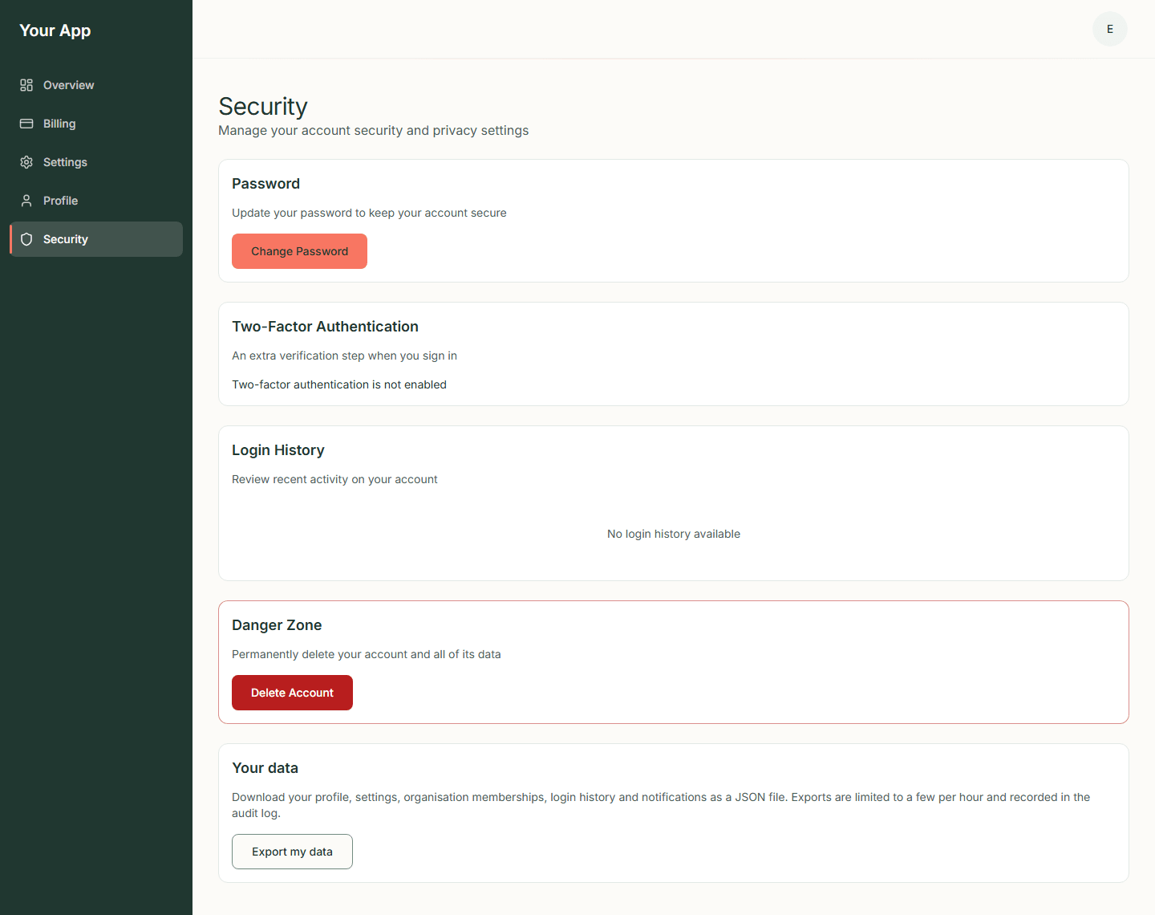  Figure 111. The Security page of an ordinary account, with the 2FA status panel | Phone:  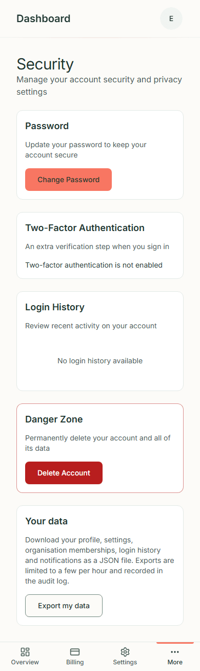  Figure 112. The Security page on a phone

Screen pending: needs the Firebase test project (owner action). There are no screenshots of the sign-in code step (Two-factor authentication), the Disable Two-Factor Authentication dialog or changing a password, because each needs a real Firebase sign-in and an account with 2FA turned on. The sign-in screenshots elsewhere in this guide show the first step, which has not changed.
The Security page also holds Change Password, Login History, Export my data and Delete Account. They are account features for the signed-in person and are not covered further in this guide. The site name at the top of the sidebar is the configured one; screenshots taken earlier still read "Your App".

Admin 5. Subscriptions and analytics
Back to the guide index
These two pages report on accounts and paid plans. They belong to the optional Stripe Billing module that Freejoy inherited from its template: paid plans are held by an organisation (the team an account belongs to), and Stripe takes the payments. Freejoy's freebies site itself is free to visitors and does not use these pages.
What the screenshots show. They come from an almost empty test database: two test accounts, no organisations, no paying customers and no Stripe account. So every figure is zero or tiny. They show the layout, not real results. Anything that needs a live Stripe account is marked Screen pending.
Reading these pages needs the subscriptions.read and users.read permissions. The currency symbol on money figures comes from the platform's currency setting, which defaults to British pounds (so amounts show £). If the setting names another currency, amounts show that currency. The screenshots on this page were taken before the default changed and still show $.

Part A. Subscriptions

Step 1. Open the page
- Click Subscriptions (under More on a phone).
- The page is headed Subscription Management: "Monitor and manage all subscriptions". Use Refresh at the top right to reload the numbers.

Step 2. Read the numbers
- A row of four figures: Total active (Pro plus Enterprise), Pro plans, Enterprise plans and MRR. MRR is monthly recurring revenue: what paying organisations are billed at list price, per month. If it cannot be worked out the box says Revenue unavailable and the rest of the page still works.
- Under them, a line such as "0 canceled (all time)". When some paying organisations could not be priced it adds "Some paying organisations could not be priced, so MRR is a minimum".
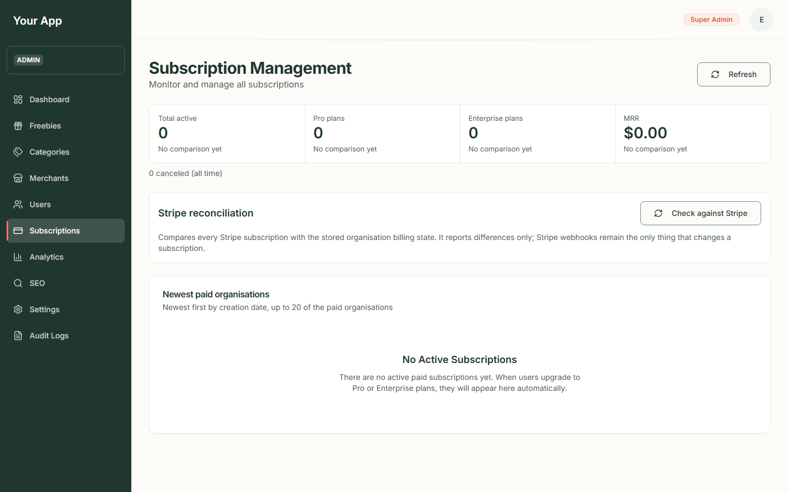  Figure 113. The Subscriptions page | Phone:  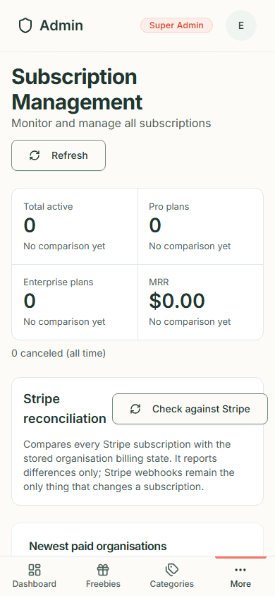  Figure 114. The Subscriptions page on a phone

Step 3. Compare with Stripe
The Stripe reconciliation panel has a Check against Stripe button.
- Press it. It reads every subscription in Stripe and compares it with what Freejoy has stored.
- A report appears: how many subscriptions were read, how many are in sync and how many differ, with one line for each difference ("No matching organisation", "Different subscription", "Status differs", "Plan differs", "Cancellation flag differs", "Not found in Stripe").
- The check only reports. It never changes a subscription: only Stripe's own messages (webhooks) do that.
- You can run it a few times a minute; the system limits it to three runs a minute per admin.
Screen pending: needs a Stripe test account (owner action). There is no screenshot of a successful report, because no Stripe account was connected. Without one, pressing the button shows "Something went wrong. Please try again." under the panel's description, as here:
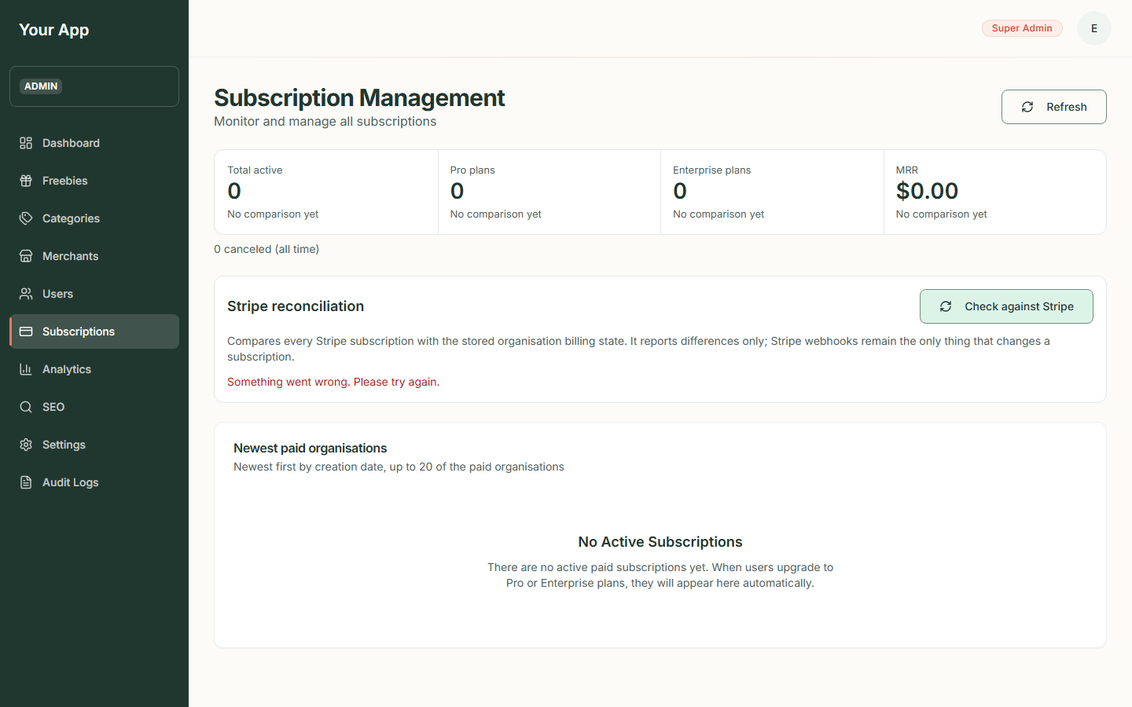
Figure 115. The reconciliation panel when Stripe is not connected

Step 4. Newest paid organisations
The table lists up to 20 of the newest paid organisations with Organisation, Slug, Plan, Status and Renewal Date. The table is read-only: it has no buttons or menus. With none it says No Active Subscriptions: "There are no active paid subscriptions yet. When users upgrade to Pro or Enterprise plans, they will appear here automatically."
Managing a subscription (cancelling it, refunding a payment, granting or revoking a plan) has no screen yet. The backend can do these, but a developer does them there for now. An earlier version of this page showed a Manage button on each row that did nothing; it has been removed.

Part B. Analytics

Step 5. Open the page
- Click Analytics (under More on a phone). It is headed "Analytics: Platform users, organisations and revenue". Use Refresh to reload.

Step 6. Read it
- Users, New this month, Active, 30 days and Organisations: counts of accounts and teams. "Active" means people who signed in during the last 30 days.
- User summary: how many users are Verified, how many are Admins, and how many New organisations this month.
- MRR, ARR (annual recurring revenue), Paying organisations and Cancelling (paid plans that end at the end of the current period).
- Revenue by plan (each plan, its organisations and its monthly amount) and Organisations by status.
- If a section fails to load, a red box with Retry appears in its place and the other section still shows.
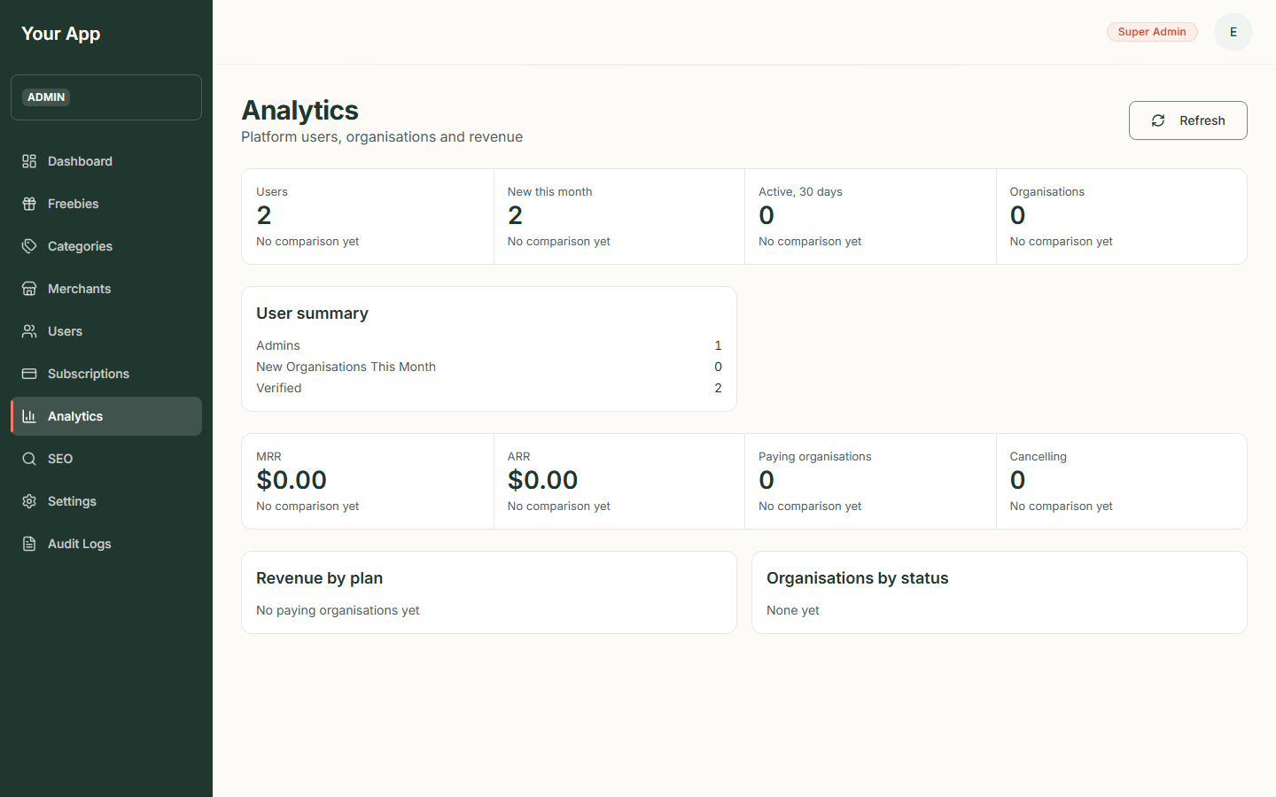  Figure 116. The Analytics page | Phone:  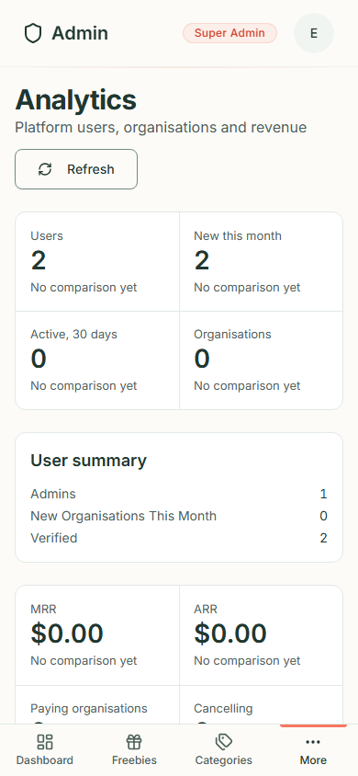  Figure 117. The Analytics page on a phone

Figures are computed from Freejoy's own records and cached prices; they are list-price figures (no coupons or tax). Trial plans and plans an admin granted for free are not counted as revenue.
There is no visitor analytics page: Freejoy deliberately runs no analytics scripts on the public site.

Admin 6. Audit logs, SEO and settings
Back to the guide index

Part A. Audit logs
The audit log is the record of who changed what, and when. Every admin change and every organisation or billing change adds one line. Use it to answer "who unpublished that offer?" or "when was this category switched off?".
Reading it needs the audit.read permission (a Super Admin has it).

Step 1. Open the log
- Click Audit Logs (under More on a phone).
- The page says "Track all administrative actions and system events", then a Filters card (see Step 2) and a card Recent Activity with a line such as "Showing 1 to 10 of 10 entries (newest first)".
- The table has these columns:
Column | What it shows
Timestamp | Date and time in UTC, for example "30 Oct 2026, 08:57 UTC"
Action | A short code in a grey outline: admin.offers.create, admin.offers.verify, admin.offers.publish, admin.offers.unpublish, admin.offers.expire, admin.offers.archive, and similar for categories, merchants, users and billing
Resource | What kind of thing it was ("offers")
User ID | The id of the admin who did it
IP Address | Where the request came from

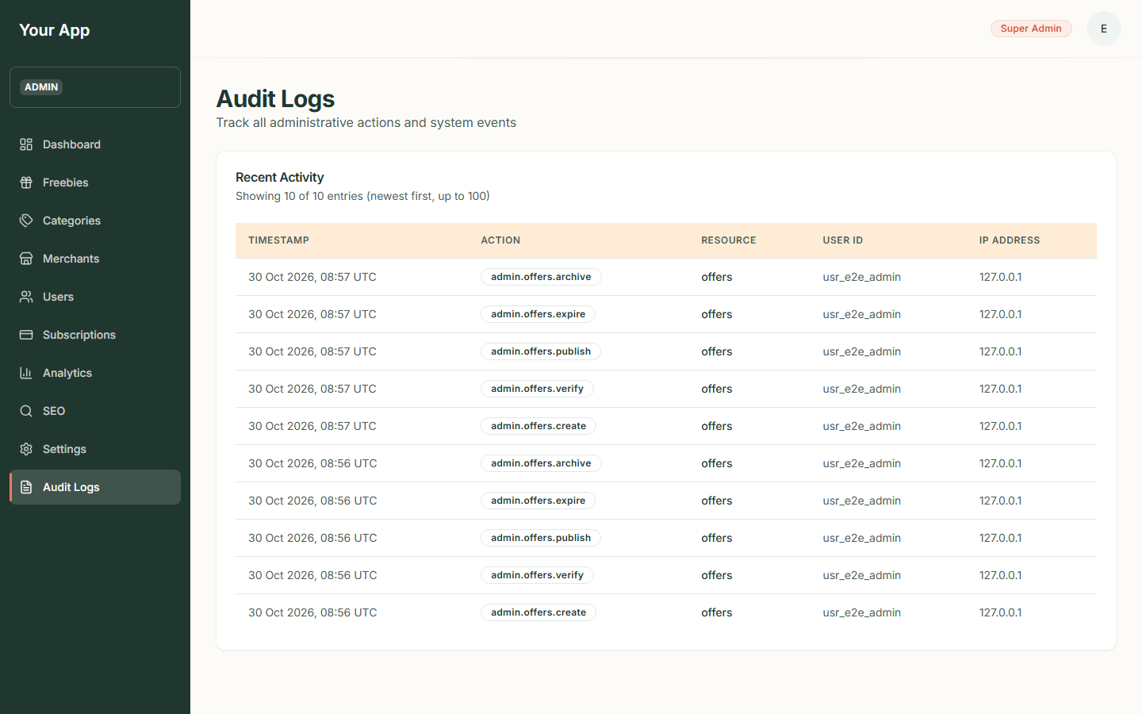  Figure 118. The audit log | Phone:  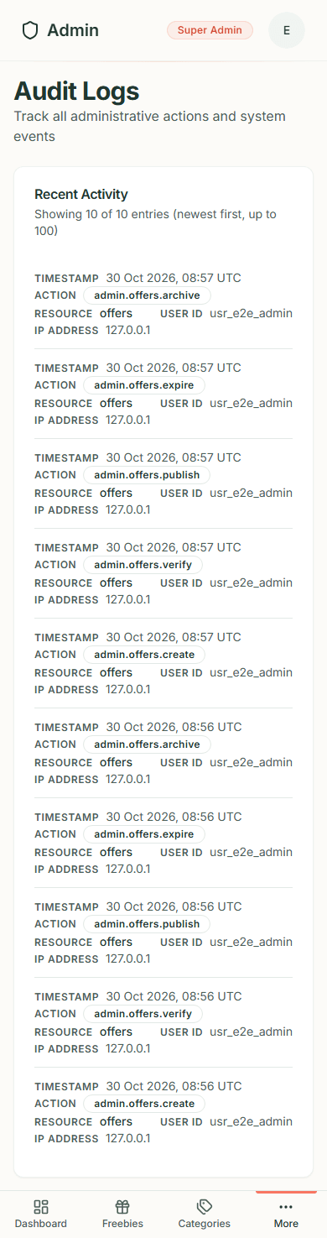  Figure 119. The audit log on a phone

In the screenshot, the ten lines are the real record of the two test offers created while writing this guide (create, verify, publish, expire and archive for each), made by the test admin account from the local computer.

Step 2. Filter and page through the log
The Filters card narrows the list. Every filter you add must match (an entry has to fit all of them).
Control | What it does
Action | Only entries with exactly this action, for example admin.offers.update
User ID | Only entries made by this admin (their id, as shown in the User ID column)
Organisation ID | Only entries about this organisation
From date and To date (grouped as Date range) | Only entries on or between these days. Dates are in UTC and each includes the whole day. The pickers will not let the range run backwards
Entries per page | 25, 50 (the default) or 100

- Fill in one or more controls and press Apply filters. The list reloads from the first page.
- Press Reset filters to clear everything and go back to the plain newest-first list.
- The line above the table says which entries you are looking at, for example "Showing 51 to 100 of 250 entries (newest first)". If nothing matches, the page says "No entries match these filters" with a Reset filters button.
- When there is more than one page, Previous and Next appear under the table with "Page 2 of 5". They keep your filters. On a phone the page count sits on its own line above the two buttons. After you press Apply filters, Previous, Next or Reset filters, keyboard focus moves to the Recent Activity heading, so a screen reader or keyboard user lands on the new results instead of being sent back to the top or losing their place when a button (such as Next on the last page) goes away. If a page past the end has no entries, the page says "No entries on this page" and offers Back to first page, which keeps your filters.
- The address of the page holds the filters, so you can bookmark it or send the link to another admin (who needs the audit-log permission to open it).
If a value cannot be used (an action that is not written like admin.offers.update, an id with spaces, a date that does not exist, or a "To" date before the "From" date) it is ignored and a red note under the controls says which one. The unusable value is not put back in the box; the box is marked as having a problem for screen readers and the note is read out when the page reloads. If you only left boxes empty, or the address held the default page size, the page quietly tidies the address (for example to ?action=admin.offers.update) and no note is shown.

Step 3. What is recorded, and what is not
- Recorded: creating, editing and every status change of an offer ("verify", "publish", "unpublish", "expire", "archive"), affiliate link changes, category and merchant changes (create, edit, enable/disable, activate/deactivate), admin changes to users and admin roles, subscription grants/cancellations/refunds, organisation and billing changes, and a person's own Export my data download.
- Not recorded: a refused action (for example the "could not publish" in Admin 2), simply looking at a page, signing in, and changes to a person's own profile, settings or two-factor.
- The log keeps which fields changed, not secrets: passwords, tokens and card details are never stored in it.

Limits of the screen
- You can page back through about the newest 10,000 entries of any search (the cap is on where a page starts, so the last page can reach a little past 10,000). When there are more, the page count shows a plus sign, such as "Page 1 of 201+". Beyond that, the page tells you to narrow the filters or the date range (for example pick a month) to reach older entries.
- You can filter by action, user, organisation and date. There is no free-text search, no filter by resource or by IP address, and no way to pick an action from a list: type it exactly.
- The screenshots below still show the earlier version of the page without the Filters card. Screenshot refresh pending: it needs the signed-in test admin account.

Part B. SEO
SEO in the sidebar is switched off. The page is headed "SEO Management" with "Meta tags and redirects are not available yet" and a panel Not available yet: "This page is switched off until its backend service is ready. Nothing is lost: it will return in a later release." The Go to Users button leaves the page.
Search-engine behaviour of the public site (which pages are indexed, the sitemap, the page titles) is set by the site's code today, not from this screen.
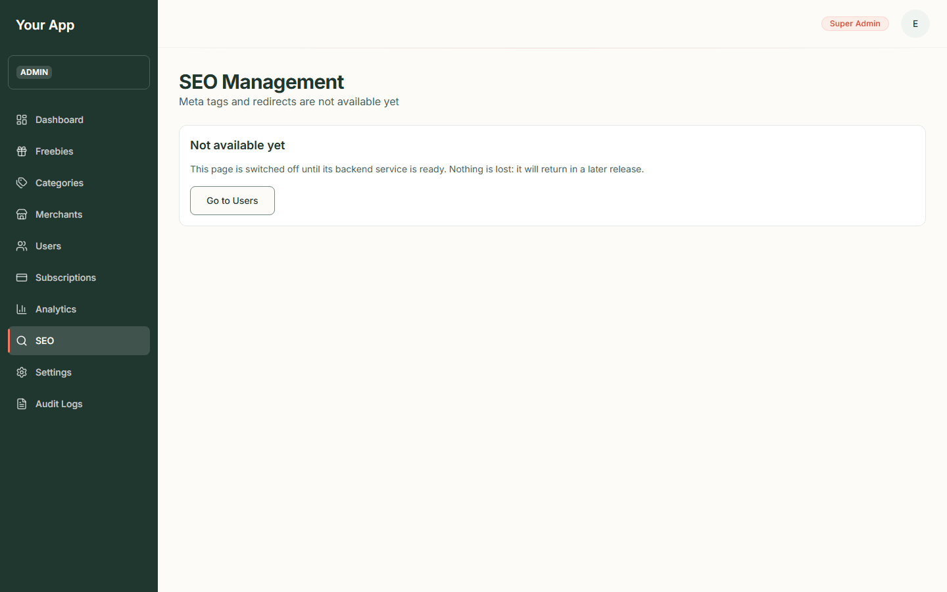  Figure 120. The SEO page | Phone:  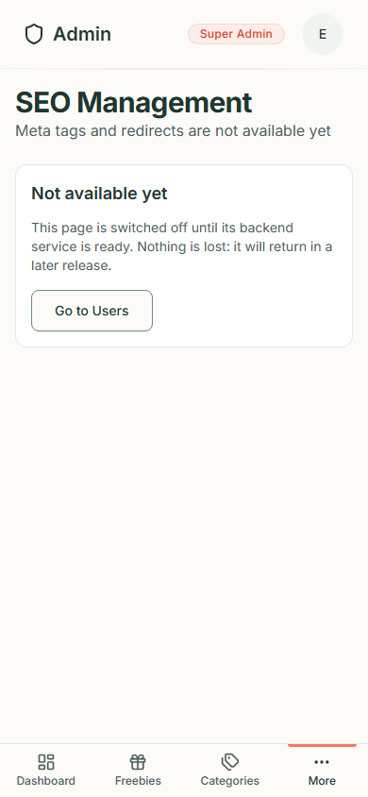  Figure 121. The SEO page on a phone

Part C. Settings
Settings shows statistics only. The page says "System statistics. Editing settings, flags and templates is not available yet." Under System stats it lists how many of each of these exist: Application settings, Feature flags, Email templates, SEO entries, URL redirects, Audit log entries, Stripe events processed and Platform admins. Use Refresh to reload.
You cannot change the site name, currency, language, theme or feature flags from this page. (The currency is currently set by a developer in the database; see admin-settings.md.)
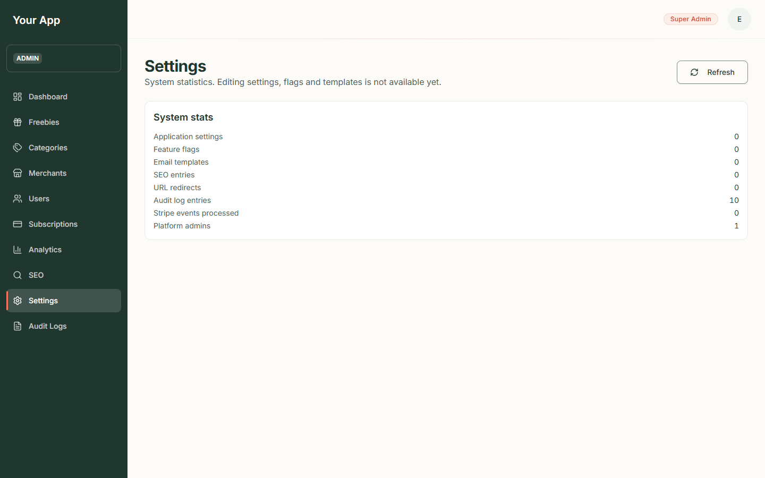  Figure 122. The Settings page | Phone:  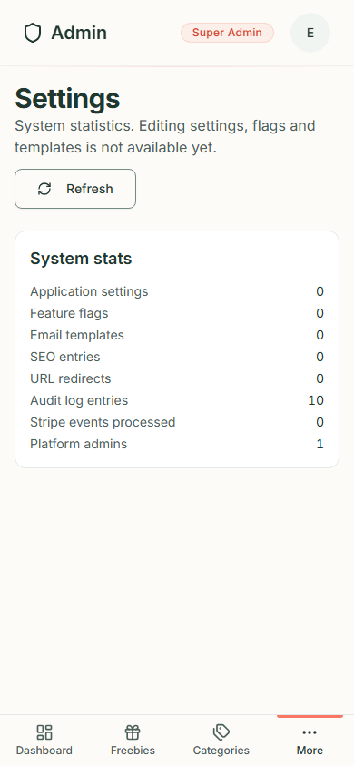  Figure 123. The Settings page on a phone

When a page cannot load
Each of these pages shows a red box with a short message and a Retry button if the system behind it is not reachable ("Something went wrong. Please try again." is typical). Nothing has been lost; try again, and tell a developer if it keeps happening.

