Task 2: Build Your Student Digital Portfolio 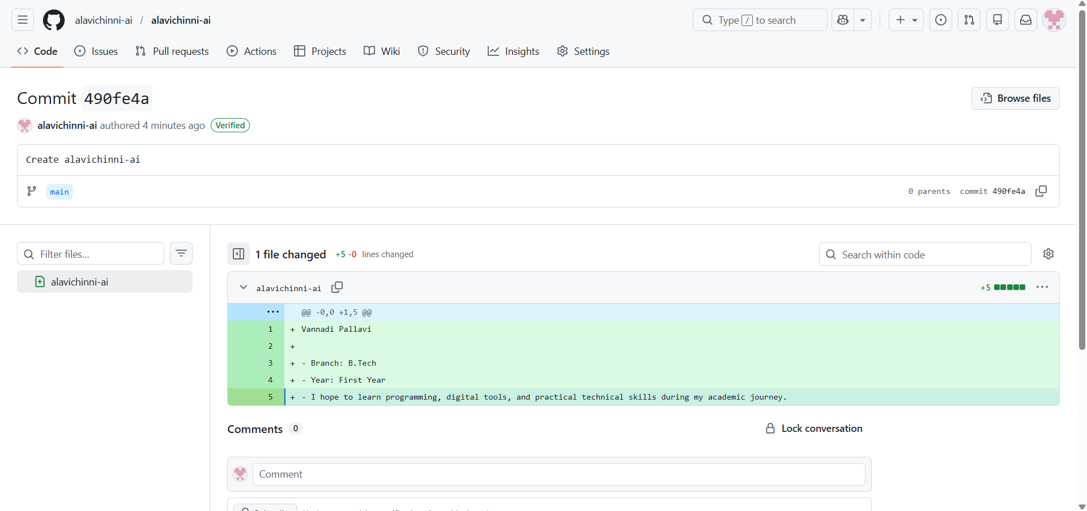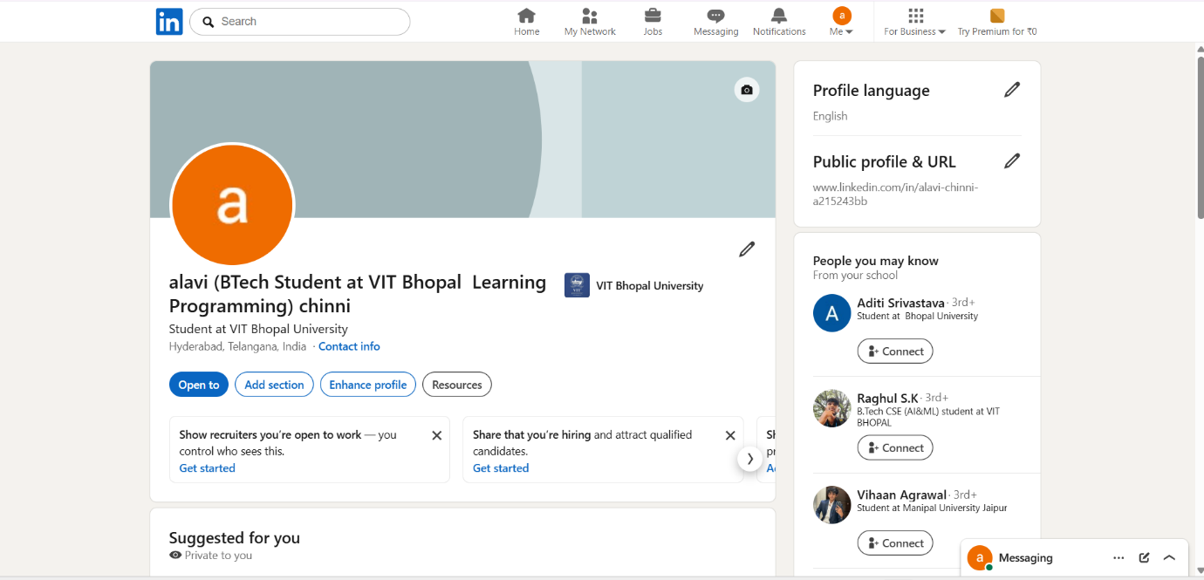
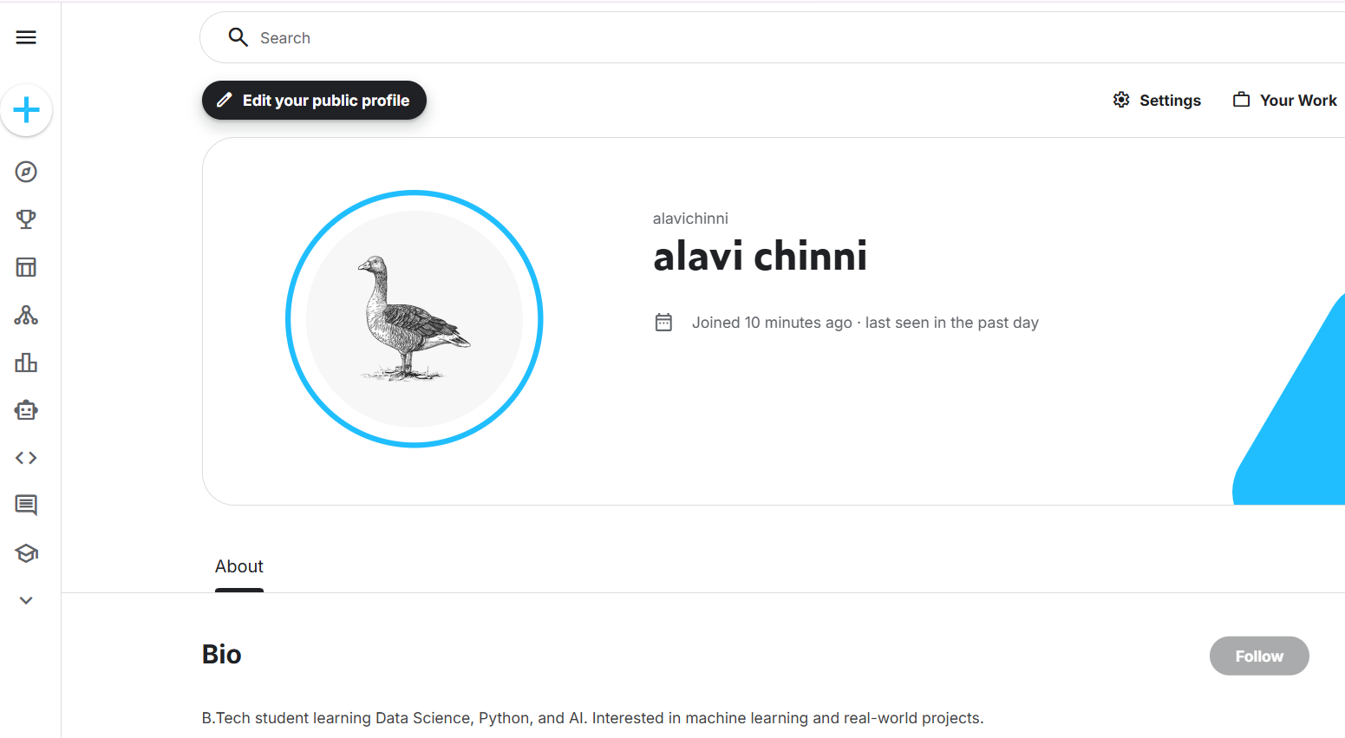
For Task 2, I created profiles on GitHub, LinkedIn, and Kaggle to begin building my student digital portfolio. GitHub is used to store coding projects, assignments, and technical work in an organized way. LinkedIn is a professional networking platform where students can present their education and future achievements. Kaggle is used for learning data science, practicing technical skills, and exploring datasets.

I selected these platforms because they are useful for both academic learning and future career development. Over the next four years, I plan to use GitHub to upload coding assignments and projects, LinkedIn to build my professional identity and connect with academic communities, and Kaggle to improve technical skills through practice and learning activities. These platforms will help me maintain a strong digital presence as a student.

