Scraped last 5 years ODI ranking data and visualization in Streamlit

**Details of scraped data:**

* Batting (Total rows:1,87,500)
* Bowling (Total rows:1,87,500)
* All Rounder (Total rows: 37,500) As ranking is only 20 ranks per day.

**Method Used:**

* Used **API** as it was very quick in scraping the data. (Depends on internet speed we can extract the data more faster, it took us 26mins to extract the data.)
* Used **Import Json** to convert the API scaped Json file data to executable format
* Used Streamlit for visualization of ODI Ranking

**Errors:**

* Beautiful soup: while requesting the old date in streamlit, it was giving the present date. Date change was not giving proper output
* Selenium: As the data size was large. The extraction of data was taking longer than expected.

**Packages used:**

- json

- pandas

- requests

- dependencies

- numpy

- os

**Steps to execute the code:**

* Download the scraped_part.py file into your local machine and save it in a path which doesn’t require administrator permissions to create, read or delete files from the directory (ex : save in D,E,F drives instead of C drive).
* Open the scraped.py file in your IDLE/Editor and define all the functions initially.

**To Start scraping the content**

* Call the function scraped while providing it the necessary input variables

variables:

1. Year: starting Year from which the scraping of content begins.
2. Month: starting Month from which the scraping of content begins.
3. Day: starting Day from which the scraping of content begins.
4. Format type: bat, bowl or all-round.

- A file named bat_21-01-01 will be saved in the location of the script.

- The amount of time running depends on the range of dates provided.

OUTPUT IMAGES:

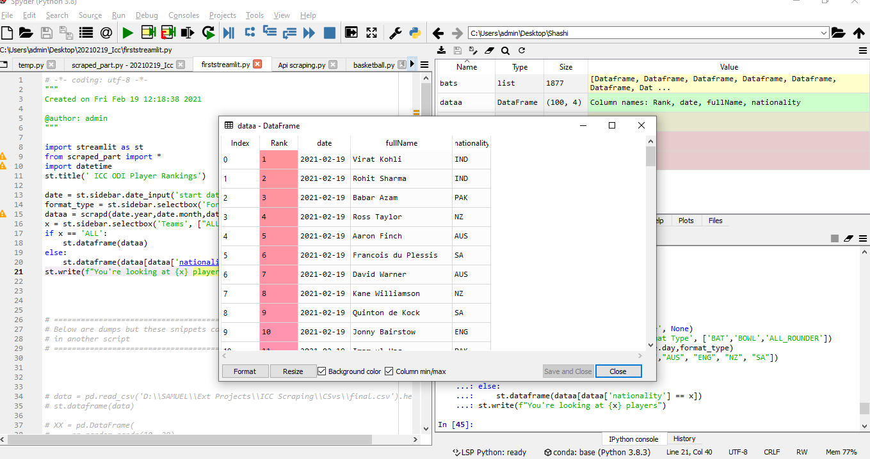

- All the formats data will be created separately in the form of .csv in the location of the scraped.py file.

Below are the images for streamlit visualization of ODI Ranking

**Screenshot image: 2016 Jan 1st ODI Batting ranking**

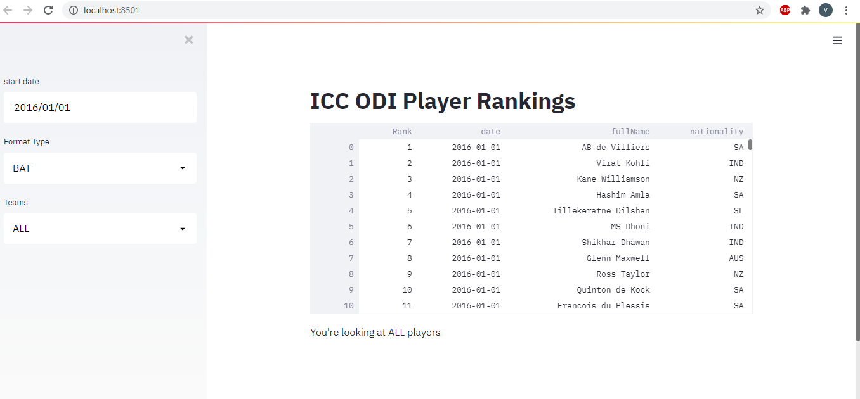

**Screenshot image: 2016 Jan 1st ODI Bowling ranking**

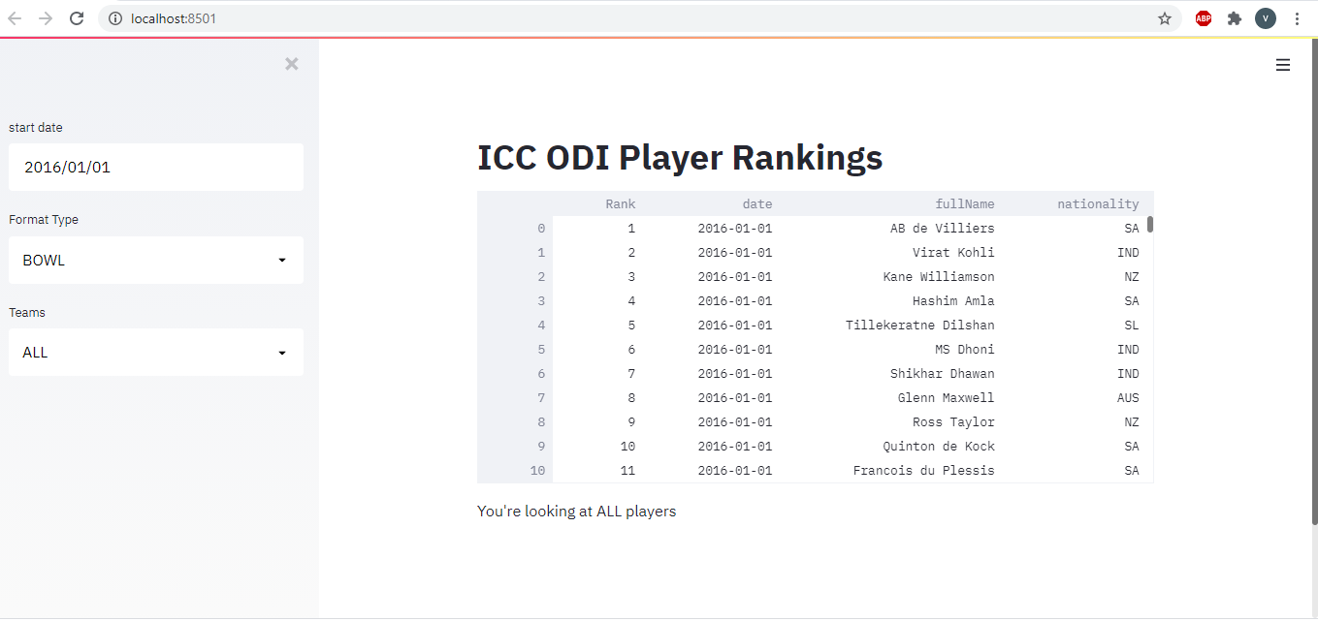

**Screenshot image: 2021 Jan 1st ODI Batting ranking**

