Facebook Integration Documentation

Version 1.0

Document Information and Approvals

Version History
Version # | Date |  | Revised By | Reason for change
1.0 | 27 FEB 2012 |  | SANTOSH MOHANTY

Document Approvals
Approver Name | Project Role |  | Signature/Electronic Approval | Date
Ashok Kumar | Tech Lead

Note : Before doing this, register your application in Facebook and get 'App ID' and 'APP SECREAT KEY'

STEP 1:
In Gemfile file, Add the following gems
gem 'oauth2'
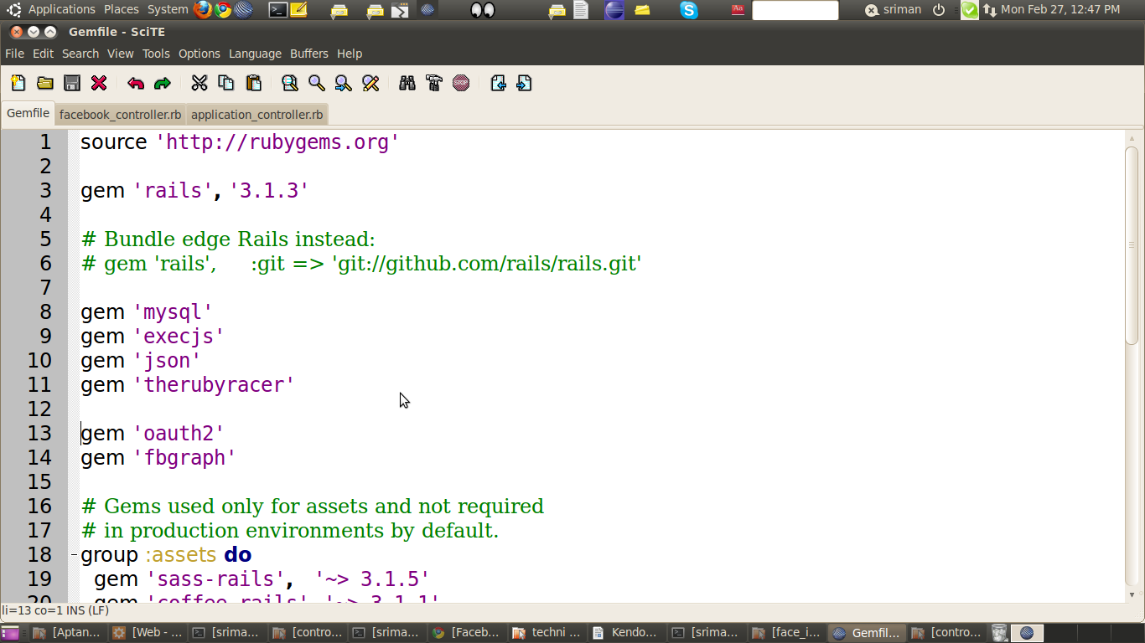
gem 'fbgraph'

SCREENSHOT :
STEP 2:
run bundle install ~

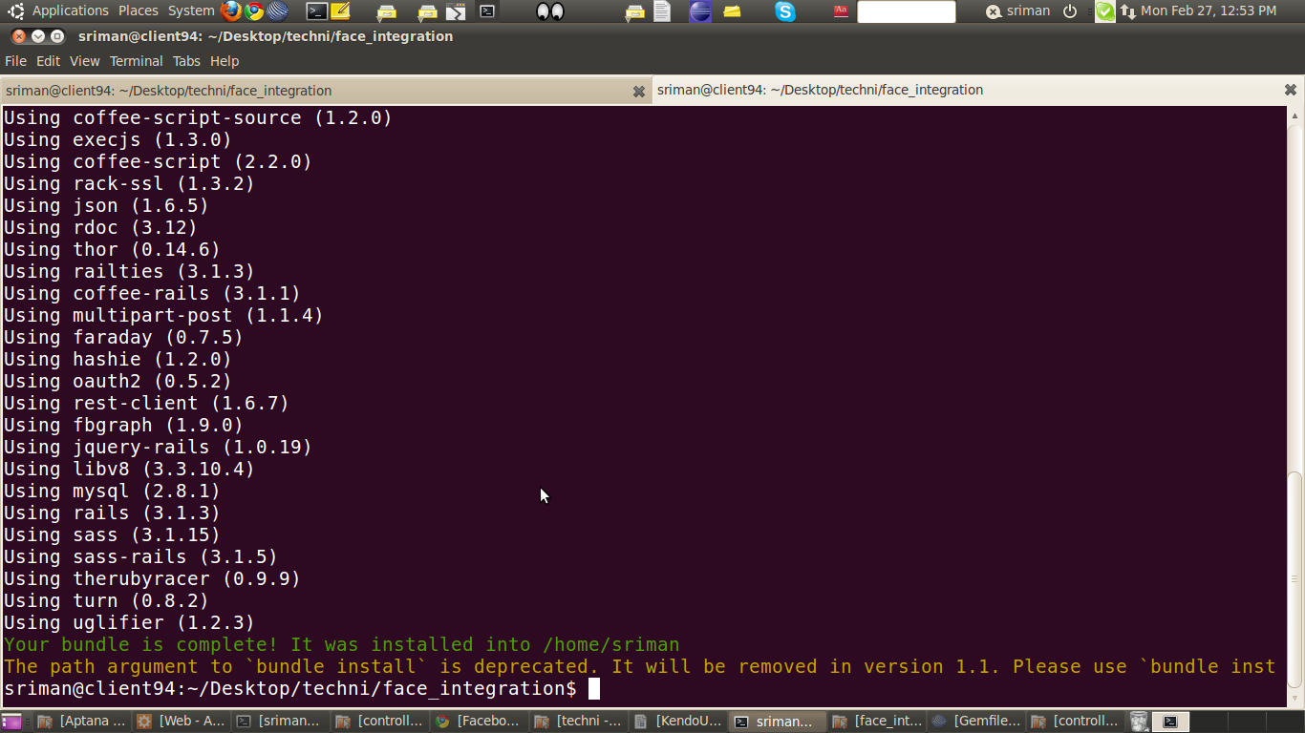
SCREENSHOT

STEP 3:
Here you have to use “APP ID” and “APP SECRET KEY”
(You can use your own application id. Eg: I used
APP ID = 352350191454910 SECRET KEY = 3b29f6c86cf1a8f16357e0c098d52f51
In application controller add the following lines
protected
def client
@client ||= FBGraph::Client.new(:client_id => '352350191454910', :secret_id => '3b29f6c86cf1a8f16357e0c098d52f51' )
end
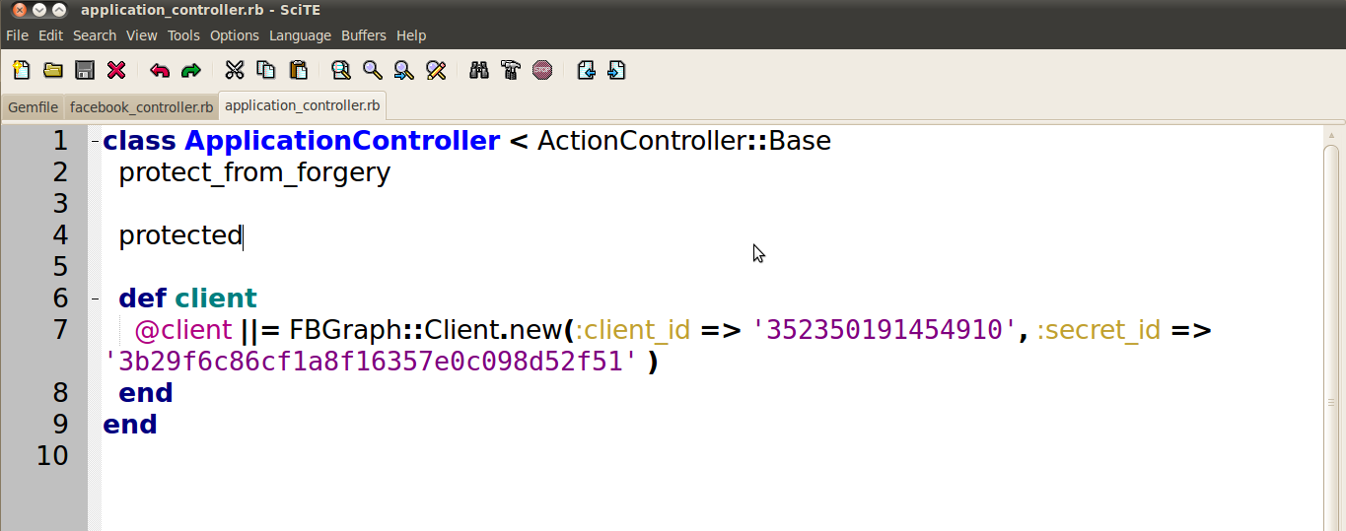
SCREENSHOT

STEP 4:
In your controller paste the following two methods (eg: I used controller name as “facebook”).
Change the following things as per your requirement method names, routes path( For example I have given method names as “facebook_login_start” and “facebook_show” , routes names as facebook_show_facebook_index_path) You can modify according to yours use.

SCREENSHOT:

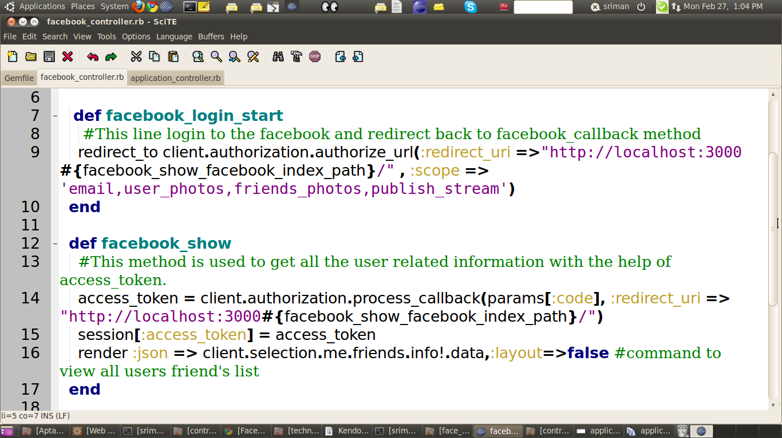

Step 5:
Change the routes as follows

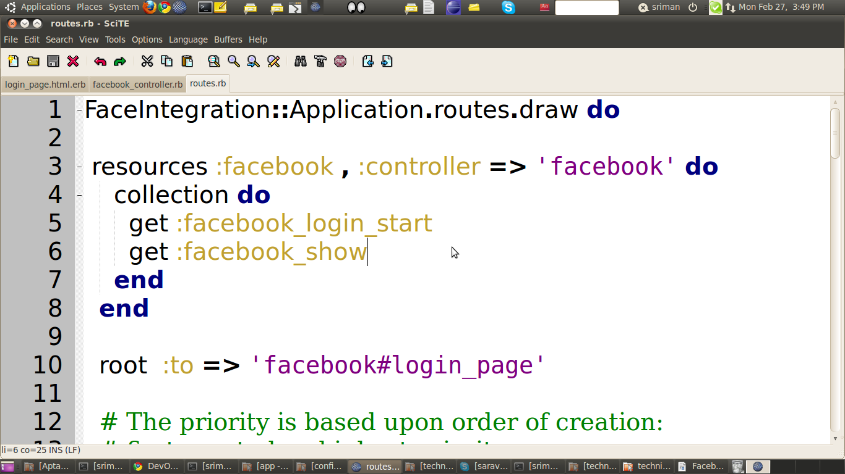

STEP 6:
Add the following line in your view file(like home page or login page or signin page(eg: I used “login_page.html.erb” as my root page, you can modify your needs ))

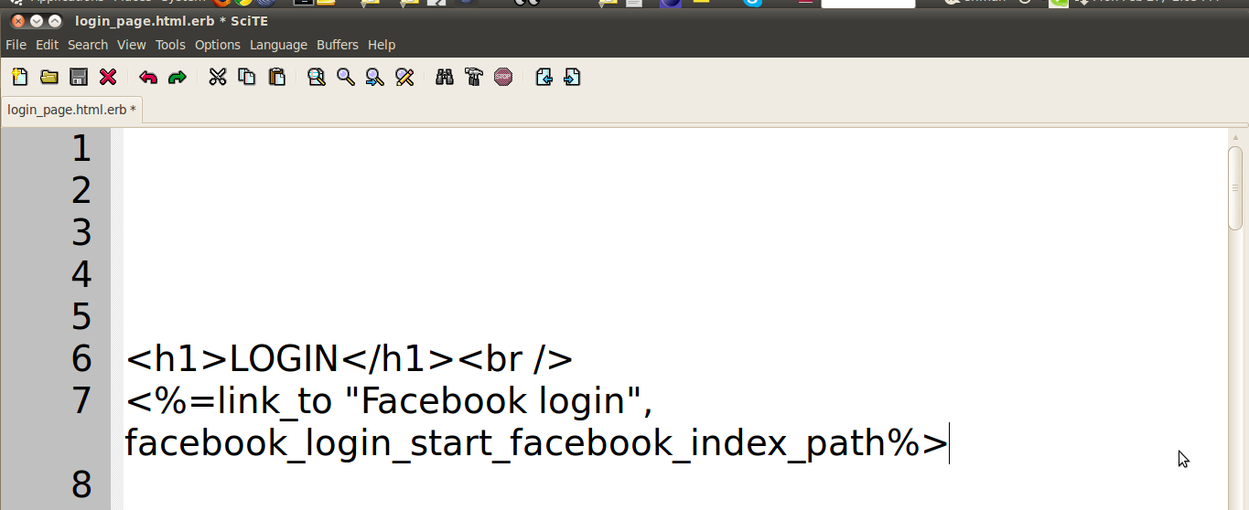
Step 7:
Finally your output will be as follows:-
EG:- I have to fetch user's friends list
OUTPUT 1:

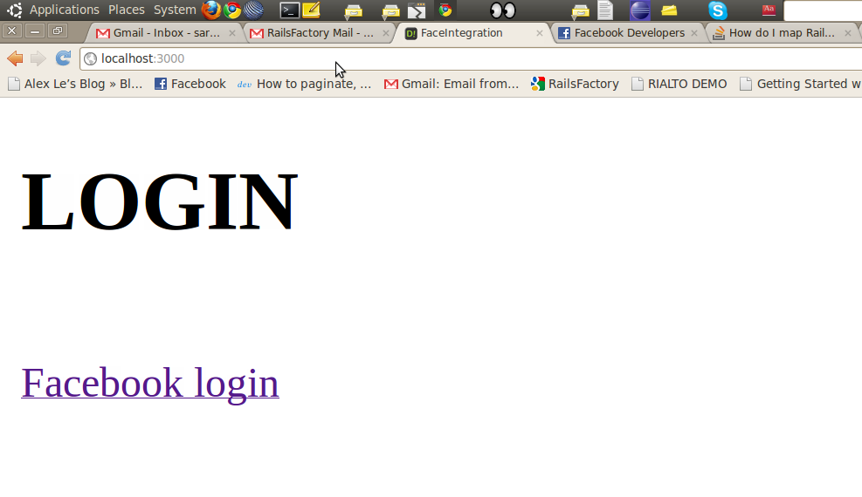

OUTPUT 2:

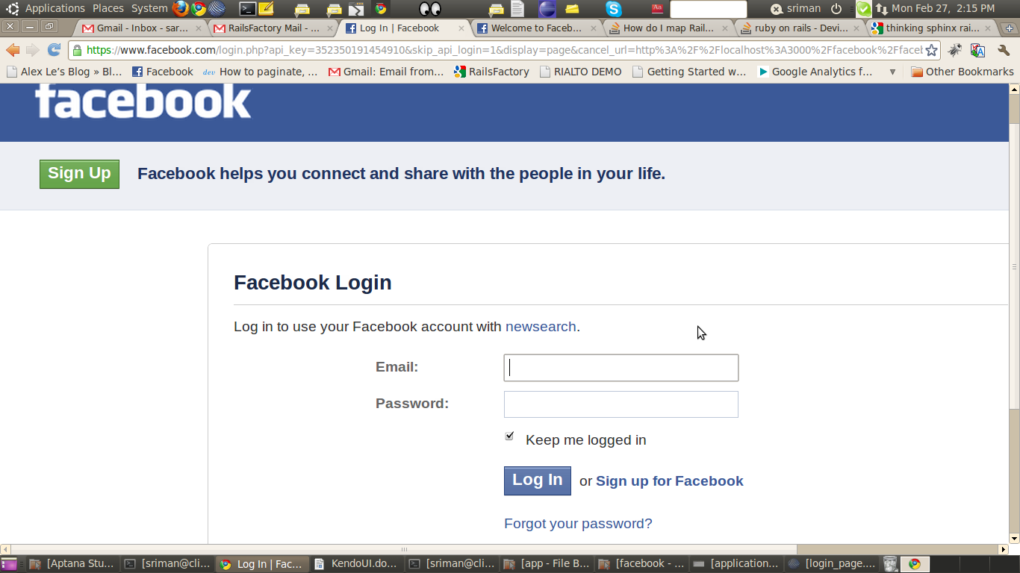

OUTPUT 3:
Finally my friend's will be displayed in my home page as json. You can save or fetch different data and also redirect to the page according to your needs.
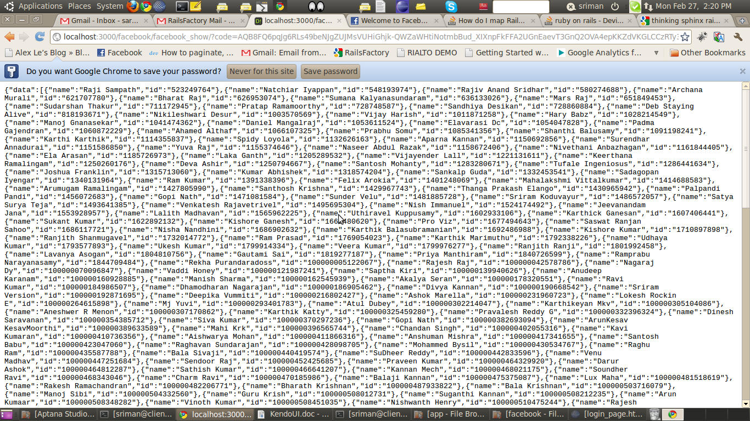
REFERENCE LINKS:
- https://github.com/nov/fb_graph

