MAIL CHIMP
DOCUMENTATION

Version 1.0

Confidentiality and Non-discloser Notice

Document Information and Approvals

Version History
Version # | Date |  | Revised By | Reason for change
1.0 | 23 Apr 2012 |  | Santosh Mohanty | Draft copy

Document Approvals
Approver Name | Project Role |  | Signature/Electronic Approval | Date

Step 1: Generating API key from MailChimp.
Log in to the website and follow the following steps to get API key
Signing Up:
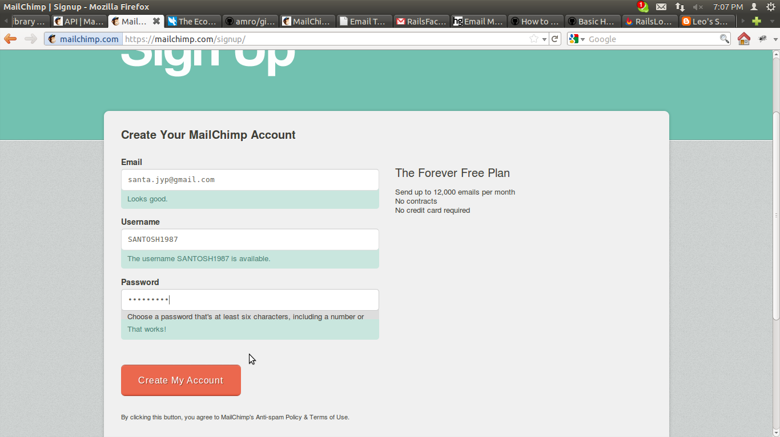

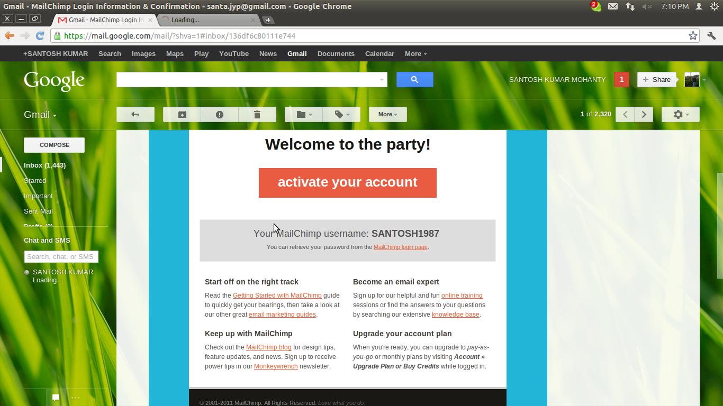
Verifying:

Generating API Key:
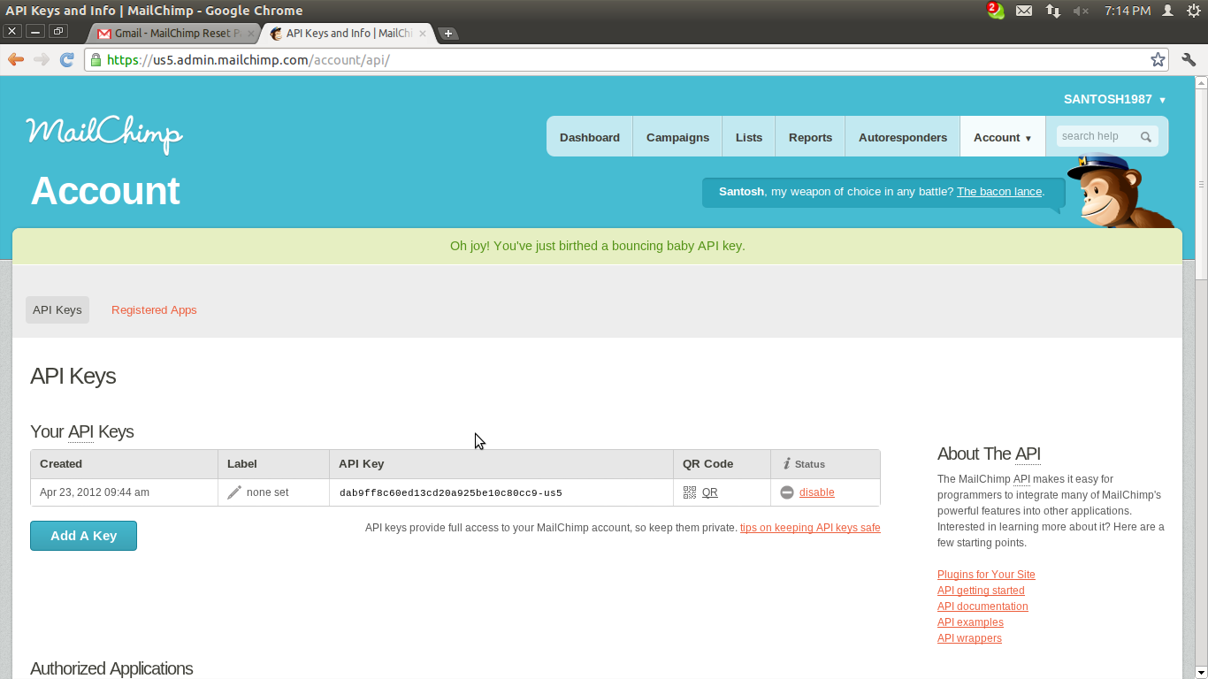

Creating Lists:
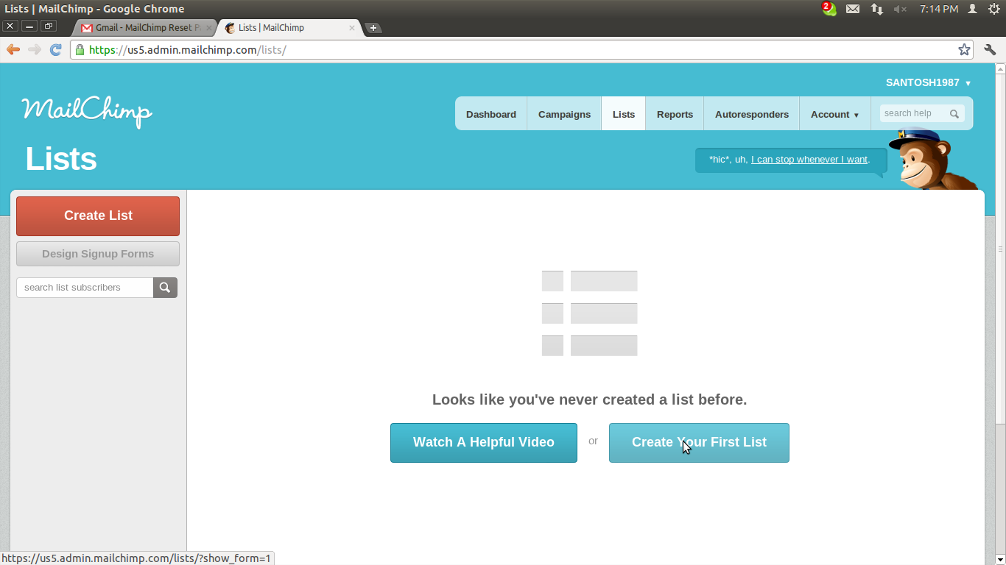

Creating Campaings:
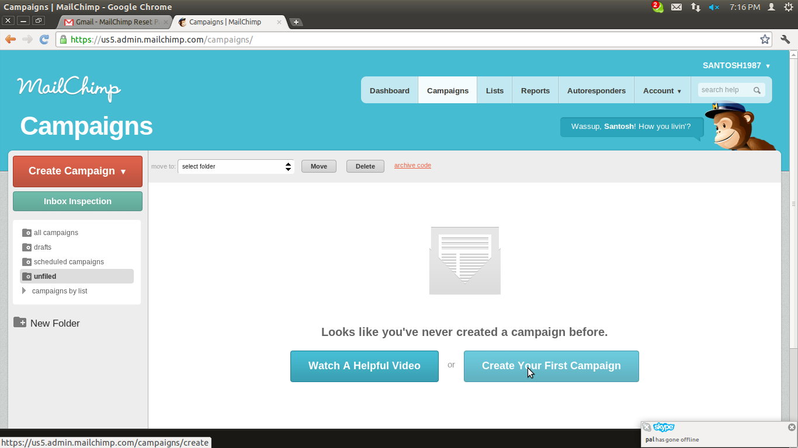

Building Campaing:
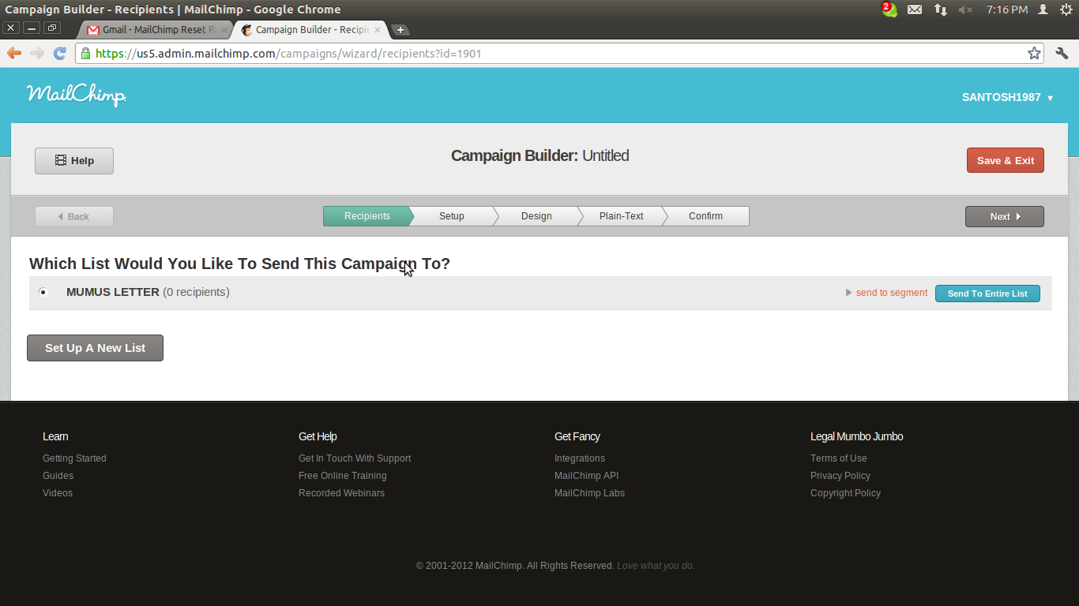

Step2 : Create your new Rails App and add A User model with various Authentication gem
e.g Devise

Step 3: In your Bundler File include a gem Called Gibbon which Supports MailChimp API

Step 4: Mention the API key in Config/Initializers.

ENV['MC_API_KEY'] = 'bd0068089b717495745926934fd314a5-us5'

Step 5: In your Controller write this line of code and Execute your application

gb=Gibbon.new
list_id = gb.lists({:list_name => "tomar"})["data"].first["id"]
gb.list_subscribe(:id => list_id, :email_address => "#{current_user.email}", :merge_vars => {'fname' => 'Hello'}, :email_type => "html", :double_optin => true, :send_welcome => true)

