Heroku deployment Documentation

Version 1.0

Confidentiality and Non-discloser Notice
The information contained in this document is confidential and proprietary to RailsFactory [Reg: Sedin Technologies Pvt Ltd]. This information may not be disclosed, duplicated or used for any other purposes. The information contained in this document may not be released in whole or in part outside RailsFactory [Reg: Sedin Technologies Pvt Ltd] for any purpose without the express written permission of RailsFactory [Reg: Sedin Technologies Pvt Ltd].
© RailsFactory [Reg: Sedin Technologies Pvt Ltd] 2007

Document Information and Approvals

Version History
Version # | Date |  | Revised By | Reason for change
1.0 | 5 march 2012 |  | Chitrank samaiya

Document Approvals
Approver Name | Project Role |  | Signature/Electronic Approval | Date
Ashok Kumar | Tech Lead

STEP 1:
1: Create account on heroku
STEP 2:
1: Before starting deployment make sure that you have three gem installed given below:-
gem install heroku
gem install git
gem install pg
2: You need to include only pg gem in your gemfile rest is not required.
Image 1
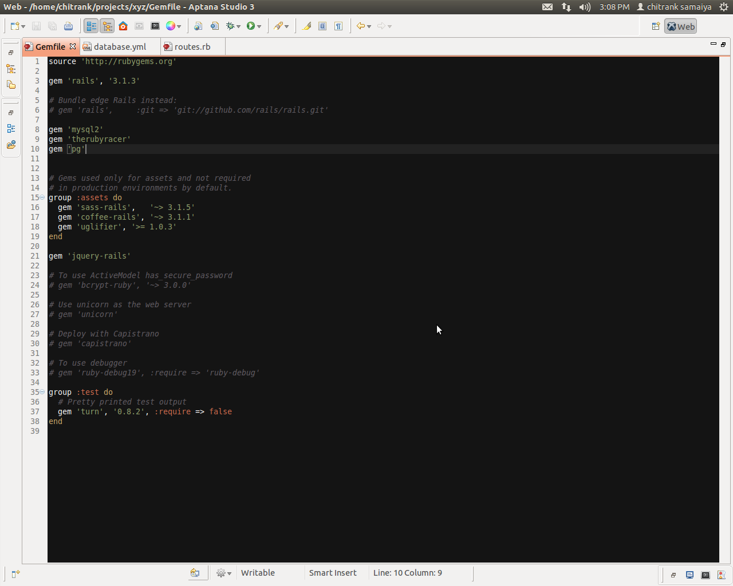
STEP 3:
1: Type command Heroku login.
2: Type email and password for authentication.
3: If you are not having ssl key it will ask you to generate.Otherwise it will find and use default one
“would you like to generate ssl key”y|n

Image 2
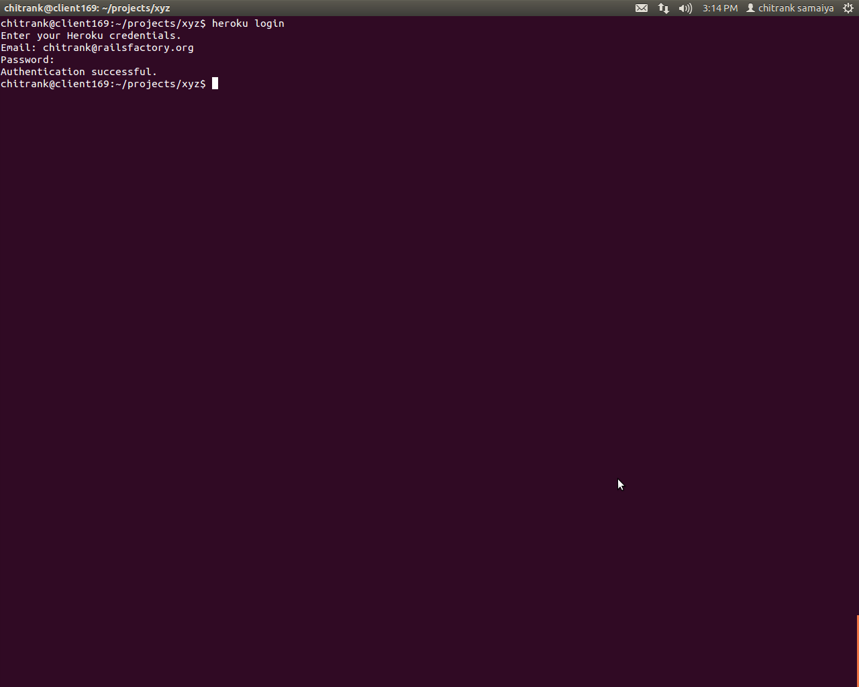

STEP 4:
Type command git init
Image 3
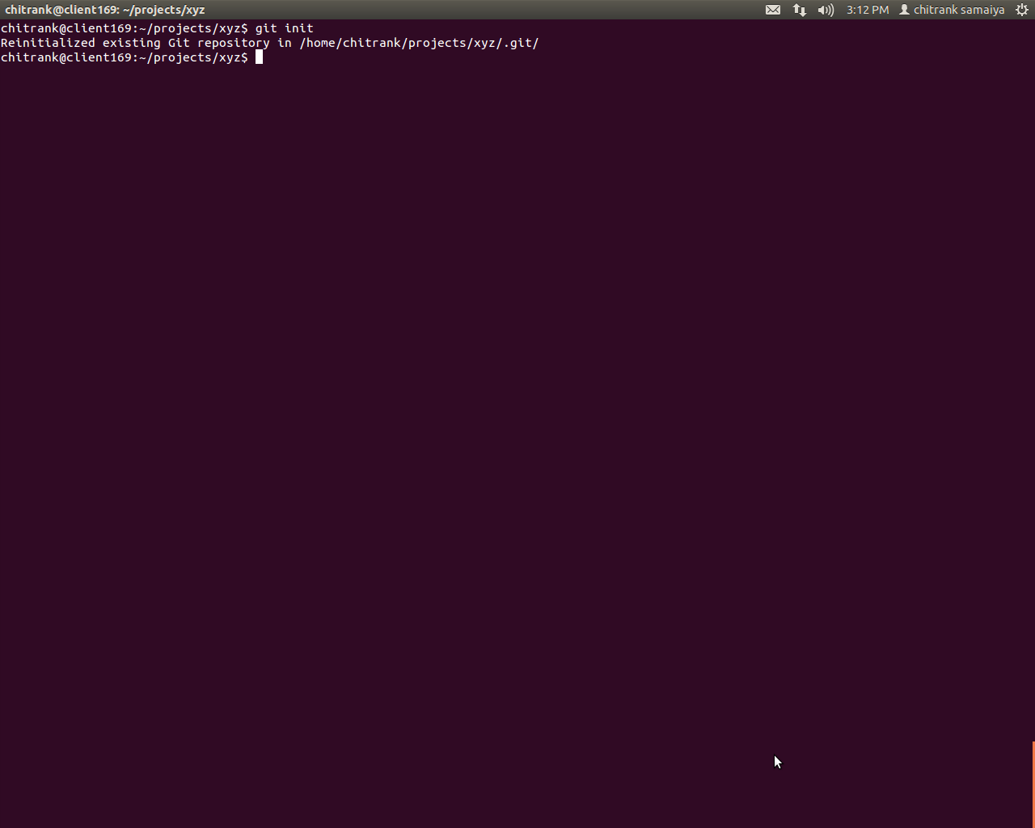

STEP 5:
Type command git add . To add the new files
Image 4
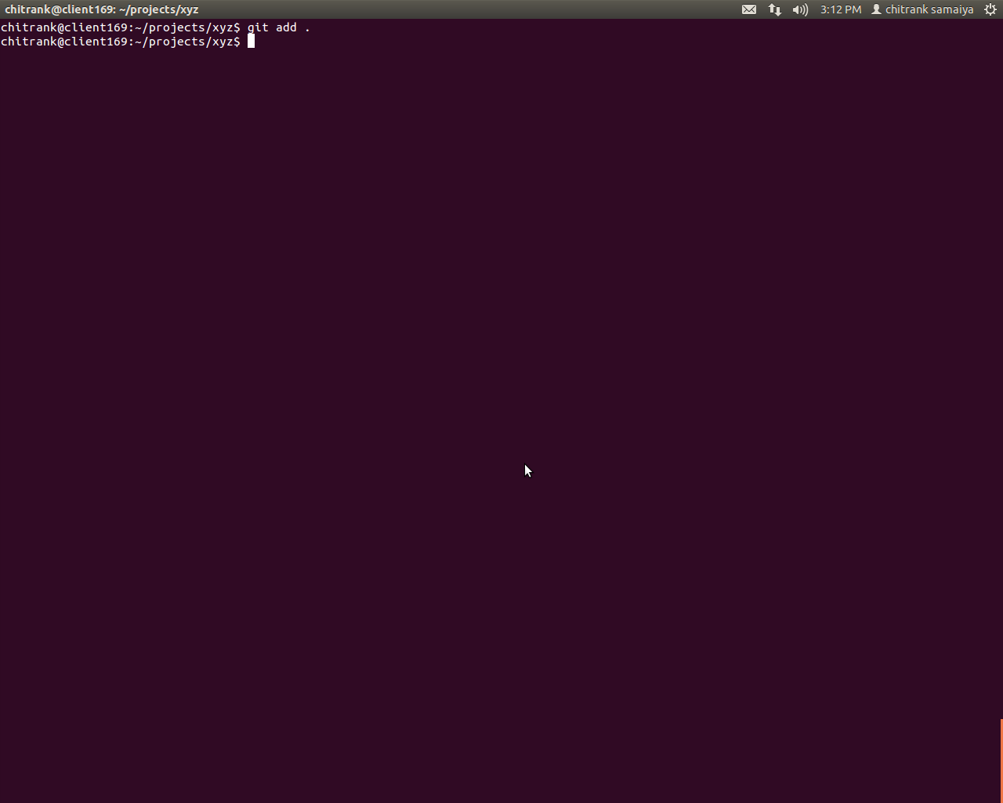

STEP 6:
Type command git commit -m “files added”,To commit the changed files
Image 5
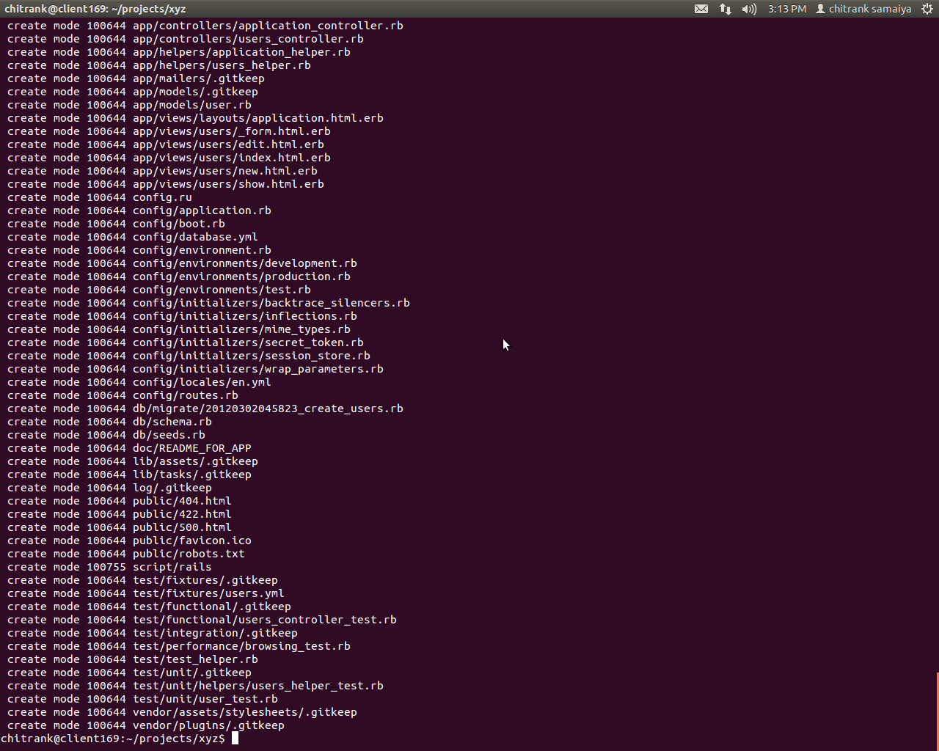

STEP 7:
Now we will be typing a command for creating project on heroku.
heroku create project_name
By this name url will generate “project_name.heroku.com”
Image 6
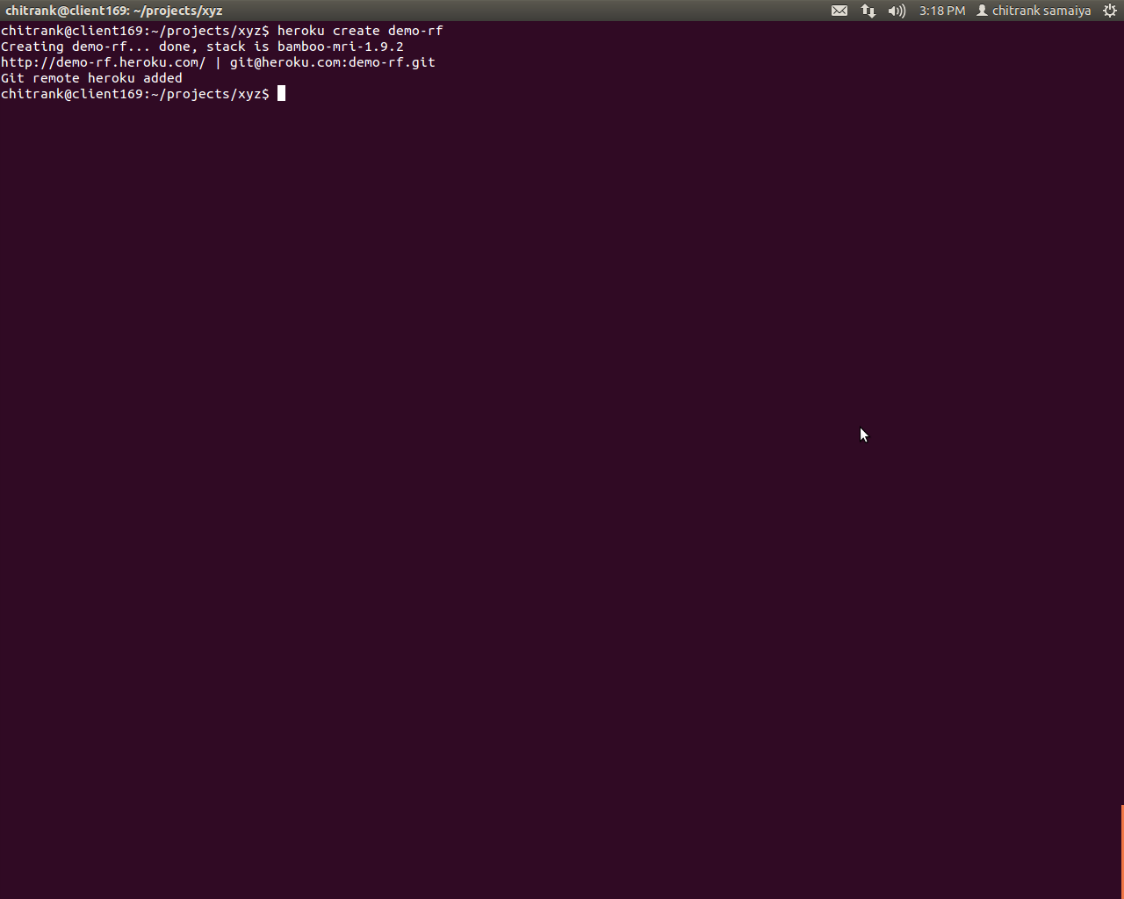

STEP 8:
Need to push the committed files,so will type a command
git push heroku master
Image 7
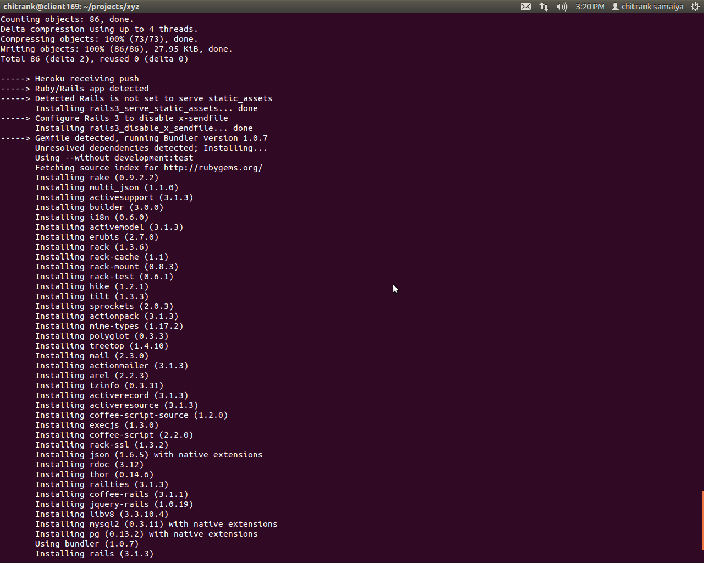

STEP 9:
After pushing the code we need to run migration on heroku so type command
heroku run rake db:migrate
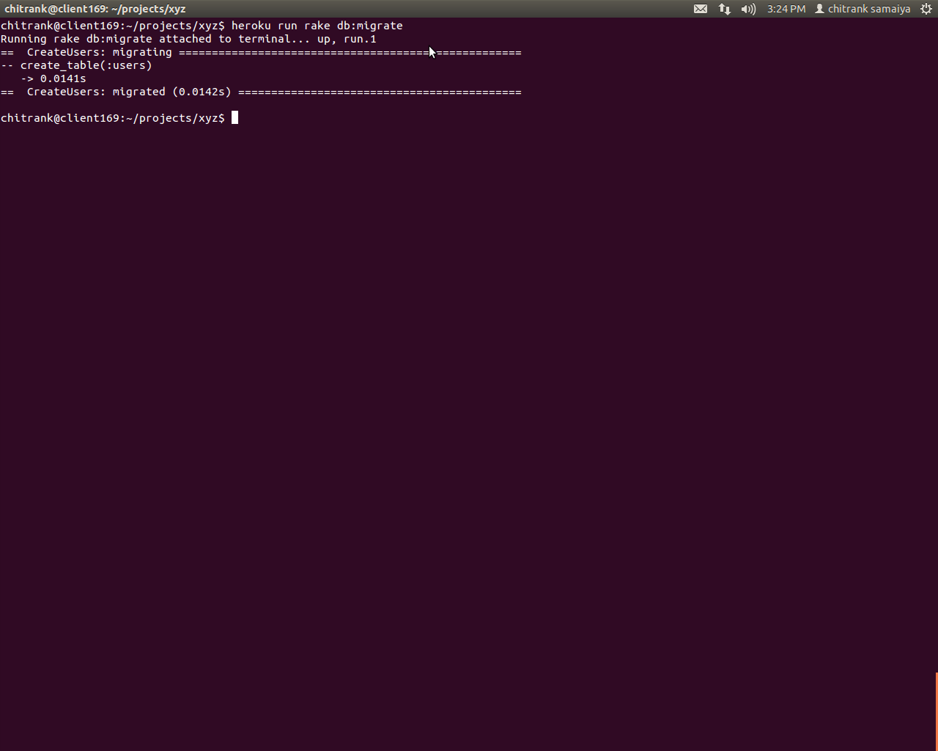

STEP 10:
Now let's check with url project_name.heroku.com
Image 9

Showing something went wrong let's check what is the problem.

STEP 11:
Actually problem is assets.Heroku does not support asset folder.Supporting folder is public.
We need to precompile assets for that we will be typing a command,
rake assets:precompile
Image 10
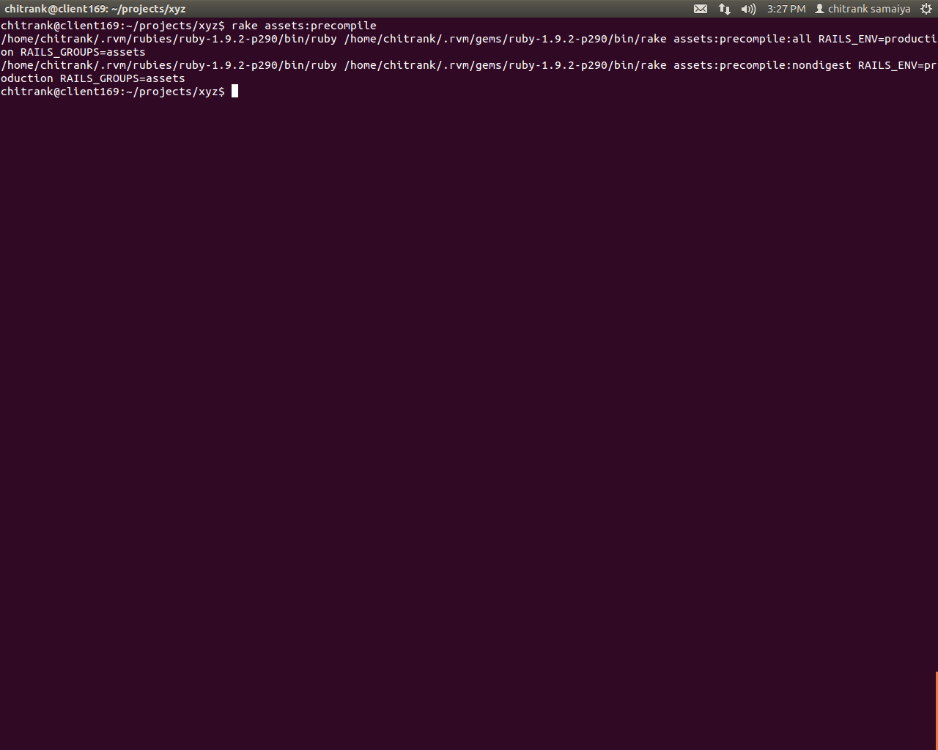

STEP 12:
Now let's check git status to find what all files are changed.
git status
Image 11
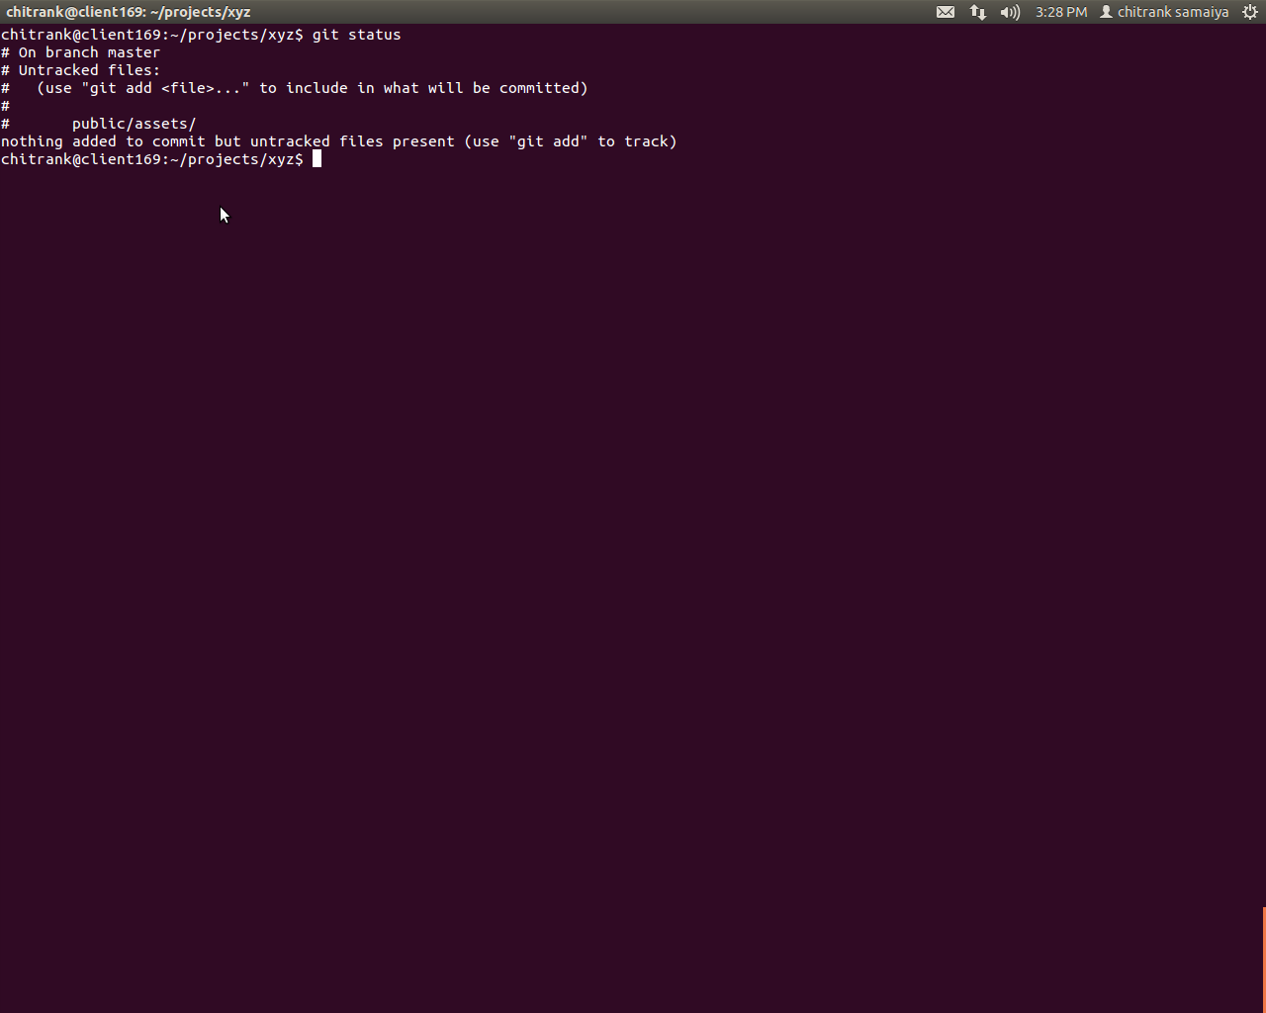

STEP 13:
To push current changes first of all add it and commit it,
git add public/assets/
git commit -m “asset precompile”
Image 12
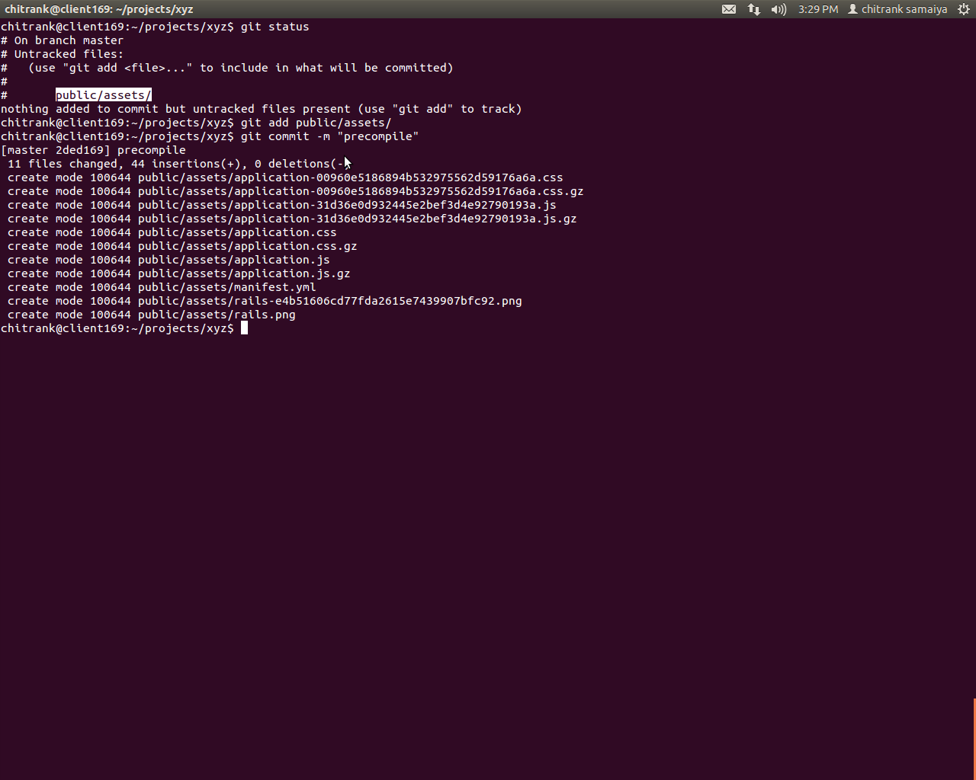

STEP 14:
Again we will type command to push currently changed files,
git push heroku master
Image 13
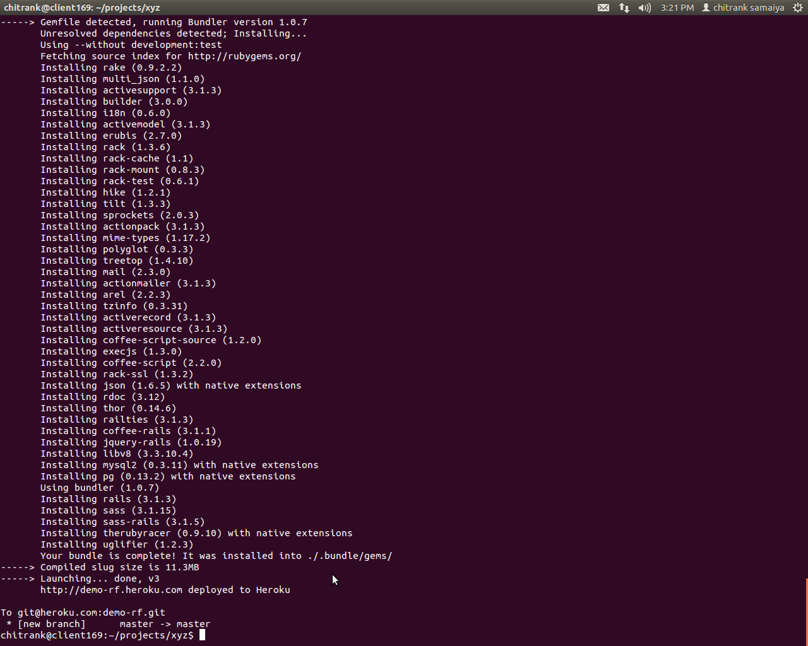

STEP 15:
So our applicatipn is deployed.

Image 14
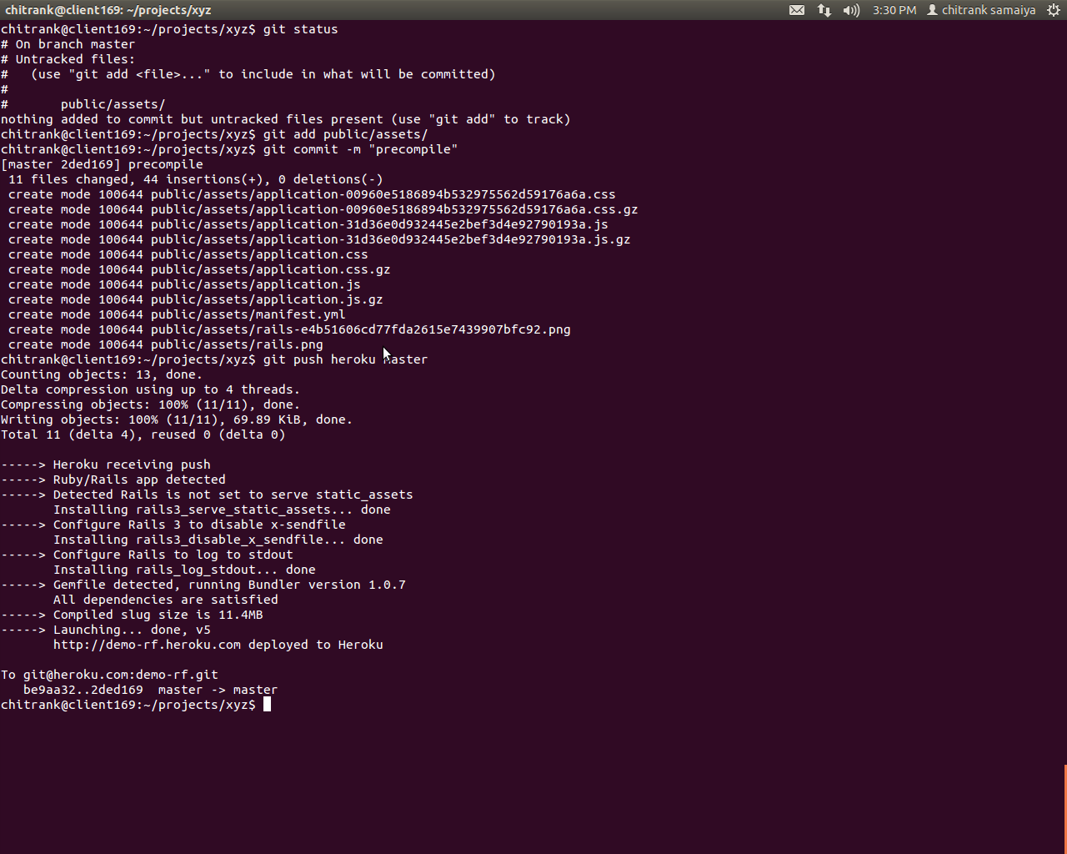

Let's check it by giving valid url “project_name.heroku.com”

Launching application
Image 15
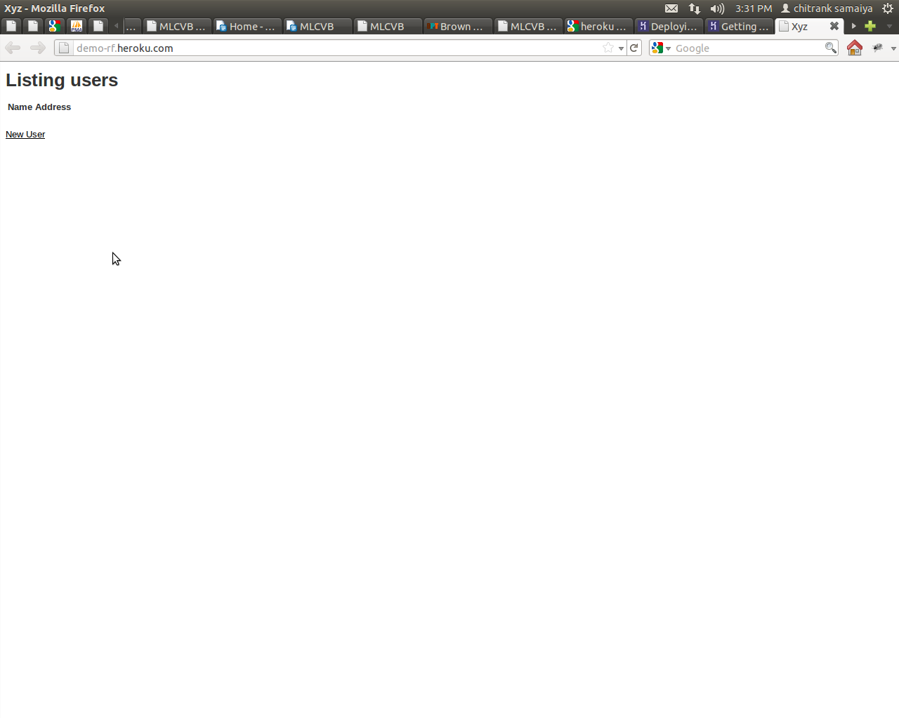

Now we can check our account
Image 16
