PARK FOOD MODEL LIST
Pigeon vs. Seagull — companion to the Game Design Document, section 10 (Food)
9 foods • 1 modeled • 8 to model, each with a free placeholder in the game until then

1. What This Is
Every food the design needs, the ability it gives, and what to build in Blender. Timed foods give their ability at once for a set number of seconds, one at a time; ice cream, bread, bagels and pizza go in a stash (up to 5 each) to use later. Dying ends both. The sizes and part breakdowns are suggestions; only the hot dog and the pigeon are measured from the game.

2. To Scale, Next to the Pigeon
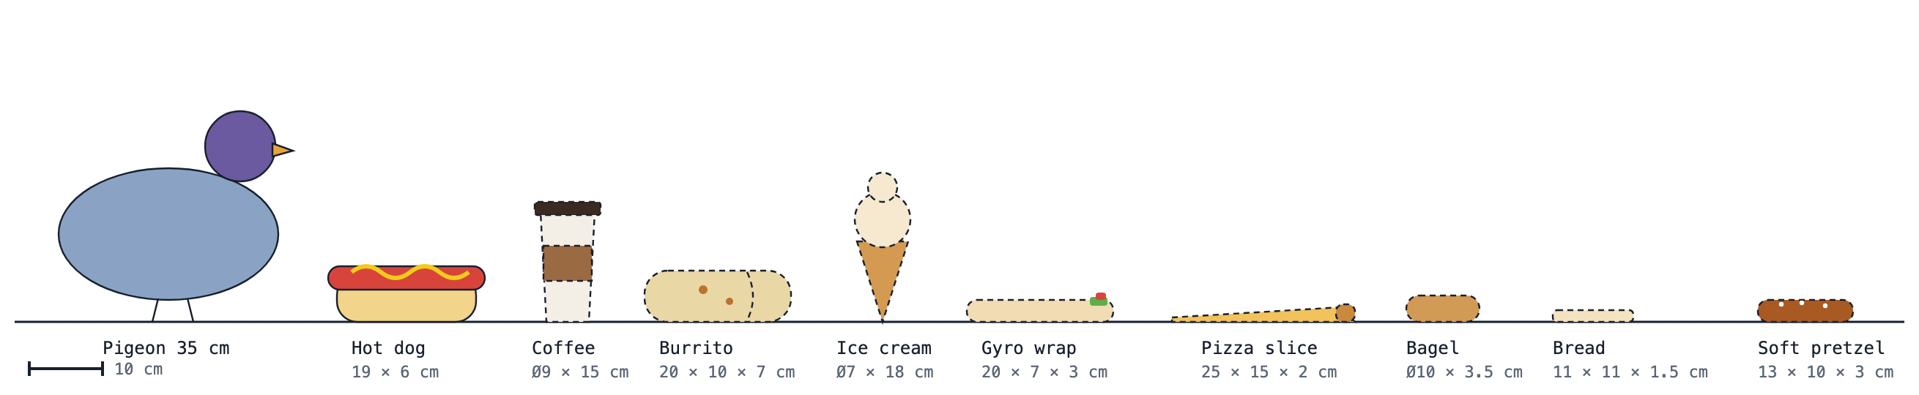
Side view at real-world size. Solid outline: modeled. Dashed: still to model. The blocks show size, not final shapes.

3. Build Order
The design doc's first prototype needs one movement food and bread. After that come the vendor foods, so each cart and truck has something to hand out, and last the foods that come from park NPCs.
1. Hot dog (done) — movement starter
2. Bread — chaos starter
3. Coffee
4. Burrito
5. Ice cream cone
6. Gyro wrap
7. Pizza slice — also the Steal lunch task
8. Bagel
9. Soft pretzel

4. Free Placeholders in the Game
Until our own models are made, each food has a free, realistic model in the game so the foods can be built and tested now. All eight are textured realistic models and scans from Sketchfab, downloaded through the open Objaverse dataset; heavy scans were reduced to about 5,000 triangles. All were rescaled to the sizes in this list and have the same clean setup as the hot dog: origin at the bottom centre, parts and materials named Food_part, URP materials (colour plus a normal map where the scan had one), a prefab with a box collider. Replace each one with our own model when it is done.
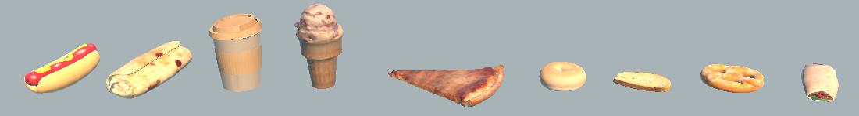
In the game, left to right: our hot dog, then the placeholder burrito, coffee, ice cream, pizza slice, bagel, bread, soft pretzel and gyro wrap.
Food | Placeholder model | Licence | Source | In Unity
Bread | "Sliced Bread" by meerschaumdigital, 960 triangles | CC-BY 4.0 | sketchfab.com/3d-models/4a13c0429e35454391c9c79a1361caa1 | Assets/Prefabs/Bread.prefab
Coffee | "Paper Cup (Unperfect)" by RoboHoloclone12, 3,764 triangles | CC-BY 4.0 | sketchfab.com/3d-models/1903f3873e2b44d2b71d37c2fa19f43a | Assets/Prefabs/Coffee.prefab
Burrito | "Burrito" by ngasbarro1, 1,970 triangles | CC-BY 4.0 | sketchfab.com/3d-models/e6a3647022fd4907b7d2364112d8188c | Assets/Prefabs/Burrito.prefab
Ice cream cone | "Ice Cream Cone Photogrammetry" by HeartOfLines, 5,000 triangles | CC-BY 4.0 | sketchfab.com/3d-models/b8cebe4d2d154bffa37ecd7a11b0d12c | Assets/Prefabs/IceCream.prefab
Gyro wrap | "Kebab - midpoly" by Pierre.Bourdon, 3,508 triangles | CC-BY 4.0 | sketchfab.com/3d-models/9e56cc9656ae4016b96cb4bb56fe3a43 | Assets/Prefabs/Gyro.prefab
Pizza slice | "Plain Pizza Slice" by inciprocal.com, 2,998 triangles | CC-BY 4.0 | sketchfab.com/3d-models/486238438ec64c3cb64d607a30d1a9e6 | Assets/Prefabs/Pizza.prefab
Bagel | "Bagel" by cyro, 996 triangles | CC-BY 4.0 | sketchfab.com/3d-models/eb3ff9a63a554526bab6318a1ef28706 | Assets/Prefabs/Bagel.prefab
Soft pretzel | "Soft Pretzel" by JeremyGrayson, 892 triangles | CC-BY 4.0 | sketchfab.com/3d-models/ec978083c86440279af2f71d7c3151ca | Assets/Prefabs/Pretzel.prefab
- Every placeholder is CC-BY, so each author must be credited in the game's credits. The full list with links is in Assets/Models/Food/CREDITS.txt.
- The burrito, gyro wrap and soft pretzel replace the taco, halal platter and fries: no clean, realistic free model of those exists, and these come from the same vendors (the Mexican trucks, halal carts and hot dog carts).
- The gyro wrap placeholder is a kebab wrap without the paper sleeve; ours should add it.

5. The Foods

Hot dog — Modeled
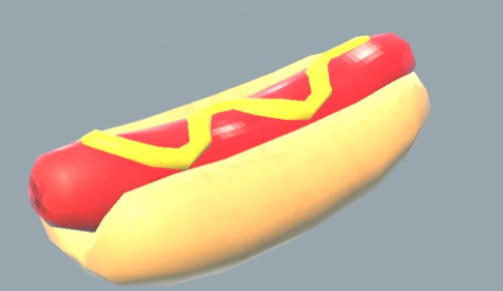
Status | Modeled
Comes from | Hot dog carts
Ability | Sprint: much faster on the ground
Lasts | 8 seconds
Pigeon (hunter) uses it to | Run down a fleeing Seagull
Seagull (hunted) uses it to | Open a gap before crossing open ground
Tradeoff | No help in the air; eating takes about 1.5 s on the spot
Model size | 19 × 7.6 × 6.4 cm, 558 triangles
Parts | Hotdog_Bun, Hotdog_Sausage (mustard painted in the texture)
What makes it read | Done: Assets/Prefabs/Hotdog.prefab

Bread — To model (placeholder in game)
Status | To model (placeholder in game)
Comes from | People feeding birds
Ability | Snitch flock: kept in the stash; on a key, the nearest flock of park birds flies to the other bird, tails it, and shows it on your minimap
Lasts | 15 seconds
Pigeon (hunter) uses it to | Find a Seagull you have lost
Seagull (hunted) uses it to | See which way the Pigeon is coming from
Tradeoff | The other bird sees the flock arrive and knows it has been found
Model size | One slice, 11 × 11 × 1.5 cm
Parts | Bread_Slice (crumb and crust in one texture, crust darker)
What makes it read | Soft square with a domed top; a bite missing helps it read as food in a beak
Placeholder now | "Sliced Bread" by meerschaumdigital (CC-BY 4.0), Assets/Prefabs/Bread.prefab

Coffee — To model (placeholder in game)
Status | To model (placeholder in game)
Comes from | Coffee carts
Ability | Jittery wings: a fourth jump and faster jump recovery
Lasts | 20 seconds
Pigeon (hunter) uses it to | Keep up through the air and over crowds
Seagull (hunted) uses it to | Escape upward and stay off the ground
Tradeoff | Steering is twitchier while it lasts
Model size | Takeaway cup, Ø9 cm top, 15 cm tall
Parts | Coffee_Cup, Coffee_Lid, Coffee_Sleeve
What makes it read | White cup, dark lid, brown sleeve; steam is the ability tell, not part of the model
Placeholder now | "Paper Cup (Unperfect)" by RoboHoloclone12 (CC-BY 4.0), Assets/Prefabs/Coffee.prefab

Burrito — To model (placeholder in game)
Status | To model (placeholder in game)
Comes from | Mexican trucks
Ability | Hot-sauce lunge: every jump becomes a long, low lunge
Lasts | 10 seconds
Pigeon (hunter) uses it to | Pounce on a Seagull busy with a task
Seagull (hunted) uses it to | Juke across a gap the Pigeon cannot follow
Tradeoff | Hard to stop or steer; hot-sauce drips mark your path
Model size | 20 × 10 × 7 cm, rolled and folded
Parts | Burrito_Tortilla (one closed roll; a torn end showing filling helps)
What makes it read | Floury tortilla with toasted spots; a little foil at one end says food truck
Placeholder now | "Burrito" by ngasbarro1 (CC-BY 4.0), Assets/Prefabs/Burrito.prefab

Ice cream cone — To model (placeholder in game)
Status | To model (placeholder in game)
Comes from | Ice cream trucks
Ability | Egg bomb: blasts you about 15 m straight up and hits everyone else within 6 m
Lasts | Kept in the stash, up to 5; set off any time
Pigeon (hunter) uses it to | Drop in on the Seagull from above, or blast it out of a crowd
Seagull (hunted) uses it to | Get out of any corner instantly, straight up
Tradeoff | Loud and obvious: the splat shows where you went up, and it hurts people near you too
Model size | Ø7 × 18 cm
Parts | IceCream_Cone, IceCream_Scoop (soft-serve swirl), plus a flat yellow IceCream_Splat for the egg-bomb blast
What makes it read | Same vanilla swirl and waffle cone as the truck's roof cone, at hand size
Placeholder now | "Ice Cream Cone Photogrammetry" by HeartOfLines (CC-BY 4.0), Assets/Prefabs/IceCream.prefab

Gyro wrap — To model (placeholder in game)
Status | To model (placeholder in game)
Comes from | Halal carts
Ability | Full belly: take half damage and cannot be knocked back
Lasts | 20 seconds
Pigeon (hunter) uses it to | Push through police fire to stay on the Seagull
Seagull (hunted) uses it to | Survive a hit or two from the Pigeon
Tradeoff | Longest eat (about 3 s); jumps are lower while it lasts
Model size | 20 × 7 × 3 cm, pita wrapped in a paper sleeve
Parts | Gyro_Pita, Gyro_Filling (meat, lettuce, tomato, white sauce), Gyro_Paper
What makes it read | Open top showing lettuce and tomato; the paper sleeve reads as street food
Placeholder now | "Kebab - midpoly" by Pierre.Bourdon (CC-BY 4.0), Assets/Prefabs/Gyro.prefab

Pizza slice — To model (placeholder in game)
Status | To model (placeholder in game)
Comes from | Picnickers (snatched)
Ability | Crowd favourite: any person you ride sprints and cannot shake you off
Lasts | 20 seconds of riding, kept in the stash until you ride someone
Pigeon (hunter) uses it to | Run down the Seagull on a fast human
Seagull (hunted) uses it to | Escape on a fast human; also counts for the Steal lunch task
Tradeoff | Only works while riding; snatching makes the picnicker shout
Model size | 25 cm long, 15 cm across the crust, 2 cm thick
Parts | Pizza_Slice, Pizza_Crust, Pizza_Pepperoni
What makes it read | A slight droop at the tip says New York slice
Placeholder now | "Plain Pizza Slice" by inciprocal.com (CC-BY 4.0), Assets/Prefabs/Pizza.prefab

Bagel — To model (placeholder in game)
Status | To model (placeholder in game)
Comes from | Commuters, bench tops
Ability | Bagel shield: each bagel soaks up one whole hit
Lasts | Kept in the stash, up to 5; used by itself on the next hit
Pigeon (hunter) uses it to | Walk through police fire, or trade shots with the Seagull
Seagull (hunted) uses it to | Survive the one hit you couldn’t dodge
Tradeoff | Spent on any hit, even a weak one you didn’t need it for
Model size | Ø10 × 3.5 cm
Parts | Bagel_Ring (sesame seeds painted in the texture)
What makes it read | Keep the hole large; it is the whole silhouette
Placeholder now | "Bagel" by cyro (CC-BY 4.0), Assets/Prefabs/Bagel.prefab

Soft pretzel — To model (placeholder in game)
Status | To model (placeholder in game)
Comes from | Hot dog carts
Ability | Low profile: people and police ignore your gunshots, and officers already after you give up
Lasts | 15 seconds
Pigeon (hunter) uses it to | Shoot in a crowd without bringing the police
Seagull (hunted) uses it to | Shake off officers on your tail
Tradeoff | Birds still scatter at your shots, which gives you away
Model size | 13 × 10 × 3 cm
Parts | Pretzel_Pretzel
What makes it read | Glossy dark-brown crust with big white salt flakes; keep the knot shape open
Placeholder now | "Soft Pretzel" by JeremyGrayson (CC-BY 4.0), Assets/Prefabs/Pretzel.prefab

6. What Each Food Covers
Every kind of help a hunter or hunted bird needs has a food, except finding or hiding from the other bird. That stays with chess pieces, the phone and sunglasses, so eating can never replace tracking.
Need | Hot dog | Bread | Coffee | Burrito | Ice cream | Gyro | Pizza | Bagel | Pretzel
Close or open distance on the ground | ● |  |  |  |  |  | ●
Height and air time |  |  | ● |  |  |  |  | ●
A sudden lunge or juke |  |  |  | ●
Staying out of reach |  |  |  |  |  |  |  | ●
Lasting longer |  |  |  |  |  | ●
Controlling ground |  |  |  |  | ● |  |  |  | ●
Breaking line of sight |  | ●
Using people |  |  |  |  |  |  | ●
Finding or hiding from the other bird | — | — | — | — | — | — | — | — | —

7. How to Model Them
These match how the hot dog was built, so each new food drops into Unity the same way.

In Blender
- Real-world size in metres; the origin at the bottom centre, sitting on the ground.
- An empty named after the food (Coffee), with one mesh per part under it (Coffee_Cup).
- One material per part, named the same way in lower case (Coffee_cup).
- Around 200 to 600 triangles each; the hot dog is 558.

Textures
- A 64 × 64 painted base colour, linked to Base Color on a Principled BSDF. Nothing else is needed.
- Image Texture set to Closest, for crisp pixels like the hot dog.
- Packed into the .blend is fine; they get saved out as PNGs on import.
- Strong, simple colours: these are seen in a pigeon's beak from a third-person camera.

Hand-off
- Save as Assets/Blender/<food>.blend.
- On import each food gets URP materials in Assets/Models/<Food>/ and a prefab in Assets/Prefabs/.
- The abilities are not in the game yet; the models come first.

