Vraj Patel

06/16/20

Classwork 1

Web Programming

Local server up and running

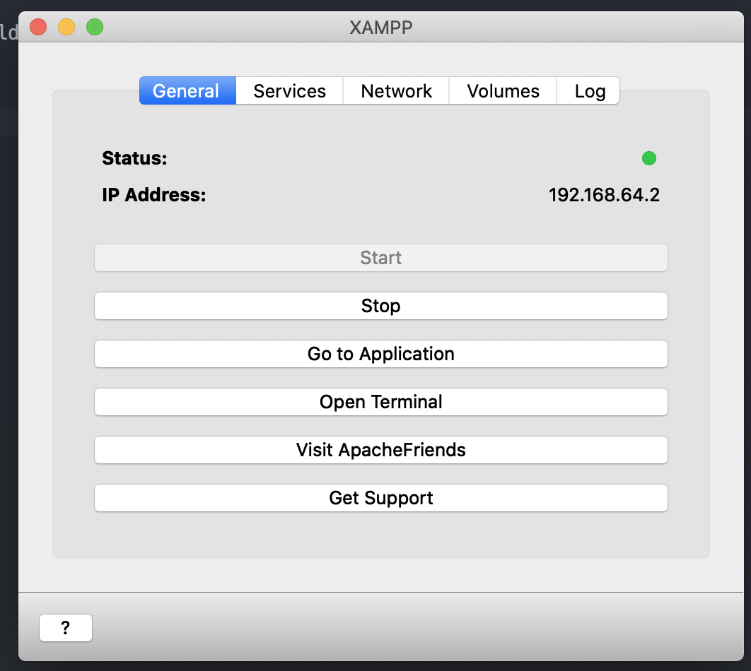

Sample index page

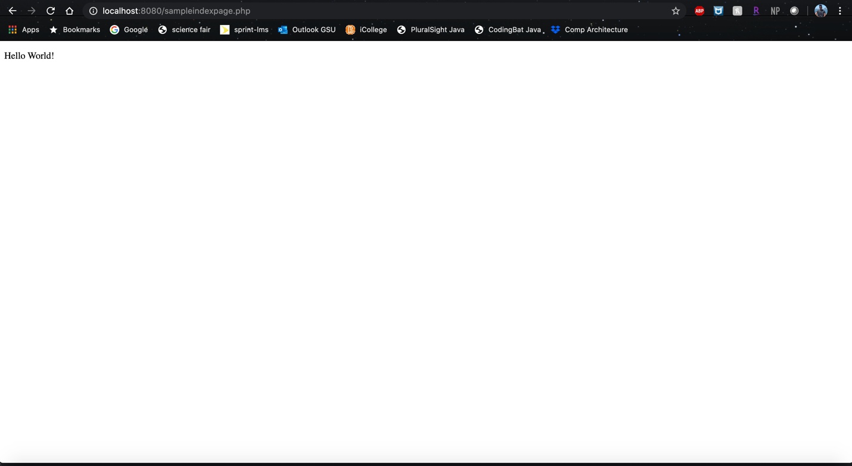

CODD server not working

