Vraj Patel

CSC 4370

Classwork 5

Ex1.html

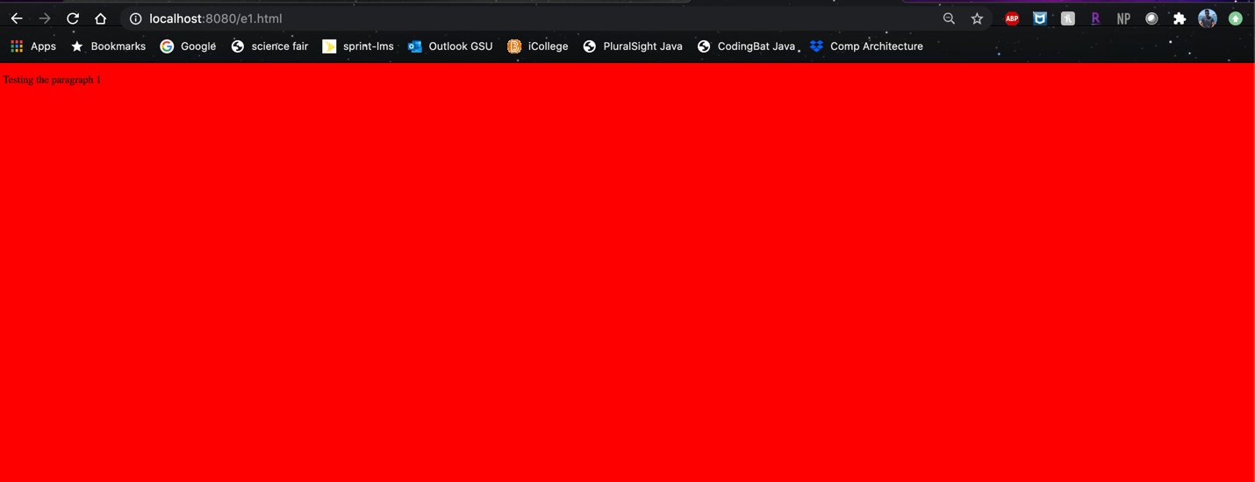

Ex2.html



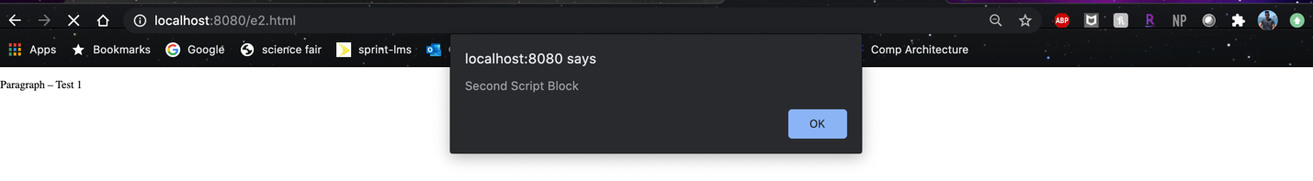

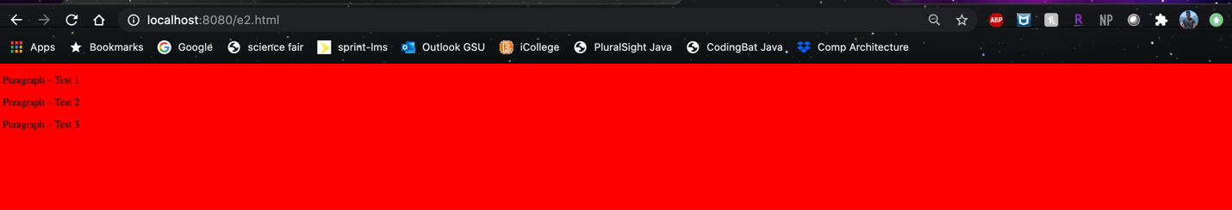

Ex3.html



Ex4.html





Ex5.html



Ex6.html





Ex7.html



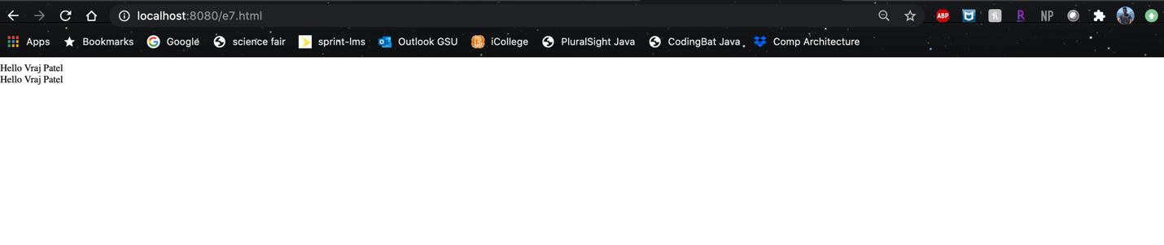

Ex8.html



Ex9.html

