Name: Vaibhav Patel (Email: vaipate@siue.edu)

Course: CS-434

Instructor: Dr. Mark McKenney

Project 4 README

For project 4, I have generated fake data for each table in Microsoft excel because I did not able to find data I need for my database. Although, they are fake data, they completely look real. I have pulled out data from different sources and put them together in csv files. I have created total 9 csv files one for each 9 tables. All tables follow primary and foreign keys constraints. I have inserted all data into tables using following query:

LOAD DATA LOCAL INFILE 'filename'

INTO TABLE 'tablename'

FIELDS TERMINATED by ','

LINES TERMINATED BY '\n';

I basically repeated this command nine times for nine tables from the command line. The data was inserted without any errors. I also inserted enough data so it fulfills all requirements listed in project 4 description.

Here is the image from phpMyAdmin which shows how many rows were inserted in each table:

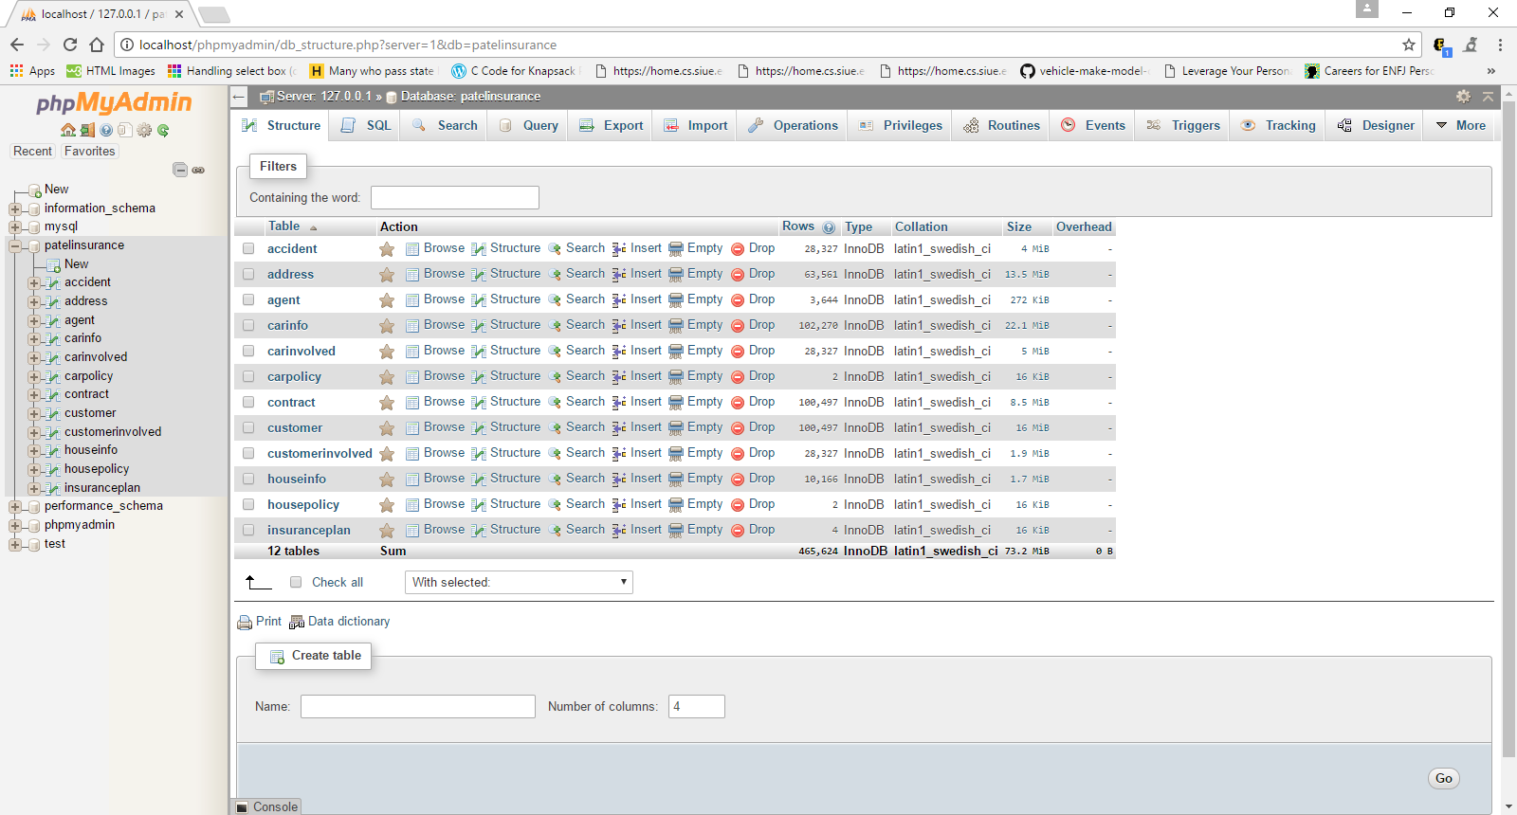

There are total 465,624 tuples in the database. You can see I only have 4 tuples for insurance plan, 2 for housepolicy and, 2 for carpolicy. It is because insurance company is providing total 4 different insurance plans 2 for car and 2 for house. All other 9 tables have more than 1000 tuples in them. I am not listing numbers of tuple in each table here but you can find out from picture above, check out “Rows” column.

Also, I have attached CS434_VaibhavPatel_P4_proof.pdf file, which contains pictures of 12 tables from phpMyAdmin which show that how many rows are in the tables and some tuples. I have exported SQL script from phpMyAdmin but it is very big file with 470,000 insert statements in it. I did not attach any script because I inserted data interactively using command line and query stated above. If you would like to see the SQL script I can show you in person.